Command Reference: WriteTimeSeriesToExcelFormatted()

Write one or more time series to a Microsoft Excel workbook file using layout

Version 11.00.00, 2015-03-11

**This command is under development.**

The WriteTimeSeriesToExcelFormatted() command writes one or more time series to an Excel workbook with control over the output layout. The following functionality is provided:

* Time series are written in blocks (see WriteTimeSeriesToExcel() for simple column output).
* The worksheet and position in worksheet can be specified.
* The output can be created or appended.
* Options are provided to select how the blocks of data are oriented.

TSTool uses the Apache POI software (http://poi.apache.org) to read/write the Excel file and consequently functionality is constrained by the features of that software package.

The following figures illustrate the dialog used to edit the command and the syntax for the command.

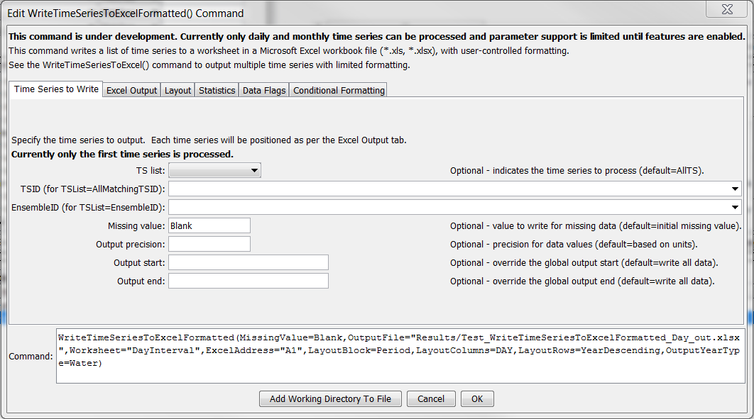

WriteTimeSeriesToExcelFormatted_TimeSeries

WriteTimeSeriesToExcelFormatted() Command Editor Showing Time Series Parameters

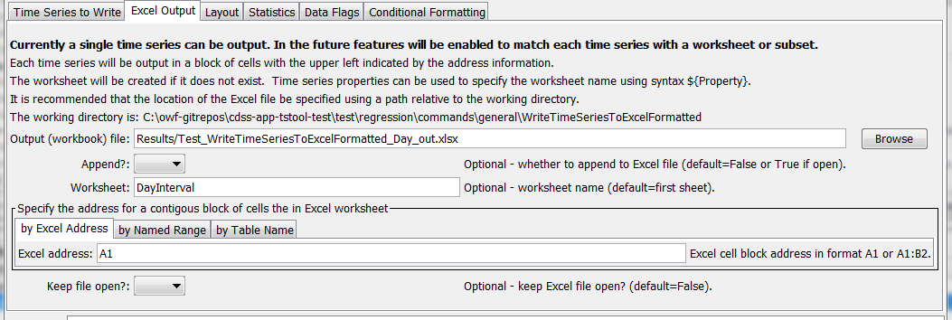

WriteTimeSeriesToExcelFormatted_Output

WriteTimeSeriesToExcel() Command Editor for Excel Output Parameters

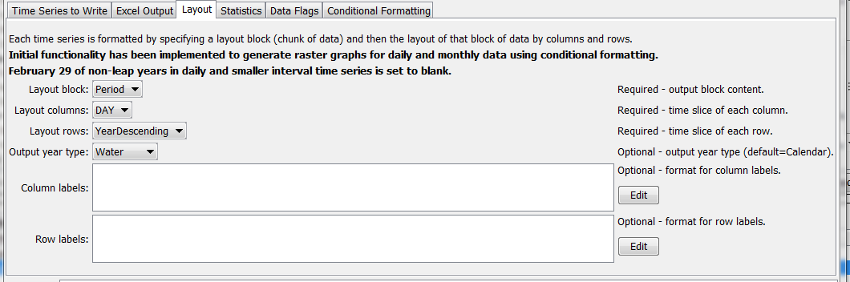

WriteTimeSeriesToExcelFormatted_Layout

WriteTimeSeriesToExcel() Command Editor for Layout Parameters

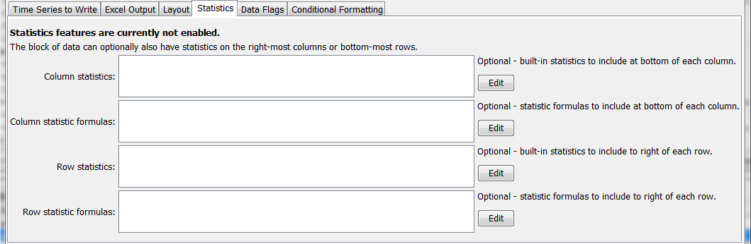

WriteTimeSeriesToExcelFormatted_Statistics

WriteTimeSeriesToExcel() Command Editor for Statistics Parameters

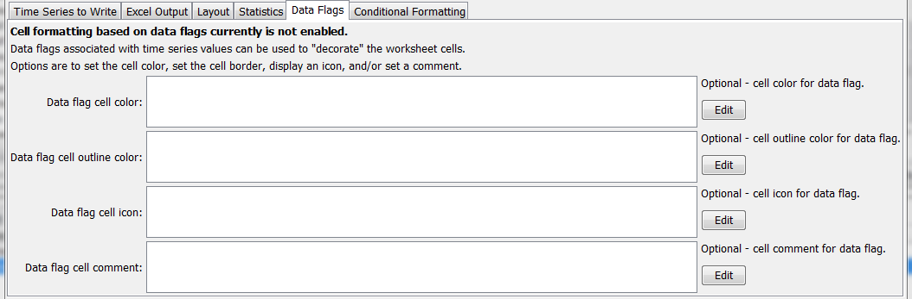

WriteTimeSeriesToExcelFormatted_DataFlags

WriteTimeSeriesToExcel() Command Editor for Data Flag Parameters

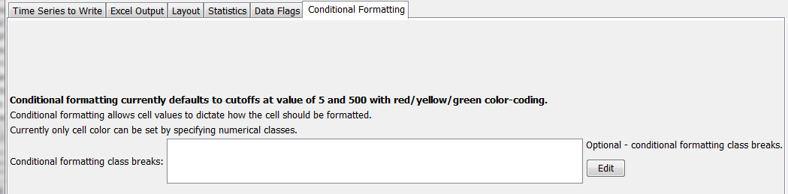

WriteTimeSeriesToExcelFormatted_Conditional

WriteTimeSeriesToExcel() Command Editor for Conditional Formatting Parameters

The command syntax is as follows:

WriteTimeSeriesToExcelFormatted(Parameter=Value,…)

Command Parameters

| Parameter | Description | Default |
| --- | --- | --- |
| TSList | Indicates the list of time series to be processed, one of:   * AllMatchingTSID – all time series that match the TSID (single TSID or TSID with wildcards) will be processed. * AllTS – all time series before the command. * EnsembleID – all time series in the ensemble will be processed. * FirstMatchingTSID – the first time series that matches the TSID (single TSID or TSID with wildcards) will be processed. * LastMatchingTSID – the last time series that matches the TSID (single TSID or TSID with wildcards) will be processed. * SelectedTS – the time series are those selected with the SelectTimeSeries() command. | AllTS |
| TSID | The time series identifier or alias for the time series to be processed, using the * wildcard character to match multiple time series. | Required if TSList=*TSID. |
| EnsembleID | The ensemble to be processed, if processing an ensemble. | Required if TSList= EnsembleID. |
| MissingValue | Value to write to Excel for missing data values, can be literal Blank to output blank cell. | Original missing value. |
| Precision | The number of digits after the decimal for data values. | Determine from units. |
| OutputStart | The date/time for the start of the output. | Use the global output period. |
| OutputEnd | The date/time for the end of the output. | Use the global output period. |
| OutputFile | The name of the Excel workbook file (*.xls or *.xlsx) to write, as an absolute path or relative to the command file location. If the Excel file does not exist it will be created. | None – must be specified. |
| Append | Indicate whether the sheet being written should appended to an existing workbook. | False – create a new workbook. |
| Worksheet | The name of the worksheet in the workbook to write. If the worksheet does not exist it will be created. | Write to the first worksheet. |
| ExcelAddress | Indicates the block of cells to write, using Excel address notation (e.g., A1:D10). | Must specify address using one of available address parameters. |
| Excel  NamedRange | Indicates the block of cells to write, using an Excel named range. | Must specify address using one of available address parameters. |
| Excel  TableName | Indicates the block of cells to write, using an Excel named range. | Must specify address using one of available address parameters. |
| KeepOpen | Indicate whether to keep the Excel file open (True) or close after creating (False). Keeping the file open will increase performance because later commands will not need to reread the workbook. Make sure to close the file in the last Excel command. | False |
| LayoutBlock | Indicate data blocks for output:   * Period – time series period of record is output as a block * Year – year of data is output in a block | None – must be specified. |
| LayoutColumns | For the output block, indicate what columns contain:   * Day – one day per column * Month – one month per column * Year – one year per column | None – must be specified. |
| LayoutRows | For the output block, indicate what rows contain:   * YearAscending – year, with earliest at top * YearDescending – year, with most recent at top | None – must be specified. |
| Output  YearType | The output year type, which controls the start and end dates for the output. | Calendar |

This page is intentionally blank