Command Reference: WriteTimeSeriesToGeoJSON()

Write time series to a GeoJSON format file

Version 11.08.01, 2016-02-14

The WriteTimeSeriesToGeoJSON() command writes time series to a GeoJSON file, which is a spatial data format that can be viewed in geographic information system (GIS) software and other visualization tools. See: http://geojson.org/geojson-spec.html

The time series must have properties for longitude and latitude or Well Known Text (WKT) geometry string. See: http://en.wikipedia.org/wiki/Well-known_text

Currently only point and polygon data can be processed but in the future support for well-known text for other geometry types will be added. A future enhancement of this command will allow the geometry feature data to be read from other spatial formats.

The following dialog is used to edit the command and illustrates the syntax of the command.

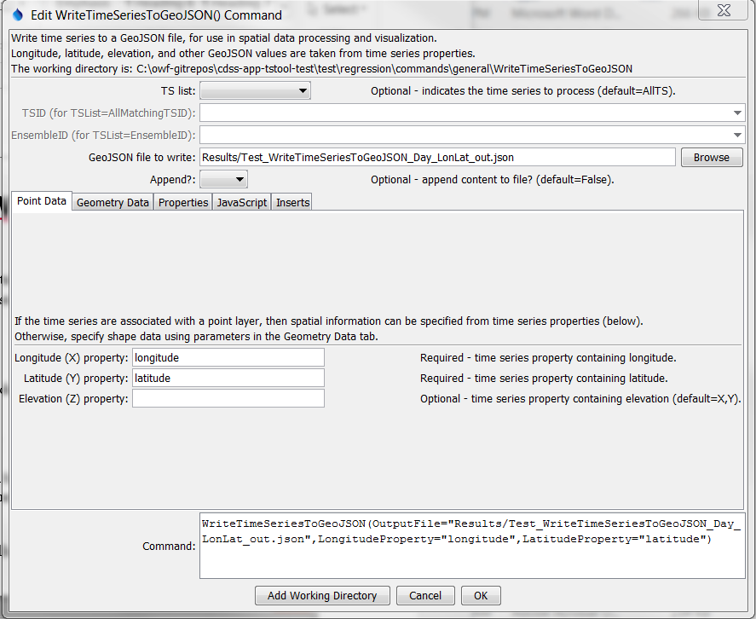

WriteTimeSeriesToGeoJSON

WriteTimeSeriesToGeoJSON() Command Editor for Point Data Parameters

The following figure illustrates the command syntax for layers specified with a WKT geometry property.

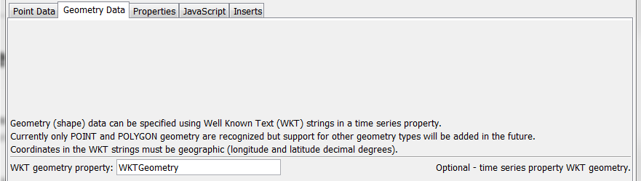

WriteTimeSeriesToGeoJSON_WKT

WriteTimeSeriesToGeoJSON() Command Editor for WKT Geometry Data Parameters

The following figure illustrates the command syntax for specifying time series properties to include as properties in the GeoJSON output.

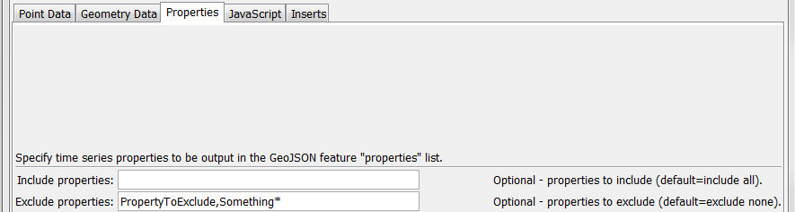

WriteTimeSeriesToGeoJSON_Properties

WriteTimeSeriesToGeoJSON() Command Editor for Property Parameters

The following figure illustrates the command syntax for specifying the JavaScript variable for the output.

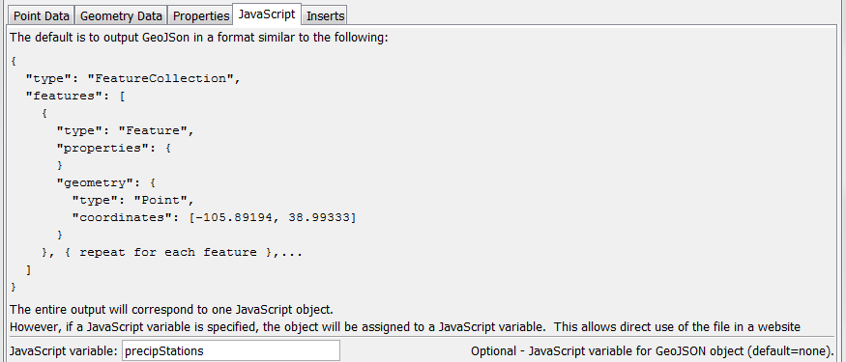

WriteTimeSeriesToGeoJSON_JavaScriptVar

WriteTimeSeriesToGeoJSON() Command Editor for JavaScript Parameters

The following figure illustrates the command syntax for specifying inserts around the GeoJSON content.

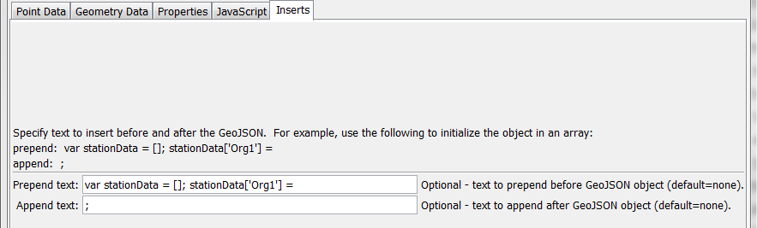

WriteTimeSeriesToGeoJSON_Inserts

WriteTimeSeriesToGeoJSON() Command Editor for Text Insert Parameters

The command syntax is as follows:

WriteTimeSeriesToGeoJSON(Parameter=Value,…)

Command Parameters

| Parameter | Description | Default |
| --- | --- | --- |
| TSList | Indicates the list of time series to be processed, one of:   * AllMatchingTSID – all time series that match the TSID (single TSID or TSID with wildcards) will be processed. * AllTS – all time series before the command. * EnsembleID – all time series in the ensemble will be processed. * FirstMatchingTSID – the first time series that matches the TSID (single TSID or TSID with wildcards) will be processed. * LastMatchingTSID – the last time series that matches the TSID (single TSID or TSID with wildcards) will be processed. * SelectedTS – the time series are those selected with the SelectTimeSeries() command. | AllTS |
| TSID | The time series identifier or alias for the time series to be processed, using the * wildcard character to match multiple time series. | Required if TSList=*TSID. |
| EnsembleID | The ensemble to be processed, if processing an ensemble. | Required if TSList= EnsembleID. |
| OutputFile | The GeoJSON output file. The path to the file can be absolute or relative to the working directory (command file location). Global properties can be used to specify the filename, using the ${Property} syntax. | None – must be specified. |
| Append | Indicate whether to append the GeoJSON content to the output file, True or False. | False |
| Longitude  Property | The name of the time series property containing the longitude to use for the GeoJSON. | Required unless WKT geometry is specified. |
| Latitude  Property | The name of the time series property containing the latitude to use for the GeoJSON. | Required unless WKT geometry is specified. |
| Elevation  Property | The name of the time series property containing the elevation to use for the GeoJSON. | Omitted |
| WKTGeometry  Property | The name of the time series property that contains Well Known Text (WKT) geometry strings. | Will use point data properties |
| IncludeColumns | List of comma-separated time series property names to include as feature properties, using * for wildcard. | Include all columns. |
| ExcludeColumns | List of comma-separated time series property names to exclude as feature properties. | Exclude no columns. |
| JavaScriptVar | Name of JavaScript variable to assign object to in output. This parameter will be ignored if PrependText or AppendText are specified. | Output GeoJSON object surrounded by { }. |
| PrependText | Provide text to insert before the GeoJSON object, for example to provide custom JavaScript. Can be specified using ${Property} notation. | No insert. |
| AppendText | Provide text to append after the GeoJSON object, for example to provide custom JavaScript. Can be specified using ${Property} notation. | No insert. |