Command Reference: WriteTimeSeriesToHydroJSON()

Write time series to a HydroJSON format file

Version 11.07.03, 2015-08-25

**This command is under development. The HydroJSON format is a new open data format that is being developed by USGS, Army Corps, and Reclamation agencies for data exchange.**

The WriteTimeSeriesToHydroJSON() command writes time series to a file using HydroJSON format, which adheres to JSON (JavaScript Object Notation) notation. The file can be included in a JavaScript script to instantiate data objects. Refer to the HydroJSON Input Type Appendix for more information about the format. The main complexity with writing the file is that the HydroJSON format has elements that cannot be mapped to standard TSTool time series properties. Consequently, default mapping is implemented where obvious and the ability to override with time series properties is provided for many HydroJSON elements. The following figures illustrate how such mapping can occur.

The following dialog is used to edit the command and illustrates the syntax of the command.

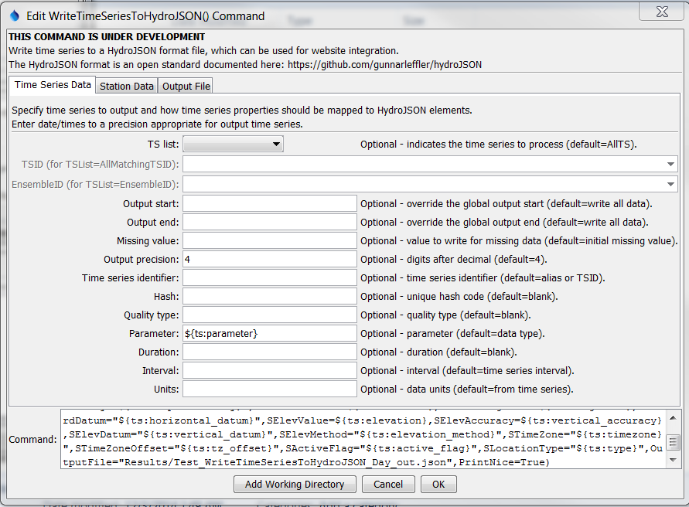

WriteTimeSeriesToHydroJSON

WriteTimeSeriesToHydroJSON() Command Editor for Time Series Parameters

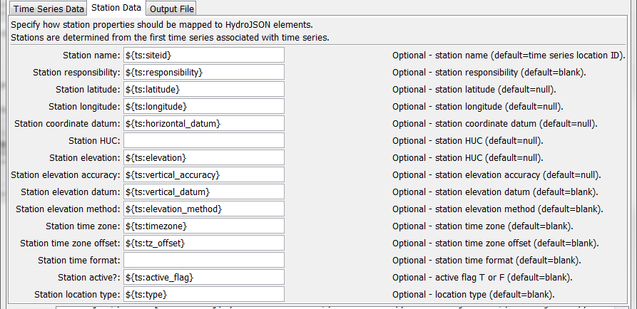

WriteTimeSeriesToHydroJSON_Station

WriteTimeSeriesToHydroJSON() Command Editor for Station Parameters

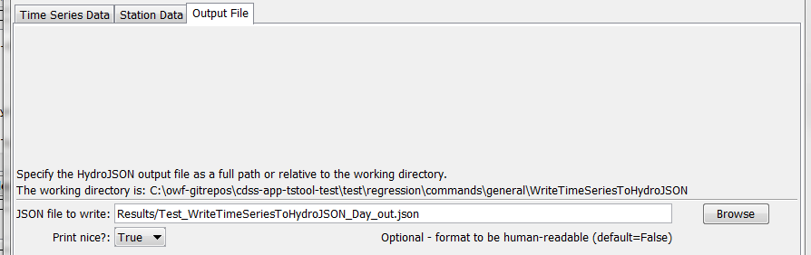

WriteTimeSeriesToHydroJSON_File

WriteTimeSeriesToHydroJSON() Command Editor for Output File Parameters

The command syntax is as follows:

WriteTimeSeriesToHydroJSON(Parameter=Value,…)

Command Parameters

| Parameter | Description (HydroJSON value in [bracket]) | Default |
| --- | --- | --- |
| TSList | Indicates the list of time series to be processed, one of:   * AllMatchingTSID – all time series that match the TSID (single TSID or TSID with wildcards) will be processed. * AllTS – all time series before the command. * EnsembleID – all time series in the ensemble will be processed. * FirstMatchingTSID – the first time series that matches the TSID (single TSID or TSID with wildcards) will be processed. * LastMatchingTSID – the last time series that matches the TSID (single TSID or TSID with wildcards) will be processed. * SelectedTS – the time series are those selected with the SelectTimeSeries() command. | AllTS |
| TSID | The time series identifier or alias for the time series to be processed, using the * wildcard character to match multiple time series. | Required if TSList=*TSID. |
| EnsembleID | The ensemble to be processed, if processing an ensemble. | Required if TSList= EnsembleID. |
| OutputStart | The date/time for the start of the output. [start_timestep] | Use the global output period. |
| OutputEnd | The date/time for the end of the output. [end_timestep] | Use the global output period. |
| MissingValue | The value to write to the file to indicate a missing value in the time series, must be a number or NaN. **Currently not enabled**. |  |
| Precision | The number of digits after the decimal for numerical output. **Currently not enabled**. |  |
| TIdentifier | The time series identifier for HydroJSON output. Can specify using ${Property} and ${ts:Property}. [tsid?] | Alias if available, or time series identifier (TSID). |
| THash | Hash code that uniquely identifies the time series. Can specify using ${Property} and ${ts:Property}. [hash] | Blank |
| TQualityType | Time series quality type? [quality_type] | Blank |
| TParameter | Time series parameter (data type). Can specify using ${Property} and ${ts:Property}. [parameter] | Time series data type. |
| TDuration | Time series duration. Can specify using ${Property} and ${ts:Property}. [duration] | Blank |
| TInterval | Time series interval. Can specify using ${Property} and ${ts:Property}. [interval] | Blank |
| TUnits | Time series data units. Can specify using ${Property} and ${ts:Property}. [units] | Time series data units |
| SName | Station name. Can specify using ${Property} and ${ts:Property}. [name] | Location part of time series. |
| SResponsibility | Agency responsible for station. Can specify using ${Property} and ${ts:Property}. [responsibility] | Blank |
| SCoordLatitude | Station latitude. Can specify using ${Property} and ${ts:Property}. [latitude] | null |
| SCoordLongitude | Station longitude. Can specify using ${Property} and ${ts:Property}. [longitude] | null |
| SCoordDatum | Station horizontal datum. Can specify using ${Property} and ${ts:Property}. [datum] | Blank |
| SHUC | Station hydrologic unit code. Can specify using ${Property} and ${ts:Property}. [huc] | Blank |
| SElevValue | Station elevation. Can specify using ${Property} and ${ts:Property}. [value] | null |
| SElevAccuracy | Station elevation accuracy. Can specify using ${Property} and ${ts:Property}. [accuracy] | null |
| SElevDatum | Station vertical datum. Can specify using ${Property} and ${ts:Property}. [datum] | Blank |
| SElevMethod | Station elevation method. Can specify using ${Property} and ${ts:Property}. [method] | Blank |
| STimeZone | Station time zone. Can specify using ${Property} and ${ts:Property}. [timezone] | Blank |
| STimeZoneOffset | Station time zone offset. Can specify using ${Property} and ${ts:Property}. [tz_offset] | Blank |
| STimeFormat | Format used for timestamps in file. [time_format] | Blank |
| SActiveFlag | Flag indicating whether station is active, T or F. [active_flag] | Blank |
| SLocationType | Station location type. Can specify using ${Property} and ${ts:Property}. [location_type] | Blank |
| OutputFile | The JSON output file. The path to the file can be absolute or relative to the working directory (command file location). Global properties can be used to specify the filename, using the ${Property} syntax. | None – must be specified. |
| PrintNice | If True, format HydroJSON with line breaks so that output is human-readable. If False, minimal formatting occurs, suitable for website products. | False |

In addition to the HydroJSON properties that can be specified above, the following values are automatically calculated:

| HydroJSON Value | Description |
| --- | --- |
| values | Time series values are taken from time series date/time, value, and flag. |
| count | Number of non-missing and missing values (?). |
| min_value | Minimum value in time series in output period. |
| max_value | Maximum value in time series in output period. |