Appendix: TSTool Installation and Configuration for CDSS

CDSS Version, 11.09.00, 2016-02-20

# 1. Overview

This appendix describes how to install TSTool in the CDSS (Colorado's Decision Support Systems) environment. CDSS consists of the HydroBase database, modeling, and data viewing/editing software. TSTool can be used within this system to process time series from the HydroBase database, CDSS model files, and other databases and files.

# 2. File Locations

Standard locations of TSTool software files are as follows. Files are normally installed on Windows on the C: drive but can be installed in a shared location on a server. Note that the following list of software *.jar files may be different from the current TSTool version. In the future separate documentation may be provided explaining software components and licenses.

|  |  |  |
| --- | --- | --- |
| C: \CDSS\TSTool-Version |  | Top-level install directory. |
| bin\ |  | Software program files directory. |
| batik*.jar |  | Scalable Vector Graphics (SVG) output packages. |
| Blowfish*.jar |  | Used for encryption/security. |
| cdss.domain*.jar |  | CDSS components. |
| h2*.jar |  | H2 embedded database. |
| HydroBaseDMI*.jar |  | State of Colorado HydroBase database interface package. |
| jcommon.jar, jfreechart.jar |  | Plotting package. |
| jsr173_1.0_api.jar, libXMLJava.jar |  | XML support. |
| jython.jar |  | Jython support. |
| msbase.jar  mssqlserver.jar  msutil.jar |  | Microsoft SQL Server packages. |
| NWSRFS_DMI*.jar |  | National Weather Service River Forecast System (NWSRFS) package. |
| RiversideDB_DMI*.jar |  | Riverside Technology, inc., RiversideDB database package. |
| RTi_Common*.jar |  | Riverside Technology, inc. supporting packages. |
| SatmonSysDMI*.jar |  | State of Colorado Satellite Monitoring System package. |
| StateMod*.jar |  | State of Colorado’s StateMod and StateCU model packages. |
| TSCommandProcessor*.jar |  | Time series command processor package. |
| tstool |  | Shell script to run TSTool on Linux and Mac. |
| TSTool.bat |  | Batch file to run TSTool using the JRE software. This may need to be edited if the installation is not standard. |
| TSTool.exe |  | Executable program to run TSTool using the JRE software, recommended over batch file. |
| TSTool.l4j.ini |  | Configuration file for TSTool.exe launcher. |
| TSTool*.jar |  | TSTool program components. |
| doc\TSTool\UserManual\ |  | Main documentation directory for TSTool. |
| TSTool.pdf |  | TSTool documentation as PDF. |
| examples\ |  | Example data and command files. |
| logs\ |  | Directory for TSTool log files (should be writable). See also user files below. |
| system\ |  | Directory for system files. |
| CDSS.cfg |  | CDSS configuration file for HydroBase database configuration. |
| DATAUNIT |  | Data units file. |
| TSTool.cfg |  | Configuration file to modify TSTool defaults. See also user files below. |
| *.cfg |  | Shared datastore configuration files. See also user files below. |
| jre*\ |  | Java Runtime Environment used by TSTool |

User files are saved in a .tstool folder under the user’s home folder and provide user-specific customization of the TSTool installation. Folders names beginning with a period are by default hidden on Linux computers. These files apply to all versions of TSTool and therefore allow settings to persist even when newer TSTool software versions are installed. User configuration files will override the installation configuration file settings when configuration setting values are found in both places.

On Windows:

|  |  |  |
| --- | --- | --- |
| C:\Users\UserID\.tstool\ |  | User’s TSTool configuration files. |
| command-file-history.txt |  | History of opened command files. |
| datastore\  *.cfg |  | User’s datastore configuration files. Unlike the installation datastore files, these files stand on their own and do not require a reference in the TSTool.cfg file. |
| system\  TSTool.cfg |  | User’s TSTool configuration settings. Mainly this includes properties to enable/disable datastores that are of interest to the user. |

On Linux:

/home/UserID/.tstool/ User’s TSTool configuration files.

See file list for Windows

# 3. Installing TSTool

TSTool can be installed either as part of the HydroBase Tools CD/DVD installation, or as a separate installation. In both cases, is recommended that the normal CDSS file structure be used.

## 3.1 Installing TSTool from the “HydroBase data set Analysis Query Tools CD/DVD”

If you have purchased a HydroBase CD/DVD, TSTool will be installed during the CD install process. Refer to the installation instructions for that distribution. The version that is installed may be older than the version available on the CDSS web site; however, multiple versions can be installed and run independently.

## 3.2 Installing TSTool from the TSTool Setup File

Use the following instructions to install TSTool using the TSTool_CDSS_Version_Setup.exe installer program, for example if TSTool software was downloaded from the CDSS web site (<http://cdss.state.co.us>):

1. Run the TSTool_CDSS_Version_Setup.exe file by selecting from Windows Explorer, the Start / Run… menu, or from a command shell. You must be logged into the computer using an account with administrator privileges. Otherwise, the following warning will be displayed:

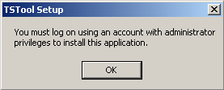

Install_AdministratorWarning

If you have administrative privileges, the following welcome will be displayed, and the installation can continue:

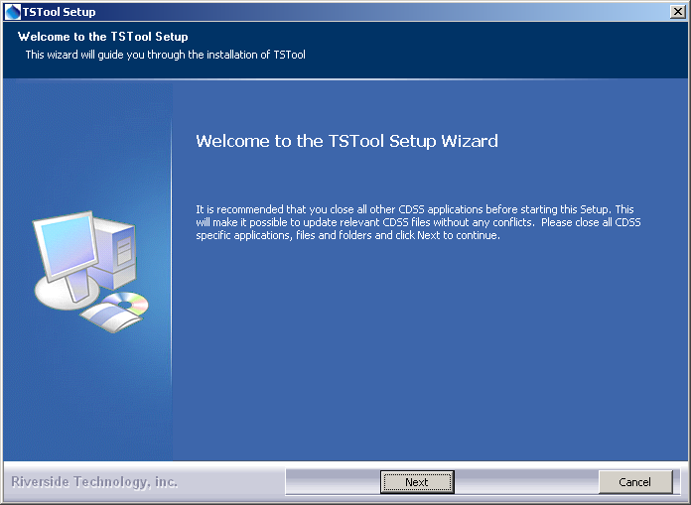

Install_Welcome

Press Next to continue with the installation.

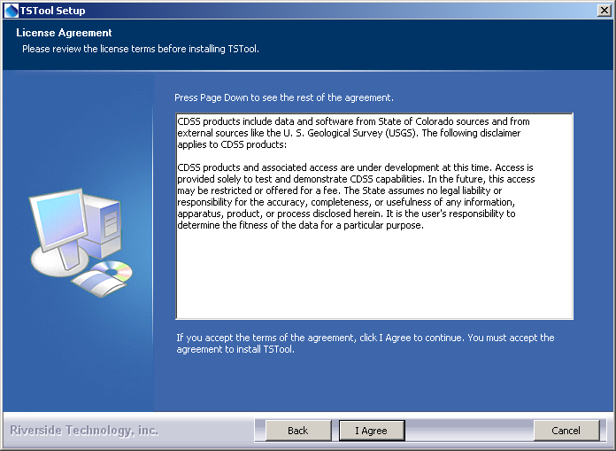

Install_Disclaimer

TSTool is distributed with CDSS with no license restrictions. However the disclaimer must be acknowledged. Press I Agree to continue with the installation.

1. Several components can be selected for the install as shown in the following dialog. Position the mouse over a component to see its description.

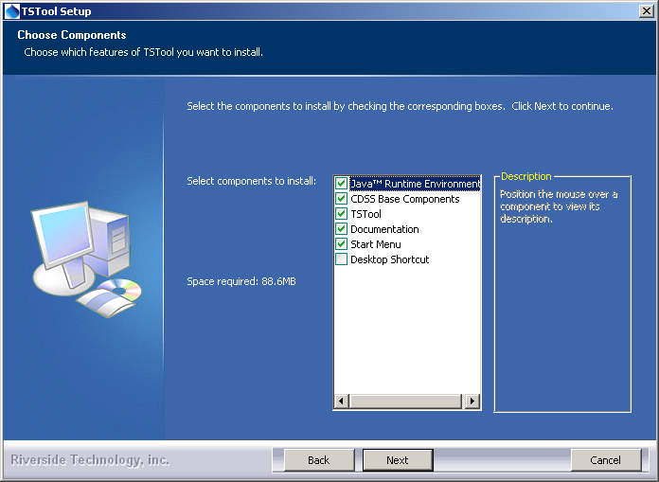

Install_SelectComponents

Select the components to install and press Next.

1. The following dialog is then shown and is used to select the installation location for TSTool. Multiple versions of TSTool can be installed and there are no dependencies between the versions. It is recommended that the default install location shown is used.

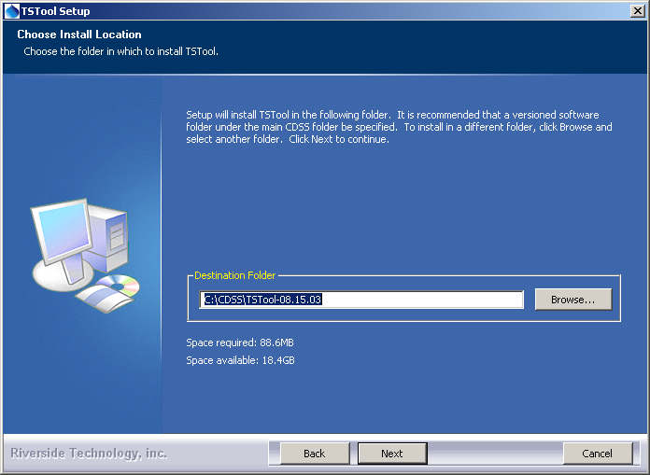

Install_SelectFolder

After selecting the install location, press Next.

Note that this location will be saved as a Windows registry setting (HKEY_LOCAL_MACHINE\Software\State of Colorado\TSTool-Version\Path) to allow future updates to check for and default to the same install location, and to allow the standard software uninstall procedure to work correctly.

1. The following dialog will be shown to select the menu for the software:

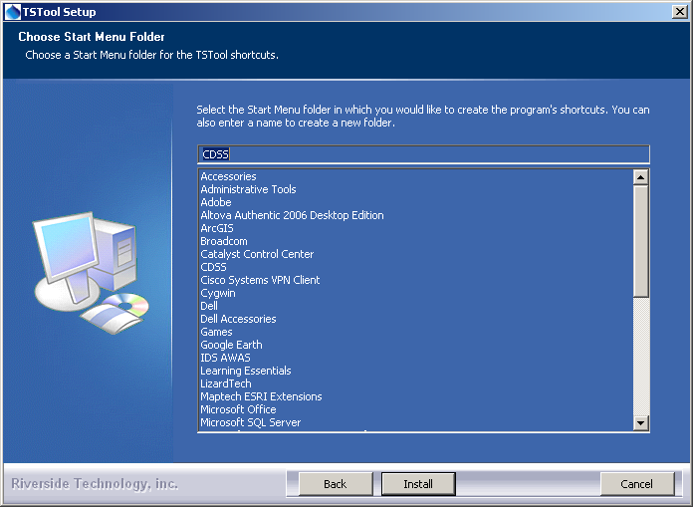

Install_StartMenuFolder

After selecting the folder, press Install.

1. The following dialog will show the progress of the installation:

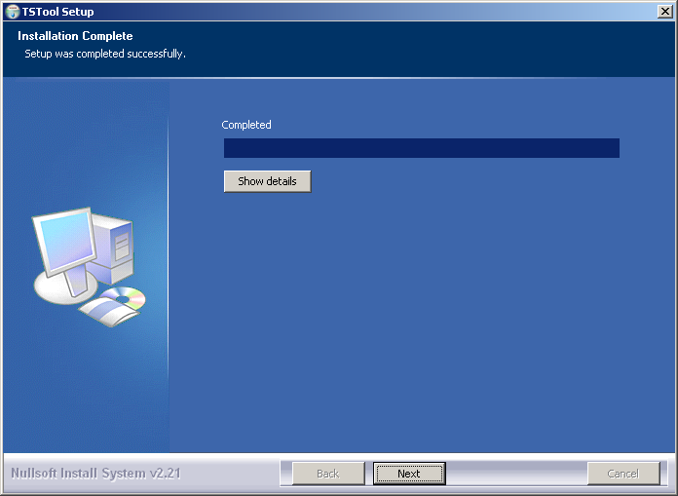

Install_Complete

Press Show details to see the files that were installed or press Next to continue.

1. If the CDSS Base Components were selected for install, the following dialog will be displayed:

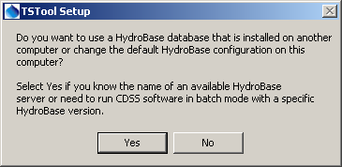

Install_HydroBaseQuestion

TSTool and other CDSS software can utilize HydroBase running on the local computer as well as other computers. Press Yes if HydroBase has been installed on another computer in the network environment and may be used by the software (then continue to the next step). Also press Yes if TSTool will be run in batch mode because the specific HydroBase name must be specified in configuration files. Otherwise, press No (skip to step 8).

1. The following dialog allows additional HydroBase servers to be specified for use by CDSS software (the example below configures CDSS software to list the dwrappsdb HydroBase server in choices and defaults to HydroBase on the local computer). The dialog will initially show previous settings from the \CDSS\TSTool-Version\system\CDSS.cfg file and settings typically only need to be changed after installing a new HydroBase version.

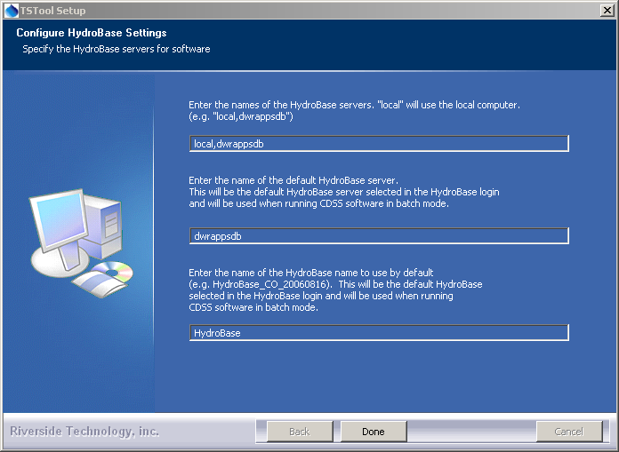

Install_HydroBaseConfiguration

After entering the name of a HydroBase server and the default server to use, press Done.

1. The following dialog will then be shown asking whether the TSTool software should be run:

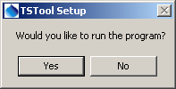

Install_RunTSToolQuestion

Press Yes to run the software or No to exit the installation procedure.

1. TSTool is distributed with a default configuration for CDSS. If you have edited the configuration properties, you can import the old configuration file using the Help / Import Configuration… menu’. See also the TSTool Tools / Options menu.

## 3.3 Installing TSTool on a File Server

TSTool can be installed on a file server, which allows software updates to be made in one location, thereby eliminating the need to install software on individual machines. As of TSTool 11.09.00 user configuration files will be saved under the user’s folder to facilitate persistence of user settings between software updates. For this type of installation, all computers that access the software should typically have similar configuration, including network configuration. The standard installer described in this documentation focuses on individual installs on user computers. To make TSTool software installed on a server available to other computers, perform the following (this is typically performed by system administrators):

1. Run the TSTool_CDSS_Version_Setup.exe installer as described above. During installation specify the TSTool installation home using a drive letter and path for the server or specify a Universal Naming Convention (UNC) path (e.g., \\ServerName\CDSS\TSTool-Version).
2. Or….Copy the files from a local installation to a network location. The TSTool software will detect the file location when run using the TSTool.exe file. If the TSTool.bat file is used to run the software, it may need to be modified to specify the location of files on the server.

The menus and shortcuts will only be configured for the computer from which the installation was run. Therefore, menus and shortcuts for other computers will need to be manually configured.

If TSTool has been installed on a local computer and it is also available on the network, the network version can be run by running the software in the ServerName\CDSS\TSTool-Version\bin folder. The software will expect that file locations use the same drives as when the software was installed.

# 4. Uninstalling TSTool Software

To uninstall TSTool software, select the CDSS / Uninstall / TSTool from the Start menu and confirm the uninstall. CDSS components that are used by other software (e.g., CDSS Base component software) as well as user data will remain installed.

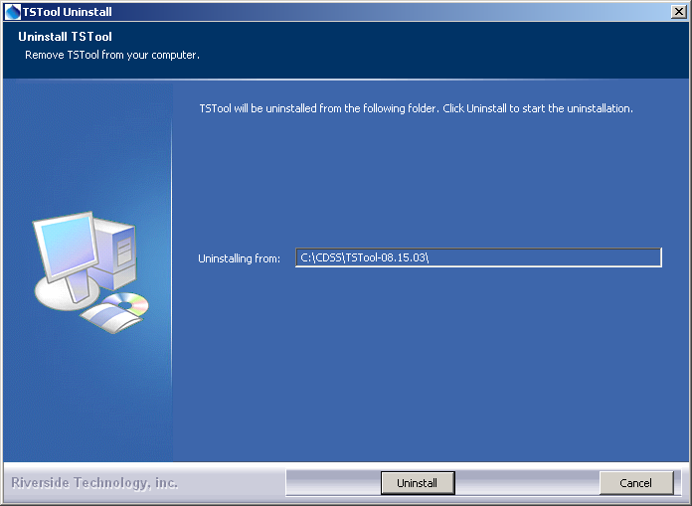

Uninstall_Confirmation

Press Uninstall to uninstall the software.

The following dialog shows the status of the uninstall process.

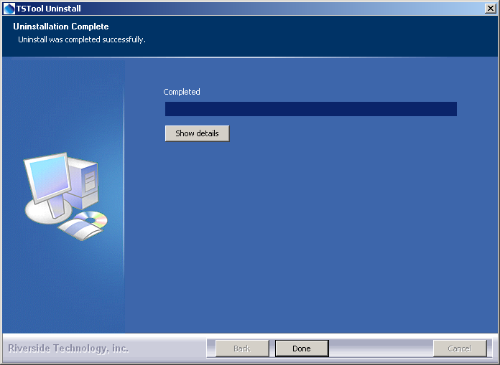

Uninstall_Complete

Press Show details to see the list of files that were removed. Press Done to exit the uninstall.

# 5. Running TSTool

TSTool can be started in several ways as described below.

## 5.1 CDSS Menu

The Start / All Programs / CDSS / TSTool-Version (or Start / Programs / CDSS / TSTool-Version) menu can be used to start the software. This runs the TSToolInstallHome\bin\TSTool.exe software.

## 5.2 Command Line Executable

The installation process does NOT add the TSToolInstallHome\bin folder to the path; however, this addition can be made by the user, allowing the TSTool software to be started anywhere by running TSTool. Running TSTool from any location will result in the software being run in the installation location. Specifying a command file on the command line or interactively will reset the working directory to that of the command file.

## 5.3 TSTool Batch File – Windows

A batch file can be used to run the TSTool.exe program, for example using the –commands command line parameter to specify a command file. In this case it may be necessary to specify the absolute path to the command file to ensure that the software can locate related files.

# 6. TSTool Configuration

TSTool requires minimal configuration after installation. This section describes TSTool configuration files that can be customized for a system. Configuration is specified for each TSTool installation and as of TSTool 11.09.00 several user configuration files.

## 6.1 TSTool Configuration File

The system\TSTool.cfg file under the main installation directory contains top-level configuration information for TSTool. The format of the file is as follows:

|  |
| --- |
| #  # Configuration file for TSTool  [TSTool]  ColoradoSMSEnabled = true  DateValueEnabled = true  HydroBaseEnabled = true  RiverWareEnabled = true  StateCUEnabled = true  StateModEnabled = true  … etc …  # Program to use for file differences, intended to be graphical file difference  # viewer. The program will be called as DiffProgram File1 File2.  # It is up to the user to install KDiff3 on the computer or change the following  # to a different program.  DiffProgram = "C:\Program Files\KDiff3\kdiff3.exe"  # Set for the user interface look and feel. Default is SystemLookAndFeel. See:  # http://docs.oracle.com/javase/tutorial/uiswing/lookandfeel/plaf.html  # For example, the following can be used on Linux if Motif is not desired  #UILookAndFeel = "com.sun.java.swing.plaf.gtk.GTKLookAndFeel"  MapLayerLookupFile = "\cdss\gis\co\TimeSeriesMapLookup.csv"  ################################################################################  # Begin configuration of data stores that will be opened when TSTool starts  # - the data store name in the data store configuration (*.cfg)  # file takes precedence; by convention the names should match  # - the data stores will be opened only if the data store type is enabled above  # - alphabetize the data stores by type below  # - also see the "Enabled" property in the configuration files, for finer  # control  # - see also user configuration files for datastores  ################################################################################  # Data store for Colorado Water HBGuest web service  #(active if ColoradoWaterHBGuestEnabled=true above)  [DataStore:ColoradoWaterHBGuest]  ConfigFile = "ColoradoWaterHBGuest.cfg"  # The license information will be removed as TSTool moves to open source licensing  LicenseOwner = "CDSS"  LicenseType = CDSS  LicenseCount = NoLimit  LicenseExpires = Never  LicenseKey = 00-77960bdfb1dde707-1dd052fe0327a332-a07266ee645e8845-7560192d374235c5-1dd052fe0327a332 |

Example TSTool Installation Configuration File

The example illustrates the format of the file. The *Enabled properties can be used to enable/disable input types. Common formats are enabled by default and more specialized formats are disabled by default, if not specified in the file. For example, use HydroBaseEnabled = false to disable the automatic HydroBase login that occurs with the HydroBase input type (e.g., if HydroBase is unavailable for some reason). Each input type can have additional properties, although only a few currently do, as described below. Use the Tools / Options menu for a dialog that helps with editing the *Enabled properties.

The optional MapLayerLookupFile property indicates the name of the time series to map layer lookup file. See the Map Configuration section below.

The user configuration file./tstool/system/TSTool.cfg under the user’s home folder provides additional configuration, for example to disable datastores based on the user’s preferences:

|  |
| --- |
| # TSTool configuration file containing user settings, shared between TSTool versions  # This file indicates which datastore software features should be enabled.  # Disabling datastore types that are not used can improve TSTool performance and  # simplifies the user interface.  # Refer to the TSTool.cfg file under the software installation folder for global  # configuration properties.  # User settings in this file will override the installation settings.  HydroBaseEnabled = true |

Example TSTool User Configuration File

## 6.2 Data Units File

The system\DATAUNIT file under the main installation directory contains data unit information that defines conversions and output precision. In most cases the default file can be used but additional units may need to be added for a user's needs (in this case please notify the developers so the units can be added to the default file distributed with installations). Currently, the DATAUNIT file is the only source for units information – in the future units may be determined from the various input sources.

## 6.3 HydroBase Configuration

The following properties can be defined in the installation TSTool.cfg file in a [HydroBase] section to control how TSTool interacts with HydroBase. See also the CDSS Configuration File section below. **These properties may be moved to a HydroBase datastore configuration file in the future**.

TSTool HydroBase Configuration Properties

|  |  |  |
| --- | --- | --- |
| Property | Description | Default |
| AutoConnect | If False, a HydroBase login dialog will be shown at startup. If True, the default database information in the CDSS configuration file (see next section) will be used to automatically connect to the database, and the login dialog will not be shown. | False |
| WDIDLength | Indicates the length of water district identifiers (WDIDs) constructed from separate WD and ID data, when creating time series identifiers. Because time series identifier strings are compared literally, it is important that the WDIDs are consistent within a commands file. | 7 |

## 6.4 CDSS Configuration File

By default, TSTool will automatically look for HydroBase databases on the current (local) machine and the State servers. State server databases are typically only accessible to State of Colorado computers. If SQL Server or MSDE HydroBase versions have been installed on a different machine, the \cdss\TSTool-Version\system\CDSS.cfg file can be used to indicate the database servers. An example of the configuration file is as follows. **These properties may be moved to a HydroBase datastore configuration file in the future**.

|  |
| --- |
| [HydroBase]  ServerNames="ServerName,local"  DefaultServerName="ServerName"  DefaultDatabaseName="HydroBase_CO_20080730"  [ColoradoSMS]  ServerNames="ServerName,local"  DefaultServerName="ServerName"  DefaultDatabaseName="RealtimeStreamflow"  UserLogin="UserLogin" |

The ColoradoSMS input type is being used to support annotation of real-time data graphs with alert information, within the State of Colorado’s offices.

Properties can be specified on the TSTool command line using the notation “Property=Value” and will in some cases override the values in the configuration file. These features are under development as necessary.

The CDSS configuration properties are described in the following tables:

CDSS HydroBase Database Configuration Properties

|  |  |  |
| --- | --- | --- |
| Property | Description | Default |
| ServerNames | A comma-separated list of server names to list in the HydroBase login dialog. | The state server is listed. |
| Default  ServerName | The default HydroBase server name to use. This allows the HydroBase login dialog to preselect a default that applies to most users in the system. If TSTool is run in batch mode and the HydroBase input type is enabled, use this property to make a default connection to HydroBase, for use with other commands in the batch run. | greenmtn.  state.co.us |
| Default  DatabaseName | The default HydroBase database name to use. This allows the HydroBase login dialog to preselect a default that applies to most users in the system. If TSTool is run in batch mode and the HydroBase input type is enabled, use this property to make a default connection to HydroBase, for use with other commands in the batch run. |  |
| Database  Engine | Reserved for internal use. |  |
| DatabaseName | The database name to use for the initial connection. This overrides the default server. |  |
| Database  Server | The server name to use for the initial connection. This overrides the default server. |  |
| SystemLogin | Reserved for internal use. |  |
| SystemPassword | Reserved for internal use. |  |
| UserLogin | Reserved for internal use. |  |

CDSS Satellite Monitoring System (ColoradoSMS) Database Configuration Properties

|  |  |  |
| --- | --- | --- |
| Property | Description | Default |
| ServerNames | A comma-separated list of server names to list in the SMS login dialog. | The state server is listed. |
| Default  ServerName | The default SMS database server name to use. This allows the SMS login dialog to preselect a default that applies to most users in the system. If TSTool is run in batch mode and the ColoradoSMS input type is enabled, use this property to make a default connection to the SMS database, for use with other commands in the batch run. | greenmtn.  state.co.us |
| Default  DatabaseName | The default SMS database name to use. This allows the SMS login dialog to preselect a default that applies to most users in the system. If TSTool is run in batch mode and the ColoradoSMS input type is enabled, use this property to make a default connection to the SMS database, for use with other commands in the batch run. |  |
| Database  Engine | Reserved for internal use. |  |
| DatabaseName | The database name to use for the initial connection. This overrides the default server. |  |
| Database  Server | The server name to use for the initial connection. This overrides the default server. |  |
| SystemLogin | Reserved for internal use. |  |
| SystemPassword | Reserved for internal use. |  |
| UserLogin | The user login, for use with TSTool batch runs. The ColoradoSMS.UserLogin parameter can be specified on the command line and will be used when making the initial SMS database connection. |  |

The SMS database cannot currently be opened with a login dialog. Therefore, correct information must be specified in the CDSS configuration file and the TSTool command line.

## 6.4 Map Configuration

TSTool can display maps configured as GeoView project files, although this functionality is experimental and has not been widely utilized. See the GeoView Mapping Tools Appendix for more information about these files. To allow a link between time series and map layers, use the TimeSeriesMapLayerLook property in the TSTool.cfg file to specify a time series to map layer lookup file (see the TSTool Configuration File section above). The following example file illustrates the contents of the lookup file:

|  |
| --- |
| # This file allows time series in TSTool to be linked to stations in spatial  # data layers. The columns are used as appropriate, depending on the direction  # of the select (from time series list or from the map).  #  # This file has been tested with the \CDSS\GIS\CO\co_TSTool.gvp file. Not all  # possible combinations of time series and map layers have been defined - only  # enough to illustrate the configuration.  # Additional attributes need to be added to the point files to allow more  # extensive functionality. For example, if attributes for data interval (time  # step) and data source are added to the attributes, then a definition query  # can be defined on the layer for displays to use the same data file. The  # configuration below can then use the different names to configure the link  # to time series.  #  # TS_InputType - the time series input type, as used in TSTool  # TS_DataType - the data type shown in TSTool, specific to an input type  # For example, TSTool uses "Streamflow" for HydroBase, whereas  # for other input types a different data type string may be used.  # TS_Interval - time series interval of interest (e.g.,"Month", "Day", "1Hour"  # "Irregular")  # Layer_Name - the layer name used in the map layer list  # Layer_Location - the attribute that is used to identify a location, to be  # matched against the time series data location  # Layer_DataType - the attribute that is used to indicate the data type for a  # station's time series (CURRENTLY NOT USED - UNDER EVALUATION)  # Layer_Interval - the attribute that is used to indicate the interval for a  # station's time series  # Layer_DataSource - the attribute that is used to indicate the data source for  # a station's time series.  #  # When matching time series in the TSTool time series query list with features  # on the map, the TS_* values are matched with the time series identifier  # values and the Layer_* attributes are matched against specific time series.  #  # Data layers are listed from largest interval to smallest.  "TS_InputType","TS_DataType","TS_Interval","Layer_Name","Layer_Location","Layer_DataSource"  HydroBase,DivTotal,Day,"Diversions",id_label_7,""  HydroBase,DivTotal,Month,"Diversions",id_label_7,""  HydroBase,EvapPan,Day,"Evaporation Stations",station_id,""  HydroBase,EvapPan,Month,"Evaporation Stations",station_id,""  HydroBase,Precip,Irregular,"Precipitation Stations",station_id,""  HydroBase,Precip,Day,"Precipitation Stations",station_id,""  HydroBase,Precip,Month,"Precipitation Stations",station_id,""  HydroBase,RelTotal,Day,"Reservoirs",id_label_7,""  HydroBase,RelTotal,Month,"Reservoirs",id_label_7,""  HydroBase,Streamflow-DISCHRG,Irregular,"Streamflow Gages - Real-time",station_id,""  HydroBase,Streamflow,Day,"Streamflow Gages - Historical",station_id,""  HydroBase,Streamflow,Month,"Streamflow Gages - Historical",station_id,"" |

Example Time Series Map Layer Lookup File

The columns in the lookup file indicate how information in the time series input/query list can be matched against time series in map layers. In particular, the TS* columns define values that are seen in the TSTool interface and the Layer* columns define the layer and attribute names for map layers. The Layer_Interval and Layer_DataSource are optional but if specified result in more specific links between time series and map layers.