Review of recent GRTS package changes – SAM 2004-04-23

These comments are for recent GRTS package changes, which implemented features for manipulationg graphs (splitting, deleting, etc.) and adding annotations. Comments are also provided with code markups. Comments in order of importance are 1) this document, 2) your marked-up email, and 3) code.

Annotations

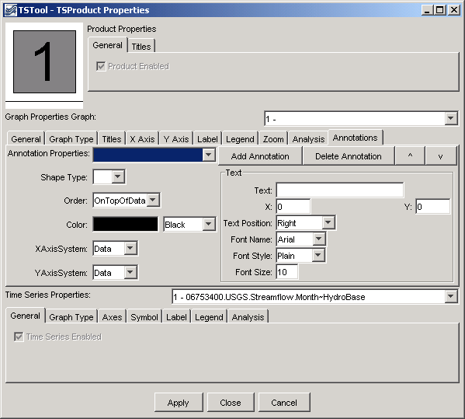

- When a Main Title is entered in the top section and Apply is pressed, exceptions are thrown.
- When a title is entered for a specific graph, the drop-down choice should be updated so that the corresponding graph has “N – Graph title”. Currently it appears that the title is added to the choices and not replaced. The selection should also be the current graph.
- For the graph properties, the “Graph:” label should be next to the choices, not smashed against “Graph Properties”.
- Annotation Properties seems to be pretty messed up – with no annotations it is full of blanks. Suggest that similar to graphs and time series, put a simple label; “Annotation:” and have have a choice with Annotation identifiers (using a new AnnotationID property). Using the property like “Annotation 1.1” is confusing – users don’t need to know about the property conventions. This could fit in the current layout.
- Buttons are ok but the up and down buttons could benefit from tool tips. The buttons need to be disabled/enabled appropriately. I generally put a void checkGUIState() method in important JFrame classes, which can examine the current state and enable/disable all buttons as necessary. See the TSTool_JFrame class for an example.
- Shape type should not be allowed to be blank. Default to text and let the user change.
- Color should perhaps be within the shape group area. At some point if we add filled polygons we might need outline color also. For now the data member for color components can be the same for all shape types. Put in as a revisit.
- In TS classes, the new methods for drag and drop need to be explicitly identified as meeting the requirements of an interface. Otherwise, they are difficult to pick out. We need to discuss the data flavor handling – I am going to review the drag and drop code now – do you need to reprint for me because of recent changes?
- I reviewed TSProduct first and had some trouble with the inconsistency in parameter names and zero or one index conventions. Even when you are adding on to other code, you should try to be as consistent as possible. After reviewing the TSProductJFrame code, I was not as sure whether zero or one-index offsets should be used. I guess it depends if code is operating on internal data and loops or external properties. The naming of parameters is more important at this stage.
- TSGraphJComponent.lookupTSColor() – Luiz found and fixed a bug in the C++ that needs to be synchronized to the Java. See the C++ version of the library and talk to me if you have questions.

Also:

I am thinking that we need general TSProductID and Owner properties to allow writing the TSProducts to a database (HydroBase and RiversideDB). Can you review how StateView is stubbed off and whether these are the only properties needed to save with permissions.

