RTi Software Development Procedures
2008-11-18

This document needs a lot of work if it is to be made useful – check in because SAM does not have time to work on but maybe someone else will.

This document documents comment procedures that utilize the RTi build tools. Each product should generally have its own build/release checklist. However, the following procedures can serve as general guideline. This document will be expanded over time.

1 Overview of Development Environment

Summarize SVN, Eclipse, Netbeans, sandbox, Windows/Linux, etc.

The following software needs to be installed to take full advantage of the development environment (see S:\develop\ExternalSoftware and S:\develop\cygwin\setup.exe for software packages):

- Python 2.5+ (install with Cygwin or stand-alone). Make sure it is in the PATH.
- Subversion v? (can install with Cygwin). Make sure it is in the PATH.

2 Setting Up a New Product

A product is defined as a collection of source files, tests, documentation, etc., that define a unique software capability. Top-level products are typically applications and have their metadata in the rtisw/trunk/ProductMetadata folder. Each product folder has svn:external properties that define which sub-products are included in the product. The actual files for the product reside in the main rtisw/trunk folder. Consequently, the product meta-data folder contains very little information. Every product should include the rtibuild product as an SVN external.

A product’s directory structure looks like:

[SandboxFolder]/
[product]/
rtibuild/
[dependent project 1]
[dependent project 2]
…

To create a new project (a product is composed of one or more projects) directory with the appropriate configuration files, use the common-setup.xml ant file located in rtibuild. Run the new-project target. This will prompt you for the name of the project you’d like to create. If the project already exists, it will not overwrite any files.

3 Testing setup

The main build file (conf/build.xml) contains a target named test. This is a shortcut to calling the test build file (test/build.xml) and running the all-tests target. If the test build file does not exist for an older project, copy the template from rtibuild/setup/test-build-template.xml to test/build.xml and replace the @product.name@ token with the name of the project.

There are two styles for organizing tests under the test directory – uncategorized and categorized. The uncategorized layout is the default created by the common-setup.xml file.
The uncategorized layout looks like:
test/
build.xml
src/
data/

The categorized layout looks like:
test/
build.xml
unit/
src/
data/
regression/
src/
data/
[other categories…]
src/
data/

In both layouts the src/ directory is the root for test code and the data/ directory should contain all test data.

Without any modifications, the generated test build file will execute all unit tests that match the pattern *Test under the src/ directory in both the uncategorized and categorized layouts.

To exclude a category of test from running, define a property skip.[category name]. For example, to exclude the regression tests:

<property name=”skip.regression” value=”true”/>

To define a virtual suite of tests to run by directory [to be written]

4 Software Development/Testing/Revision Control Guidelines

Describe high level process for development.

Subversion FAQ

- How do I tag a release of a product, before moving on to new development? A Python script is available that will tag each sub-product in a product with an SVN tag. By convention the tag is the product name, the depending product and the date on which the tag occurs. The product version can also be included in the tag. Run the tag-product Python script in rtibuild/svntools.
(MUST use cygwin), Use the –d option to do a dry run before actually doing the tag. For example (running from the top-level product folder):

python rtibuild/svntools/tag-product.py .

The results in the repository (using Tortoise Repo-Browser) will be similar to the following. The tagged version can be used later to check out a branch if troubleshooting is needed.

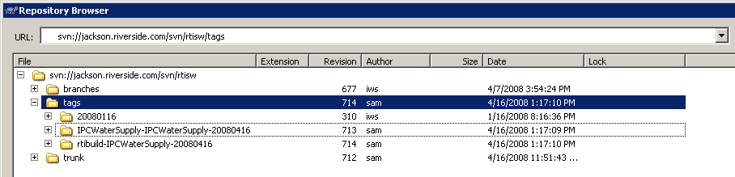
RepoBrowserShowingTags
2. How do I list all the tags related to a product and its dependencies? A python script is available that will list all of the tags in each dependent product. Run the list-product-tags script in the rtibuild/svntools directory (MUST use cygwin). If you are in the top-level directory of the product, no arguments are needed. Otherwise, provide a path the product to list. The output will be each tag directory, followed by its contents. Enhancement requests welcome.

Build Process FAQ

Eclipse FAQ

- What files are saved with the workspace vs. a project?
- How can launch scripts be configured to be saved with a product? By default, launch scripts are saved in the workspace metadata and therefore will not be saved to the repository. To promote reuse by developers, configure the launch specification using the Common, tab, similar to the following:

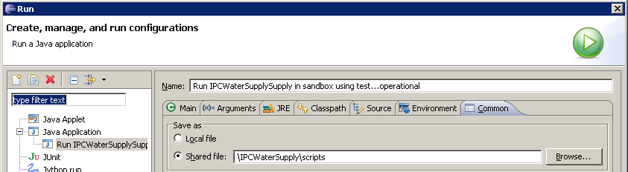
EclipseLaunchSpec

7 NetBeans FAQ

