Running CityCAT on DAFNI
Example 1 _Longbenton
In this example a 1km² part of Longbenton, Newcastle upon Tyne is run with a 5m grid resolution. The example includes friction coefficient, spatial green areas, spatial rainfall and a reservoir break.
Click on Workflows and click on Global CityCat Model with extra functionality (at this stage do not select Execute)
To see the Workflow click on View workflow (top of screen).
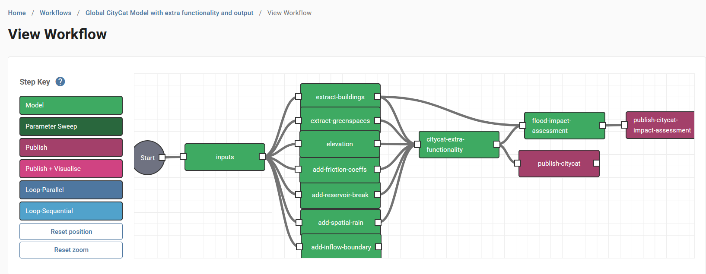

Back in the Workflow click on Create next to Parameters sets to produce a parameter set to run this model.
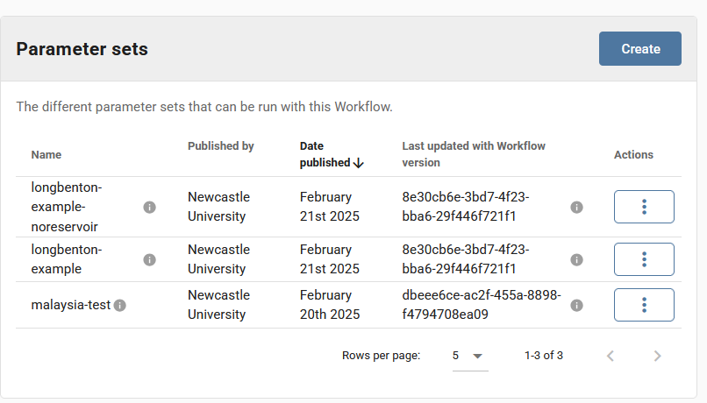
Inputs Model (data required)
Click on inputs box which is then highlighted.
In this section the country, location, projection and boundary data are input and this feeds into the remaining models. Anything with a red star is required. Both the Parameters section and the Datasets to use in Model need to be filled.
The country is used in the names of the parameter files that feeds into the other models. The location is used in the names of the parameter files and the output files. The projection is the EPSG code to run CityCAT. For the UK the code is 27700 which is OSGB36 / British National Grid. If the projection is set to 0 a UTM zones projected value is used depending on the location in the world which is located from the Boundary file.

The Boundary file needs to be in gpkg format. The UTM Zones file is needed to find the correct EPSG code for the location of the Boundary file.

For this example the filled in boxes should look like the following:

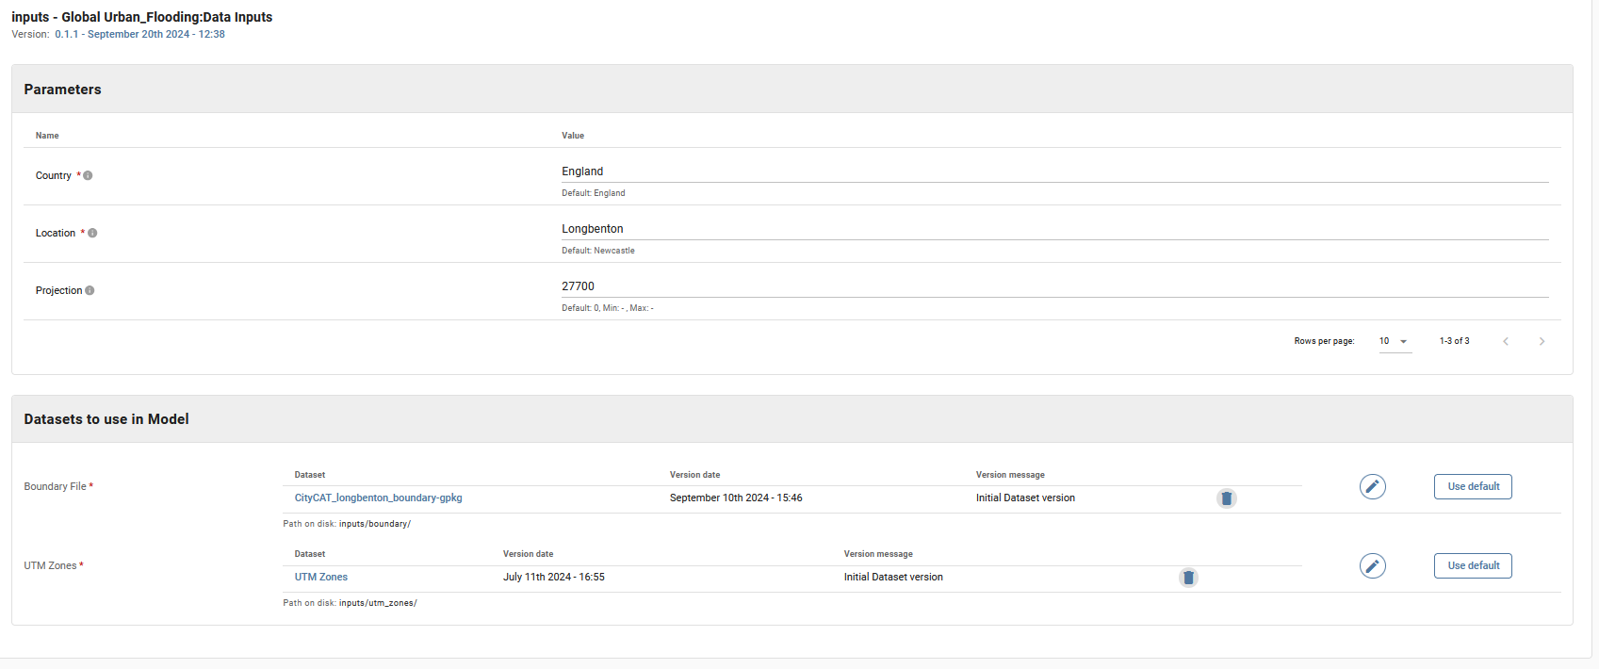
Note the projection is set to 27700.
Click on the Apply Changes button or click on the grid at the top to exits from the Inputs model.
Notes:
- there are a lot of datasets and it can be hard to find the correct one. In this example Search for Longbenton
- Additional datasets (for example a second Boundary File) can be removed by clicking on the rubbish bin icon on that row.

Extract-buildings Model (data required)
Click on extract-buildings box which is then highlighted.
In this section the location of the buildings is required as input as a gpkg file as below. The remaining data is automatically copied over from the inputs model. The buildings data is clipped to the domain specified by the boundary file and ensures it is in the correct projection.
For the UK OS buildings data is available on DAFNI. Open source data can be obtained from Open Street Map (https://www.openstreetmap.org/), Open Buildings (https://sites.research.google/open-buildings/) etc
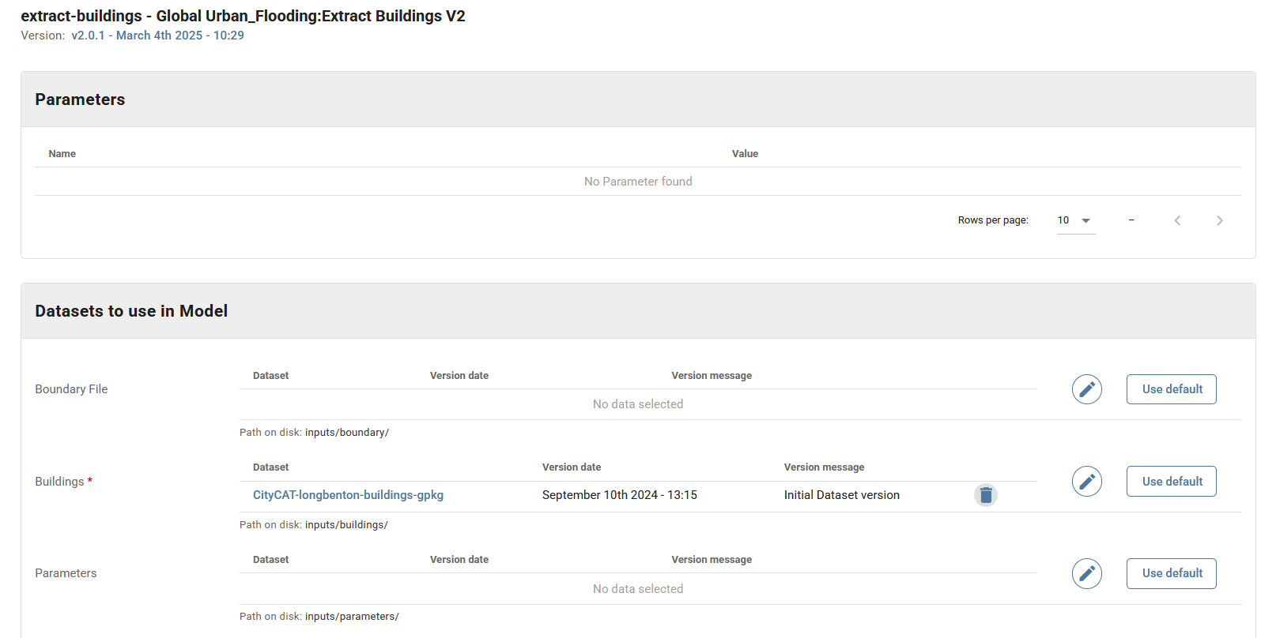

Click on the Apply Changes button or click on the grid at the top to exits from the extract-buildings model.

Extract -greenspaces Model (data optional)
If nothing is input here all the domain is assumed to be impermeable.
Click on extract -greenspaces box which is then highlighted.
If greenspaces are available the “Permeable areas” parameter should be set to “polygons”.
In this section the location of the green spaces can be input as a gpkg file. Spatial green areas can be used in the same way. If spatial green-areas are used the polygon must have a "Value" parameter with the parameters associated with this value given in infiltration.csv file
The remaining data needed in this model is automatically copied over from the inputs model. The green spaces data is clipped to the domain specified by the boundary file and ensures it is in the correct projection. If no greenspaces data is added the ground is all assumed to be impermeable (worst case scenario for flooding).
Click on the grid at the top or on Apply changes to exit from the extract-greenspaces model.
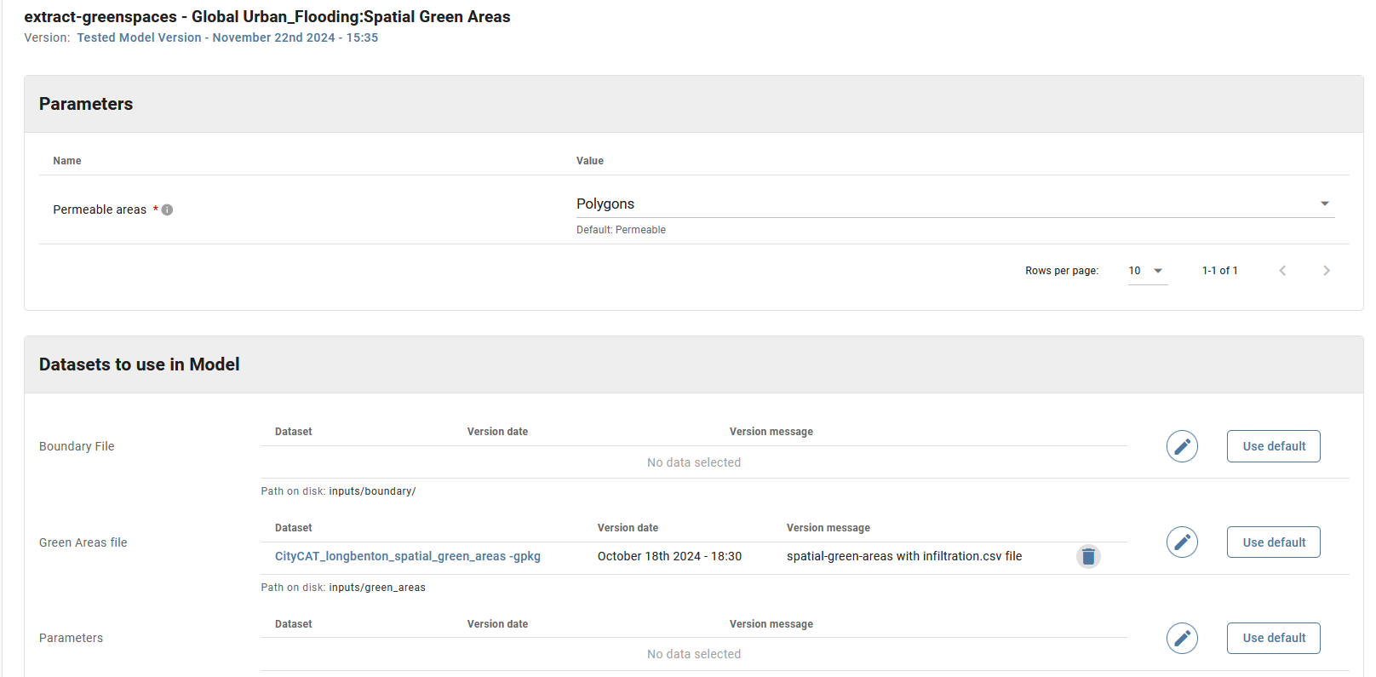

Elevation Model (data_required)
Click on elevation box which is then highlighted.
In this section details of the elevation data used in CityCAT is supplied. This model accepts elevation data in .asc, .tif or .tiff format, clips the data to the selected area, and ensures all data is in the same projection. If the file sizes are too large, multiple files can be added directly, or zipped.
Under Parameters the DTM Resolution or elevation grid square size needs to be supplied, currently this is only used in the add-inflow-boundary model (elsewhere it is calculated from the DTM dataset). Under Datasets to use in Model the 5km DTM information needs to be supplied (it does not need to be 5km data).
The remaining data is automatically copied over from the inputs model. The output from this model is a single elevation data file in ASC format.

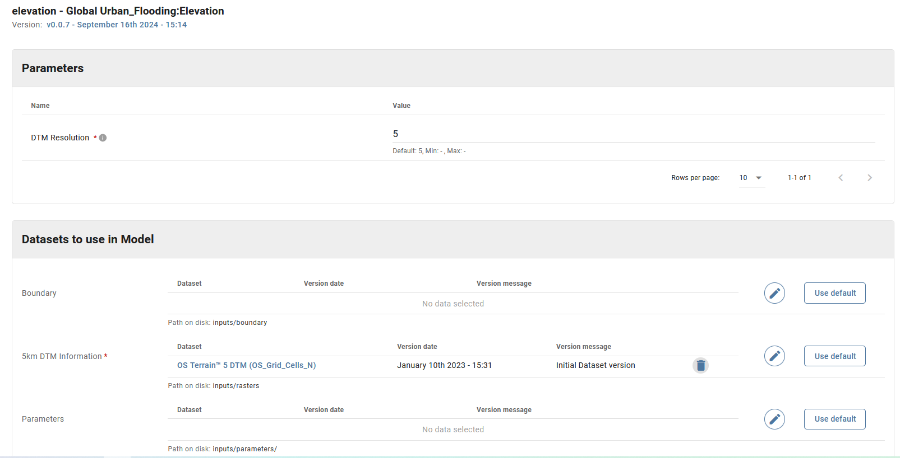
For the UK 5m grid resolution is available. The default datasets on DAFNI is for two letter grid squares starting with S. T and N datasets are also available. For the dataset here change the DTM to use the N datasets “OS Terrain™ 5 DTM (OS_Grid_Cells_N)”. See below for details:

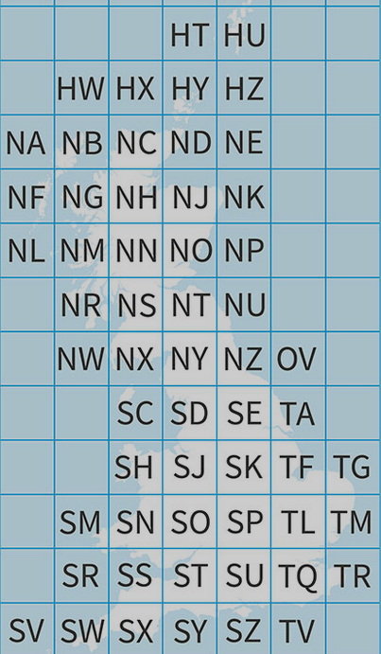

Click on the grid at the top or Apply changes to exit from the elevation model.

Add-friction-coeffs Model (data optional)
Click on add-friction-coeffs box which is then highlighted. This allows for non-standard friction coefficients to be used in specified areas.
The new friction coefficient is set as "Value" in an gpkg file. The model clips the data to the selected area, and ensures all data is in the same projection. If the file sizes are too large, multiple .gpkgs can be added directly, or zipped.
Click on the grid at the top or Apply Changes to exit from the friction model.

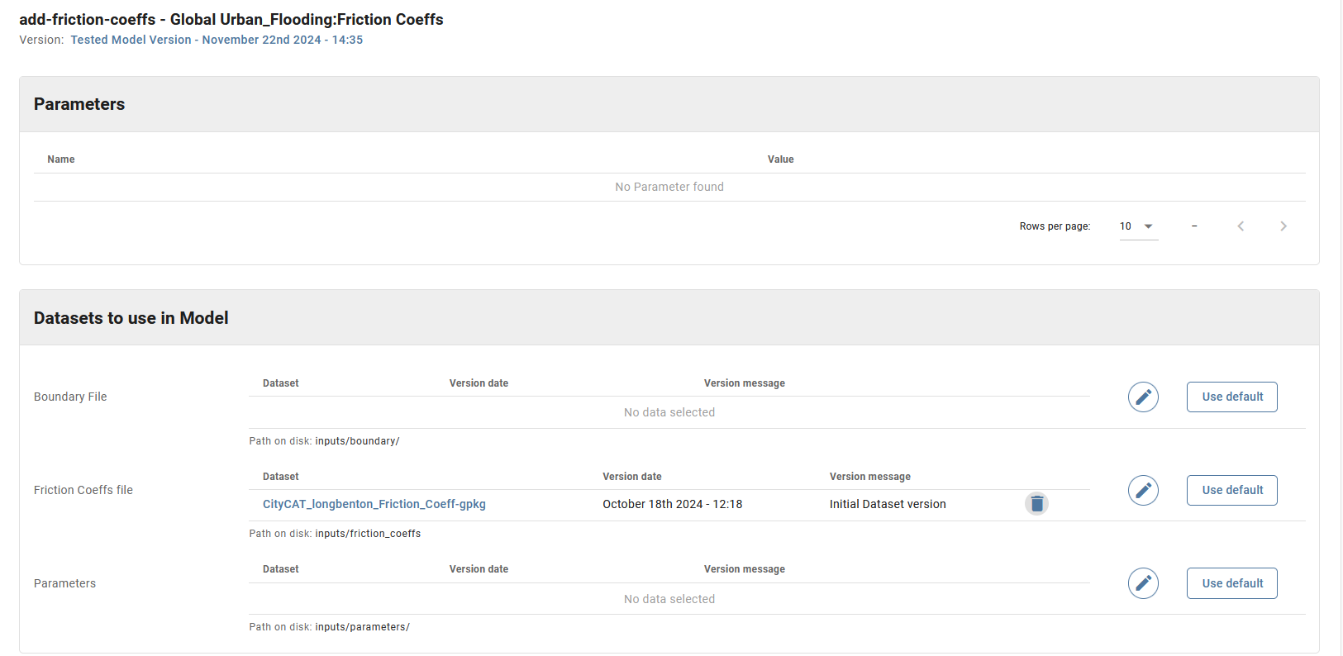

Add-reservoir-break Model (data optional)
Click on add-reservoir-break box which is then highlighted. This allows for reservoir polygons to determine an initial reservoir elevation (m AOD) in specific locations. This is assumed to fail and the released water flows through the domain.
The reservoir water level is set as "Value" in an gpkg file. The model clips the data to the selected area, and ensures all data is in the same projection. If the file sizes are too large, multiple .gpkgs can be added directly, or zipped.
Click on the grid at the top or Apply Changes to exit from the add-reservoir-break model.
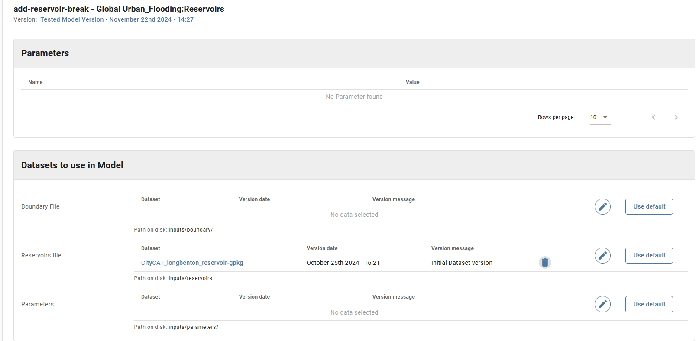

Add-spatial-rain Model (data optional)
Click on add-spatial-rain box which is then highlighted. This allows for spatial rainfall to be used (rather than have the same rainfall throughout the domain which is input as a parameter in the citycat-extra-functionality model and is overwritten by any data added here).
If spatial-rain is used the polygon must have a "Value" parameter with the parameters associated with this value given in Rainfall_depth.txt. The model clips the data to the selected area, and ensures all data is in the same projection. If the file sizes are too large, multiple .gpkgs can be added directly, or zipped.
Click on the grid at the top or Apply changes to exit from the add-spatial-rain model.
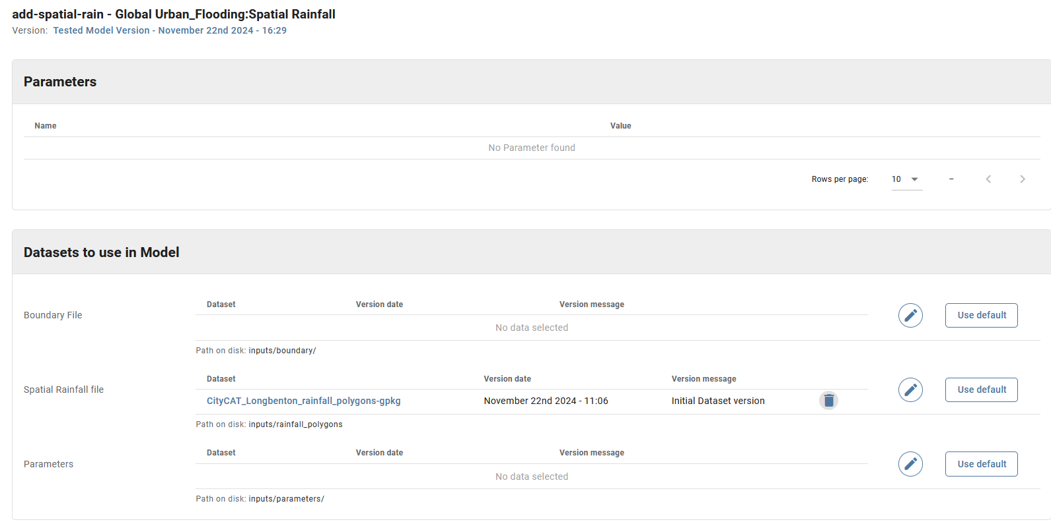

Citycat-extra-functionality Model (data required)
Click on citycat-extra-functionality box which is then highlighted.
This model takes all the data from the proceeding models and runs CityCAT. The Parameter values highlighted with a red star are needed here plus some other values. With Rainfall mode set to Total Depth the Total Depth (mm) and Duaration(hours) are both needed. The Projection is fed into here from the Inputs Model and so a value is not required. In this example the Permeable Areas is fed in from the extract-greenspaces model and so the value is not used although a value must be assigned. Only the first 10 parameters are shown initially, the others can be seen by clicking on the arrow.
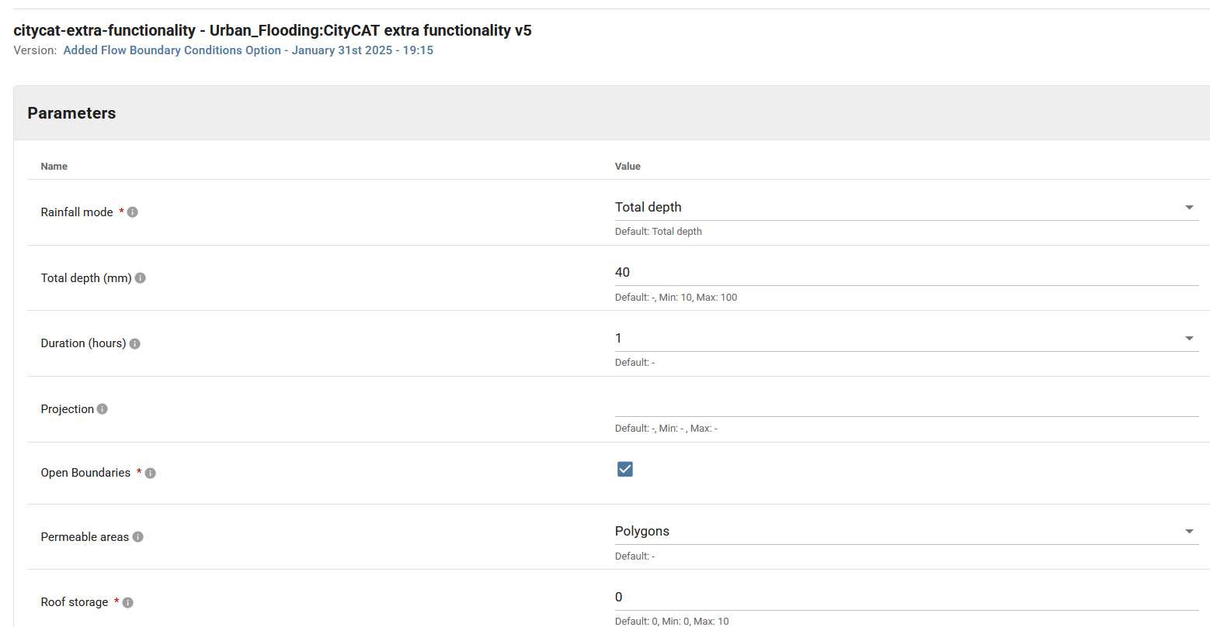
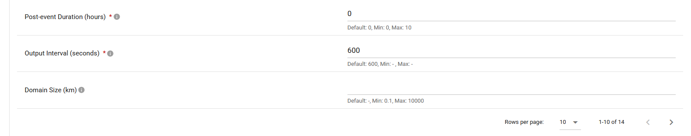
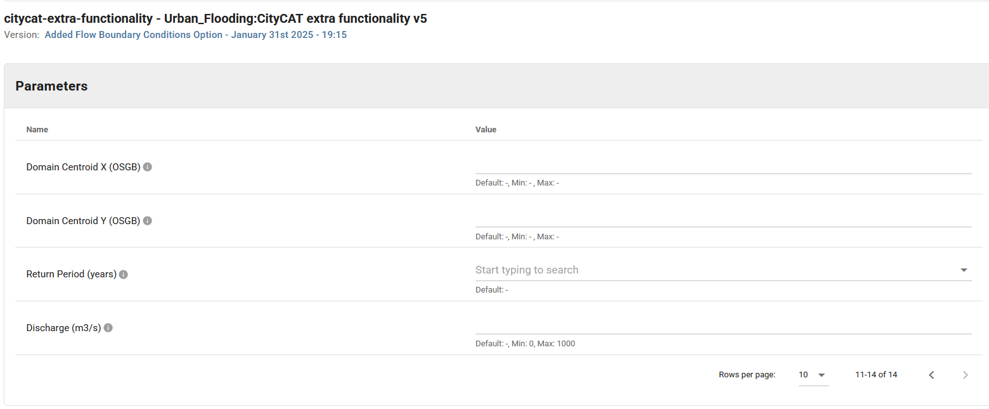
The Datsets to use in Model are all taken from the previous models.
Click on the grid at the top or Apply Changes to exit from the citycat-extra-functionality model.

Flood-impact-assessment (data optional)
All the data needed for this model comes directly from the citycat-extra-functionality model and the model extract buildings model. So no data needs adding here

Running the workflow
Click on Continue, just below the model grid.
Then specify the metadata. e/g
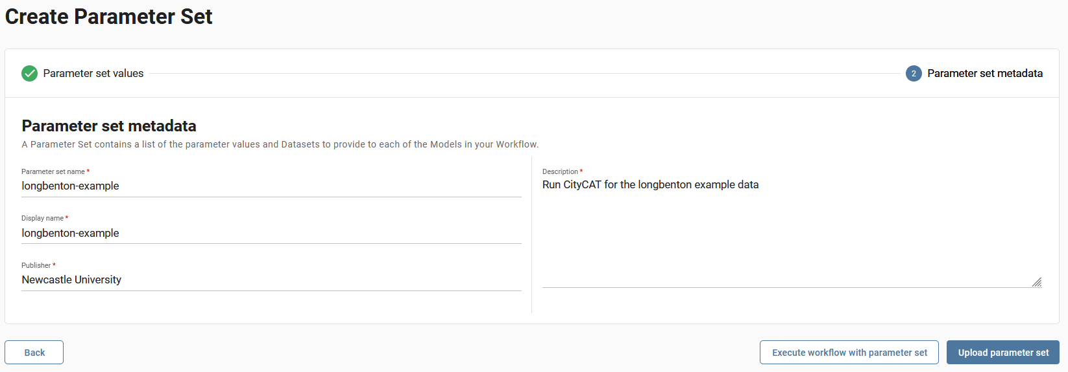
And click on upload parameter sets
Then in Parameter sets click the Actions for the parameter-set just specified and click on Execute workflow

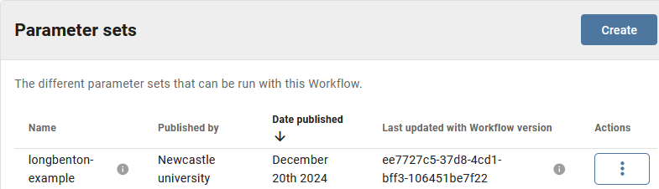

In Instances details about the model run can be seen
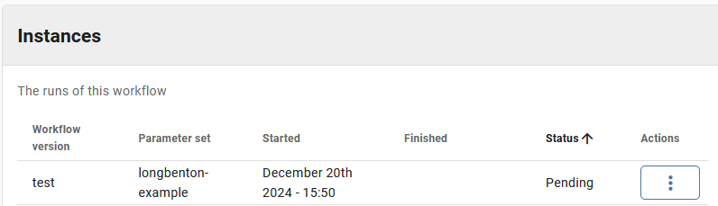
Click on the Actions button and then View Detailed status.

This is what it initially looks like:

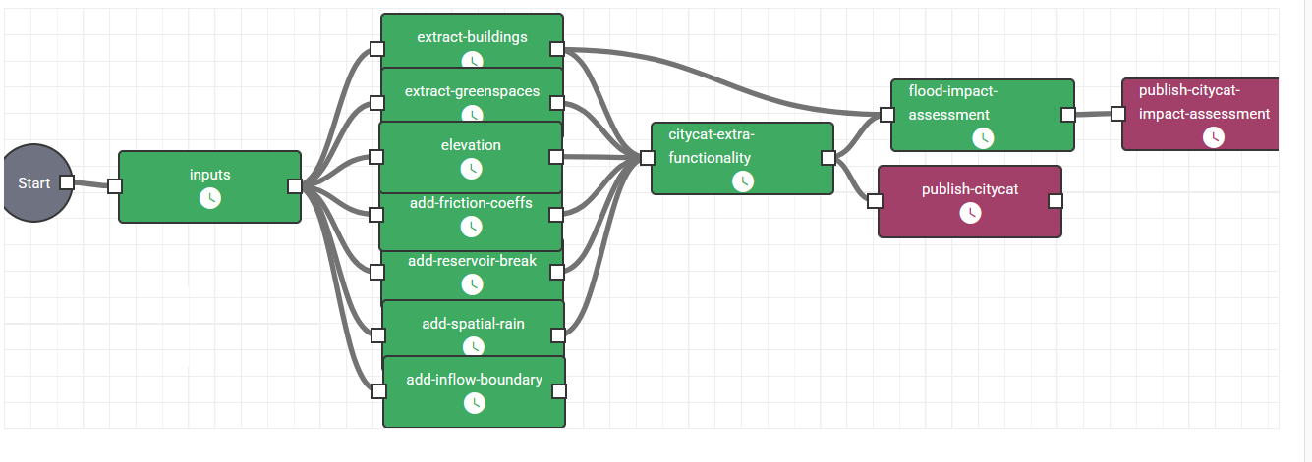
As it progresses -most models have finished. Elevation is the slow stage (so it is still in progress) as it has to extract the data for this domain from a large dataset.

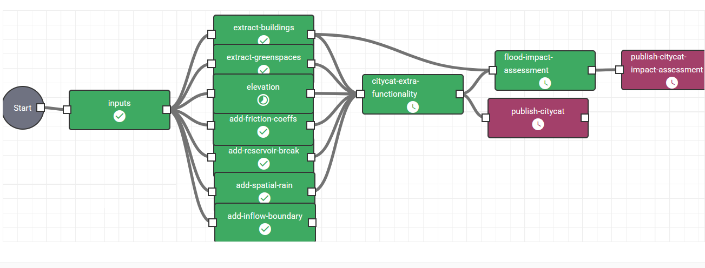

When it has finished the status changes to Succeeded.
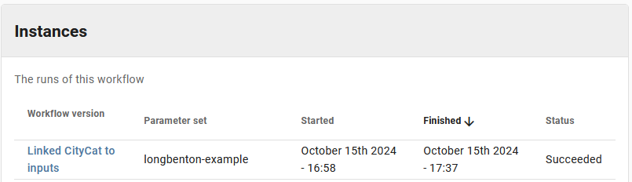
The final CityCAT output can be seen. e.g click on publish-citycat and go to dataset. In the Data files scroll to run/max_depth.png, select and Download selected files. In this case the maximum water depths are dominated by the dam break from the reservoir
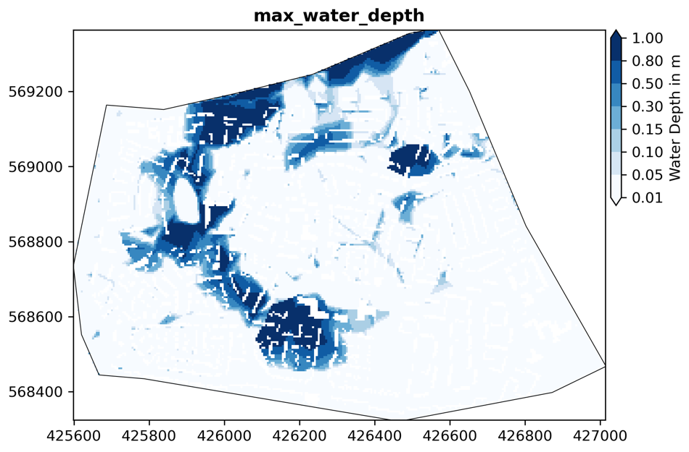

The final CityCAT flood impact assessment output can also be seen. e.g click on publish-citycat-impact-assessment and Go to dataset. In the Data files the file impact/exposure_plot.png can be seen, select and Download selected files. In this case the mean exposure depths for each building can be seen and again they are dominated by the dam break from the reservoir
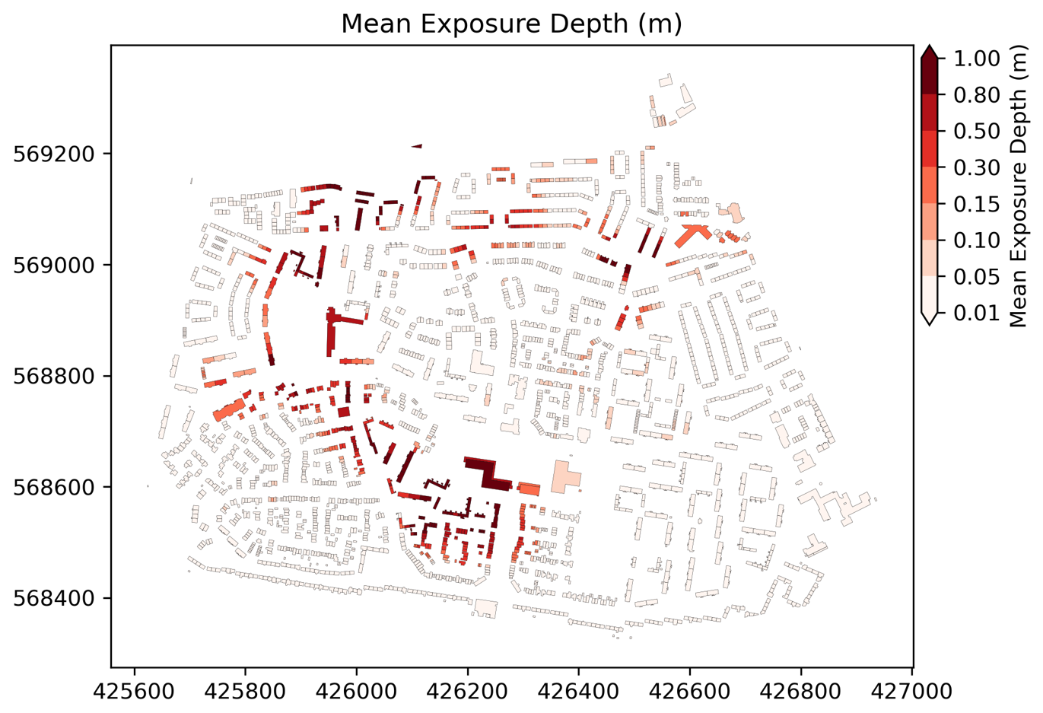

There seems to be a bug where only one file (the first selected in the list) can be downloaded at a time.
The published files are also available in the Data catalogue. A lot can be produced and deleting them needs to be done individually (Edit dataset then delete dataset at the end of the page).
Additional Notes
- Additional runs of this dataset can be made be going to Actions and clicking on Edit parameter set. To use a slightly different parameter set it is best to go to Actions and then click on Duplicate parameter set.
- If a run has failed then it is currently very hard to work out what the issue is. A warning triangle will let you know which model has failed. But to get more information then you need to request the logs on Slack in the Dafni group for this instance. The instance ID is in the address bar on the browser. E.g. for the example below the ID = 95e8054f-33e1-4592-a0eb-21806a258528
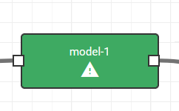

Example 2 _Kotatinggi
In this example a 62km² around Kotatinggi, Malaysia is run with a 10m grid resolution. The example includes a river inflow boundary condition. A boundary, DEM and buildings (but no green areas) are defined.
Create a parameter set as before with the inputs, extract-buildings and elevation set as below. The elevation is a TIF file and the DTM data is from SRTM using the UTM48N CRS resampled to 10m with burnt in rivers.
This example also includes an inflow boundary condition to account for fluvial flooding in Kotatinggi. Click on the add-inflow-boundary model and fill in the data as below, this defines the polygon where the inflow boundary is applied. Within CityCAT the inflow boundary is set using the Discharge parameter in the citycat-extra-functionality model second page (see image below). Discharge is distributed uniformly over the Duration parameter also set in the citycat-extra-functionality and gets multiplied by the number of cell boundaries intersected by the polygons specified here. Therefore, it is normally advisable to divide the total desired discharge by the number of overlapping cell boundaries. In this example the extract-greenspaces model is not used and so the Permeable Area parameter specified in the citycat-extra-functionality model is used.

The output max_depth.png shows the high water depths corresponding to the inflow boundary condition on the west side of the domain. The mean exposure depth for each building can be seen in exposure_plot.png

In this example to find the correct datasets search for Malaysia.

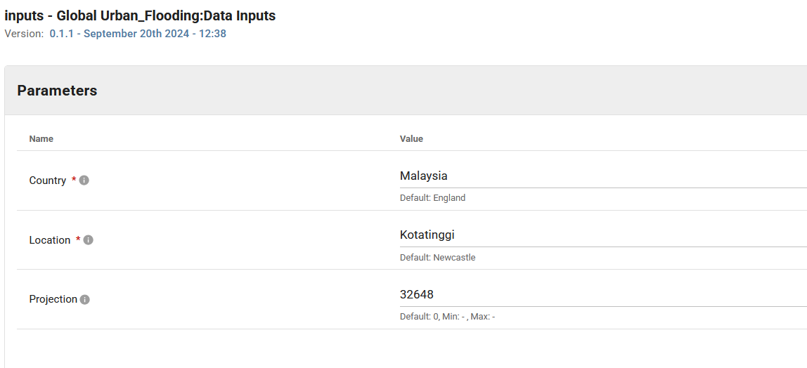

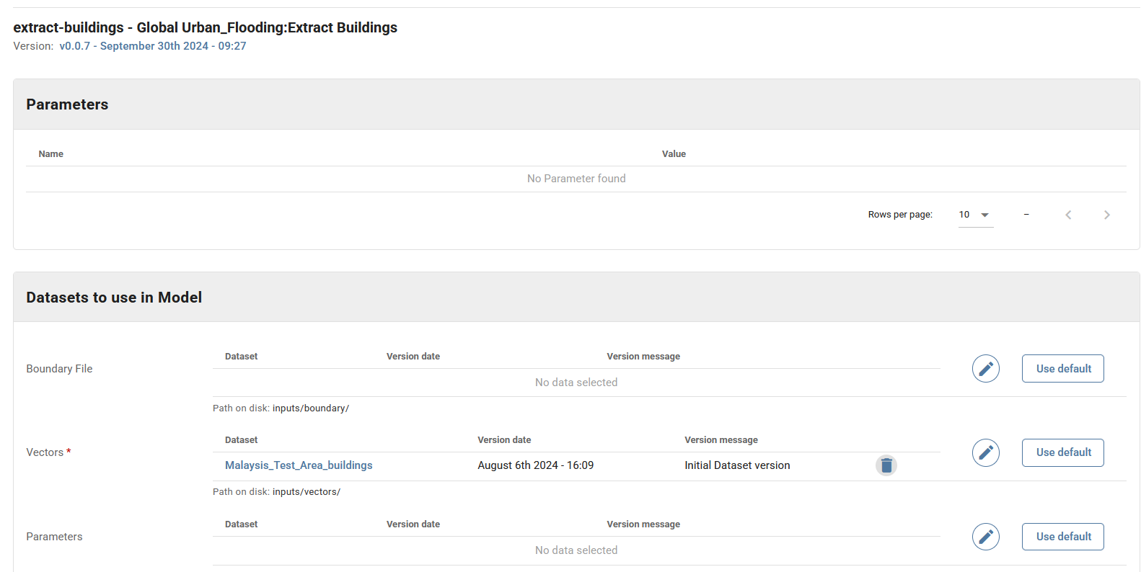
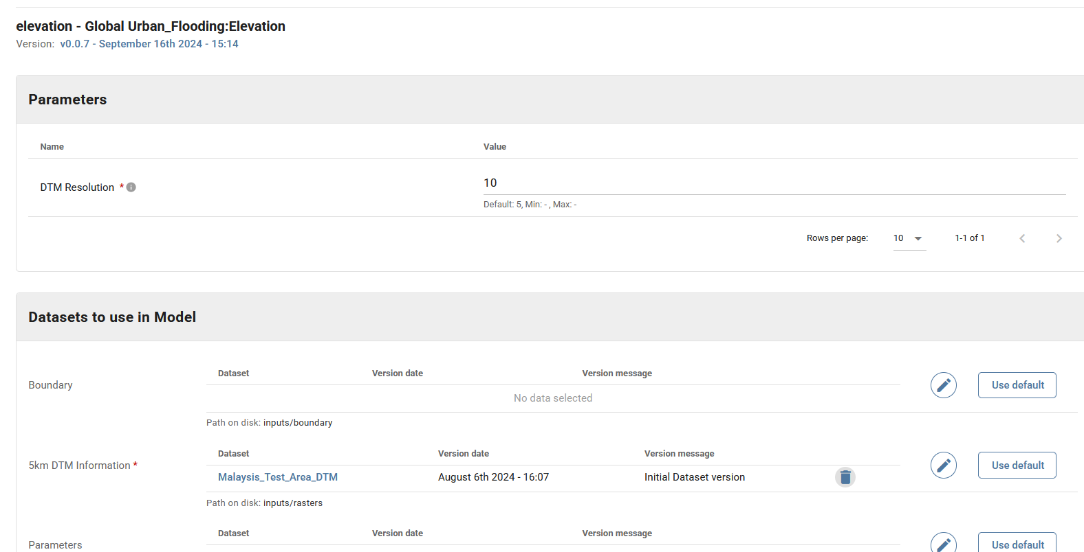
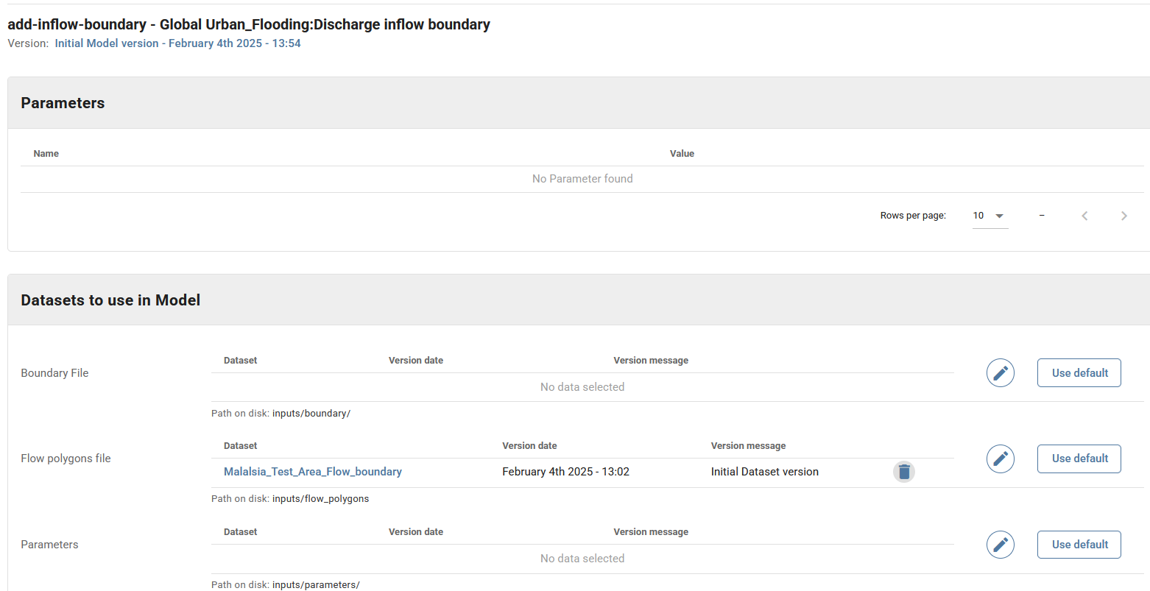

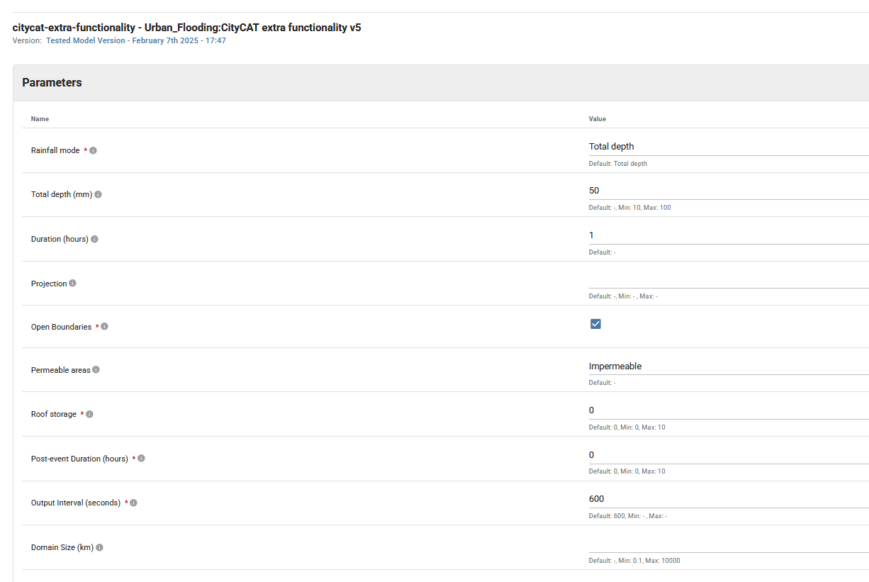
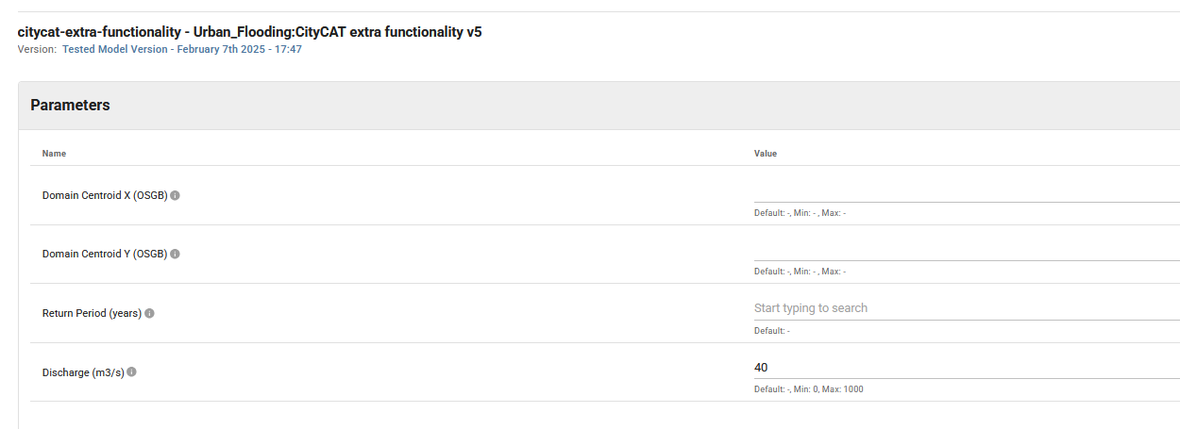
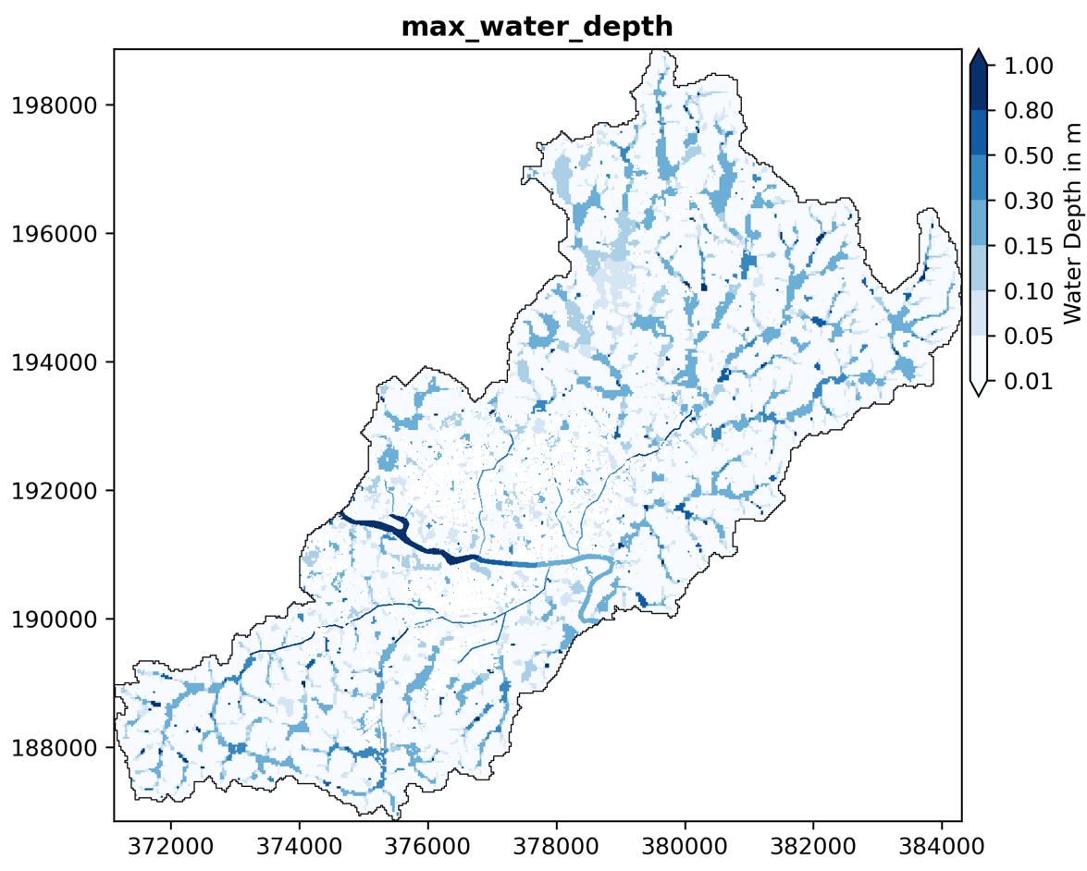
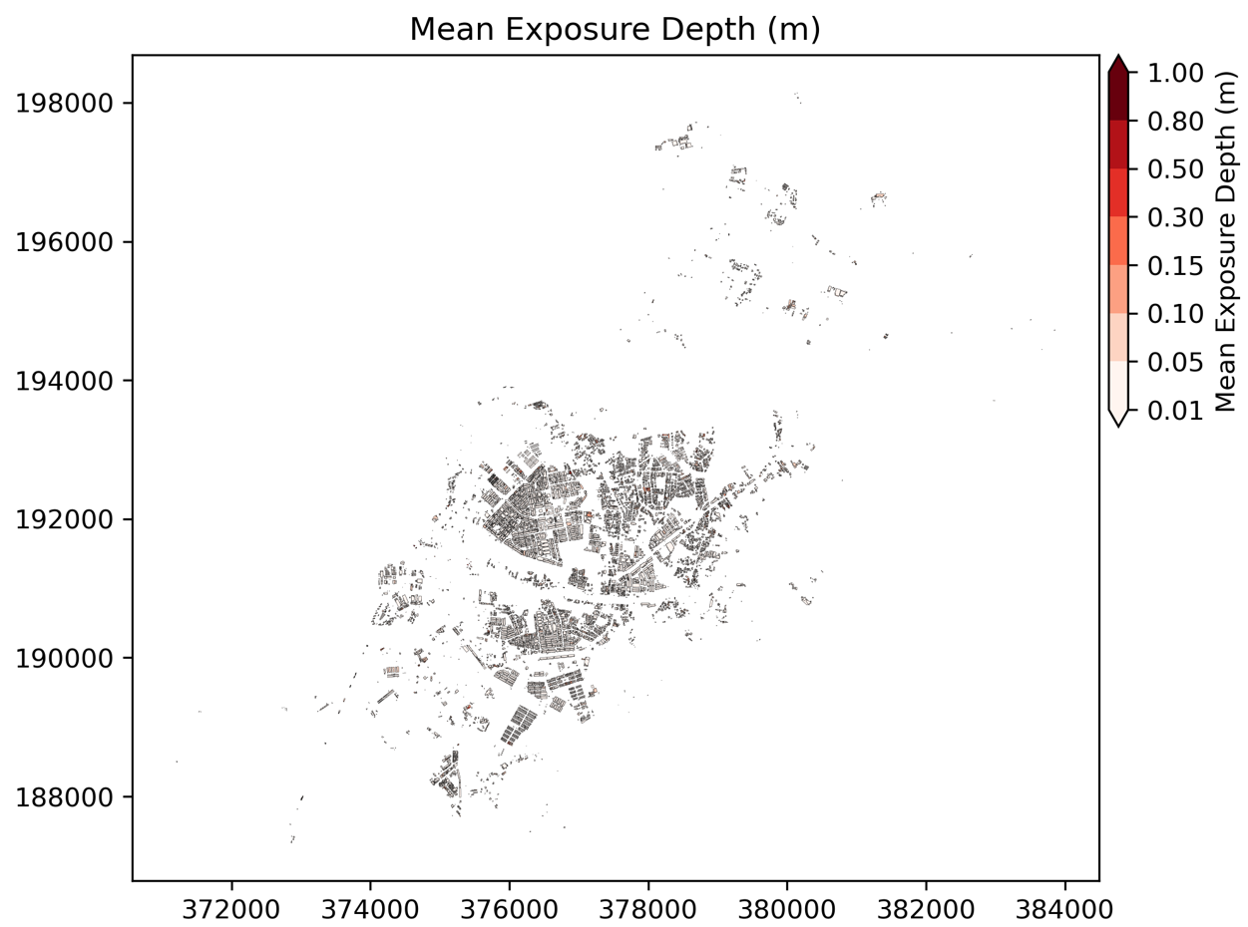
Notes:
- Remember citycat-dafni used here is a branch of the main version (see code in Github) https://github.com/OpenCLIM/citycat-dafni/tree/citycatio-additional-functionality
- In the elevation model DTM resolution is supplied, this currently only used the add-inflow-boundary model. Elsewhere it is found automatically from the DTM data.

