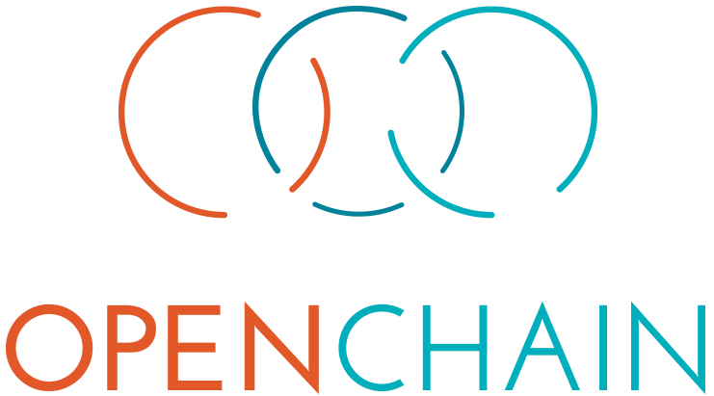

**On-Boarding**

# Introduction

The OpenChain Project identifies key recommended processes for effective open source management. The project builds trust in open source by making open source license compliance simpler and more consistent. The OpenChain Specification defines a core set of requirements every quality compliance program must satisfy. The OpenChain Curriculum provides the educational foundation for open source processes and solutions, whilst meeting a key requirement of the OpenChain Specification. OpenChain Conformance allows organizations to display their adherence to these requirements. The result is that open source license compliance becomes more predictable, understandable and efficient for participants of the software supply chain.

# OpenChain Specification

The core of the OpenChain Project is the Specification. This identifies identifies a series of processes that help ensure organizations of any size can address open source compliance issues effectively. The main goal of organizations using the OpenChain Specification is to become conformant. This means that their organization meets the requirements of a certain version of the OpenChain Specification. A conformant organization can advertise this fact on their website and promotional material, helping to ensure that potential suppliers and customers understand and can trust their approach to open source compliance.

You can learn more about the OpenChain Specification here: <https://www.openchainproject.org/spec>

# OpenChain Conformance

OpenChain Conformance can be done manually or via a free Online Self-Certification questionnaire provided by the OpenChain Project. We recommend that organizations of all sizes use the Online Self-Certification. It is the quickest, easiest and most effective way to check and confirm adherence to the OpenChain Specification.

The Online Self-Certification service is available here in the English language: <https://www.openchainproject.org/conformance>

# OpenChain Curriculum

The OpenChain Curriculum helps organizations meet certain aspects of the OpenChain Specification. More specifically, it provides a generic, refined and clear example of an open source compliance training program that can either be used directly or incorporated into existing training programs. The OpenChain Curriculum is available with very few restrictions to ensure organizations can use it in as many ways as possible. To accomplish this it is licensed as CC-0, effectively public domain, so remixing or sharing it freely for any purpose is possible.

You can learn more about the OpenChain Curriculum here: <https://www.openchainproject.org/curriculum>

# Frequently Asked Questions

The OpenChain Project offers a Specification and supporting material to help organizations of all sizes maximize their benefit from engagement with open source technology. The most important point is that OpenChain builds trust by providing a clear way to show adoption of industry-standard processes. The simple Online Self-Certification makes engagement as simple as possible. The Curriculum offers numerous training and best practice opportunities both inside and outside of activities directly related to the OpenChain Project.

You can learn more about each aspect of the OpenChain Project here: <https://www.openchainproject.org/faq>

# Supporters

OpenChain has nine Platinum Members that support its development and adoption: Adobe, ARM, Cisco, GitHub, Harman, HPE, Qualcomm, Siemens and Wind River. OpenChain also has a wide community of volunteers helping to make open source compliance easier