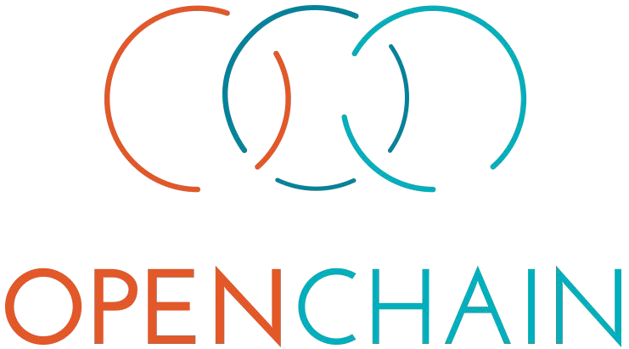

Onboarding

May 2017

The OpenChain Project Onboarding 1.0 © 2016-2017 The Linux Foundation

This document is made available under the Creative Commons CC0 1.0 Universal license.

Duplicated Compliance Efforts in Supply Chains

* Each company in a supply chain needs to respect developer rights and license choices
* Each company is re-creating essentially identical processes for open source compliance
  + Each company needs to identify, track and comply with FOSS components used in software distributions
  + When code moves downstream, receiving company has to perform the same work
  + Receiving company has no visibility into compliance decisions or processes from upstream vendors

Friction Points Resolved

* Desired State = Broad Respect for Developer Rights + Low Transaction Costs
* OpenChain provides a baseline process with freedom to optimize and customize
  + Upstream compliance work is preserved, available, and reusable for others
  + Downstream recipients understand upstream compliance processes, can reuse compliance work
  + More trustworthy results throughout the supply chain
  + Compliance has less impact on the software development process

Common Process for Open Source Software Governance

* A new conformity assessment standard that specifies a minimum standard for providing
  + Reliable internal processes
  + Educated personnel
* Reliable internal processes include
  + Documentation of policies
  + Governance by a decision-making body with authority and expertise
  + Monitoring of internal conformance
  + Compliance with open source license obligations
* Core of the OpenChain Project
* Identifies a minimum level of processes that organizations of any size can use address open source compliance issues effectively
* Developed by a broad base of corporate and community participants

You can learn more about the OpenChain Specification here: <https://www.openchainproject.org/spec>

* Organizations certify that they meet the requirements of a certain version of the OpenChain Specification
  + OpenChain Conformance can be done manually or via a free Online Self-Certification questionnaire provided by the OpenChain Project
  + Organizations can advertise their conformance on their website and promotional material

The Online Self-Certification service is available here in the English language: <https://www.openchainproject.org/conformance>

* The OpenChain Curriculum helps organizations meet certain aspects of the OpenChain Specification
  + Provides a generic, refined and clear example of an open source compliance training program that can either be used directly or incorporated into existing training programs
  + Licensed as CC-0, so remixing or sharing it freely for any purpose is possible

You can learn more about the OpenChain Curriculum here: <https://www.openchainproject.org/curriculum>

1. Review the OpenChain specification at <https://www.openchainproject.org/spec>
2. Implement and document processes to meet the spec requirements. Use the curriculum slides as an easy starting point for training - <https://www.openchainproject.org/curriculum>
3. Certify conformance with the OpenChain specification at <https://www.openchainproject.org/conformance>
   * Join the Specification, Conformance process and Curriculum work teams
   * Participate in bi-monthly work team calls
   * Corporate Sponsorship and Board opportunities

For opportunities, see <https://www.openchainproject.org/community>

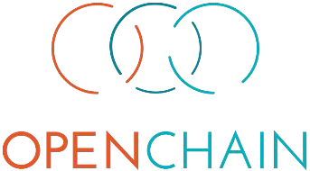

Thank You

