Installing OpenClinica 3.1.1
on Windows

Screenshots used as examples and might not match exactly what is written in the instructions. Please follow the instructions as they are written.

Note: Many windows systems are not configured to show the file extensions by default. In order to use this guide, you will need to be able to see the file extensions. To configure this behavior, open a Windows Explorer window. Click Tools > Folder Options. Go to the View tab, and in Advanced settings uncheck the ‘Hide extensions for known file types’.

This installation was performed successfully on Windows Server 2003 Standard Edition SP2.
This installation was performed successfully on Windows Server 2003 Standard Edition SP1.
This installation was performed successfully on Windows XP Professional Version 2002 SP2.
The system should work on Windows 2000 Professional and compatible systems, but has not been tested on other Windows platforms.

NOTE: All characters are case sensitive. Please be aware of any additional white space between or after characters this may cause installation errors.

Table of Contents*

1. About OpenClinica 3
2. Install Java 5
3. Install PostgreSQL 6
4. Install Tomcat 7
5. Install OpenClinica Package 9
6. Setup PostgreSQL OpenClinica DB and User. 9
7. Configuring Tomcat and the Web Application 11
8. Verify your Environment 13
9. Configure SSL Certificate 13
10. Deploy Enterprise Postgres Configuration 14
11. Final Verification of your Environment 15
12. Using Oracle as the Database 16

1. About OpenClinica

Professional Open Source Solutions for the Clinical Research Enterprise

OpenClinica: Open Source Software Platform for Managing Clinical Research Studies Professional Open Source Solutions for the Clinical Research Enterprise
OpenClinica is a free, open source clinical trial software platform for Electronic Data Capture (EDC) clinical data management in clinical research. The software is web-based and designed to support all types of clinical studies in diverse research settings. From the ground up, OpenClinica is built on leading independent standards to achieve high levels of interoperability. Its modular architecture and transparent, collaborative development model offer outstanding flexibility while supporting a robust, enterprise-quality solution.
More about OpenClinica: https://www.openclinica.com
Software License
OpenClinica is distributed under the GNU Lesser General Public License (GNU LGPL). For details see: http://www.openclinica.org/license or LICENSE.txt distributed with this distribution.
Developer and Contact Information
Akaza Research, based in Cambridge, MA, provides clinical trials informatics solutions based on OpenClinica, the world's most widely used open source clinical trials software.
Akaza Research
460 Totten Pond Rd
Suite 200
Waltham, MA 02451
email: contact@akazaresearch.com
For more about Akaza’s products and services see:
https://www.openclinica.com
Software Dependencies
OpenClinica runs on top of any Servlet/JSP container that implements the Servlet 2.4 and JavaServer Pages 2.0 specifications from the Java Community Process. It was developed to run on Apache Jakarta Tomcat 6.0.32.

Currently, OpenClinica runs on top of either the Postgres relational database or an Oracle relational database. Using a JDBC (Java Database Connectivity) driver, the database connects to the web application and provides the data to the end-user.

Required for new installs:
Jakarta Tomcat 6.0.32
Java 2 Standard Edition Development Kit 6.0 Update 24
Postgres 8.4.7.2 or Oracle 10g or higher

This installation guide will show you how to acquire and setup each of the required components and configure the OpenClinica web application.

Note: The software stack OpenClinica runs on is open source, and most open source projects release minor versions and revisions often. Sometimes only a matter of weeks may separate the release of two adjacent versions of the software.

For this release, the latest stable version of each component was used in integrated testing, and its revision number is referenced in this document. In some cases, the revision number mentioned may no longer be available. For the most part, you should be able to use later minor versions and revisions of the same software without incident. For instance, if the install guide uses PostgreSQL 8.4.7.2, PostgreSQL 8.4.8 should work as well.

We recommend that you record the revision number you use. If you have concerns about a particular combination, please post your question to the users@openclinica.com mailing list.

2. Install Java

OpenClinica 3.1.1 is designed to run on a Java 2 SDK 1.6x platform. To avoid conflicts with other versions of Java, you should clear out any other Java installations on the system.

- Go to Start>Control Panel>Add Remove Programs, and remove all Java JRE and SDKs.
- Create a directory called “c:\oc\install”
- Download J2SE Development Kit 6.0 Update 24 into “c:\oc\install”

Windows offline installation (EXE)
Filename: jdk-6u24-windows-i586.exe
Size: 77 MB
Website: https://cds.sun.com/is-bin/INTERSHOP.enfinity/WFS/CDS-CDS_Developer-Site/en_US/-/USD/ViewProductDetail-Start?ProductRef=jdk-6u24-oth-JPR@CDS-CDS_Developer

Our Download Site: http://svn.akazaresearch.com/oc/software/OpenClinica-3.1.1/windows/

- Run C:\oc\install\jdk-6u24-windows-i586.exe
- When the “Open File – Security Warning” opens click on “Run”
- Click “Next >” on the Welcome to the Installation Wizard for Java screen.
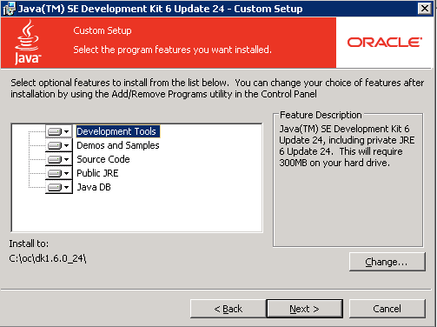

- On the “Custom Setup” screen Click “Change…”
- Change the path to “c:\oc\jdk1.6.0_24\” and click “OK”
- Your screen should look like the screenshot above, now click “Next >”
- Setup installs the JDK
- Once the first setup completes you will see another page for installing the JRE6. Click “Cancel” and then “Yes” on the confirmation pop-up with the message “Are you sure you want to cancel installation…?”.
- Now click “Finish” on the Install Success screen.
- Exiting the setup will open a web browser to register the JDK, feel free to register or close the web browser.

3. Install PostgreSQL

The default installation of OpenClinica uses a PostgreSQL database. PostgreSQL is an open source application and can be installed to the Window platform as follows. If you are using an Oracle database skip this step.

- Download postgresql-8.4.7-2-windows.exe and save it to “c:\oc\install”

Windows binary distribution (ZIP)
Filename: postgresql-8.4.7-2-windows.exe
Size: 42 MB
Website: http://svn.akazaresearch.com/oc/software/OpenClinica-3.1.1/windows/

- Run c:\oc\install\postgresql-8.4.7-2-windows.exe
- When the “Open File – Security Warning” opens click on “Run”
- The PostgreSQL Installation Wizard Opens, and click “Next >” to continue.
- For the Installation directory screen accept the defaults by clicking “Next >”
- For the Data directory screen accept the defaults by clicking “Next >”
- For the Password screen, please enter a password for the postgres superuser. (Remember this password you will need it later)
- Once you have entered the password twice click “Next >”
- For the Port screen accept the defaults (5432) by clicking “Next >”
- Next you will see the Advanced Options screen
Advanced Options
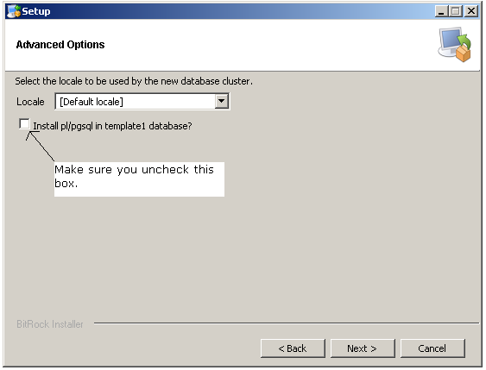

- Use Default locale
- Uncheck the checkbox next to Install pl/pgsql in template1 database
- Click “Next >”.
- For the Ready to install screen click “Next >” to start the installation.
- Once you see the Completing the PostgreSQL Setup Wizard screen, uncheck the “Launch Stackbuilder at exit” checkbox and click “Finish”

4. Install Tomcat

- Download Apache Tomcat 6.0.32 and save it to “c:\oc\install”, use the Windows Service Installer version.

Windows binary distribution (EXE)
Filename: apache-tomcat-6.0.32.exe
Size: 7 MB
Website: http://tomcat.apache.org/download-60.cgi

Our Download Site: http://svn.akazaresearch.com/oc/software/OpenClinica-3.1.1/windows/

- Run c:\oc\install\apache-tomcat-6.0.32.exe, the Apache Tomcat Setup installation wizard appears.
- When the “Open File – Security Warning” opens click on “Run”
- On the Welcome to the Apache Tomcat Setup Wizard page click “Next >”
- On the License Agreement page click “I Agree” to accept the agreement.
- On the Choose Components screen click “Next >” to accept the defaults.
- On the Configuration page leave the defaults and click “Next >”
- On the Java Virtual Machine page click on the “…” and select the path we installed the jdk into “c:\oc\jdk1.6.0_24\”. Should look like screenshot below. Once the jdk path is shown click “Next >” to continue.

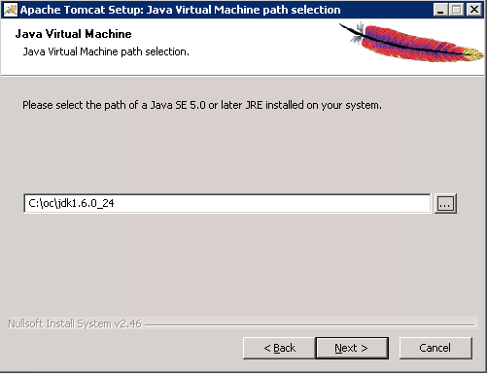

- On the choose Install Location page edit the destination folder to read “c:\oc\tomcat”. This should now look like the screenshot below.
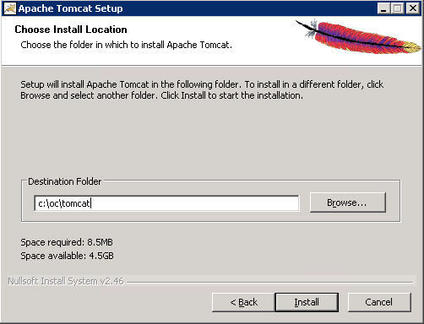
- Now click “Install” to start the installation.
- Once done you will be on the Completing the Apache Tomcat Setup Wizard page

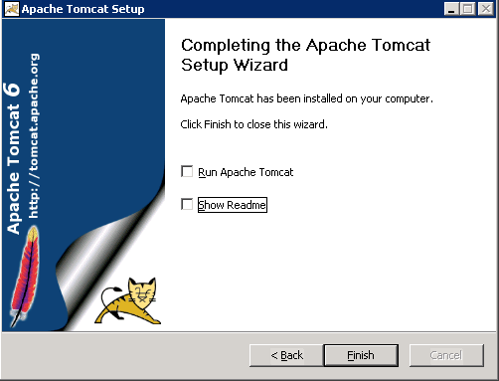

- Uncheck the Run Apache Tomcat checkbox.
- Uncheck the Show Readme checkboxes.
- Click Finish. Tomcat is now installed
- Create a new directory in “c:\oc\tomcat” called “oldwebapps”
- Move all default webapps from “c:\oc\tomcat\webapps” to “c:\oc\tomcat\oldwebapps”
- Click on “start -> control panel” once in Control Panel click on “Administrative Tools” and then on “Services”
- Once the Services screen is open locate “Apache Tomcat 6” and right click on it and select properties.
- In the properties dialog change “Startup Type:” from “Manual” to “Automatic” once changed click “OK”. You can exit the “Services” window.

5. Install OpenClinica Package

To install OpenClinica, you must first acquire the package and install it on the server.

Download OpenClinica 3.1.1
Filename: OpenClinica-3.1.1.zip (ZIP)
Website: https://www.openclinica.com (you must register)

- Download OpenClinica-3.1.1.zip and save it to “c:\oc\install”
- Right click on OpenClinica-3.1.1.zip and click “Extract All”
- On the extraction wizard window click “Next >”
- Now change the directory to “c:\oc\install” and click “Next >”
- Uncheck the “Show Extracted Files” checkbox and click “Finish”
- Now copy “c:\oc\install\OpenClinica-web-3.1.1\ OpenClinica-web-3.1.1\distribution\OpenClinica.war” to “c:\oc\tomcat\webapps”

6. Setup PostgreSQL OpenClinica DB and User.
Note: If you are using Oracle as your database skip this step

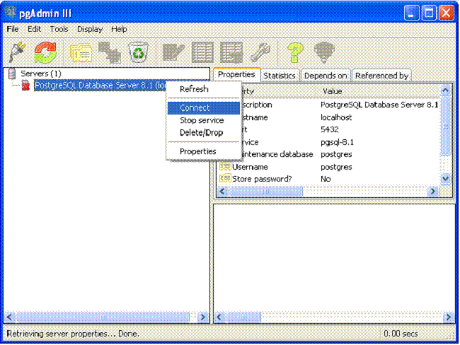

- Open pgAdminIII. Go to Start>Programs>PostgreSQL 8.4 > pgAdminIII. The pgAdminIII interface opens.
- Right click on the “PostgreSQL 8.4 (localhost:5432)” icon with a red “X” next to it and select “Connect”.
- Now login to the database server. Enter the password you setup in the PostgreSQL installation.
- Next we will create the DB user “clinica” which OpenClinica uses to connect to the database with.
- Expand databases and click the “postgres” database so that it is highlighted
- Now click “Tools” and select “Query tool”.
- The Query window is now open, please select and delete all text in the “SQL Editor” box so it is blank.
- Once the “SQL Editor” box is blank type the following into the “SQL Editor” box:

“CREATE ROLE clinica LOGIN ENCRYPTED PASSWORD 'clinica' SUPERUSER NOINHERIT NOCREATEDB NOCREATEROLE;”
(NOTE: NO QUOTES)

- Once the above is in the “SQL Editor” box click on “Query” from the top menu and select “Execute” to run the sql query.
  - You will see a message in the “History” window indicating the query has completed.
- Once the query has been executed delete all text in the “SQL Editor” box so it is blank again.
- Once the “SQL Editor” box is blank again type the following into the “SQL Editor” box:

“CREATE DATABASE openclinica WITH ENCODING='UTF8' OWNER=clinica;”
(NOTE: NO QUOTES)

- Once the above is in the “SQL Editor” box click on “Query” from the top menu and select “Execute” to run the sql query.
  - You will see a message in the “History” window indicating the query has completed.
- Once the query has been executed please delete all text in the “SQL Editor” box so it is blank again.
- Once the “SQL Editor” box is blank again type the following into the “SQL Editor” box:
“CREATE DATABASE openclinica_test WITH ENCODING='UTF8' OWNER=clinica;”
(NOTE: NO QUOTES)

- Once the above is in the “SQL Editor” box click on “Query” from the top menu and select “Execute” to run the sql query.
  - You will see a message in the “History” window indicating the query has completed.
- Once done close the “Query” window, when prompted to save changes click “No”
- We have created the “clinica” db user and the two db’s that OpenClinica will use. As of right now the “clinica” db user has a default password of “clinica”. Since this is a potential security risk we recommend you change the password immediately.
- To change the “clinica” db users password expand and highlight “Login Roles” within PGAdmin and then click “View” from the top menu and select “Refresh”.
- Now you should see the “clinica” db user. Right click on the “clinica” account and select “Properties”
- In the Login Role clinica box that opens up you should see two relevant fields “Password” and “Password (again)”. Enter your new password for the “clinica” db user into both fields and the click “OK” to apply the changes. You have now changed the “clinica” db user’s password. (Remember this password as you will need it when you configure OpenClinica)

7. Configuring Tomcat and the Web Application

- Open the “Configure Tomcat” application by going to “Start -> Apache Tomcat 6.0 -> Configure Tomcat”
- Now click on the “Java” tab
- Put “1280” into the “Maximum memory pool” section
- Now add “-XX:MaxPermSize=180m” on a new line in the JAVA Options text entry on the “Java” tab.
- Once done it should look like the screenshot below.
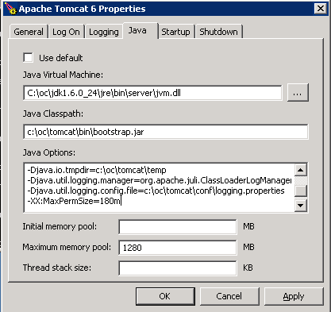
- When all settings have been entered and it looks like the screenshot above click “Apply”.
- Tomcat is now configured; next we will deploy and configure OpenClinica.
- We have already copied the OpenClinica.war into the tomcat webapps directory so to deploy it all we have to do is start tomcat.
- To start tomcat click on the “General” tab, once on the tab click on “Start”
  - We have to wait for tomcat to fully startup, you can do this by looking at catalina.out in “c:\oc\tomcat\logs” and look for a line that says “INFO: Server Startup in XXXXX ms” or just wait about 5 minutes.
- Once tomcat has fully started up click on “Stop” on the “General” tab.
  - Wait two minutes for tomcat to stop.
- Now that tomcat is stopped go to “c:\oc\tomcat\webapps” and right click on “OpenClinica” and select “Copy”, then right click within the “c:\oc\tomcat\webapps” directory and slect “Paste”
- Now rename “Copy of OpenClinica” to “OpenClinica_test”
- Now delete “OpenClinica.war” from “c:\oc\tomcat\webapps”
- Next we will modify the OpenClinica configuration files for each instance to match the server specific settings.
- Open the OpenClinica instance configuration file located C:\oc\tomcat\webapps\OpenClinica\WEB-INF\classes\datainfo.properties file in WordPad and modify it to suit your setup, save when done.
  - Note the only thing you have to change for OpenClinica to startup in 3.1.1 is the dbPass entry to match what you changed the “clinica” db users password to.
  - There are other options you should configure for your environment such as sysURL, please read the full file and configure accordingly.
- Now open the OpenClinica_test configuration file located C:\oc\tomcat\webapps\OpenClinica_test\WEB-INF\classes\datainfo.properties file in WordPad and modify it to suit your setup, save when done..
  - Note the only thing you have to change for OpenClinica to startup in 3.1.1 is the dbPass entry to match what you changed the “clinica” db users password to.
  - There are other options you should configure for your environment such as sysURL, please read the full file and configure accordingly.
- There are many other configuration options in these files. Please read the instructions in the file for more information. This installation document was created to get the application up and running in as few steps as possible.

- Once the files are configured and saved proceed.
- Now start tomcat. This can be done in general through one of the following methods.
  - The “General” tab in “Configure Tomcat” that we used earlier allows you to start and stop tomcat.
  - Click “start -> run” type “cmd” in the run box and click “OK”. In the new command prompt window the following will start tomcat “net start tomcat6” the following will stop tomcat “net stop tomcat6”
  - Via windows services mmc.
- Once tomcat is started quickly verify your environment

Verify your Environment

- Open a web browser on the server and load http://localhost:8080/OpenClinica and http://localhost:8080/OpenClinica_test and verify the web application loads. You should see the OpenClinica login screen.
- Now we have verified your environment and that OpenClinica starts. We will now configure an SSL certificate for your server and other enterprise features.
- At this point the application has been installed correctly. We now need to make it a secure environment.

9. Configure SSL Certificate

Akaza Research strongly recommends securing the Tomcat application server using SSL. SSL is the technology used to make secured 'https://' connections. SSL requires a third-party security certificate to be effective. Information regarding configuring ssl certificates for tomcat can be found here. http://tomcat.apache.org/tomcat-6.0-doc/ssl-howto.html

Get your tomcat compatible ssl certificate from your IT department and place it on the server into the "c:\oc\install" directory and rename the file to be "tomcat.keystore”. If no certificate was given to you follow the Self Signed Certificate instructions below.

Setup Self-Signed Certificate
SKIP THIS SECTION IF THE CUSTOMER PROVIDED A CERTIFICATE OR IF THE IT DEPARTMENT GAVE A CERTIFICATE TO YOU.

- Click on “start -> run” type “cmd” in the run dialog box.
- On the new command prompt window type the following “cd c:\oc\jdk1.6.0_24\bin” and hit “enter”
- Now type the following in the command prompt “keytool -genkey -alias tomcat_key -keyalg RSA -keysize 2048 -keystore tomcat.keystore -validity 365”
  - When prompted with "Enter keystore password:" please enter a password for you ssl certificate and remember this password as your keystore password as you will need it in future steps, once password is entered press "enter" and retype the password when you are prompted with "Re-enter new password: ".
- The next sets of questions are related to your certificate and should be filled out accordingly for this server. Below are some examples and explanations when needed.
  - What is your first and last name? [Unknown]: (This is your server name or IP so you wool enter "openclinica.example.com" or an IP like 192.168.1.15)
  - What is the name of your organizational unit? [Unknown]: (Usually people put the name of the company or department ex. "Akaza Research LLC")
  - What is the name of your organization? [Unknown]: (This is almost always the company name and most people have this and the above option be the same but it is not required)
  - What is the name of your City or Locality? [Unknown]: (Enter your city, ex. "Waltham")
  - What is the name of your State or Province? [Unknown]: (Enter your state, ex "Massachusetts")
  - What is the two-letter country code for this unit? [Unknown]: (Enter your countries two letter abbreviation, ex "US")
  - Is CN=192.168.15.156, OU=Akaza Research LLC, O=Akaza Research LLC, L=Waltham, ST=Massachusetts, C=US correct? [no]: (This is just making sure you entered the correct data, if it looks good type "yes" and press "enter" otherwise type "no" and press "enter" and you will start the questions over)
  - Enter key password for <tomcat_key> (RETURN if same as keystore pass word): (For this prompt do NOT enter your password and just hit "enter")
- Now move the created self signed certificate to c:\oc\install vie the following command “move tomcat.keystore c:\oc\install”

Implement SSL certficate.
Do the following to implement your SSL certificate.

- Copy c:\oc\install\tomcat.keystore to c:\oc\tomcat\openclinica.data
- Copy and rename c:\oc\tomcat\conf\server.xml so you have it as c:\oc\tomcat\conf/server.xml-orig also.
- Now download https://svn.akazaresearch.com/oc/software/OpenClinica-3.1.1/enterprise/windows/ssl-server.xml to c:\oc\install (Enterprise installer user and pass is required to download file)
- Copy and rename c:\oc\install\ssl-server.xml to c:\oc\tomcat\conf\server.xml
- Edit "usr/local/tomcat/conf/server.xml" and replace "SSLPASSWORD" with your keystore password in the port 443 connector section. If your certificate is in "java keystore" format this is the only thing you need to edit, if your certificate is in "pkcs12" format you have to add the following to the connector "<keystoreType="pkcs12>", example is below.
  - <Connector port="443" protocol="HTTP/1.1" SSLEnabled="true"
maxThreads="150" scheme="https" secure="true"
clientAuth="false" sslProtocol="TLS"
ciphers="SSL_RSA_WITH_RC4_128_MD5, SSL_RSA_WITH_RC4_128_SHA, TLS_RSA_WITH_AES_128_CBC_SHA, TLS_DHE_RSA_WITH_AES_128_CBC_SHA, TLS_DHE_DSS_WITH_AES_128_CBC_SHA, SSL_RSA_WITH_3DES_EDE_CBC_SHA, SSL_DHE_RSA_WITH_3DES_EDE_CBC_SHA, SSL_DHE_DSS_WITH_3DES_EDE_CBC_SHA"
keystoreFile="c:\oc\tomcat\openclinica.data\tomcat.keystore"
keystorePass="SSLPASSWORD" <keystoreType="pkcs12> />
- Once done with your edits save the file
  - If you have not already done so you will need to change the localhost URLs in the datainfo.properties to match your desired server settings. If you are planning on using OpenClinica over the web, this will need to be your server’s or proxies URL and you may need to open the Tomcat port. These SysURLs will be used in emails the application sends (This should have been done when we edited the datainfo.properties file)
- More information on setting up SSL for Tomcat is available here: http://tomcat.apache.org/tomcat-6.0-doc/ssl-howto.html

10. Deploy Enterprise Postgres Configuration

To deploy the custom Enterprise Postgres configuration do the following.

- Copy “C:\Program Files\PostgreSQL\8.4\data\postgresql.conf” to “C:\Program Files\PostgreSQL\8.4\data\postgresql.conf-orig”
- Download http://svn.akazaresearch.com/oc/software/OpenClinica-3.1.1/enterprise/linux/postgresql.conf and save it c:\oc\install (Enterprise installer user and pass is required to download file)
- Copy c:\oc\install\postgresql.conf” to “C:\Program Files\PostgreSQL\8.4\data\postgresql.conf” (Select “Yes” if prompted to confirm overwrite)
- Now lets restart your server to make sure everything comes up on boot. To restart your server click on “Start -> Shut Down”, select “Restart” from the dropdown list and give a comment like “Final Install Test” and click “OK”

11. Final Verification of your Environment

- Open a web browser on the server and load https://localhost/OpenClinica and https://localhost/OpenClinica_test and verify the web application loads. You should see the OpenClinica login screen.
- Enterprise support services, mailing lists, and additional resources for OpenClinica are available at https://www.openclinica.com.

12. Using Oracle as the Database

OpenClinica 3.1.1 has been ported so it can work on the Oracle database as well as the PostgreSQL database. We will not instruct you on how to install Oracle, but there are instructions on how to create the database OpenClinica will use.

Please go to the following page for separate instructions for installing OpenClinica with Oracle. https://docs.openclinica.com/3.1.1/installation/oracle-database-setup. The document you find there should be followed instead of Chapters 3 and 6 above.

