Yuma Installation Guide

YANG-Based Unified Modular Automation Tools

YUMA Package Installation

Version 2.2

Last Updated: 2012-07-24
Table of Contents
1 Preface 3
1.1 Legal Statements 3
1.2 Additional Resources 3
1.2.1 WEB Sites 3
1.2.2 Mailing Lists 4
1.3 Conventions Used in this Document 4
2 Introduction 5
2.1 Intended Audience 5
3 Installation Requirements 5
3.1 Supported Platforms 5
3.2 External Packages 6
3.2.1 libxml2 6
3.2.2 libssh2 6
3.2.3 ncurses 6
3.2.4 zlib 6
3.3 Yuma Packages 6
3.3.1 yuma 6
3.3.2 yuma-doc 6
3.3.3 yuma-dev 7
4 Quick Installation 7
4.1 Ubuntu 7
4.1.1 External Libraries 7
4.1.2 Install the Yuma Package(s) 7
4.2 Fedora 8
4.2.1 External Libraries 8
4.2.2 Install the Yuma Package(s) 8
5 Installed Files 8
5.1 yuma Package 8
5.2 yuma-doc Package 9
5.3 yuma-dev Package 10
6 Next Steps 11
6.1 More Documentation 11
6.2 Running the Yuma Programs 12
6.2.1 yangcli, yangdump, yangdiff 12
6.2.2 netconfd and netconf-subsystem 12

Preface

Legal Statements
Copyright 2009 – 2012, Andy Bierman, All Rights Reserved.

Additional Resources
Other documentation includes:
Yuma Quickstart Guide
Yuma User Manual
Yuma netconfd Manual
Yuma yangcli Manual
Yuma yangdiff Manual
Yuma yangdump Manual
Yuma Developer Manual

To obtain additional support you may join the yuma-users group on sourceforge.net and send email to this e-mail address
yuma-users@lists.sourceforge.net

The SourceForge.net Support Page for Yuma can be found at this WEB page:
http://sourceforge.net/projects/yuma/support

There are several sources of free information and tools for use with YANG and/or NETCONF.
The following section lists the resources available at this time.

WEB Sites
- Netconf Central
  - http://www.netconfcentral.org/
  - Yuma Home Page
    - Free information on NETCONF and YANG, tutorials, on-line YANG module validation and documentation database
- Yuma SourceFource OpenSource Project
  - http://sourceforge.net/projects/yuma/
    - Download Yuma source and binaries; project forums and help
- Yang Central
  - http://www.yang-central.org
  - Free information and tutorials on YANG, free YANG tools for download
- NETCONF Working Group Wiki Page
  - http://trac.tools.ietf.org/wg/netconf/trac/wiki
  - Free information on NETCONF standardization activities and NETCONF implementations
- NETCONF WG Status Page
  - http://tools.ietf.org/wg/netconf/
  - IETF Internet draft status for NETCONF documents
- libsmi Home Page
  - http://www.ibr.cs.tu-bs.de/projects/libsmi/
  - Free tools such as smidump, to convert SMIv2 to YANG
- YumaWorks
  - http://www.yumaworks.com
  - Offers support, training, and consulting for Yuma.
  - Offers YumaPro, a professional version of Yuma that includes concurrency, external database support, sub-agent support, multiple northbound interfaces, and more. API compatible with Yuma. Availability: September, 2012. Licensed.

Mailing Lists
- NETCONF Working Group
  - http://www.ietf.org/html.charters/netconf-charter.html
  - Technical issues related to the NETCONF protocol are discussed on the NETCONF WG mailing list. Refer to the instructions on the WEB page for joining the mailing list.
- NETMOD Working Group
  - http://www.ietf.org/html.charters/netmod-charter.html
  - Technical issues related to the YANG language and YANG data types are discussed on the NETMOD WG mailing list. Refer to the instructions on the WEB page for joining the mailing list.

Conventions Used in this Document
The following formatting conventions are used throughout this document:
Documentation Conventions

Convention | Description
--foo | CLI parameter foo
<foo> | XML parameter foo
foo | yangcli command or parameter
$FOO | Environment variable FOO
$$foo | yangcli global variable foo
some text | Example command or PDU
some text | Plain text

Introduction
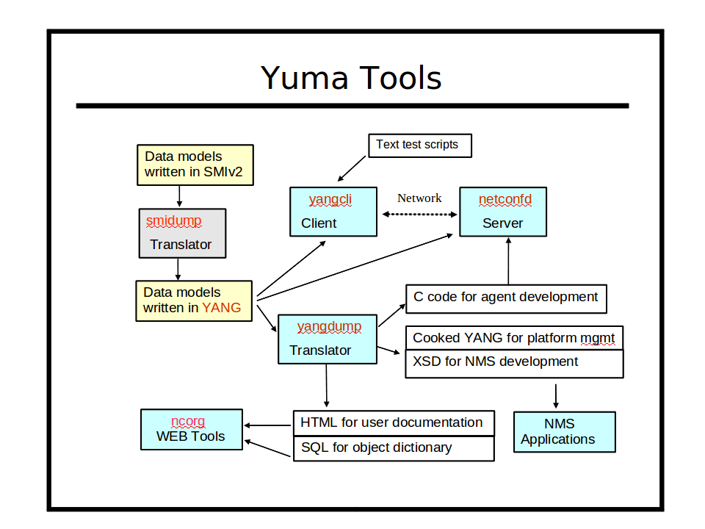

Refer to section 3 of the Yuma User Manual for a complete introduction to Yuma.
This section focuses on the client and server tools within the Yuma programs.

Intended Audience
This document is intended for users of the Yuma NETCONF client and server programs. It covers the installation of the Yuma packages.

Installation Requirements
The following requirements must be met for Yuma to be installed.

Supported Platforms
The following platforms are supported at this time for the Yuma binary package:
- Ubuntu version 9.10 (32 bit x86 and 64-bit AMD)
- Ubuntu version 12.04 (32 bit x86 and 64-bit AMD)
- Fedora version 12 (32 bit x86)

External Packages
The following programs and libraries need to be available for Yuma to work.

libxml2
The libxml2 package is needed by the yuma package for some of the XML parsing functions. This package is installed by the default Linux installation process.
To build yuma sources, also install the developer version of this package. It is called libxml2-dev on Ubuntu systems.

libssh2
The libssh2 package is needed by the yuma package for the yangcli program to connect to NETCONF servers using the SSH protocol. This package is called libssh2-1 on Ubuntu platforms. This package is not installed by the default Linux installation process.
To build yuma sources, also install the developer version of this package. It is called libssh2-1-dev on Ubuntu systems.

ncurses
The ncurses library is needed by the yuma package for some terminal support. This package is installed by the default Linux installation process.
It is called libncurses5 on Ubuntu systems.
To build yuma sources, also install the developer version of this package. It is called libncurses5-dev on Ubuntu systems.

zlib
The zlib library is needed by the yuma package for some compression support, used by other libraries that yuma imports. This package is installed by the default Linux installation process.
To build yuma sources, also install the developer version of this package. It is called libz-dev on Ubuntu systems.

Yuma Packages
The yuma files are split into 3 packages, described below.

yuma
The yuma package contains all the shared libraries, binary programs, man files, YANG files, sample .conf files, needed to run all the programs. It must be installed.

yuma-doc
The yuma-doc package contains all the documentation files, including this file. It is only needed if you want the PDF and HTML versions of the documentation installed. Since these files take up a lot of disk space, an optional package is used to install them.

yuma-dev
The yuma-dev package contains all the server instrumentation library (SIL) developer files. It is only needed if you want to add YANG modules to the server, and develop your own server instrumentation library code to load into the netconfd server at run-time.

Quick Installation
This section describes how to use the platform package manager program to install the Yuma programs.

Ubuntu

External Libraries
First, make sure the external libraries are installed.

mydir> dpkg --list libxml2 libssh2-1

If the library is installed, the status will show 'ii libxml2', as in the example below:

Desired=Unknown/Install/Remove/Purge/Hold
| Status=Not/Inst/Cfg-files/Unpacked/Failed-cfg/Half-inst/trig-aWait/Trig-pend
|/ Err?=(none)/Reinst-required (Status,Err: uppercase=bad)
||/ Name Version Description
+++-==============-==============-============================================
ii libssh2-1 1.2.2-1 SSH2 client-side library
ii libxml2 2.7.6.dfsg-1ub GNOME XML library
mydir>

If the libxml2 library is not installed, then install it with following command:

mydir> sudo apt-get install libxml2 libssh2-1

Install the Yuma Package(s)
Next, install the Yuma package. Here is an example showing all 3 packages being installed.
The actual hardware platform identifier may be different:

mydir> sudo dpkg -i yuma-2.1-1.u1004.i386.deb
mydir> sudo dpkg -i yuma-doc-2.1-1.u1004.i386.deb
mydir> sudo dpkg -i yuma-dev-12.1-1.u1004.i386.deb

Fedora

External Libraries
First, make sure the external libraries are installed.

mydir> rpm -q libxml2 ncurses libssh2

If the packages are installed then a line will be printed for each package showing the version, such as in the following example (your versions may be different)

libxml2-2.7.6-2.fc14.i686
ncurses-5.7-3.20090207.fc14.i686
libssh2-2.3.8.fc14.i686

If a package is not already installed, then install it. This example shows how to install both external libraries:

mydir> sudo yum install libxml2 ncurses libssh2

Install the Yuma Package(s)
Next, install the Yuma package. Here is an example.
The actual yuma revision and hardware platform may be different:

mydir> sudo yum localinstall yuma-2.1-1.fc14.i686.rpm

Installed Files

yuma Package
This section describes all the files and/or directories installed by the yuma package:
- /usr/bin directory contains the following programs:
  - yangcli
  - yangdiff
  - yangdump
- /usr/sbin directory contains the following server programs:
  - netconfd
  - netconf-subsystem
- /usr/lib directory contains the following files:
  - libncx.so.2.1 (file extension may vary based on platform)
  - libagt.so.2.1 (file extension may vary based on platform)
- /usr/lib/yuma directory contains the following file:
  - libtoaster.so
- /usr/share/doc/yuma directory containing the following files:
  - AUTHORS
  - README
  - yuma-legal-notices.pdf
- /usr/share/doc/yuma directory (Ubuntu only) containing the following files:
  - copyright
  - changelog.Debian
- /usr/share/yuma/modules directory contains all the YANG modules:
  - ietf/
  - netconfcentral/
  - yang/
  - test/
- /usr/share/man/man1 directory contains the following files:
  - yangcli.1.gz
  - yangdiff.1.gz
  - yangdump.1.gz
  - netconfd.1.gz
  - netconf-subsystem.1.gz
  - make_sil_dir.1.gz
- /etc/yuma directory contains the following sample configuration files:
  - yangcli-sample.conf
  - yangdiff-sample.conf
  - yangdump-sample.conf
  - netconfd-sample.conf

yuma-doc Package
This section describes all the files and/or directories installed by the yuma-doc package:
- /usr/share/doc/yuma directory containing the following files:
  - AUTHORS
  - README
- /usr/share/doc/yuma/pdf directory containing the following files:
  - yuma-legal-notices.pdf
  - yuma-installation-guide.pdf
  - yuma-quickstart-guide.pdf
  - yuma-user-cmn-manual.pdf
  - yuma-yangcli-manual.pdf
  - yuma-yangdiff-manual.pdf
  - yuma-yangdump-manual.pdf
  - yuma-netconfd-manual.pdf
  - yuma-dev-manual.pdf
- /usr/share/doc/yuma/html directory containing the HTML files for all the manuals:
  - index.html
  - (directories for each HTML manual)
- /usr/share/doc/yuma-doc directory (Ubuntu only) containing the following files:
  - copyright
  - changelog.Debian

yuma-dev Package
- /usr/bin directory contains the following programs:
  - make_sil_dir
- /usr/include/yuma directory contains H files needed to compile SIL code so it can be loaded into the server at runtime:
  - ncx/*.h
  - agt/*.h
  - platform/procdefs.h
- /usr/share/yuma/src/libtoaster directory contains the following contents:
  - Makefile
  - src directory
    - Makefile
    - toaster.c
    - toaster.c.start
    - toaster.h
    - toaster.h.start
  - bin directory
  - lib directory
- /usr/share/yuma/util directory contains the following files:
  - makefile.sil
  - makefile-top.sil
- /usr/share/doc/yuma-dev directory (Ubuntu only) containing the following files:
  - copyright
  - changelog.Debian
- /usr/share/man/man1 directory contains the following files:
  - make_sil_dir.1.gz

Next Steps

More Documentation
- Yuma Quickstart Guide:
  - /usr/share/doc/yuma/pdf/yuma-quickstart-quide.pdf
- Yuma Common User Manual:
  - /usr/share/doc/yuma/pdf/yuma-user-cmn-manual.pdf
- Yuma Program Specific User Manual
  - /usr/share/doc/yuma/pdf/yuma-netconfd-manual.pdf
  - /usr/share/doc/yuma/pdf/yuma-yangcli-manual.pdf
  - /usr/share/doc/yuma/pdf/yuma-yangdiff-manual.pdf
  - /usr/share/doc/yuma/pdf/yuma-yangdump-manual.pdf
- Yuma Developer Manual:
  - /usr/share/doc/yuma/pdf/yuma-dev-manual.pdf

The unix 'man' program can be used to get documentation about each program. For example:
- man yangcli
- man yangdump
- man yangdiff
- man netconfd
- man netconf-subsystem
- man make_sil_dir
Each program also has extensive help information available with the --help CLI parameter. For example:
- yangcli --help
- yangdump --help
- yangdiff --help
- netconfd --help

Running the Yuma Programs

yangcli, yangdump, yangdiff
If you are just using the Yuma client applications, then there is no further mandatory setup required.
- If a work directory is used, then the $YUMA_HOME environment variable needs to be defined. Refer to the user manual for details.
- If Yuma is installed in a location other than the default location described above, then the $YUMA_INSTALL environment variable needs to be defined. Refer to the user manual for details.
- The following binary applications are available:
  - /usr/bin/yangcli: NETCONF-over-SSH client application
  - /usr/bin/yangdump: YANG compiler
  - /usr/bin/yangdiff: YANG compare program
  - /usr/bin/make_sil_dir: Bash script to create a new SIL work directory. Refer to the Yuma Developer Manual for details.

netconfd and netconf-subsystem
The Yuma server does not automatically start running when installed. This will be supported in a future release.
The following steps must be taken to start the netconfd server:
- You must modify the /etc/ssh/sshd_config file, and add the 'netconf' subsystem, as described in the user manual.If the yuma package was installed in a non-default location, then the path to the netconf-subsystem will be different than the example below. The following commands must be present:

Port 22
Port 830
Subsystem netconf /usr/sbin/netconf-subsystem

- Start the netconfd server, as described in the user manual or quickstart guide. This can be in the foreground or the background. If it is in the background, then the '--log' CLI parameter should be provided, as shown below:

mydir> /usr/sbin/netconfd --log=$HOME/mylog &

- Restart the SSH server. This is a platform-specific task. Refer to the sshd manual page for your system for more details. This step may need to be run as root or with the 'sudo' program.

Fedora 12 version
mydir> sudo /etc/rc.d/init.d/sshd restart

Ubuntu 9.10 version:
mydir> sudo /etc/init.d/ssh restart

