Product Requirements Document

Version 0.9

Revision History

Date | Version | Description | Author(s)
8/5/03 | 0.1 | Working draft | Eyal Arasu, Hong Lu
8/14/03 | 0.2 | Incorporated comments from Hong | Eyal Arasu
8/19/03 | 0.3 | Incorporated comments from review | Eyal Arasu
11/04/03 | 0.4 | Added comments from Anil, Venkat and Team | Eyal Arasu
08/24/04 | 0.5 | Expanded based on system, component and UML view | Anil R. Rao
10/13/04 | 0.6 | Comments from India Team | Eyal Arasu
10/14/04 | 0.7 | Moved to new PRD template | Eyal Arasu
12/13/04 | 0.8 | First cut priority of R2.0 & R2.1 items | Eyal Arasu
1/3/05 | 0.9 | Updated PRD to incorporate R2.0, R2.1 and R3.0 items including comments from Clovis India Team | Eyal Arasu

Table of Contents

1. Introduction 4
1.1 Purpose 4
1.2 Overview 4
1.3 Scope 5
1.4 Definitions, Acronyms, and Abbreviations 6
1.5 References 6
1.6 Overview 7
2. Overall Description 7
3. Specific Requirements 9
3.1 Functionality 9
3.2 Standards 19

Introduction

Purpose
The purpose of this Engineering Requirements Specification (ERS) is to define requirements detailed enough to define and accept the product. In other words, the product will be considered complete when all of the requirements listed have been validated. This document focuses mainly on externally visible functionality, however, it also covers some non-functional requirements and design constraints. Again, this is intended to be a comprehensive requirements document.
“The Holy Grail of programming is the construction of reusable, modular components. Ideally, you'd like to take them off the shelf, customize them, and plug them together to construct an application, with a bare minimum of additional coding and additional compilation.”
-- Sun Microsystems (Java Web Services website)
Clovis Works™ (CW) platform makes this vision a reality for embedded developers. As developers navigate through their software development, CW tools are available to streamline design, implementation, integration, testing and maintenance.

Overview
Clovis Works provides the ability for customer to use and define the Information Model:
- To Architect, Design, Develop, Test, Integrate and profile SISP software in a single intuitive visual environment
- To quickly convert design to code
Figure 1 Clovis Works - Overview, captures the scope and high level functionality of CW. Clovis Works is a platform that shall be used to capture the system model (system that is under development) using easy to use visual tools. The system configuration is then converted to appropriate configuration file/ header files/source code and then compiled with the Clovis Infrastructure components to get the SISP as per customer specs.
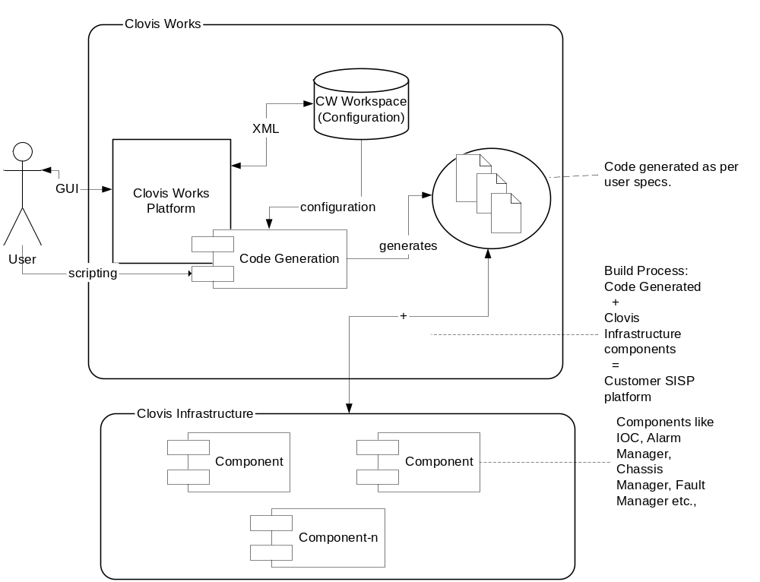
Figure 1 Clovis Works - Overview

Scope
Clovis SISP™ consists of a family of system infrastructure products being developed. Clovis’ products include:
Clovis Blade Director™
Clovis Blade Director™ (BD) is SISP for blade applications. Functionality includes provisioning, alarm processing, performance monitoring, resource management, event handling, etc.
Clovis System Director™
Clovis System Director™ (SD) is SISP for system controller applications. Functionality includes OAM&P, database, high availability, software upgrade, etc. SD is fully interoperable with BD.
Clovis Management Director™
Clovis Management Director™ (MD) is SISP for network management applications. MD is fully interoperable with SD and BD.
Clovis Works™
Clovis Works™ is a tool suite supporting usage of the Clovis Director Product family through the entire software development lifecycle.
Clovis Test Director™
Clovis Test Director™ (TD) is simulation and run-time testing environment as well as host applications for debugging, tracing, profiling user application based on Clovis BD, SD and MD.
This ERS is focused on the Clovis Works product package of the SISP. This document focuses mainly on externally visible functionality or the services visible to the user of the Clovis Works™ product. This document to be complimented with
- Clovis Works™ Architecture document - Shall brief high level modules and their functionality (architecture document shall have modules, that map to all functional requirements specified in this document)
- Clovis Works UI Flow document – Shall detail the UI look and feel and flow of information. This can be a document or a prototype
This document shall be used as reference between product marketing and product development teams. This is a live document that shall capture product roadmap and engineering requirements.

Definitions, Acronyms, and Abbreviations
ATCA Advanced TeleCommunication and Computing Architecture
BD Clovis Blade Director™
CPE Customer Premise Equipment
CW Clovis Works™
FRU Field Replaceable Unit
HAL Clovis Hardware Abstraction Layer
ISR Interrupt Service Routine
MD Clovis Management Director™
NE Network Element
NEM Networking Equipment Manufacturer
PM Performance Monitoring
RTOS Real-Time Operating System
SISP System Infrastructure Software Platform
TD Clovis Test Director™
TEM Telecommunication Equipment Manufacturer
SD Clovis System Director™
IPC Inter-Process Communication
IM Information Model
UML Unified Modeling Language
STD State Transition Diagram

Workspace - CW configuration is also referred as Workspace, where projects, users, configuration info is stored.
Project – CW Project is a grouping that indicates configuration/code info for a target SISP (Network Element)
RT - Run Time Environment, is the scenario when CW is used when the target is up and running (probably CW is used to configure the details in modules that are up and running in the target)
Target – refers to the SISP that might be running on production environment / refers to the SISP that behaves like the target (simulator)

References
Clovis Works™ Feature Specification
Clovis SISP™ Software Requirements Specification
Clovis C Coding Standard

Overview
This section provides an overview of the organization of the various sections within this document.
Section 1. Introduction.
Section 1 provides a general introduction to this document.
Section 2. Overall Description.
Section 2 provides an overview of the Clovis embedded SISP product.
Section 3. Specific Requirements.
Section 3 enumerates the software requirements.
Section 4. Supporting Information.
Section 4 contains the index and appendices.

Overall Description
The objective is to drastically reduce SISP users round trip time to design and develop SISP by introducing Clovis Works visual product packages.
Figure 2 Clovis Works shows the high level use case for such a system. From functional stand point, the use case tries to convey the user interfacing with Clovis Works to manipulate projects and modules configuration, which are captured in xml form and used by code generator to generate code. Also, the scripting interface allow user to manipulate stuff directly instead of going thru the GUI.
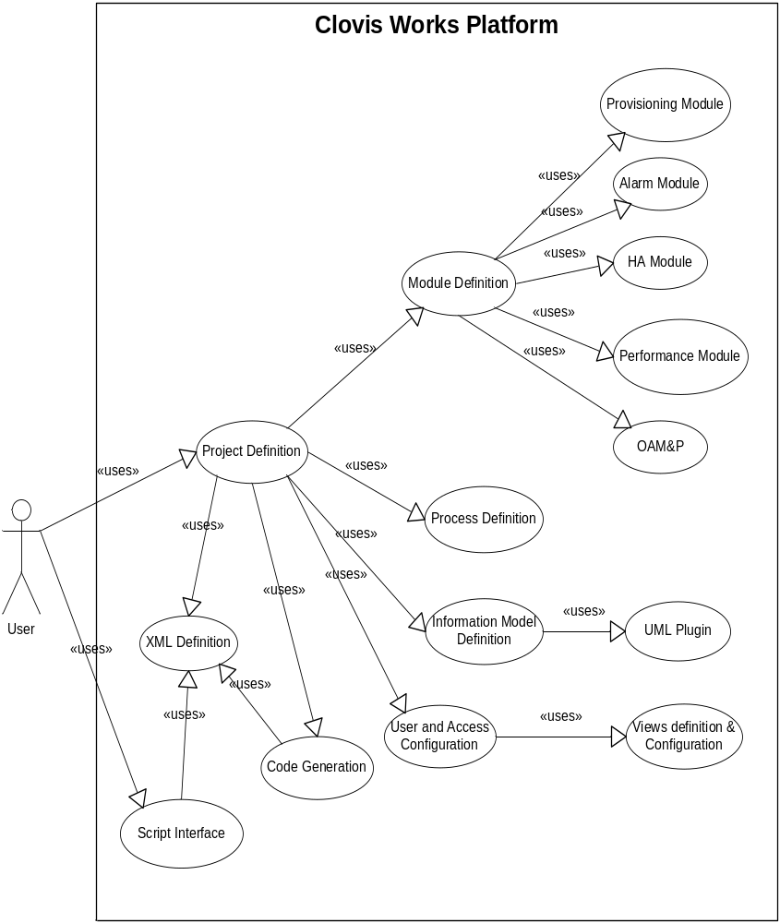
Figure 2 Clovis Works – Use case

Specific Requirements

Functionality
The following sections describe Clovis Works SISP functional requirements:
REQ # | Requirement | Description | Release
General Product Applicability

 | Shall adhere to SISP-GPA requirements | Clovis Works Shall adhere to the General Product Availability requirements specified in SISP ERS Document (SISP-GPA section) |  | All
 | Shall support CW Internal Standards | - Shall adhere to Clovis Java style guide  - Shall follow Clovis UI style guide |  | All
Code Generation Requirements

 | Shall Support code generation for SISP | Shall convert user defined model in Clovis Works to equivalent code that is compatible with current SISP release. |  | All
 | Shall allow selection of target OS | Shall support selection and configuration of target OS for which code has to be generated. Shall support list of OS’es that are supported at SISP (please refer to SISP ERS for the list of target OS supported) |  | All
 | SISP Style compliance | Code generated by Clovis Works shall be SISP Code style compliant (Refer to SISP Coding Style Guide for further details) |  | 1.0
 | Shall Support User defined copyright info | Shall support user defined copyright, header, footer configuration in the code generated |  | 1.0
 | Shall support validation of the model | Validation of model includes  - Checking basic types defined in model (allowing only types that are supported at SISP, refer to SISP PRD for the types supported)  - Checking for any stereotypes compliance, if required  - Checking for any invalid range values specified in the model  - Checking for any loop in containment relationship  - Check for current SISP compatibility (refer to SISP PRD for its release limitations and add validation) |  | 1.0
 | Shall support Makefile generation | Shall generate relevant make files for the target OS |  | 1.0
 | Shall support User defined coding style | Code generated shall follow user defined coding style (User can configure his coding style guide (and/or) select style from a list of templates) |  | Future
 | Shall support test code generation | Shall generate relevant test code associated with the model |  | Future
 | Support selective code generation | Shall allow code generation to the lowest unit (it can be a single object in the system)  Shall generate code for only the changes that have been made from the previous save), instead of full code generation (complete code generation shall be an option).  NOTE: Merging capability is NOT required for this release |  | 2.5
 | Support simulator code generation | Shall be able to generate simulator from the specs |  | Future
 | Shall support modification of code generation scripts | Shall support viewing and modification of code generation scripts  - Shall support viewing and editing the script files  - Shall support sand box of scripts, where user can test his scripts (with or without dummy data) and see the results in the output window |  | Future
 | Shall support merging edited code | Shall support regeneration of code with user edited portions re-generated as they are.  NOTE: User code changes shall be assumed to be within some tags (predefined) |  | Future

Scripting Requirements

 | Shall support scripting (for code generation) | Shall contain scripts that will interpret the information model and configuration to generate code for the customer. Along with interpreting the information model, the scripts shall allow customers to tweak the script themselves to generate code as desired by the customer.  - The script language shall support a syntax that’s close to ‘C’ syntax  - The script language shall support XML loading and accessing elements in it seamlessly  - The script language shall support template capabilities to simplify code generation |  | 1.0
Module Requirements

 | Shall support Module Selection and configuration | Shall provide customers with the ability to select modules and configure them if required (a default configuration will be supplied on selection of the module). Also, Clovis Works shall capture the dependency between modules (if selection of module A depends on module B, then module B also shall be added to the selected list).  The list of modules supported by clovis works shall depend on the list of modules supported at SISP. Please refer to SISP PRD/ERD for the list of modules supported by the release. |  | 1.0
 | Shall provide an Information Model approach for customer application specific definitions and configuration | An information model shall be developed to capture application dependent information and requirements on their infrastructure platform (application specific details/configuration). This information model shall be captured/presented using standard Information Model schemes like  - UML |  | 1.0
 | Shall support State Transition Diagram (STD) | Modules that have state management capabilities and configuration shall be captured using standard UML State Transition Diagram UI syntax.  For example: Boot Manager and Chassis Manager have state machines that co-ordinate to deliver the card boot up sequence. This info shall be captured using STD |  | 1.0
 | Shall be able to link and extend modules from existing projects | Shall allow user to link to existing modules from other projects into current project.  For example: A new Chassis project might link GigE project, T1 Project (as sub modules). On Code generation, code shall be generated for the chassis project, which includes GigE & T1 modules. |  | 2.0
 | Shall support XML as medium of persistence and interface | The entire configuration shall be accessible in the form of XML. This shall be the interface between various other modules like code generation to generate code |  | 1.0
 | Shall support extending base data structures of modules selected | For the modules that are selected in a project, the user shall be able to configure the base data structure, if present in those modules.  For example: Provisioning Manager uses baseProvMSO class as the base data structure. User shall be able to change (only extension) this data structure. |  | Future
 | Shall support extending base functionality | For the modules that are selected in a project, the user shall be able to configure the default base functions, if present.  For example: Provisioning Manager has a default set function for baseProvMSO class. This shall be edited / changed using clovis works |  | Future
 | Shall be able to copy and extend modules from existing projects | Shall allow user to copy the existing modules from other projects into current project. This imports the module to the current project and any change done becomes localized and not reflected in the original project.  Basically to support export and import functionality. |  | 2.0
 | Clovis Run-Time component shall be started separately | Clovis Run-Time Module component allows user to debug/browse/profile a running system. This module is necessary if any diagnostics/profiling to be done in the field |  | 3.0
 | Shall support object browsing | CW Run-Time component shall have run-time object browsing capability |  | 3.0
 | Shall support process configuration | In multi process environment, the list of processes and functionality in each process shall be configurable. The processes and their configuration shall be captured using UML process diagram. |  | 2.0
 | Shall support Interface definition and thereby codegeneration | Shall support RMD definition and associated codegeneration (both client side stubs and server side skeletons) |  | 2.0
 | Shall support SNMP MIB import | Shall support importing predefined SNMP MIBs onto clovis information model |  | 2.0
 |  |  |  | 2.5
User Interface Requirements

 | Shall support drill down interface | User interface shall allow user to drill down from high level artifact to low level finer details with a context sensitive interface.  For example: From card, one can drill down to see the components, on selecting a component, shall be able to see the state machine of it, from there one can select the transition, from there one can go to the code for the transition |  | 1.0
 | Shall support same look & feel throughout | Shall provide a uniform look & feel for all operations  For example: OK is to accept the changes (if this is how implemented, then all the screen have OK with same semantics) |  | 1.0
 | Shall support wizards in accepting sequence of information | Shall use wizards in accepting sequence of information to configure a complex task.  Example(s):  - Capture chassis configuration and its associated information in a wizard and thereby generate the preliminary containment tree  - Capture Chassis Manager / Boot Management state machine dependencies in a wizard and thereby generate an initial state machine for both these modules (TBD) |  | 2.0
 | Shall support context sensitive help | Support Context Sensitive help on F1 |  | 2.0
 | Shall support multiple views | Shall present information in different user views (same information can be viewed across differently. So wherever possible, multiple views as per user role shall be presented). |  | 3.0
 | Shall support visual busy indicators | Any activity that involves more than <10> seconds, shall allow the user to operate other functionalities using the visuals (or) a sandglass (busy) icon to be shown (or) a progress bar to be displayed to the user |  | 1.0
 | Shall support customer preferred view | Shall Provide a preferential view. Preferential view is defined as the view that the customer prefers to work in. Please see more information on views for the different types of views in the system.  Example: If there are multiple views to edit the chassis configuration, say System View, UML View and component View. If customer switched to UML view to edit and add information, the same view will be presented to him the next time for accessing chassis configuration. |  | 1.0
 | Shall support listing views available for a given module and switching to a different one. | Shall provide an easy to use transition from one view to another view.  Example: With the same example described in previous requirement, when the user is editing information with UML view, he can see the views available and shall be able to switch to another view (say system view) for further usage and editing. |  | 1.0
 | Shall support project life cycle phases | Clovis works project phases shall be  - Requirements/Analysis (Future)  - Design  - Build/Development  - Debug/Diagnostics/Testing (Future)  - Deployment (Future)  NOTE: Phases can also be used interchangeably with views |  | 1.0
 | Shall support design phase | For example, in design phase, provides access to define/configure information model & component configuration |  | 1.0
 | Shall support development/build phase | For example, in Development phase, user shall:  - Configure code generation properties  - Build & make capability (Capability to run make files) |  | 1.0
 | Shall support deployment phase | Deployment of binaries to the target  Shall support code generation, build (compile and link), deploy to target options from clovis works |  | 2.5
 | Shall support debug phase | Diagnostics & debug allow one to browse objects running in the system, test the components |  | 3.0
System View Requirements (2.5)

 | Shall Support Hardware View | The look and feel of defining a system using the system view shall be similar to an actual hardware look and feel. A chassis based graphical view in capturing the containment hierarchy similar to the ones used by EMS development tools like AdventNet.  A separate func requirement document shall be used to capture specific UI requirements for this module.  P.S: Refer to sample EMS (AdventNet) visual chassis development packages for similar toolkits. |  | 2.5
 | Shall support templates | System view shall provide the customer with the ability to select different objects from a pre-defined set of templates. |  | 2.5
 | Support icons to mimic hardware | The physical system view shall provide special graphical icons to define and accept customer input for the following:  Chassis Based System(s) and their elements  - Line Modules  - Network Interface Blades  - CPU Modules (System Controllers etc.)  - Sub Modules  - AMCs/PMCs etc.  - Pluggable Ports – SFP, GBIC etc.  - Pizza Box Systems  - CPEs  - Clustered Elements  - Consisting of a set of 1, 2, 3 above in any type of interconnection including  - Classic Clusters  - Grids  - Stacked Elements  - Tightly coupled Client Server Elements |  | 2.5
 | Support different icon properties | System View shall allow users to define the characteristics of their system. Such characteristics include:  - Max number of various system elements such as chassis (including Pizza boxes, CPEs etc.), Line Modules per chassis, Sub Modules per main module (example, ports per line module) etc.  - Any additional equipment relevant to SISP such as Alarm Panels, Chassis Ports, CMM modules etc.  Rules and Constraints – ability to tie in certain elements with certain other types of elements. Example: Chassis Management Modules can only go in specific slots in ATCA. |  | 2.5
 | Shall Support Other views for specific information | Any definitions that cannot be captured by the system view should have an easy to use transition (i.e. menu item/right mouse click) to another specific view. |  | 2.5
 | Support sub-module configuration | System View shall provide the ability for customers to define the detailed system information for modules and sub-modules such as:  - Line Modules  - Type of Line Module  - CPU  - Network Processing/ASIC processing  - Switch Fabric Module  - Characteristics of the Line Module  - Number and type of ports  - Number and type of sub-modules  - Number and type of LEDs |  | 2.5
 | Shall support dependency between modules and sub-modules (used for selection) | System View shall provide the ability for customers to select various components on each of the line modules and sub-modules. Such component definition will be based on the type of the line module. For example, on a certain type of line module, the customer should be able to right mouse click and select the components that need to be run as part of the line module. |  | 2.5
 | Shall support State machine definition | Ability to define State Machine Logic  - CW should provide a way in which state machine diagrams can be created.  Any input required for state transitions such as events should be accepted into CW and a mechanism must be provided to map an event generated by the hardware to the state machine logic. |  | 2.5
UML View Requirements

 | Support for standard UML notation | Clovis Information Model shall be captured using standard UML notations (a subset can be used and documented) |  | 1.0
 | Shall support Class Association Diagram for Information Model | - Supports Classes (Name, Attributes, Methods)  - Supports Inheritance  - Support Association  - Supports Aggregation  - Supports basic data types like uint8, uint16, uint32, uint64, int8, int16, int32, int64, float  - Supports arrays  - Supports Enums  - Supports initialization of attributes |  | 1.0
 | Shall support UML State transition Diagram | - Supports State  - Supports Composite States  - Supports Transitions  - Supports Event Definition |  | 1.0
 | Processes shall be captured using process / component diagram | In case of multi-process environment, multi process configuration shall be captured using UML component diagram that:  - Supports Components  - Supports Grouping components  - Supports naming |  | 2.0
 | Shall support importing rational rose models | Shall support import of rational rose model and petal (MDL/PTL) files |  | 2.0
 | Shall support importing XMI models | Shall support importing XMI models  XMI is OMG standard for storing UML models in XML format |  | 2.0
Component View Requirements (Future)

 | Shall support component view | The component view shall consist of various representative samples of objects being created within the system. The objects shall be defined by the customer with essential object properties being captured by the system. Such object properties include but are not limited to:  - Physical/Logical Object representing all entities in the system view  - Object properties  - Object associations including containment and inheritances  - Object Relationships including maximum number of supported instances |  | Future
 | Shall support templates | Ability to select from a pre-defined set of templates |  | Future
Workspace Requirements

 | Shall support project based development environment | Shall allow users to define their own workspaces, projects and allow users to create projects, open them, close them, save the modules in it as a single project entity |  | 1.0
 | Shall support automatic backup feature | Shall support auto backup feature, so in case of corruption the backup file can be used for recovery.  On save, a backup copy is created and saved before overriding the current project file. |  | 2.0
 | Projects shall contain users, roles and access configuration | Shall allow defining users, the roles including architect, developer, tester and thereby defining access to information |  | Future
 | Shall support integration to configuration management system | Shall be able to support popular configuration management systems like CVS/Clearcase/PVCS/CMVC etc., |  | Future
Misc Requirements

 | Shall support IDE (Integrated Development Environment) | Shall be a single unified platform that have all the functionalities integrated and everything is accessible from a single launch environment. |  | 1.0
 | Shall support windows & Linux | - Shall be able to install and launch Clovis Works on platforms with <256-MB> RAM  - Platform is either Linux or Windows XP |  | 1.0
 | Shall support build and release info | All the CW modules/plug-ins released shall display its build and release no |  | 1.0
 | Support splash image | Shall display splash image clearly mentioning company, copyrights, module info(module names with with version no) |  | 1.0
 | Shall support Java 1.4 | Shall be able to run above Java 1.4 JVMs |  | 1.0
 | Shall support printing | Shall support printing of the information presented in different views (graphical/text) |  | 2.0
 | Shall publish schema for XML interface | All the configuration and software interfaces shall be standard xml interface. The xml interface shall be clearly defined using XML schema |  | All
 | Shall support online user guide | Shall support context sensitive help  Shall have html help available with user guide accessible in electronic format from Clovis works (online, context sensitive) |  | 2.0
 | Shall include Chip-director functionality | Shall also capture information related to devices (IO) – so that it’s used for code generation (device driver). Need to capture more information/requirements on this . |  | Future
 | Support internationalization | Shall be able to display interfaces in any selected language  To support English (En) for release 2.0 |  | 2.0
 | Support online upgrades | Shall allow users to upgrade to latest Clovis Works online |  | 3.0
 | Support version compatibility | Shall allow users to import / export Clovis Works project definition at-least one release below (for compatibility)  If product release is 1.1, it will allow import/export project definitions in release 1.0. |  | 2.0
 | Support resource usage view | Shall provide a view to display resource usage |  | Future
 | Shall integrate knowledge base query | Shall allow developers to use knowledge base directly from the platform (based on subscription) |  | Future
 | Shall support one click support | Shall have interface directly to capture the system state information and pass it to the technical support group (one click menu option) |  | Future
 | Shall have tutorials integrated | Shall have demo / tutorials of clovis works integrated with help system |  | 2.0
 | Shall support functionality to view log | Clovis Works shall allow user to view the logs generated by the tool |  | 2.0
 | Shall support license validation | Clovis Works shall contact Clovis License Manager to check for validity in using the product.  On startup, the License Key is validated for its correctness and its expiry date.  Parameters of licensing include modules purchased, number of users, number of times code generated used, number of projects created etc., |  | Future
 | Shall support floating licenses | Clovis License Manager Module shall support Floating Licenses.  Floating license (At any given instance only specified number of users can operate Clovis Works) |  | Future
 | Shall support one click license up gradation | Clovis Works shall have one click license upgrade features |  | Future
 | Clovis License Manager Module shall support Host Based License Management and Trial/Demo license | Host/VolumeId based license (The license is tied to host and/or volume id of hard disk on which the product is installed) and Floating license (At any given instance only specified number of users can operate Clovis Works) |  | Future
 | Shall support packaging relevant modules | Shall support packaging and releasing only relevant modules specified in the build |  | Future
 | Shall include documenting capabilities. | Modules allow user to add documentation at each phase and then shall generate necessary documentation of the product right within CW |  | Future
 | Shall generate PDF documents | The documents that are generated shall be in adobe PDF format |  | Future
 | Clovis Works shall be extended by vendors | CW shall have well defined extension points, so different vendors can extend it with their own specific extensions |  | Future
 | Shall access the module and tune its configuration in run-time (This shall be our Clovis Run-Time Director) | For the modules that are selected in a project, there shall be a run-time view, where user can view configuration from those modules and can configure them. |  | Future
 | Inter process communications shall be captured using time line diagram / event trace diagram | Inter process communication among various modules/processes shall be captured using sequence diagram. Any dynamic time bound sequence of activity, for example, sequence of messages between provisioning manager of the primary card to the redundant card during a switchover is a good candidate that can be seen in a sequence diagram. NOTE: Also intra chassis communication to be covered if its different from inter-process communication. |  | Future
 | Shall support Component Specification and Code generation | Support for development by means of capturing component API, documentation via wizards and thereby generating appropriate  - API code  - Documentation  - Test Code |  | Future

Standards
The following is a list of the standards being referred in this PRD:

OMG UML (www.omg.org) specification
Eclipse (www.eclipse.org) specifications and plugin information

