Engineering design document for Auto arrange support in OpenClovis IDE
Revision No. | Revision Date | Revision note | Author
1 | 9/15/2006 |  | Pushparaj

Table of Contents

Engineering design document for Auto arrange support in OpenClovis IDE 1
Table of Contents 1
Purpose 2
Scope 2
Intended audience 2
Problem statement 2
Solution overview 2
Class diagrams: 4
Class detail: 4

Purpose
The purpose of this document is to describe the design details auto arrange support in editors.

Scope
This document refers only to the design details of the proposed solution. It does not cover any implementation details.

Intended audience
This document is intended for developers, architects and testers for the OpenClovis IDE product as well as those developing third party applications based on the IDE.

Problem statement
The Editors in OpenClovis IDE should support scalable views of the class models to improve usability in case of the user creating a large model.

Solution overview
Solution for this problem is to provide support for the following:

Auto-arrange:
- Line-up all nodes: All nodes will be arranged row by row. position for each node will be decided based on the parent position. For example, if parent node is placed in first row the child will be placed in the second row.
- Rearranging all connections: Connections points for all edges will be rearranged based on the location of source and target nodes.
- Collapse and Expand hierarchical objects (nodes and edges) in the editors.
- Automatically arranging all editor objects.

Collapse / Expand of nodes in editor view:

Editor will have menu option for Collapse and Expand. Collapse action will hide all childs those have hierarchical relationship from the selected node. Expand action will unhide all hidden nodes.

For creating complex model user have to follow three steps:

1.Using Collapse action user can create large number of boxes(nodes) and relationship arrows(edges) in the viewable editor area.
2. Using Expand action user can unhide all the hidden objects. Mostly editor will be cluttered after Expand.
3. Using Auto arrange action user can automatically arrange all the nodes and edges.

Class diagrams

The class diagrams for auto-arrange and expand/collapses functionality are given below.

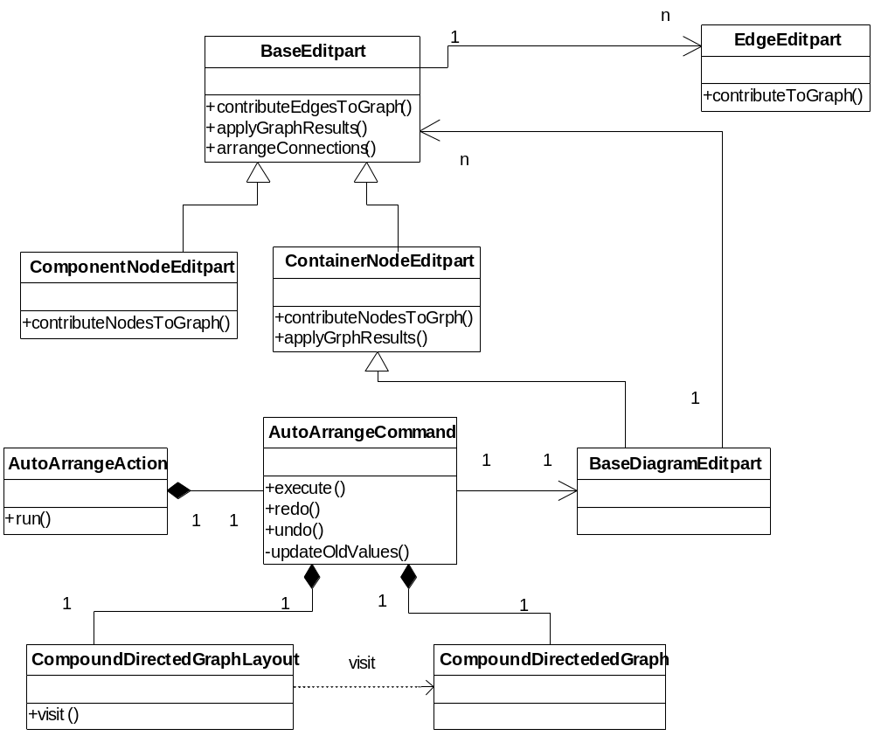
Class diagram for Auto-arrange

GEAutoArrangeAction: Menu action for auto arrange. This menu is enabled based on the selection in the editor.
- run() : This method creates instance of CollapseCommand with root editpart(instance of BaseDiagramEditPart) as a argument and executes the command.

AutoArrangeCommand: Command for automatically arranging all the nodes and edges in the editor.
- execute() : This method calls redo() method.
- redo() : This method creates instance for CompoundDirectedGraph and call the methods which are adding all nodes and edges in to the graph.
Then it passes graph instance to graph layout, which will position all of the nodes in that graph.
Then new positions will be applied for all nodes.
Then it calls the method in root editpart, which will arrange all connections.
- undo() : This method calls updateOldValues() method.
- updateOldValues() : This method sets the old values for all UI properties like location, size and connection points.

CompoundDirectedGraph: A graph consisting of nodes and edges. This graph serves as the input to a graph layout.

CompoundDirectedGraphLayout: A layout which will position all nodes.

BaseDiagramEditpart: Root editpart. This is the container editpart for all other editparts.

ContainerNodeEditpart: Base class for all container editparts.
- contributeNodesToGraph(): This is the starting point for adding all nodes to
the graph. This method adds the node to the graph and calls the same method in each child editparts.
- applyGraphResults(): This method calls the same method in child editparts.

ComponentNodeEditpart: Base class for all component editparts.
- contributeNodesToGraph(): This method adds the node to the graph.

BaseEditpart: Base class for all editparts(both component and container).
- contributeEdgesToGraph(): This is the starting point for adding all edges into graph. This method adds all outgoing connections to the graph and calls the same method in child editparts.
- applyGraphResults(): This method sets the new location for node.
- arrangeConnections(): This method rearrange all connections based on source and target position and calls the same method in child editparts.

EdgeEditpart: Base class for all connection editparts.
  - ContributeToGraph(): This method adds the edge to the graph.

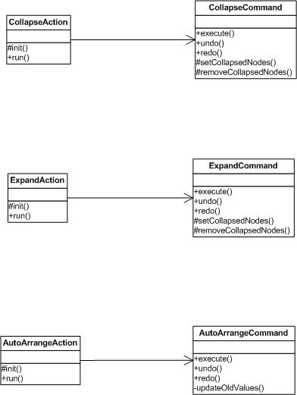

Class diagram for Expand/Collapse

GECollapseAction: Menu action for collapse. This menu is enabled based on the selection in the editor.
- run() : This method is getting called when user select any top level node(which have hierarchical child nodes) and select 'collapse' menu in the editor. This method creates instance for CollapseCommand with selected node editpart as the argument and calls execute() method.

CollapseCommand: Command for hiding nodes.
- execute() : This method calls the redo() method.
- redo() : This method calls setCollapsedNodes() method with source connections list as the argument.
- setCollapsedNodes() (base class): Using source connections list, this method disable all the child editparts(both nodes and edges).
- undo() : This method calls removeCollapsedNodes() method with source connections list as the argument.
- removeCollapsedNodes() (base class): Using source connections list, this method enables all the child editparts(both nodes and edges which are hidden).

GEExpandAction: Menu action for expand. This menu is enabled based on the selection in the editor.
- run() : This method is getting called when user select some collapsed node and select 'expand' menu in the editor. This method creates instance for ExpandCommand with selected node editpart as the argument and calls execute() method.

ExpandCommand: Command for unhide all hidden nodes.
- execute() : This method calls the redo() method.
- redo() : This method calls removeCollapsedNodes() method with source connections list as the argument.
- removeCollapsedNodes() (base class) : Using source connections list, this method enables all the child editparts(both nodes and edges which are hidden).
- undo() : This method calls setCollapsedNodes() method with source connections list as the argument.
- setCollapsedNodes() (base class): Using source connections list, this method disable all the child editparts(both nodes and edges).

GEAutoArrangeAction: Menu action for auto arrange. This menu is enabled based on the selection in the editor.
- run() : This method creates and execute a command for Collapse. This method is called based on the user event.

AutoArrangeCommand: Command for automatically arranging all the nodes and edges in the editor.
execute() : This method calls redo() method.
redo() : This method calls appropriate methods in the editparts which actually contains the algorithm for automatically arranging editparts.
undo() : This method calls updateOldValues() method.
updateOldValues() : This method sets the old values for all UI properties like location, size and connection points.

