Engineering design document for

Revision No. | Revision Date | Revision note | Author
0.1 | 18/08/2006 |  | Suraj Rajyaguru

Table of Contents

Purpose

The purpose of this document is to describe the design for solving the need of a new tool - Log Display Utility for displaying and manipulating the log records generated by ASP logging system and the modeling facility for the same. This document only states the design considerations for parsing and displaying the log records to the user with this tool.

Scope

This document refers only to the design details of the proposed solution. It does not cover any implementation details.

Intended audience

This document is intended for developers, architects and testers for the OpenClovis IDE product as well as those developing third party applications based on the IDE.

Problem statement

There is a requirement for a new tool to display and manipulate the log records generated by the ASP logging system. The tool should be able to display the log records in user readable form and provide the facility for filtering, searching and sorting to end user. It should also be able to model the details required by the ASP logging system and other configuration details.

Solution overview

The Log Display Utility will take care of reading the records generated by the ASP logging system, group them if required i.e. apply the filter, search or sort criteria, parse them as per the structure defined and display the records to the end user in user readable format in this sequence only.

The components in the solution are Stream, Record Factory, Record Parser, Message Formatter, UI, Record Manager and Utils. Here is a brief description of each of them in the sequence of their operations.

1] Stream:
Stream is responsible for providing the wrapper over the underlying source of data. It provides the methods to open it, read data from it and close it

2] Record Factory:
Record Factory will provide the support for reading a single record or a batch of records from the associated Stream. It in turn wraps the underlying Stream for getting the data as a record in the form of byte sequence. It also provides support to change the Stream associated with it.

3] Record Parser:
Record Parser is responsible for parsing the record from the byte sequence into the defined structure. It also provides support for both single record parsing and the parsing of record batch.

4] Message Formatter:
Message Formatter is responsible for formatting the message into user readable format with the help of corresponding message for that message id and the data i.e. passed as a part of the record.

5] UI:
UI is responsible for showing the records to the end user and it also supports the modeling for the ASP logging system. It co-ordinates all other components in order to perform the record displaying task.

6] Record Manager:
Provides interface between the UI and the backend. It manages factory, stream, parser and filter to provide UI with records to display.

7] Utils:
Utils will contain the supported operations required for the Log Display Utility; those are not part of any particular component and the constants for the same.

Class diagram

Figure A – Class Diagram for Log Display Utility.
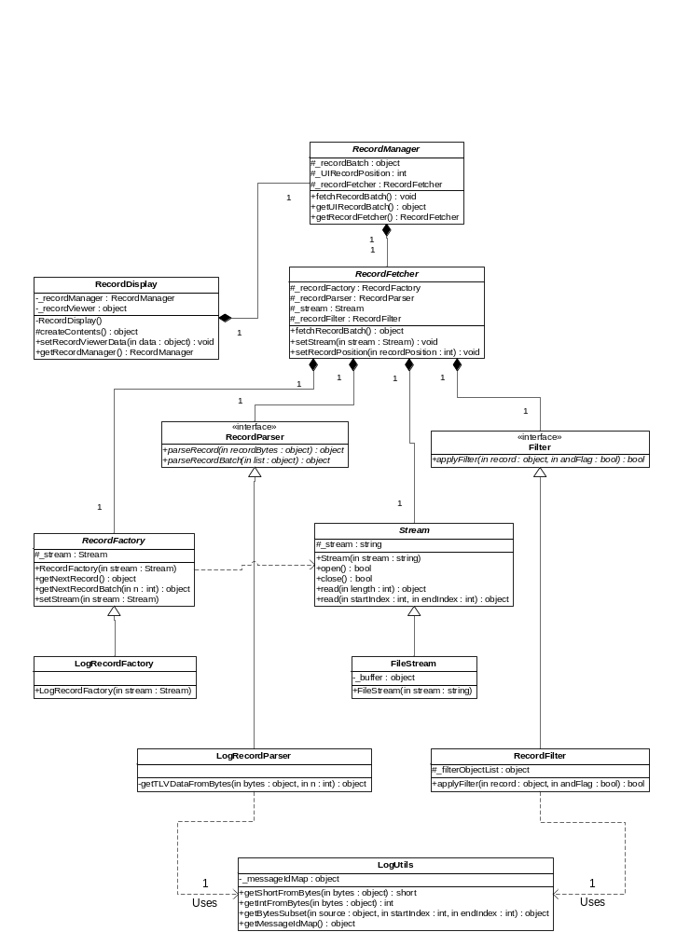

Major classes which contribute to the solution along with important methods and their description are listed below,

1] Stream: Abstract implementation for the stream which is the source for data.

- open(): Opens the stream. It takes care for creating the stream as well as allocating the other resources like creating the buffer for faster access of data from the source.
- close(): De-allocates all the resources like buffer associated with the stream. It assumes that the stream resources are not now required means stream is to be closed.
- read(byte[] bytes): Reads the number of bytes equal to the length of the bytes array from the stream starting at the current position for the stream.
- read(int index, byte[] bytes): Reads the number of bytes equal to the length of the bytes array from the stream starting at the index position for the stream.
- setPosition(int position): Allows to set the current position for the stream.

2] RecordFactory: Abstract implementation of the Record Factory to create the records.

- getNextRecord(): Reads a single record from the associated stream.
- getNextRecordBatch(int n): Reads n number of records from the associated stream.
- setStream(): Associates the given stream with this record factory.
- setRecordPosition(int position): Allows to set the current record position for the factory. This in turns sets the corresponding stream's position.

3] RecordParser: Abstract implementation for record parsing. It will parse a record and its header as specified per format.

- parseRecord(): Parses the record from the given byte sequence.
- parseRecordBatch(): Parses the batch of record from the given list of record in the byte sequence format.

4] Formatter: Formats the log message for the given log record.

- format() : Formats the log message for the given log record by combining it with the message format and data part for TLV type record. For ASCII and binary it just gives the String equivalent of the same.

5] RecordDisplay: UI for record display and manipulation.

- createContents() : Creates the controls for the UI and the log viewer object.
- setRecordViewerData() : Sets the input data for the log viewer.

6] RecordManager: Abstract implementation which specifies the behaviour for managing the records.

- getUIRecordBatch () : Returns the list of record for UI to show in response to the user action.
- fetchRecordBatch() : Fetches the record batch from the Stream.

7] LogUtils : Contains the supported operations for Log Display Utility.

- getShortFromBytes() : Parses the short value from the given byte sequence.
- getIntFromBytes() : Parses the int value from the given byte sequence.
- getBytesSubset() : Returns the required byte subset from the given byte sequence as per the range specified with startIndex and endIndex.
- getMessageIdMap() : Returns the message id and message format map.

Sequence diagram

Figure B – Sequence Diagram for Log Display Utility.

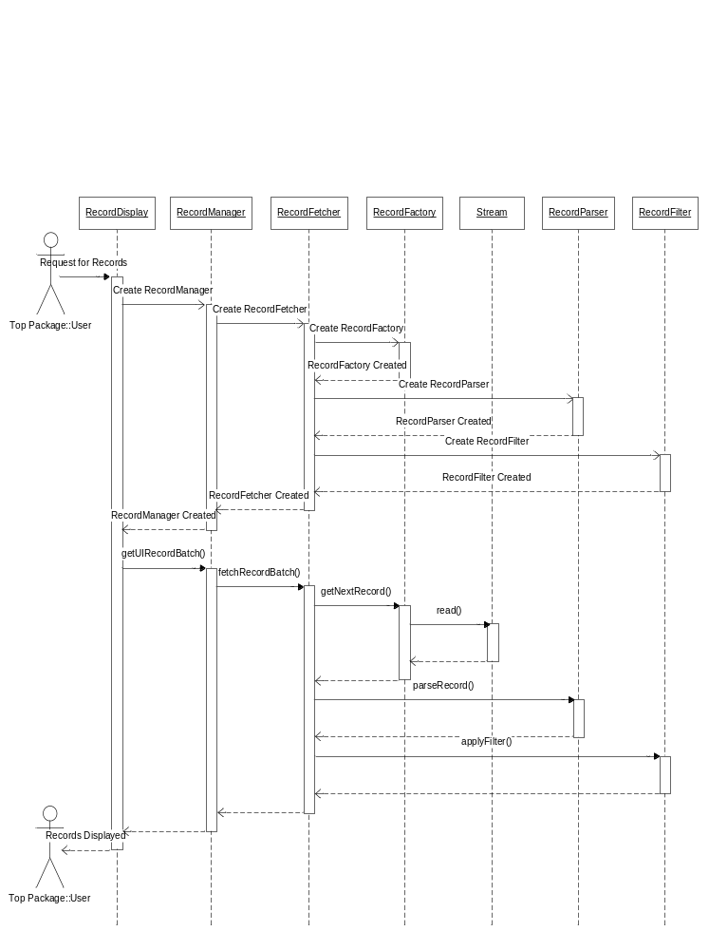

Known Limitations/Issues
Log Display Utility is in its initial design state and it requires many details from ASP logging system which are not yet finalized.
Filtering, searching and sorting of records will be provided by calling the APIs for the same from Record Factory while reading a record or record batch.
Modeling support for the ASP logging system will be provided as part of the UI component.

