Engineering design document for

Project Migration to new IDE version

Revision No. | Revision Date | Revision note | Author

Table of Contents
- PURPOSE…………………………………………………2
- SCOPE…………………………………………………….2
- INTENDED AUDIENCE………………………………....2
- PROBLEM STATEMENT……………………………….2
- SOLUTION OVERVIEW………………………………...2
- CLASS DETAILS…………………………………………4
- CLASS DIAGRAM………………………………………..5
- SEQUENCE DIAGRAM………………………………….6

Purpose

The purpose of this document is to describe the design for solving the problem of migrating the old projects to the new OpenClovis IDE version. Old projects become obsolete as the IDE comes with new versions. Automatic Migration support plays a key role in order to prevent the user from repeating all the effort of modeling again.

Scope

This document refers only to the design details of the migration feature. It does not cover any implementation details.

Intended audience

This document is intended for developers, architects and testers for the OpenClovis IDE product as well as those developing third party applications based on the IDE.

Problem statement

The models which have been created in the older versions of IDE may not be usable without any changes in the newer versions of the IDE. Recreating the model all over again is a painful work which will not entertain the users. There are chances that users will miss some part of the configuration while redoing the work. This will result in wasting the effort of modeling in old release.

Solution overview

Proposed Solution to this problem is to convert all the configuration data in the old model to a format which is acceptable to the new version of the IDE. The solution should meet following requirements
Keeping track of what data is being changed over the releases.(i.e Addition/Deletion/Modification of the schema)
Should be able to migrate the project(s) over multiple intermediate releases to the latest release.
Migration report should be displayed to the user. If migration is not successful due to any errors, the cause of the error and possible ways to correct it should be mentioned.

and it should cover all other requirements specified in migration requirements document.
Given below is the description of the components with the functionality and their interaction with other components.

- MigrationUtils Component: This component does the utility functions like checking the validity of the user entered data, taking backup of the files to be migrated and writing the migration results to the log file. This component will interact with User Interface code.
- ChangeInformationParser Component: This component takes the source and destination versions as input and reads the recorded changes in each schema for each xml/xmi file between the given source and destination releases. This component interacts with the MigrationManager component.
- MigrationManager Component: This component mainly carries out the converting old resource data to a format acceptable by changed schema in the destination release. It also copies the resource to the new location in case of location change between releases.

Flow diagram of the migration activity is shown below.

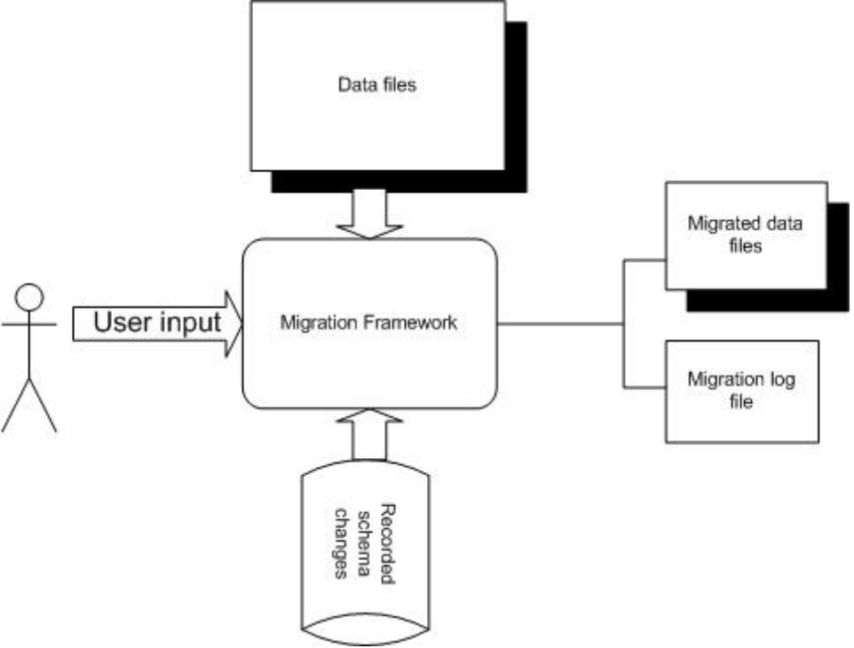
Figure 1. Flow diagram

Class details:
Functionality of each class and its important methods are detailed below;
- MigrationInfoReader Class: This class reads the pre-recorded schema changes between the releases specified by the user.
- MigrationUtils Class: This class does the utility functions like validations, taking the backup, writing problems to log etc. Main methods include:
  - isVersionValid() method: This method checks the source and destination release number validity. There might be cases where a particular version of IDE does not support migration.
  - createBackupFiles() method: This method creates the backup of the files in the following relative path:
<eclipse installation loc>/Backup_Projects
Here <eclipse installation loc> refers to the complete path where user has installed eclipse.
  - writeProblemsToLog() method: This method writes the migration result to the file.
- Migration Manager Class: This class does the work of actual data conversion from old format to new format. Main methods include:
  - callSpecificHandler() method: This method calls the specific handler (if any) specified in the annotation. Specific handlers should be used if generic migration framework won’t be able to migrate the data files.
  - readFilesAndUpdate() method: This method does the actual conversion of data from one format to another. It delegates the actual copy work to ResourceCopyHandler class.
  - readEcoreFile() method: This method reads the old and new ecore files and returns the corresponding EPackage.
  - getResource() method: This method reads the old resource and creates the new resource. It returns the read/created resource.
  - deleteResource() method: This method deletes the old resource in case where the resource location is changed between the releases.
  - copyToNewResource() method: This method maps all the objects from old resource and their corresponding objects in the new resource and delegates the object copy work to ResourceCopyHandler.

- ResourceCopyHandler Class: This class will mainly handle the object copy work.
  - copySimpleValue() method: This method copies the values of simple features of source object to destination object.
  - copyReferencedFeatures() method: This method copies the values of complex features of source object to destination object.

Class diagram
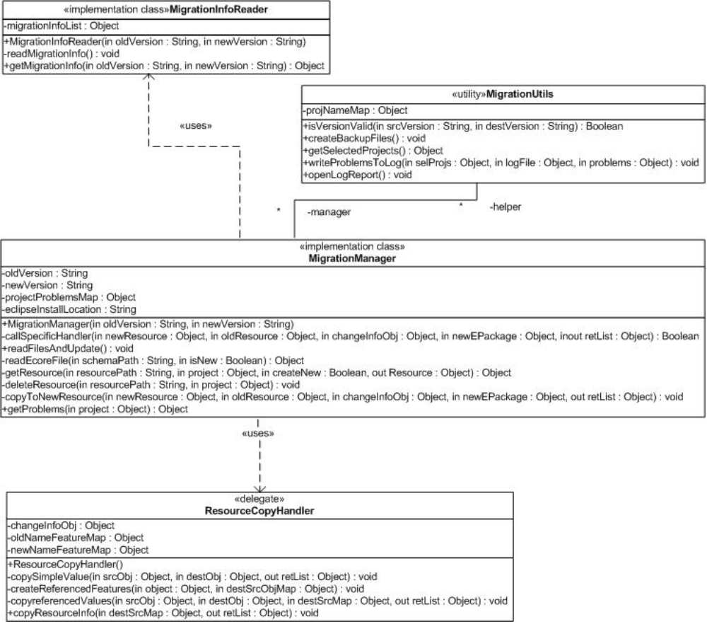

Figure 2. Migration Framework Class Diagram

Sequence diagram
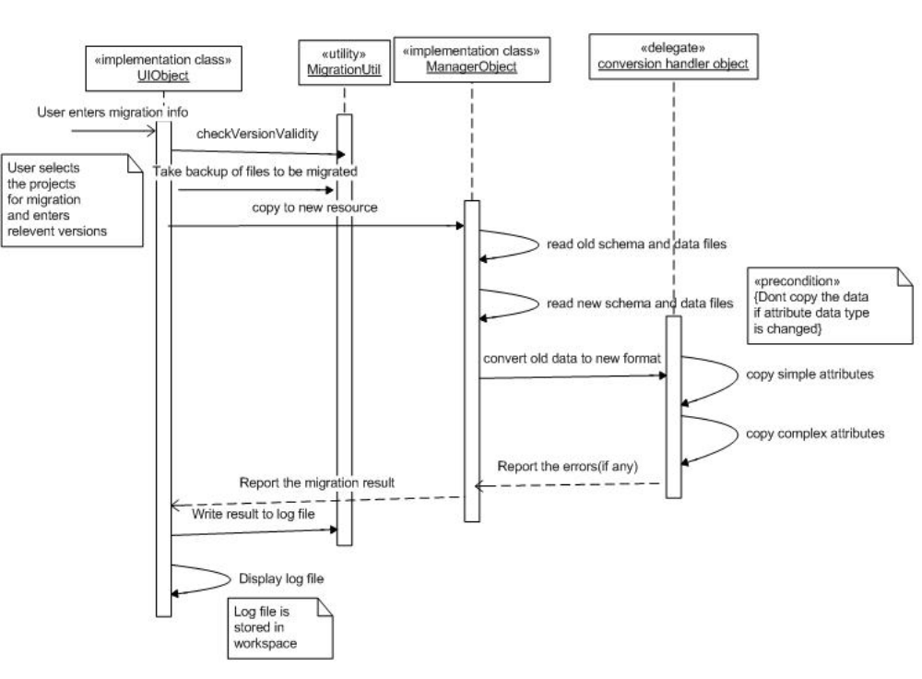
Figure 3. Migration Sequence Diagram

