Prior to this, install Eclipse. (http://www.eclipse.org/downloads/) Use any Java package installation.

1. Install ADT (Android Development Tools) plugin for Eclipse

(http://developer.android.com/sdk/eclipse-adt.html#installing)

This requires installation of the Android SDK package first.

The basic package is available here: http://developer.android.com/sdk/index.html

Next, individual SDK components can be added. We specifically need SDK Platform Android 2.2, API 8.

Run as Admin SDK Manager.exe which is found at the root of the installation folder for the SDK package.

A checklist with the heading "Choose Packages to install" pops up. Press cancel, since there is no Uncheck all option and we only want one specific API.

Check the Android 2.2 (API8) box.

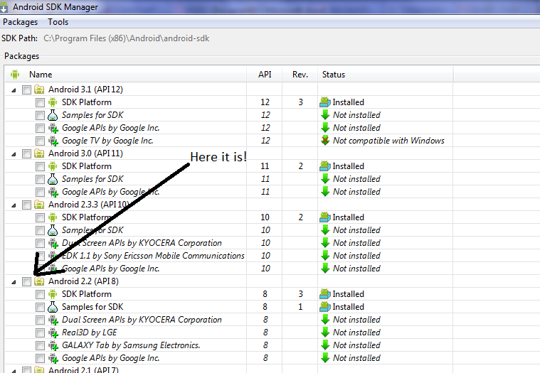 Install the package. Later on, other SDK platforms can be installed in similar ways.

Next, install Android ADT for Eclipse. Follow the heading "Downloading the ADP Plugin" on this link http://developer.android.com/sdk/eclipse-adt.html

2. Import project into workspace

In Eclipse, under File > Import, select Import Source under "General" > "Existing Projects into Workspace"

Root Directory should be the directory of a build (Eg. OpenComm_CommonLispDylan folder). Press Finish.

3a. To test project on Android phone

Enable developer mode on phone (Menu > Settings > Applications > Development, then check "USB debugging"

Plug in phone to computer with USB.

On Eclipse, go to the Project Explorer. (If not found, it is under Window > Show View > Project Explorer)

Find the imported project, and right click > Run As > Android Application.

The application should be automatically installed onto the phone for testing. (See log below)

[2011-11-06 12:57:44 - OpenComm_CommonLispDylan] ------------------------------

[2011-11-06 12:57:44 - OpenComm_CommonLispDylan] Android Launch!

[2011-11-06 12:57:44 - OpenComm_CommonLispDylan] adb is running normally.

[2011-11-06 12:57:44 - OpenComm_CommonLispDylan] Performing edu.cornell.opencomm.controller.Login activity launch

[2011-11-06 12:57:44 - OpenComm_CommonLispDylan] Automatic Target Mode: using device 'TA2070I3O3'

[2011-11-06 12:57:44 - OpenComm_CommonLispDylan] Uploading OpenComm_CommonLispDylan.apk onto device 'TA2070I3O3'

[2011-11-06 12:57:44 - OpenComm_CommonLispDylan] Installing OpenComm_CommonLispDylan.apk...

[2011-11-06 12:57:47 - OpenComm_CommonLispDylan] Success!

[2011-11-06 12:57:47 - OpenComm_CommonLispDylan] Starting activity edu.cornell.opencomm.controller.Login on device TA2070I3O3

[2011-11-06 12:57:47 - OpenComm_CommonLispDylan] ActivityManager: Starting: Intent { act=android.intent.action.MAIN cat=[android.intent.category.LAUNCHER] cmp=edu.cornell.opencomm/.controller.Login }

3b. To test application on emulator:

Note: The phone has to be unplugged prior to this.

On Eclipse, go to Window > AVD Manager

Click New... and create a new Android Virtual Machine with the target of Android 2.2 - API Level 8

SD Card size can be 32MiB. The rest of setting can be the default. The resolution depends on the build. I believe our final goal is for the application to be able to ran on any resolution supported by the API. But some common ones are HVGA (480x320) and WVGA(800x480). I think some older builds are 480x320, but opening a build only supporting 480x320 on a bigger resolution virtual machine works. The app will just be squished into the top left corner.

Then, go to the Project Explorer. (If not found, it is under Window > Show View > Project Explorer)

Find the imported project, and right click > Run As > Android Application and select the appropriate emulator.

Console log should say:

[2011-11-06 13:31:52 - OpenComm_CommonLispDylan] ------------------------------

[2011-11-06 13:31:52 - OpenComm_CommonLispDylan] Android Launch!

[2011-11-06 13:31:52 - OpenComm_CommonLispDylan] adb is running normally.

[2011-11-06 13:31:52 - OpenComm_CommonLispDylan] Performing edu.cornell.opencomm.controller.Login activity launch

[2011-11-06 13:31:52 - OpenComm_CommonLispDylan] Automatic Target Mode: using existing emulator 'emulator-5554' running compatible AVD 'Chris'

[2011-11-06 13:31:52 - OpenComm_CommonLispDylan] Uploading OpenComm_CommonLispDylan.apk onto device 'emulator-5554'

[2011-11-06 13:31:53 - OpenComm_CommonLispDylan] Installing OpenComm_CommonLispDylan.apk...

[2011-11-06 13:31:59 - OpenComm_CommonLispDylan] Success!

[2011-11-06 13:31:59 - OpenComm_CommonLispDylan] Starting activity edu.cornell.opencomm.controller.Login on device emulator-5554

[2011-11-06 13:32:00 - OpenComm_CommonLispDylan] ActivityManager: Starting: Intent { act=android.intent.action.MAIN cat=[android.intent.category.LAUNCHER] cmp=edu.cornell.opencomm/.controller.Login }