**Design Specifications**

This cycle will include the design for a persistent action bar and a notification log. This spec details what will be included in the action bar for each screen.

Action bar:

* At the top with the title of the screen, action items specific to the screen, and an overflow icon
* Back button on very left (for all screens aside from main) takes you to the previous screen
* 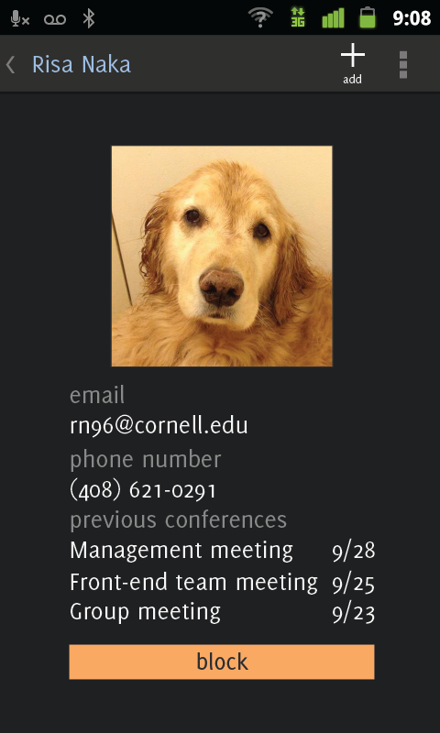Overflow includes screens you aren't in (if you looking at your contact list, the overflow items will be account and contacts)

New contact card screen

Main screen:

* Menu buttons for conferences, contacts, and account
* Take out create conference button
* Title on action bar: ‘OpenComm’
* Action bar items:
  + Notifications
* The notification icon will include a number to indicate new notifications since the user last opened the app (similar to Facebook)
* Pressing notifications will take user to a new list of notifications

Notifications:

* There will be a list of notifications that the user will get pertaining to conferences, which could include:
  + An invitation for a conference
  + When a conference starts
  + A change in a scheduled conference
  + If you are the creator/moderator of a conference and someone has accepted the conference invitation
* If you press on any item in the list, it will take you to the relevant conference card
  + If the notification is for a conference starting, you will be taken directly to the conference itself
* Title on action bar: ‘notifications’
* Action bar item:
  + Overflow: accounts, contacts
* Aside from this notification screen, users will receive push notifications on their phone for a conference 15 minutes before it starts and for any of the events specified above

Conference list:

* Same layout and ordering
* Info in each list item:
  + Icon of moderator/creator
  + Conference title
  + Start date & time
* Title on action bar: 'conferences'
* Action bar items:
  + Add conference
  + Notifications
  + Overflow: account, contacts
* Pressing add conference will bring a drop down menu with options 'start now' and 'schedule conference'

Conference card:

* Title on action bar: title of conference
* Action bar items:
  + edit (only if you are the creator/moderator of the conference)
  + overflow: account, contacts

Contact list:

* Title on action bar: 'contacts'
* Action bar items:
  + Add
  + search
  + overflow: conferences, account
* clicking on add or search will bring up the same interface (but each will have different functionalities)

Contact search/add:

* title on action bar: either search contacts or add contacts
* Action bar item:
  + overflow: conferences, account
* when you add you can search through registered accounts not in the contact list, people in your email contact list, or manually enter an email addres
* when you search you only see people already in your contact list

Contact card:

* title on action bar: name of contact
* action bar items:
  + add (only if the user selected add in the previous activity)
  + overflow: conferences, account
* After user selects add, icon on action bar will change to a check and text will change from add to added

Account:

* title on action bar: my account
* action bar items:
  + edit
  + overflow: conferences, contacts
* The default screen is the regular view of the user's account information, but once the user clicks edit name, password, photo, and title fields become editable