**Design Specifications**

This cycle will include the design for a persistent action bar and a notification log. This spec details what will be included in the action bar for each screen.

Action bar:

* At the top with the title of the screen, action items specific to the screen, and an overflow icon
* Back button on very left (for all screens aside from main) takes you to the screen that is hierarchically above it
* Overflow includes screens you aren't in (if you looking at your contact list, the overflow items will be account and contacts)
* If the screen size changes:
  + Action bar should still stay at the top of the page
  + Height can change
  + Text and icons should still be vertically centered
  + Title/back button should be left justified, overflow and page-specific icons should be right justified (same space kept between edge of screen and icons)
  + Space between icons should be kept the same

App Hierarchy:

Dashboard:

* Menu buttons for next conference, conference list, contacts, and account
* Title on action bar: ‘OpenComm’
* Action bar items:
  + Notifications
* The notification icon will include a number to indicate new notifications since the user last opened the app (similar to Facebook)
* Pressing notifications will take user to a new list of notifications
* ‘Conference info’ button should take user to the conference card of a conference that is either currently going on or a conference that will occur next
* If the screen size changes:
  + Content should be centered and the space between all icons and text should be the same

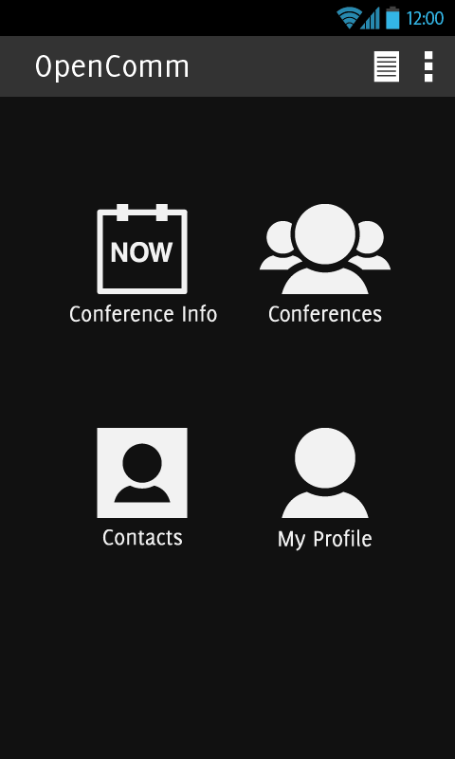

Figure 1. Dashboard

Notifications:

* There will be a list of notifications that the user will get pertaining to conferences, which could include:
  + An invitation for a conference
  + When a conference starts
  + A change in a scheduled conference
  + If you are the creator/moderator of a conference and someone has accepted the conference invitation
* 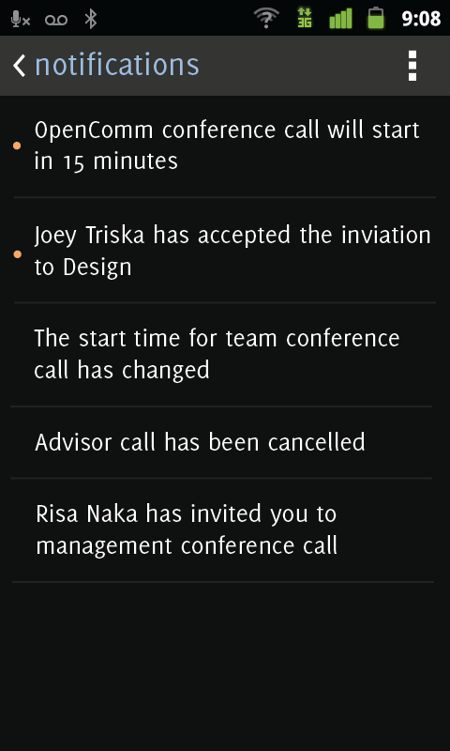If you press on any item in the list, it will take you to the relevant conference card
  + If the notification is for a conference starting, you will be taken directly to the conference itself
* Title on action bar: ‘notifications’
* Action bar item:
  + Overflow: accounts, contacts
* Aside from this notification screen, users will receive push notifications on their phone for a conference 15 minutes before it starts and for any of the events specified above
* If the screen size changes:
  + Text should be left justified
  + Line separating notification item should be centered and the space between the line and the edges should be kept the same
  + Height of notification items should be the same (should be 24 pixels of space on top and bottom of text)

Conference list:

* Same layout and ordering
* Info in each list item:
  + Conference title
  + Start date & time
* Title on action bar: 'conferences'
* Action bar items:
  + Add conference
  + Notifications
  + Overflow: account, contacts
* Pressing add conference will bring a drop down menu with options 'start now' and 'schedule conference'
  + 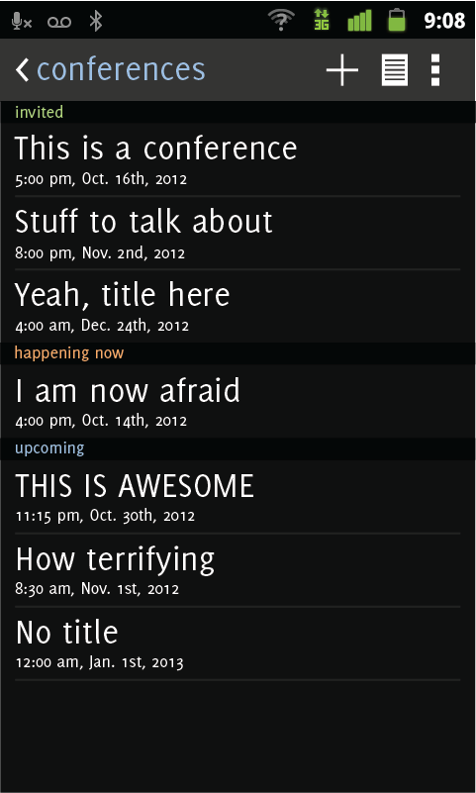Start now will spontaneously start a conference
    - After they select start conference they will have to select contacts they want to invite to the conference
    - Once they select contacts, they will be taken directly to the conference
  + Schedule conference will bring up the current conference scheduling page
* If the screen size changes:
  + Text should be left justified
  + Line separating notification item should be centered and the space between the line and the edges should be kept the same
  + Height of items in list should be the same

Conference card:

* Title on action bar: title of conference
* If there is a time conflict with this conference and another, there should be a warning message displayed underneath the date & time saying so
* If you have been invited to the conference, there will be a button on the bottom of the page to accept or decline the invitation
  + If you decline it will disappear from your list of conferences
  + If you accept it will be moved to upcoming conferences
* If the conference is currently going on there will be a button at the bottom to enter the conference
* Action bar items:
  + edit (only if you are the creator/moderator of the conference)
  + overflow: account, contacts
* 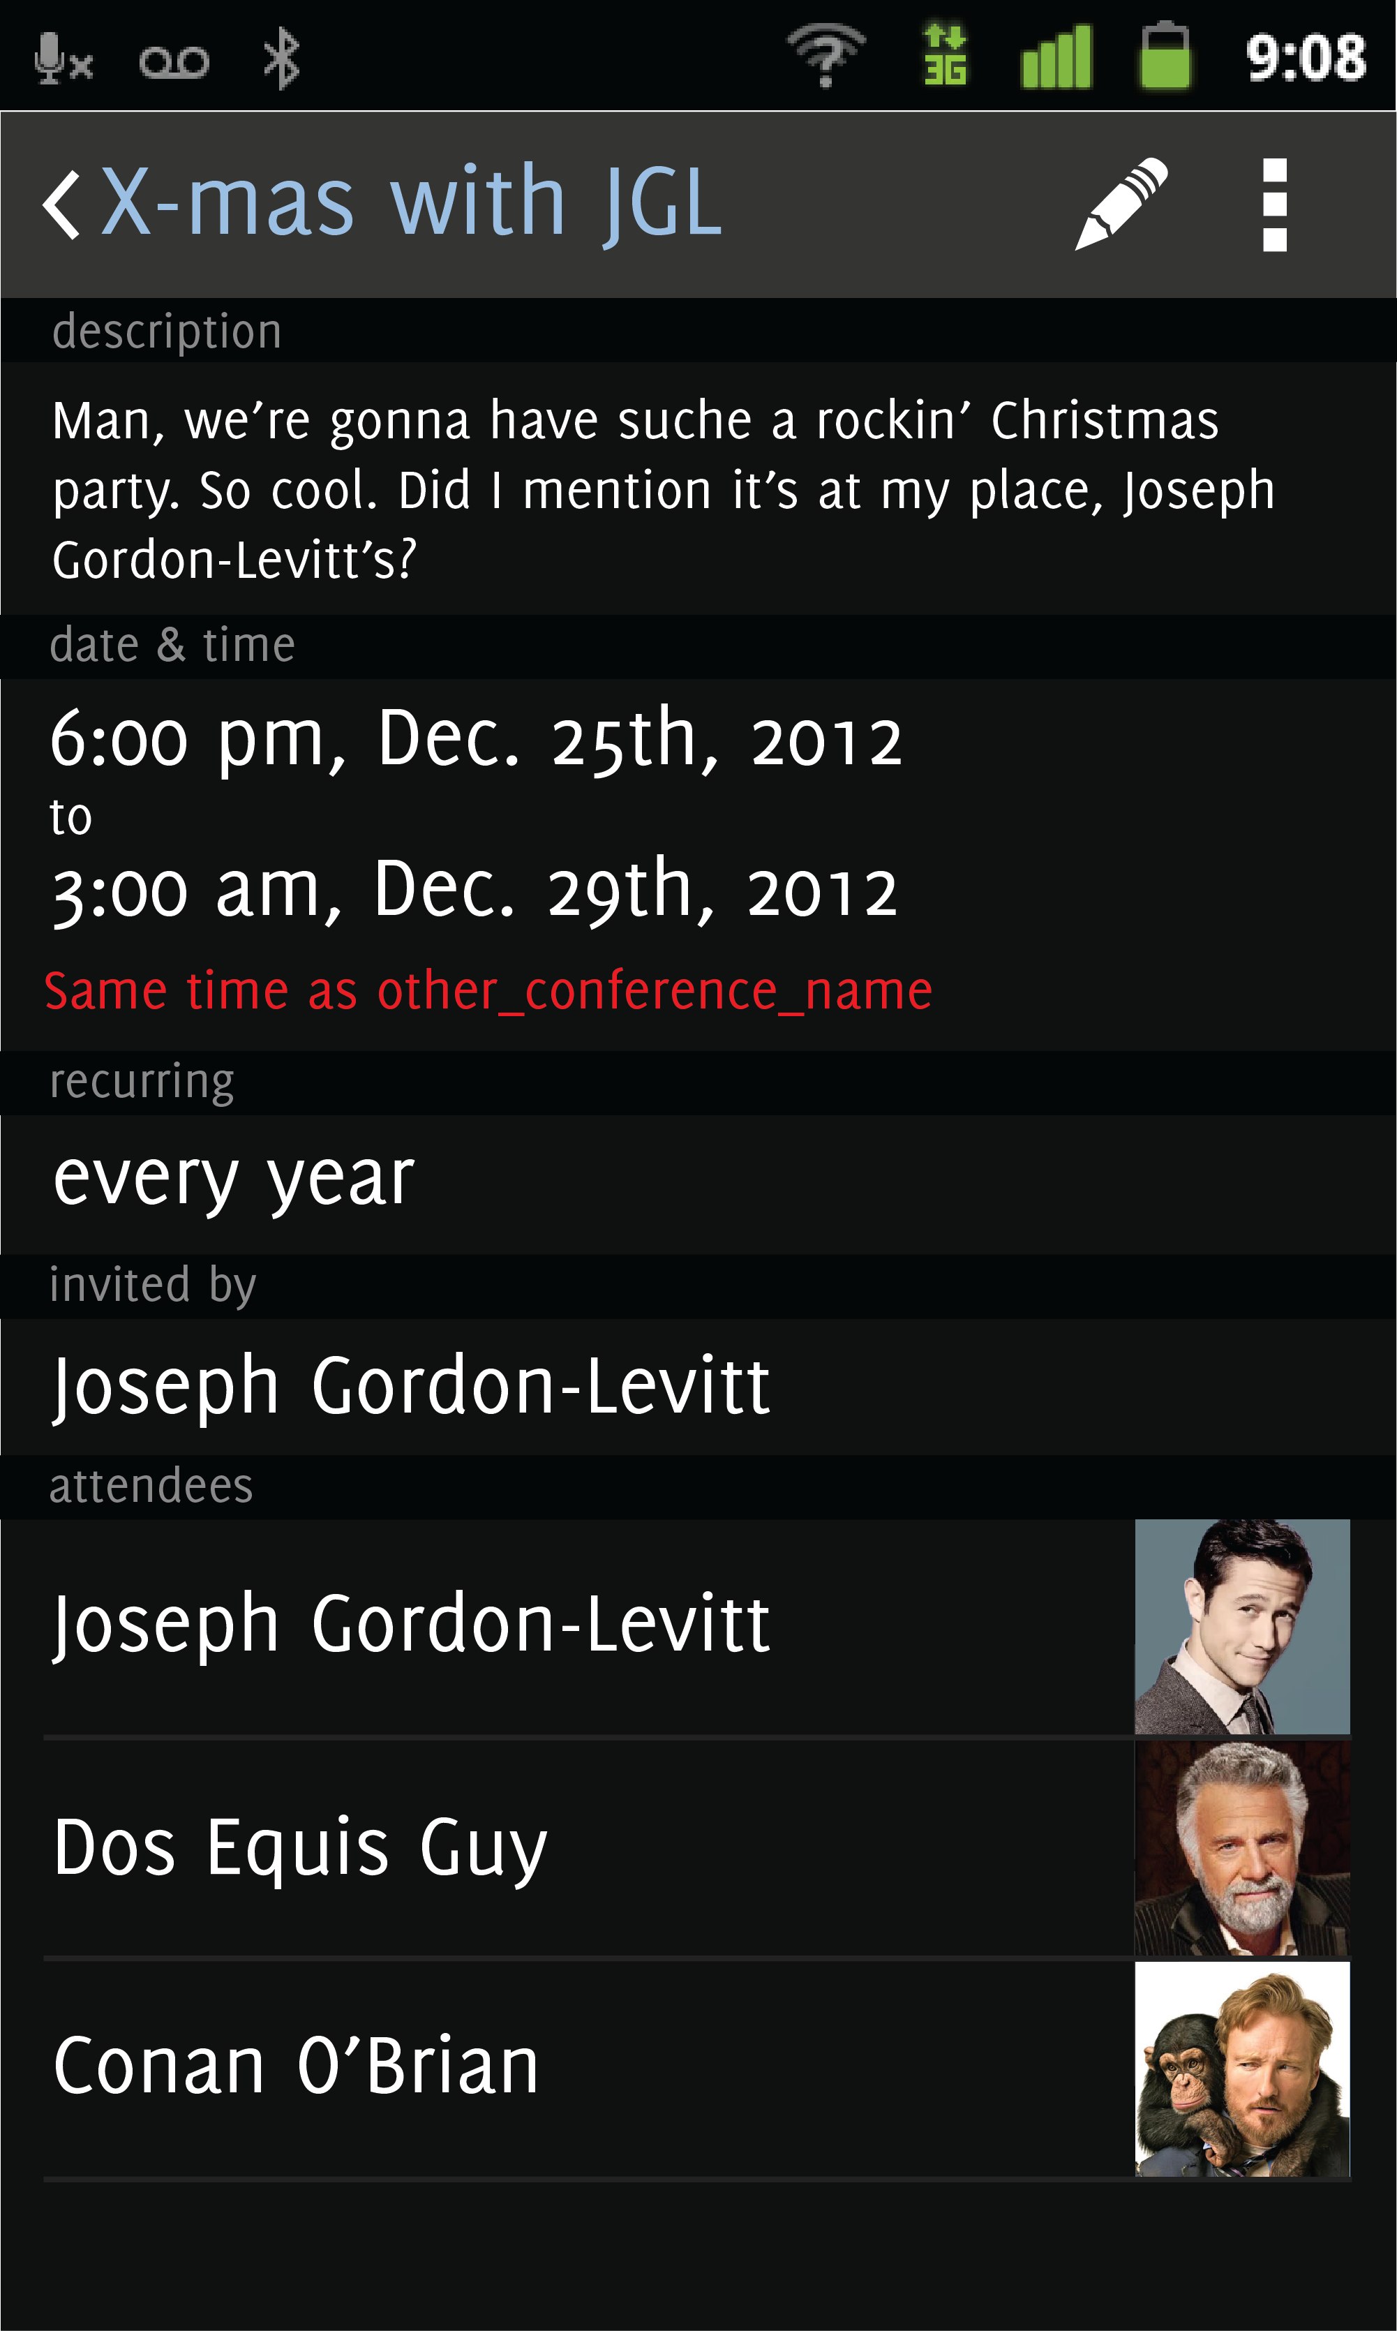If the screen size changes:
  + Text should be left justified
  + User icons should be right justified
  + Line separating attendees should be centered and the space

Contact list:

* Title on action bar: 'contacts'
* Action bar items:
  + Add
  + search
  + overflow: conferences, account
* clicking on add or search will bring up the same interface (but each will have different functionalities)
* If the screen size changes:
  + Text should be left justified
  + Line separating contacts should be centered and the space between the line and the edges should be kept the same
  + Height of contacts should be the same (should be 24 pixels of space on top and bottom of text)

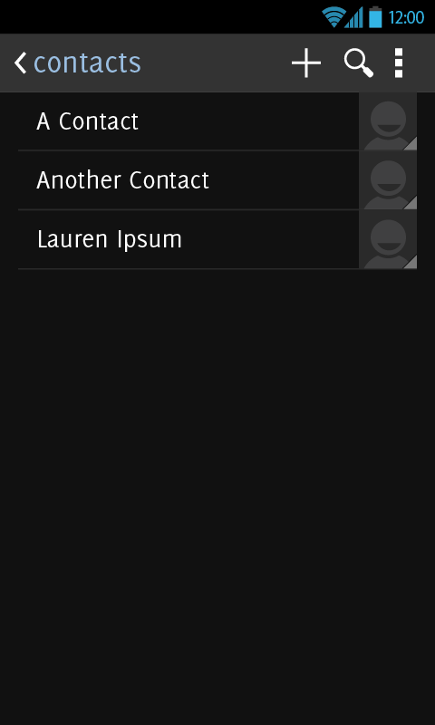

Contact search/add:

* title on action bar: either search contacts or add contacts
* Action bar item:
  + overflow: conferences, account
* when you add you can search through registered accounts not in the contact list, people in your email contact list, or manually enter an email address
* when you search you only see people already in your contact list
* If the screen size changes:
  + Text and icons should be left justified

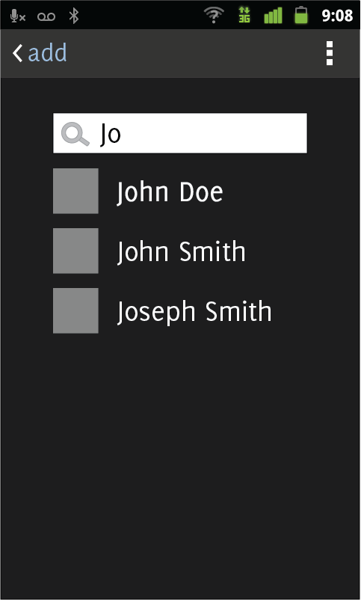

Contact card:

* title on action bar: name of contact
* action bar items:
  + add (only if the user selected add in the previous activity)
  + overflow: conferences, account
* After user selects add, icon on action bar will change to a check and text will change from add to added
* If the screen size changes:
  + Wrapper containing contact info (photo, email, etc) should be centered
  + Block button should be at the bottom with the same height

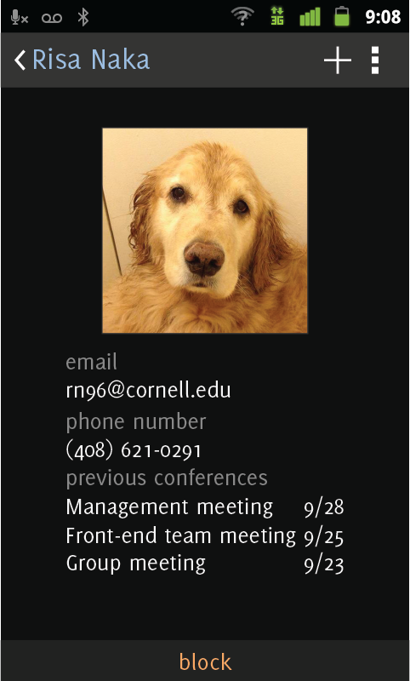

Account:

* title on action bar: my account
* action bar items:
  + edit
  + overflow: conferences, contacts
* The default screen is the regular view of the user's account information, but once the user clicks edit name, password, photo, and title fields become editable
* If the screen size changes:
  + Wrapper containing contact info (photo, email, etc) should be centered

