Simplified 1D Wave model for North Sea

For testing data-assimilation techniques a simple and fast model for the North Sea has significant benefits compared to a full scale forecasting model. Both for sensitivity studies and regression tests many repeated runs are needed. Smaller computational effort allows for more tests to be run.

The SWAN spectral wave model can be run in a 1D mode, where the other direction is considered homogeneous. A convenient curve is the arc between the locations North Cormorant and Europlatform.
The grid follows a great arc at roughly 172 to 174 degrees with respect to North. This arc is divided in 25 grid points of 43.6063km. Several observation locations are available near this curve.

Location | longitude | latitude | Distance from boundary
North Cormorant | 1.165698 | 61.340238 | 0.000
Anasuria | 0.785556 | 57.260556 | 454.151
D151 | 2.934321 | 54.324861 | 786.995
K13 | 3.220278 | 53.217778 | 911.464
Europlatform | 3.275201 | 51.998767 | 1046.550

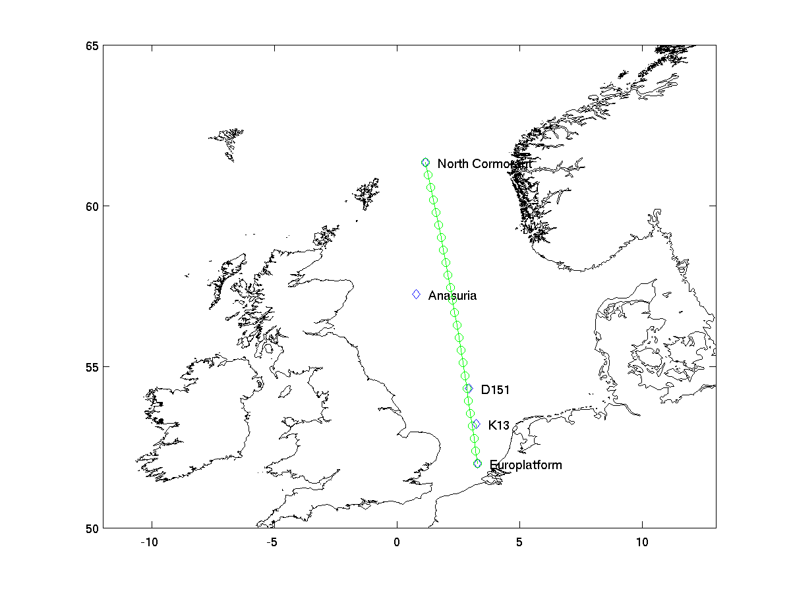Figure 1: Model domain and observation locations

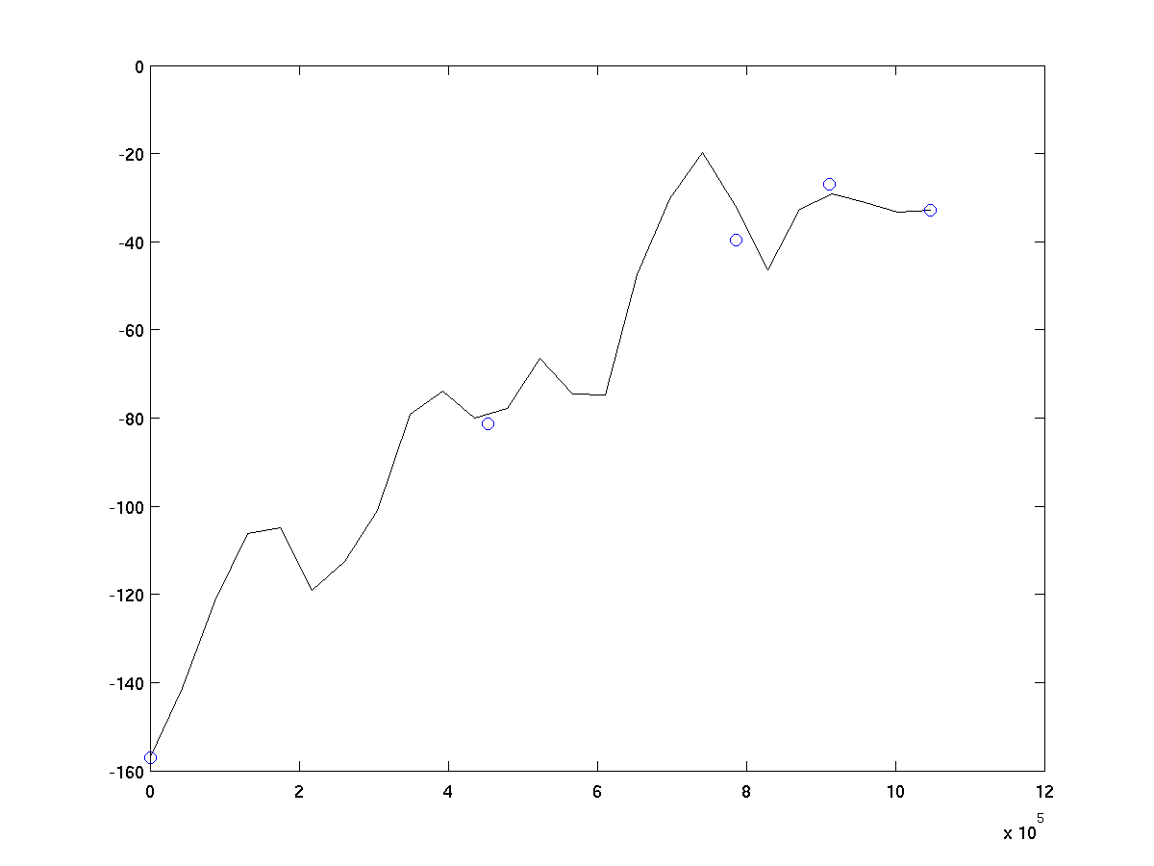Figure 2: Depth along transect

Case 1

The first testcase is an identical twin experiment, that is the observations are generated with same model. The purpose is to show that the data-assimilation works and that the observations are sufficient to recover a significant part of the model errors.
The experiment is composed of 4 parts:
- swell that is present at the boundary for the truth (observations), but not in the reference model
- swell that is present in the reference model, but not in reality/observations
- strong wind that is present in the observations, but not in the reference model. The wind forcing is uniform over the domain.
- large wind waves present in the reference model, but not in the observations.

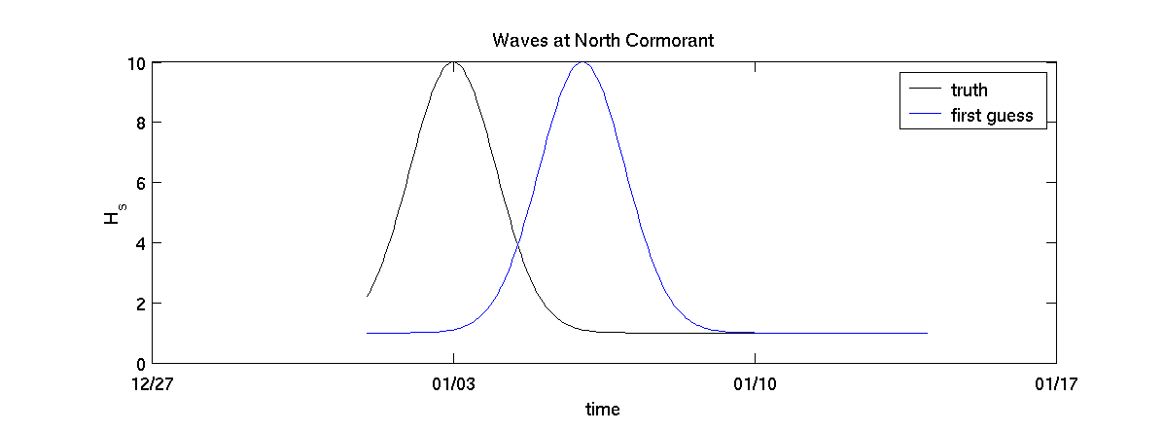
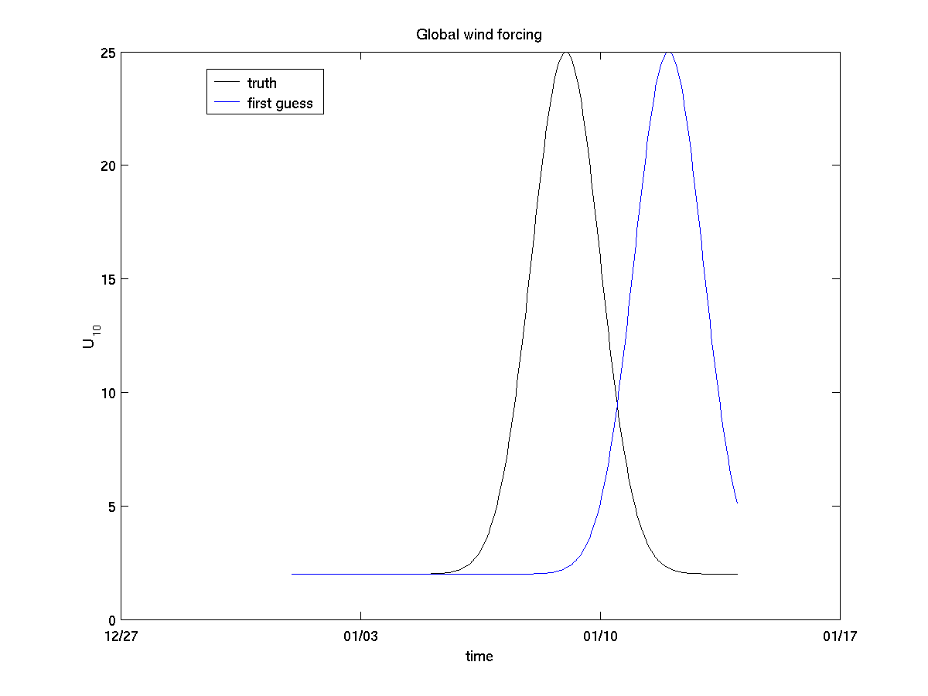An example of both truth and first-guess is given below.
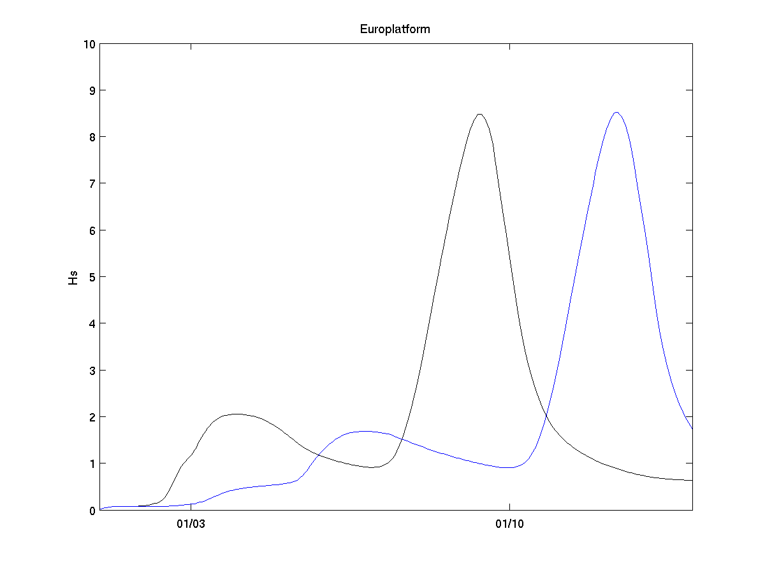

The Kalman filter setup includes uncertainty for the open boundary. Here an AR(1) model with exponential temporal correlation with scale 6 hours and standard deviation 0.4m for Hs is used.
Similar perturbations can be added to eg period, but this is not used for now.
Control variables/noise is also used for the wind forcing. The temporal correlation has scale 12 hours and magnitude 1.0m/s and spatial correlation 500km. The two wind components are treated independently. The noise is specified on the same grid as the wind input, which may be different from the computational grid.
Observations of Hs are assimilated every hour at the 5 locations. The standard deviation for errors in the observations is set to 0.2m.

Results

