Sensitivity Tests

**Results & Discussion**

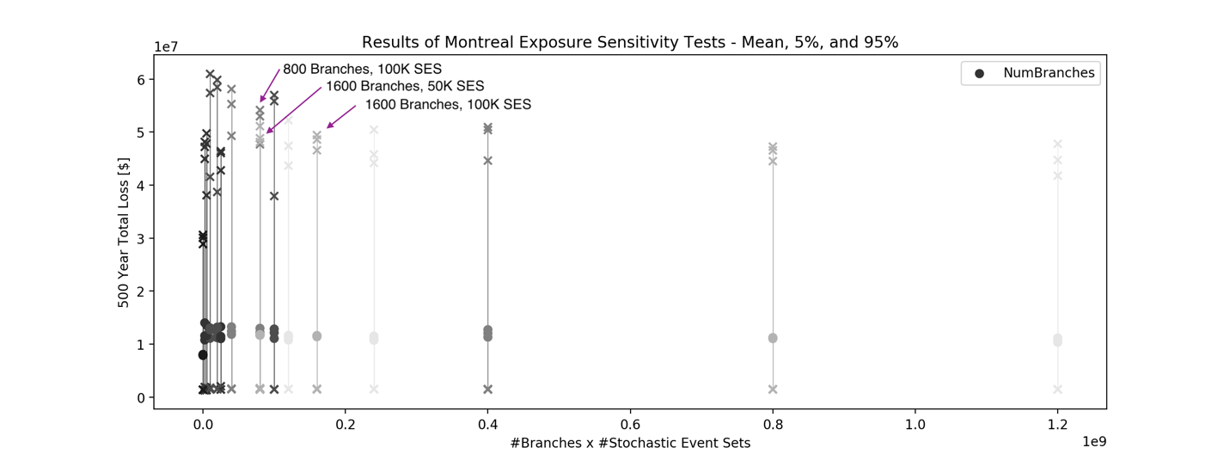

Our overall objective is to accurately constrain the seismic risk (loss) while minimizing computational burden. Computing demands go up as the number of stochastic event sets and the number of logic tree branches goes up, therefore the above figure is particularly demonstrative. We want to stay as far to the left of this chart, omitting the full enumeration calculation which has “zero” branches, while keeping the mean loss as close to the full enumeration as possible and the confidence bounds as tight as possible. Based on the results shown here, we select the optimal parameters as 1600 branches with 50,000 stochastic event sets each.

NOTE: the 50 branches with 50000 SES actually has smaller error bounds but more sensitive to RS (10-14 million mean versus pretty tight 11 million for 1600/50K)..

start by adding van stuff and see what that looks like