Trusted AI Kernel (TAK)
Normative Runtime Governance Standard
Generated 2026-10-01

Abstract
The Trusted AI Kernel (TAK) is a normative agent-harness and runtime-governance standard for trustworthy AI agent operation. It defines the minimum harness contract and control model needed when AI agents act on behalf of human principals inside enterprise, public-sector, or cross-organizational systems.
The problem TAK addresses is broader than runtime mediation alone: model capability does not create trustworthy agency, and ad hoc agent wrappers do not create a consistent basis for governed deployment. Trustworthy agency requires a standard harness that defines how authority, instructions, tool invocation, provider use, data sensitivity, memory, oversight, and evidence are assembled and enforced at runtime. TAK defines that harness contract.
TAK is intentionally concerned with runtime governance and harness consistency. It does not attempt to solve global agent naming or public badging; those concerns belong to the companion GAID standard. It does not define whether an operating profile is qualified for a particular job; that concern belongs to the TAK-JSI qualification profile. TAK defines what a trustworthy agent harness and runtime MUST, SHOULD, and MAY do once an identified, appropriately qualified agent is allowed to operate.

1. Scope
This standard specifies requirements for:
- a consistent, vendor-neutral agent harness contract
- authority mediation between humans, agents, tools, and data
- runtime policy enforcement
- immutable directive handling
- tool execution gating
- provider rate budgeting, backpressure, queueing, and failover handling
- human-in-the-loop (HITL) controls
- qualification-aware autonomy ceilings and regression
- proactivity controls that cannot widen authority or qualification
- delegation and escalation
- memory and context-window governance
- audit, evidence, and non-repudiation records
- runtime transparency
- defenses against fabrication, unsafe narration, and prompt-driven misuse
- minimum evaluation and conformance expectations
This standard applies to:
- single-agent systems
- orchestrator and specialist agent systems
- conversational coworker systems
- tool-using coding, administrative, analytical, and workflow agents
- enterprise-private and public-facing agent runtimes
This standard does not define:
- global namespace governance for public agent identifiers
- public issuer accreditation models
- external identity and badging formats
- job definitions, qualification schemes, and job-specific competence assertions
Those concerns are addressed by GAID and the companion Job-Specific Intelligence (TAK-JSI) profile.

1.1 AI-coworker operating reference architecture
The following implementation-neutral view places the TAK runtime boundary inside the wider AI-coworker operating system. It is independently derived from DPF's TAK, GAID, TAK-JSI, DigitalProduct, and work-allocation semantics in response to the bounded operator direction recorded as OP-CSDM-02 in the PAAW source register. ServiceNow's current Common Service Data Model (CSDM) shapes page, identified by SCIT-SNOW-AICT-GUIDANCE, is a reference-only implementation target for the source-validated PAAW Section 13.4 bridge; its figure, terminology, and vendor data model were not copied into this view. A concrete ServiceNow adapter still requires release/plugin/dictionary and relationship fingerprints.
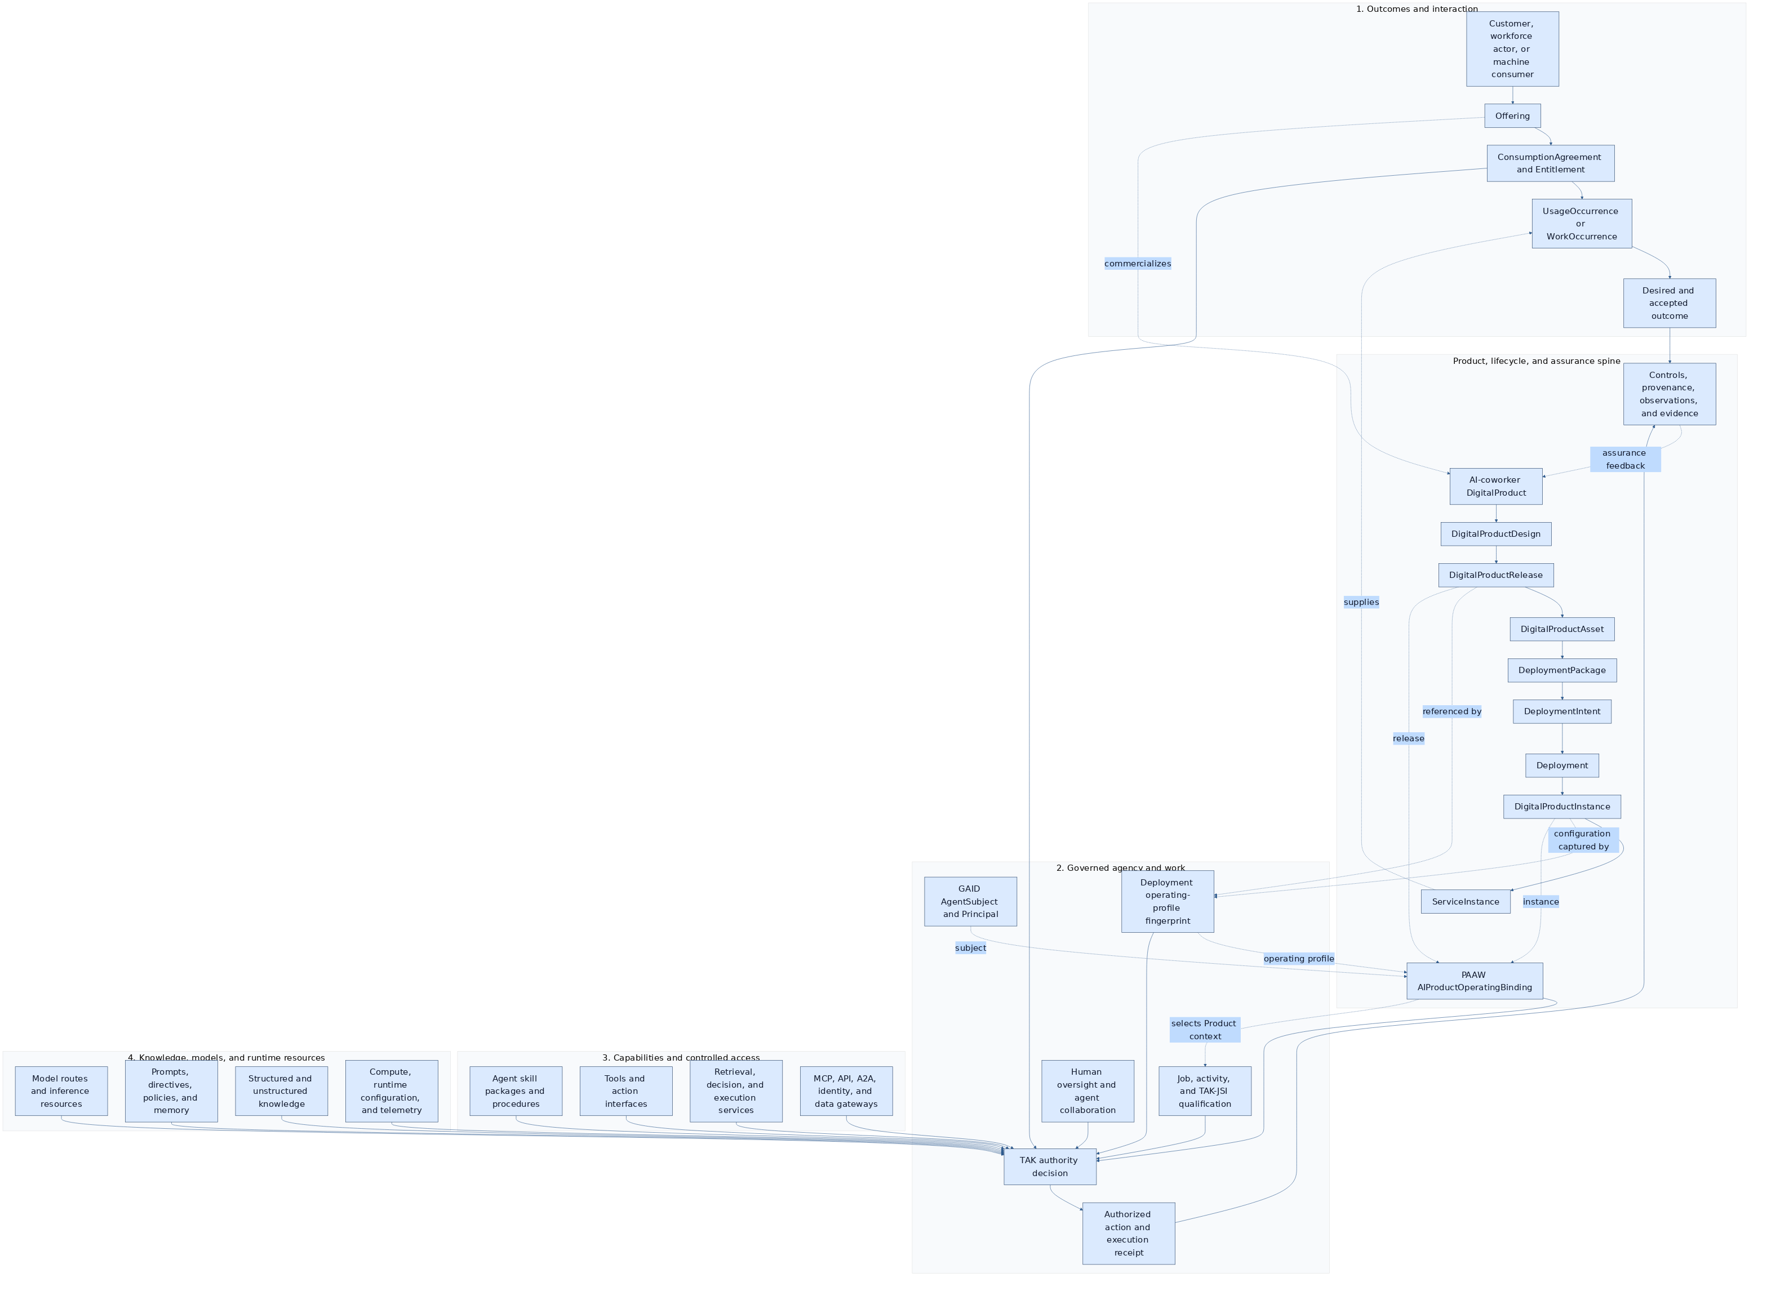
The fan-in is intentional: identity, operating profile, qualification, oversight, skills, tools, services, gateways, models, directives, data, and runtime state are independent control inputs to AUTH, not a linear transformation chain. The consequential-action path crosses AUTH and produces attributable evidence. TAK owns the authority decision, runtime gate, delegation, and execution-receipt semantics. GAID owns the AgentSubject and operating-profile identity; TAK-JSI owns job/activity qualification; the Portfolio Aligned Agent and Workforce Operating Standard owns the Product, service, work, and lifecycle bridge. Offering, accepted agreement, entitlement, usage, asset, package, deployment, product instance, and service instance remain separate identities. Context nodes in this view do not transfer that ownership to TAK.

1.2 AI-coworker lifecycle and architecture view
The operator direction in OP-CSDM-02 also calls for an implementation-neutral lifecycle picture. The view below is DPF's own expression. It separates the PAAW DigitalProduct lifecycle-state axis from the IT4IT 3.0.1 seven-stream value network, architecture scope, and governed-entity maturity. The five product states are not aliases for IT4IT streams, and the seven streams are not a mandatory sequence. This is the lifecycle companion to the runtime stack above, not a vendor data model or a claim that every state or stream is executed by TAK.
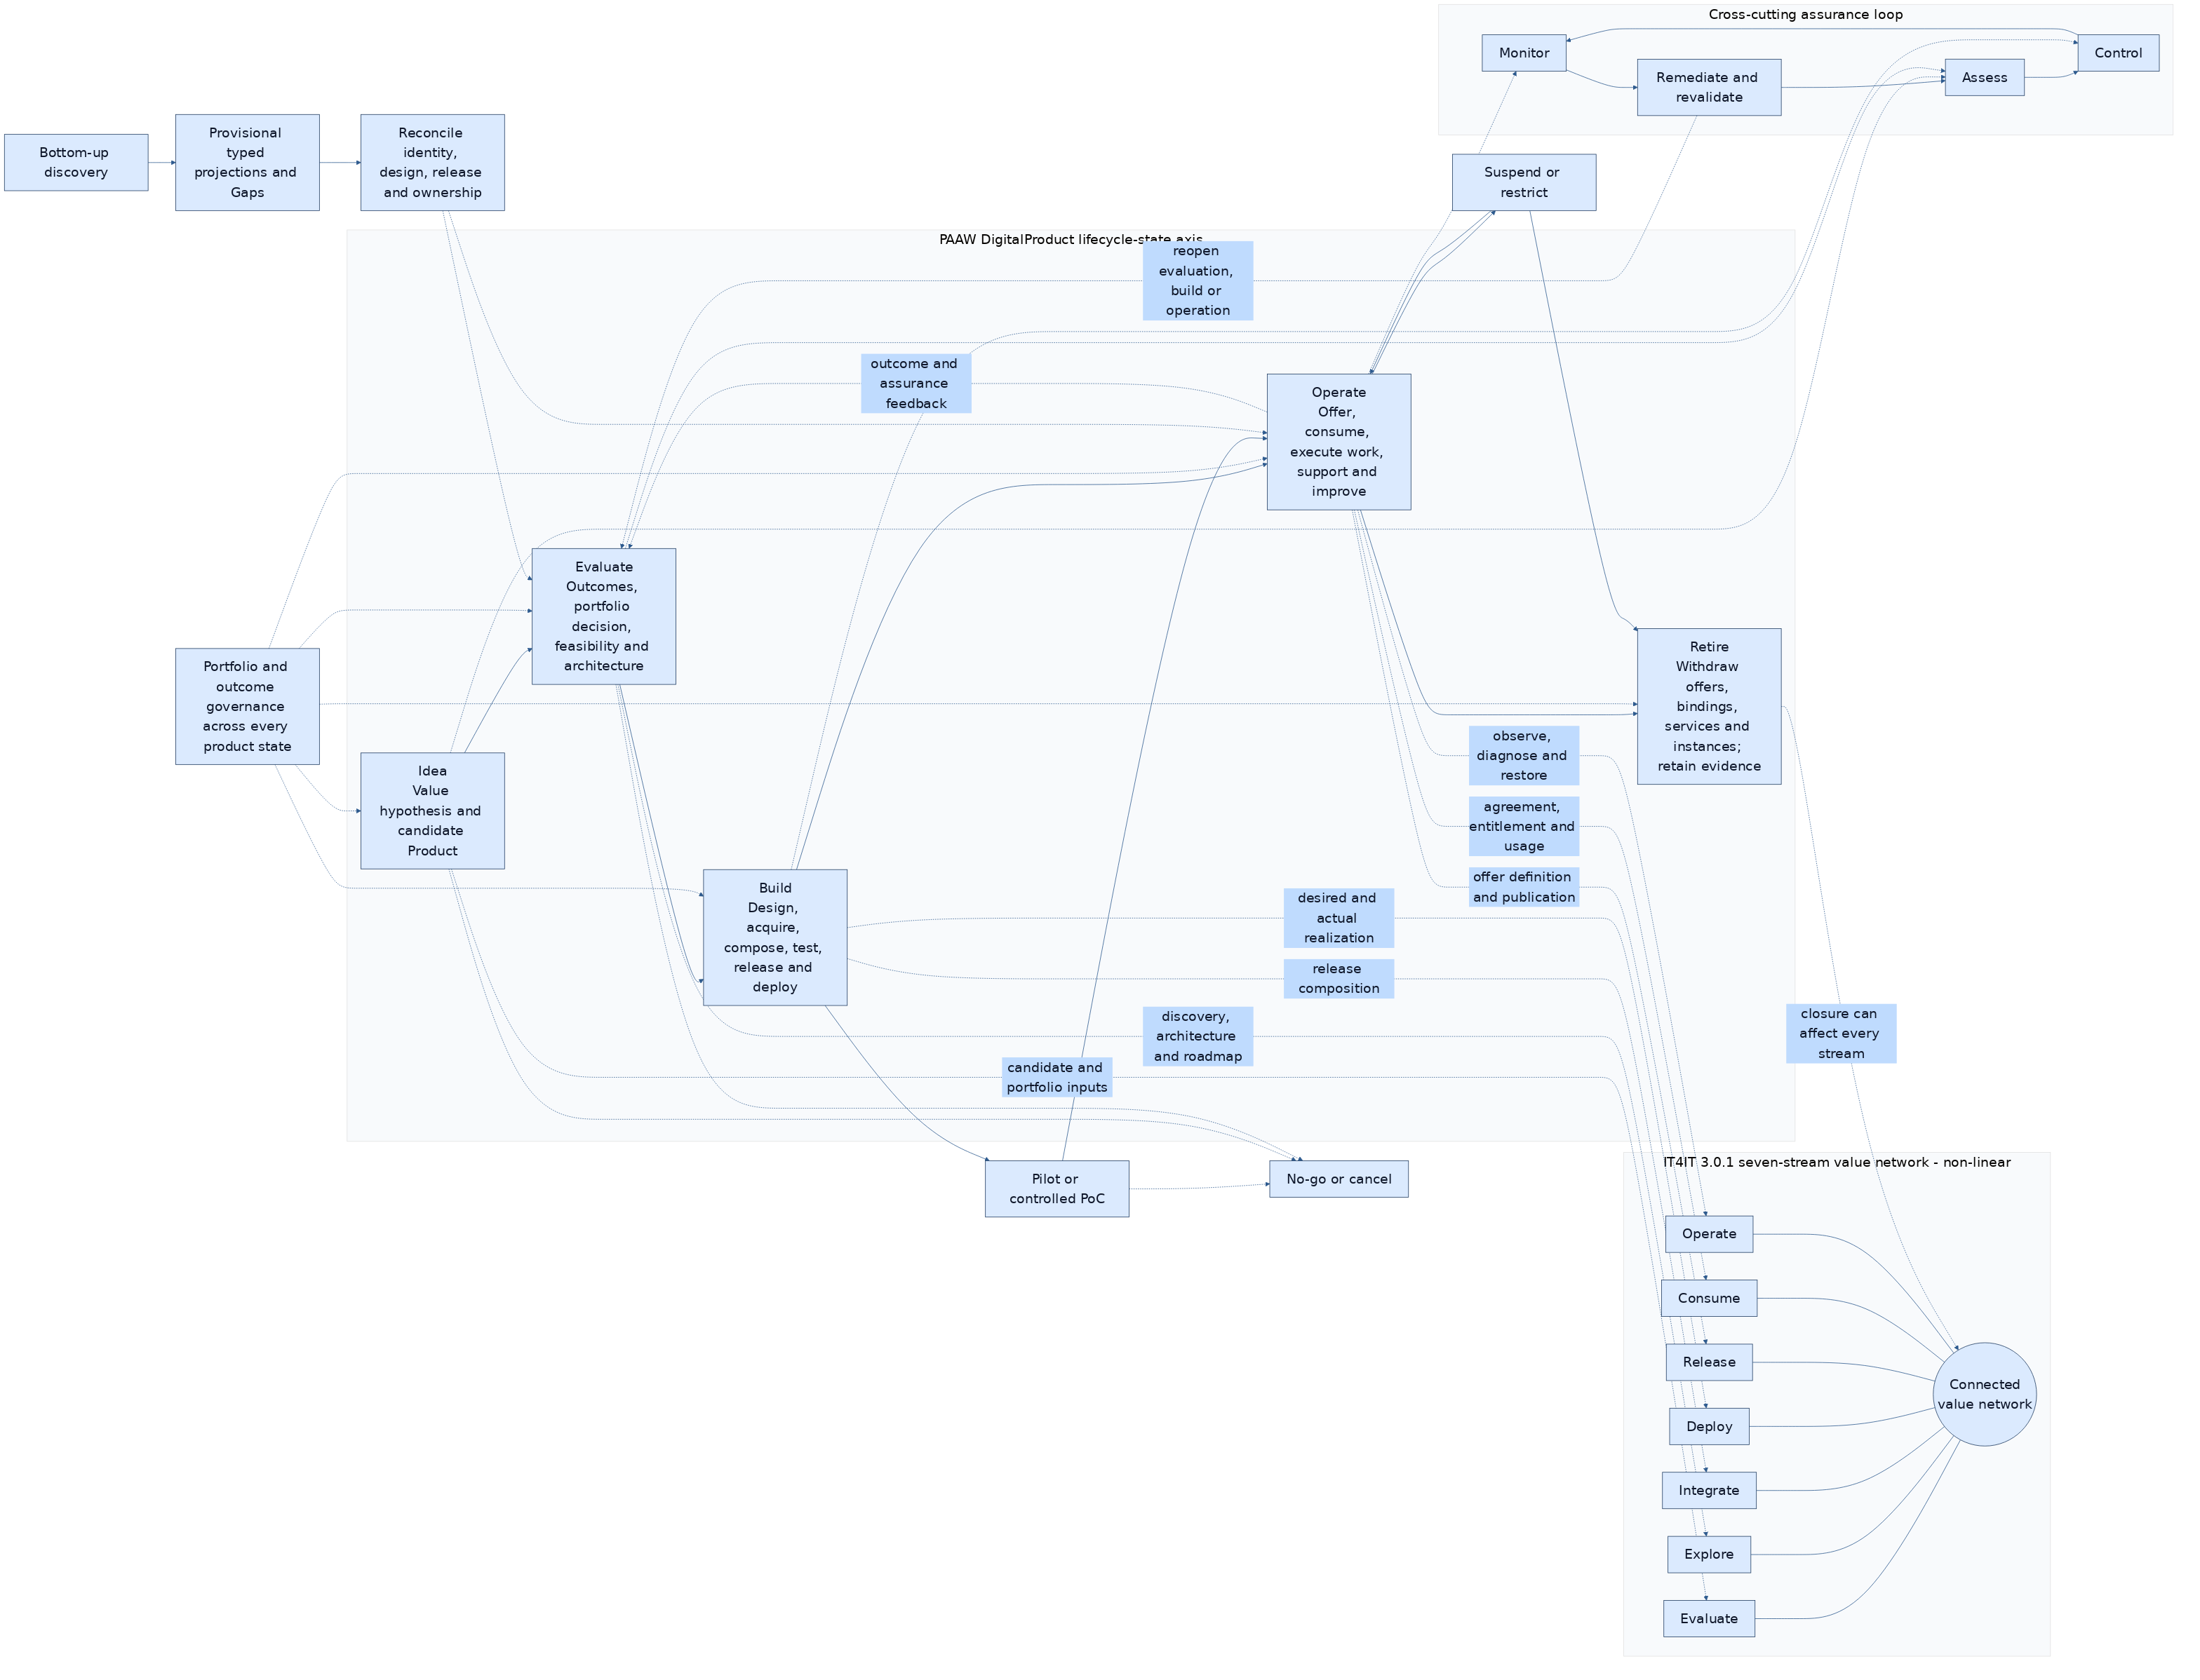
The solid five-state path governs Product lifecycle. The hub-and-spoke network preserves all seven IT4IT streams without inventing a process order; dotted state-to-stream edges identify common touchpoints, not exclusive ownership or mandatory sequencing. Architecture bands overlap both axes:
Architecture band | PAAW product-lifecycle coverage | Typical IT4IT network touchpoints
strategy and business model | Idea through Retire; stakeholder value, Outcomes, and four-portfolio decisions | Evaluate, Explore, plus Consume/Operate feedback
business operational architecture | Evaluate through Operate, with retirement impact analysis | Explore, Consume, Operate
solution architecture | Evaluate through Operate; design, releases, assets, packages, dependencies, security, and deployment topology | Explore, Integrate, Deploy, Operate
service, engagement, sales, and support model | Build through Retire; ServiceDefinitions, Offerings, agreements, entitlements, service instances, support, and usage | Deploy, Release, Consume, Operate
foundation | every state; Organization/Principal/GAID identity, TAK-JSI qualification, vocabulary, data, controls, provenance, and evidence | all seven streams as applicable
Within the Idea/Evaluate/Build/Operate/Retire state axis, Product lifecycle state MUST separately represent pilot, promotion, suspension, end-of-support, retirement, and decommissioning where applicable; AIProductOperatingBinding.bindingState does not substitute for Product, release, asset, deployment, instance, service, or Offering state. An IT4IT stream position does not substitute for a Product state. A discovered operational record creates provisional typed projections and Gaps only; discovery MUST NOT synthesize a Product definition, release, or GAID subject identity.
PAAW owns the Product, portfolio, work, service, and AIProductOperatingBinding semantics; GAID owns the enduring subject; TAK-JSI owns qualification; TAK owns the action-time authority, delegation, execution, and receipt boundary in Consume/Operate. An AI Agent record, design, release, asset, package, deployment, product instance, service instance, AgentSubject, Offering, agreement, entitlement, usage, and WorkAssignment are therefore related but never interchangeable.

2. Conformance
An implementation conforms to this standard only if it satisfies all requirements identified as MUST for its claimed conformance profile.
This standard defines three conformance profiles:
- TAK-Basic
- TAK-Managed
- TAK-Assured
An implementation:
- MUST declare the highest conformance profile it claims
- MUST NOT claim a higher profile if any mandatory control for that profile is absent
- SHOULD publish an implementation statement showing how each control is met
- MAY implement controls beyond those required by its claimed profile

2.1 Standard Versioning, Lifecycle, and Conformance Assertions
This standard SHOULD be versioned using a semantic-style scheme:
- major versions for normative incompatibilities
- minor versions for additive normative requirements or profile extensions
- patch versions for clarifications, errata, or non-substantive corrections
Implementations claiming conformance SHOULD declare:
- the TAK version supported
- the claimed conformance profile
- any profile extensions or deployment-specific constraints
Each normative MUST statement in this standard SHOULD map to one or more explicit conformance assertions in a companion test suite or implementation statement. This document does not require a single central test harness, but it does require that conformance claims be testable rather than rhetorical.
A suggested companion assertion rubric for this revision is published in tak-conformance-tests.md.
The intended lifecycle of TAK is open standards progression through multistakeholder implementation and liaison rather than indefinite treatment as an internal white paper.
The preferred near-term disposition is publication as an open industry specification with liaison into NIST, the Agentic AI Foundation, OASIS / CoSAI, and relevant IETF OAuth and GNAP work, with later venue-specific profiles or submissions preserving the same core runtime semantics.

3. References

3.1 Normative References
The following companion standards are indispensable to applying this document:
Reference | Normative relationship
GAID | Defines the identified agent subject, operating-profile binding, assurance claims, and receipts consumed by TAK
Job-Specific Intelligence (TAK-JSI) | Defines the job qualification and evidence-supported autonomy ceiling enforced by TAK

3.2 Informative External References
The following references are relevant to this standard and informed its design. Publication in this table does not imply that every reference is normatively incorporated in full. The exact relationship—adoption, profiling, augmentation, mapping, or adjacency—is maintained in the informative External Standards Alignment companion.
Reference | Relevance
ISO/IEC 42001:2023 | Organization-level AI management systems
ISO/IEC 17024:2026 | Competence-scheme, assessment, surveillance, and reassessment prior art profiled by TAK-JSI
ISO/IEC 25059:2023 | AI-system quality characteristics for specification and evaluation
ISO/IEC 5259-5:2025 | Data-quality governance and stewardship relevant to qualified agent work
ISO/IEC TS 42119-2:2025 | Risk-based AI-system testing practices that TAK runtime and qualification evaluation can exercise
ISO/IEC 42119-3 | Verification and validation analysis across the AI-system lifecycle; active work augmented by operating-profile and revalidation semantics
ISO/IEC FDIS 42105 | Human oversight guidance under development, complemented by enforceable oversight floors, proactivity clamping, and autonomy regression
ISO/IEC JTC 1/SC 42 | Horizontal AI standards program, including trustworthiness, data, systems engineering, and AI conformity-assessment work
NIST AI RMF 1.0 | Risk management framing for AI systems
NIST AI Agent Standards Initiative | Current U.S. public-sector standards activity for agent security, identity, interoperability, and evaluation
NCCoE concept paper: software and AI agent identity and authorization | Identity, authorization, auditing, and non-repudiation concerns for agents
NIST AI 800-2 benchmark evaluation draft | Evaluation transparency and benchmark discipline
IEEE P3709 | Active agentic-AI framework project to which TAK runtime-control and conformance requirements can contribute
IEEE P3833 | Active proactive-agent project complemented by TAK separation of proactivity, authority, qualification, and autonomy
Model Context Protocol specification | Tool and context interoperability
Model Context Protocol authorization specification | HTTP transport authorization profile for MCP servers and clients
Anthropic: Introducing the Model Context Protocol | Background on MCP as an open protocol
Linux Foundation: Agentic AI Foundation announcement | Neutral governance venue for MCP and AGENTS.md stewardship
AGENTS.md | Open declarative instruction format used across coding-agent ecosystems
RFC 9728 OAuth 2.0 Protected Resource Metadata | Discovery and metadata for protected resource authorization surfaces
RFC 9635 Grant Negotiation and Authorization Protocol (GNAP) | Negotiated delegated authorization model for dynamic access decisions
RFC 9767 GNAP Resource Server Connections | Resource-server-side GNAP discovery and access-right connection model
RFC 9449 OAuth 2.0 Demonstrating Proof of Possession (DPoP) | Sender-constrained token binding for high-assurance agent calls
IETF WIMSE working group | Workload identity, credentials, and authentication substrate for multi-system and agent deployments
AI Agent Authentication and Authorization | Active IETF draft for agent identity and delegated authorization; protocol substrate rather than a substitute for TAK runtime policy
Signed Authorization-Evidence Records for AI Agent Actions | Active IETF draft aligned with attributable authorization and action evidence
OpenAI Preparedness Framework | Frontier-model safety governance prior art, useful for scoping what TAK does and does not standardize
Anthropic Responsible Scaling Policy | Frontier-model safety and deployment governance prior art, complementary rather than substitutive to runtime kernel controls
Google DeepMind Frontier Safety Framework | Model-level severe-risk framework used to distinguish model governance from runtime governance
CoSAI: Agentic Identity and Access Management | Agentic IAM control framing aligned to enterprise runtime operation
OWASP Top 10 for Agentic Applications | Concrete agentic risk taxonomy and mitigation guidance
W3C Trace Context | Cross-system trace propagation
RFC 9421 HTTP Message Signatures | Message-level signatures for integrity and non-repudiation
in-toto Attestation Framework Specification | Practical attestation statement and envelope model for signed evidence
Sigstore Documentation | Operational signing, transparency, and verification substrate for attestations and release evidence
CSA MAESTRO | Agentic AI threat-modeling framework
MITRE ATLAS | Adversarial tactics and techniques knowledge base for AI systems
IMDA Model AI Governance Framework for Agentic AI | National governance framework for agentic AI deployment
ISO/IEC 12792:2025 | Transparency taxonomy for AI systems
ISO/IEC DIS 42102 | Framework for characterizing AI system methods and capabilities

3.3 Reuse and Profiling Rule
TAK is intended to compose adjacent standards, not replace them.
Accordingly:
- TAK MUST adopt an existing standard directly where that standard already defines the relevant control surface well
- TAK SHOULD define a profile when an existing standard is useful but needs agent-runtime-specific constraints
- TAK MUST NOT redefine transport, directory, credential, or trace standards merely because they are used by AI agents
- TAK MAY define new runtime semantics only where the agent-governance problem is not already solved elsewhere
In practice this means:
- MCP and A2A are protocol-profile targets, not substitutes for runtime governance
- MCP authorization and discovery mechanisms define transport-facing auth behavior; TAK defines the runtime policy and evidence semantics layered behind them
- W3C Trace Context is the default correlation carrier for cross-system execution traces
- RFC 9421 is the preferred message-signing basis where TAK evidence crosses HTTP trust boundaries
- declarative instruction artifacts such as AGENTS.md may complement runtime governance, but they do not replace kernel-governed control metadata
- LDAP, SCIM, VC, and other adjacent standards remain companion carriers or claim envelopes rather than being redefined by TAK

3.4 External Augmentation Boundary
TAK augments adjacent work specifically where a conforming runtime must connect broad policy, identity, qualification, and protocol authorization to the action being attempted.
In particular:
- ISO/IEC 42001, ISO/IEC 23894, ISO/IEC 42005, and the NIST AI RMF remain the authorities for organization-level management, risk, and impact processes; TAK converts applicable outcomes into enforceable runtime constraints
- IEEE P3709 remains the broader agentic-AI framework project; TAK contributes concrete harness, authority, evidence, proactivity, and autonomy requirements
- ISO/IEC 42105 remains the human-oversight guidance layer; TAK adds runtime tiers, ceilings, escalation, and regression behavior
- IETF WIMSE, OAuth, GNAP, and SPIFFE remain identity, credential, and authorization transports; TAK independently decides whether an authenticated and authorized protocol request is allowed under current qualification, data, workflow, and oversight constraints
- TAK does not infer job competence from successful authentication, protocol authorization, a model benchmark, or a declared capability

4. Terms and Definitions
For the purposes of this standard:
Term | Definition
agent | A software system that can reason, decide, and perform actions with or without tool use on behalf of a principal or workflow
principal | The human or organizational authority under which an agent operates
runtime | The execution environment that implements the agent harness and mediates prompts, tools, memory, policies, and outputs
agent harness | The standard runtime structure that binds authority, instructions, model access, tools, memory, oversight, and evidence into one governed execution contract
immutable directive | A runtime-enforced instruction that the agent cannot change through conversation
tool | A callable capability that reads, writes, transforms, or acts on an internal or external system
execution mode | The enforcement class governing how a tool call is handled at runtime
proposal | A gated action that requires explicit human approval before execution
immediate | An action the runtime may execute without per-action approval because policy allows it
delegation | Transfer of a bounded task from one agent or orchestrator context to another
escalation | Routing of a decision or blocker to a higher-authority human or agent context
memory | Persisted or replayed context intended to influence subsequent agent behavior
context window governance | Controls that determine what prior information is preserved, summarized, truncated, or excluded
provider budget | The governed runtime view of rate, concurrency, token-throughput, quota, credit, funding-token, or contractual limits imposed by a model provider or inference service
backpressure | Runtime behavior that slows, queues, defers, or rejects new inference work so provider and policy limits are not exceeded
inference queue | A bounded, resumable runtime queue holding model invocations awaiting execution, retry, failover, or operator intervention
capability tier | A policy classification that defines the minimum acceptable model capability and the allowed substitution set for a task or workflow
runtime transparency | The ability for humans and auditors to inspect what the agent was allowed to do, attempted to do, and actually did
fabrication | A model output that claims work, change, or completion not supported by tool or runtime evidence
operating profile | The governed bundle of materially relevant runtime state for an identified agent, including model binding, instructions, tools, autonomy posture, and verification references
profile fingerprint | A digest or equivalent marker derived from the materially relevant operating profile state
validation continuity | Whether the currently running operating profile remains the same validated operational subject previously assessed or approved
job qualification | A versioned assertion that an identified operating profile satisfies a declared job/activity qualification scheme within stated data, risk, tool, and deployment constraints
proactivity | The requested degree of initiative an agent may take before involving a human; it does not create authority or competence
earned autonomy | Runtime action latitude justified by evidence and policy for a specific (agent × activity × risk) scope
autonomy ceiling | The highest oversight tier allowed after authority, qualification, data, regulatory, and risk constraints are intersected

5. Core Principle
The core principle of TAK is:
Humans hold authority. Agents hold capability. The kernel provides the standard harness on which trustworthy AI agents are built, operated, and evidenced.
The point is not merely to restrict the model or intercept model calls. The point is to establish a consistent and governable basis for how AI agents are built, invoked, supervised, and evidenced. Mediation is one function of that harness, but the larger purpose is to ensure that authority, capability, directives, execution, and evidence remain aligned throughout runtime operation.

6. Design Principles
An implementation of TAK:
- MUST provide a consistent harness contract for how governed agents are assembled, invoked, supervised, and evidenced
- MUST mediate all consequential agent action through an explicit control plane
- MUST treat mediation as one responsibility of a broader governed harness rather than as the entirety of the kernel
- MUST separate human authority from model capability
- MUST load only approved operating profile state for governed agents
- MUST treat tool invocation as governed execution, not model free-form behavior
- MUST treat provider rate, quota, budget, and availability constraints as kernel-governed runtime concerns rather than application-local exception handling
- MUST preserve an auditable chain from human authority to agent action
- MUST treat qualification as a ceiling on autonomy rather than as authorization
- MUST prevent proactivity preferences from widening authority, qualification, data eligibility, or mandatory oversight
- MUST make material runtime-state changes visible to policy and audit layers
- SHOULD minimize the tools and context exposed to an agent at any point in time
- SHOULD favor bounded specialists over unconstrained generalists for operational tasks
- SHOULD assume multi-provider operation may be necessary for resilience, policy fit, or capability coverage
- MAY increase autonomy only where evidence and policy justify doing so

7. Runtime Trust Model

7.1 Required Control Layers
A conforming implementation MUST apply runtime control in layers. At minimum, those layers MUST include:
- authentication of the human or calling system
- resolution of authority or role context
- evaluation of allowed capabilities
- agent-side grant or scope filtering
- execution gating for side-effecting operations
The runtime MUST NOT allow a lower layer to widen permissions restricted by a higher layer.

7.2 Effective Permission Rule
For any (principal, agent, tool) combination, the runtime MUST compute effective permission as the intersection of:
- what the principal is allowed to do
- what the agent is allowed to do
- what the route, workflow, or context is allowed to expose
The runtime MUST NOT treat the model's request as sufficient evidence of authorization.

7.3 Domain and Route Scoping
The runtime SHOULD expose only the domain-relevant subset of tools and context for a given route, task, or workflow stage.
This is not only a usability optimization. It is a control. Smaller, better-bounded tool surfaces reduce:
- mis-selection of tools
- hallucinated capability claims
- prompt injection blast radius
- token waste
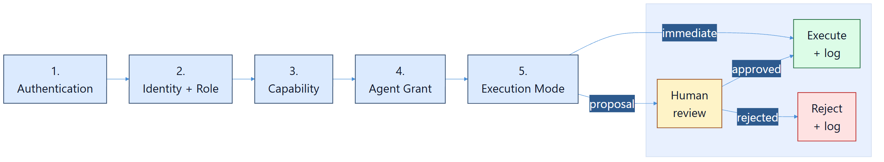
Figure 1. Layered authority mediation is a required kernel behavior inside the broader TAK harness, not only a UI convenience.

7.4 Approved Operating Profiles
A conforming runtime MUST treat an agent's approved operating profile as a governed runtime artifact.
At minimum, the operating profile SHOULD include:
- model or provider binding
- immutable and governed instruction references
- enabled tool surface
- autonomy and oversight posture
- relevant verifier references
- current approved badge or authorization posture references
For governed agents, the runtime MUST NOT execute against undeclared or unapproved materially relevant profile state.

7.5 Runtime Identity Proof Posture
For an identified governed agent, the runtime SHOULD be able to support a stronger claim than:
- "the agent says it is X"
The stronger claim is:
- the subject identity is X
- the approved operating profile is Y
- the runtime is executing that profile under trusted kernel enforcement
TAK does not define the external identity namespace itself. That belongs to companion identity work such as GAID. TAK does, however, define the runtime conditions under which such identity claims can be trusted in operation.

7.6 Core Runtime Semantics Versus Protocol Carriers
TAK implementations SHOULD follow a stable-core and profile pattern similar to mature identity and directory standards.
In that pattern:
- the core TAK model defines approved operating profile semantics, runtime enforcement rules, validation continuity rules, and attestation expectations
- runtime or deployment extensions define additional environment-specific control fields without changing those core semantics
- protocol carriers or profiles define how TAK state is exposed through directories, APIs, event systems, or attestation envelopes
TAK therefore MUST NOT be treated as a replacement for LDAP, SCIM, HTTP, or message protocols. It defines what those carriers need to say about trusted runtime state, not the transport itself.

7.7 Material Change and Validation Continuity
The runtime MUST treat material change as a trust-relevant event.
Material change includes:
- changes to model or provider binding
- changes to immutable or governed instruction bundles
- changes to tool surface
- changes to autonomy or approval posture
- changes to the applicable job profile, qualification scheme, profession corpus, decision axes, or qualification evidence
- changes to data classification, permitted use, residency, or stewarded quality requirements
- changes to an approved routed-model substitution set or routing policy
- changes in runtime dependencies that materially alter practical capability or risk
The same enduring subject identity MAY remain valid while validation continuity is broken.
Therefore, the runtime SHOULD distinguish:
- identity continuity
- validation continuity
and MUST NOT silently assume they are equivalent.

7.8 Profile Fingerprints and Attestation
For governed agents, the runtime SHOULD support:
- a visible fingerprint or version marker for materially relevant operating profile state
- stronger protected attestation material sufficient to bind that profile state to trusted kernel execution
Acceptable higher-assurance attestation substrates MAY include hardware-rooted measurements such as TPM, TDX, or SEV-SNP, as well as software evidence stacks such as DSSE, in-toto, Sigstore, or SCITT-style statement publication, provided they let a verifier bind profile state to the governed runtime instance that actually executed the work.
This allows relying parties and auditors to distinguish between:
- the same enduring agent subject
- the same validated operational subject

7.9 Attestation and Projection Profiles
When TAK state is projected into external systems, the projection SHOULD preserve the distinction between:
- enduring subject identity
- current approved operating profile
- current validation status
- stronger attestation material that may not be appropriate to publish broadly
For example:
- LDAP projections MAY publish profile fingerprints, validation state, and verifier references needed for coarse trust decisions
- SCIM projections MAY carry selected operating-profile and validation metadata for lifecycle automation
- direct API or attestation carriers SHOULD carry the stronger signed or protected material needed to prove runtime state across trust boundaries
An implementation SHOULD document those profile mappings explicitly so external systems know which parts of TAK they can rely on and which parts remain internal kernel evidence.

7.10 Vendor-Neutral Reference Model
The following reference model is intentionally independent from any one product platform.
It shows the stable TAK control relationship between:
- human and organizational authority
- identity and governance context
- interaction surfaces
- coordinator and specialist agents
- the kernel control plane
- tools, protocols, and evidence
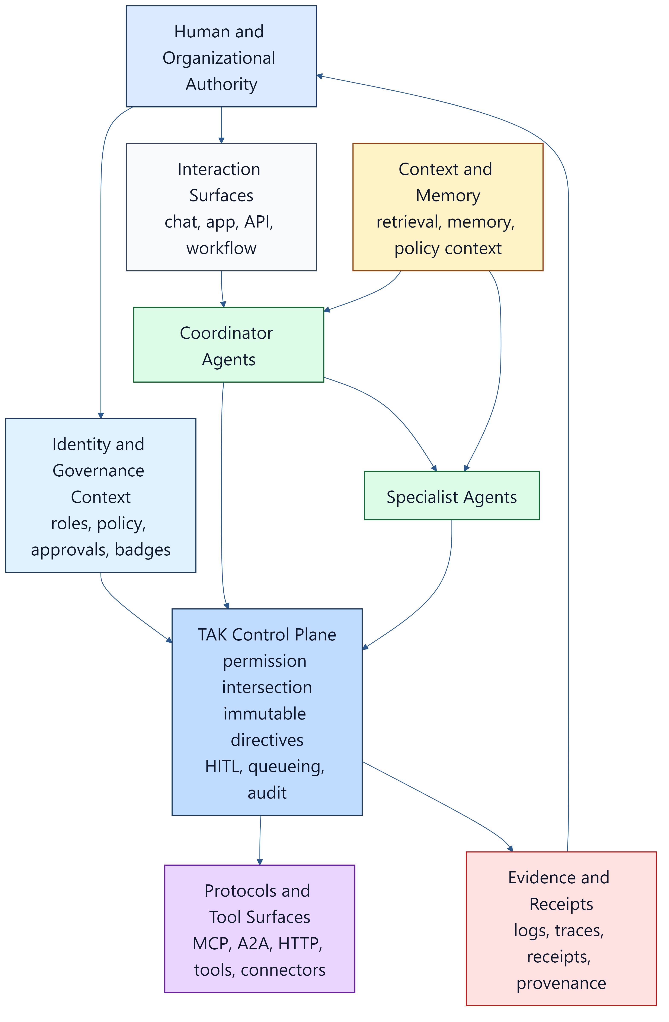
Figure 2. TAK defines a vendor-neutral harness control plane that sits between authority, agents, tools, and evidence.

7.11 Qualification-Aware Runtime Enforcement
For job-scoped autonomous work, a conforming runtime MUST distinguish:
- declared capability
- tested capability
- job qualification
- present authorization
- evidence-earned autonomy
None is interchangeable with another.
A GAID capability or qualification badge MUST NOT be treated as live authorization. A TAK-JSI qualification MUST NOT be treated as permission to perform every qualified action. At execution time, the runtime MUST compute the effective action posture from the intersection of:
principal authority
∩ agent grants
∩ route or workflow policy
∩ active job-qualification scope
∩ data, residency, and permitted-use constraints
∩ regulatory and contractual ceilings
∩ evidence-earned autonomy for (agent × activity × risk)
If the applicable qualification is absent, expired, suspended, revoked, outside scope, or pending revalidation, the runtime MUST fail closed, narrow the action, reduce the oversight tier, or escalate according to policy.
The runtime MUST NOT infer job qualification solely from:
- a model or provider name
- a model card or system card
- a generic benchmark
- a successful demonstration in another job
- a high proactivity setting
- a high-cost or high-quality execution posture

7.12 Proactivity, Earned Autonomy, and Assurance Posture
Proactivity, autonomy, and execution assurance are separate control axes:
- proactivity states how readily the agent should initiate, suggest, or continue work
- earned autonomy states how much of a scoped activity the runtime may permit without a pre-action human decision
- assurance posture states how much model, reasoning, review, verification, and retry resource the runtime should allocate
A conforming implementation:
- MUST enforce hard authority, qualification, data, and regulatory ceilings before applying any proactivity preference
- MUST scope autonomy evidence to an agent, activity, and risk class
- MUST support autonomy regression when evidence, qualification status, or operating conditions deteriorate
- MUST NOT allow a resourcing control such as the Golden Triangle to reduce a mandatory safety, data, qualification, or human-oversight floor
- SHOULD expose the reason when requested proactivity or autonomy is clamped
- SHOULD preserve evidence showing why an autonomy increase or regression occurred
An implementation MAY use progressive stages such as shadow, propose, bounded execution with review, and bounded autonomous execution. The exact labels are implementation-specific; reversible, evidence-based progression and enforcement are normative.

7.12.1 Autonomy Is Bounded by Gate Coverage
An autonomy level is a statement about which controls stop applying. Progressive stages typically work by removing constraints in order: at the most supervised level the runtime withholds side-effecting tools entirely; at an intermediate level it diverts them to human proposal; at the most autonomous level it executes them directly. At that final level the per-action human control is gone by design, and the action gating of §8 is the only remaining control.
It follows that autonomy cannot safely exceed gate coverage. A conforming implementation:
- MUST NOT grant an agent an autonomy level at which side-effecting tools execute directly unless the consequential tools reachable by that agent's authority are classified and gated under §8.1 and §8.4
- MUST evaluate that condition against the tools the agent can actually reach, not the platform tool surface as a whole
- SHOULD state the coverage bound as the reason when a requested autonomy level is clamped
- SHOULD re-evaluate the bound when an agent's authority widens, since a grant change can enlarge the reachable consequential surface without any autonomy change
This is the operational form of the §7.12 rule that hard ceilings apply before proactivity preferences. Raising a proactivity or autonomy setting does not create the risk; it converts an existing coverage gap from latent to live.

7.12.2 Admission Criteria for Autonomous Operation
Before an agent operates at a level where side-effecting tools execute without per-action human decision, a conforming implementation MUST establish that the agent:
- can consult the governing decision procedure before a consequential act
- has a declared escalation target
- has its reachable consequential tools classified and gated
- operates inside an activity shape with declared stop conditions and a review point (see §8.11)
and SHOULD establish that the agent has passed a behavioural evaluation that exercises a real action of its own domain rather than a generic capability probe (see §16.1).
These criteria SHOULD be machine-evaluable. An admission rule that depends on human recollection degrades silently as the tool surface and the agent roster grow.

7.13 Principle-Directed Decision Contract
Working-draft amendment, EP-B932453F / BI-A484D58F. The stable clause IDs below identify proposed requirements for independent review. They are not a statement that DPF or another implementation currently satisfies them. A conformance claim to this amendment names its reviewed document revision as well as the TAK profile.
A principle directs judgment; a policy constrains action; a grant establishes authority. A vector or other ranking mechanism can implement preferences, but cannot replace any of these distinct responsibilities. This contract does not require a particular model, scoring algorithm, numerical representation or vendor.
Clause | Requirement
TAK-PD-001 | Before resolving a governed decision, the runtime MUST identify the owning authority scope, accountable principal and applicable doctrine. It MUST NOT treat advice from a neighboring scope as binding authority without an attributable decision by the owning scope.
TAK-PD-002 | The decision record MUST bind the evaluated versions of the work definition, operating profile, applicable principles/policies and material evidence. It MUST distinguish observed facts, assumptions and model judgments, including unavailable or stale evidence.
TAK-PD-003 | The decision procedure MUST apply hard constraints before ranking eligible alternatives. It MUST NOT compensate for a failed constraint with a preference score, confidence score, low cost or urgency. If vectors are used, axis definitions, direction, scale and weight versions MUST be recorded.
TAK-PD-004 | A recommendation MUST remain distinct from authorization. Before a consequential effect, the runtime MUST apply the current effective-permission rule of §7.2 and the applicable qualification/oversight ceilings to the exact proposed action.
TAK-PD-005 | An unresolved material fact, scope conflict or authority gap MUST produce a recorded disposition that prevents the dependent effect and identifies the needed evidence or accountable resolver. Bounded evidence collection may continue only within existing authority.
TAK-PD-006 | Authorization MUST bind the action, parameters or their canonical digest, target, purpose, operating profile and validity conditions. The execution boundary MUST reject material substitution, expired/revoked authority or stale preconditions before the effect. The implementation MUST document how it prevents or contains a race between validation and use.
TAK-PD-007 | An ambiguous result after submission MUST be recorded as an uncertain effect. Before retrying, the runtime MUST reconcile the effect or use a verified idempotency contract. It MUST NOT equate transport failure with evidence that no effect occurred.
TAK-PD-008 | Autonomous decision loops MUST have declared work, time/resource and retry bounds, stop conditions and an accountable recovery path. Exhaustion MUST NOT relax authority or mandatory controls. Recovery from a hold MUST re-evaluate changed facts and current authority.
These clauses refine §§7.2, 7.7, 8.7, 8.11 and 13.3. They do not create a second authorization engine. An implementation statement identifies the enforcement boundary for each reachable effect, including effects reachable through shell, browser, code execution, delegation and model-provider calls. Prompt instructions alone do not establish complete mediation. Host compromise and controls outside the declared boundary remain explicit assurance limits.
The assertion rubric maps these clauses to observable challenges. The informative composition design describes MBSE views and the DPF scope binding without adding normative owners.

8. Tool Execution and Action Gating

8.1 Tool Definitions
A conforming implementation MUST define tools with machine-readable metadata sufficient to enforce policy. At minimum, each tool definition MUST declare:
- identifier
- purpose
- parameter schema
- whether the tool is side-effecting
- its execution mode
- required authority or capability class
- its consequence class (see below)
The runtime MUST NOT rely solely on natural-language tool descriptions for governance decisions.
Consequence class. Implementation experience shows that a side-effect flag alone is not a sufficient governance discriminator: it separates tools that write from tools that read, but not tools whose effects are routinely reversible from tools that move money, reach a third party, change authority, or destroy state. A runtime that can only ask "does this write?" must either gate everything — which makes the gate unusable and invites operators to disable it — or gate a hand-picked subset, which is the failure mode §8.4 addresses.
Each side-effecting tool MUST therefore declare a consequence class sufficient to distinguish at least:
- ordinary — reversible within the system, effects contained, no external reach
- consequential — hard to reverse, externally visible, or authority-, money-, or identity-affecting
A runtime MAY define finer classes. An undeclared side-effecting tool MUST be treated as consequential until classified, never as ordinary.
Declarative instruction artifacts such as AGENTS.md MAY provide human- and agent-readable operating guidance for coding or workflow agents, but the runtime MUST still maintain machine-readable tool and control metadata independently of those documents.

8.2 Execution Modes
At minimum, the runtime MUST support two execution modes:
Mode | Meaning
immediate | Runtime may execute without per-action approval, subject to policy
proposal | Runtime must pause and request human approval before execution
The runtime MAY define more granular subclasses, but it MUST NOT weaken the semantics of proposal.

8.3 Proposal Requirements
For proposal actions, the runtime MUST present:
- the tool or action requested
- the structured parameters
- the principal or authority context
- enough explanation for a human reviewer to make an informed decision
The runtime MUST record whether the proposal was:
- approved
- rejected
- expired
- superseded

8.4 Default Safety Rule
If a tool:
- modifies state
- affects production systems
- changes identity or authorization
- creates or deletes records
- publishes or deploys
- reaches across an organizational boundary with consequences
then the runtime MUST default that tool to proposal unless a higher-assurance policy explicitly permits immediate execution.

8.4.1 Derived Classification, Not an Enumerated Allowlist
The default in §8.4 is only real if the runtime can determine, for an arbitrary tool, whether the rule applies. A conforming implementation:
- MUST derive the set of gated tools from the per-tool consequence class declared under §8.1
- MUST NOT implement the gated set as a hand-maintained enumeration of tool names
- MUST treat an undeclared side-effecting tool as consequential, so that omission fails closed
- SHOULD fail its own build or conformance run when a side-effecting tool carries no consequence class
Normative anti-pattern. A hand-maintained opt-in list of gated tools inverts §8.4: every tool not on the list is silently treated as ordinary, and the list does not grow as the tool surface grows. The resulting posture is indistinguishable, at runtime, from having no gate — the gate exists, is correctly implemented, is enforce-by-default, and governs almost nothing. This pattern is called out explicitly because it is a demonstrated real-implementation failure, not a theoretical one, and because it is invisible to every test that asks whether the gate works rather than what it covers.

8.4.2 Gate Coverage Is a Governed Metric
Because the risk lives in the gate's reach rather than its correctness, a conforming implementation:
- MUST be able to report gate coverage — the proportion of side-effecting tools carrying a consequence class, and the proportion of consequential tools actually gated
- SHOULD report coverage per agent, over the tools that agent's authority can reach, since a platform-wide average conceals an individual agent with broad reach and no gating
- SHOULD surface coverage wherever autonomy is configured, so the operator raising an autonomy level can see what that level is bounded by

8.5 Provider Budgets and Backpressure
A conforming runtime MUST implement provider-aware rate budgeting and backpressure for any provider, model, or upstream inference service that can impose:
- request-rate limits
- concurrency limits
- token-throughput or context limits
- quota exhaustion
- usage-credit or funding-token exhaustion
- contractual or policy ceilings
These limits are runtime-governance signals, not merely application exceptions.
Predictive backpressure is often inferred rather than explicitly published by providers. A conforming runtime MAY derive predictive state from recent 429 behavior, Retry-After hints, token-usage headers, contract ceilings, or observed admission patterns where direct provider telemetry is incomplete.
The runtime MUST:
- maintain a governed representation of provider budget state
- apply backpressure before provider limits are violated where predictive signals are available
- surface blocking or degraded capacity in both machine-readable and human-consumable form
- avoid presenting provider-specific failures as unexplained or opaque application errors

8.6 Dependency Drift and Revalidation
The runtime MUST recognize that material drift can originate from dependencies as well as from deliberate local configuration edits.
Examples include:
- provider-side model behavior changes
- safety or moderation behavior changes
- undocumented capability changes under the same marketed model label
- runtime or harness dependency changes
Where such drift materially affects capability or risk posture, the runtime SHOULD trigger revalidation requirements or equivalent policy review rather than continuing to treat prior approval state as unquestionably current.
At minimum, the human-consumable runtime state SHOULD distinguish conditions such as:
- queued due to rate budget
- deferred until reset window
- rerouted to an approved alternate provider
- blocked pending approval or escalation
- blocked by provider auth, billing, contract, or policy status

8.7 Bounded and Resumable Inference Queues
A conforming runtime MUST support bounded, resumable inference queues rather than assuming every user request maps directly to an immediate model call.
The inference queue MUST:
- be bounded by declared policy or capacity
- preserve request identity and ordering semantics sufficient for safe resumption
- retain retry, deferral, and failover state
- support explicit expiry, cancellation, or operator intervention
- prevent unbounded replay of queued work
For consequential or side-effecting workflows, the runtime MUST ensure that queue resumption does not silently duplicate already-completed actions.
Queue entries SHOULD carry, at minimum:
- agent identity
- principal or workflow identity
- requested capability tier
- sensitivity class
- retry count
- next eligible execution time
- current provider or failover state

8.8 Policy-Based Failover and Scheduled Retry
A conforming runtime SHOULD support policy-based fallback to another approved model or provider when the originally selected path is unavailable, rate-limited, misconfigured, or otherwise unsuitable.
If failover is supported, the runtime:
- MUST evaluate failover eligibility against capability tier, sensitivity, contract, jurisdiction, and policy constraints
- MUST NOT fail over to a provider or model that is not approved for the relevant task class
- MUST NOT use failover to bypass GAID scope, badge, or operating-surface restrictions
- MUST record the policy basis for the substitution
When failover is not allowed or not useful, the runtime MAY schedule retry after a known reset window or budget-replenishment event.
If scheduled retry is used, the runtime MUST:
- preserve queue state across the deferral
- surface the deferred state and next retry condition to operators and users
- stop retrying when policy, expiry, or repeated failure thresholds require escalation instead

8.9 Illustrative Queue and Provider Pseudocode
The following pseudocode is informative, but it expresses the minimum runtime behavior the standard expects.
function processInferenceRequest(request):
prior = findCompletedInferenceByIdempotencyKey(request.idempotency_key)
if prior is not null:
emit("tak.inference.reused", request, prior)
return prior

profile = resolveApprovedOperatingProfile(request.agent_id)
tier = resolveCapabilityTier(request.task_class, request.sensitivity_class)
budget = getProviderBudget(profile.primary_provider, profile.model_binding)

if not budget.canAdmit(request):
emit("tak.provider.backpressure", request, budget)
queue.defer(
request,
reason = "provider_budget",
next_eligible_time = budget.nextResetWindow()
)
emit("tak.queue.deferred", request, budget)
return deferredToUser(request, budget)

queue.admit(request)
emit("tak.queue.admitted", request, budget)

result = tryPrimaryExecution(request, profile)
lastResult = result
if result.success:
emit("tak.inference.completed", request, result)
return result

if policyAllowsFailover(request, profile, tier, result.failure_reason):
alternate = selectApprovedAlternateProvider(request, profile, tier)
emit("tak.provider.failover_selected", request, alternate)
retry = executeWithProvider(request, alternate)
lastResult = retry
if retry.success:
emit("tak.inference.completed", request, retry)
return retry

if lastResult.retry_after_window is not null:
queue.defer(
request,
reason = "retry_after_window",
next_eligible_time = lastResult.retry_after_window
)
emit("tak.queue.deferred", request, lastResult)
return deferredToUser(request, lastResult)

escalateToHuman(
request,
incident_class = classifyProviderIncident(lastResult),
evidence = lastResult
)
emit("tak.hitl.escalated", request, lastResult)
return escalationNotice(request, lastResult)
At minimum, this behavior demonstrates:
- idempotent resumption and duplicate-prevention behavior
- provider budget is checked before execution
- queueing is bounded and explicit
- failover is policy-controlled rather than opportunistic
- retry-after windows are first-class runtime state
- unresolved provider or governance incidents escalate to humans

8.10 Example Runtime Event Shapes
TAK implementations SHOULD make runtime state machine-readable even when the user-facing UI remains conversational.
Illustrative examples:
{
"event_type": "tak.queue.admitted",
"agent_id": "AGT-ORCH-200",
"principal_id": "HR-200",
"request_id": "req-7d1a",
"task_class": "architecture-review",
"capability_tier": "reasoning-high",
"provider": "anthropic",
"model": "claude-opus-4-6",
"queue_depth": 3,
"created_at": "2026-05-11T14:06:12Z"
}
{
"event_type": "tak.provider.backpressure",
"agent_id": "AGT-ORCH-200",
"request_id": "req-7d1a",
"provider": "anthropic",
"reason": "token_throughput_limit",
"retry_after_seconds": 45,
"budget_state": {
"daily_remaining": 142000,
"burst_state": "exhausted"
},
"created_at": "2026-05-11T14:06:14Z"
}
{
"event_type": "tak.provider.failover_selected",
"agent_id": "AGT-ORCH-200",
"request_id": "req-7d1a",
"primary_provider": "anthropic",
"primary_model": "claude-opus-4-6",
"alternate_provider": "openai",
"alternate_model": "gpt-5.4",
"policy_basis": [
"capability_tier_match",
"approved_for_internal_confidential"
],
"created_at": "2026-05-11T14:06:16Z"
}
{
"event_type": "tak.hitl.escalated",
"agent_id": "AGT-ORCH-200",
"request_id": "req-7d1a",
"incident_class": "provider_auth_or_contract_failure",
"needs_human_action": true,
"gaid_scope_violation_detected": false,
"created_at": "2026-05-11T14:06:20Z"
}

8.11 Governed Activity Shapes and Triggers
Action gating governs a single tool call. It does not govern the standing activity that produces a stream of such calls. Once an agent can initiate work — on a schedule, on an external signal, or on a deadline — the governed unit is no longer the call but the activity shape: the reusable structure describing what starts the work, what stages it moves through, what must be true to advance, who answers for it, and what ends it.
An implementation that supports agent-initiated or recurring work MUST bind that work to a declared activity shape. Each shape MUST declare:
- a stable identifier and version
- its trigger set — the conditions that start or advance it
- an accountable principal for each stage
- the advance conditions for each stage, and which advances require a governed decision under §8.4 rather than a status change
- stop conditions, including the failure exit and not only the successful one
- a review point at which the activity is examined regardless of whether it has progressed
- the evidence the activity is expected to leave behind
A conforming implementation MUST NOT allow recurring or agent-initiated work to run without stop conditions and a review point. An activity that can start itself and cannot stop itself is an unbounded grant of authority, however narrow each individual tool call may be.

8.11.1 Trigger Classes
Triggers SHOULD be declared from an explicit vocabulary so that the runtime can reason about what may start work. At minimum an implementation SHOULD distinguish:
Trigger class | Starts work when
claim | A principal takes ownership of an identified unit of work
cadence | A schedule elapses, subject to the agent's proactivity setting
deadline-horizon | A recorded obligation, review, or expiry falls inside a look-ahead window
authority-change | An external source of record is observed to have changed
estate-drift | Observed state diverges from recorded state
evidence-decay | Evidence supporting a prior conclusion passes its freshness budget
escalation | Another activity escalates into this one
A recorded intention that no trigger consumes — a stored cadence, review date, or expiry with no reader — SHOULD be treated as a defect rather than as latent configuration. Such a field reads to an operator as a control that is in force, and behaves as one that is not.

8.11.2 Proactivity Does Not Widen a Shape
A proactivity or autonomy setting MAY change how often a shape is triggered and how much of it proceeds without a human. It MUST NOT change the shape's stop conditions, its accountable principal, its review point, or which advances require a governed decision. Those are properties of the activity, not of the agent's eagerness.
Where an agent exposes a proactivity control but is bound to no shape and no cadence trigger, the runtime SHOULD say so rather than presenting a setting that has no effect.

9. Human-in-the-Loop and Oversight Tiers

9.1 HITL Tiers
A conforming implementation SHOULD classify agents and actions by oversight tier. At minimum, the following conceptual levels SHOULD exist:
Tier | Meaning
0 | blocked; no autonomous action permitted
1 | approve-before-execution
2 | review-after-execution
3 | autonomous with mandatory logging

9.2 Enforcement
The runtime MUST enforce the effective oversight tier at execution time. It is not sufficient to store a tier as metadata without affecting behavior.
The runtime MUST NOT allow the model to self-upgrade its oversight tier.
The effective tier MUST not exceed the lowest applicable ceiling established by authority, qualification status, data policy, regulation, contract, and evidence-earned autonomy.
Increasing proactivity or execution effort MUST NOT increase that ceiling.

9.3 Supervisor Visibility
For TAK-Managed and above, the runtime MUST provide a human-supervisor-visible view of:
- current oversight tier
- available tools
- recent actions
- pending approvals
- escalations and failures

10. Immutable Directives and Hidden Instruction Governance

10.1 Directive Sources
A conforming implementation MUST distinguish between:
- user conversation content
- runtime directives
- system or domain instructions
- safety and sensitivity policies
- agent identity and role instructions

10.2 Immutability
If a directive is marked immutable, the runtime MUST ensure that:
- the runtime presents and enforces it on every relevant governed call
- contradictory user or downstream-agent instructions do not silently displace it
- downstream agents cannot silently remove it
- tool outputs cannot weaken it

10.3 Governance of Hidden Instructions
Because hidden instructions are a material governance surface, a TAK-Managed or TAK-Assured implementation MUST maintain a reviewable record of:
- directive class
- owning authority
- change control mechanism
- effective version
- deployment or activation date
The runtime SHOULD NOT expose raw hidden prompts to end users by default, but it MUST preserve enough metadata for authorized audit and governance review.
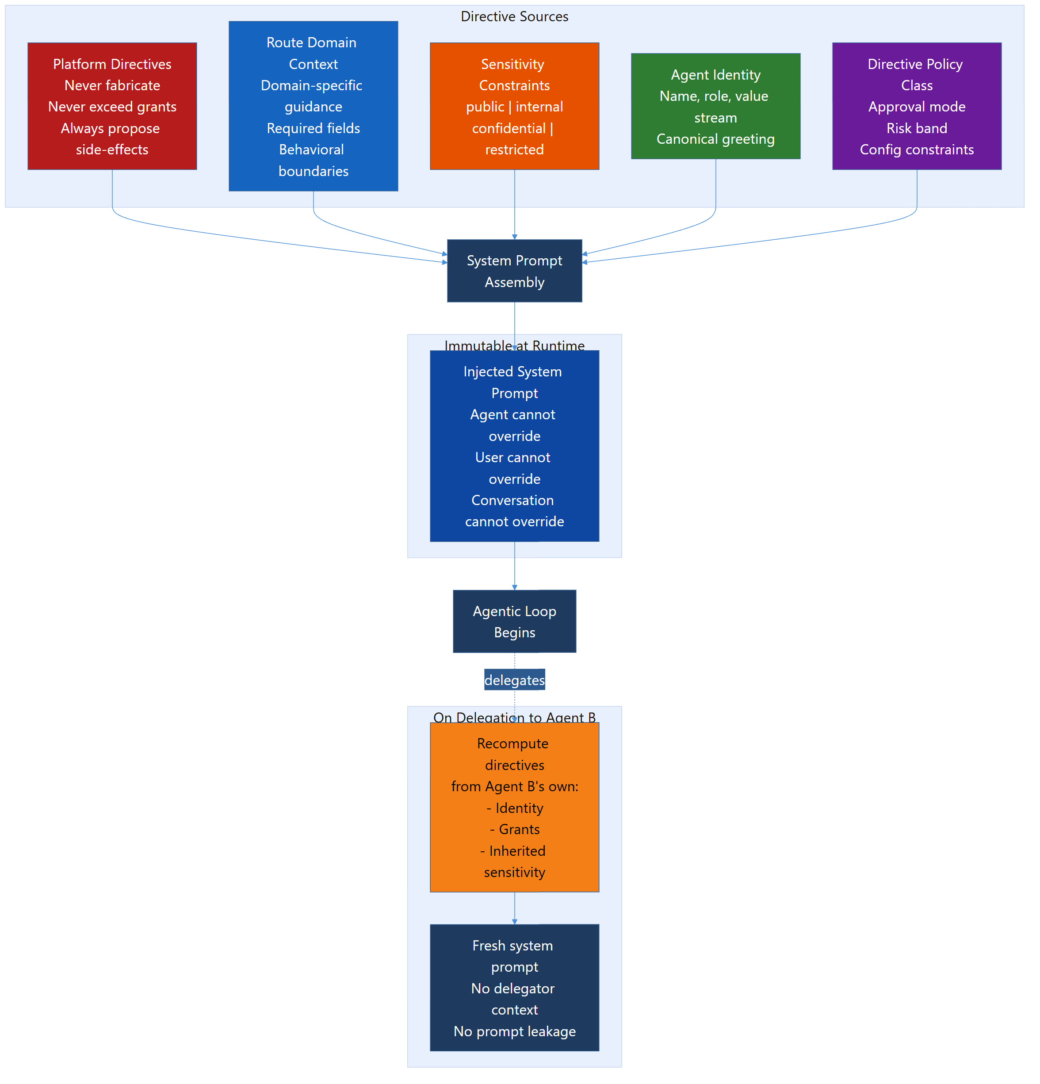
Figure 3. Directives are not merely prompt text. They are a governed runtime control surface.

11. Delegation, Coordination, and Specialist Topology

11.1 Delegation Narrowing
When an agent delegates to another agent, the delegated agent:
- MUST receive only the authority and context needed for the delegated task
- MUST NOT inherit broader permissions than the delegating context
- MUST operate under a recomputed effective permission set

11.2 Specialist and Coordinator Patterns
An implementation SHOULD distinguish:
- coordinators or orchestrators, which decompose, route, and synthesize
- specialists, which operate within narrower domain or tool scopes
This distinction matters because the same agent shape should not be assumed to fit all work equally well.

11.3 Escalation
A conforming runtime MUST support escalation to a human or higher-authority control point when:
- the action exceeds allowed authority
- the confidence or evidence is inadequate
- policy requires review
- the agent encounters a repeated failure or unresolved blocker

11.4 Provider and Governance Incident Escalation
A conforming runtime MUST support HITL and human escalation for operational incidents that cannot be safely resolved through autonomous retry or failover alone.
At minimum, the escalation path MUST cover:
- provider authentication failures
- billing, funding-token, quota, or contract problems
- provider or platform policy denials
- persistent platform misconfiguration
- repeated rate-budget exhaustion or queue starvation
- detected GAID scope or operating-surface violations
- suspected cross-boundary leakage or other reportable governance incidents
The runtime SHOULD treat these conditions similarly to an employee reporting an observed security or data-handling incident: safe continuation pauses, the issue is surfaced clearly, and a human owner is brought into the loop.
When such an incident is detected, the runtime MUST:
- preserve enough context for a human to diagnose the issue
- prevent unsafe continuation of the affected workflow until policy permits it
- present a pragmatic reason and next-step state to the user or operator
- record the escalation outcome
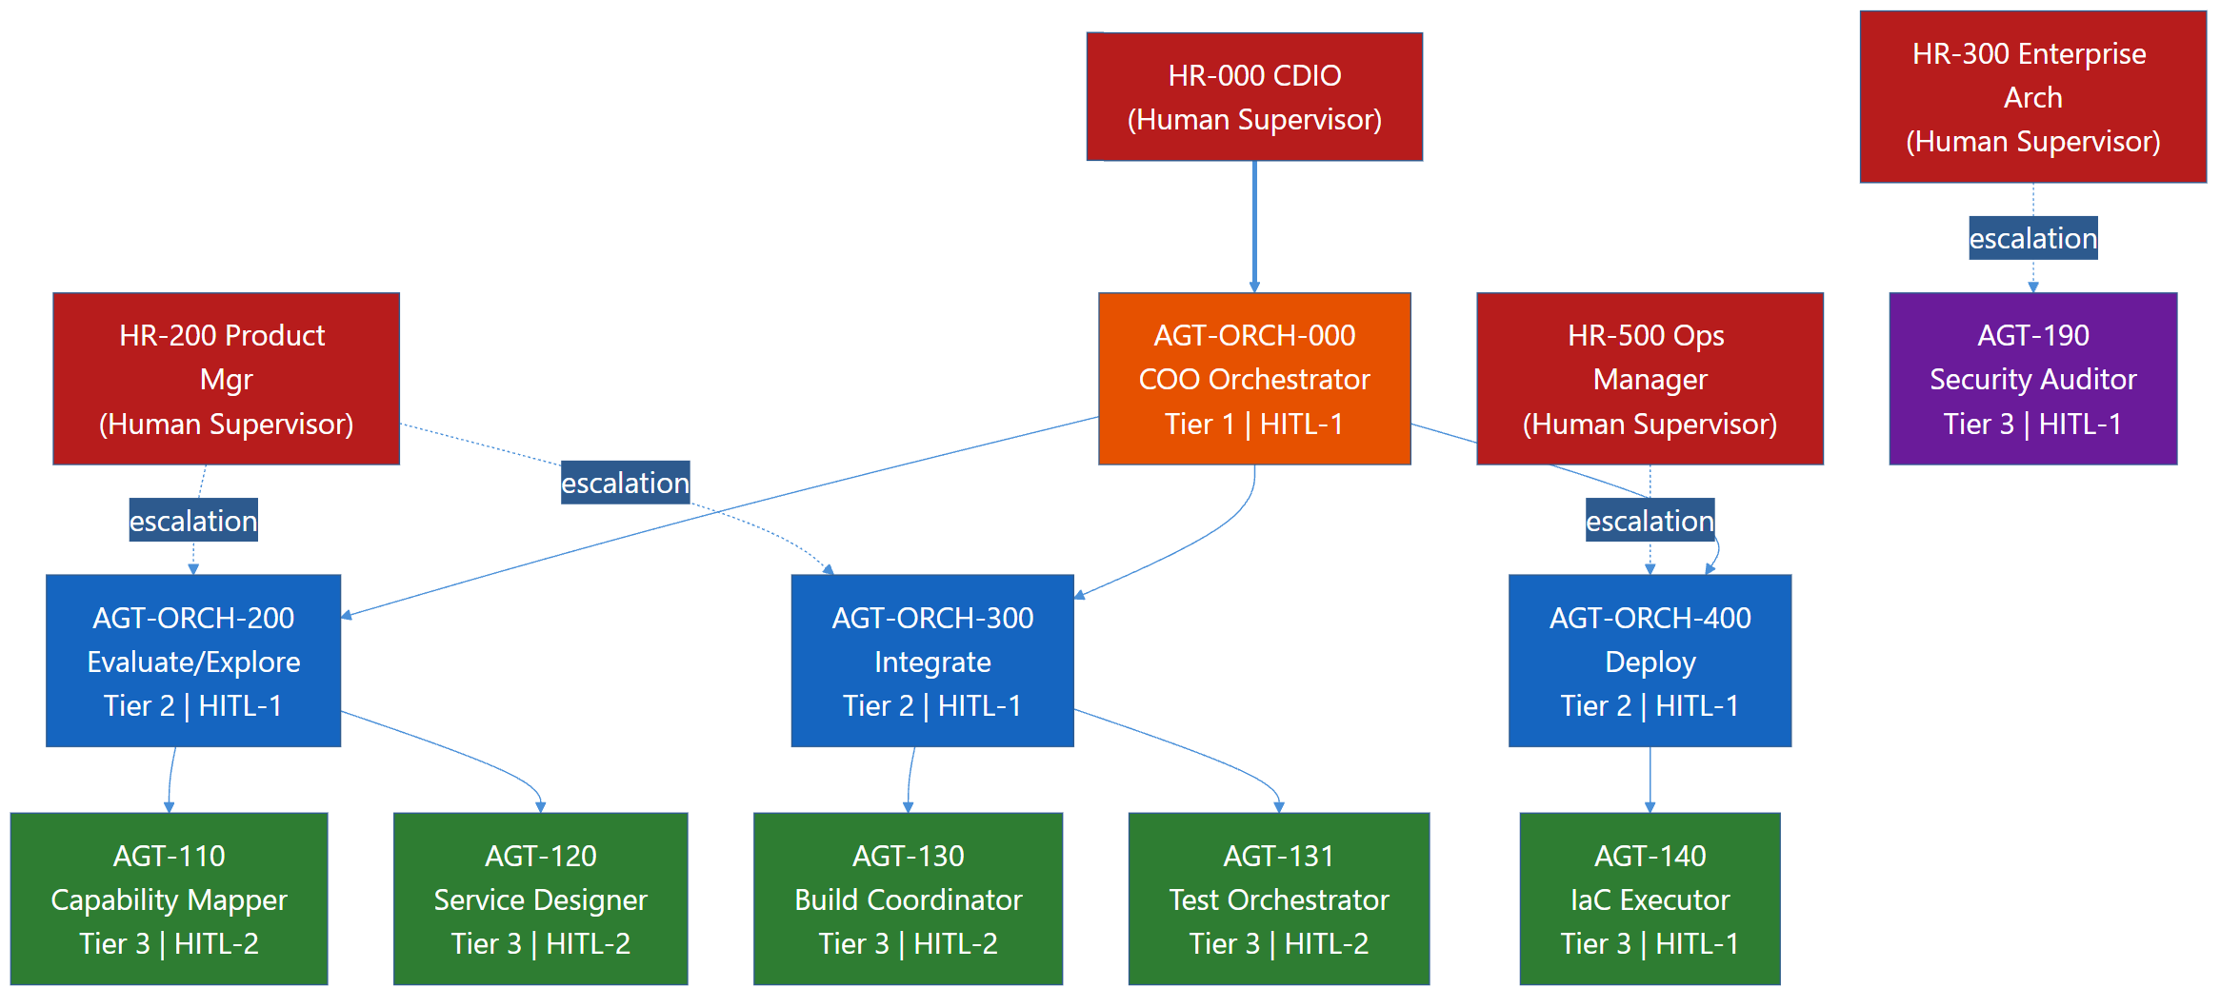
Figure 4. Delegation is valid only when authority narrows, not widens.

12. Memory and Context-Window Governance

12.1 Memory Is a Governed Surface
Persistent memory, retrieved memory, and prior conversation context MUST be treated as governed runtime inputs.
Memory is not a neutral convenience. It changes future behavior. Therefore, TAK requires explicit control over:
- what is retained
- how long it is retained
- who may retrieve it
- what confidence it carries
- when it must be re-validated

12.2 Retention Rules
A TAK-Managed or higher implementation MUST define policies for:
- transient conversation context
- durable preference or decision memory
- operational evidence and audit history
- sensitive data retention and expiry
The runtime MUST NOT expose memory derived from one principal, tenant, or authorization boundary to another principal, tenant, or authorization boundary without explicit policy permission.

12.3 Context Truncation and Summarization
When context windows are limited, the runtime MUST favor:
- durable decisions over transient chatter
- structured summaries over raw transcripts
- validated facts over speculative earlier drafts
The runtime SHOULD document summarization and truncation behavior so operators understand what information may have been omitted.

12.4 Memory Validation
For TAK-Assured, memory that materially affects consequential action SHOULD be treated as advisory until revalidated against a current source of truth.

12.5 Data Admission and Processing Boundaries
The following working-draft clauses belong to the same amendment as §7.13. They make admission and downstream processing separately testable.
Clause | Requirement
TAK-DG-001 | Before admitting data to an agent context, the runtime MUST resolve its classification, permitted purpose and source-access constraints against the actual principal, agent context and workroom. Missing classification MUST NOT silently become Public.
TAK-DG-002 | Where grants enumerate permitted data classes, the runtime MUST use set membership/intersection. It MUST NOT infer intermediate or lower classes from the highest listed class unless the governing policy explicitly defines that inheritance.
TAK-DG-003 | The runtime MUST preserve applicable source restrictions and provenance through retrieval, attachments, summaries, memory, caches and derived context. Recall and egress MUST apply current access, purpose and revocation rules; transformation alone MUST NOT declassify data.
TAK-DG-004 | Before a processing or disclosure boundary, the runtime MUST evaluate the actual destination account/connection and applicable data, purpose, residency and contract constraints. Fallback and outbound tool results MUST undergo the same evaluation. A model name, Public repository or room assignment MUST NOT substitute for destination approval.
Classification changes require the existing accountable data authority and an attributable record. These controls govern eligibility independently of whether the model is local, hosted or embedded in hardware. Audit visibility remains subject to minimization and access control; a denial need not disclose protected source content to explain the unsatisfied condition.

13. Audit, Evidence, and Non-Repudiation

13.1 Minimum Audit Events
A conforming implementation MUST record, at minimum:
- tool execution attempts
- tool execution results
- proposals and approval decisions
- escalation events
- policy denials
- provider backpressure, rate-budget exhaustion, and queue admission or rejection events
- scheduled retries, failover decisions, and provider-selection changes
- provider auth, billing, contract, or policy failures that affect execution
- detected GAID scope or operating-surface violations
- model and provider attribution for consequential actions
- governed decisions taken before consequential actions, and the linkage between the decision and the action it authorized
- the observed outcome of an authorized consequential action

13.2 Evidence Fields
Audit records SHOULD include:
- agent identity
- acting principal
- route or workflow context
- action or tool name
- parameters or parameter digest
- result or result digest
- execution mode
- queue state and retry count where applicable
- provider budget or backpressure state where applicable
- selected provider and model, and substituted provider and model if failover occurred
- timestamp
- duration
- success or failure

13.3 Decision Records and the Review Loop
Audit under §13.1 establishes what happened. It does not by itself establish whether the governing judgement was sound, or improve it. A runtime that gates consequential actions on a governed decision MUST also preserve that decision as a record, and SHOULD close the loop from the record back to the decision procedure.
A conforming implementation:
- MUST record, for each governed decision: the question, the options considered, the evidence and its sources, the recommendation, the outcome, and the risk class
- MUST bind the decision record to the action it authorized, so that an action can be traced to its authorization and an authorization to its effect
- MUST record the observed outcome of the authorized action — at minimum whether it succeeded, failed, or was subsequently reversed
- SHOULD protect decision records against retrospective alteration, for example by sealing them into an append-only structure
- SHOULD periodically re-evaluate whether the evidence a past decision relied on still holds
- SHOULD detect drift in the decision procedure itself, for example by re-scoring a frozen panel of canonical decisions against the current governing corpus and reporting changed outcomes
Why outcome linkage is normative rather than advisory. Where a human reviews or overrules each action, the human's ruling is itself a corrective signal, and a runtime can improve from rulings alone. Under autonomous operation that signal disappears: nobody overrules anything, so a system that learns only from rulings stops learning at exactly the point where its judgement is least supervised. Outcome linkage is the only corrective signal available in that mode, and an implementation claiming autonomous operation without it has an open loop, not a closed one.

13.4 Non-Repudiation
For TAK-Assured, the runtime SHOULD support cryptographic binding or message-level evidence sufficient to prove:
- who requested or approved an action
- what action was attempted or completed
- what evidence supports that conclusion
GAID provides the companion identity and receipt model for this purpose.
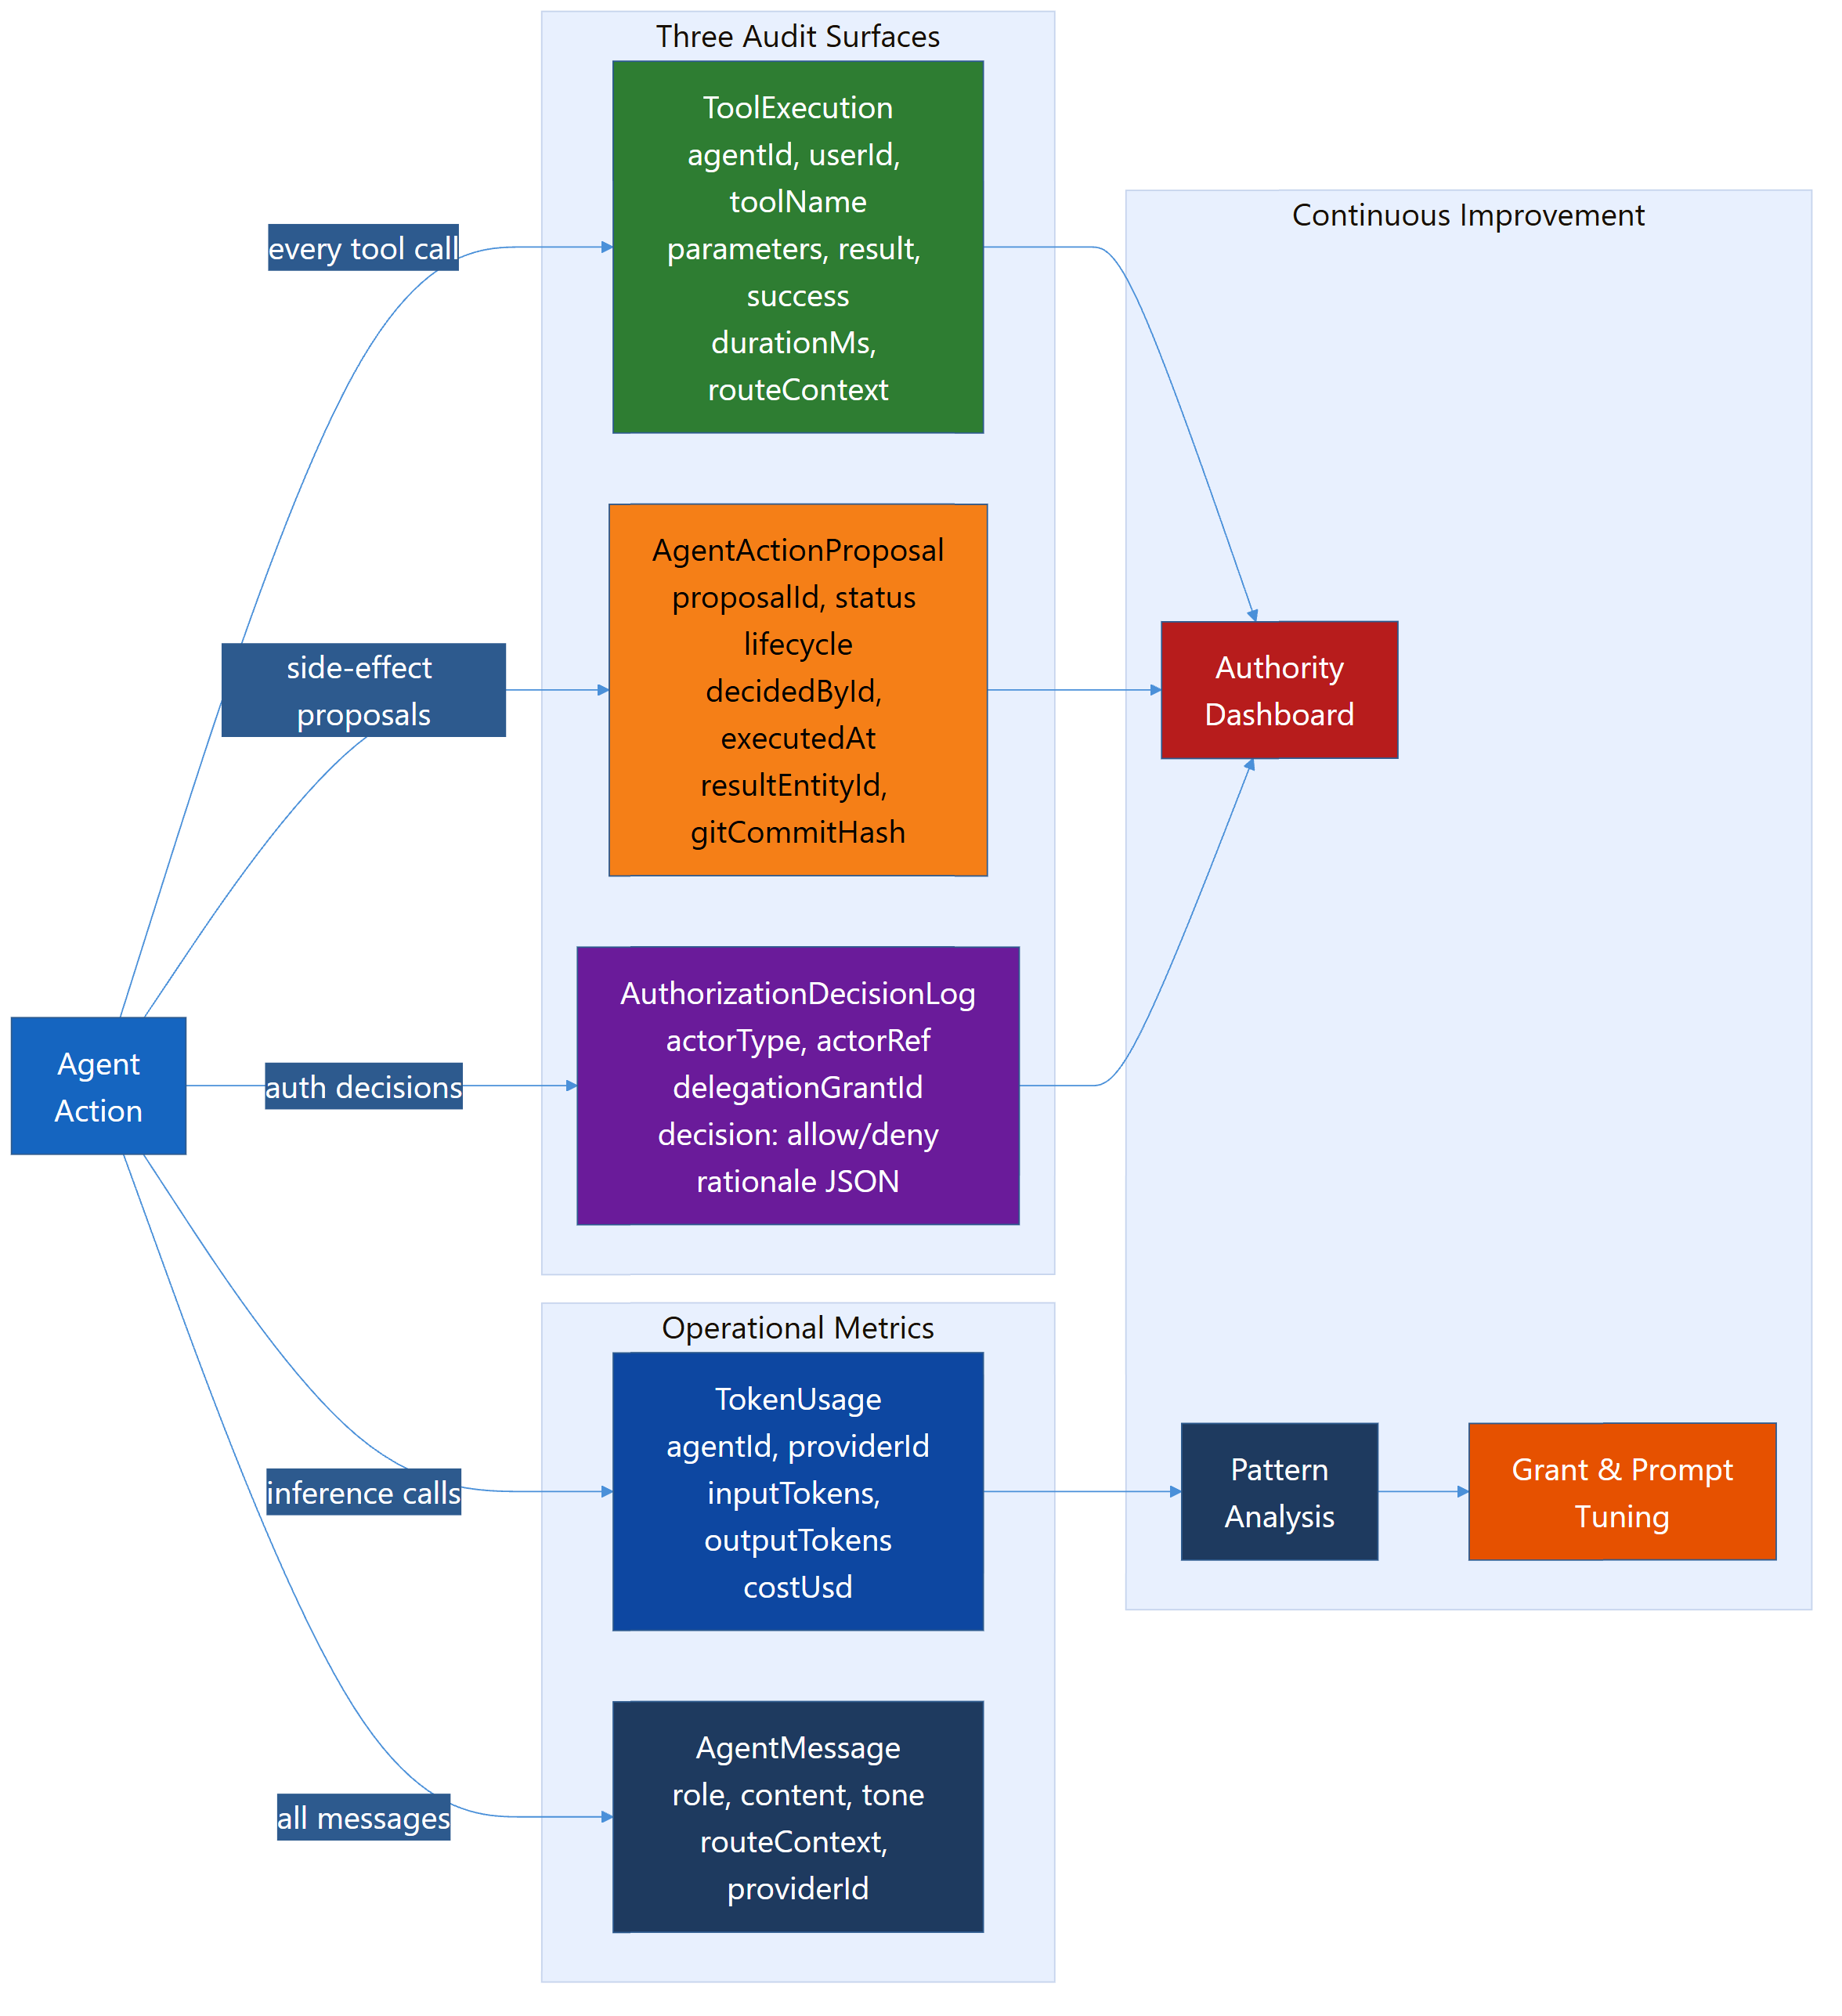
Figure 5. Audit is not a side effect of the runtime. It is part of the runtime.

14. Runtime Transparency

14.1 Required Transparency
A TAK-Managed implementation MUST provide operators with a way to inspect:
- effective permissions
- active tools
- oversight tier
- recent actions
- proposal state
- queue, retry, and deferral state
- provider budget, backpressure, and failover state
- failures and retries

14.2 Human-Facing Honesty
The runtime MUST prevent or correct outputs that falsely claim:
- completion without evidence
- deployment without deployment
- creation without creation
- testing without testing
This control is fundamental to trust.

15. Safety and Security Controls

15.1 Fabrication and Unsafe Narration
A conforming runtime MUST detect and mitigate situations where the model:
- claims completion without tool evidence
- narrates code or actions instead of performing governed tool use
- loops on unproductive retries

15.2 Injection Resistance
The runtime SHOULD implement layered defenses against:
- prompt injection
- malicious tool output used as instructions
- unsafe skill or template injection
- cross-agent context contamination

15.3 Sensitivity Handling
The runtime MUST allow policy to vary by data sensitivity. At minimum, the implementation SHOULD distinguish sensitivity classes such as:
- public
- internal
- confidential
- restricted
The runtime MUST NOT silently route restricted data into lower-trust tools, providers, or delegated contexts that are not cleared for it.

15.4 Open-World Tooling
External network or cross-boundary tools SHOULD be treated as higher-risk surfaces. A TAK-Managed implementation SHOULD explicitly classify such tools rather than treating them as ordinary local operations.

15.5 Threat-Model Alignment
An implementation SHOULD maintain an explicit threat model for the agent runtime.
At minimum, that threat model SHOULD identify:
- protected assets such as authority context, tool credentials, memory, evidence, and provider bindings
- relevant attackers such as malicious users, compromised delegates, compromised tools, hostile providers, and prompt-injection sources
- trust boundaries across prompts, tools, memory, providers, and cross-agent delegation
Threat enumeration SHOULD align where useful to emerging public catalogs such as the OWASP Top 10 for Agentic Applications, CSA MAESTRO, and MITRE ATLAS.
A shared starter artifact for this work MAY be published as agent-standards-threat-model.md, provided implementations still adapt it to their real deployment boundaries.

16. Evaluation and Red Teaming

16.1 Minimum Evaluation Expectations
A conforming implementation MUST test the runtime, not only the model. At minimum, it MUST evaluate:
- authorization boundary behavior
- tool selection correctness
- fabrication resistance
- incomplete-information handling
- unsafe narration
- provider backpressure and rate-budget handling
- queueing, resumption, and duplicate-prevention behavior
- approval-gate compliance
- qualification-scope enforcement
- autonomy progression and regression behavior
- proactivity clamping against authority, data, and qualification ceilings
- model-routing eligibility under sensitivity, residency, and job-fit constraints
Fabrication resistance and related trust claims MUST be backed by a published evaluation methodology and baseline rates, either by profiling a recognized benchmark suite or by documenting an organization-specific evaluation pack with reproducible pass criteria.
For job-specific claims, generic benchmark evidence is insufficient by itself. The applicable TAK-JSI scheme MUST evaluate the identified operating profile under representative job, tool, data, workflow, and consequence conditions.

16.2 Advanced Evaluation
A TAK-Assured implementation SHOULD additionally evaluate:
- prompt injection resistance
- cross-agent handoff contamination
- sensitivity handling
- audit completeness
- failure-mode transparency
- failover-policy correctness across capability tiers
- repeatability across provider and model combinations

16.3 External Signals
The growing public focus on agent security, identity, evaluation, and interoperability is relevant here. NIST's current work on agent standards and benchmark evaluation confirms that trustworthy agency is not only a model-quality problem, but a runtime governance problem as well.

16.4 Evaluation Cadence and Threat Catalog Coverage
Evaluation MUST NOT be treated as a one-time launch ritual.
At minimum, a conforming implementation MUST re-run the applicable evaluation set:
- on material runtime change
- on model or provider substitution
- on major instruction-bundle or tool-surface change
- on release into a new trust boundary or exposure state
- on a material job-profile, profession-corpus, decision-axis, routing-policy, or data-policy change
- when the applicable qualification expires, becomes restricted, or enters pending revalidation
TAK-Assured implementations SHOULD additionally map at least the most relevant scenarios to external threat catalogs such as OWASP Top 10 for Agentic Applications, CSA MAESTRO, and MITRE ATLAS, so evaluation coverage is legible outside one vendor stack.

17. Conformance Profiles

17.1 TAK-Basic
TAK-Basic requires:
- standardized runtime harness control-plane behavior
- layered authority mediation
- tool metadata with execution modes
- basic approval gating for consequential actions
- a declared consequence class on every side-effecting tool (§8.1)
- gating derived from tool metadata rather than an enumerated allowlist (§8.4.1)
- provider-aware rate budgeting and backpressure
- bounded, resumable inference queueing
- immutable directive support
- minimum audit logging
- fabrication mitigation

17.2 TAK-Managed
TAK-Managed requires everything in TAK-Basic, plus:
- reviewable oversight tiers
- runtime transparency views
- governed memory retention and truncation
- documented hidden-instruction governance
- delegation narrowing
- human-visible provider and governance incident escalation
- sensitivity-class-aware handling
- qualification-aware action ceilings
- explicit proactivity clamping and autonomy regression
- gate-coverage reporting over the tool surface and per agent (§8.4.2)
- autonomy bounded by gate coverage, with machine-evaluable admission criteria (§7.12.1-7.12.2)
- bounded activity shapes with declared triggers, stop conditions, and review points (§8.11)

17.3 TAK-Assured
TAK-Assured requires everything in TAK-Managed, plus:
- stronger non-repudiation support
- higher-assurance audit evidence
- advanced evaluation and red-team coverage
- governed failover and substitution traceability across approved provider sets
- stronger traceability across delegation and cross-system flows
- documented control ownership and change management
- evidence-backed, scoped autonomy progression with qualification and operational-surveillance links
- decision records bound to the actions they authorized, with observed outcomes (§13.3)
- outcome feedback into the decision procedure where autonomy operates without a human (§13.3)
- decision-procedure drift detection against a frozen canonical panel (§13.3)
Implementations claiming any TAK profile SHOULD publish an assertion mapping, evidence pack, or equivalent rubric such as the companion tak-conformance-tests.md document.

18. Security Considerations
This standard assumes:
- models are fallible
- tools increase both usefulness and risk
- memory can become an attack and error surface
- hidden instructions create real governance obligations
- interoperability without runtime governance is insufficient
The consequence is that a trustworthy agent runtime cannot be reduced to prompt design alone.

19. Informative Annex A: Relationship to GAID and TAK-JSI
TAK, GAID, and TAK-JSI are designed to work together.
- GAID identifies and attests the agent, its claims, and its public or cross-boundary posture.
- TAK-JSI defines whether a versioned operating profile is qualified for a declared job, activity, data, and risk scope.
- TAK governs the runtime in which that agent actually operates.
In practical terms:
- GAID answers "who is this agent and what claims does it carry?"
- TAK-JSI answers "what job is this operating profile qualified to perform, under which constraints, and what evidence keeps that claim current?"
- TAK answers "how is this agent actually constrained, supervised, and evidenced at runtime?"
The canonical family map is agent-standards-family.md.

20. Informative Annex B: Relationship to DPF
DPF already demonstrates a number of TAK patterns in practice, including:
- layered permission intersection
- execution-mode gating
- immutable runtime instructions
- route-scoped tool exposure
- anti-fabrication controls
- audit logging
- orchestrator and specialist patterns
- proactivity controls separated from hard approval ceilings
- sensitivity-aware model/provider routing
- shadow-ledger and progressive-autonomy mechanisms
That makes DPF a useful proving ground for the first conformance assessment of this standard.
For the purposes of this standards family, DPF should be understood as an initial implementation prototype rather than as a claim of full conformance.
The prototype value is that DPF can concretely demonstrate:
- which TAK controls are already practical in a real enterprise-facing platform
- which controls require more explicit machine-readable surfaces
- what evidence and runtime-state publication patterns need to be added next
The most useful near-term DPF outcomes under this standard include:
- explicit queue and provider-budget state publication
- stronger runtime event typing for backpressure, failover, and escalation
- tighter linkage between runtime evidence and companion GAID receipts
- clearer supervisor-facing transparency for active runtime posture
- qualification-aware runtime enforcement and revalidation through the companion TAK-JSI profile

21. Revision History
Revision | Change | Origin
2026-08-20 | Added §7.12.1 (autonomy bounded by gate coverage), §7.12.2 (admission criteria), §8.1 consequence class, §8.4.1 (derived classification; enumerated-allowlist anti-pattern), §8.4.2 (gate coverage as a governed metric), §8.11 (governed activity shapes and triggers), §8.11.1 (trigger classes; dead-intent rule), §8.11.2 (proactivity does not widen a shape), §13.3 (decision records and the review loop). Profile requirements in §17 extended accordingly; assertions TAK-020–TAK-028 added to the companion rubric. | Derived from operating a real implementation. Each addition addresses a failure observed in practice rather than an anticipated one: a correctly-implemented, enforce-by-default action gate that governed 2 of 169 side-effecting tools because its scope was an opt-in list; recurring agent-initiated activity with no declared stop condition; and a governance loop that could learn from human rulings but not from outcomes, leaving it open in precisely the autonomous mode it was built for.
This revision is additive: it introduces new normative requirements without weakening or contradicting existing ones, and is therefore a minor-version change under §2.1. Implementations conforming to the prior revision remain conformant to the requirements they already met, and will show gaps against the new assertions.

22. Summary
The key message of this standard is simple:
AI agents become trustworthy and repeatable in practice only when they run inside a standard kernel harness that governs authority, tools, memory, provider use, oversight, and evidence with discipline.
TAK provides that discipline. It is not a substitute for broader organizational governance. It is the runtime harness standard and control model that makes operational governance real.

