# 

*Prepared by: Corey Snipes*

*For: UC DroneCamp, July 2021 (v1)*

# About WebODM for DroneCamp

OpenDroneMap normally runs on a server, which could be on your local computer or could be somewhere on the cloud. Once you have a server going, you typically access OpenDroneMap through a web browser.

For DroneCamp, we’ll be using WebODM Lightning. WebODM Lightning has two parts. The Desktop App for Windows is a modest program you can install and provides a user-friendly interface to submit your images for processing, select processing options, view results, etc. However the destkop app by itself is useless - it doesn’t actually process any data! For that you need to connect it to a processing engine or ‘node’, which in this case is running in the cloud.

For the DroneCamp WebODM workshop, we would like everyone to:

* Sign-up for a free WebODM Lightning account, and
* Install the WebODM Lightning client for Windows

This combo will give you a user-friendly interface and easy access to a good server in the cloud to process your images. The WebODM Lightning server is not free, but your WebODM Lightning account includes a generous 150 free credits which will be plenty for the DroneCamp exercise (don’t use them up before then!)

# WebODM Setup

To get started, please visit webodm.net. Look for the blue “Sign Up” button to create your WebODM Lightning account. Use the blue “Download For Windows 64bit” button to download and install the WebODM Lightning client. Finally, download the test dataset. Once you’ve performed these steps, you’ll be all set for DroneCamp.

Power users may wish to install OpenDroneMap locally on your own hardware. A Windows 10 or Ubuntu Linux computer with at least 16 GB RAM is required. Manual installation instructions are here: <https://github.com/OpenDroneMap/WebODM/#getting-started> . This process has more steps and may require some fiddling. We won’t be able to address any installation or configuration issues during the presentation, so if it gives you trouble please use WebODM Lightning instead.

# Step 1: Sign Up for Free Account

Sign up for a free WebODM Lightning account. Make a note of the email address and password you select during this process, as you will need it later.

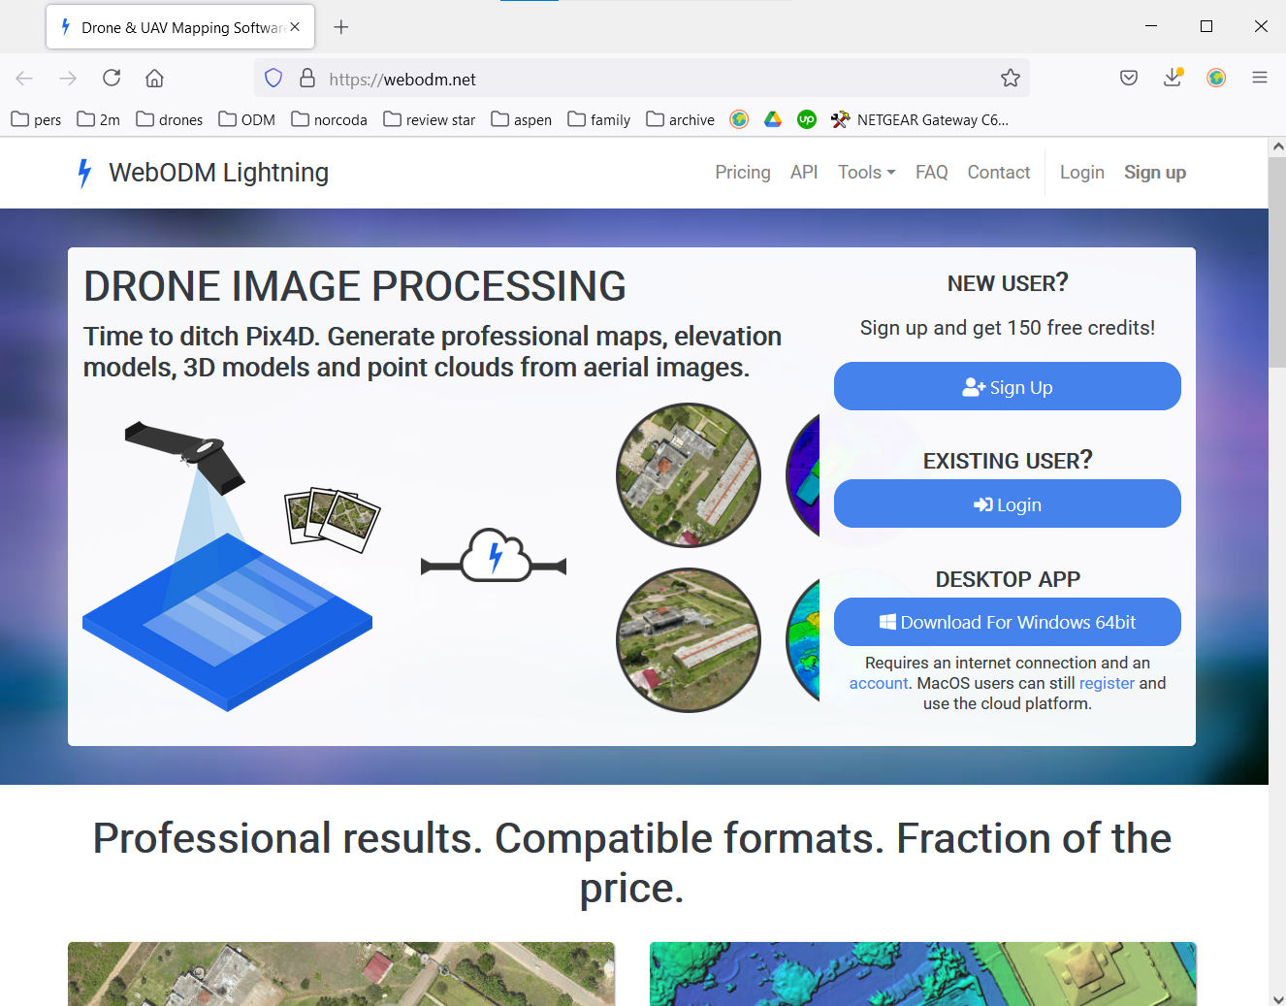



# Step 2: Download WebODM Lightning





# Step 3: Install and Connect Your Account

Run the installation file you downloaded and follow the steps to install WebODM Lightning on your local machine. After installation is complete, open WebODM Lightning and connect your account as shown below. You will need the email address and password you selected earlier.

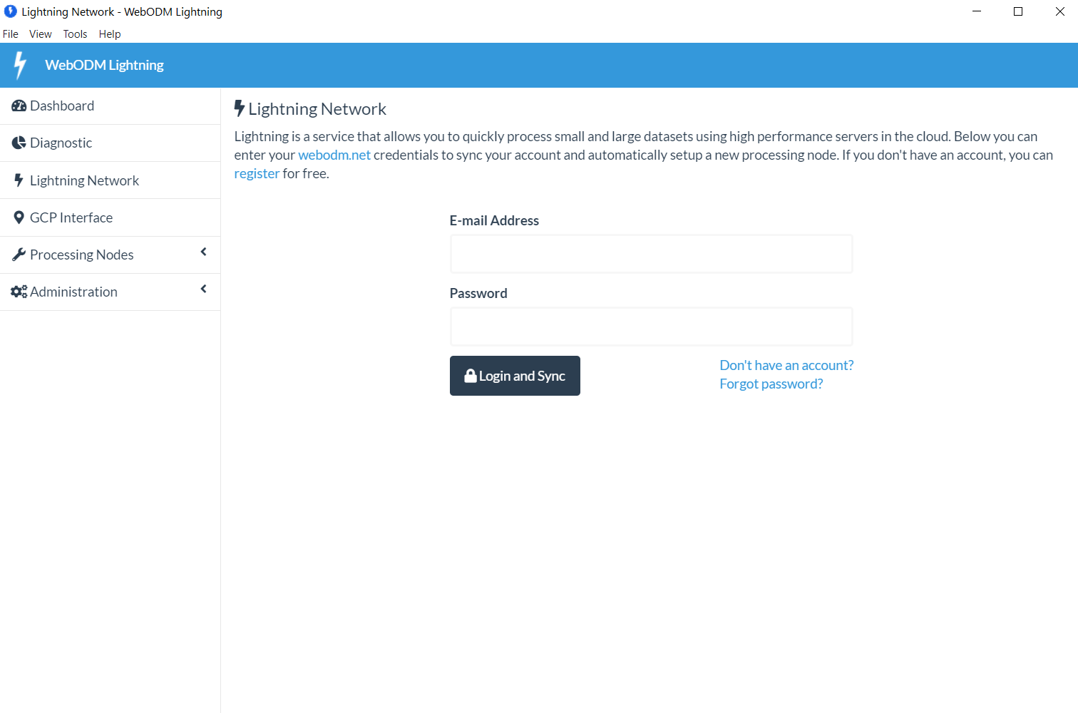



# Step 4: Download the Sheffield Park 1 Test Dataset

Go to the github page: <https://github.com/pierotofy/drone_dataset_sheffield_park_1/tree/master>

Download the zipfile, as shown below.

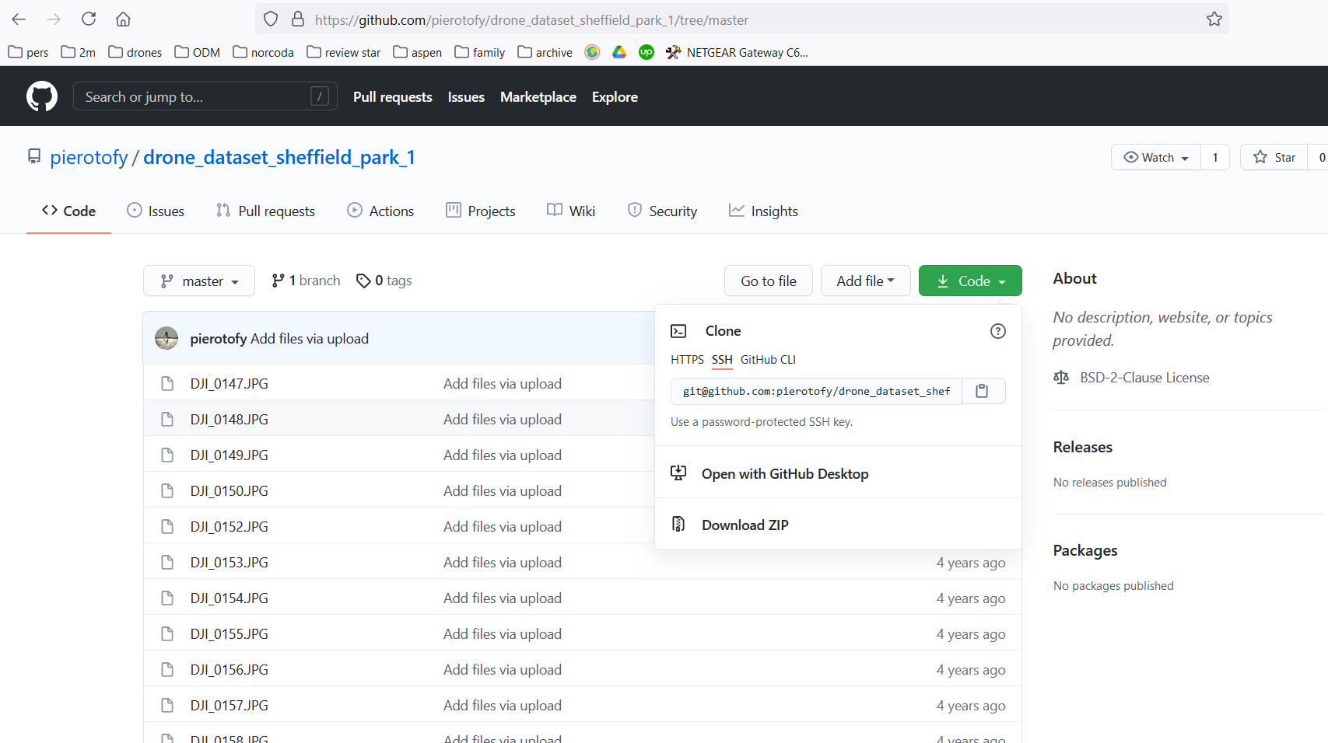



That’s it! You’re ready for the OpenDroneMap session at DroneCamp 2021.

# Need Help?

If you are having trouble with the installation or setup steps, feel free to contact the instructor at [corey@twomile.com](mailto:corey@twomile.com) for assistance.

###