Getting Started with Quarterhorse – a Geek’s guide to Ford Tuning:

A couple of years ago I began a Factory Five Roadster project, using a donor smallblock driveline from a 1990 Mustang. As appealing as the simplicity of a barely controlled fuel leak was (aka, a carburetor), I decided to stick with fuel injection. Over the build I decided to plan for future supercharging and performance improvements, so larger injectors were added, larger throttle body, bigger MAF, emissions were deleted, hotter cam went in, ported heads, free flow exhaust... The stock tune wasn’t cutting it any more, and I didn’t want to shell out $800 for a “one shot” chip to be burned for it. I wanted to be able to hack the system to my current and future needs.

The hardware choices came down to Tweecer or Moates Quarterhorse, and I chose the Quarterhorse because of superior emulation and a much lower price. This is what this note talks about.

Quick background – what is a Chip/Emulator/tuning system?
Fuel injection relies on having a computer control the timing/duration of the fuel injectors, the opening/shutting of EGR passages, air bypass (thermactor) plumbing, spark timing, throttle bypass (IAC), lots of etc. Ford did an incredible job of coding their engine control software 20 years ago, it is a small image that seems VERY flexible, adaptable, open and resilient to tampering.
There are hundreds of variables, scalars, flags, maps and behaviors that can be changed to improve (or not) the engine performance, and with a bit of study and thinking it provides the modern tuner with FAR more control than messing with jet sizes, octane bars, spark advance or carb balancing ever did.

How does it work?? What is a “chip”?
Just like your desktop PC, the Ford EEC computer consists of a CPU (processor, microcontroller, whatever) that simply reads inputs, executes instructions out of memory and drives outputs. The memory in this case is a read-only image that is soldered to the circuit board and internal random-access-memory – there isn’t a “chip” that you can remove and replace in the computer case. Luckily though, Ford provided a connector on the computer (J3 you will hear it called) that provides access to the memory bus – presumably this was used for factory diagnostics or a planned-but-never-built dealer tool. This connector is usually covered with a tape or sticker, it is on the opposite side of the computer case than the BIG bolted-on computer connector, and it provides a “back door” to the computer system. Mad scientists like Craig Moates have built hardware that can spy on what goes on between the computer and it’s memory bus, and can intercept and control the bus – essentially “replacing” the factory read-only memory image with another image – or “bin” which is short for “binary image” or geek for “program”.

This is what a “chip” does – it replaces the factory computer code with another image that is modified to behave differently. Quarterhorse is FAR cooler than a simple chip though, it lets you change the code image “on the fly”, it lets you watch the computer work in near-realtime, and it provides complete access to the innards of the system – with the ENGINE RUNNING. How cool is that??

Anyhow, that’s why I bought one. On with the note

- I ordered the Quarterhorse online, and in 4 days UPS Ground had it on my step. What to say? It’s a box with a bumper sticker, USB cable and Quarterhorse circuit board wrapped in a static bag. Don’t open the bag and play with the board until you are in a proper environment (more later). All electronics are succeptible to being zapped by static charges, the bag keeps Quarterhorse safe from you zapping it accidentally – leave it in the bag until later.
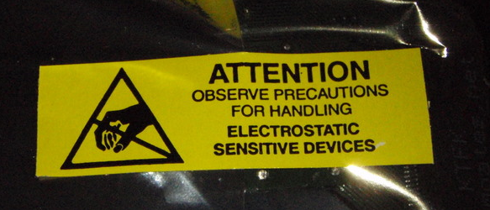

- Quarterhorse is different than some other chips/emulators/systems in that it is installed INSIDE the computer case on the J3 connector. This means you are going to have to open up your computer, bend some components out of the way carefully, and then close it up again. Not a big deal– if you can work on your own car you can easily do this, and it’s not like there is still a warranty on a 20 year old computer!!

- Installation – this has been well written up elsewhere, so this install section will be short & sweet. TURN OFF THE IGNITION. Get to your computer (passenger kick panel RHS in a stang, behind the dash and under the heater fan on my Cobra). Use a 10mm wrench to unbolt the ~60 wire connector from the computer case, unscrew the computer holding strap, remove, take it to your workbench.

- Use a TORX set to open the case – it’s 4 larger torx, and 2*T10 – case opens up and you can see the main ‘puter board. Use a bit of brake cleaner on a rag/paper towel to clean off the cosmoline/goo from the J3 connector – be sure to clean both sides.

- Bend over the obviously in-the-way components, but do NOT bend them back-and-forth, or you’ll be googling “solder replacement parts circuit board”. Seriously – just bend them out of the way ONCE and you’ll be fine. Insert the Quarterhorse on the J3 connector, and if you like, insulate the bits that poke out with tape and re-assemble with the USB cable suck under the board
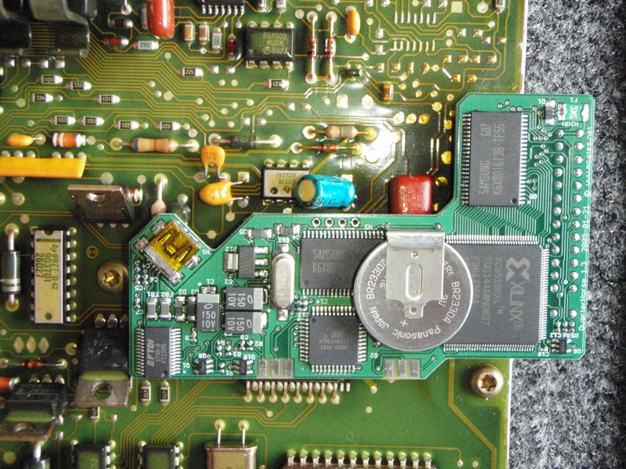
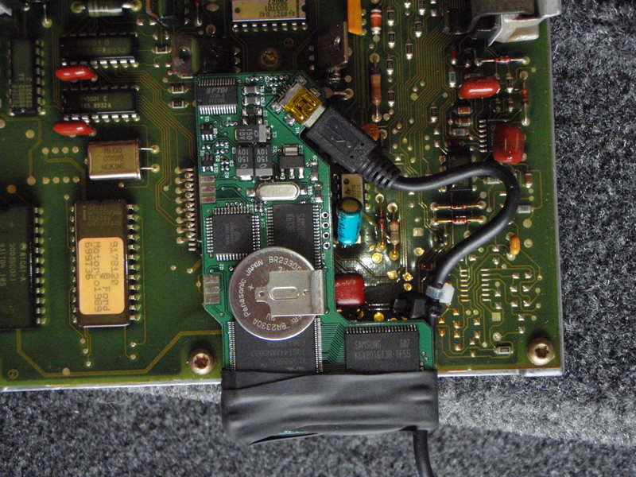
- Re-install the big connector onto the ‘puter, then connect a laptop to the US cable with either EEC Editor or BE installed (more later). When installed, you should see “USB device detected” and then a bunch of automatic driver installation. Obviously, it’s good to have the laptop connected to the Internet at this point to grab the needed drivers (else, goto Moates.net and look for USB troubleshooting)

YOU ARE NOW READY FOR SOFTWARE!!!

- Procure a bin that matches your ‘puter or vehicle – mine was based on a 1990 Mustang GT, so I wanted A9L binary image and defs (gufb.def) – this is what we need to load into the Quarterhorse – who knows what image Craig left behind after testing….. The A9L bin and defs comes with the default EECEditor install.

- Software – Now that you have the QH installed and the computer back in place you need to have something to talk to the QH to tell it what to do, what software image to use, etc. There are 3 main options at this time:

EEC Editor – freeware,
exclusively Ford EEC editing and datalogging software
by Paul Booth.
http://www.moates.net/zips/boothware/
As this was the first FREE software (nothing is really free, send Paul some paypal $ to buy beer or keyboards) available that supported QH, it is what I chose to use first.
From Moates webpage:
“Software for Ford vehicles only! This is the new Paul Booth EEC Editor software! Supports the BURN1, Ostrich, 27SF512, F3, and FORDEMU directly. Instructions included. No registration or keycoding needed. You can edit your binary and the definitions. Click on the 'Product Web Page' below to download (about 7mb). The linked page also contains definitions and binaries.”

Using EEC Editor, specifically for an A9L bin image (88-93 Mustang 5 sp):
Here’s a step-by-step guide to getting started tuning with EEC Editor – based upon my newbies step-by-step experience and using a laptop with XP:

NB – Paul does this as a hobby, so don’t expect 7*24 phone support! Get yourself a yahoo account and join http://tech.groups.yahoo.com/group/eeceditor/ which is the group that Paul runs to discuss/support EECEditor. Also, for your own Karma, if this software helps you then send him a few bucks, write some docs, host a better online support group for him….. pay it forward!

- Install EEC Editor from Moates.net software page - http://www.moates.net/product_info.php?cPath=33&products_id=75 and click “product webpage” to go to http://www.moates.net/zips/boothware/
- Install the installer/updater (step 1) onto the computer you will be tuning with (use a laptop, seriously).
- Run EECEditor, and see if it will automatically update. As this is often trickier than it seems, if it doesn’t update to the latest and greatest automatically, you can manually download the “update CAB” file from this page onto your PC, double click the CAB file (which will open like an archive or ZIP file), then copy & paste ALL of the files inside the CAB into c:\program files\EECEditor\ or wherever you installed EECEditor two steps earlier.
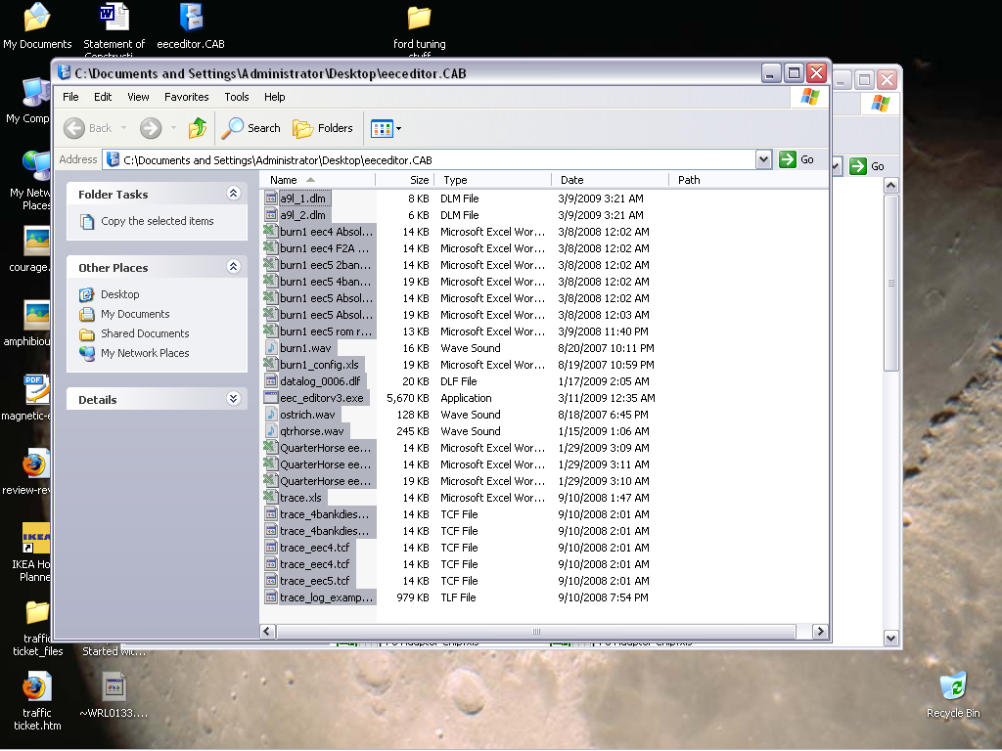

NOTE – for some reason when you copy from the CAB to the EECEditor directory, you will be prompted to “SAVE” each file – drop a note to Bill Gates if you want to know why, and just click “Save” 20X to copy the update files over.
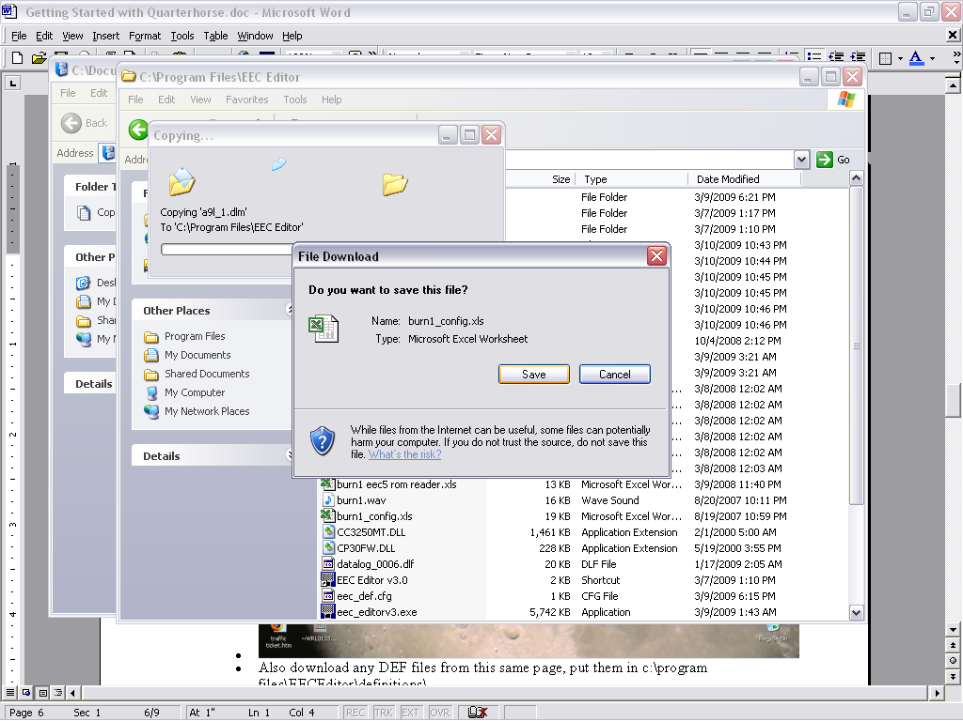

- Also download any DEF files from this same page, put them in c:\program files\EECEditor\definitions\
- Download or copy the binary file (bin) that matches your application. In my case I was using most of the parts from a 1990 5sp 5L mustang, so I used an A9L image. If you have no idea what build to use, there is a Ford defs and bins list at:
http://www.tunerpro.net/downloadBinDefs.htm (I’ll do a writeup for them as soon as QH is supported, great site)
and you can download many images at http://www.moates.net/fileman/index.php?dir=1)%20Stock%20Binaries/Ford%20Binaries
- Connect your laptop to the USB connector from the QH – see earlier mention of drivers being installed automatically. DO NOT TURN ON YOUR IGNITION KEY – you can talk to QH without the car being “on”
- Start EECEditor, listen for the “Whinny” sound as it discovers the attached Quarterhorse. If you don’t hear the horsie, then check your cables and USB drivers. With Windows XP, the drivers automagically installed themselves – it you’re using Windows 98, then I’d suggest taking of your parachute pants and joining the rest of us in the year 2009!! Seriously – upgrade to XP. It’s time.
- Note – Moates QH ships with either a default load or “binary noise” – neither of which is good for running your car. In fact when I did turn on my ignition with QH installed BEFORE I installed my A9L build, the bogus code running turned on my fuel pump and “buzzed” a bunch of injectors – judging by the fuel smell I think it flooded out “real good”. Luckily I did no damage, but don’t do this yourself! Load the code BEFORE turning the key.

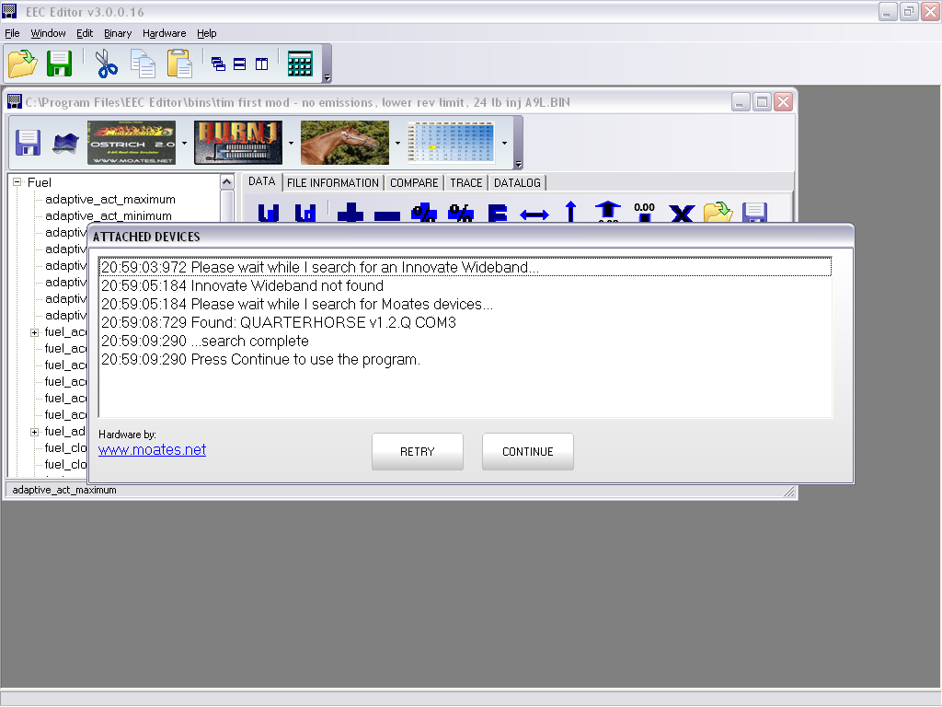

- Open the A9L binary (if you have a different car, you’ll use a different bin – a 1990 automatic Mustang would use A9P, an 1993 Cobra would use X3Z, etc.)
- IF the appropriate def file doesn’t open, then open it – for my case the GUFB.def file opened automagically.
- NB – there is a good selection of Bins and references on the Moates EECEditor page
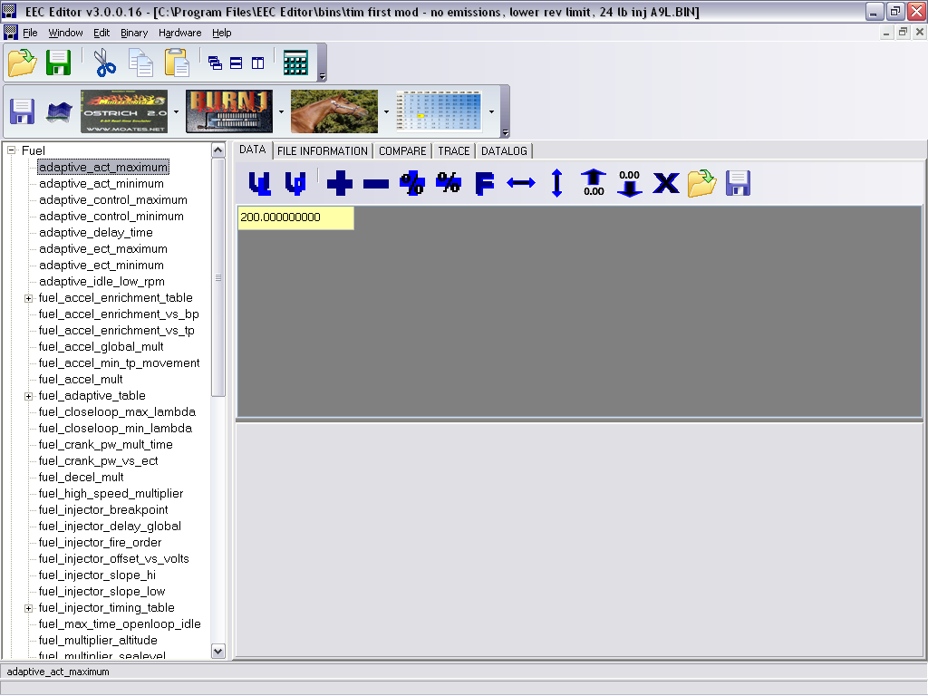

- in my case I changed the injector size to match my engine (24 lbs, set in fuel_injector_slope_hi and lo), turned off my emissions (various, mainly in misc), changed the rev limits, increased idle to suit the cam/flywheel and a couple of other misc issues for my first tune. Clicking the picture of the quarterhorse and telling it to download showed:

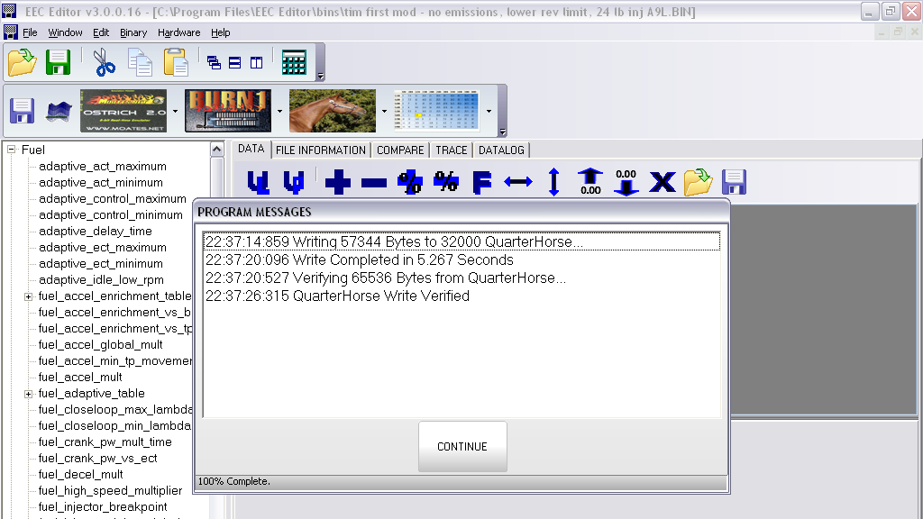

- and not surprisingly, the car started up just fine. Ran much better than with the factory (adapted) tune.

- NOW – exploring this definition file yields LOTS of things you could play with. It’s up to you to google, read newsgroups, and study to figure out what SHOULD be messed with. Most of the variables in the bin will not help you if messed with.

Setup EEC Editor for datalogging
- Quarterhorse can give visibility to the “memory bus” between the ‘puter’s microcontroller and what it thinks is it’s factory installed memory image (the code, or the bin). QH intercepts this bus, and lets you datalog/view/edit this information IF it is correctly configured. Further, Paul Booth has written “patch code” that tells the microcontroller to share memory values that QH cannot usually see (containing interesting info like throttle position, rpm, etc.) – the patch tells the CPU to put these “normally hidden” values into memory locations that QH can see. NB – if you configure QH correctly, this works like a champ. If you make the smallest mistake, it might not work at all. Here’s what you need to know to configure it:
- For an EEC-IV, configure the file:setup menu as follows, explanation follows the screenshot (file – setup):
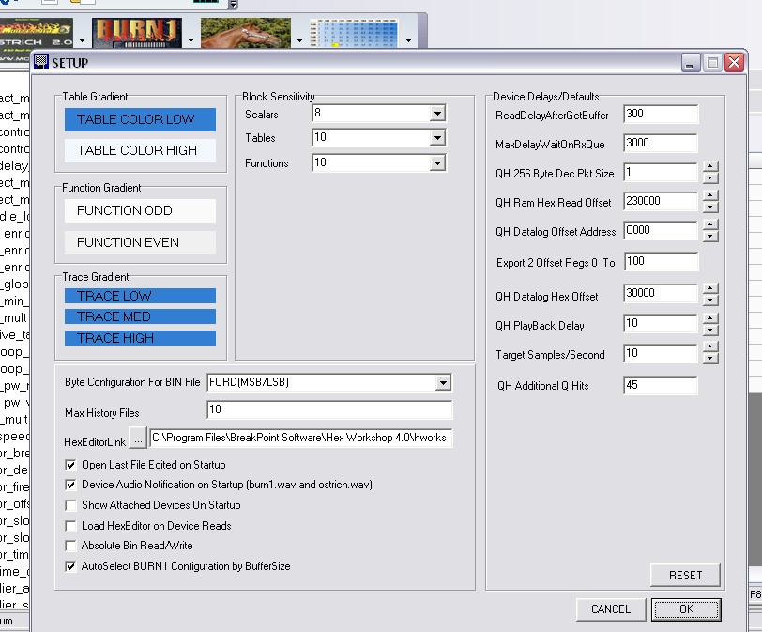

NOTE – enter these exactly BEFORE messing with the variables – fat fingering a single one (like export offset) can prevent things from working. Get it working, THEN mess with these variables.

Lets’ go over these values in detail – it IS important! From the Help File:

- 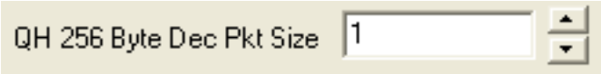
Description: This is the number of 256 byte packets requested when using RAM IMAGE. It is not used by the datalogging portion of the software. This packet address starts at the ram hex read offset.
Format: decimal
Min : 1
Max: 32;
Notes: 1=256 bytes, 32 = 8192 bytes. EEC-IV’s have 8192 bytes of ram memory. Generally recommend logging 1 or 2 packets at a time. Increasing this number can load the com port and slow things down.

- 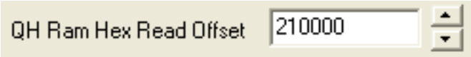

Description: This is the starting address to read memory from when using RAM IMAGE. It is not used by the datalogging portion of the software. An address of 210000 = 0 for an EEC-V, 270000 for an EEC-IV
Format: hexadecimal
Min : 210000
Max: 27FFFF
Notes: set to 210000 for an EEC-V and 270000 for an EEC-IV. This will read bank8 memory of both.

- 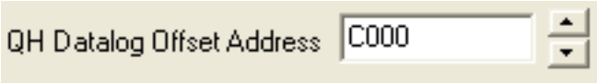

Description: When applying patch code to your processor, this is the data range you write the data to in
The QuarterHorse(QH). This field is only used when the export field is greater than or equal to 0x100.
In cases of the EEC-IV, where you want memory from 0-FF or an EEC-V where you may want 0-3FF, you would set this to C000 or your desired write range. Patch code written for EEC Editor will generally be written in this range.

Format: hexadecimal

Min: 2000

Max: FFFF

Notes: Patch code written for EEC Editor will follow the layout of the original eec memory block.

Example1: if you read internal memory at address 0xF2, this memory will reside at the datalog offset + F2, or C0F2. This allows you to use the correct addressing in DLM files without regard to i/o in the QH.

- 

Description: When using patch code, you must tell the software how many blocks of 256 bytes you are expecting at the datalog offset address.
This value should always be multiples of 256 bytes. 100 hex = 256 dec. NOTE! Increasing this value puts a significant load on the processor.
I would suggest not going much beyond 100. I have tested 1000, but that was with an EEC-V.

Format: hexadecimal

Min: 0 ; When set to zero, there is no code patch in use. You will get whatever the QH sees from EEC Memory.

Max: 2000 ; recommend not more than 100-200.

Notes: The QH can not read internal memory, ie 0-FF for the EEC-IV and 0-3FF for the EEC-V. There may be other memory areas like this as well.
This is the only time you would use this field or set it to non-zero. It is used by both the DATALOGGER and RAM IMAGE functions.

Example1: packet size =1, this param set to 100, datalog param addr = 2E. reads 2E from C02E. Note, eec patch code must be applied for this to work.

Example2: packet size = 1, this param set to 0. datalog param addr = 2E. reads address from 2E.

- 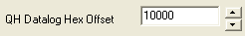

Description: This is the datalog version of the ram image's ram read offset.

Format: hexadecimal

Min: 10000

Max: 7FFFF

Notes: Set to 30000 for EEC-IV and 10000 for EEC-V.

- 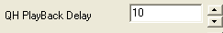

Description: Playback delay in milliseconds.

Min: 0

Max: 2,147,483,647

Notes: 1000=1 sec, 2000=2 sec, 500 = 1/2 second. This the playback delay between frames.

Description: Target rate for the software to achieve while logging. When set to 100, you are requesting 100 samples/sec. A sample may contain
from 0 to a large number of parameters. This parameter acts as a speed limiter and functions to slow data i/o as needed. This pounds your PC if set to high, keep it at 100 until you have things working, increase until you see issues then back off again.

Min: 1

Max: None, but your PC/USB/QH might puke if too high

Notes: Use sparingly. The faster you go with larger blocks of data, the more likely you are to overrun the comm buffer.

- 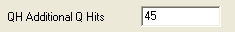

Description: The QH has an input buffer. Increasing this value puts a constant load on the QH input buffer causing it to write a constant
stream of data to EEC Editor.

Min: 1 – set to 1 for using the RAMIMAGE.dlm file, set to 45 for regular datalogging.

Max: 2,147,483,647. Recommend not more than 45.

Notes: Increase this to speed data transmission or reduce to prevent errors.

Now, once the program is setup appropriately, you need to ensure that the computer is loaded with the right code image.
BACKGROUND – as explained above, the software loads a “patch” into the EEC ‘puter that tells it to “expose” internal variables to the bus so that you can see them. After opening the ‘bin file, you need to open the appropriate DLM file (open the bin, the def, then select datalogging and then OPEN the datalogging.drm file) which tells EEC Editor how to patch the EEC to expose these magical variables.

PROCESS –
- Key off, write the BIN and calibration data (click the horsie icon) – make sure it verifies OK…. If it fails, reboot the PB, cycle ignition, start over

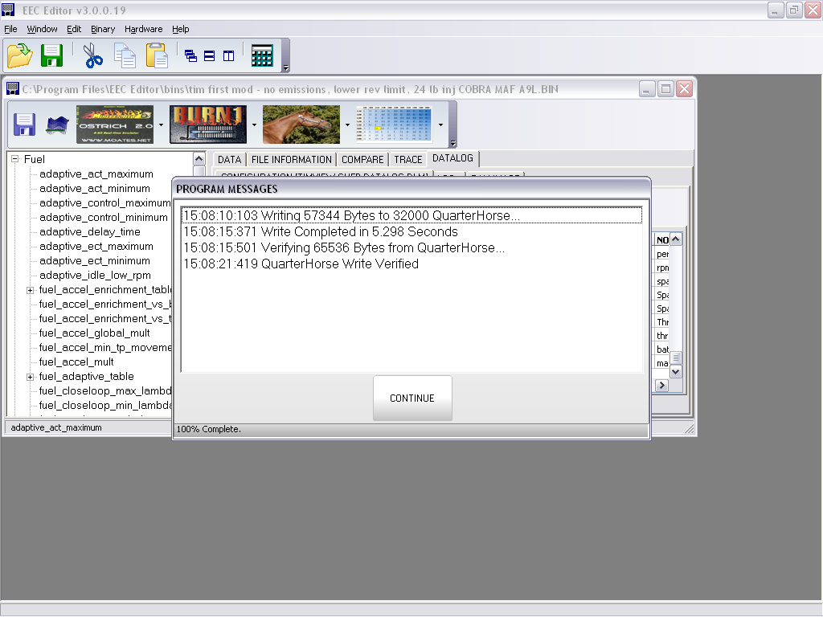

- Select Datalog tab, click “Configuration” and load up one of the templates.
- Click to select the variables you want to watch/log
- Click “log”, click “start”, watch the variables change – TP is a handy one to watch to make sure it tracks what you do – without even starting the car you can watch the throttle position change as you step on the gas pedal.
- If TP isn’t changing when you move the pedal, then something is wrong – check to see that other variables make sense (battery voltage, temps, RPM).
- If you notice that ONLY variables whose address is above “100” work, then something is wrong with the patch that you wrote (the patch makes variables not normally readable get copied to a memory space that IS readable – the unreadable memory is below 100 on the EEC-IV)

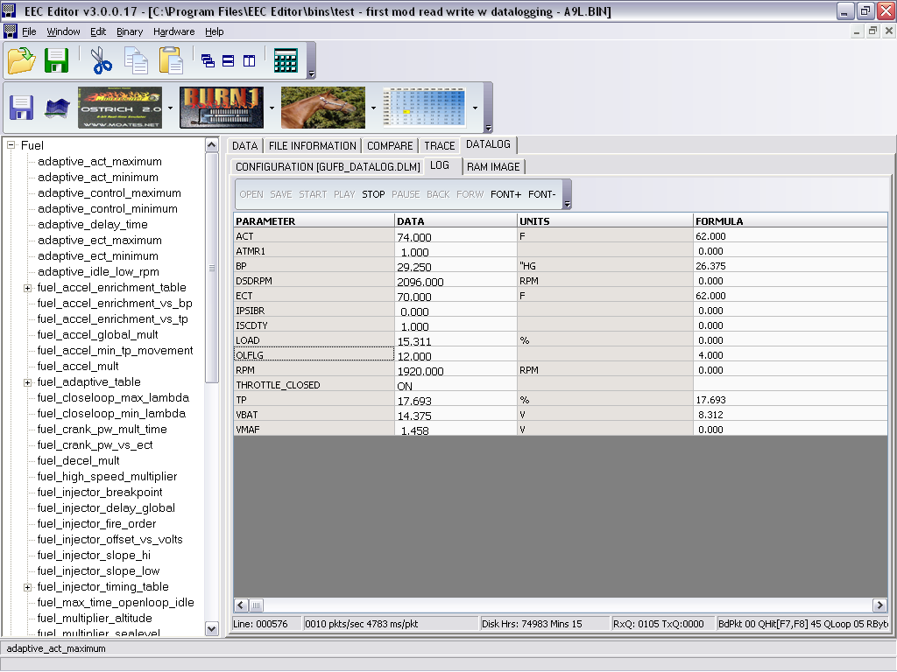

OK – if you make it this far, and can write the patch, watch your own tune behave, and see the realtime specs like RPM, TP, ECT, etc. – then you are ready to start tuning! Congrat – you just leapfrogged 100 years of engine tweakers!!

** Add practical “how to tune”

Other packages –

BE - $80 – Binary Editor, by Clint Garrity
(http://www.eecanalyzer.net/).
This software package lets you read, explore, change and export the Ford code images. Basically this lets you “hack” the code to do what you want (change injector sizes, turn off emissions, modify behavior, remove rev/speed limits, etc.). From his site:
”The Binary Editor software allows for editing of the Ford EEC binary data. Its definition files (Strategy Files) are open source and are saved in Excel. The Excel format makes editing the definitions very user friendly. You can look at the download page to see what definitions are supported. There is also a definition template that can be downloaded for those that would like create there own definition file. The Binary Editor can also display differences between binaries (Ford Tunes). “.
It looks like Clint is actively maintaining these tools, there are new releases almost weekly!

Tunerpro RT – shareware, by Mark Mansur
( http://tunerpro.markmansur.com/ )
If you use this, send him $!! This looks like a decent package but it DOES NOT SUPPORT QUARTERHORSE YET – slated for v5 of QH, not sure when that is scheduled. As of March 6 2009 it was not supported.
TunerPro Features
- Full bin editing capability raw or via definition referencing
- Full bin definition editing capability including reordering and item comments
- Supports publically available ECU files
- 2D Graphing with multi-point dragging
- 3D Graphing with multi-point dragging, surface plot, colored height map, rotation, translation, and zoom.
- Function graphing (Ford-style)
- Table manipulation functions for scaling rows, columns, and entire tables
- 3D table smoothing functionality with user-defined alpha
- Compare the current bin to up to 4 other bins at once
- Includes a bin stacking tool for compiling multiple bins into one image for switches
- Docking windows
- Bin Change Logging - changes can be auto-saved to a log file for easy tracking
- Search for items by title keyword, address, or size
- Rapidly list the differences between two bin files
- View bins graphically for finding patterns and tables
- Export bin data/contents to a plain text file for easy viewing and/or printing
- Table range selection and editing ability - pull fuel/spark out of regions with minimal effort
- Ability to Copy/Paste tables to/from Excel for extensive editing
- Full-featured raw hex/octal/binary/dec editor
• TunerPro RT Features
TunerPro RT includes all of the features of the free version of TunerPro, plus:
- Emulation functionality
- Simultaneously emulate and data log using AutoProm or serial->USB converter
- ALDL Data monitoring and logging - record to file for later playback
- ALDL Dashboard and data graphing for easy viewing of ALDL data in-car
- View/Log 3 additional channels of A/D (WBO2, etc) using the AutoProm
- ALDL Dashboard for easy in-car viewing of critical real-time engine data
- Easily view engine parameters and state information via easy to use tabs
- View parameter history in 4 simultaneous side scrolling charts
“

