The following are transformation equations defining the angular orientation of each coordinate system inherent in FAST.

Before providing these, it is useful to discuss the transformation equation relating coordinate system to coordinate system 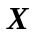 where (with orthogonal axes 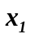, 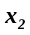, and 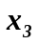) is the coordinate system resulting from three rotations (,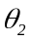, and 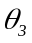) about the orthogonal axes (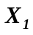, 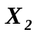, and 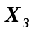) of coordinate system . With all rotation angles assumed to be small, the order of rotations does not matter and Euler angles do not need to be used. Instead, what we want, is a transformation equation that is consistent with classical Bernoulli-Euler beam theory (which assumes small rotations). The correct transformation equation is:

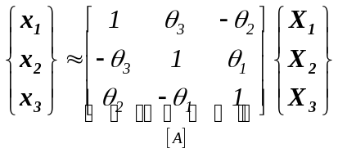,

where 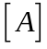 is referred to as the Bernoulli-Euler transformation matrix in this work. The approximation symbol (≈) is used in place of an equals symbol (=) in the above expression since is not orthonormal, which implies that the resulting from this expression is not made up of a set of mutually orthogonal axes (all transformation matrices between sets of mutually orthogonal axes must be orthonormal). So it is evident that in place of , what we want is the closest orthonormal matrix to , which is referred to as 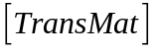 in this work. From linear algebra, we know that the closest orthonormal matrix to in the Frobenius Norm sense is:

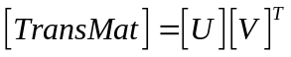,

where the columns of 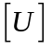 contain the eigenvectors of 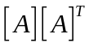 and the columns of 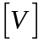 contain the eigenvectors of 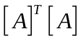. This result follows directly from the Singular Value Decomposition (SVD) of :

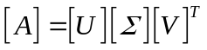,

where 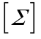 is a diagonal matrix containing the singular values of , which are 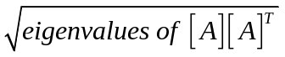 = 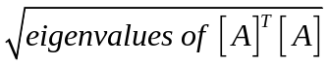.

The algebraic form of the resulting transformation matrix is:

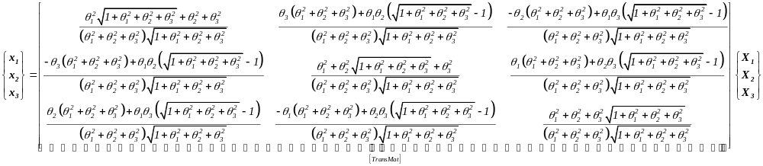

This was derived symbolically by J. Jonkman by computing 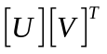 by hand with verification in Mathematica.

Tower Base / Platform Coordinate System
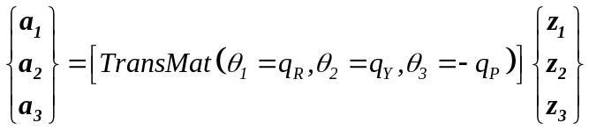

Tower Element-Fixed Coordinate System
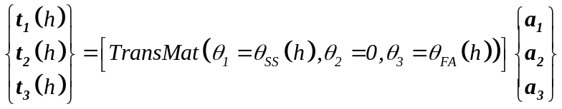
where,
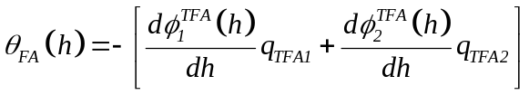 and 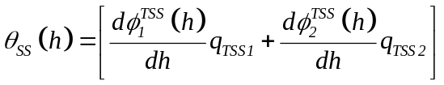

Tower-Top / Base Plate Coordinate System
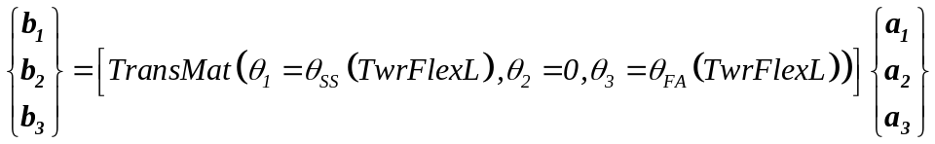
where,
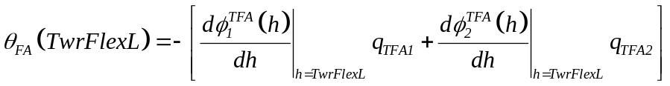 and 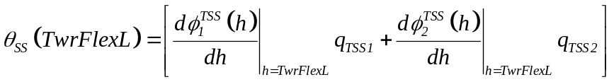

Nacelle / Yaw Coordinate System
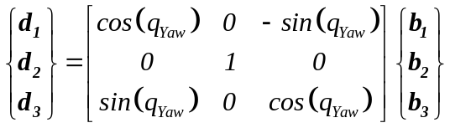

Rotor-Furl Coordinate System
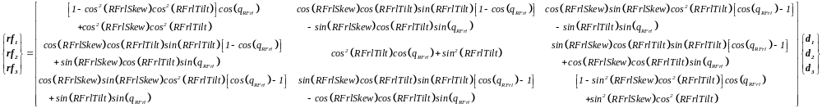

Shaft Coordinate System
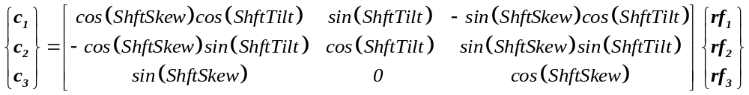

Azimuth Coordinate System
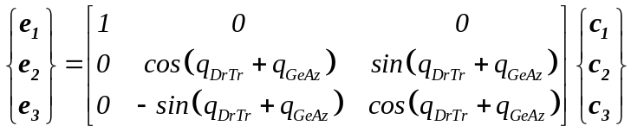

Teeter Coordinate System
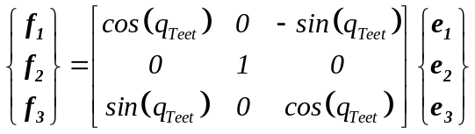

Hub / Delta-3 Coordinate System
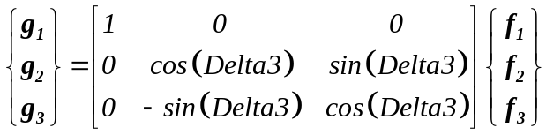

Hub (Prime) Coordinate System
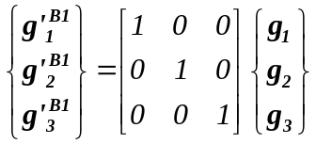

The equation for g’^{B2} of blade 2 is similar.

Coned Coordinate System
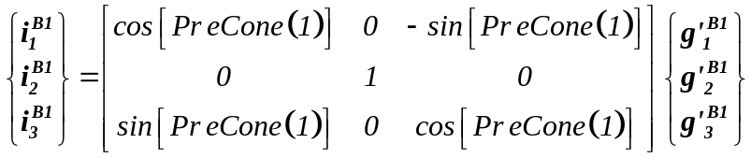

The equation for i^{B2} is similar.

Blade / Pitched Coordinate System
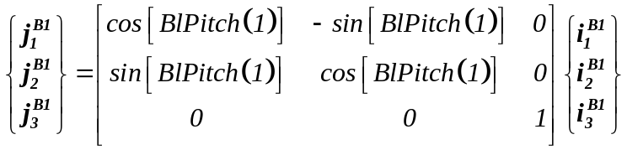

The equation for j^{B2} is similar.

Blade Coordinate System Aligned with Local Structural Axes (not element fixed)
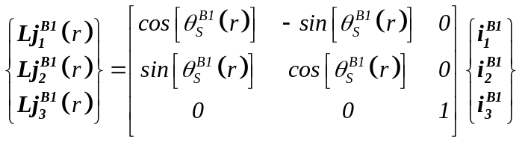

The equation for Lj^{B2}(r) is similar.

Blade Element-Fixed Coordinate System Aligned with Local Structural Axes
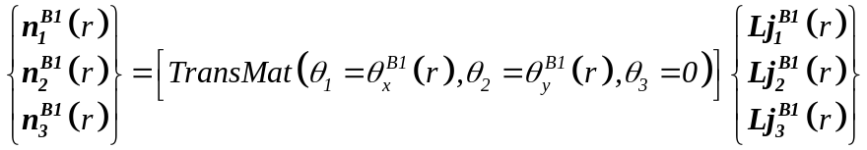
where,
, , and
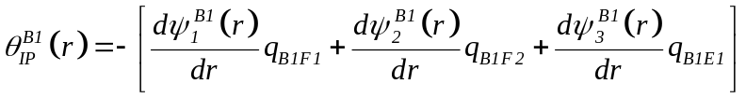, 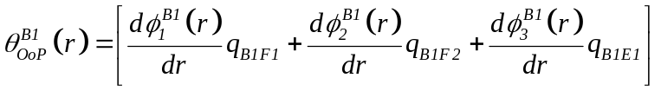

The equation for n^{B2}(r) is similar.

Blade Element-Fixed Coordinate System Used for Calculating and Returning Aerodynamic Loads
This coordinate system is coincident with i^{B1} when the blade is undeflected.
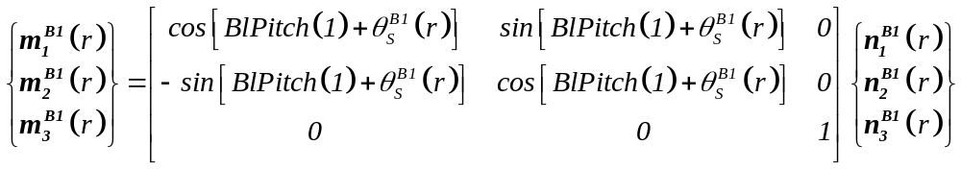

The equation for m^{B2}(r) is similar.

Blade Element-Fixed Coordinate System Aligned with Local Aerodynamic Axes (i.e., chordline) / Trailing Edge Coordinate System
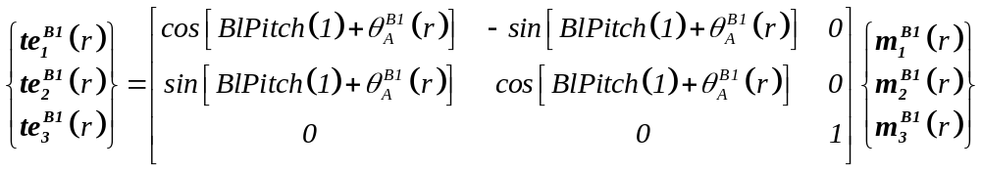

The equation for te^{B2}(r) is similar.

Tail-Furl Coordinate System
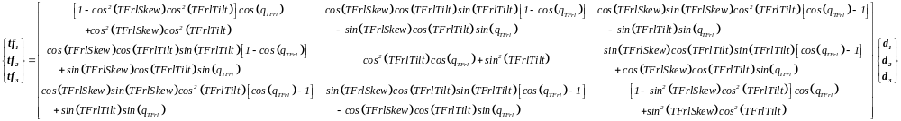

Tail Fin Coordinate System
