The following are derivations of the output motions available in FAST for a 2-bladed turbine configuration. The motions for a 3-bladed turbine are very similar. Note that some of the motions are given multiple names in order to support variation among the user’s preferences.

Blade 1 Tip Motions:
Blade 1 OoP tip deflection (relative to rotor) (directed along the xc1-axis), (m)
Blade 1 IP tip deflection (relative to rotor) (directed along the yc1-axis), (m)
Blade 1 flapwise tip deflection (relative to rotor) (directed along the xb1-axis), (m)
Blade 1 edgewise tip deflection (relative to rotor) (directed along the yb1-axis), (m)
Blade 1 axial tip deflection (relative to rotor) (directed along the zc1-/zb1-axis), (m)
Blade 1 flapwise tip acceleration (absolute) (directed along the xb1-axis), (m/sec²)
Blade 1 edgewise tip acceleration (absolute) (directed along the yb1-axis), (m/sec²)
Blade 1 axial tip acceleration (absolute) (directed along the zc1-/zb1-axis), (m/sec²)
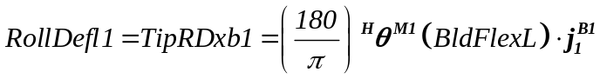 Blade 1 roll tip deflection (relative to the undeflected position), (about the xb1-axis), (deg)
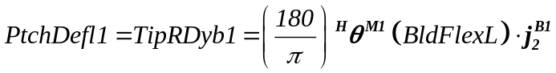 Blade 1 pitch tip deflection (relative to the undeflected position), (about the yb1-axis), (deg)
where:
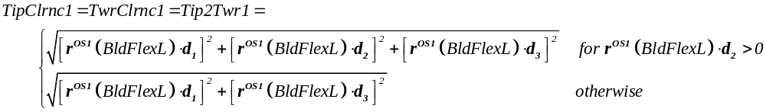 Blade 1 tip-to-tower clearance, (m)
where:

Blade 1 Local Span Motions:
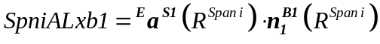 Blade 1 local flapwise acceleration (absolute) of span station i (directed along the local xb1-axis) (i = 1,2,…,5), (m/sec²)
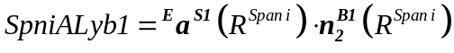 Blade 1 local edgewise acceleration (absolute) of span station i (directed along the local yb1-axis) (i = 1,2,…,5), (m/sec²)
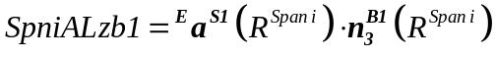 Blade 1 axial acceleration (absolute) of span station i (directed along the zc1-/zb1-/local zb1-axis) (i = 1,2,…,5), (m/sec²)

Blade 2 Tip Motions:
The output motions of blade 2 are similar to those of blade 1.

Blade Pitch Motions:
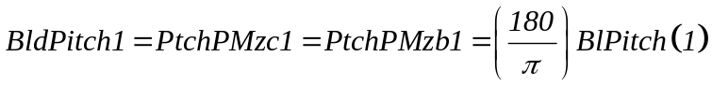 Blade 1 pitch angle (position) (positive towards feather / about the minus zc1-/minus zb1-axis), (deg)
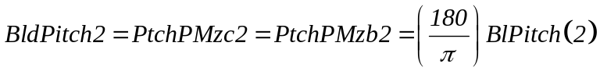 Blade 2 pitch angle (position) (positive towards feather / about the minus zc2-/minus zb2-axis), (deg)

Teeter Motions:
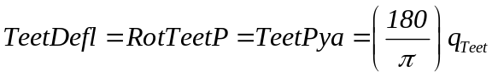 Rotor teeter angle (position) (about the ya-axis), (deg)
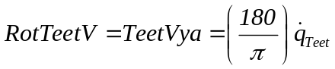 Rotor teeter angular velocity (about the ya-axis), (deg/sec)
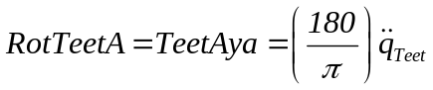 Rotor teeter angular acceleration (about the ya-axis), (deg/sec²)

Shaft Motions:
Rotor azimuth angle (position) (about the xa-/xs-axis), (deg)
Rotor azimuth speed / angular velocity (about the xa-/xs-axis), (rpm)
Rotor azimuth angular acceleration (about the xa-/xs-axis), (deg/sec²)
Low-speed shaft strain gage azimuth angle (position) (on the gearbox side of the low-speed shaft) (about the xa-/xs-axis), (deg)
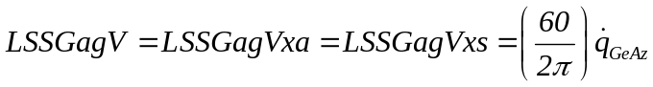 Low-speed shaft strain gage angular velocity (on the gearbox side of the low-speed shaft) (about the xa-/xs-axis), (rpm)
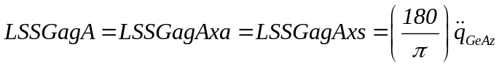 Low-speed shaft strain gage angular acceleration (on the gearbox side of the low-speed shaft) (about the xa-/xs-axis), (deg/sec²)
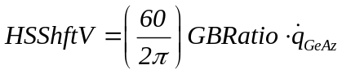 High-speed shaft speed / angular velocity, (rpm)
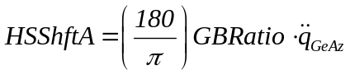 High-speed shaft angular acceleration, (deg/sec²)
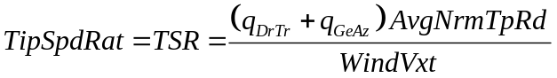 Tip speed ratio, (-)

Nacelle IMU Motions:
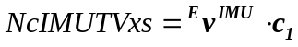 Nacelle IMU translational velocity (directed along the xs-axis), (m/sec)
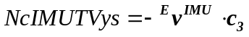 Nacelle IMU translational velocity (directed along the ys-axis), (m/sec)
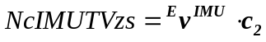 Nacelle IMU translational velocity (directed along the zs-axis), (m/sec)
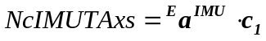 Nacelle IMU translational acceleration (directed along the xs-axis), (m/sec²)
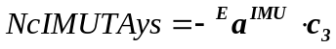 Nacelle IMU translational acceleration (directed along the ys-axis), (m/sec²)
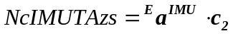 Nacelle IMU translational acceleration (directed along the zs-axis), (m/sec²)
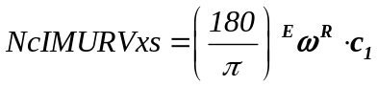 Nacelle IMU angular (rotational) velocity (about the xs-axis), (deg/sec)
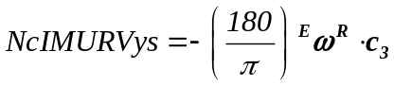 Nacelle IMU angular (rotational) velocity (about the ys-axis), (deg/sec)
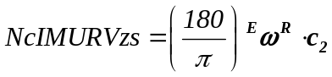 Nacelle IMU angular (rotational) velocity (about the zs-axis), (deg/sec)
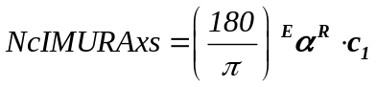 Nacelle IMU angular (rotational) acceleration (about the xs-axis), (deg/sec²)
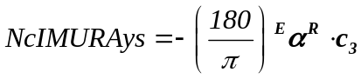 Nacelle IMU angular (rotational) acceleration (about the ys-axis), (deg/sec²)
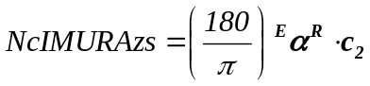 Nacelle IMU angular (rotational) acceleration (about the zs-axis), (deg/sec²)

Rotor-Furl Motions:
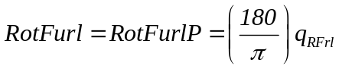 Rotor-furl angle (position) (about the rotor-furl axis), (deg)
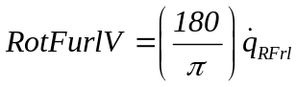 Rotor-furl angular velocity (about the rotor-furl axis), (deg/sec)
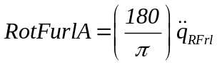 Rotor-furl angular acceleration (about the rotor-furl axis), (deg/sec²)

Yaw Motions:
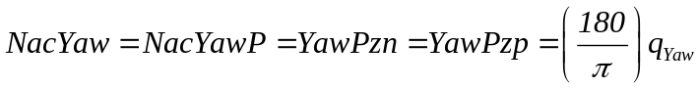 Nacelle yaw angle (position) (about the zn-/zp-axis), (deg)
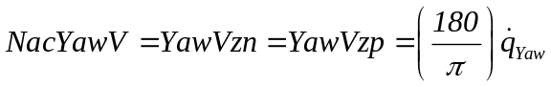 Nacelle yaw angular velocity (about the zn-/zp-axis), (deg/sec)
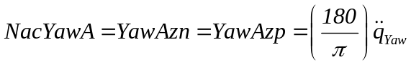 Nacelle yaw angular acceleration (about the zn-/zp-axis), (deg/sec²)
Nacelle yaw error (about the zt-axis), (deg)

Tower-Top Motions:
Tower-top / yaw bearing translational deflection (relative to undeflected position) (directed along the xp-axis), (m)
Tower-top / yaw bearing translational deflection (relative to undeflected position) (directed along the yp-axis), (m)
Tower-top / yaw bearing translational deflection (relative to undeflected position) (directed along the zp-axis), (m)
Tower-top / yaw bearing fore-aft (translational) deflection (relative to undeflected position) (directed along the xt-axis), (m)
Tower-top / yaw bearing side-to-side (translational) deflection (relative to undeflected position) (directed along the yt-axis), (m)
Tower-top / yaw bearing axial (translational) deflection (relative to undeflected position) (directed along the zt-axis), (m)
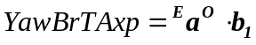 Tower-top / yaw bearing translational acceleration (directed along the xp-axis), (m/sec²)
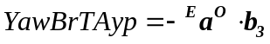 Tower-top / yaw bearing translational acceleration (directed along the yp-axis), (m/sec²)
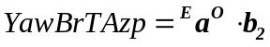 Tower-top / yaw bearing translational acceleration (directed along the zp-axis), (m/sec²)
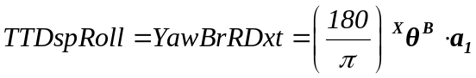 Tower-top / yaw bearing roll deflection (relative to the undeflected position) (about the xt-axis), (deg)
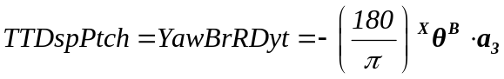 Tower-top / yaw bearing pitch deflection (relative to the undeflected position) (about the yt-axis), (deg)
where:
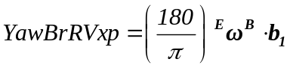 Tower-top / yaw bearing angular (rotational) velocity (about the xp-axis), (deg/sec)
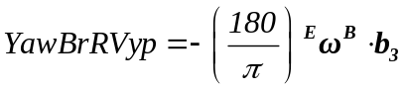 Tower-top / yaw bearing angular (rotational) velocity (about the yp-axis), (deg/sec)
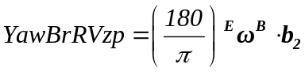 Tower-top / yaw bearing angular (rotational) velocity (about the zp-axis), (deg/sec)
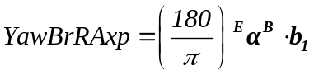 Tower-top / yaw bearing angular (rotational) acceleration (about the xp-axis), (deg/sec²)
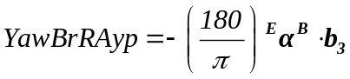 Tower-top / yaw bearing angular (rotational) acceleration (about the yp-axis), (deg/sec²)
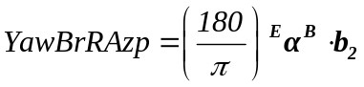 Tower-top / yaw bearing angular (rotational) acceleration (about the zp-axis), (deg/sec²)

Tower Local Gage Motions:
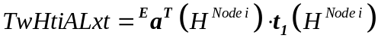 Tower local fore-aft translational acceleration (absolute) of node i (directed along the local xt-axis) (i = 1,2,…,5), (m/sec²)
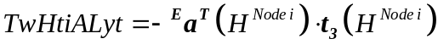 Tower local side-to-side translational acceleration (absolute) of node i (directed along the local yt-axis) (i = 1,2,…,5), (m/sec²)
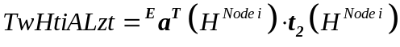 Tower local axial translational acceleration (absolute) of node i (directed along the local zt-axis) (i = 1,2,…,5), (m/sec²)

Tail-Furl Motions:
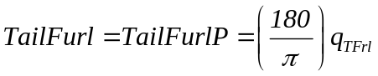 Tail-furl angle (position) (about the tail-furl axis), (deg)
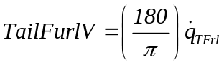 Tail-furl angular velocity (about the tail-furl axis), (deg/sec)
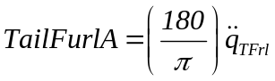 Tail-furl angular acceleration (about the tail-furl axis), (deg/sec²)

Platform Motions:
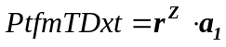 Platform horizontal surge displacement (directed along the xt-axis), (m)
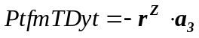 Platform horizontal sway displacement (directed along the yt-axis), (m)
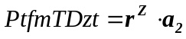 Platform vertical heave displacement (directed along the zt-axis), (m)
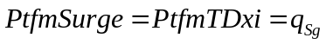 Platform horizontal surge displacement (directed along the xi-axis), (m)
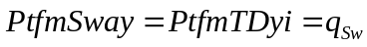 Platform horizontal sway displacement (directed along the yi-axis), (m)
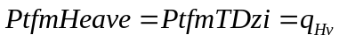 Platform vertical heave displacement (directed along the zi-axis), (m)
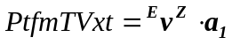 Platform horizontal surge velocity (directed along the xt-axis), (m/sec)
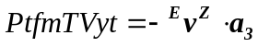 Platform horizontal sway velocity (directed along the yt-axis), (m/sec)
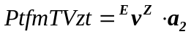 Platform vertical heave velocity (directed along the zt-axis), (m/sec)
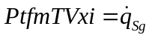 Platform horizontal surge velocity (directed along the xi-axis), (m/sec)
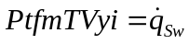 Platform horizontal sway velocity (directed along the yi-axis), (m/sec)
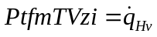 Platform vertical heave velocity (directed along the zi-axis), (m/sec)
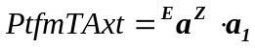 Platform horizontal surge acceleration (directed along the xt-axis), (m/sec²)
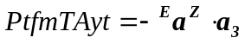 Platform horizontal sway acceleration (directed along the yt-axis), (m/sec²)
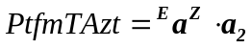 Platform vertical heave acceleration (directed along the zt-axis), (m/sec²)
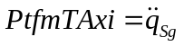 Platform horizontal surge acceleration (directed along the xi-axis), (m/sec²)
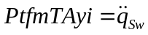 Platform horizontal sway acceleration (directed along the yi-axis), (m/sec²)
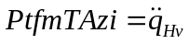 Platform vertical heave acceleration (directed along the zi-axis), (m/sec²)
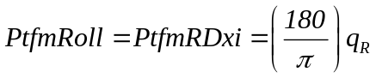 Platform roll tilt displacement (about the xi-axis), (deg)
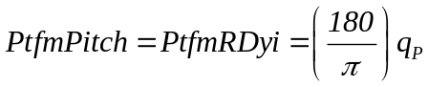 Platform pitch tilt displacement (about the yi-axis), (deg)
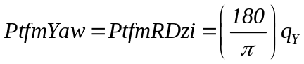 Platform yaw displacement (about the zi-axis), (deg)
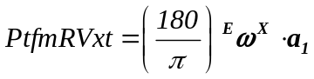 Platform roll tilt velocity (about the xt-axis), (deg/sec)
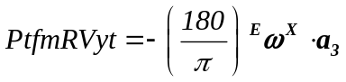 Platform pitch tilt velocity (about the yt-axis), (deg/sec)
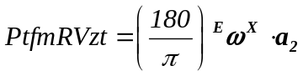 Platform yaw velocity (about the zt-axis), (deg/sec)
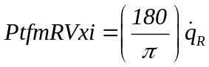 Platform roll tilt velocity (about the xi-axis), (deg/sec)
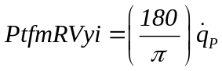 Platform pitch tilt velocity (about the yi-axis), (deg/sec)
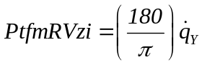 Platform yaw velocity (about the zi-axis), (deg/sec)
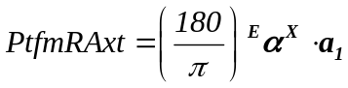 Platform roll tilt acceleration (about the xt-axis), (deg/sec²)
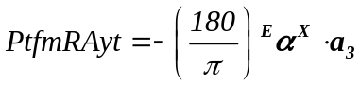 Platform pitch tilt acceleration (about the yt-axis), (deg/sec²)
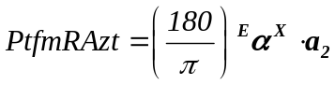 Platform yaw acceleration (about the zt-axis), (deg/sec²)
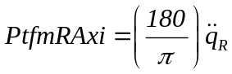 Platform roll tilt acceleration (about the xi-axis), (deg/sec²)
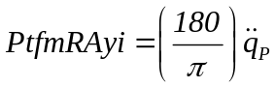 Platform pitch tilt acceleration (about the yi-axis), (deg/sec²)
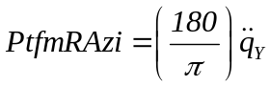 Platform yaw acceleration (about the zi-axis), (deg/sec²)

Tail-Furl Motions:
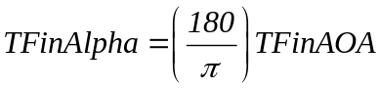 Tail fin angle of attack, (deg)
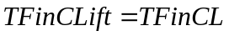 Tail fin lift coefficient, (-)
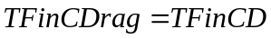 Tail fin drag coefficient, (-)
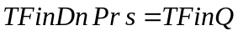 Tail fin dynamic pressure, (Pa)
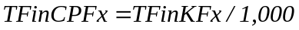 Tail fin tangential force, (kN)
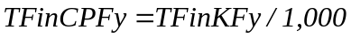 Tail fin normal force, (kN)

Wind Motions:
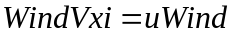 Nominal hub-height wind velocity (directed along the xi-axis), (m/s)
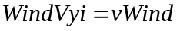 Cross-wind hub-height velocity (directed along the yi-axis), (m/s)
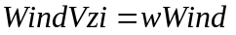 Vertical hub-height wind velocity (directed along the zi-axis), (m/s)
Total hub-height wind velocity magnitude, (m/s)
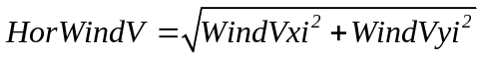 Horizontal hub-height wind velocity magnitude (in the xi-/yi-plane), (m/s)
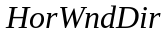 Horizontal hub-height wind direction (about the zi-axis), (deg)
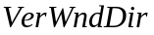 Vertical hub-height wind direction (about an axis orthogonal to the zi-axis and the horizontal wind vector), (deg)

