There are several points on a 2-bladed turbine: Z (platform reference), Y (platform mass center), T (tower node), O (tower-top / base-plate / yaw bearing mass center), U (nacelle mass center), V (arbitrary point on rotor-furl axis), W (arbitrary point on tail-furl axis), D (center of mass of structure that furls with the rotor [not including rotor]), IMU (nacelle inertial measurement unit), P (teeter pin), SG [shaft strain gage location: i.e., a point on the shaft a distance 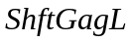 towards the nacelle from point P (or point Q for a 3-blader since point P does not exist)], Q (apex of coning angle), C (hub mass center), S1 (blade node for blade 1), S2 (blade node for blade 2), I (tail boom mass center), J (tail fin mass center), and K (tail fin center-of-pressure). There are also several reference frames: E (earth / inertial), X (platform / tower base), F (tower element body), B (tower-top / base plate), N (nacelle), R (structure that furls with the rotor—generator housing, etc…), L (low speed shaft on rotor end of LSS-compliance), H (hub / rotor), M1 (blade 1 element body), M2 (blade 2 element body), G (fixed in the high speed shaft / generator), and A (tail). The following are derivations of the position vectors, angular velocities, linear velocities, partial angular velocities, partial linear velocities, angular accelerations, and linear accelerations of all these points on the 2-bladed turbine (point SG’s velocities and accelerations are not derived since they wont be used in the ensuing analysis). The velocities and accelerations of points on a 3-bladed turbine are very similar.

Position Vectors:
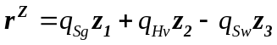 (relative to the ground)

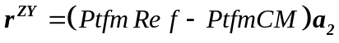

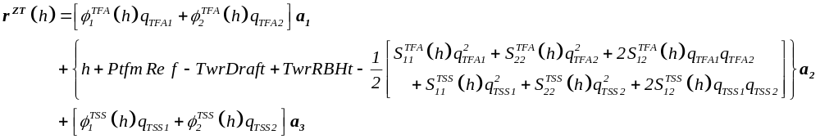
where,
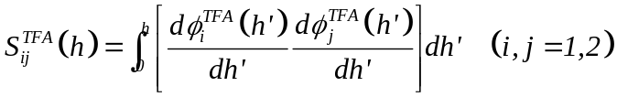 (which is symmetric)
and
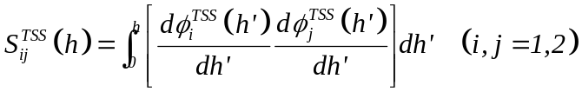 (which is symmetric)

Note limits on :

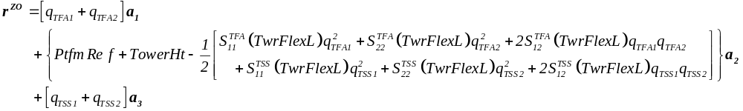

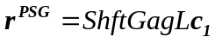

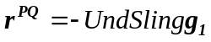

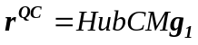

where,
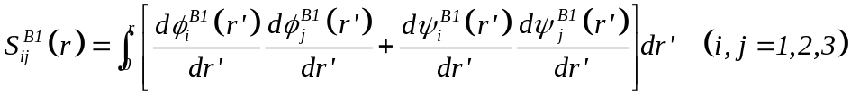 (which is symmetric)
and the twisted shape functions are defined as follows:
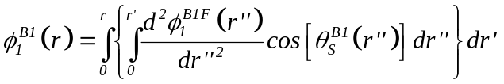, 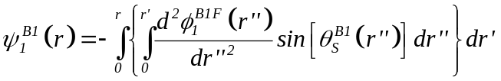,
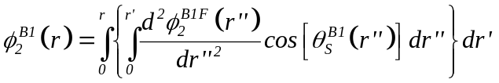, 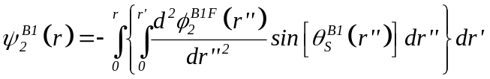,
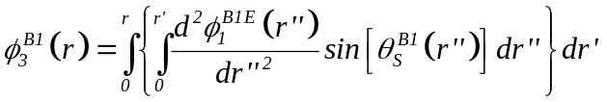 , and 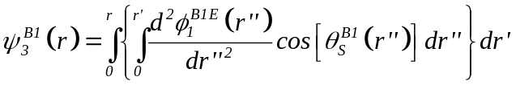

The equation for 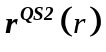 is similar.

Note limit on :

Angular Velocities:
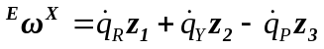

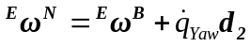

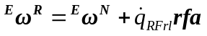
where,

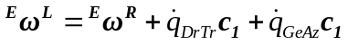

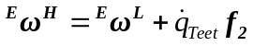

The equation for 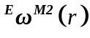 is similar.

Since the generator is attached to the high speed shaft which may or may not rotate in the opposite direction of the low speed shaft and since 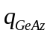 represents the position of the low speed shaft near the entrance of the gearbox,
where,
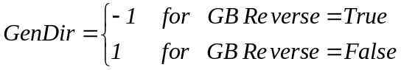

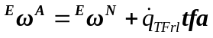
where,

Linear Velocities:
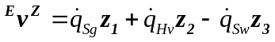

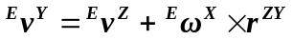

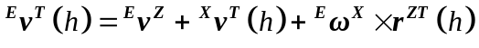
where,
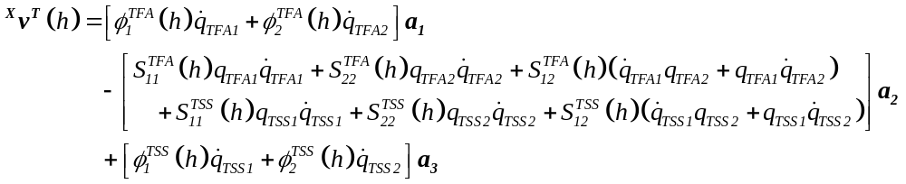

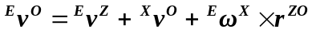
where,
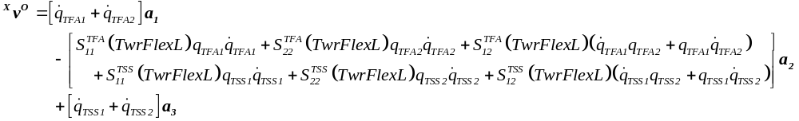

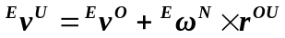

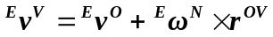

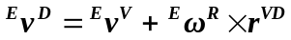

The equation for 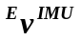 is similar.

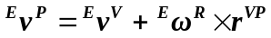

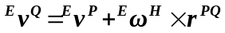

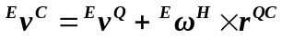

where,
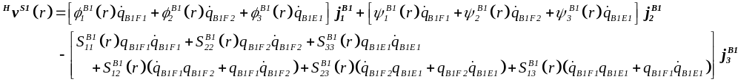

The equation for 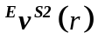 is similar.

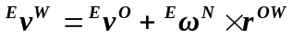

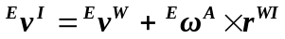

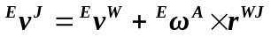

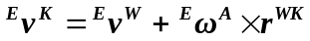
Partial Angular Velocities:
Recall that: 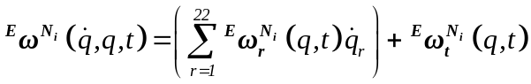 for each rigid body 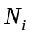 in the system. Note that all of the 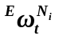 terms are zero as will be shown.

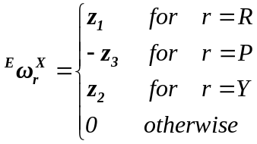
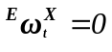

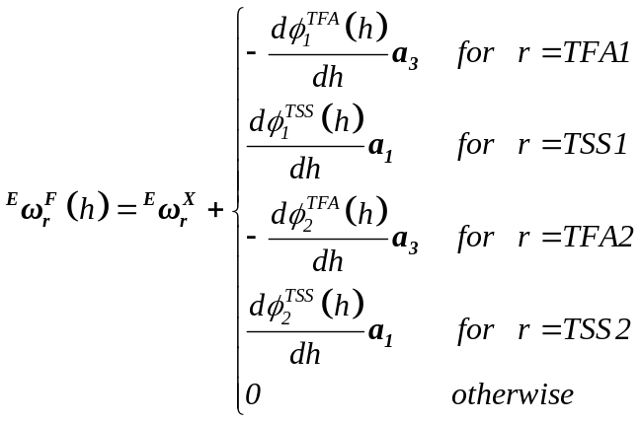
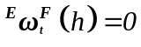

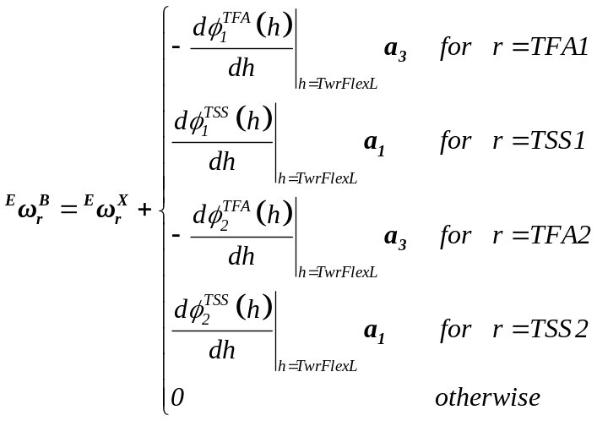
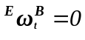

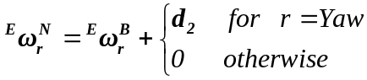
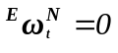

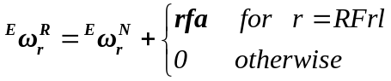
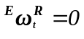

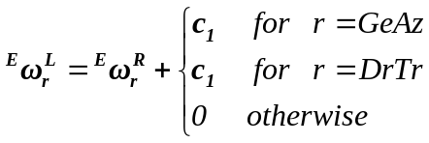
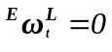

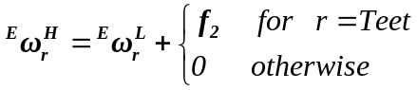
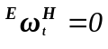

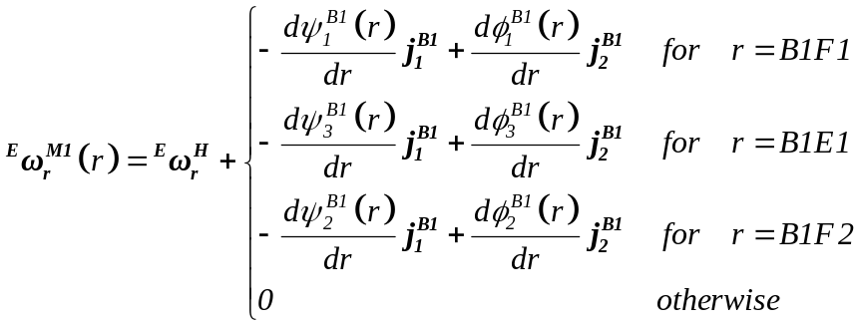
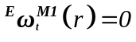

The equations for 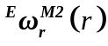 and 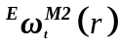 are similar.

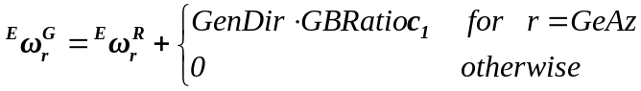
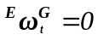

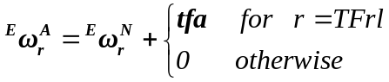
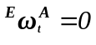
Partial Linear Velocities:
Recall that: 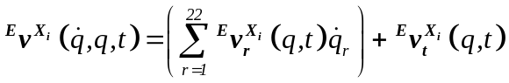 for each point 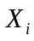 in the system. Note that all of the 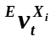 terms are zero as will be shown.

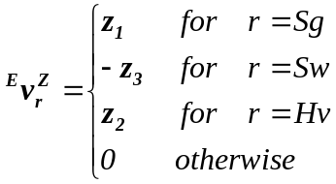
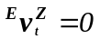

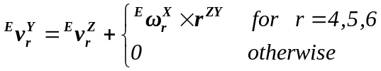
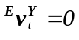

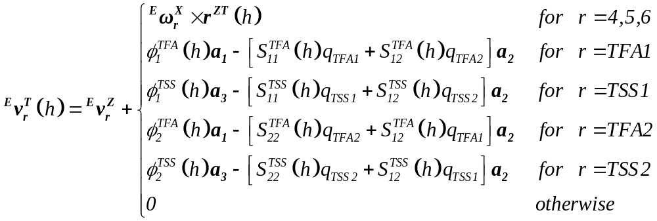
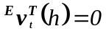

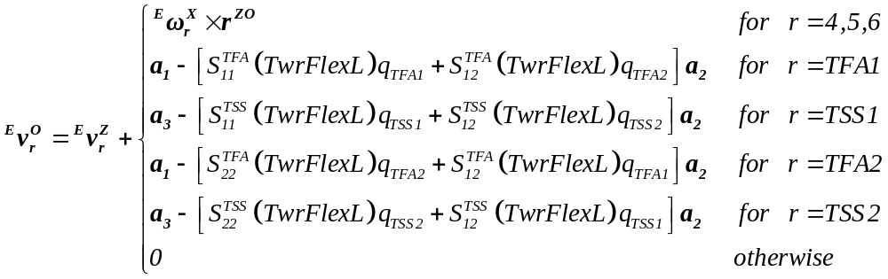
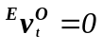

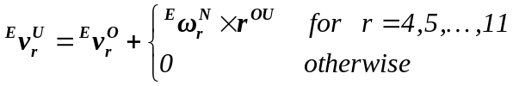
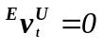

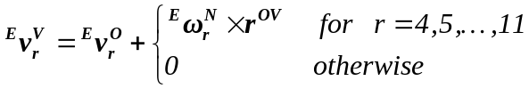
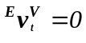

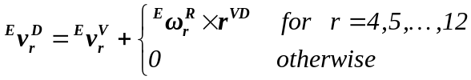
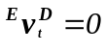

The equations for 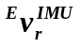 and 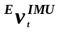 are similar.

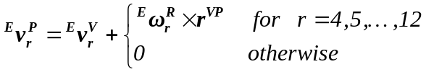
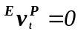

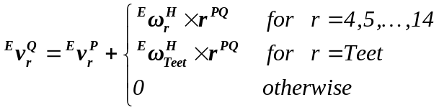
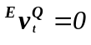

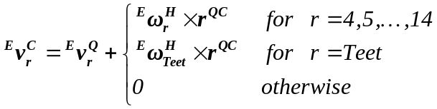
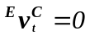

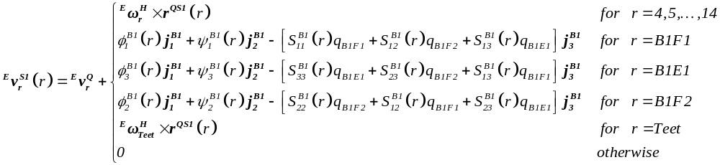
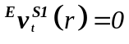

The equations for 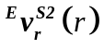 and 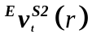 are similar.

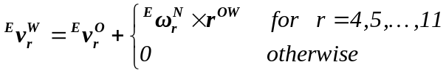
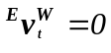

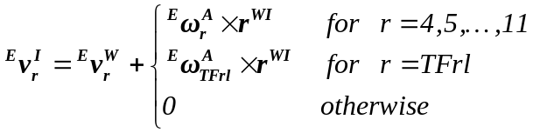
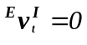

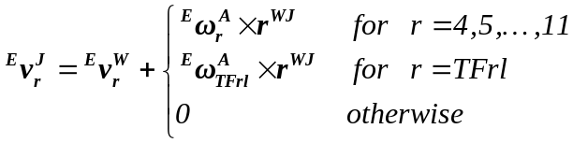
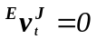

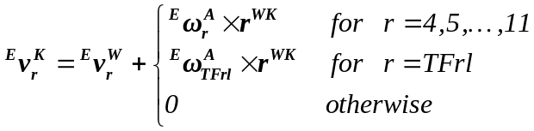
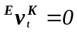
Angular Accelerations:
Recall that: for each rigid body in the system. Note that the 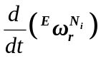 terms are all vector functions of 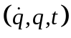 and that all of the 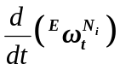 terms are zero as will be shown.

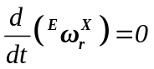
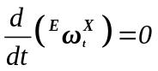

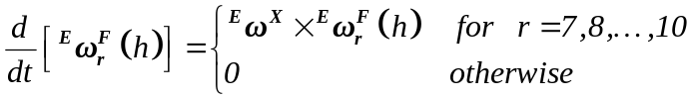
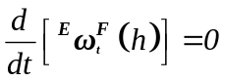

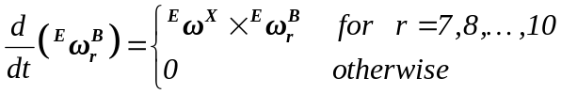
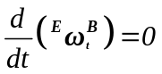

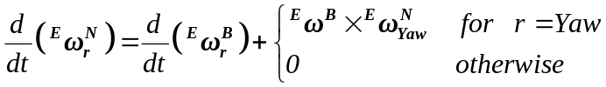
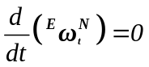

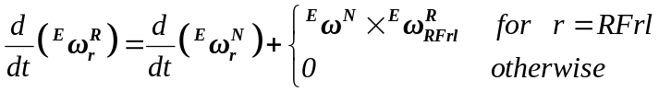
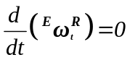

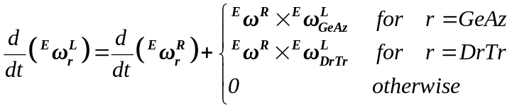
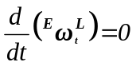

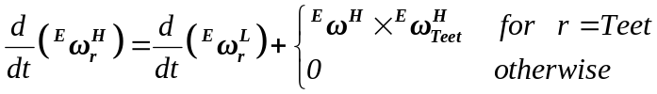
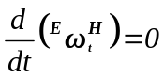

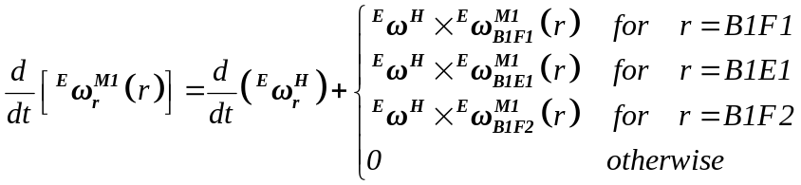
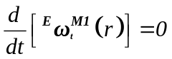

The equations for 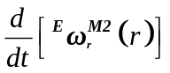 and 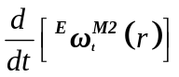 are similar.

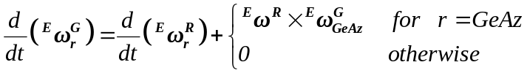
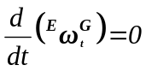

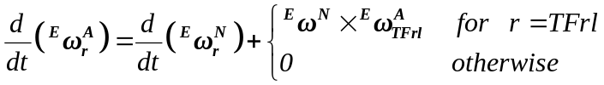
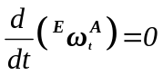

Linear Accelerations:
Recall that: for each point in the system. Note that the 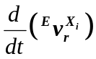 terms are all vector functions of and that all of the 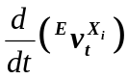 terms are zero as will be shown.

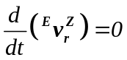
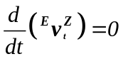

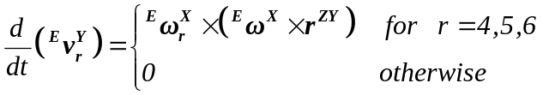
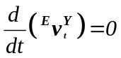

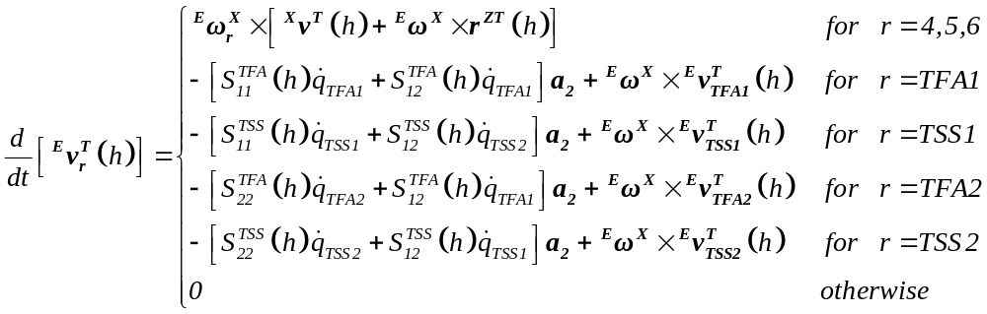
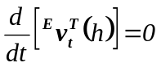

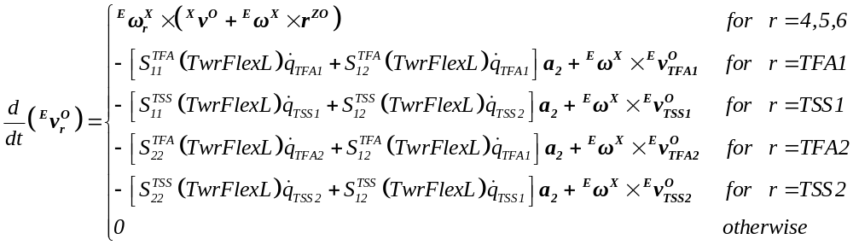
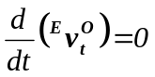

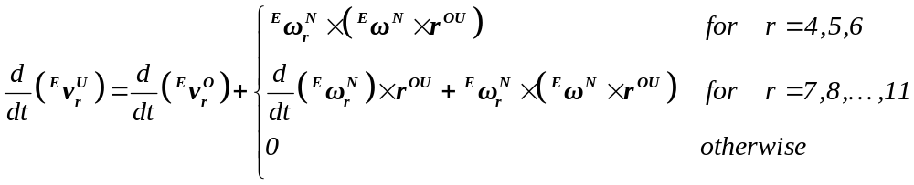
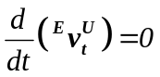

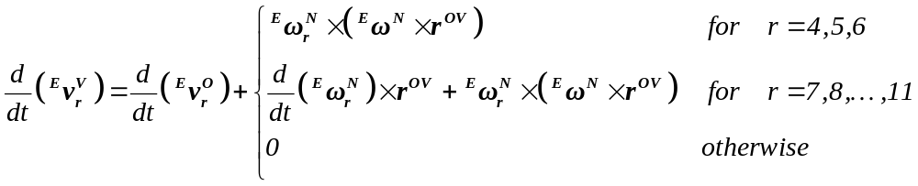
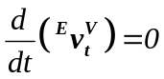

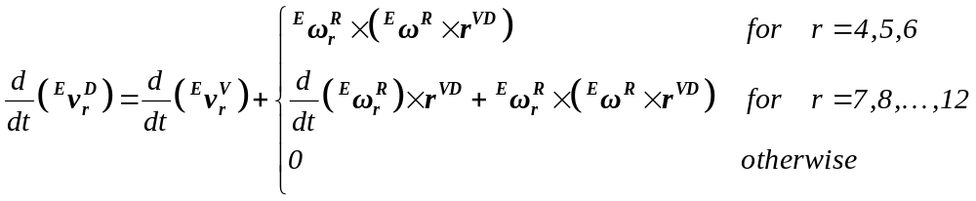
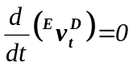

The equations for 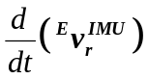 and 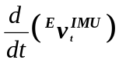 are similar.

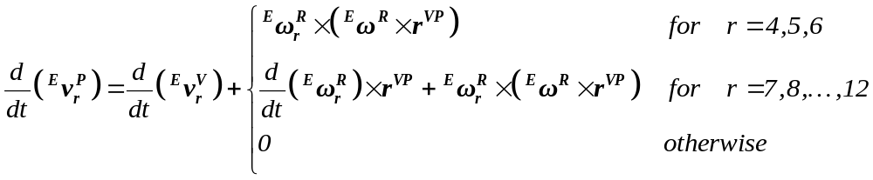
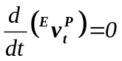

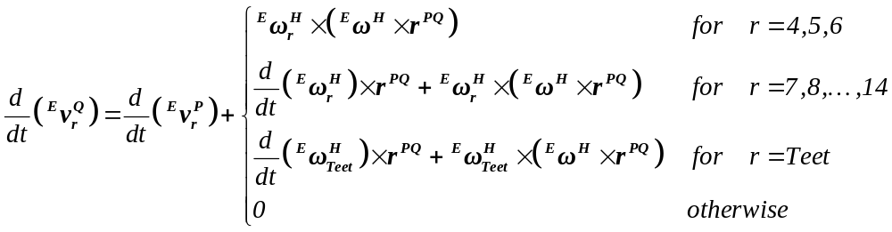
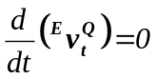

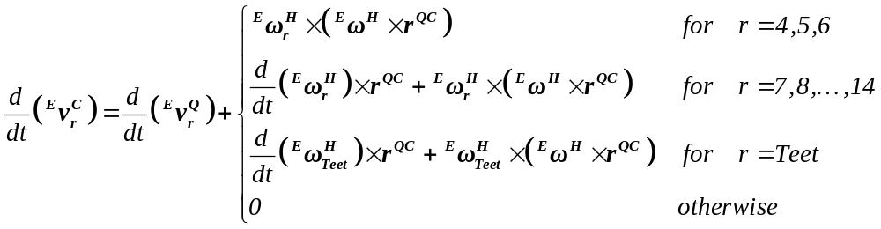
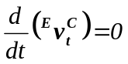

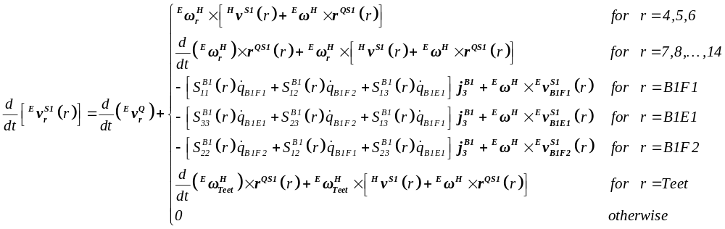
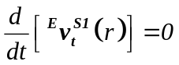

The equations for 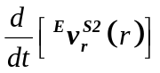 and 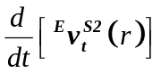 are similar.

