Aero Disk (MODULE AeroDisk)
Solves quasi-steady actuator disk to calculate the 3 forces/3 moments dependent on the rotor tip-speed ratio () or rotor speed (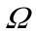) and rotor inflow relative wind speed (ambient + rotor motion) (vector magnitude 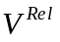), as well as on the rotor-collective blade-pitch angle () and rotor inflow skew angle (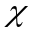). Allowing and in place of allows for consideration of elastic deflection in the forces/moments. If is not specified, skew effects are computed internally by a 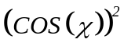 effect.

Note: The actuator disk is defined in a local coordinate system with local normal to the disk (pointed nominally downwind) and positive rotation (, ) about positive local . The vector is always in the local - plane, and unless is 0˚ or 180˚, the vector has a component along negative local . Local follows the right-hand rule. (That is, the local coordinate system rotates with the vector.) The skew angle is defined about positive from to , or equivalently, about from to .

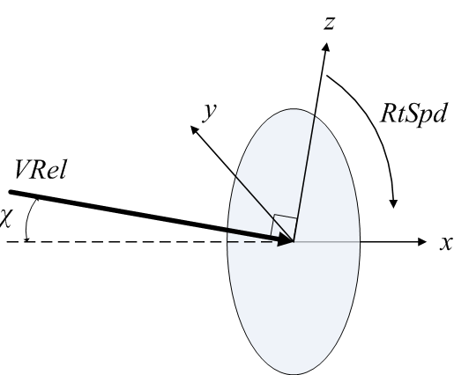

A local actuator disk coordinate system is also defined with 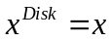 normal to the disk (pointed nominally downwind), 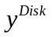 in the global horizontal plane (with no global 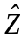 contribution, and 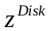 following the right hand rule with no contribution along negative global . Note: this coordinate system is undefined if the orientation of the rotor centerline is directed vertically upward or downward (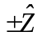)

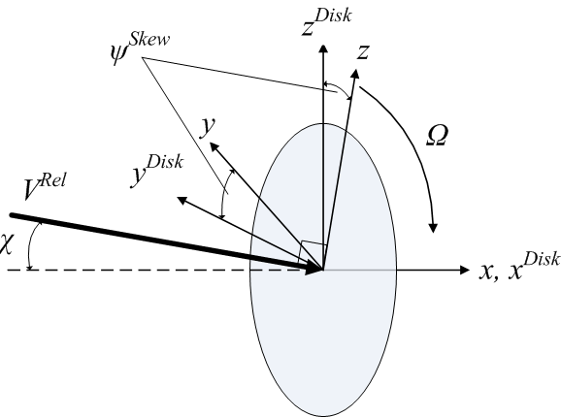

Inputs | Outputs | States | Parameters
- 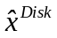 – Orientation of rotor centerline, normal to disk (-)  - – Rotor speed (rad/s)  - 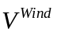 – Disk-averaged wind velocity in global coordinates (m/s)  - 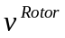 – Rotor translational velocity in global coordinates (m/s)  - – Rotor-collective blade-pitch angle (rad) | - 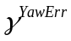 – Nacelle-yaw error, i.e., the angle about positive 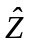 from the rotor centerline to the rotor-disk-averaged relative wind velocity (ambient + rotor motion), both projected onto the horizontal plane (rad)  - 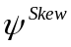 – Azimuth angle (from the nominally vertical axis in the disk plane, 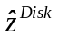) to the vector about which the inflow skew angle is defined, i.e., the angle about positive from to the vector about which the positive inflow skew angle is defined (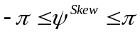) (rad)  - – Inflow skew angle (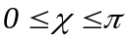) (rad)  - 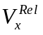 – Rotor-disk-averaged relative wind speed (ambient + rotor motion), normal to disk (m/s)  - 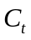 – Thrust force coefficient (normal to disk) (-)  - 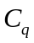 – Torque coefficient (normal to disk) (-)  - 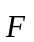 – Aerodynamic force in global coordinates (N)  - 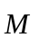 – Aerodynamic moment in global coordinates (Nm) |  | -  – Rotor radius (m)  - 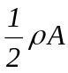 – ½ air density times rotor swept area (kg/m)  - 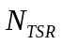 – Number of rotor tip-speed ratios in tables (-)  - 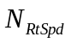 – Number of rotor speeds in tables (-)  - 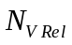 – Number of rotor inflow wind speeds in tables (-)  - 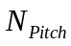 – Number of rotor-collective blade-pitch angles in tables (-)  - 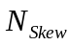 – Number of rotor inflow-skew angles in tables (-)  - 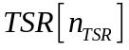 – Rotor tip-speed ratios in tables (-)  - 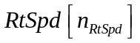 – Rotor speeds in tables (rad/s)  - 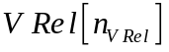 – Rotor inflow wind speeds in tables (m/s)  - 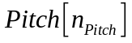 – Rotor-collective blade-pitch angles in tables (rad)  - 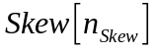 – Rotor inflow-skew angles in tables (rad)  - 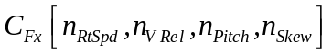 – Thrust (x/axial) force coefficient (-)  - 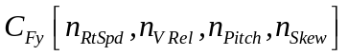 – Transverse (y) force coefficient (-)  - 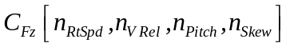 – Transverse (z) force coefficient (-)  - 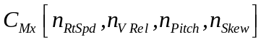 – Torque (x) coefficient (-)  - 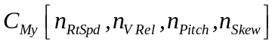 – Transverse (y) moment coefficient (-)  - 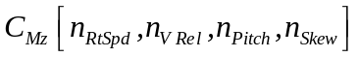 – Transverse (z) moment coefficient (-)

Initialization:
Initialization Inputs | Initialization Outputs
- – Rotor radius (m)  - 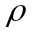 – Air density (kg/m^3)  - 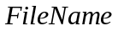 – File name (including path) of the aero disk input file (string) | - WriteOutputHdr – Names of write outputs (-)  - WriteOutputUnt – Units of write outputs (-)

Read in parameters from (, , InColNames, InColDims, , , , , , , , , , , , , , , , , OutList).
Note: InColNames and InColDims determine the number of independent input dimensions. Either 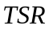 or 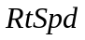 and 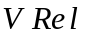 must be specified, as well as 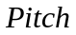 and 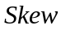. If is not specified, skew effects are computed internally by a effect.

Use and from , or if set to “DEFAULT” use the initialization inputs, to set parameters (, 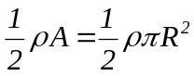)

Convert units of from rpm to rad/s (multiplying by 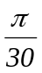) and and from degrees to radians (multiplying by 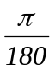).

Note/verify restrictions on input data:
- 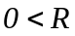.
- 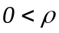.
- 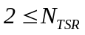; must be the same for each table; note: 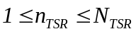.
- 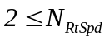; must be the same for each table; note: 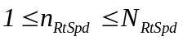.
- 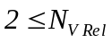; must be the same for each table; note: 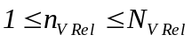.
- 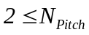; must be the same for each table; note: 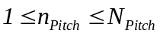.
- 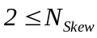; must be the same for each table; note: 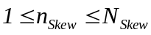.
- ; data must be entered monotonically increasing (can include negative values for rotors spinning opposite).
- ; data must be entered monotonically increasing (can include negative values for rotors spinning opposite).
- 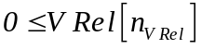; data must be entered monotonically increasing.
- 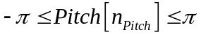 (radians); data must be entered monotonically increasing.
- 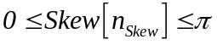 (radians); data must be entered monotonically increasing.

Check OutList and set WriteOutputHdr and WriteOutputUnt.

Update States:
Blank.

Calculate Outputs:
Calculate the rotor-disk-averaged relative wind velocity (ambient + rotor motion):
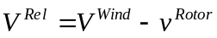

Trigger a fatal error if the orientation of the rotor centerline or rotor-disk-averaged relative wind speed is directed vertically upward or downward () whereby the nacelle-yaw error and disk coordinate system are undefined i.e. if 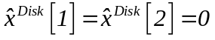 or 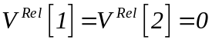.

Calculate , , , , , , , and based on and 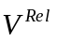:
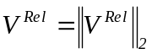
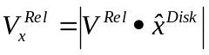
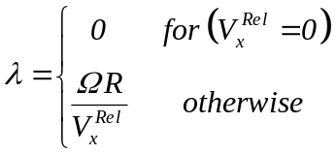
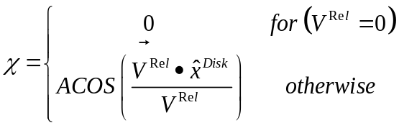
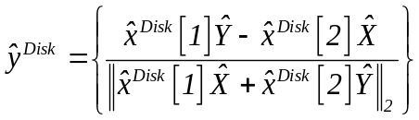
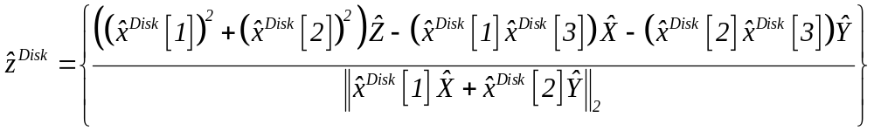
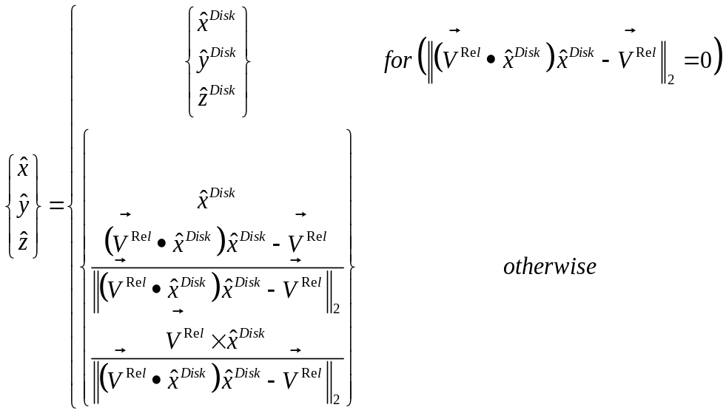
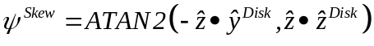

Trigger a fatal error if: 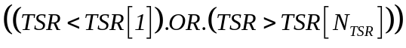, 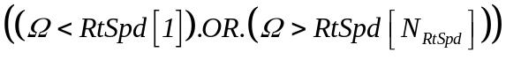, 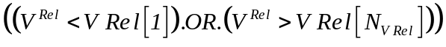, 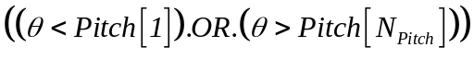, or 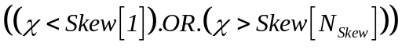.

Calculate the loads in the local actuator disk coordinate system and power via 2D, 3D, or 4D interpolation:
If 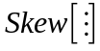 is not in the tables, then the effect of skew is computed as follows:
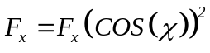
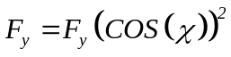
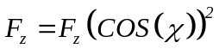
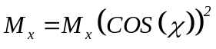
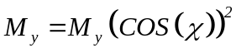
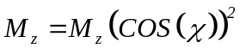

The thrust and torque coefficient outputs are the interpolated values ( is the interpolated value of 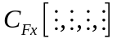 and 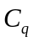 is the interpolated value of 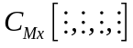).

Convert loads to global coordinates for output:
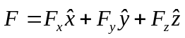
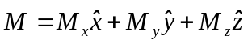

Compute write outputs:

This is the list of all possible output parameters available within the AeroDisk module. The names are grouped by meaning, but can be ordered in the OUTPUTS section of the AeroDisk input file as you see fit.

Channel Name(s) | Unit(s) | Description
ADSpeed | (rpm) | Actuator disk rotational speed
ADTSR | (-) | Actuator disk tip-speed ratio
ADPitch | (deg) | Actuator-disk collective blade-pitch angle
ADVWindx, ADVWindy, ADVWindz | (m/s), (m/s), (m/s) | Actuator-disk-averaged wind velocity in the local coordinate system
ADSTVx, ADSTVy, ADSTVz | (m/s), (m/s), (m/s) | Actuator-disk structural translational velocity in the local coordinate system
ADVRel | (m/s) | Actuator-disk-averaged relative wind speed
ADSkew | (deg) | Actuator-disk inflow-skew angle
ADCp, ADCt, ADCq | (-), (-), (-) | Actuator-disk power, thrust, and torque coefficients
ADFx, ADFy, ADFz,  ADMx, ADMy, ADMz | (N), (N), (N)  (N·m), (N·m), (N·m) | Actuator disk aerodynamic loads in the local coordinate system
ADPower | (W) | Actuator disk power

These write outputs are calculated as follows:

