Performance / Aerodynamic Maps
Functional requirements:
- Rotor only
- No tilt/yaw/skew
- No gravity
- Steady/uniform inflow, no shear
- Include cone and optional blade flexibility
- Specify rotor speed, and range of TSRs and blade-pitch angles
- Output Cp, Ct, Cq, and other blade-related outputs, e.g., deflections/loads
- Work with ElastoDyn, BeamDyn, and MBDyna
- Run in parallel/batch mode to speed up process; aggregate results
  - Expect 81000 points in 2 hours

Approach:
- Develop a specialized glue code that performs a nonlinear solve using ElastoDyn/BeamDyn/MBDyna together with AeroDyn.

Input file sketch:
- Echo Echo input data to <RootName>.ech (flag)
- Structural
  - CompElast Compute structural dynamics (switch) {0=None; 1=ElastoDyn; 2=BeamDyn; 3=MBDyna}
  - NumBl Number of blades (-)
  - FlapDOF1 First flapwise blade mode DOF (flag) [used only for CompElast=1]
  - FlapDOF2 Second flapwise blade mode DOF (flag) [used only for CompElast=1]
  - EdgeDOF First edgewise blade mode DOF (flag) [used only for CompElast=1]
  - TipRad The distance from the rotor apex to the blade tip (meters) [used only for CompElast=1]
  - HubRad The distance from the rotor apex to the blade root (meters)
  - PreCone Blade cone angle (degrees)
  - BldNodes Number of blade nodes (per blade) used for analysis (-) [used only for CompElast=1]
  - BldFile Name of file containing properties for all blades (quoted string)
- Aero
  - WakeMod Type of wake/induction model (switch) {0=none, 1=BEMT}
  - AirDens Air density (kg/m^3)\
  - KinVisc Kinematic air viscosity (m^2/s)
  - SpdSound Speed of sound (m/s)
  - Blade-Element/Momentum Theory Options (from AD input file)
  - Airfoil Information (from AD input file)
  - UseBlCm Include aerodynamic pitching moment in calculations? (flag)
  - ADBlFile Name of file containing distributed aerodynamic properties for all blades
- Cases
  - RotSpeed Fixed rotor speed (rpm)
  - NumTSR Number of TSRs (-)
  - TSR List of TSRs (-) [>0]
  - NumPitch Number of pitch angles (-)
  - Pitch List of pitch angles (deg)
- Solver options
  - Toler Convergence tolerance for nonlinear solve residual equation [>0]
  - MaxIter Maximum number of iteration steps (-) [>=1]
- Outputs
  - Structural
  - Aero

Problem formulation – for each TSR and Pitch:

Parameters Variable
- Hub position 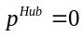
- Hub orientation 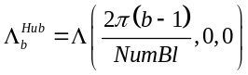 for 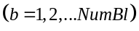
- Rotor rotational velocity 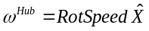
- Root position
- Root orientation of blade 1 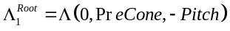
- Wind velocity 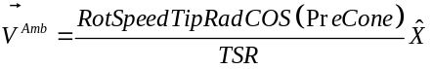

Continuous States Prescribed/Solved Prescribed Value
/ Variable
- x_BD%q(6,node_total-1) Solved 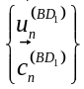 for 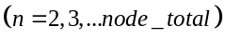
- x_BD%dqdt(6,node_total-1) Solved 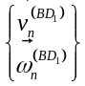 for

Constraint States
- z_AD%phi(NumBlNds,NumBlades) Solved

Inputs Prescribed/Solved Prescribed Value
- u_BD%RootMotion%TranslationDisp(3,1) Prescribed 0
- u_BD%RootMotion%Orientation(3,1) Prescribed 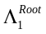
- u_BD%RootMotion%TranslationVel(3,1) Prescribed 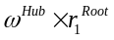
- u_BD%RootMotion%RotationVel(3,1) Prescribed 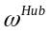
- u_BD%RootMotion%TranslationAcc(3,1) Prescribed 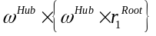
- u_BD%RootMotion%RotationAcc(3,1) Prescribed 0
- u_BD%PointLoad%Force(3,node_total) Prescribed 0
- u_BD%PointLoad%Moment(3,node_total) Prescribed 0
- u_BD%DistrLoad%Force(3,NNodes) Solved 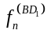 for 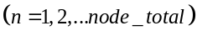
- u_BD%DistrLoad%Moment(3,NNodes) Solved 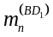

- u_AD%TowerMotion%TranslationDisp(3,NumTwrNds) Prescribed 0
- u_AD%TowerMotion%Orientation(3,NumTwrNds) Prescribed 0
- u_AD%TowerMotion%TranslationVel(3,NumTwrNds) Prescribed 0
- u_AD%HubMotion%TranslationDisp(3,1) Prescribed 0
- u_AD%HubMotion%Orientation(3,1) Prescribed 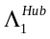
- u_AD%HubMotion%RotationVel(3,1) Prescribed
- u_AD%BladeRootMotion(NumBlades)%Orientation(3,1) Prescribed 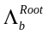
- u_AD%BladeMotion(NumBlades)%TranslationDisp(3,NumBlNds) Solved 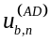 for 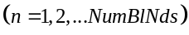
- u_AD%BladeMotion(NumBlades)%Orientation(3,NumBlNds) Solved 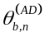
- u_AD%BladeMotion(NumBlades)%TranslationVel(3,NumBlNds) Solved 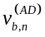
- u_AD%BladeMotion(NumBlades)%RotationVel(3,NumBlNds) Prescribed 0
- u_AD%BladeMotion(NumBlades)%TranslationAcc(3,NumBlNds) Prescribed 0
- u_AD%InflowOnBlade(3,NumBlNds,NumBlades) Prescribed 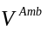
- u_AD%InflowOnTower(3,NumTwrNds) Prescribed 0
- u_AD%UserProp(NumBlNds,NumBlades) Prescribed 0

Outputs Used/Ignored Variable
- y_BD%ReactionForce%Force(3,1) Ignored
- y_BD%ReactionForce%Moment(3,1) Ignored
- y_BD%BldMotion%TranslationDisp(3,NNodes) Used 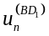 for 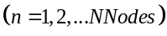
- y_BD%BldMotion%Orientation(3,NNodes) Used 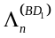
- y_BD%BldMotion%TranslationVel(3,NNodes) Used 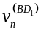
- y_BD%BldMotion%RotationVel(3,NNodes) Used 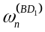
- y_BD%BldMotion%TranslationAcc(3,NNodes) Ignored
- y_BD%BldMotion%RotationAcc(3,NNodes) Ignored
- y_BD%WriteOutput(NumOuts) Ignored

- y%AD%TowerLoad%Force(3,NumTwrNds) Ignored
- y%AD%TowerLoad%Moment(3,NumTwrNds) Ignored
- y%AD%BladeLoad(NumBlades)%Force(3,NumBlNds) Used 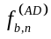 for
- y%AD%BladeLoad(NumBlades)%Moment(3,NumBlNds) Used 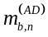
- y%AD%WriteOutput(NumOuts) Ignored

Problem formulation:
- Continuous states 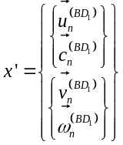 (only blade 1)
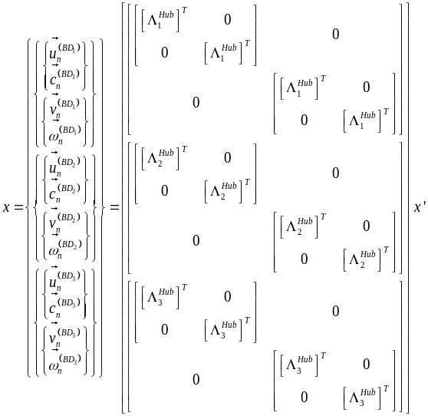 (all blades)
- Continuous state functions 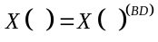
- Continuous state derivative constraint 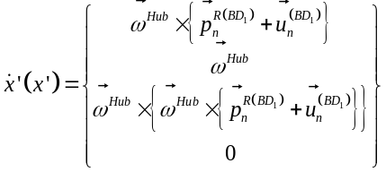
Note that 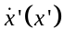 is linearly related to the states, i.e,:
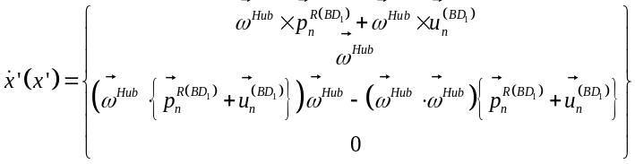
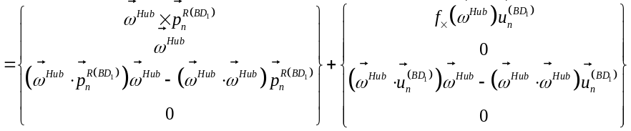
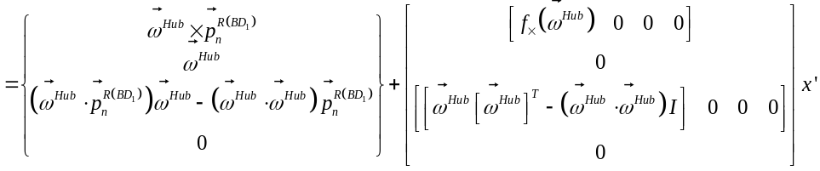
- Inputs 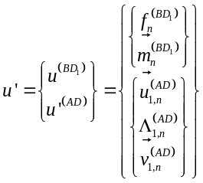 (only blade 1)
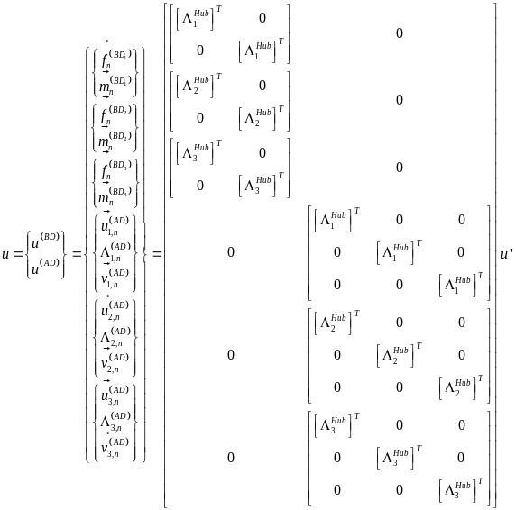 (all blades)
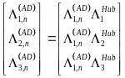
- Input-output functions 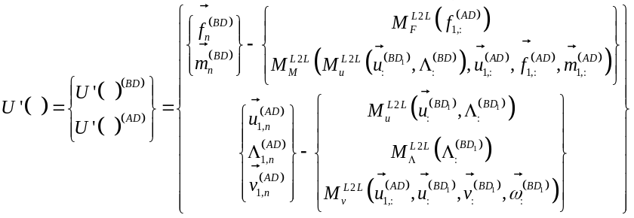
- Outputs 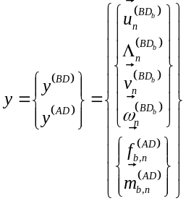
- Output functions 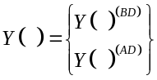

The nonlinear equilibrium equation to be solved is:
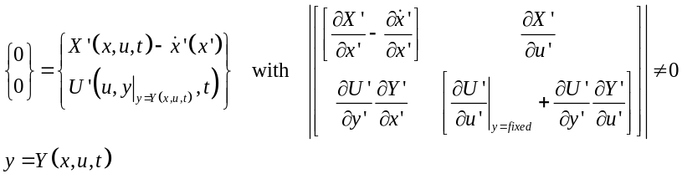

With the following Jacobians:
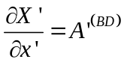
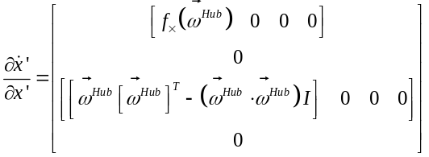

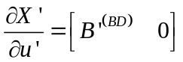
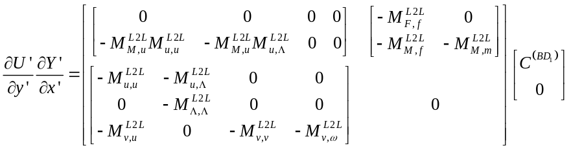
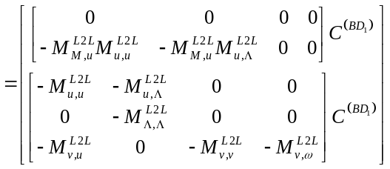
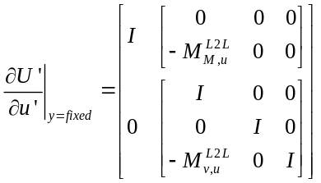
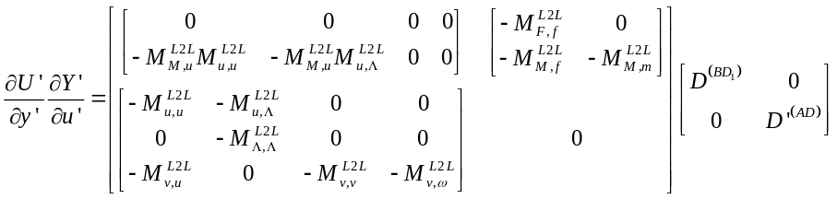
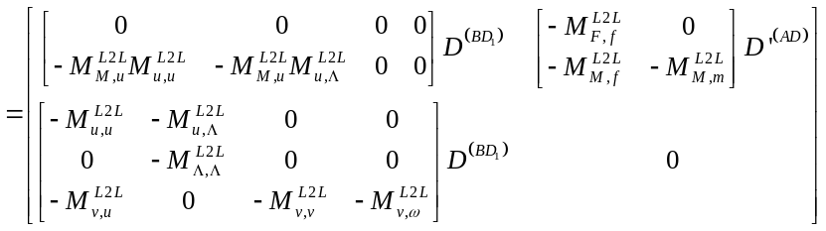

The proposed solution is Newton’s method (other methods are available). The algorithm for each TSR and each Pitch is:
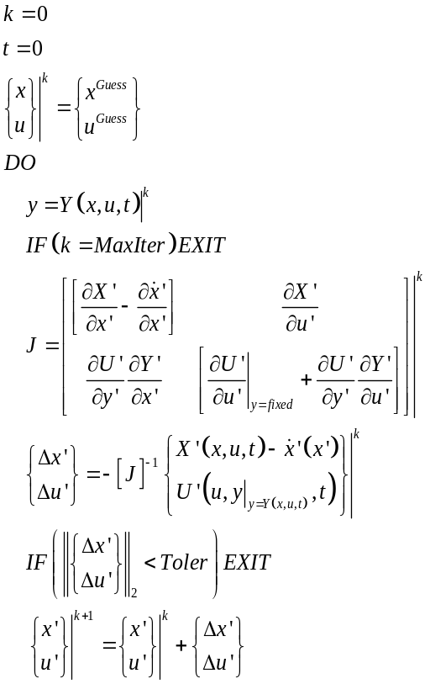
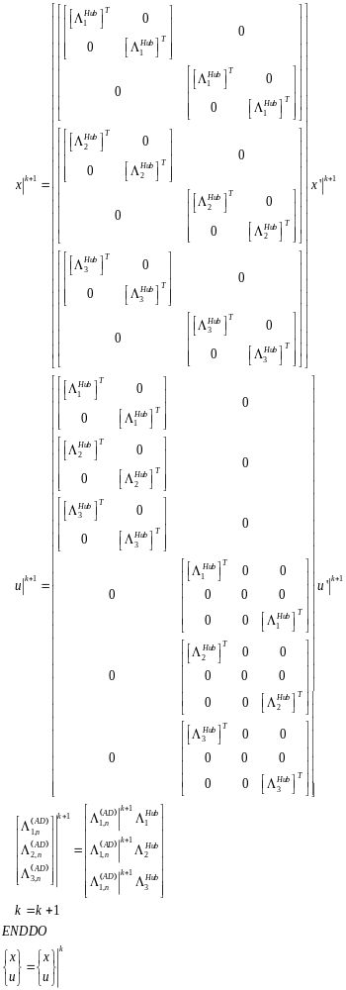
Steady-State Solve
Functional requirements:
- Full turbine
- Prescribed wind speed
  - Works with turbulence, but uses the mean
- Prescribed yaw angle and azimuth angle
- Calculate pitch and speed with simpler controller or fixed speed and pitch
  - Region 2 – torque-speed curve, with min/max speed
  - Region 3 – Fixed speed, with min/max pitch
  - Parked – zero rotor speed
- Calculates turbine deflections
- Expect a few seconds solve at the beginning of any simulation
- To create a database – define a range of wind speeds←Don’t need this if the solve is quick
- Output any states, inputs, and outputs

Approach:
- Add a STEADY-STATE SOLVE section to the OpenFAST primary input file (after INPUT FILES and before OUTPUT) – see below
- Initial conditions in the various OpenFAST modules are used as initial guesses

Input file sketch for new STEADY-STATE SOLVE section of the OpenFAST primary input:
- InitSteady Initialize the time-domain simulation from a steady-state solution (switch) {0:No (use initial conditions instead); 1:Yes, through a solve; 2:Yes, by reading from a file}
- CntrlCase Control case (switch) {1:Prescribed rotor speed and pitch, 2:Calculated rotor speed and pitch}
- Toler Convergence tolerance for nonlinear solve residual equation [>0] [used only when InitSteady=1]
- MaxIter Maximum number of iteration steps (-) [>=1] [used only when InitSteady=1]
- SSJacSclFact Scaling factor used in steady-state Jacobians (-)
- SteadyFile Name of file containing the steady-state solution (quoted string)

Two problems
- How to find a steady-state solution
- How to initialize from a given steady-state solution
  - Use the states and inputs from (1) or read-in the states from SteadyFile when InitSteady = 2
  - Have the calling program overwrite the states set during *_Init()

InflowWind
Create a function that calculates the time-series mean for any wind file of PropogationDir, HWindSpeed, RefHt, and PLexp.

Modularization Framework Changes:
- Add the InitSteady switch to InitInput to all *_Init() routines.
- Allow *_Init() to be called a second time, whereby the initial conditions now calculated are set and the overwritten settings are restored

Modules Supported:
- Envision: MBDyna (ElastoDyn, BeamDyn), AeroDyn, InflowWind, ServoDyn (TMD)
- NREL: SubDyn, HydroDyn, MAP++, MoorDyn, External Platform MCKF,
- Not including: AeroDyn v14, OLAF, AeroAcoustics, FEAMooring, OrcaFlex, IceFloe, IceDyn

Overriding certain models that cannot be linearized during initialization
- InflowWind
  - WindType = 1 (steady) or 2 (uniform)
- ServoDyn/StC
  - PCMode = 0
  - Generator offline (GenTiStr = TRUE with TimGenOn > 0)
- ElastoDyn
- BeamDyn
  - analysis_type = 2 (dynaimc)
  - UsePitchAct = False (no pitch actuator)
  - RotStates = False
- AeroDyn
  - WakeMod = 1 (BEMT)
  - AFAeroMod = 1 (steady)
  - FrozenWake = False
- HydroDyn
  - WaveMod = 0 (still water)
  - PotMod = 0 (none)
- SubDyn
- MAP++
- MoorDyn

Values stored in SteadFile
- Time-series mean of HWindSpeed, RefHt, and PLexp
- All module-level continuous states
- All module-level inputs
- Simulation aborts if the states or inputs differ from what is used

Questions:
We can only calculate continuous states and inputs during linearization.
Initialize the constraint states based on the continuous states and inputs
Likely just initialize the discrete states and other states as they are now
What is meant be “find speed and pitch”?

The nonlinear equilibrium equation to be solved is:
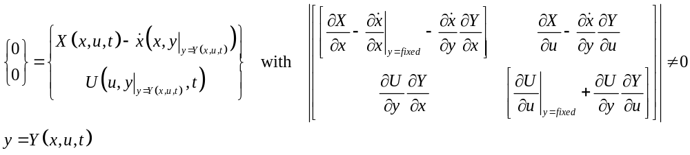

With the following Jacobians:
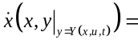
- 0 for all states except the generator/rotor speed state and blade velocity states in BeamDyn, which are nonzero due to the rotor rotation
- 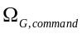 for the generator/rotor speed state, which is either the prescribed (initial) rotor speed specified in ElastoDyn (CntrlCase = 1) or output from the simple controller (CntrlCase = 2). The following Jacobians apply:
  - 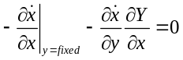 (no involvement of states in the controller)
  - 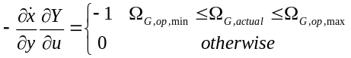 for the generator speed input (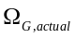) / output () and 0 otherwise

New ServoDyn controller:
Inputs | Outputs | States | Parameters
- – Actual generator speed (rad/s)  - 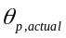 –Actual blade-pitch angle (rad) | - – Generator torque (Nm)  - – Desired (commanded) generator speed (rad/s)  - 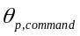 – Commanded blade-pitch angle (rad) |  | - 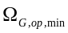 – Minimum generator speed in optimal mode (Region 2) (rad/s)  - 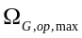 – Maximum generator speed in optimal mode (Region 2) (rad/s)  - 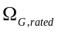 – Rated generator speed (rad/s)  - 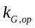 – Generator torque gain in optimal mode (Region 2) (Nm/(rad/s)^2)  - 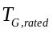 – Rated generator torque (Nm)  - 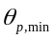 – Minimum (rated/fine) blade-pitch angle (rad)  - 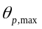 – Maximum (parked/idling) blade-pitch angle (rad)  - – Proportional gain in pitch regulation mode (Region 3) (s)

Initialization:
Input parameter checks:
- 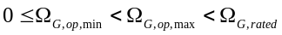
- 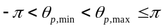
- 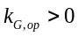
- 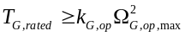
- 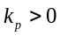

Calculate Output:
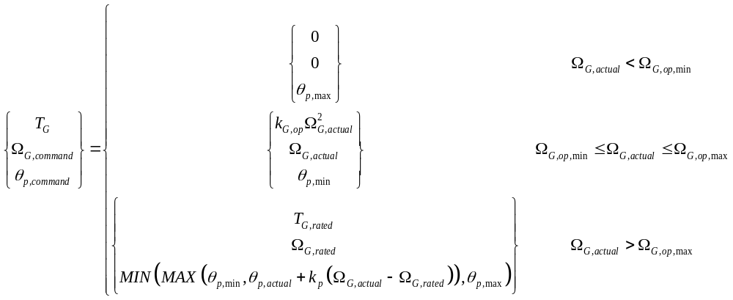

Jacobian (computed analytically):
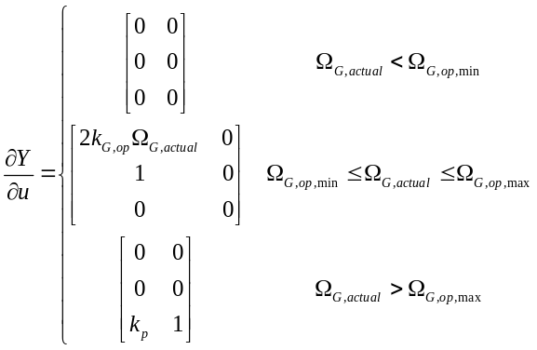

Background Material

General OpenFAST Equations (without other states):
Equilibrium solutions are permitted for any modules that follow the most general form allowed by the framework for tight coupling, i.e., a hybrid semi-explicit DAE of index 1.
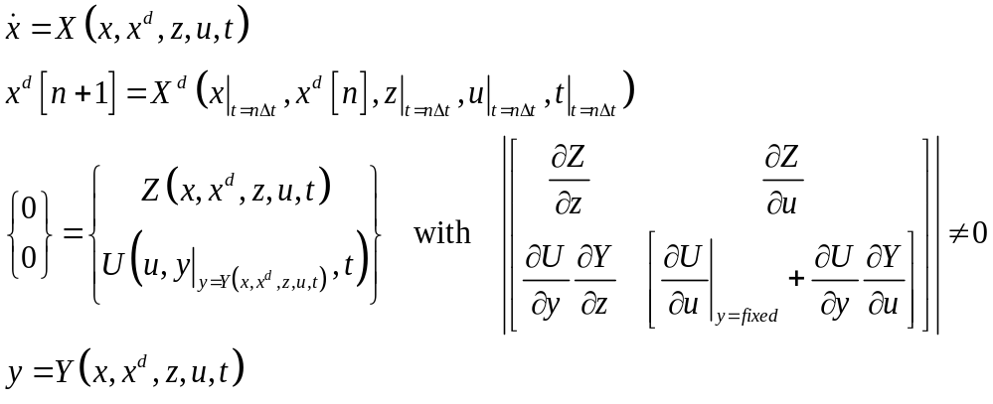

For second-order continuous-time systems:
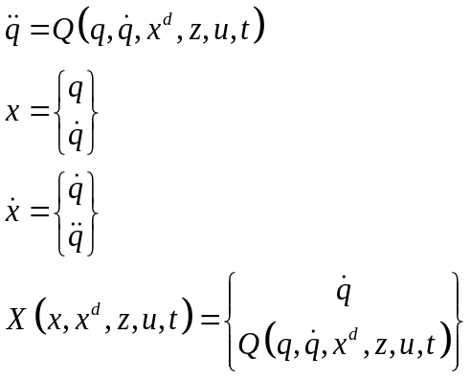

Static-Equilibrium Solution (likely solved at 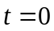 and 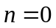):
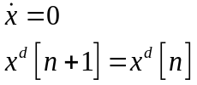
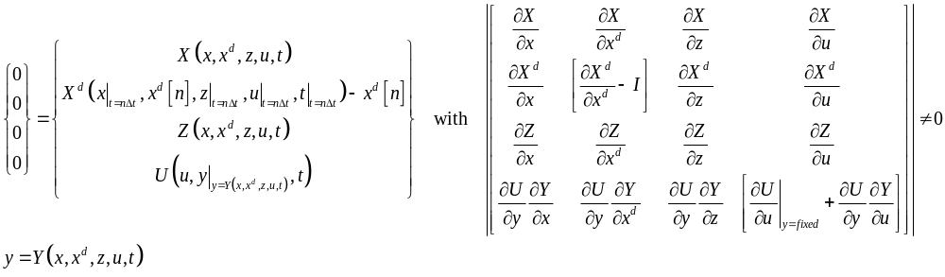
The stated determinant must be nonzero for a bounded solution to exist in a neighborhood around the solution. Based on the properties of the determinant, this means that the determinant of each submatrix on the diagonal must be nonzero, i.e., 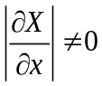, 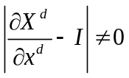, 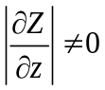, and 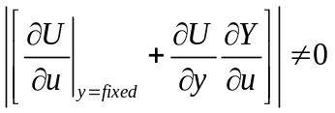 (there are other restrictions, but this one is easiest to check). This will limit the types of equilibrium problems that can be formulated and solved. (E.g., it is likely that the rotor-azimuth angle would have to be prescribed, rather than solved.)
This approach also applies to prescribed nonzero values of (e.g., the rotor speed), assuming the rotor rotation DOF is eliminated (i.e., the rotor speed and azimuth angle becomes a parameter).

The solution could be as simple as Newton’s method (other methods are available) (with the iteration counter and 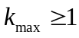, and initial guess values (or initial conditions) provided for the continuous states, discrete states, constraint states, and inputs):
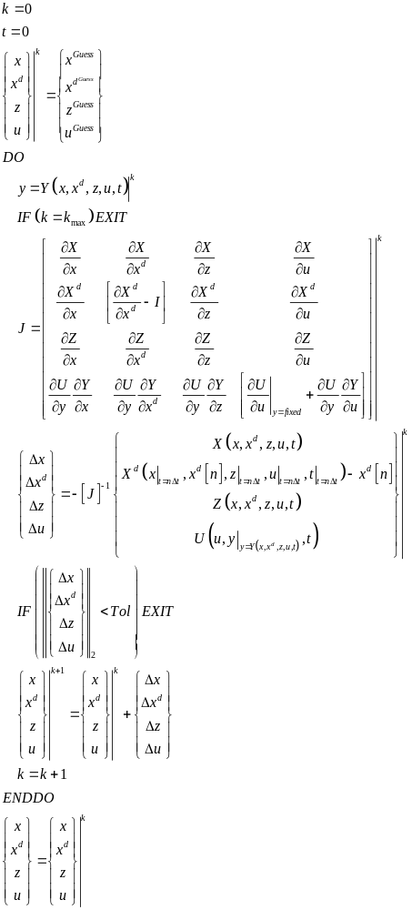

Steady-State Solution (for solved (not prescribed) nonzero values of ) (likely solved at and ):
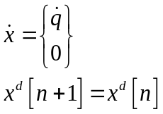
For states where (potentially) nonzero values of are desired (e.g., the rotor speed), the corresponding value of is prescribed (e.g., the desired azimuth angle) and the solution is the same as for static equilibrium, except that 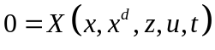 is replaced with 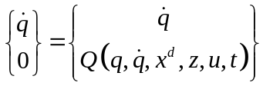, or—because the first equation is trivial and can be eliminated—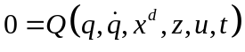,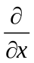 is replaced with 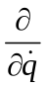, and the potentially nonzero values of are solved based on prescribed values of .

Periodic steady state (skip):
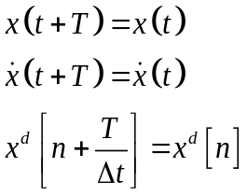

Rotation Notation/Convention 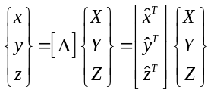 (from global to local) or equivalently: 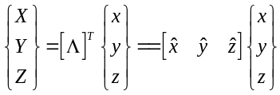 where X/Y/Z are global coordinates, x/y/z are local coordinates, is the DCM from global to local, and // are the unit vectors of the local coordinate system expressed in the global coordinate system. 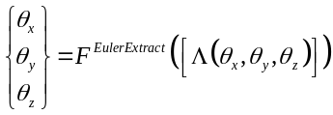 where function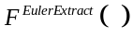 returns the 3 Euler angles of the x-y-z (1-2-3) rotation sequence used to form (that is, first a rotation about the global X axis, followed by rotation about the Y’ axis, followed by rotation about the Z’’ axis ) defined as follows: 