**Breaking Wave Modeling Approach for FAST**

Amy Robertson, 5/11/16

**Implementation**

The breaking wave will be modeled as an impact force, to be added with the other hydrodynamic forces. It will only be applicable to wave models that include stretching (or embedded higher-order regular waves in the future), otherwise, we will not have kinematics data above the SWL that are needed to calculate this force.

***Identification (Threshold)***

This impact will be applied when a given wave peak reaches a threshold defined as (IEC 61400-3):

***H = b/(1/d+a/(g*T^2))***

***b = 1.6/(1+exp(-19*tan(alpha)))***

***a = 44*(1-exp(-19*tan(alpha)))***

where *H* is the wave height, *d* is the water depth, *T* is the wave period, and *a* and *b* are coefficients based on the slope of the seabed (*alpha*). Alpha will be an input by the user. Using this approach identifies some extremely small wave events as well (issues with period?), so I suggest implementing an additional constraint that *H > 0.4*d*. The period could be identified as the time between the troughs on either side of the wave.

Identification is based on looking at the wave elevation time series for every node that is above the SWL. Zero crossings in each time series are identified, and the peaks and troughs (alternating) between the crossings recorded. The wave height, *H*, is calculated as the difference between a given peak and the following trough. This height was found to be higher than the difference between a given peak and the preceding trough (Babanin confirms that the following trough is deeper - haven’t read anywhere which is more appropriate). For the DTU/DHI data, more breaking wave events seemed to occur (based on high-frequency response) than are identified, so anything that creates a larger wave height or lower limit, would allow more peaks to be identified as breaking. If a wave peak exceeds the threshold, it is then determined whether the node lies within the force location area (see next section). If it does lie in this area, a breaking wave event is flagged. For vertical members, a modified procedure might be used so that not every node needs to be examined, as they will all have the same wave time history.

***Force Location***

The impact force is located over a specific region of the member. It is located on the upper half of the wave region considering the portion above the SWL up to the wave peak. According to Wienke, this region could be from 0.4 to 0.5 times the distance from SWL to wave peak, but we’ll just assume 0.5, which is the value recommended by IEC 61400-3. The load will be implemented using the line force approach within FAST for those nodes that fall within this region of the wave. The application of the load is determined on a per-node basis. If a node has a breaking wave and sits within the region of the upper half of the wave, it will have the force applied to that node on a force per length basis, based on the total force for the applicable region (upper half of SWL to wave peak). A fine discretization of the structure above the waterline will likely be needed to get an accurate implementation.

* After this approach is accomplished, we’ll examine whether a floating node is needed.

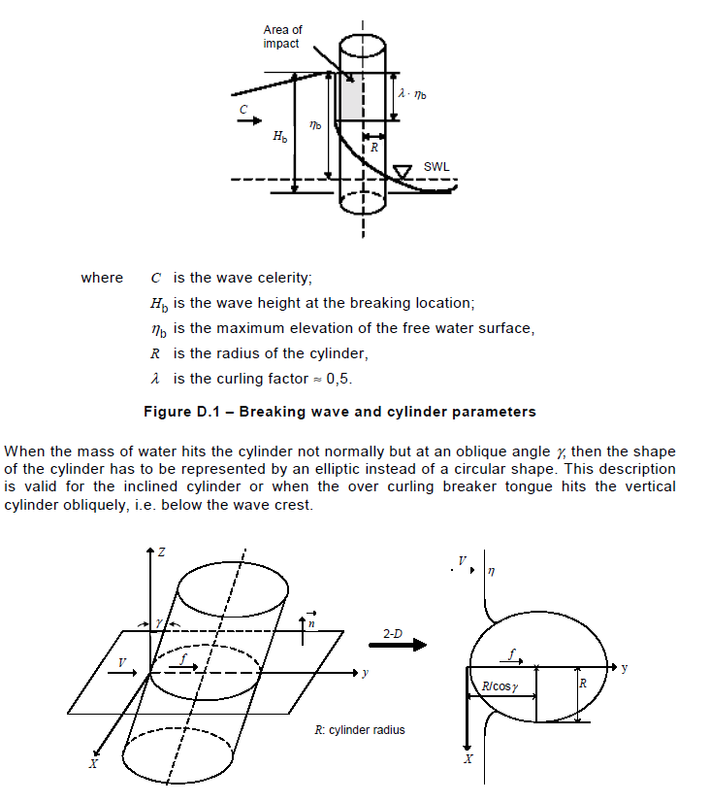

***Force Magnitude***

The magnitude of the impact force is given below, and is based on both the wave velocity and the geometry of the structure. This is the total force, and needs to be divided by the length over which it is applied for each node. The time period for the force is also specified, and there is a change in the force during this period. The plot below shows an example of this force for the DTU/DHI cylinder over time.

* V = horizontal velocity of water when it hits the cylinder. This will be chosen as the horizontal velocity at the wave peak when the wave peak passes the node. Wienke mentions this velocity should be the wave celerity, which is equal to the maximum horizontal velocity.
* *d* = water depth
* *T* = period (derived from zero crossings or troughs)
* *g* = gravity
* *ηb* = wave peak (distance from SWL to peak for a given node)
* *λ* = curling factor = 0.5
* *R* = radius of cylinder
* *γ* = angle between cylinder and vertical (see figure below), for vertical, cos *γ* = 1. In 3D, this angle will have to be determined vectorally based on the inclination of the member and the local velocity vector V.

**

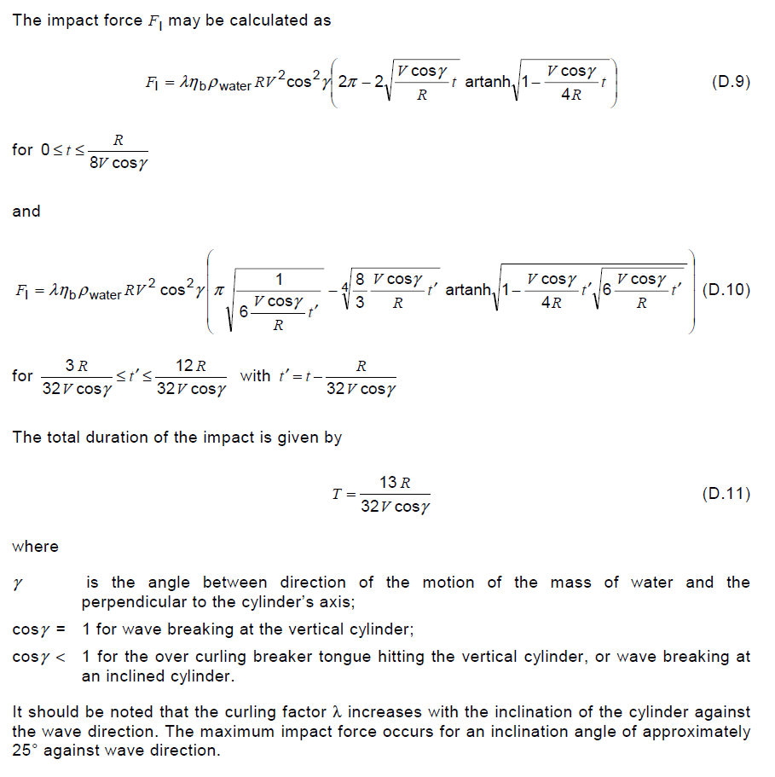

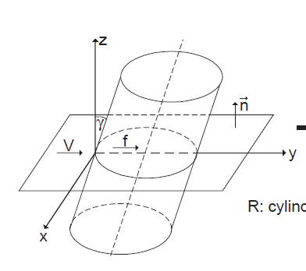

Figure : Description of Gamma

***Force Timing***

The timing of the impact force is a bit of a conundrum. The papers I’ve read don’t give a precise timing, but rather state that it occurs when you first start feeling the wave. With a breaking wave, the breaking component is happening before the wave peak arrives. This could mean that you start it at the time of the zero-crossing before the breaking wave peak, or at the peak. However, regardless of when the impact force is applied, it should still use the velocity of the wave at its peak.

The plot below shows 3 breaking waves from this dataset. I have plotted a black star at the location of the wave peak that is breaking, and then a black circle at the point that the breaking wave load should be applied (zero crossing before peak). Ideally, this placement should coincide with the peak force for that wave. You can see that the timing is varied. Also, you can see that the first breaking wave event is not identified with this new criterion.

* Another option is to just start the impact force at the time that the peak of the wave hits the center line of the cylinder, or have users input a set offset between the wave peak and the force initiation (force prior to wave peak).
* Enzo seems to define this time offset as a constant value, based on his higher-order simulations (2 or 3 seconds) [Enzo]:

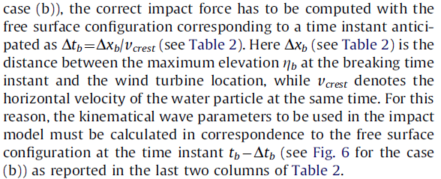



Figure : DTU/DHI Example: Black Stars are the wave peaks that break. We see that the impulsive force appears to be initiated before this peak occurs. Black circles in force plot indicate the zero-crossing location before the breaking wave, and is suggested as a time point to initiate the impulsive load.