Open IP Fast Path
Open IP Fast Path (OIP-FP) is an IP stack intended to be used as a Linux application. It receives and transmits packets by using ODP.
Main features are:
- Ethernet and GRE interfaces
  - VRFs and VLANs supported
  - Copied from Linux kernel or set manually
- IPv4 and IPv6
  - IPv4 reassembly and fragmentation. IPv4 Options not supported.
- ARP and NDP support
- Routing
  - IPv4 with VRF support
  - IPv6
  - Routes copied from Linux kernel or set manually
- Protocol termination:
  - UDP, TCP, UDP6
- ICMP support
- Command line interface
  - Packet dumping and other debugging
  - Statistics, ARP, routes, and interface printing
  - Configuration of routes and interfaces with VRF support
- APIs
  - IPv4 and IPv6 packet sending
  - Support for packet callbacks (local, forward)
  - Socket interface

Components
OIP-FP is composed of the following components:
- Command line interface (CLI): Internal Command Line Interface to configure and debug OIP-FP.
- Packet handler: Received packet handling.
- Init: ODP environment, and internal memory initialization.
- Netlink: Copies routes and interfaces from Linux.
- TUN/TAP: Communication with Linux kernel, slowpath.
- Port configuration: Ethernet interface functionality.
- Route, arp: Route and ARP functions.
- Application API: Function calls for configuration, packet processing, logging, etc...
- AVL and Radix trees: Functionalities to be used by other modules.
- Socket: BSD style socket interface
- Protocols: UDP, TCP, UDP6, ICMP implementation

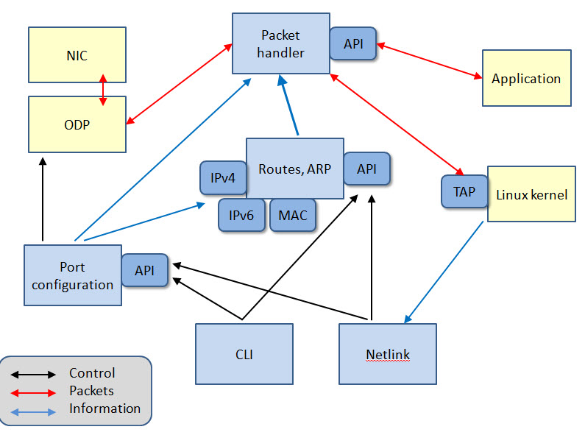
Setup
Setup is done when the application starts. All the memory for the port configuration table, routing trees, AVL trees etc. is allocated. This ensures that any pointer to a data structure will never be invalid although data may not be correct. Memory is shared between processor cores. Drawback is that if there should not be enough memory it is not possible to allocate more.
One core (#0) is required for Linux system calls, mainly for CLI and route copy. One core is needed for communication with Linux kernel using TUN/TAP interface. Other cores are free for traffic handling.

Port configuration
Information about physical ports is saved in a table. Logical interfaces (VLAN, GRE) are in AVL trees that are based on a physical interface. Table element holds the following information:
- Port number of an Ethernet interface.
- VLAN tag. Elements in the table has VLAN tag 0.
- VRF the interface belongs to.
- MTU of the interface.
- IPv4 address.
- Point-to-point IPv4 address for a GRE interface.
- Local IPv4 address for a GRE interface.
- Remote IPv4 address for a GRE interface.
- IPv4 address mask length.
- IPv6 address.
- MAC address.
- Linux index maps Linux virtual interface to the OIP-FP interface.
- Interface type (ether, loop, gre, etc.).
- AVL tree for logical VLAN interfaces based on this physical interface.
The following picture depicts the port data structures:
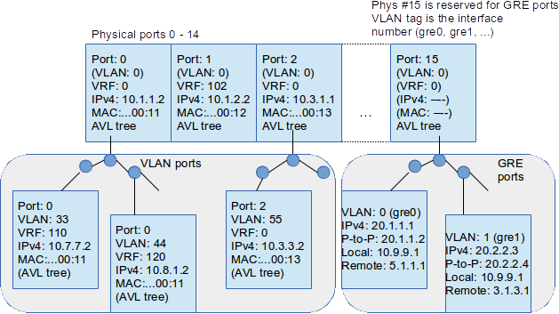
Physical and logical port data structures are called devices. Device is defined by two numbers, physical port and a VLAN tag. Port number of a GRE device is always 15 and VLAN tag is the interface number. Thus accessing the basic physical interface device is fast; it is just a table lookup. VLAN interfaces require an additional AVL search.

Routes
IPv4 and IPv6 routes are in Radix trees. IPv4 routes support VRFs. At the moment there is no VRF support for IPv6 routes, but implementation would be easy.

IPv4 routes
IPv4 route tree structures are depicted below:
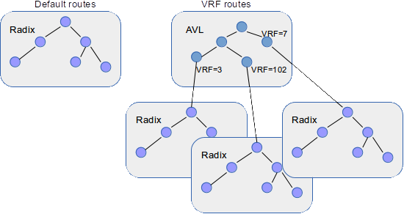
There is a Radix tree for default routes (VRF = 0). VRF route trees can be accessed via an AVL tree where an entry exists for each VRF. Route consists of the following data:
- Gateway address.
- Physical port number.
- VLAN tag.

IPv6 routes
IPv6 routes are in a Radix tree whose depth is 128. 64 bit depth should be enough, but it is TBD. Route data is composed of:
- Gateway link local address.
- Port number.
- VLAN.
- MAC address of the gateway.

ARP table
MAC addresses are in an ARP hash table. Keys for the table are
- VRF
- IPv4 address
Result is MAC address, if it exists. For IPv6 MAC addresses are included in the routing table.

Route copy
Routes and interfaces are copied from Linux kernel by using netlink sockets:
- IPv4 routes.
- IPv6 routes.
- Virtual ODP interfaces (fpX).
- GRE interfaces.
- Interface data:
  - IPv4 and IPv6 addresses
  - Netmask
  - MAC address
  - MTU
  - GRE point-to-point, local, and remote addresses
Normal Ethernet interfaces, loopbacks etc. are ignored. Route and device tables are updated accordingly using the APIs.
VRFs are not supported since there exists no proper VRF implementation in Linux. However, Linux has several routing tables whose number is used as a VRF identity. This is a workaround to be able to use VRFs without CLI.

Packet handler
Packet handler receives data packets from Ethernet interfaces and Linux kernel. Ethernet packets are processed the following way:
- Update statistics while processing.
- Create PCAP type dump to a file if requested by configuration.
- Remove and save Ethernet header.
- Find input device.
- Save device's VRF to the packet.
- If packet is IPv4 destined to a local interface:
  - Offer packet to the application local hook input. If not accepted check if packet protocol is GRE.
    - If it is remove GRE header and offer packet to the application forward hook input.
    - If not, send the packet to upper layer protocol specified in the IPv4 proto field: UDP, UDP6, TCP or ICMP.
  - Unaccepted packets are forwarded to Linux kernel using TAP interface.
- If packet is an IPv4 non-local packet:
  - Offer to the application forward hook input.
  - If not accepted drop the packet.
- If packet is IPv6 destined to a local interface:
  - Offer to the application local input hook.
  - If packet is not accepted check if it is Neighbor advertisement. Learn MAC address. Finally send packet to Linux kernel.
- If packet is an IPv6 non-local packet:
  - Find next hop and offer to application forward input hook.
  - If not accepted forward packet to Linux kernel using TAP interface.
- If IP protocol is ARP:
  - Learn MAC address if ARP operation type is 2.
  - If packet is destined to our interface and ARP operation type is 1 create and send a reply.
- Unknown packets are sent to the Linux kernel using TAP interface.
Packets from TAP are on their way to Ethernet interfaces.
Packet handler provides API for sending packets. IPv4 packets are transmitted the following way:
- There may exists a next hop already resolved by the function caller. Otherwise next hop will be looked up.
- Important things in the next hop are
  - gateway
  - output port
  - VLAN
- Output device is looked up using the port number and VLAN tag.
- If port is 15, i.e. GRE port:
  - Find out a new next hop based on GRE device's remote address.
  - Prepend packet with a GRE header.
- Find out destination gateway's MAC address.
  - Prepend packet with Ethernet header and send the packet if MAC address was found.
  - Otherwise send ARP request and save the packet for sending when ARP reply arrives.
IPv6 packet transmission:
- Use provided next hop if exists; otherwise lookup next hop.
- Next hop contains
  - Gateway's link local address
  - Gateway's MAC address
  - Port number
- Find output device.
- If gateway's MAC address doesn't exist send neighbor solicitation and return status to drop the packet.
- Otherwise prepend packet with Ethernet header and send the packet.

Command line interface
OIP-FP contains a Telnet based CLI for configuration and statistics browsing. It can also read the commands from a file when the application starts. Basically CLI is used for debugging and enabling some routing features that are not available by copying routes from Linux kernel. Basic commands are:
- Dump traffic to the console or to a PCAP file. Configuration options:
  - What kind of traffic (RX, TX, slowpath)
  - Which ports to print
  - File name to print
- Show information
  - ARP table
  - Routing tables
  - Interfaces
  - Statistics
- Configure
  - Routes (IPv4 with VRF)
  - Interfaces (VRF, VLAN)

