Lab Activity: Computing Canopy Height and Crown Width Using CloudCompare
Madhumitha Katam and Chelsea Scott, Arizona State University

Learning Objectives
- Remember: Define canopy height and crown width in a lidar point cloud. Identify the CloudCompare tools used: the database (DB) tree panel, scalar fields, and point picking in single-point and two-point distance modes.
- Understand: Explain why canopy height and crown width matter for biomass, competition, and stand health. Describe how CloudCompare lets users interrogate lidar data directly and explain what height normalization does to a point cloud.
- Apply: Load the original and normalized point clouds into CloudCompare. Measure canopy height on both clouds and crown width on the normalized cloud along two perpendicular diameters.
- Analyze: Take multiple measurements each across five trees and quantify the spread. Compare heights on the standard and normalized point clouds to find where they agree and/or disagree and interpret differing perpendicular diameters.
- Evaluate: Justify why averaging five measurements is better than a single pick. Judge which point clouds better support a landscape-scale canopy height model.
- Create: Complete the measurement tables and calculate average canopy height and crown width for each of the five trees.

Summary
This lab introduces two structural measurements of a tree. Canopy height describes how tall the tree stands from the ground to its top. Crown width describes how far its branches spread. Students work in CloudCompare, an open-source point cloud viewer used across surveying, forestry, and geosciences. Unlike a browser-based application, CloudCompare runs locally and gives direct access to the full point cloud rather than a rendered preview. It is free to install and is the same class of tool that professionals use to inspect lidar data. Students use the “Point Picking” tool to select points in the point cloud and measure the distance between them. They repeat each measurement five times to show how values shift with each pick, then calculate an average for both canopy height and crown width.

Thinking Skills
Lower-order thinking skills (remember, understand, and apply):
Students recall the definitions of canopy height and crown width, explain why single-tree measurements matter for forestry and ecology, and apply the Point Picking tool to collect real distances from the point cloud.
Higher-order thinking skills (analyze, evaluate, create):
Students analyze the spread across their five measurements, evaluate why averaging improves reliability over a single reading, and create a results table that reports the averaged canopy height and crown width.

Context
Lidar point clouds capture the three-dimensional structure of a landscape as a dense set of measured points. Foresters use point cloud data to measure individual trees from a desktop computer without needing to go into the field. Canopy height and crown width are two of the most common structural traits derived this way. They inform estimates of biomass, growth, competition for light, and stand health. In this activity, students measure both traits directly from a point cloud in CloudCompare. The workflow mirrors how researchers extract tree-level metrics from remotely sensed data.

Materials/Tools required
- Point Cloud and Normalized Point Cloud (.laz files) found in data folder of GitHub repo - https://github.com/openForest4D/lidar_applied_tree_measurements
- CloudCompare Software (https://cloudcompare.org)

Lab Activity

Step 1: Pre-activity discussion
Normalized Point Cloud:
In a standard point cloud, each Z value is the elevation above sea level. A normalized point cloud is a point cloud with the terrain elevation removed. A tree on a hill carries the hill's height inside its Z value. Normalization subtracts the ground elevation from every point above it. The ground becomes flat at Z equal to zero.

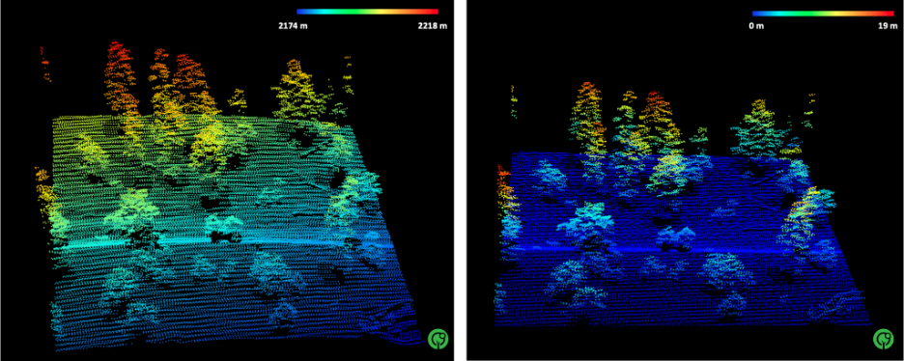
Figure 1: Lidar point cloud of a forested site near Flagstaff, Arizona (left), and the normalized point cloud of the same landscape [1].

Canopy Height Model:
In forestry, we often need to know the height of vegetation across an area. A canopy height model (CHM) provides this and is defined as the vertical distance from the ground surface to the top of a tree. It can be generated using two common approaches:
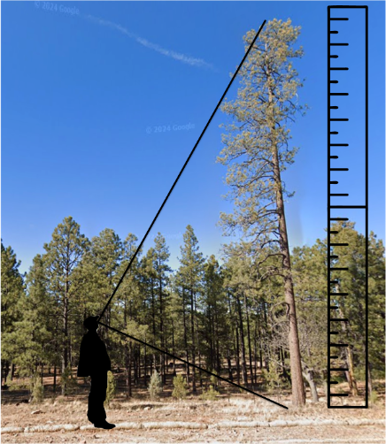
Figure 2: Measuring canopy height in the field of Sitgreave’s National Forest [1]
- Subtracting the DTM from the DSM: In a lidar point cloud, the ground is defined by classified ground returns, and the top is the highest vegetation return above that point. The difference is the height of vegetation above the ground surface
$$CHM = DSM - DTM$$

- Height Normalization: The terrain elevation is first flattened or normalized to create a leveled reference surface. The elevation of each point is then measured relative to this normalized surface, resulting in the canopy height

Crown Width:
Crown width is the width of a tree's crown. The measurement is taken across the leafy part of the tree at its widest point, viewed from directly above. Crown width is a horizontal measurement and depends only on the X and Y positions of the crown edges, not on the Z value. Crowns are rarely round, so field crews and lidar analysts measure the width in two directions set at right angles and take the average.
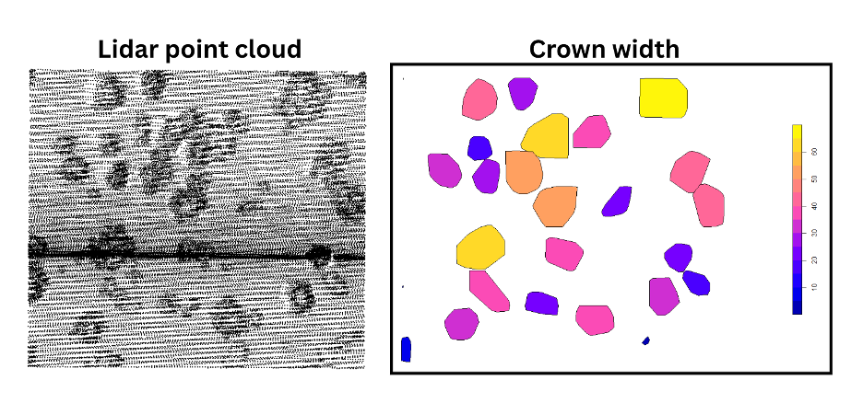
Figure 3: Lidar point cloud of a forested site near Flagstaff, Arizona (left), delineated individual tree crowns, colored by crown width (right) [1]
Crown width shows how much space a tree crown occupies. The measurement supports estimates of how much ground the canopy covers, how strongly neighboring trees compete, and how the crown relates to trunk size and tree biomass.

Questions:
- Define canopy height in one sentence.
- Define crown width in one sentence.

- What does the Z coordinate represent in a lidar point cloud? (Hint: Think about first activity graphs.)

Step 2: Download the CloudCompare Software
- Go to the official CloudCompare website at https://www.cloudcompare.org/ and download the “Latest stable release” version of the CloudCompare software.
- CloudCompare is free and is available on Windows, macOS, and Linux.
- Choose the installer, not the zip or archive file.
- Run the file you downloaded. You need admin rights, and your computer may restart, so save your work first.
- Accept the license and keep the default settings.
- Open CloudCompare. You should see a 3D window with a panel on the left. The software is ready.

Step 3: Open the point cloud and normalized point cloud in CloudCompare.
You can refer to the following YouTube video on how to use CloudCompare https://www.youtube.com/watch?v=hSySzdWPD08
- Download the lidar point cloud files found in the GitHub repository’s data folder (https://github.com/openForest4D/lidar_applied_tree_measurements) and open CloudCompare.
- Click File > Open and select your lidar point cloud (.LAZ file).
- A window pops up asking you to select the standard fields needed; click on “Apply All."
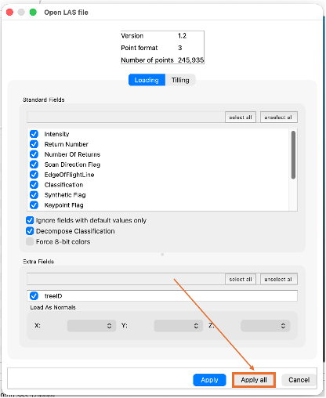
- This will lead you to the global shift/scale window; simply click on “Yes to All.”
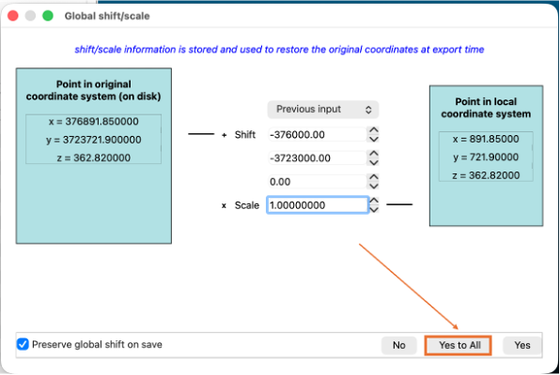
- The point cloud will appear in the 3D view. Use your mouse to rotate, zoom, and pan around until you can see a clear tree.
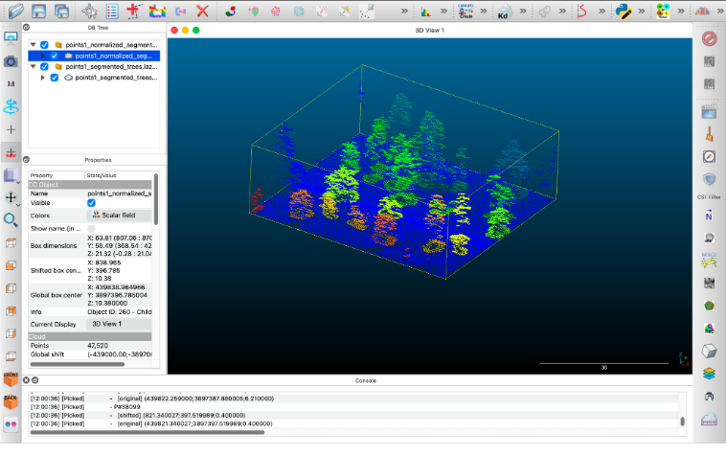

Step 4: Canopy Height
4A. Measure the lidar point cloud.
- Click on the point cloud in the left-side panel. Rotate to a side view so the trees are seen in profile against the ground.
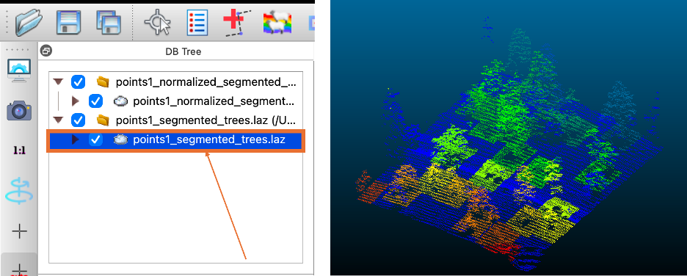

- For this activity, choose 5 trees of your choice. Zoom into the first tree, take a screenshot of it, and paste it in Table 1.
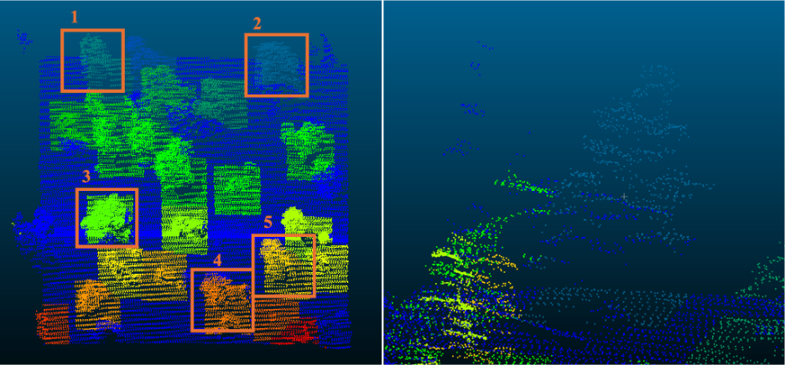
- Open the point-picking tool from the toolbar. Set it to two-point distance mode.

- Click a ground point at the base of Tree 1's trunk. Record its Z value as Ground Z.
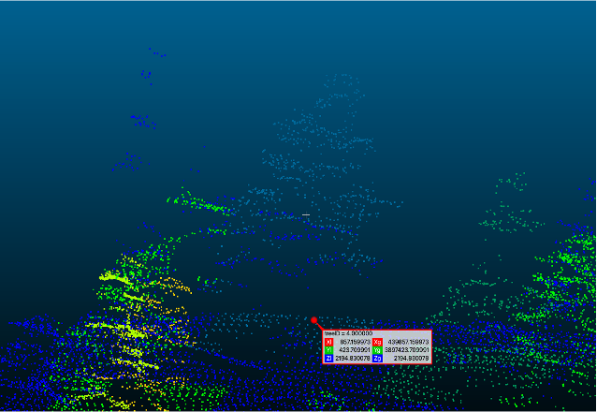

- Click the highest point of Tree 1's crown. A label shows its X, Y, and Z. Record the Z value as Top Z.
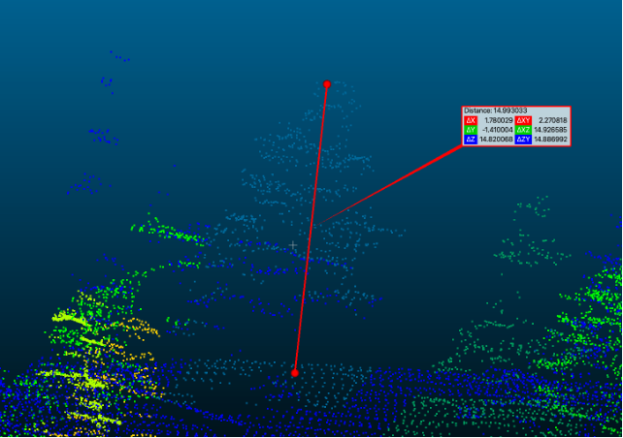
6. Tree Height is the ΔZ inside the box. Enter the value in Table 1.
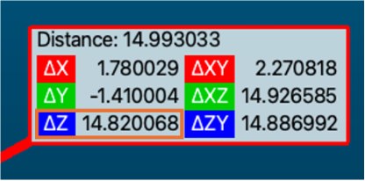
7. Repeat steps 4–6 five times on Tree 1, picking a slightly different ground point and treetop point each time. Record all five values in Table 1, then calculate the average.
8. Repeat steps 2 and 4 for Trees 2 through 5 and enter values in their respective tables.

4B. Measure the normalized lidar point cloud.
- Click on the normalized point cloud in the left-side panel. Rotate to a side view so the trees are seen in profile against the ground.
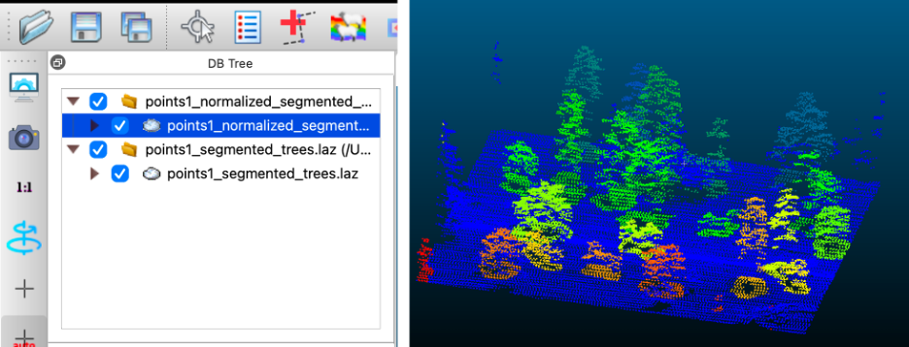
- Use the same trees for this part of the activity as well. Zoom into the 1st tree.
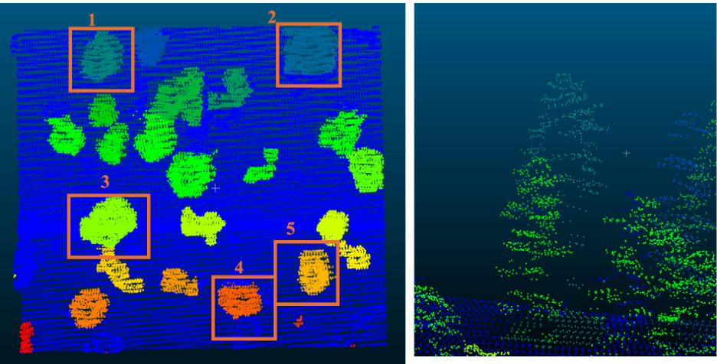
- Open the point-picking tool from the toolbar. Set it to single-point mode.

- With single-point picking, click the highest point of each tree. The Z value is the canopy height directly. Enter each value in Table 1.
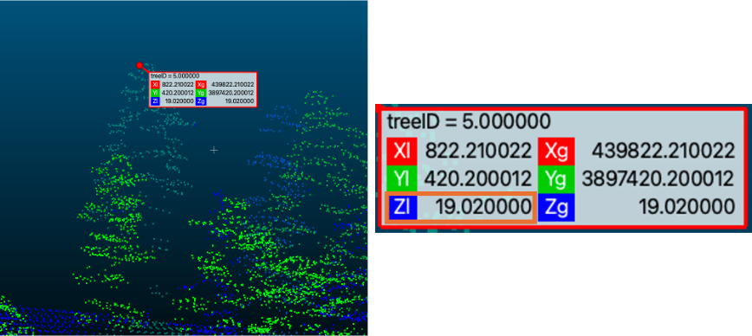
- Repeat step 4 five times on Tree 1, clicking a slightly different point near the treetop each time. Record all five values in Table 1, then calculate the average.
- Repeat step 3 for Trees 2 through 5 and enter values in their respective tables.
Table 1: Tree 1 Canopy Height Measurements
 | Measurement Number | Canopy Height using point cloud (m) | Canopy Height using normalized point cloud (m)
 | 1
 | 2
 | 3
 | 4
 | 5
Screenshot of Tree 1 | Average
Table 2: Tree 2 Canopy Height Measurements
 | Measurement Number | Canopy Height using point cloud (m) | Canopy Height using normalized point cloud (m)
 | 1
 | 2
 | 3
 | 4
 | 5
Screenshot of Tree 2 | Average
Table 3: Tree 3 Canopy Height Measurements
 | Measurement Number | Canopy Height using point cloud (m) | Canopy Height using normalized point cloud (m)
 | 1
 | 2
 | 3
 | 4
 | 5
Screenshot of Tree 3 | Average
Table 4: Tree 4 Canopy Height Measurements
 | Measurement Number | Canopy Height using point cloud (m) | Canopy Height using normalized point cloud (m)
 | 1
 | 2
 | 3
 | 4
 | 5
Screenshot of Tree 4 | Average

Table 5: Tree 5 Canopy Height Measurements
 | Measurement Number | Canopy Height using point cloud (m) | Canopy Height using normalized point cloud (m)
 | 1
 | 2
 | 3
 | 4
 | 5
Screenshot of Tree 5 | Average

Questions:
- What is the range of tree heights measured?

- Explain in your own words what height normalization does to a point cloud.

- A student reports a canopy height of 412 m for a single tree. Is this correct? Which cloud did they most likely measure on, and what mistake did they make?

- In the measurements, where do the point cloud and normalized point cloud heights disagree most? (Hint: what does the ground surface look like at those trees?)

- You measured canopy height two ways: on the standard point cloud by picking a ground point and a treetop point, and on the normalized point cloud by picking the treetop only. If you needed canopy heights for every tree across a full landscape rather than five trees, which of these two clouds would you work from, and why?

Step 5: Crown Width
- Click on the normalized point cloud in the left-side panel. Rotate to a top-down view so the tree crowns are seen as outlines from above, with branches spreading outward from the trunk.
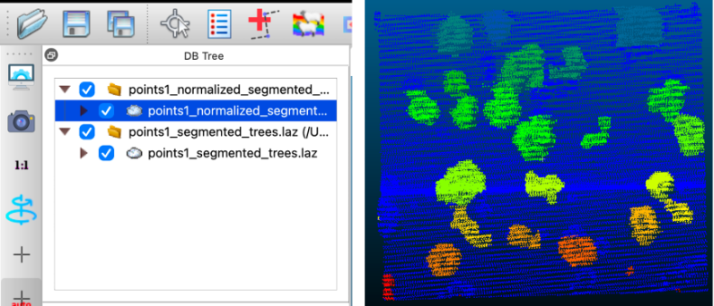
- For this activity, choose 5 trees of your choice. Zoom into the first tree, take a screenshot of it, and paste it in Table 1.
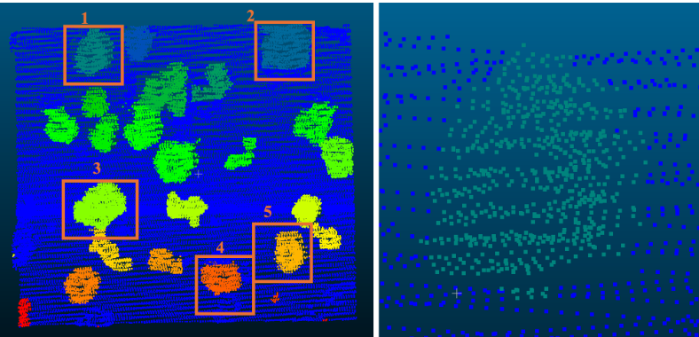
- Open the point-picking tool from the toolbar. Set it to two-point distance mode.

- Click a point on one edge of the tree's canopy, at its widest part.
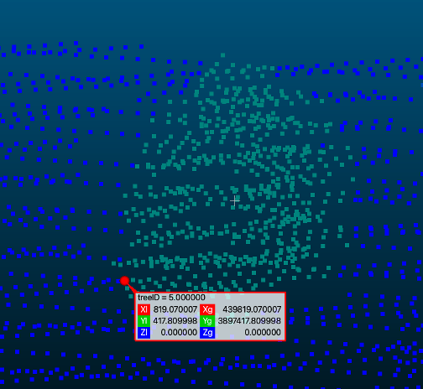
- Click a point on the opposite edge of the canopy.
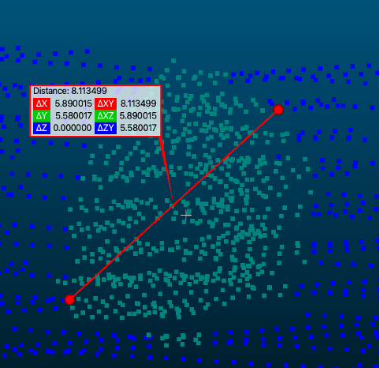
- Record the ΔXY value (distance in the XY-plane), which gives you the crown width.
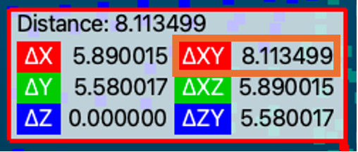
- Take a point approximately perpendicular to the line drawn in the previous step and repeat steps 4-6. Take the average of both the ΔXY values derived and write this number down in Table 6 below.
- Repeat this five times on the same tree, picking slightly different edge points each time. Calculate the average of your five measurements.
- Do the same for the rest of the 4 trees.

Table 6: Tree 1 Crown Width Measurement
 | Measurement Number | Crown width measure 1 (m) | Crown width measure 2 (m) | Average Crown Width
 | 1
 | 2
 | 3
 | 4
 | 5
Screenshot of Tree 1 | Average
Note - measure 1 = first diameter, measure 2 = perpendicular diameter
Table 7: Tree 2 Crown Width Measurement
 | Measurement Number | Crown width measure 1 (m) | Crown width measure 2 (m) | Average Crown Width
 | 1
 | 2
 | 3
 | 4
 | 5
Screenshot of Tree 2 | Average
Table 8: Tree 3 Crown Width Measurement
 | Measurement Number | Crown width measure 1 (m) | Crown width measure 2 (m) | Average Crown Width
 | 1
 | 2
 | 3
 | 4
 | 5
Screenshot of Tree 3 | Average

Table 9: Tree 4 Crown Width Measurement
 | Measurement Number | Crown width measure 1 (m) | Crown width measure 2 (m) | Average Crown Width
 | 1
 | 2
 | 3
 | 4
 | 5
Screenshot of Tree 4 | Average
Table 10: Tree 5 Crown Width Measurement
 | Measurement Number | Crown width measure 1 (m) | Crown width measure 2 (m) | Average Crown Width
 | 1
 | 2
 | 3
 | 4
 | 5
Screenshot of Tree 5 | Average

Questions:
- Which two coordinates are used to measure crown width?

- Are the crown width measurements uniform across the tree? Explain the reason behind your answer

- You measured crown width on the normalized point cloud. Now open the standard point cloud, find the same tree, and measure the crown width once. Report both values. Do they match? Explain why, using what you know about which coordinates crown width depends on.

- Two perpendicular diameters give different values for the same crown. What does that difference tell you about the shape of the tree? What might cause this asymmetry in the shape of a tree?

Attribution Notice
Educators are welcome to share, adapt, and use this activity for instructional purposes. If you include this resource in your teaching materials, please provide attribution by citing:
Katam, M., & Scott, C. (2026). Computing Canopy Height and Crown Width Using CloudCompare [Educational curriculum lab activity]. Arizona State University & OpenForest4D.

Funding Acknowledgment
This educational resource was developed in connection with OpenForest4D, supported by the U.S. National Science Foundation under NSF Award Nos. 2409885, 2409886, and 2409887.



References

[1] U.S. Geological Survey (2021). AZ USFS 3DEP Processing 2019. Distributed by OpenTopography. https://portal.opentopography.org/usgsDataset?dsid=AZ_USFS_3DEP_Processing_2019. Accessed 2026-09-01

