Lab Activity 1: Creating and Visualizing a Lidar Point Cloud
Madhumitha Katam and Chelsea Scott, Arizona State University

Learning Objectives
- Remember: Students will define a lidar point cloud and identify its core attributes (X, Y, Z, intensity, classification, and return number).
- Understand: Students will be able to explain what a lidar point cloud represents, how lidar data is collected, and how individual points correspond to real landscape features such as terrain, vegetation, and built structures.
- Apply: Students will find and download lidar point cloud data for a self-selected area using OpenTopography, then run prewritten R code in Google Colab to read that file and print its attributes.
- Analyze: Students will examine the point cloud's attributes, including elevation range, classification categories, and point density, using both the Potree Viewer and the printed outputs from the R code, and answer questions about the dataset.
- Evaluate: Students will be able to explain why certain landscape features like trees produce more lidar returns than buildings.
- Create: Students will generate an interactive 3D visualization of their selected point cloud in the Potree Viewer and produce their own plots from the point cloud using the lidR package in Google Colab.

Summary
This activity is designed for lower-level undergraduate students in geographic information science, forestry, geography, and environmental science. No prior background in coding, remote sensing, or forestry is assumed.
In this lab, students work with real lidar point cloud data. They will download the point cloud file from OpenTopography (https://opentopography.org/) for a small area in Salt Lake City, Utah. They explore the point cloud in a browser-based visualization tool (Potree Viewer) by viewing elevation, classification, and return number views. Next, students will run the R code in Google Colab (no coding experience assumed) using the lidR package (https://r-lidar.github.io/lidRbook/), inspect its attributes, and create their own visualizations. At each step, the students answer questions that help them connect the data to real landscape features like trees, buildings, and bare earth.

Thinking Skills
Lower-order thinking skills (remember, understand, and apply):
Students will understand core lidar terminology (point cloud, intensity, classification, and return number), explain how aerial laser scanning captures 3D geometry, and independently navigate OpenTopography to locate and download real point cloud data for a selected study area.
Higher-order thinking skills (analyze, evaluate, create):
Students interrogate point cloud attributes by comparing elevation, classification, and return number visualizations to infer surface type and vegetation structure. They evaluate why trees produce more lidar returns than buildings. They synthesize these insights by generating an interactive 3D visualization in both Potree Viewer and lidR.

Context
Lidar (Light Detection and Ranging) is an active remote-sensing technology that emits laser pulses and measures the time it takes for each pulse to return after hitting a surface. The result is a dense 3D point cloud, which is a collection of georeferenced points that each carry attributes like elevation, intensity, classification, return number, etc. Point clouds are foundational to applications in forestry, urban planning, and flood modeling. In this lab, students work with lidar point cloud data from the Wasatch Front region of Utah, downloaded through the NSF funded OpenTopography Facility, to build hands-on familiarity with how point clouds are structured, visualized, and analyzed using tools like Potree Viewer and open source packages like lidR in the R programming language.

Materials/Tools required
- Introduction to Remote Sensing and Lidar lesson
- Internet access, Google account for Google Colab. (OpenTopography.org account is optional)

Lab Activity

Step 1: Pre-activity discussion
Review what lidar and point clouds are and go over their main attributes.

Step 2: Download the data
- Use the following link to open the point cloud processing page for a pre-selected area of interest near the Wasatch Front, Salt Lake City, Utah. This opens OpenTopography's processing page for the State of Utah Acquired Lidar Data – Wasatch Front dataset (DOI: 10.5069/G9TH8JNQ), pre-loaded to the study area shown below.
If the link doesn't load or the area of interest doesn't appear pre-selected: go to www.opentopography.org, search "Wasatch Front" under Data > Point Cloud Data, select the dataset with ID OTLAS.122014.26912.1, and manually draw a small box (roughly a few city blocks) over Salt Lake City using the map interface before continuing.
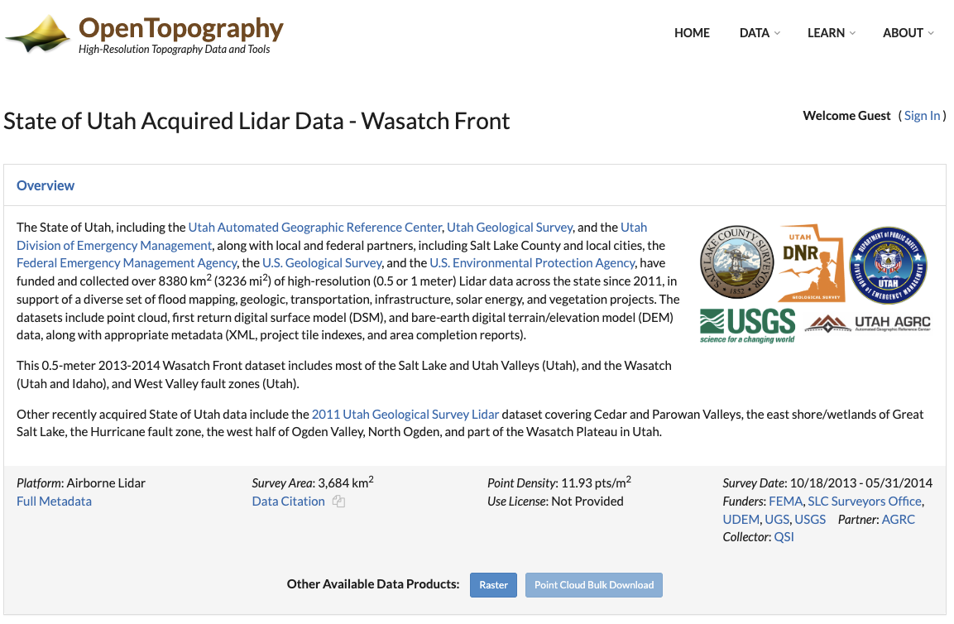
- Select an area of interest using the map interface (Select a region)
- Below, there are many sections. In section “1. Coordinates and Classification," check the “Exclude noise" option.
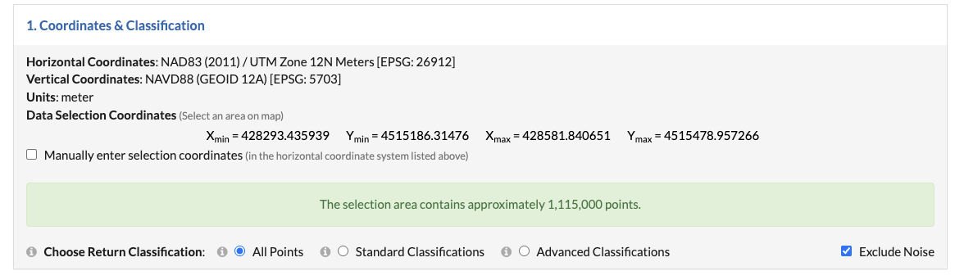
- Scroll down and check the box that states “Generate 3D point cloud browser visualization” under “4. 3D Cloud Visualization."
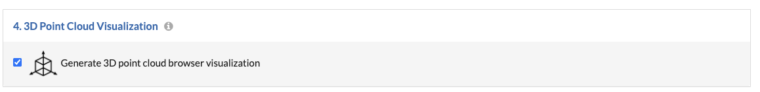
- Go all the way to the bottom, enter your email, and submit the job.
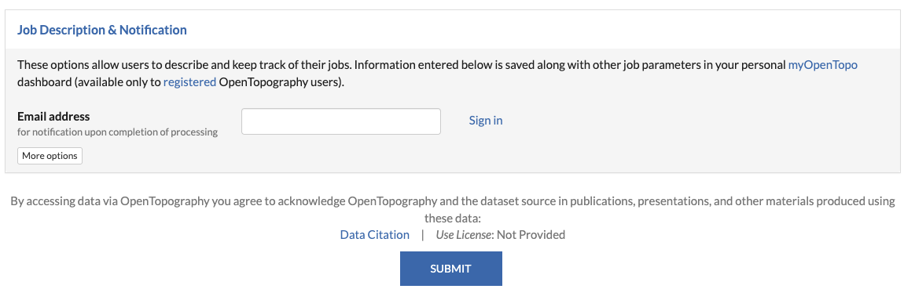
- You will be redirected to another page that shows the processing status and will show processing results once finished. OpenTopography will also send an email with a download link once the processing has completed.
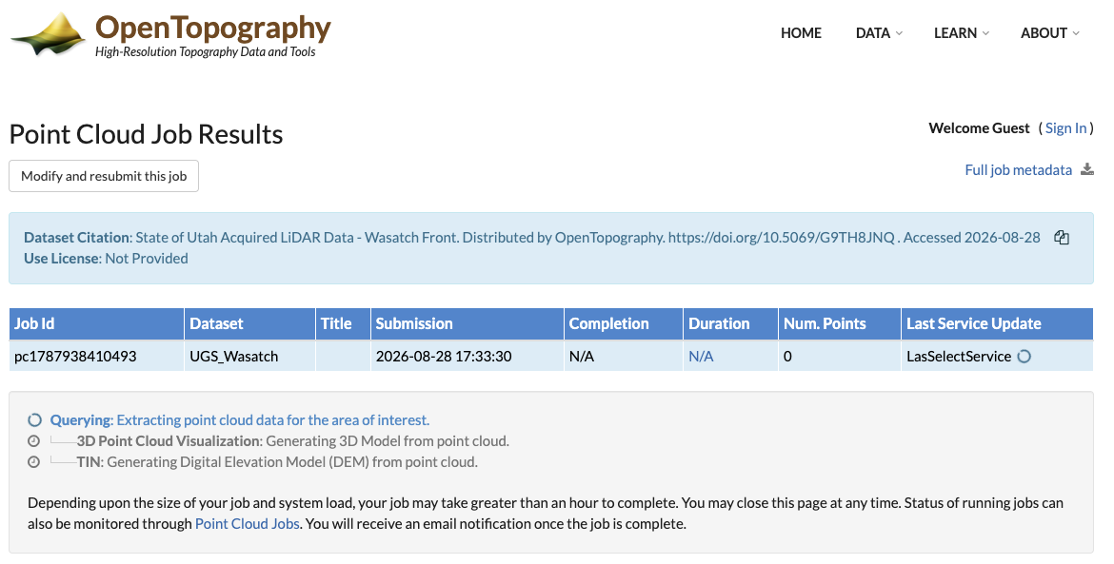

- On the results page, scroll down and click on "3D Point Cloud Visualization." It will open a Potree Viewer, a web-based visualization tool showing the point cloud.
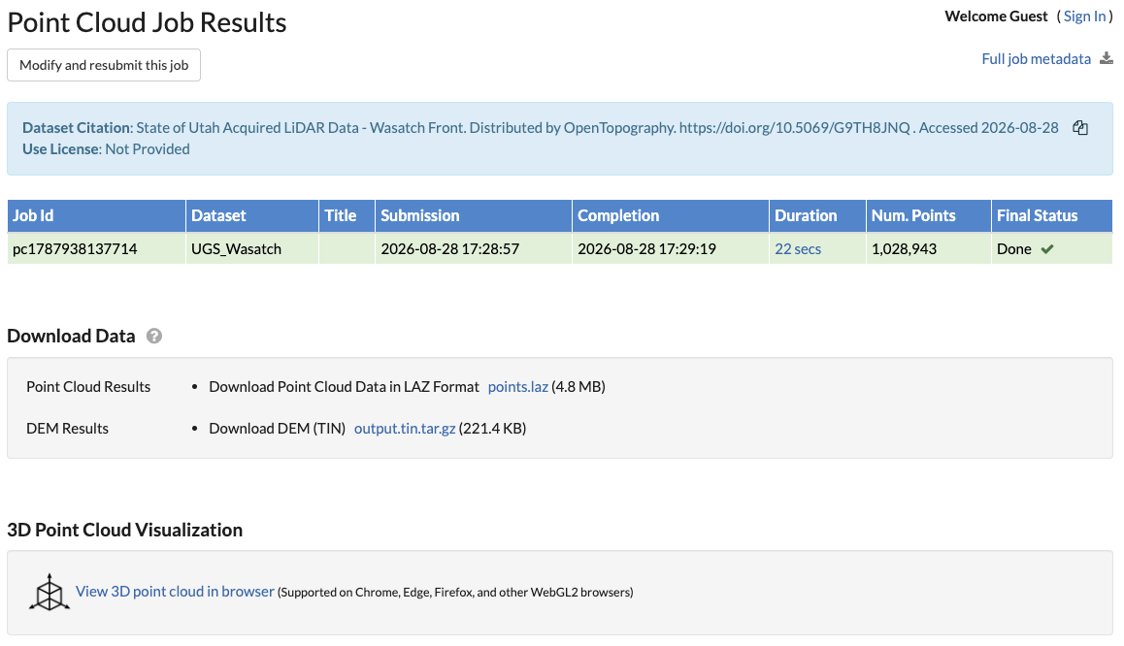
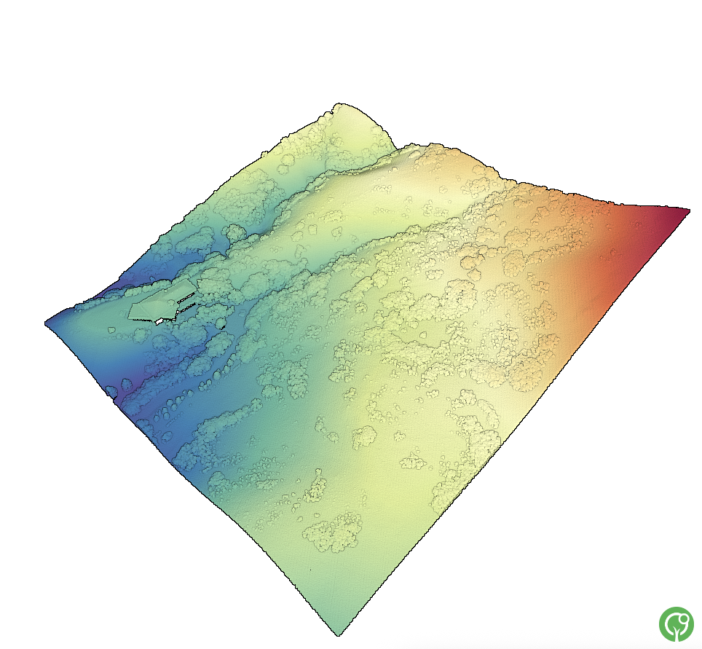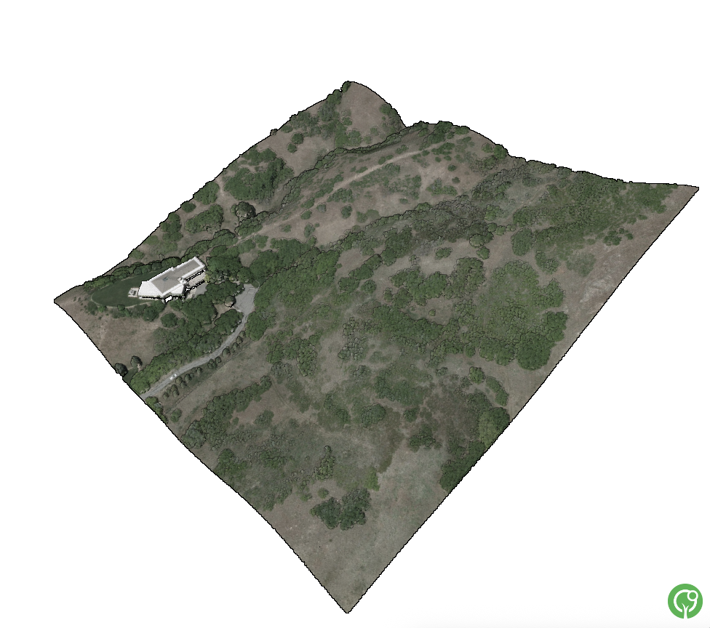
Elevation profile (left) and RGB profile (right) of the Wasatch Front, located near Salt Lake City, Utah

Questions:
- Describe what a point cloud is in one sentence. How is a point cloud different from a regular photo?

- Describe the landscape that you see in the point cloud. Is it flat? Does it have buildings and trees? What else do you see?
- In the Potree Viewer, the point cloud is colored based on elevation on the ground. Which colors do you think represent lower and higher elevations?

Step 3: Check different attributes of the point cloud in the Potree viewer.
You can watch this YouTube video or follow the steps below.

- In the Potree viewer, click on the 3 lines button present in the top-left corner of the page. You will see different attributes.
- Under the “Scene” section, look for “Display attributes"; there is a drop-down menu below.
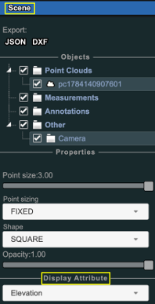

- Click on the drop-down menu, change it from “Elevation” to "Classification," and take a screenshot of the point cloud.
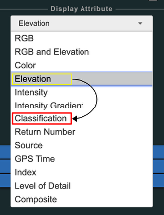
- Now, change it from “Classification” to “Return Number” and take a look at your point cloud.
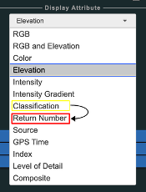
- Take another screenshot of this point cloud as well and paste it below.

Task: Paste the screenshot of your point clouds here.

Point cloud colored based on classification | Point cloud colored based on return number

Questions:

- How many colors do you see in the classification-colored point cloud, and what does each color represent?

- How many colors do you see in the return-number-colored point cloud, and what do you think each color represents? (Hint: closely look at any tree structure.)

- Which color represents the first return number in the point cloud?

- Zoom into a building and count the colors representing its structure, then do the same for a tree. Why does a tree generate far more lidar returns than a building?

End of the Potree Viewer exercise.

Step 4: Visualize the point cloud using Google Colab.
Open the notebook link below, then click the Open in Colab badge at the top of the notebook to launch it in Google Colab. Once there, go to File > Save a copy in Drive to create your own editable copy, then run the code cells under Activity 1.
Notebook link (https://github.com/openforest4d/lidar_basic_concepts_and_exercises/blob/main/notebooks/Act1_Act2_combined.ipynb)
Once done, answer the questions below.

Questions:
- Step 5's first output gives the point count. Can you derive this value using the area and density values printed in step 4? Show your work.
(Hint - think about what density means)
- How many attributes were available in the point cloud? (Hint: Look into step 5's printed outputs.)
- What is the range of elevation values in the point cloud? (Hint: Use the min. and max. elevation values printed in step 5’s Elevation summary.)

End of the activity questions:
- What feature of the landscape do you think is responsible for the highest Z values in your data?
- A canyon in northern Arizona, lined with ponderosa pine forests on both hillslopes, was impacted by a catastrophic wildfire in 2018 [3]. Examine the before- and after-images and lidar point clouds provided below.
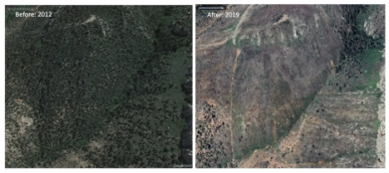
Google Earth satellite imagery of a northern Arizona canyon before (left) and after (right) the 2018 Cat Fire.
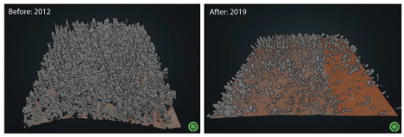
Lidar point clouds collected before (left) and after (right) the Cat Fire, with ground-classified points shown in brown and unclassified points in grey.
- What structural changes in the forest canopy can you identify when comparing the pre-fire and post-fire conditions?

- Mention one insight that you can measure or see in the lidar point cloud data that you cannot see in the Google Earth satellite imagery.

- Steps 6 and 7 in Google Colab showed the point cloud as a 2D visualization, whereas the Potree viewer rendered it in 3D. What advantages does 3D visualization have?

- Reflect upon what you have learned in this activity. Which part of the activity was easy? Which parts were challenging? What did you learn?

Attribution Notice
Educators are welcome to share, adapt, and use this activity for instructional purposes. If you include this resource in your teaching materials, please provide attribution by citing:
Katam, M., & Scott, C. (2026). Creating and Visualizing a Lidar Point Cloud [Educational curriculum lab activity]. Arizona State University & OpenForest4D.

Funding Acknowledgment
This educational resource was developed in connection with OpenForest4D, supported by the U.S. National Science Foundation under NSF Award Nos. 2409885, 2409886, and 2409887.



References
- State of Utah Acquired LiDAR Data - Wasatch Front. Distributed by OpenTopography. https://doi.org/10.5069/G9TH8JNQ . Accessed 2026-08-27
- Google. (2026). Google Colaboratory [Computer software]. https://colab.research.google.com
- Analyzing Forest Change After the 2018 Cat Fire Using Multi-Temporal Lidar Data – OpenForest4D. (n.d.). OpenForest4D. https://openforest4d.org/kaibab-change-analyis-2018-cat-fire/

