Lab Activity 2: Creating Gridded Datasets from Point Clouds
Madhumitha Katam and Chelsea Scott, Arizona State University

Learning Objectives
- Remember: Students will be able to define digital elevation model (DEM), digital surface model (DSM), digital terrain model (DTM), and canopy height model (CHM) and list the differences between these gridded datasets.
- Understand: Students will be able to explain how each dataset type is derived from a lidar point cloud and why different point classifications are used for each dataset.
- Apply: Students will generate a DEM, DSM, DTM, and CHM from a lidar point cloud using lidR code in Google Colab and will modify the input point cloud file in the code to produce outputs at different locations.
- Analyze: Students will inspect and compare the three gridded datasets side by side and identify where and why they differ.
- Evaluate: Students will assess which gridded dataset type is most appropriate for a given real-world application and justify their reasoning based on how each gridded dataset is derived.
- Create: Students will produce a final side-by-side visualization of all three gridded datasets and interpret what each one tells them about the landscape.

Summary
This activity is designed for lower-level undergraduate students in geographic information systems (GIS), forestry, geography, and environmental science. Students are required to know what lidar is.
In this lab, students build on what they learned in Activity 1 by converting a lidar point cloud into three gridded datasets: a digital elevation model (DEM), a digital surface model (DSM), and a digital terrain model (DTM). Then, they will use the DTM and DSM gridded datasets that they built and create a canopy height model (CHM). They start by reviewing the “Point Cloud and Gridded Datasets” document that talks in detail about which points are used to generate each dataset. They then run R code in Google Colab to produce and compare the three gridded datasets. In the final part, students choose their own study area, download a lidar point cloud, and generate gridded datasets independently. At each step, questions guide them to think about what the gridded datasets show, how they differ, and what those differences mean for the landscape.

Thinking Skills
Lower-order thinking skills (Remember, Understand, Apply):
Students recall the definitions of DEM, DSM, and DTM and explain how each is derived from a different subset of point cloud classifications. They apply this knowledge by running R code in Google Colab to generate all three gridded datasets from the same lidar point cloud used in Activity 1.
Higher-order thinking skills (analyze, evaluate, create):
Students compare the three gridded datasets side by side to identify where and why they differ across the landscape. They evaluate which gridded dataset is most appropriate for different real-world use cases such as wildfire recovery and tree height estimation. Finally, they produce a composite visualization of all three gridded datasets and interpret what each one reveals about the landscape.

Context
A lidar point cloud contains millions of points, each tagged with a classification label that identifies what the laser pulse hit, such as ground, low vegetation, buildings, or water. These classifications make it possible to generate different types of gridded datasets by selecting only a subset of points: A DSM represents the top of the landscape, including trees and buildings, and is made with first returns. A DTM represents the bare earth beneath all the surface features and is made with only ground-classified points. A DEM is a gridded elevation dataset made with all the points in the lidar point cloud. Subtracting the DTM from the DSM gives a Canopy Height Model (CHM), which shows the height of trees and other surface features above the ground. These gridded datasets are widely used in hydrology, forestry, urban planning, and natural disaster management. In this activity, students generate all four of them from the same lidar point cloud, compare them visually, and develop an understanding of when and why each one is used.

Materials/Tools Required
- Point clouds and gridded datasets lesson
- Internet access, Google account for Google Colab

Lab Activity
Step 1: Pre-activity Discussion
Start by reviewing the “Point Cloud and gridded datasets” lesson document. Think back to Activity 1. Remember the classification attribute in lidar point clouds? Each gridded dataset uses a different subset of points from the point cloud that are selected based on the classification attribute.
Questions:
- If you want to know the height of the tallest tree, which gridded dataset would you use? Why?

- If you removed all the trees and buildings from a landscape, which gridded dataset would best represent what is left?

- Which gridded dataset uses all points from the point cloud? Which uses only ground-classified points?

- In activity 1, the lidar point cloud (.laz) file contained two classification attributes in it. Do you remember what they were? Define those attributes.

Step 2: Understanding the R code to plot gridded datasets
Open the notebook link below, then click the Open in Colab badge at the top of the notebook to launch it in Google Colab. Once there, go to File > Save a copy in Drive to create your own editable copy, then run the code cells under Activity 2.
Notebook link (https://github.com/openforest4d/lidar_basic_concepts_and_exercises/blob/main/notebooks/Act1_Act2_combined.ipynb)
Come back here to answer the questions.

Questions:
- Describe what a hillshade is in two sentences? (Hint: Read the description under “DEM Plotting.")

- Paste the line of the code that creates a CHM model. Explain this line of code in one sentence.

- Canopy height model (CHM)
  - What is the height of the tallest tree (be sure to include units)?

  - What is the height of the average tree?

- A classmate says, "The DEM and the DSM are basically the same thing." Based on your outputs, do you agree or disagree? What evidence from your visualizations supports your answer?

Step 3: Apply what you have learned.
You can refer to this YouTube video on how to upload the file in Google Colab.
- Go to OpenTopography and zoom into a place of interest, for example, your neighborhood, a park, or somewhere you'd like to explore.
- Process and download a lidar point cloud for your chosen area. It will be saved as a “points.laz” file. We recommend keeping your selection under 10 million points, since larger point clouds can be slow to process and display.
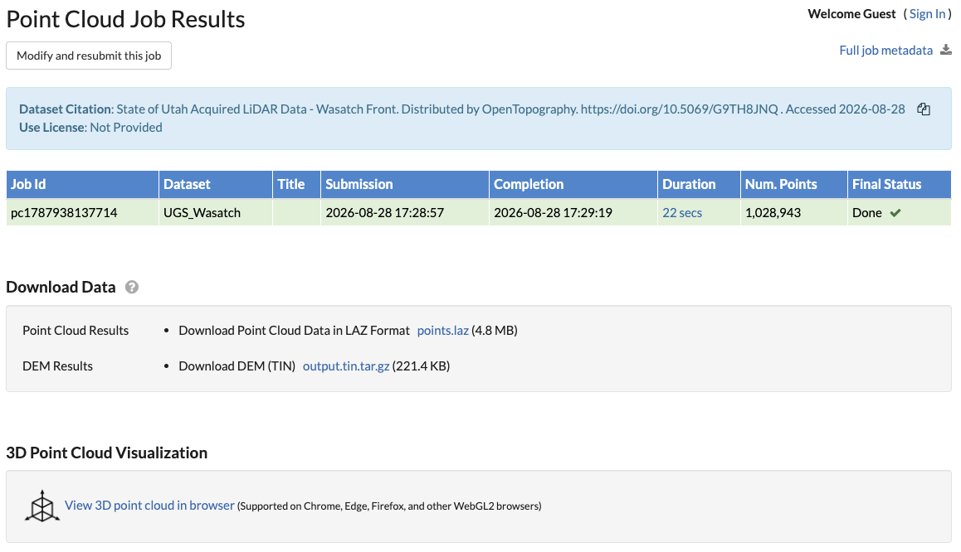
- In Google Colab, click the folder icon on the left sidebar. A file panel will open.
- At the top of this panel, click the "Upload to session storage" icon.
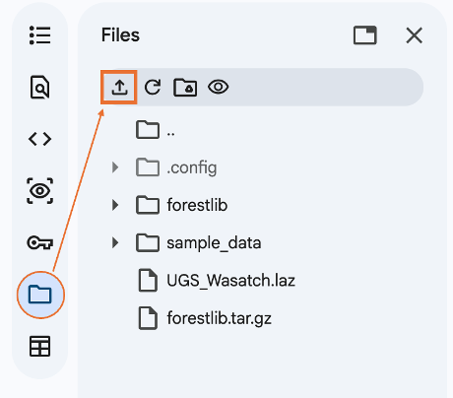
- In the window that appears, navigate to your Downloads folder (or wherever you saved the file), select points.laz, and click Open. The upload may take a few minutes.
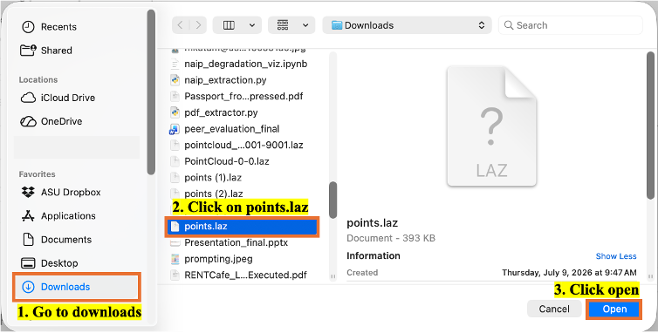
- Go to Step 3 of the code. Select the cell and comment out the existing code using Control + / (Windows) or Command + / (Mac).
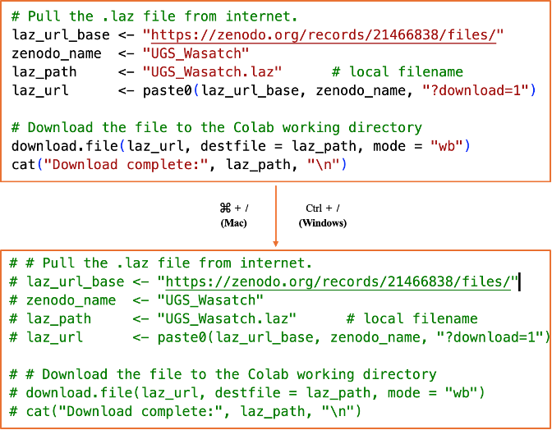
- Scroll to the “Activity 2: Generating DEM, DTM and DSMs from Lidar Point Cloud (.laz)” section.
- In Step0 code, replace <file_name> with the saved file name (points.laz).
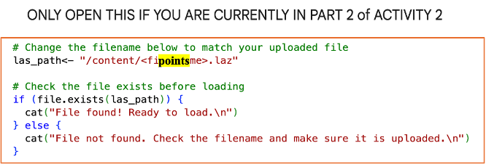
- Run that cell, then run all the cells below it.
End of Activity Questions:
- Narrate the scene you picked in two sentences.

- Compare your DEM and DSM. Where do they differ the most, and what features in your scene explain those differences?

- Look at your CHM. What does it reveal about the vegetation in your area? Are there tall trees, low shrubs, or mostly bare ground?

- Compare your gridded datasets with a classmate who picked a different landscape. How do the products differ between, say, a forested area and a neighborhood?

- If you wanted to monitor how a forest is recovering after a wildfire using a lidar point cloud, describe the workflow you would follow. Which gridded datasets would you generate, how would you compare them across time (imagine multiple lidar datasets collected in the fire area), and what would you expect to see at different stages of recovery?

Attribution Notice
Educators are welcome to share, adapt, and use this activity for instructional purposes. If you include this resource in your teaching materials, please provide attribution by citing:
Katam, M., & Scott, C. (2026). Creating Gridded Datasets from Point Clouds [Educational curriculum lab activity]. Arizona State University & OpenForest4D.

Funding Acknowledgment
This educational resource was developed in connection with OpenForest4D, supported by the U.S. National Science Foundation under NSF Award Nos. 2409885, 2409886, and 2409887.



