Introduction to Remote Sensing and Lidar
Madhumitha Katam and Chelsea Scott, Arizona State University

Introduction
Have you ever looked outside an airplane window or at Google Maps and observed rooftops, roads, or mountains? Have you taken a picture of a landscape or cityscape on your phone? Congrats! You’ve already encountered remote sensing.

Remote sensing is a way of measuring what the landscape looks like from a distance, including its colors, shapes, textures, and elevation. Remote sensing is the science behind the technology that helps visualize the Earth’s surface. Scientists and engineers use remote sensing to study forests, cities, and the Earth surface. Cameras and sensors are placed on airplanes, drones, or satellites to capture images and measurements over large areas, as shown in Figure 1. These measurements help us answer questions such as "Where are roads and buildings located?" “How healthy is a forest?", and “How much did the landscape shift during an earthquake?”

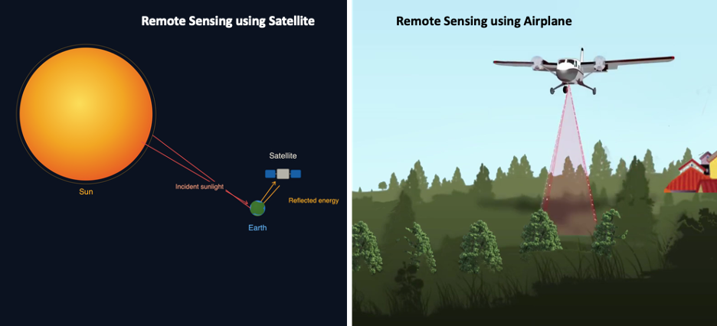
Figure 1: (left) Satellite-based remote sensing captures sunlight reflected from Earth's surface to monitor large areas cost-effectively. (right) Airborne remote sensing uses aircraft equipped with lidar sensors that emit laser pulses toward the ground. Source [1]

Remote sensing instruments use light of different wavelengths to study the Earth.
Lidar, which stands for Light Detection and Ranging, is one type of remote sensing. It uses laser pulses to measure distance. The sensor sends laser light towards the ground, and the light bounces back to the sensor. By measuring how long it takes the light to return, lidar can calculate how far away the ground or object is. By sending these pulses multiple times, lidar creates a detailed 3D view of the environment, which shows the elevation of the ground, trees, and buildings.

Lidar operates within specific wavelengths of the electromagnetic spectrum, as shown in Figure 2. Near-infrared light is the preferred wavelength for most lidar applications. This type of light works well because it can travel through the atmosphere with little scattering. It also reflects well from many surfaces, which helps the sensor receive a clear signal.

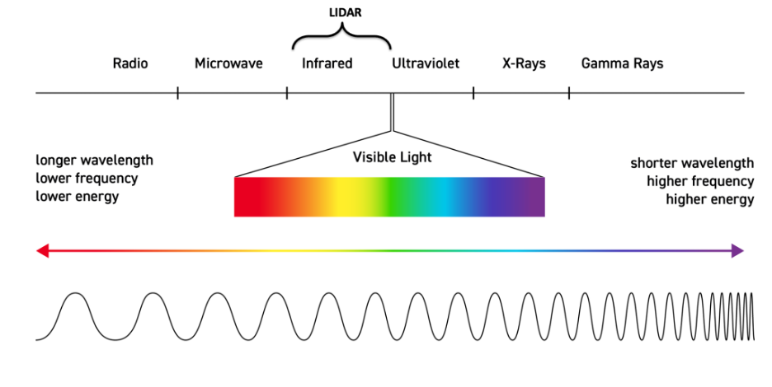
Figure 2: Electromagnetic Spectrum showing the lidar operating range. Source image [2]

Types of lidar
Lidar sensors can be mounted on different platforms. Three common platform types are as follows:
- Terrestrial lidar: This is often used in architecture, mining, and cultural heritage preservation. The sensor is on a stationary tripod on the ground. The sensor rotates and scans the environment in all directions, capturing the area in very high detail (Figure 3, left).
- Airborne lidar: The sensor is mounted on an aircraft that flies over the target area from an approximate distance of 1 km. The lidar sensor continuously fires laser pulses towards the ground, capturing data over square kilometers to hundreds of square kilometers (Figure 3, middle).
- Satellite lidar: At the largest scale, lidar sensors can be mounted on satellites orbiting the Earth. While satellite lidar has lower detail than airborne or terrestrial systems, its data are global in scale (Figure 3, right).

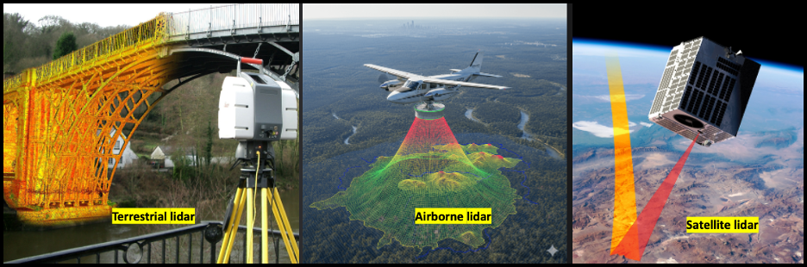
Figure 3: (left) Terrestrial lidar positions sensors at ground level to capture highly detailed point cloud data of localized infrastructure and structures. (middle) Airborne lidar flies at moderate altitudes to survey regional areas with balanced resolution and coverage, as shown by the colorized elevation data. (right) Satellite lidar operates from orbit to monitor vast continental-scale regions with lower resolution. Image source: [3, 4, 5]

How does lidar collect data?
Stage 1 - Emitting the laser pulse
The laser transmitter fires pulses of laser light toward the target surface. These pulses are typically in the near-infrared wavelength and are invisible to the human eye.
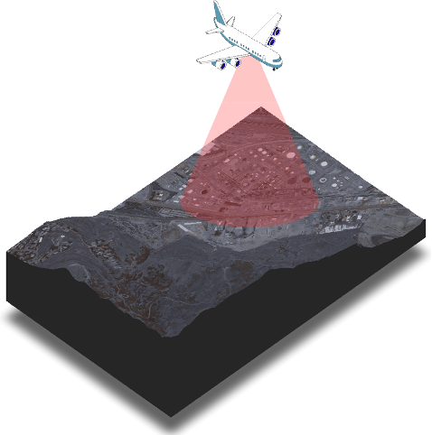
Figure 4: The image depicts airborne lidar sending laser pulses onto the Wasatch Front in Salt Lake City, Utah. Source: [6, 7, 8].
Stage 2 - Pulse hits the target and bounces back
A laser pulse contains photons that carry energy. The laser pulse travels downward and hits a surface (ground, building, tree, road, etc.), and portions of the energy reflect toward the sensor, scatter in other directions, are transmitted through gaps in the surface (like leaves), or are absorbed by the surface (see figure 5). The reflected signal is called the return.
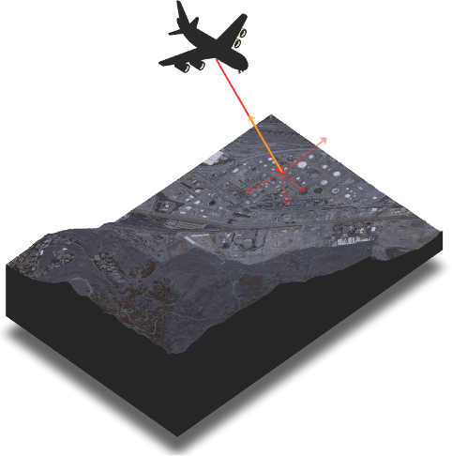
Figure 5: Light hitting the surface and reflecting in different directions.
Stage 3 - Measuring the time of flight
The sensor records the time for the pulse to travel to the surface and back, known as the time of flight (ToF). Since the speed of light is a known constant, the sensor can calculate the distance from the airplane to the object using the following relationship:
$Distance =\frac{Speed of light × time of flight}{2}$
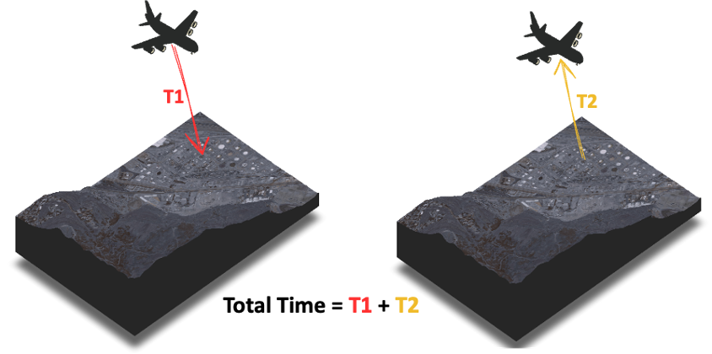
Figure 6: Total time taken for the sensor to send the pulse and get information back
Stage 4 - Recording of Position and Orientation
Lidar sensors are paired with a GNSS (Global Navigation Satellite System, or GPS in the US) to record the exact location of the sensor at the time of each pulse. An IMU (Inertial Measurement Unit) tracks the orientation and movement of the sensor, as shown in figure 7. This ensures that every single data point is accurately placed in space.
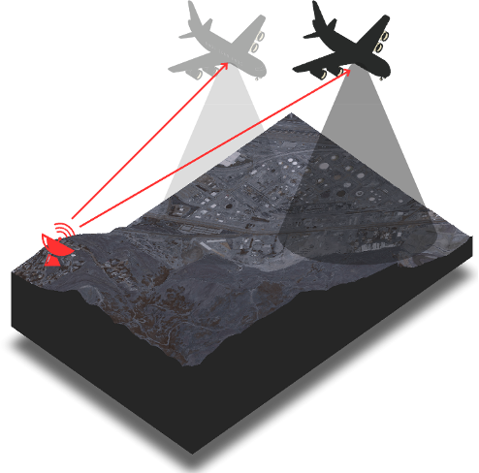
Figure 7: GPS tracking the airplane while collecting data

Stage 5 - Point Cloud Generation and processing
Each measured point is assigned an X, Y, and Z coordinate in three-dimensional space. The resulting large set of points (often at least millions) is known as a point cloud. Please note that lidar itself does not have any color. This color shown in figure 8 depicts the lidar point cloud colored based on the elevation of the landscape.
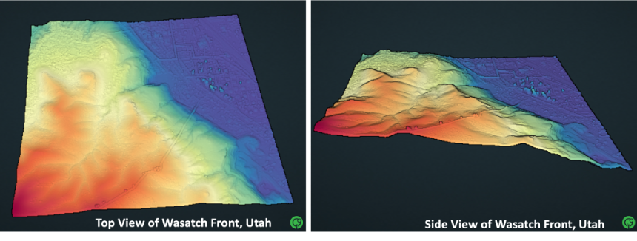
Figure 8: A 3D point cloud of the Wasatch Front in Salt Lake City, Utah. (left) The top view shows the elevation variations across the landscape, while (right) the side view provides a cross-sectional perspective, clearly showing how the terrain moves down from warmer tones (orange-red) mountain peaks towards the cooler tone (blue) valleys as we move right. [6]

Uses of lidar
Lidar has a wide range of applications. It is used in self-driving vehicles to detect obstacles and navigate safely. In geology, it is used to study and monitor natural hazards such as floods, landslides, and earthquakes. In forestry, lidar is used to estimate forest density and assess vegetation loss after a wildfire.

Check Your Understanding / Questions
- Lidar uses pulses of _________ wavelength to measure the distance to the surface and produce a map of elevation.

- Define Time of Fight.
- Explain in one sentence how airborne lidar is different from satellite lidar.
- The image below shows an example of remote sensing.

What other examples can you think of? Reflect upon what you've learned so far.

- As seen in figure 8, a point cloud contains 3D information of any area of interest. Discuss ways in which this 3D information is used in real life.

Attribution Notice
Educators are welcome to share, adapt, and use this activity for instructional purposes. If you include this resource in your teaching materials, please provide attribution by citing:
Katam, M., & Scott, C. (2026). Introduction to remote sensing and lidar [Educational curriculum document]. Arizona State University & OpenForest4D.

Funding Acknowledgment
This educational resource was developed in connection with OpenForest4D, supported by the U.S. National Science Foundation under NSF Award Nos. 2409885, 2409886, and 2409887.



References
- OpenTopography. (n.d.). What is lidar? Retrieved July 1, 2026, from https://opentopography.org/lidar_basics
- National Institute of Standards and Technology. (n.d.). The electromagnetic spectrum [Infographic]. U.S. Department of Commerce. https://www.nist.gov/image/electromagnetic-spectrum-graphic
- LiDAR Magazine. (2024, September 4). Space flight laboratory selected by NuView for space-based LiDAR satellite development. https://lidarmag.com/2024/09/04/space-flight-laboratory-selected-by-nuview-to-develop-pathfinder-satellite-bus-for-its-space-based-lidar-constellation/
- Dronitech. (n.d.). LiDAR in modern aerial surveying is transforming precision mapping. https://www.dronitech.com/lidar-in-modern-aerial-surveying-is-transforming-precision-mapping/
- HiveVP. (n.d.). Advantages of 3D terrestrial laser scanners. https://hivevp.com/advantages-of-3d-terrestrial-laser-scanners/
- State of Utah Acquired LiDAR Data - Wasatch Front. Distributed by OpenTopography. https://doi.org/10.5069/G9TH8JNQ. Accessed 2026-08-26

