Point Clouds and Gridded Datasets
Madhumitha Katam and Chelsea Scott, Arizona State University

Point Cloud
"Point cloud" refers to the data points collected for a given geographical area, terrain, building, or space. Point cloud data have standard attributes, as described below:

- X, Y, Z coordinates: The X and Y coordinates represent the geographic location of a point on the ground, and the Z coordinate represents the elevation of that point above sea level (Figure 1).
- Intensity: Intensity measures the strength or magnitude of the reflected laser signal returning to the sensor (Figure 2b).
- Classification: This attribute assigns a specific category to each point, representing the type of surface/objects it is reflecting from. Classifications include vegetation (low, medium, high), noise, ground, building, water, etc. (Figure 2c).
- Return Number: Since lidar pulses can penetrate through certain objects and still reflect back to the sensor, a single pulse can generate multiple returns. This attribute indicates which return number a point represents from a single laser pulse (Figure 2d).

Point cloud files are often stored in a .las file format (or .laz format, which is the compressed version of the .las file). Figure 1 shows a visualization of a point cloud captured over Granite Dells, AZ [1]. The point cloud shows a largely flat terrain with a few isolated trees or shrubs rising above the surface. The parallel strips visible across the ground are artifacts from the flight paths taken by the lidar plane during data collection.
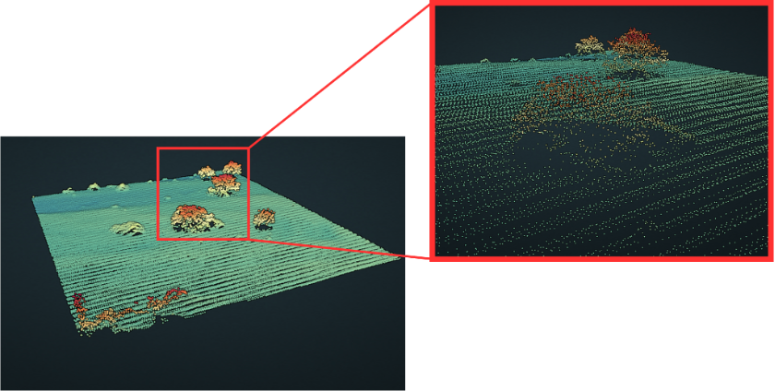

Figure 1: Point Cloud Representation of Terrain in the Granite Dells Study Area, Arizona. The enlarged view reveals the aircraft flight path and detailed shrub structures captured by lidar.

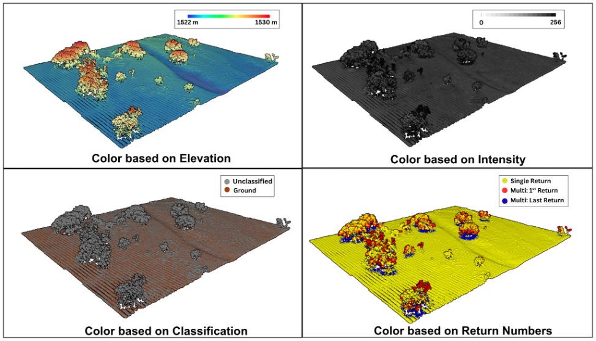
Figure 2: Point cloud with attribute-based color coding
(2a) Color based on elevation
Blue = low (~1522 m), red = high (~1530 m). The flat ground is cool-toned while the tree canopy shifts to warm reds and yellows, revealing the height difference between terrain and vegetation.
(2b) Color based on intensity
Brighter points mean stronger laser return. Bare ground reflects pulses well and appears light. The canopy absorbs and scatters energy, returning a weaker signal and appearing dark.
(2c) Color based on classification
Only two classes are present: Ground (orange) and Unclassified (gray). The trees are gray because vegetation classes have not been assigned.
(2d) Color based on return numbers
Yellow points are single returns, where the pulse hit a solid surface like the canopy top or open ground and bounced back. Red points are first returns, where the pulse struck a leaf or branch but continued downward. Blue points are second or last returns, where that same pulse passed through the canopy and often reached the ground. This layering is what lets lidar measure tree height and structure.
A point cloud contains millions of points to create a precise 3D view of the landscape. However, working with these millions of individual points has drawbacks. The points are unevenly distributed (dense in vegetation, sparse in open areas), and visualizing them over large areas is difficult and slow. To make the data more accessible, we can derive simplified models using selected points from the point cloud. One of the most common approaches is converting the point cloud into a gridded dataset.

Gridded Datasets
Gridded datasets are two-dimensional digital representations of a terrain or surface. Unlike point clouds, which are made of distinct points, gridded datasets represent continuous surfaces. A useful way to picture this is a sheet of graph paper laid over the landscape, with one value record inside each square. Gridded datasets are also called rasters.

Each square in a raster is called a pixel, and the pixels are arranged in a regular grid indexed by x and y positions. This grid structure is what makes a raster continuous. Every location on the surface falls inside a pixel, and every location has a value. The value allotted to each cell in a raster could be something like elevation, temperature, or land cover type. Lidar data always takes the value as the elevation of the surface.
The size of each pixel determines how detailed the raster is. This is called resolution. For general lidar data, 1 m resolution is commonly used. Smaller pixels (each cell is 10 cm x 10 cm) mean higher resolution. More detail is captured about the surface. Larger pixels (each cell is 1m x 1m) mean lower resolution. The surface looks rough and less precise.
To convert a point cloud into a raster, an algorithm assigns one elevation value to each pixel of an evenly spaced grid. The points are spread out unevenly, so the algorithm has to work out that single value for each cell.
So we need a way to take all these discrete points and aggregate them to one single value.
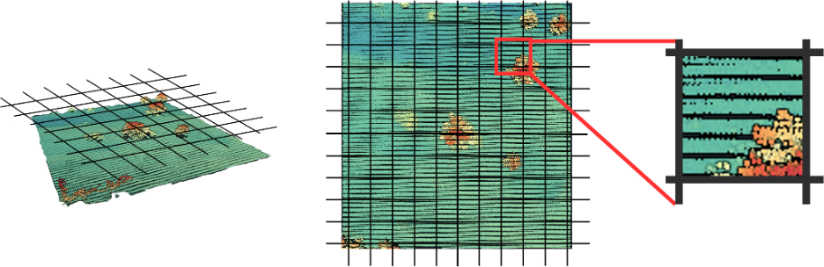
Figure 3: Visual Representation of the Rasterization.
Recall the graph paper from earlier, now laid over the point cloud. Zoom into a single cell and look straight down, as in Figure 3. Inside that cell you find a cluster of discrete points, perhaps 5, perhaps 30, depending on the point density and the chosen resolution. Those points must be combined into one value. This step is called interpolation. Several interpolation methods exist. The most common methods are triangulated irregular networks (TIN), inverse distance weighting, local neighborhood, and local gridding. Further detail on each is available here [3].
Interpolation turns an uneven scatter of points into a clean, even grid. Every cell holds one elevation value, so the surface can be read like an image. Rasters are mainly divided into three types, based on points used to build them.

1. Digital Elevation Models
A Digital Elevation Model (DEM) is built using every point in the point cloud, including points that represent ground, vegetation, and buildings using a TIN (Triangulated Irregular Network) algorithm. A DEM represents an approximate average of the elevation across the landscape. Figure 4 compares a top view of the point cloud showing the color attribute and a hillshade of a DEM. A hillshade view is a visualization technique that simulates directional sunlight illuminating the terrain surface, typically from a northwestern sunlight source.
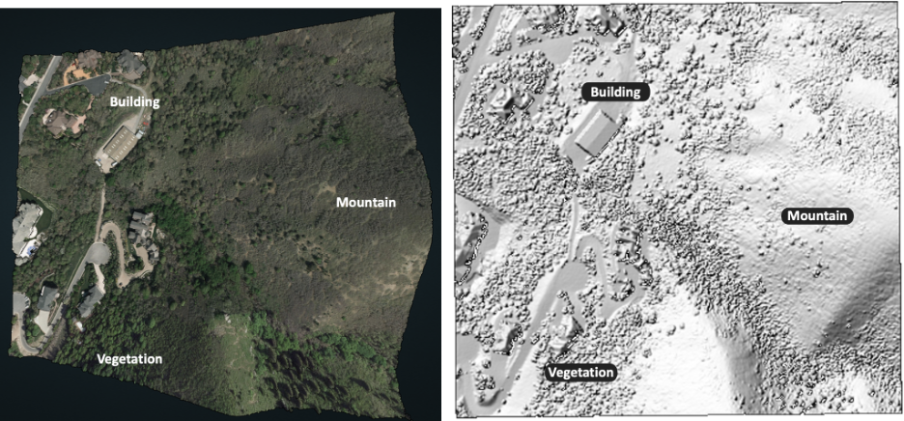
Figure 4: Top view of a 3D colored point cloud of the Wasatch Front study area, Utah [2] (left), and hillshade digital elevation model of the Wasatch Front study area, Utah (right).

2. Digital Surface Models
A digital surface model (DSM) captures the very top elevation of features at the Earth’s surface. This includes trees, buildings, and any other objects sitting on top of the ground. DSMs are made by gridding the first returns of the point cloud. Figure 5 represents a hillshade DSM.

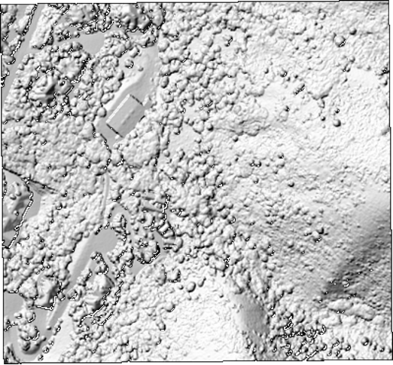
Figure 5: Hillshade digital surface model of the Wasatch Front study area, Utah.

3. Digital Terrain Models
A Digital Terrain Model (DTM) captures the bare ground. Trees and buildings are removed. Points that are classified as ground are only taken into consideration, and then interpolation methods are used on those points. Figure 6 represents a hillshade DTM. These models are often used by geologists to understand geologic hazards at the Earth’s surface
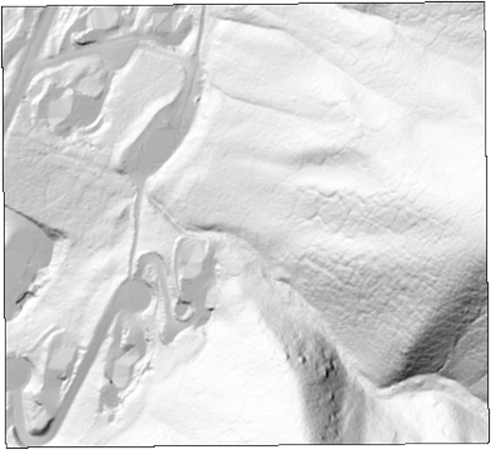
Figure 6: Hillshade digital terrain model of the Wasatch Front study area, Utah.

4. Canopy Height Models
In forestry, we often need to know the height of vegetation across an area. A Canopy Height Model (CHM) provides this, giving the vegetation height at each location. It can be generated using two common approaches.
- Subtracting the DTM from the DSM: the difference is the height of vegetation above the ground surface.
$CHM =DSM -DTM$
- Height Normalization: The terrain elevation is first flattened or normalized to create a leveled reference surface. The elevation of each point is then measured relative to this normalized surface, resulting in the canopy height

Figure 7 represents a CHM, and Figure 8 represents the histogram of height of trees across the Wasatch-Front study area. CHMs are sometimes referred to as normalized digital surface models (nDSMs), particularly when buildings or other man-made structures are present.

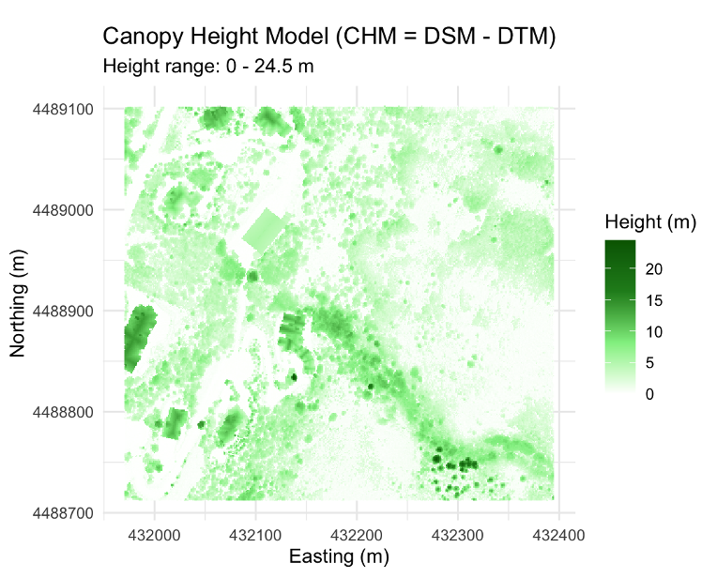
Figure 7: Canopy Height Model along the Wasatch Front, Utah

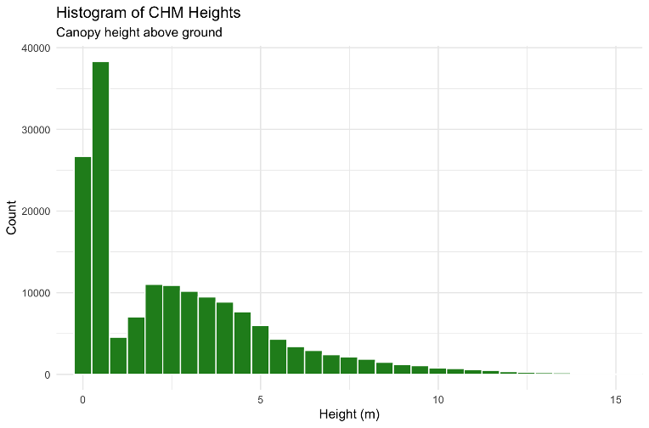
Figure 8: Distribution of tree heights across the Wasatch Front study area in Utah.

Check Your Understanding / Questions

- Which attribute indicates the strength of the reflected laser signal returning to the sensor?
A. Classification
B. Intensity
C. Return Number
D. Number of Returns

- A digital terrain model is constructed using points from the point cloud classified as ________.

- Why is interpolation used when creating DEMs from point clouds?
A. To remove all vegetation
B. To classify buildings
C. To fill gaps between discrete points and create a continuous surface
D. To compress LAS files into LAZ files

- How would you use CHM to detect gaps in a forest canopy, and why does that matter?

- A CHM shows a large area with a uniform canopy height of 2 m. What might this indicate about the forest? (Hint: An old forest would show highly variable canopy heights of 10 m to 40 m+).

- Figure A shows two lidar surveys of the same forest at the Susquehanna Shale Hills Critical Zone Observatory in Pennsylvania [4]. The left panel is a leaf-off survey (winter, no leaves on the deciduous trees), and the right panel is a leaf-on survey (summer, full canopy). The red box shows the difference.
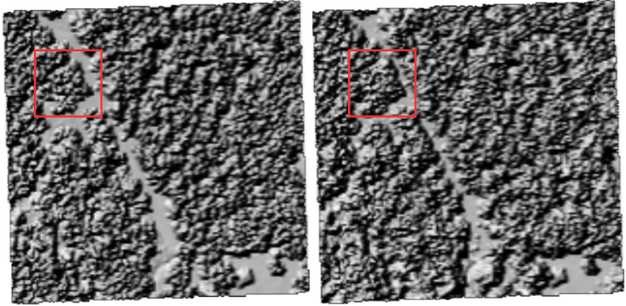
Figure A: Susquehanna Shale Hills Critical Zone Observatory: Leaf-Off Survey (left), Leaf-On Survey (right).
Figure B shows the difference between the two surveys. The map on the left subtracts one survey from the other at every pixel, where red means the leaf-off height is lower than leaf-on and blue means it is higher. The histogram on the right shows how often each difference value occurs across the whole area.
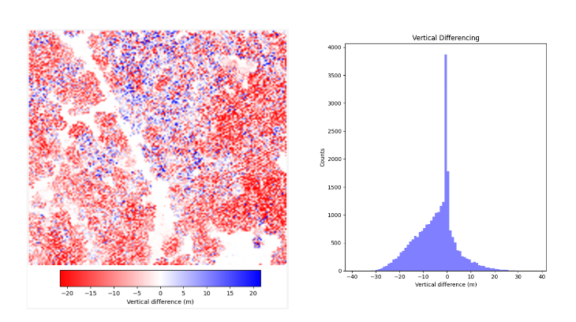
Figure B: Susquehanna Shale Hills Critical Zone Observatory: Vertical Differencing Map (left) and Histogram (right)
Using the above information, answer the following questions.
- Most of the map is red, meaning the canopy height is lower in the leaf-off survey than in the leaf-on survey. Why do you think this difference occurs?

- Looking at the histogram, what is the largest vertical difference (in meters) between the two surveys?

Attribution Notice
Educators are welcome to share, adapt, and use this activity for instructional purposes. If you include this resource in your teaching materials, please provide attribution by citing:
Katam, M., & Scott, C. (2026). Point Clouds and Gridded Datasets [Educational curriculum document]. Arizona State University & OpenForest4D.

Funding Acknowledgment
This educational resource was developed in connection with OpenForest4D, supported by the U.S. National Science Foundation under NSF Award Nos. 2409885, 2409886, and 2409887.



References
- Granite Dells, AZ. Distributed by OpenTopography. https://doi.org/10.5069/G92Z13FN. Accessed June 29, 2026.
- State of Utah Acquired LiDAR Data - Wasatch Front. Distributed by OpenTopography. https://doi.org/10.5069/G9TH8JNQ. Accessed July 1, 2026.
- OpenTopography. (n.d.). Points2Grid: A local gridding method for DEM generation from LiDAR point cloud data. Retrieved July 20, 2026, from https://opentopography.org/otsoftware/points2grid.
- Susquehanna Shale Hills Critical Zone Observatory: Leaf-Off Survey. Distributed by OpenTopography. https://doi.org/10.5069/G9VM496T. Accessed July 27, 2026.

