GATE-RTion TPSPencilBeam Source validation procedure

Author: Loic Grevillot, MedAustron
Test release date: 21/7/2017
Test specifications
Test Name: TPSPencilBeam
Type of test: Functional testing (acceptance)
Test developer: Loïc Grevillot, MedAustron

Configuration: GATEv8.0 (develop branch), GEANT4-10.3, ROOTv6.08.06

Background
The TPSPencilBeam source is used to simulated pencil beam scanning treatment plans (like in a TPS). It contains a collection of pencil beams, which are described by the PencilBeam source.
For details, please read the GATE manual.

Purpose of the test
To test that the TPSPencilBeam source works as specified:
- The simulated plan (number of particles per spot, spot positions at isocenter) shall be as specified in the treatment plan file
- The simulated energy properties (mean energy and energy spread) and optics properties (beam size, divergence and emittance) shall be as specified in the source description file and treatment plan file (the planned energy is provided in the treatment plan file, but the properties (mean energy and energy spread) of the delivered beam are parametrized in the source description file as a function of the planned energy)
- The various options available to configure the TPSPencilBeam source work as specified.

Disclaimer
- This validation test aims at providing confidence that the TPSPencilBeam source works as specified and the installation is correct.
- This validation test does not cover all the possibilities offered by the TPSPencilBeam source.
- It is recommended that the user adapt the test macros as closely as possible to its intended use, if different from the one proposed here.

Overview of the test
Three spots starting 100 mm upstream the iso-center are delivered at 3 different positions at isocenter for an energy layer of 200 MeV (planned energy). The optics properties (spot sizes and divergence) in x and y are different. The simulation occurs in vacuum in order to neglect scattering in air. Three phase spaces are set-up at isocenter perpendicularly to the beam axis, one per spot, and analyzed separately. The simulation is performed for the 4 cardinal gantry angles. For each gantry angle, different options are used in order to test different functionalities. Scripts are provided to run the simulations and analyze the differences between simulated and expected spot parameters at iso-center. The evaluated spot parameters at iso-center are the following: number of particles, mean energy, energy spread, spot size (x and y), divergence (theta and phi), position (x and y). An illustration of the simulated set-up for gantry 0 (GTRY0) is illustrated below with and without beam. For details, look into the mac and data folders.
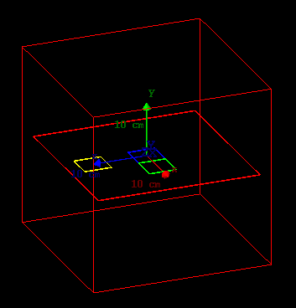
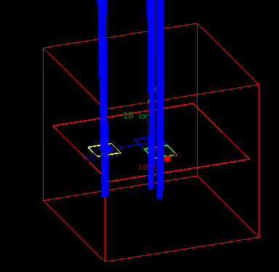

Test procedure and validation example: part1
- run the script “./OrientationTestRun.sh” in order to automatically run the 4 simulations for each cardinal angle of the gantry (make sure the script is executable, otherwise execute the following command in the terminal “chmod + X OrientationTestRun.sh”) - alterantively you could run each simulation separately (Gate mac/main_orientation_GTRYX.mac) – the simulation time should be around 1 minute.
- When the simulations are finished, list all the phase spaces in a text file, e.g. using the following command “ls output/*.root > listPhS.txt”
- run the script “root LGPhSListProcess.C” in order to automatically analyze all the phase spaces (Line 22 in the script, adapt the input “FileListName=./listPhS.txt" if different)
- open the analysis summary “results/AnalysePhSs.txt” and verify that the outputs are correct. To support the evaluation process, a template spreadsheet based on the Gnumeric software (must be installed if you do not have it) is provided. Copy/paste the values from the analysis summary “results/AnalysePhSs.txt” into the tab “Input” from the spreadsheet “TPS-Validation-Summary.gnumeric” as below.
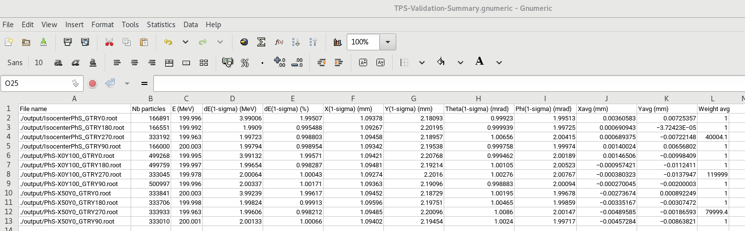

- Evaluate the results for each gantry angle in the respective tabs and make sure the observed deviations are statistically acceptable (e.g. <0.5% in number of particles, <0.05mm in size and <0.05mrad in divergence, etc.) - the evaluation data shall turn green if they are within tolerances or red otherwise (see example below for the gantry angle 0). The evaluation concerns the number of particles delivered, the energy, the energy spread, the spot size, position and divergence in x and y, the particle weight. Additional specificities are tested for each gantry angle separately and require additional check as described in the following section.

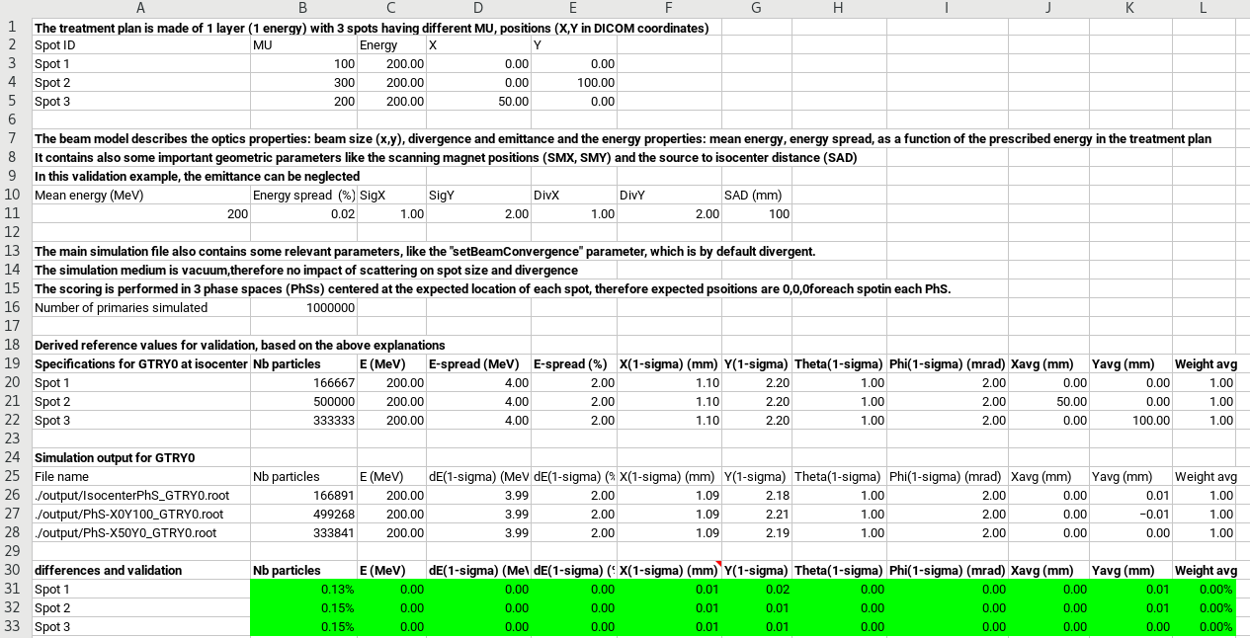
- Test procedure and validation example: part2
- Backup your results by copying the output folder (e.g. cp output output-backup -r)
- Clean the current output folder (e.g. rm output/*)
- The main differences between the 4 GTRYXX simulations are the following:
  - GTRY0
    - /gate/source/PBS/setParticleType proton
    - /gate/source/PBS/setSpotIntensityAsNbIons true
    - /gate/source/PBS/setSigmaEnergyInMeVFlag false
    - /gate/source/PBS/setSortedSpotGenerationFlag false
    - /gate/source/PBS/setFlatGenerationFlag false
    - /gate/source/PBS/setBeamConvergence true
    - /gate/source/PBS/setNotAllowedFieldID 2

  - GTRY90
    - /gate/source/PBS/setParticleType GenericIon
    - /gate/source/PBS/setIonProperties 2 4 2 0
    - /gate/source/PBS/setSpotIntensityAsNbIons false
    - /gate/source/PBS/setSigmaEnergyInMeVFlag true
    - /gate/source/PBS/setSortedSpotGenerationFlag false
    - /gate/source/PBS/setFlatGenerationFlag false
    - /gate/source/PBS/setBeamConvergenceXTheta true
    - /gate/source/PBS/setBeamConvergenceYPhi false

  - GTRY180
    - /gate/source/PBS/setParticleType GenericIon
    - /gate/source/PBS/setIonProperties 3 6 3 0
    - /gate/source/PBS/setSpotIntensityAsNbIons false
    - /gate/source/PBS/setSigmaEnergyInMeVFlag true
    - /gate/source/PBS/setSortedSpotGenerationFlag true
    - /gate/source/PBS/setFlatGenerationFlag false
    - /gate/source/PBS/setBeamConvergenceXTheta false
    - /gate/source/PBS/setBeamConvergenceYPhi true

  - GTRY270
    - /gate/source/PBS/setParticleType GenericIon
    - /gate/source/PBS/setIonProperties 3 6 3 0
    - /gate/source/PBS/setSpotIntensityAsNbIons false
    - /gate/source/PBS/setSigmaEnergyInMeVFlag true
    - /gate/source/PBS/setSortedSpotGenerationFlag true
    - /gate/source/PBS/setFlatGenerationFlag true
    - /gate/source/PBS/setBeamConvergence false

- The correct particle type delivery can be verified using root and Tbrowser (e.g. root [0] TBrowser T). Open the phase space trees from the output-backup folder and look at the particle type. The histogram should show “proton” (GTR0 – see example below), “alpha” (GTRY90), “Li6” (GTRY180) or “C12” (GTRY270).
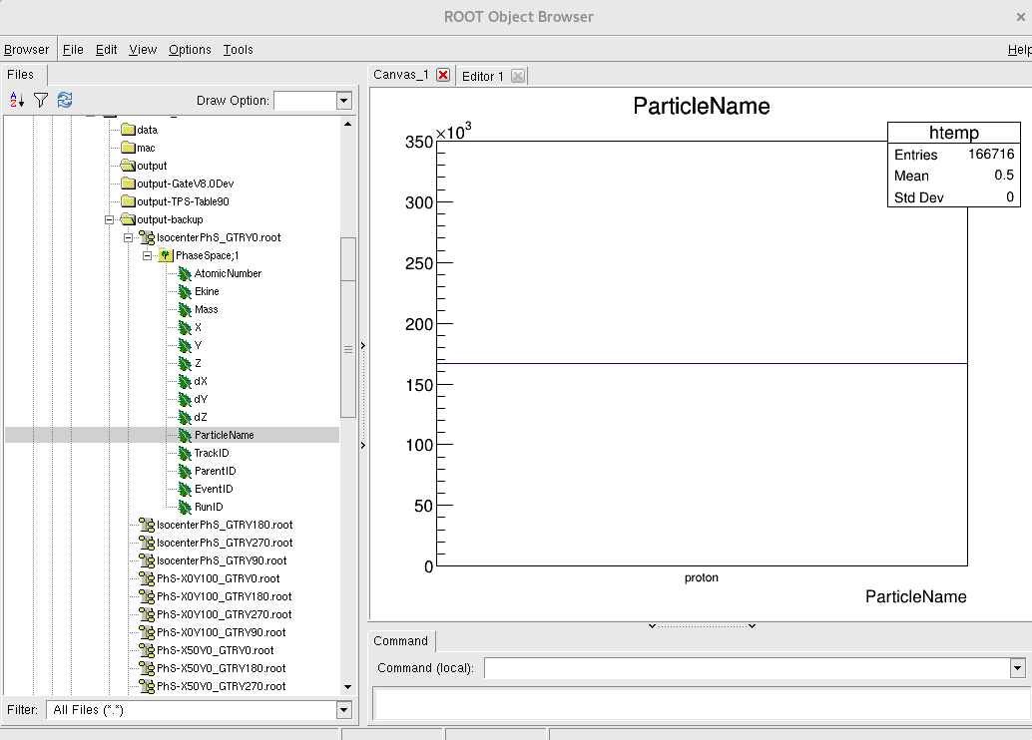
- The specification “setSpotIntensityAsNbIons true or false” can be partly verified in the tabs “GTRY0” and “GTRY90 (or 180 or 270)”. In order to precisely check the influence of the option “setSpotIntensityAsNbIons true”, the user shall open the macro GTRY0 (e.g. gedit mac/main_orientation_GTRY0.mac), turn the option Testflag to true (/gate/source/PBS/setTestFlag true) and decrease the number of primaries to 10 (/gate/application/setTotalNumberOfPrimaries 10) and run the macro (e.g. Gate mac/main_orientation_GTRY0.mac). In the simulation logs printed in the terminal, one can figure out the prescribed spot metersetweight for each spot (in number of protons). The values should be 100, 200 and 300 for spot 1,2, and 3, respectively.
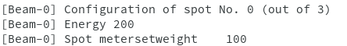

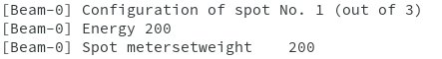

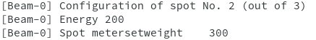

- In order to check the influence of the option “setSpotIntensityAsNbIons false” in more details, the user shall open the macro GTRY90 (or 180 or 270), turn the option Testflag to true and decrease the number of primaries to 10 and run the macro. In the simulation logs printed in the terminal, one can figure out the prescribed spot metersetweight for each spot. Since the protons/MU calibration function inserted in the source description file corresponds to N=(2*E+0)*MU, where N stand for number of particles, E for energy and MU for Monitor Unit, the expected spot meterset (number of protons) should be 2*200*100=4E4, 2*200*200=8E4 and 2*200*300=1.2E5 for spot 1,2, and 3, respectively.
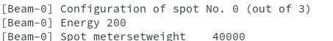

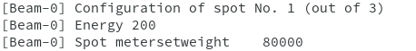

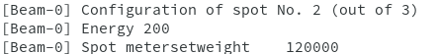

- The specification of the energy spread spread in % or MeV can be verified in the respective tabs “GTRY0” and “GTRY90” from the spreadsheet “TPS-Validation-Summary.gnumeric”.
- The definition of the energy spread in MeV or percent can additionally be defined directly in the source description file. In this case, it will override the command /gate/source/PBS/setSigmaEnergyInMeVFlag true (or false). Just add the symbol “%” or “PERCENT” or “percent”, or “MeV” in the source description file before the polynomial order in the source description file in order to define the energy spread
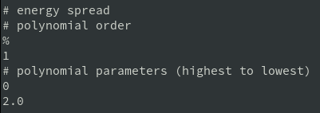

You can then check in the log information of the terminal that the energy spread has been defined as specified in the source description file (see below).
You can also analyze the simulation output as before using the root macro LGPhSListProcess or simply open the energy histogram with the Tbrowser in root and look at the energy spread.
- The specification of the random or sorted spot delivery “setSortedSpotGenerationFlag false or true” can be verified graphically by activating the display (/control/execute mac/visu.mac) and by reducing the number of primaries. It may be useful to activate or de-activate the accumulation of events in the macro “Visu.mac” (/vis/scene/endOfEventAction accumulate)
- The specification setFlatGenerationFlag true can be verified in the tab “GTRY270” from the spreadsheet “TPS-Validation-Summary.gnumeric”: each spot has the name number of particles and the weight have been modified according to the metersetweight. For the GTR0, 90 and 180, the weight is always 1, since the FlatFlag is false.
- The specification of the beam divergence is tested in all the 4 macros, with x and y converging in GTR0, x and y diverging in GTR270, x converging and y diverging in GTRY90, x diverging and y converging in GTRY180. It can be verified in the tabs “GTRYXX” from the spreadsheet “TPS-Validation-Summary.gnumeric” by looking at the spot size which is increasing (decreasing) if the beam is diverging (converging).
- The specification “setNotAllowedFieldID” and “setAllowedFieldID” can be tested in GTR0 macro (mac/main_orientation_GTRY0.mac). The user should activate the graphical display and by reduce the number of primaries. If both lines are commented, then both beams shall be delivered.
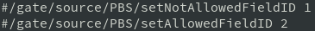

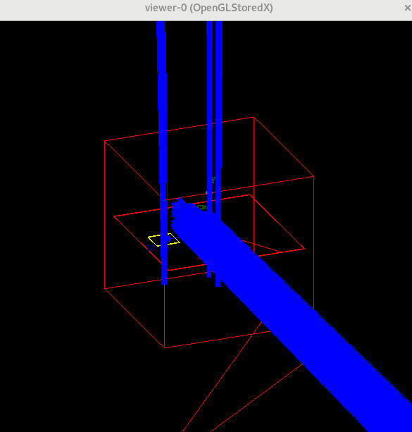

If only SetAllowedField 1 (or 2) is activated, then only the allowed field shall be delivered. If only SetNotAllowedField 1 (or 2) is activated, then only the not allowed field shall not be delivered.
- The functionality “/gate/source/PBS/selectLayerID” can be simply tested, for example by selecting the second field (/gate/source/PBS/setAllowedFieldID 2) and selecting a layer ID. Not that the first layer of the field has ID 0, the second has ID 1, etc. if we select the third layer (/gate/source/PBS/selectLayerID 2), increase the verbosity (/gate/verbose Beam 10) and run only 10 primaries (to reduce log info), we could check in the log that the system delivers the layer 3 which has an energy of 183.83 MeV and 37 spots (see below). Please note that a field must be selected to guarantee a proper behavior.

- The functionality “/gate/source/PBS/selectSpotID” can be simply tested, for example by selecting the second field (/gate/source/PBS/setAllowedFieldID 2), the third layer (/gate/source/PBS/selectLayerID 2) and selecting the second spot ID (/gate/source/PBS/selectSpotID 2). Not that the first Spot of the layer has ID 0, the second has ID 1, etc. if we select the third spot (/gate/source/PBS/selectSpotID 2), increase the verbosity (/gate/verbose Beam 10) and run only 10 primaries (to reduce log info), we could check in the log that the system delivers the spot 3 of the layer 3 of the field 2, which has a position -8/32 (x/y) and a meterset of 33.26.

The proper layer information can also be checked

We can also see that all other spots are rejected from the simulation (see example of one spot below).
Please note that a field and a layer must be selected to guarantee a proper behavior.

- Annexes
The PencilBeam source is set-up according to IEC coordinate system; i.e. beam direction –Z, spot position in X and Y (see picture below)
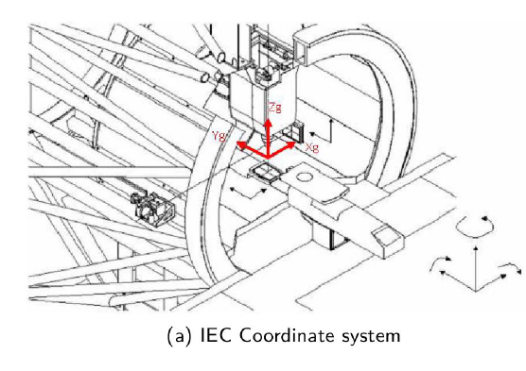
The TPSPencilBeam source consists in a collection of PencilBeam sources and DICOM image coordinate system is considered as illustrated below
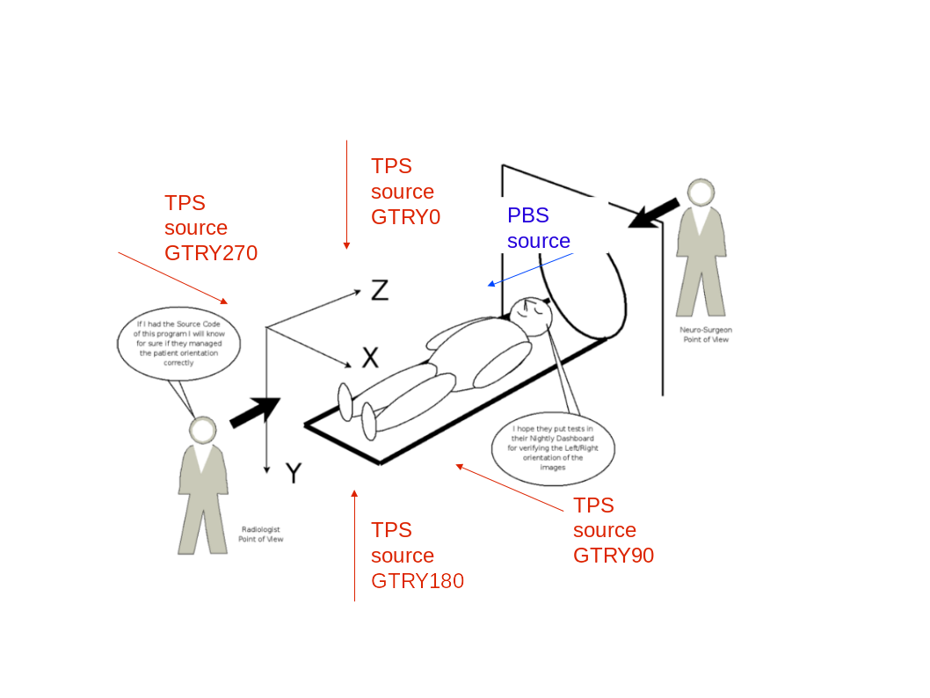

The conversion of each pencil beam coordinate defined as a PencilBeam source in the TPSPencilBeam source, i.e. in the GATE world (or DICOM image coordinate convention) is as follows:
TPS source \ PBS source | X | Y | Beam direction
GTRY0 | X | Z | +Y
GTRY90 | Y | Z | -X
GTRY180 | -X | Z | -Y
GTRY270/-90 | -Y | Z | +X

