HIVE

# Hive Interface

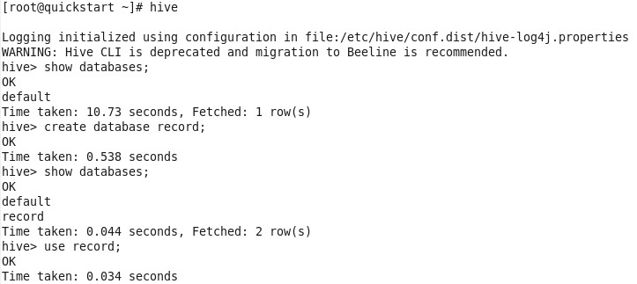

# Creating Table

Loading Data from Local Shell into Hive

Table

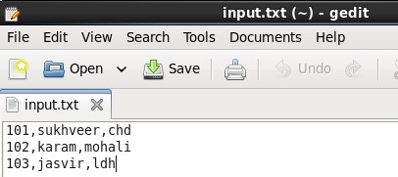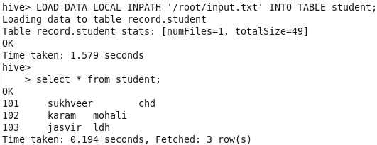

# Describe Table

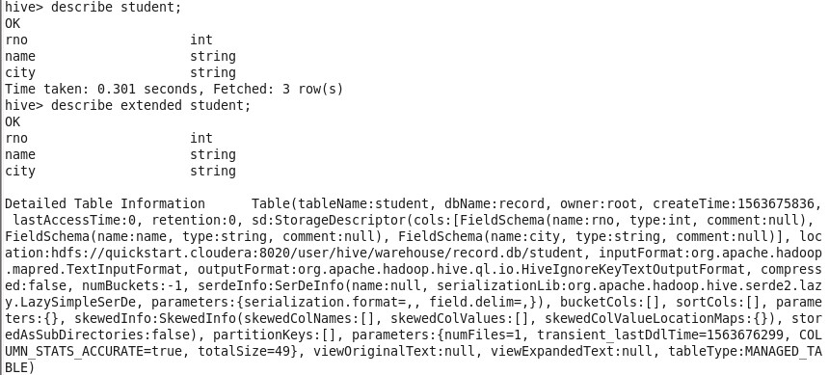

# Creating External Table



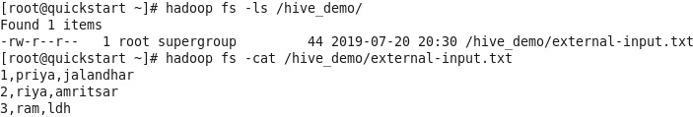

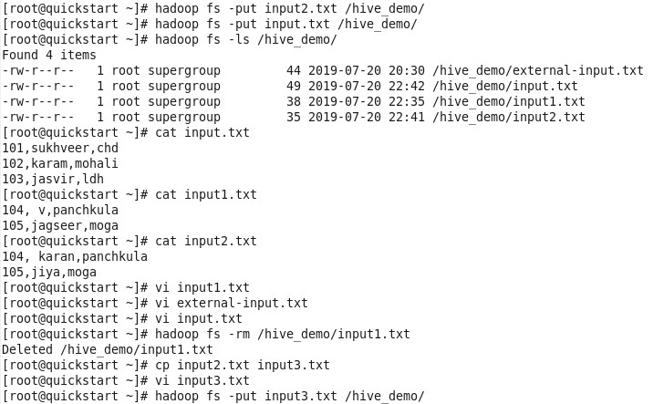

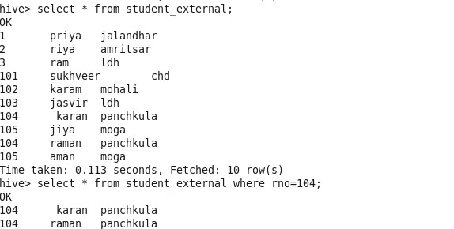

Partition

* Partition means dividing a table into a coarse grained parts based on the value of a partition column such as a date. This make it faster to do queries on slice of the data.
* It define how data is stored in HDFS.
* Grouping data bases on some column
* **Buckets**

– Partitions divided further into buckets bases on some other column

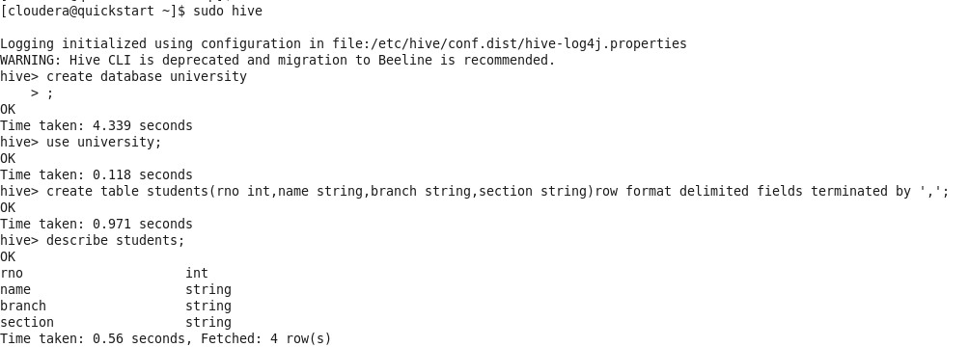

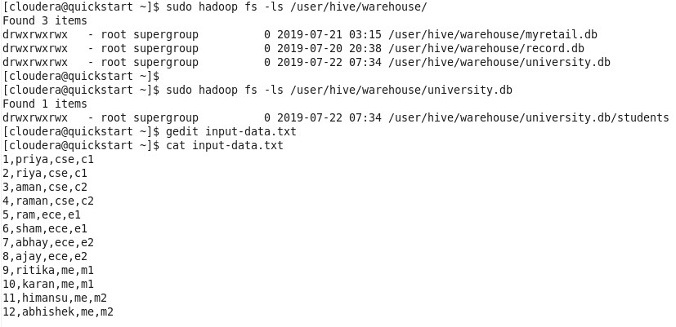

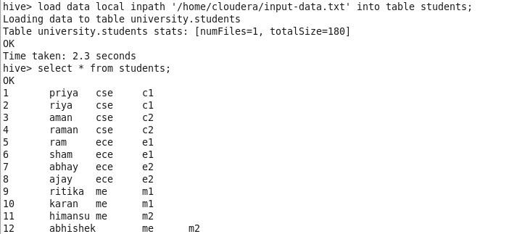

# Creating Partition and Buckets

create table studentsbybranch(rno int,name string,section string)partitioned by (branch string)clustered by (section) into 2 buckets row format delimited fields terminated by ',';

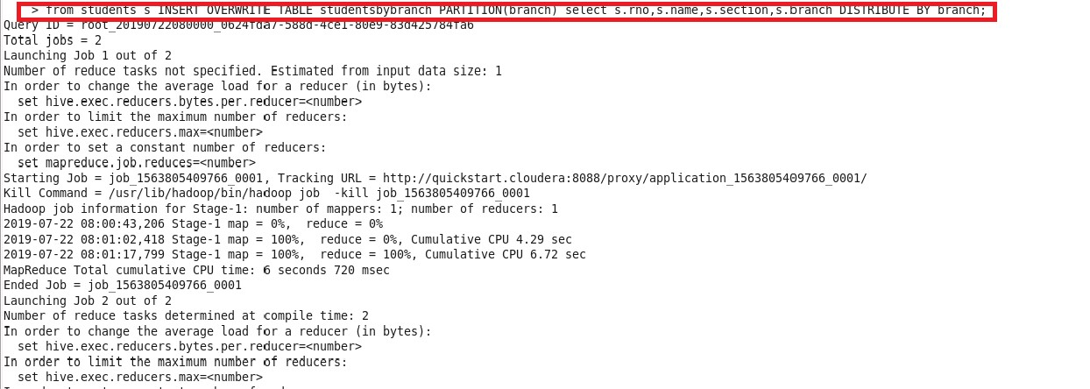Load Data from original Table into Partition Table

# Partition in HDFS

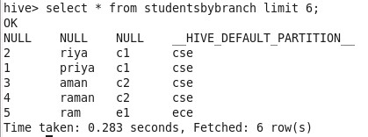

# Joins

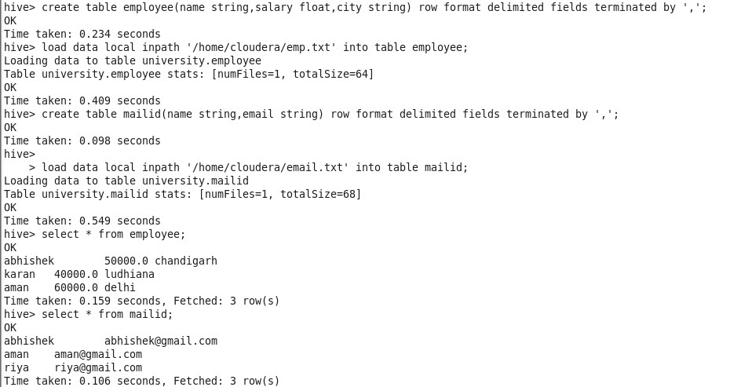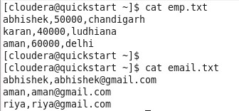

# Equal Join

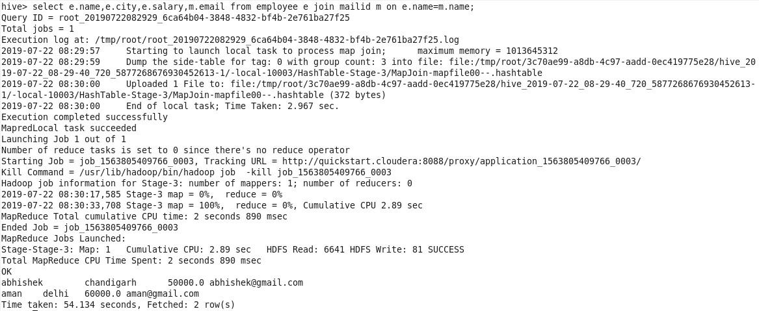

# Left Outer Join

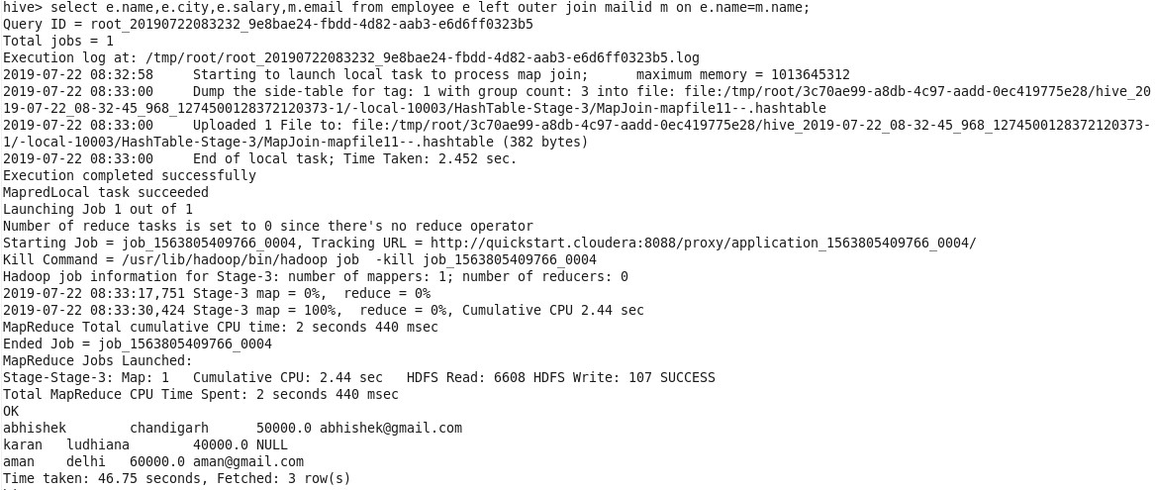

# Full Outer Join

