**The Challenge**

The Federal Government has had a long history of failed information technology (IT) programs. The Federal Government has spent over $600 billion on IT over the past decade. Yet too often these programs are behind schedule, over budget, or fail to deliver results at all, wasting taxpayer dollars.

**What is TechStat?**

* Face-to-face, evidence-based accountability reviews of IT programs
* Results in concrete actions to address weaknesses
* Reduces wasteful spending by turning around troubled programs and terminating failed programs sooner
* A forum for identifying lessons learned to better manage Federal IT investments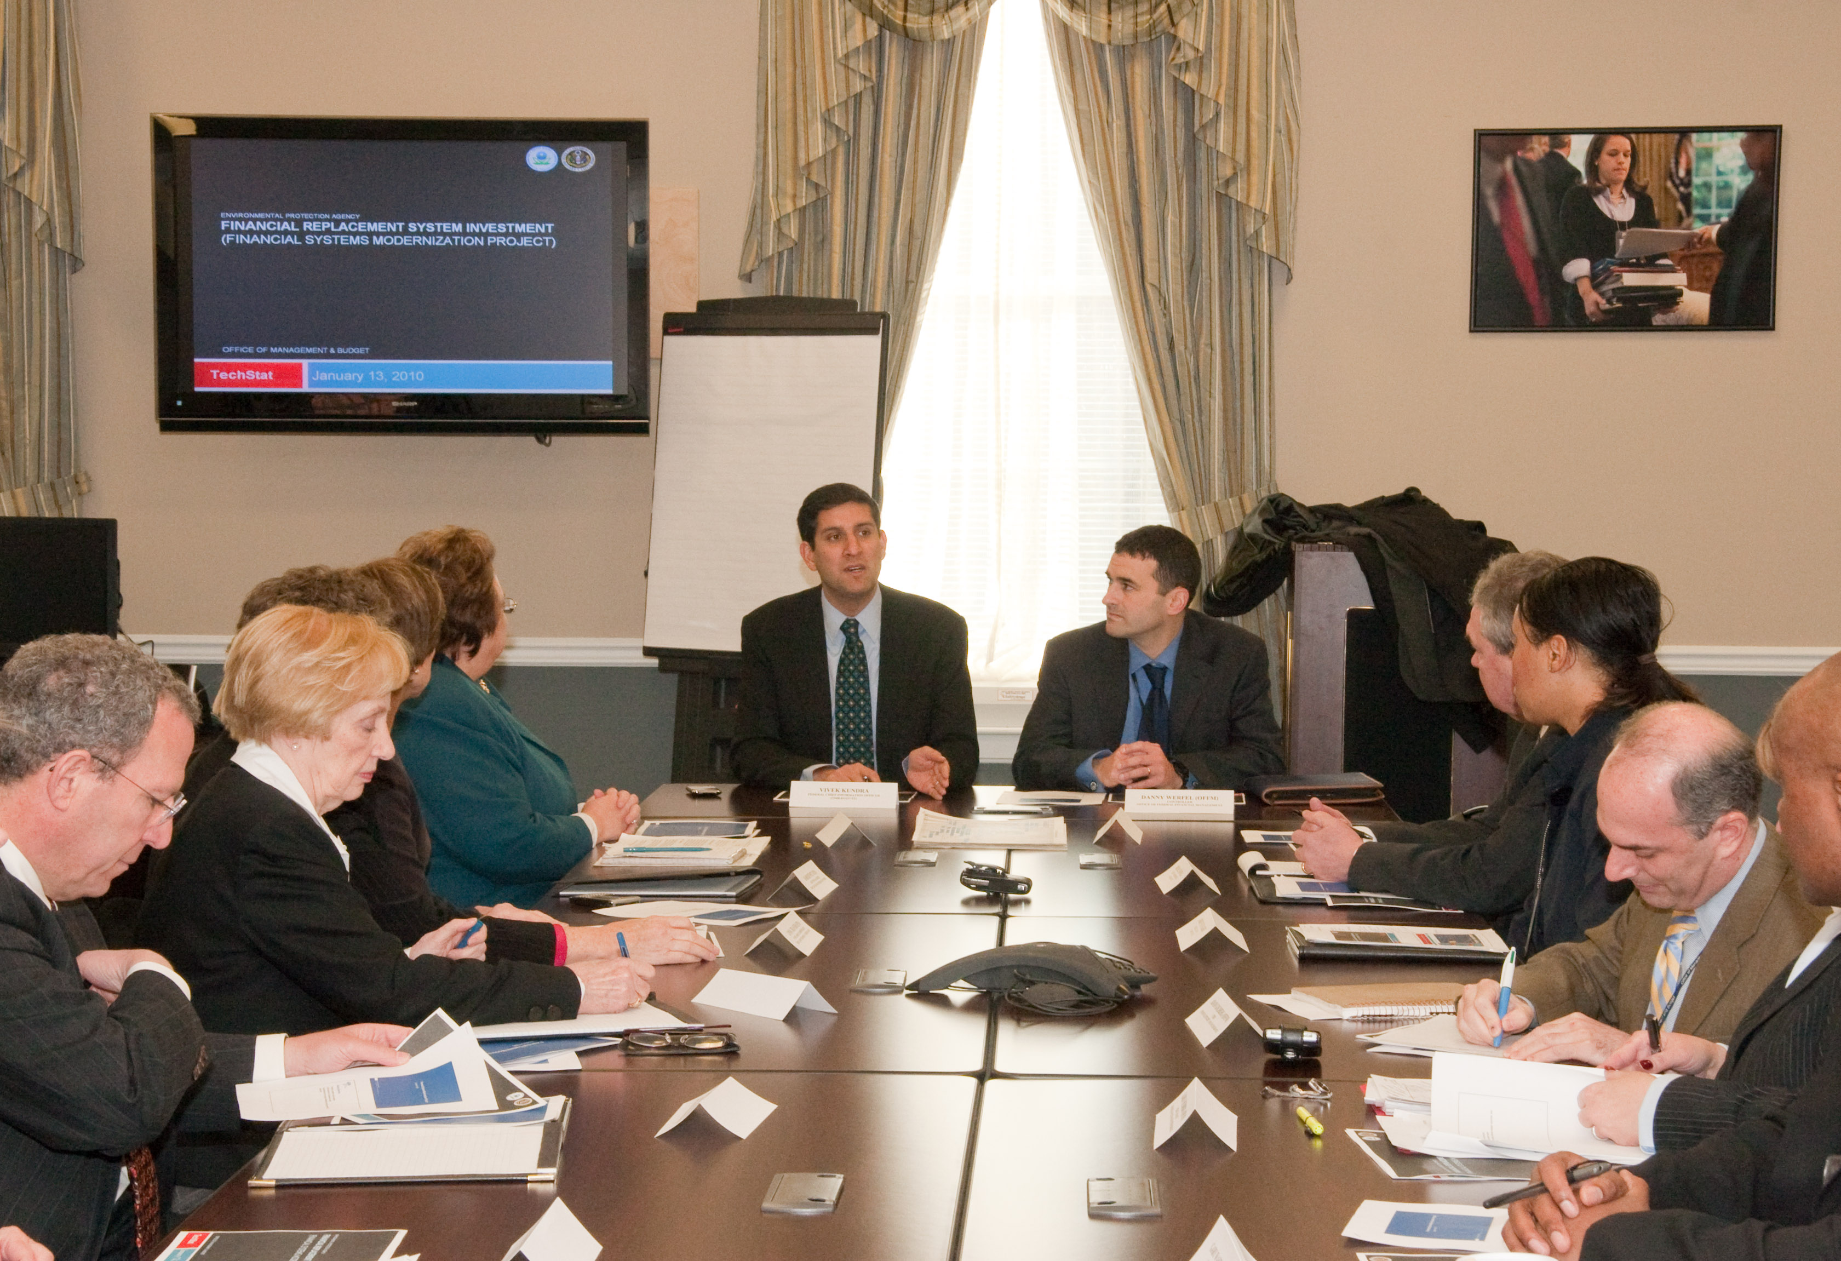

The IT Dashboard allows the American people to monitor the cost, schedule, and CIO rating for every major IT investment in the Federal Government. However, it is not enough to simply shine a light and hope performance improves for troubled projects. We must actively use this transparency to hold government managers accountable for the performance of IT programs.

**The Solution**

A TechStat is a face-to-face, evidence-based review of an IT investment. A TechStat is triggered when <Agency> OCIO determines that a project is underperforming, using data from the IT Dashboard and other sources. In the session, the <Agency> CIO, along with other members of <Agency’s> leadership team, meet for one focused hour; they review the analysis assembled by the TechStat team through a briefing that highlights the management of the investment, examines program performance data, and explores opportunities for improvement.

<Insert agency TechStat image>

In many cases, the immediate result of a TechStat session is a collaboratively developed, concrete action plan to address issues and turn around the troubled or failing program. With new perspectives and renewed vigor, Federal managers are then responsible for executing the plan and correcting the program’s performance. Federal portfolio managers will continue to monitor these programs through the IT Dashboard as agencies make progress against their plans and ultimately yield benefits for the public. However, in some cases, a TechStat session may reveal that the best course of action for an investment is to temporarily halt or even terminate the program. Finding these failed programs sooner saves taxpayers money and promotes accountability to high standards and program management success.

**Moving Ahead**

In December of 2010, the Federal CIO launched a 25 Point Implementation Plan to Reform Federal IT that called CIOs to stand up the “TechStat” model at the departmental level by March 2011, and at the bureau level within 18 months, in order to turnaround or terminate at least one-third of poorly performing projects in their portfolio. As the IT Dashboard continues to provide unprecedented insight into Federal IT investment performance, agency TechStat sessions allow us to take action and turn around these poorly performing programs across the government. The <Agency> CIO will monitor the performance of information technology programs at the agency, evaluate the performance of those programs on the basis of the applicable performance measurements, and advise the head of the agency <and/or IRB> regarding whether to continue, modify, or terminate a program or project.

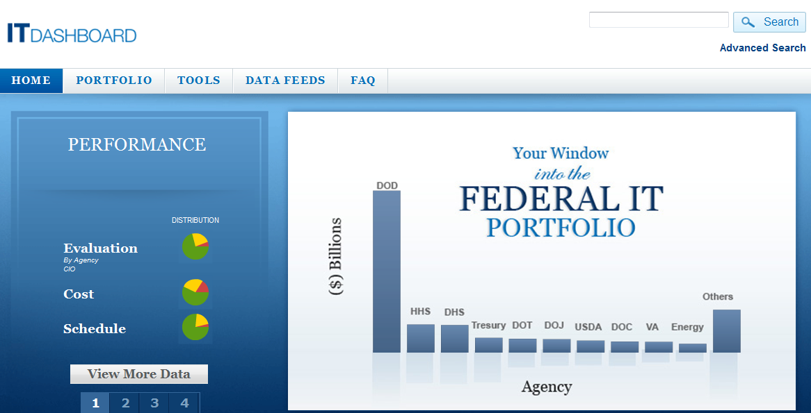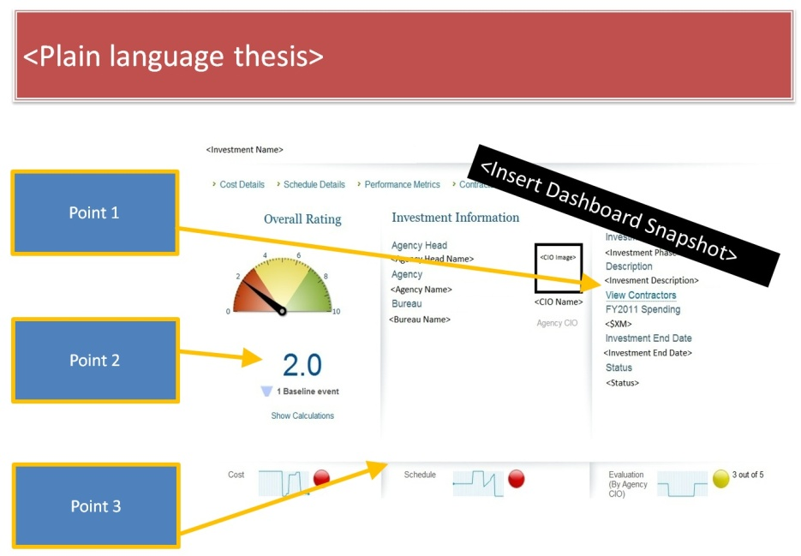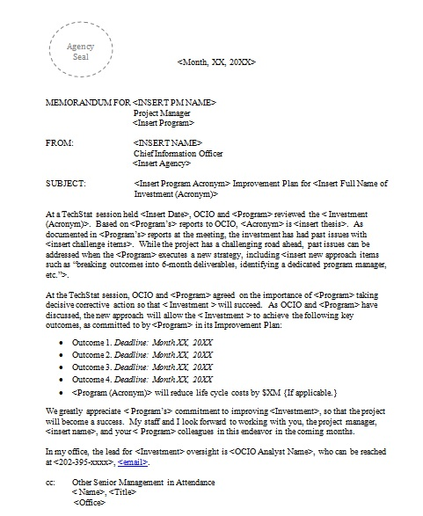

Conduct TechStat Accountability Sessions

Relentless Follow up

Identify Troubled Projects