DFDL: The XML Proposal
Martin Westhead

Motivation

The discussion on DFDL seems to have reached the point where we generally agree that we need to define a composite transformation that will take us from a representation in bits to XML or some in-memory data model accessible to a language:

memory
bits
model-0
model-n
This has seemed to me to naturally appear to be a series of transformations: bits -> bytes, bytes-> characters, characters to lines, lines to comma separated strings. Each transformation moves us to a different data model. By data model here I mean structured composition of “things”.

So it seems to me that we need the ability to describe (at least):
- Model Types: The structure of a model and its components
- Transformations: Some amount of the semantics of the transformation from one model to another (i.e. we are happy to let gzip be “magic” but we want to be able to say how we get the values of the CSV file from the characters).
- Orchestration mechanisms: Ways to map all this stuff together so that we can take the separately defined pieces to describe a specific representation.
- Structured Data: A way to write down descriptions of example data in a model.
- APIs: To access the data from a program
- Translation to XML: What is the transformation to an XML document

The proposal here is to leverage XML for all its worth. Lets adopt the XML Schema data model wholesale. If we do that then all our data models, at every level, can be written in XML and described by XML Schema. For example a byteStream would look like:

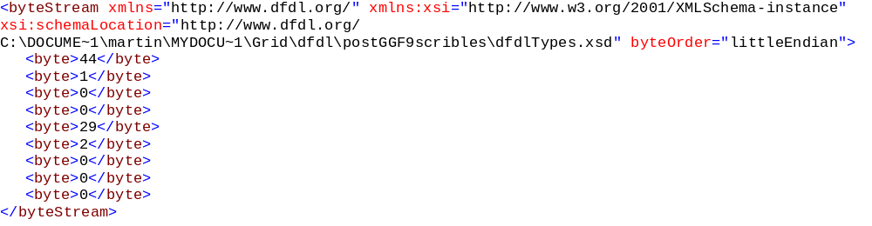
and would be described by the following Schema:

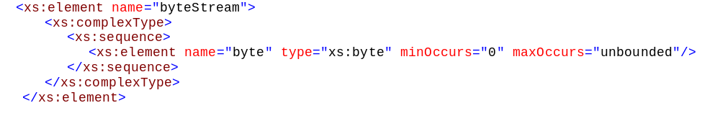
Further we could describe the transformations between models in XSLT which has defined mechanisms for extension.

The intention here is (of course) not that we propose to translate our binary files through a series of textual XML representations, just that we use the XML tools to characterise the transformations that we want our data to undergo. Clearly most of the existing XSLT implementations work at the level of text-based XML but many people are pushing XML as the standard model for data (which conveniently has a standard textual serialisation).

There are a lot of advantages to this approach; primarily we leverage a lot of existing standards with corresponding tools and existing human expertise. Further, if this were to work it would be effectively extending the XML paradigm to all data. Now, whilst this has sort of been on the agenda, I have been thinking of this in a much more limited sense. If XML is brought into the centre like this it becomes much more tightly integrated. For example, if this worked we should be able to use it to describe arbitrary ways of representing an existing XML format in binary.

What does DFDL become?
So the idea is that instead of writing our (arbitrary syntax) decription of a struct describing our data, we describe an XML document, using XML Schema. So our first example becomes:

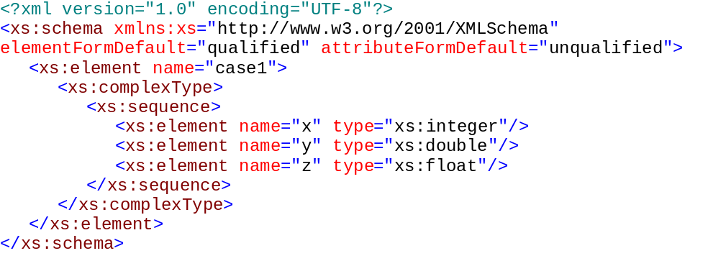
Which describes an XML file like:

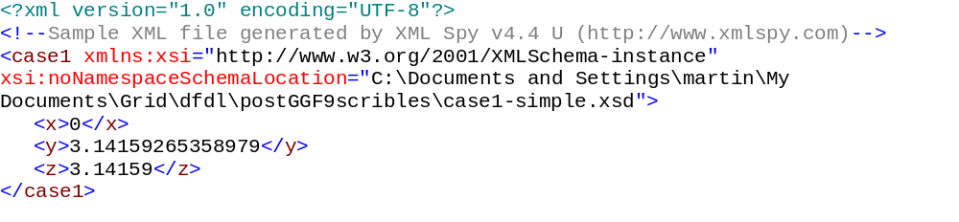
Notice that the element names are arbitrarily chosen by the user. What we still need to do here is to describe how we get to this model from the bits. To do this I propose we use the appinfo annotation which allows us to give applications extra information about the tags. So the finished example might look like:

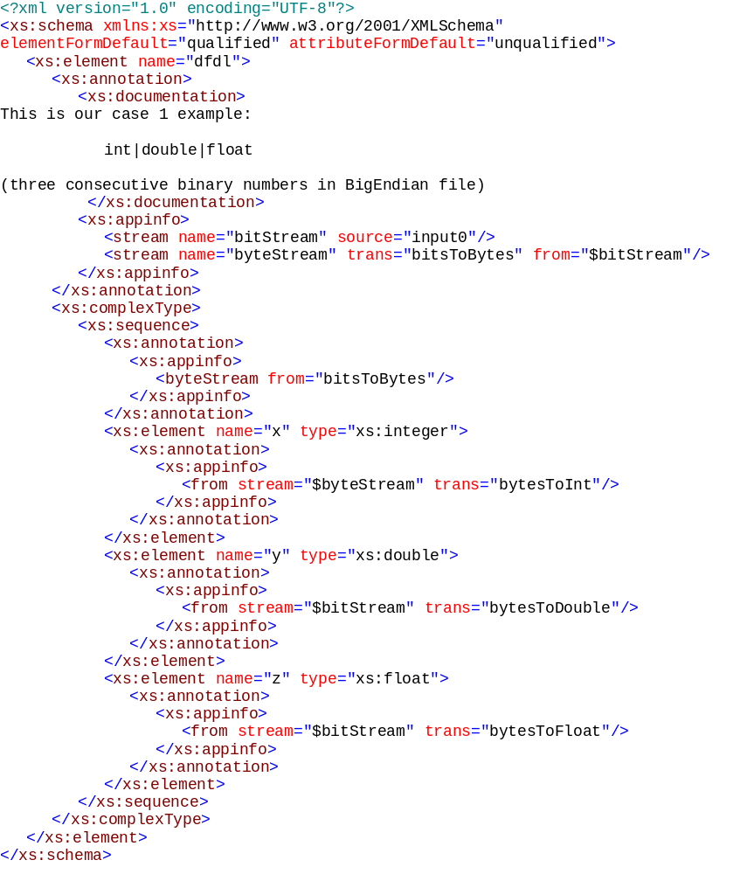
So this is true to the sorts of things that we have been writing so far an initial definition of some streams (using transformations) and then annotations associated with the individual elements to describe where they have come from.

This is somewhat verbose, I admit, but:
- I was able to use existing tools to help me write it
- We can work on
  - Default behaviour (most of what is in the second description could be assumed by the first here)
  - An alternative representation to make writing this stuff out easier

Continuing in this way, and stealing from Mike’s notation, I got the following for the second example:
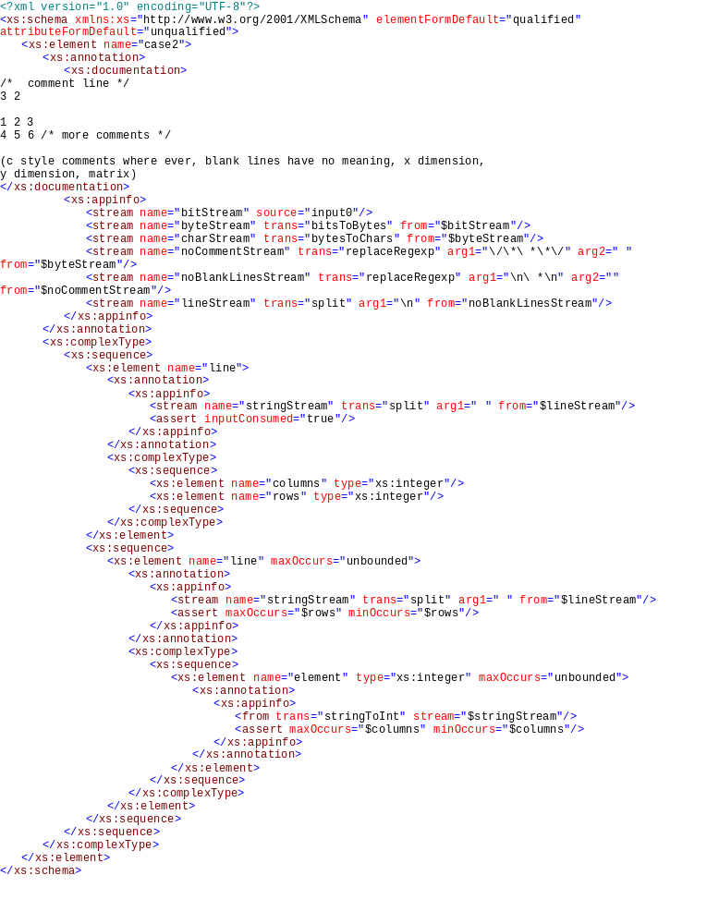
A really nice feature of this is that the hierarchical structure can be used to help break down the file structure. What I have tried to describe here, is that the top level structure captures the stream level transformations which include splitting by line-feed. The <line> tag reads from this stream and splits by space and then the individual numbers read from their tokenised strings.

I have included <asserts> to make statements about valid formatting that cannot be captured in the Schema itself.

As you would expect then case 4 (below) is very similar:
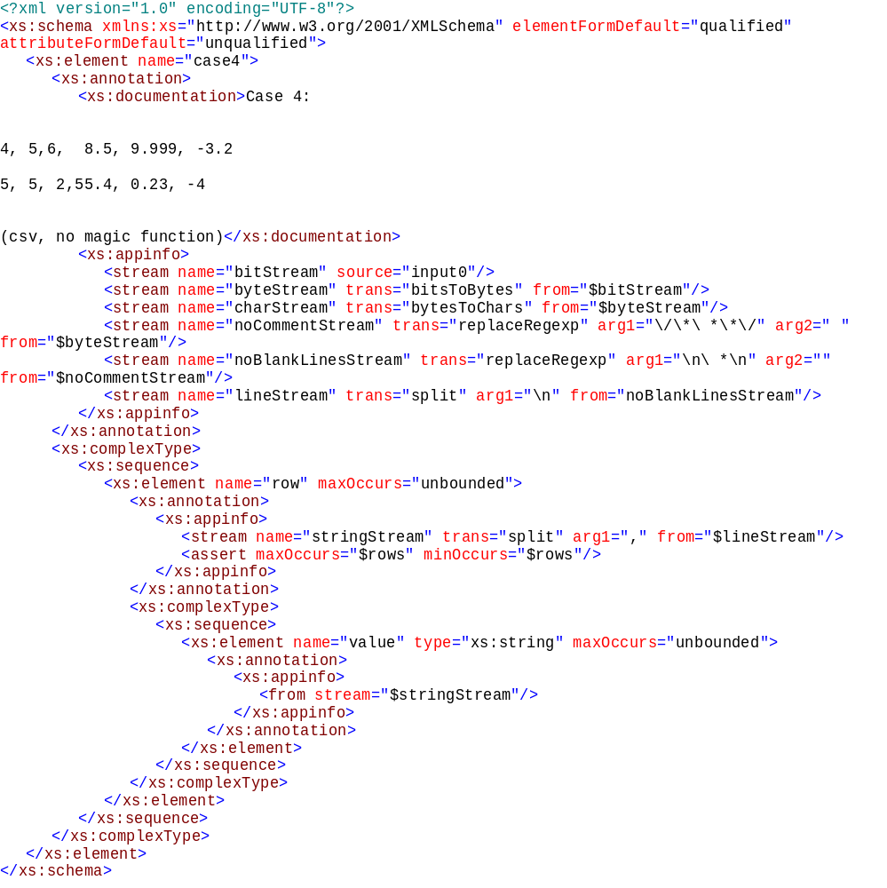

Case 3 is interesting because it is lower level. My Schema for this is very dull, just a length integer element (which may be excluded) and a string element, and one magic function “getMyString” that figures out the string logic. I include the Schema below, but just to push the method a little further I tried to write getMyString in XSLT.
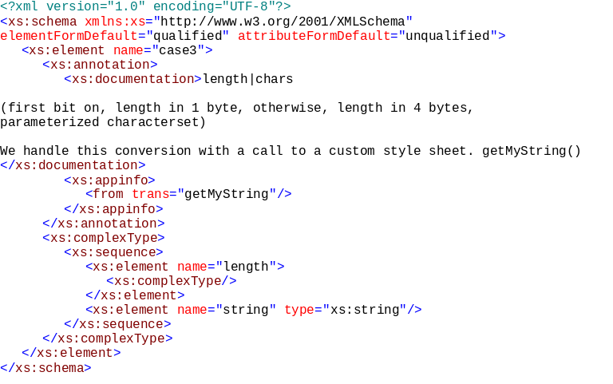
In order to write getMyString I needed to write a bytesToInt and a bytesToString first. I have attached these as appendices. I should point out that my maths is broken (I forgot XML bytes are signed…and also to worry about the sign of the integers…I also wasn’t sure about the logic of the bit setting in the example). However, an XSLT for getMyString might look like:

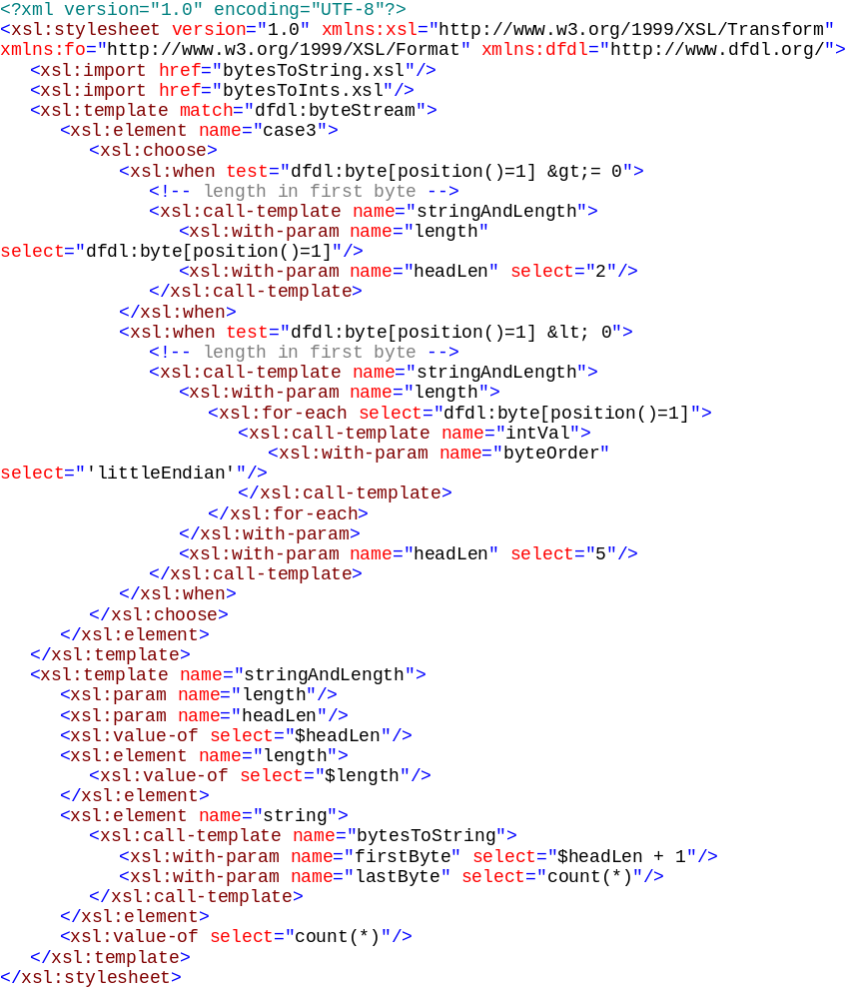
This is clearly ugly and really not the way that you would want to solve the problem if you are going to face this often. However, I think it’s useful to understand that it can be done because it means that if we were to take this route we could figure out standard ways to do the stuff that needs doing all the time really fast but always allow the user to handle their corner cases using a standard, portable language. It also means that we could build reference implementations that might be hideously slow but would be very lightweight. Also making XSLT etc. go fast is a major industry goal so maybe the problem would be solved for us.

So, DFDL if we took this route would consist of:
- Standard transformation set
- Standard XML for gluing transformations and Schema that could work inside or outside Schema annotations
- Default behaviours to save typing and reduce complexity of decription
- An API that will let me get to my 50 Gb floating point array without using DOM!
- Lots of examples
- ….?

Appendices
The XSLT for integers from bytes. Note that the maths for this is broken:
- XML bytes are signed
- XML integers are also signed
But it illustrates that this is possible in principle.

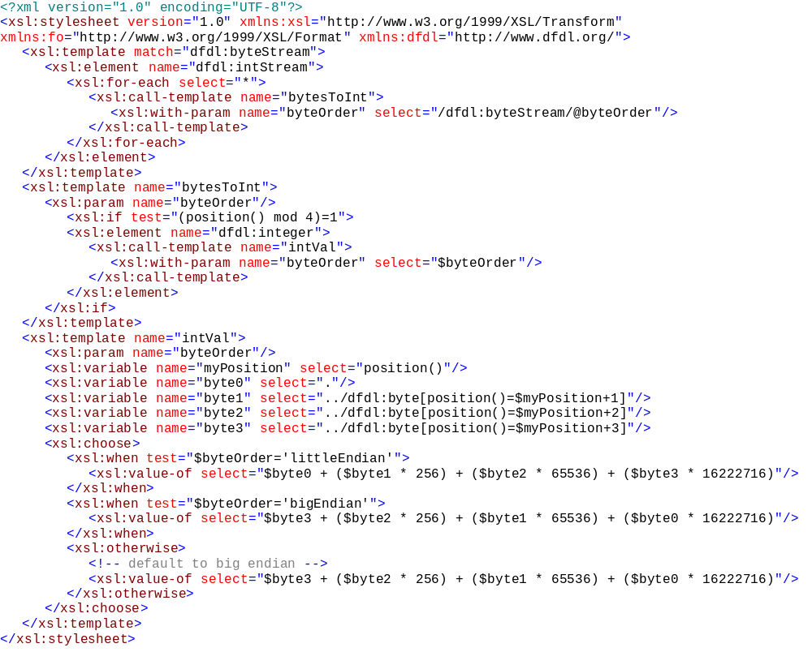
The XSLT for converting from bytes to characters (assuming ASCII characters)…I only did part of the character set here since this is rather tedious. There might be a built in function that I couldn’t find…
