GGF DFDL Primer

Status of This Memo

This memo provides information to the Grid community regarding the specification of a Data Format Description Language. The specification is currently a draft. It does not define any standards or technical recommendations. Distribution is unlimited.

Copyright Notice

Copyright © Global Grid Forum (2004). All Rights Reserved.

Abstract

A Data Format Description Language (DFDL) is proposed as an open industry standard. Rather than prescribing a data format, DFDL is descriptive of existing formats. DFDL leverages the XML standard and XSD standard for defining the structure of data, but extends these to include the ability to describe data formats.

Revision History
Latest entry at the top please
Version | Author/Contributor | History | Date(yyyy-mm-dd)
007 | Jim Myers | Mods | 2004-05-13
006 | Martin Westhead | Accepted changes. | 2004-05-02
005 | Mike Beckerle | Modified a few keywords, accepted changes. Updated XSD simple types figure. | 2004-05-02
004 | Martin Westhead | Extended the examples | 2004-04-26
003 | Mike Beckerle | More Mods | 2004-04-23
002 | Martin Westhead (GGF) | Mods | 2004-04-23
001 | Mike Beckerle | Created | 2004-04-14

Contents
GGF DFDL Primer 1
Abstract 1
Revision History 2
Contents 3
1. Introduction 4
2. Glossary 5
3. DFDL and XML and XSD 5
4. DFDL Layers 5
5. DFDL Information Model 6
6. Definition Libraries 7
7. DFDL Examples 7
7.1 Example 1: A simple binary file 7
7.2 Example 2: A simple text file 9
7.3 Example 3: Separating Model and Mappings 9
7.4 Example 3: Annotation scope 11
7.5 Transitivity of type substitution 12
8. Associating DFDL with Data 13
9. Implied XML Schema 14
10. The leverage of using XSD 14
10.1 Differences from XSD 14
11. Conclusion 15
12. Security Considerations 15
13. Appendix: About Literal String Values in DFDL 15
14. Appendix: About Length of Character Strings 16
15. Appendix: Character code vs. UTF-16 codepoints 16
16. Intellectual Property Statement 17
17. IPv6 Considerations 17
18. Full Copyright Notice 17
19. Author Information 17
20. References and Notes 18
21. Appendix A Supporting type definitions 18
22. Appendix B Mapping definitions 20
23. Appendix C Library types 21

Introduction
Data interchange is critically important for the Grid. The grid is about getting distributed software and hardware resources to work together. Inevitably these resources read and write data in different formats. General tools for data interchange are essential to solving such problems.
We envisage 3 dominant kinds of file-oriented data in the future:
Textual XML data.
Binary data in standard formats.
Data with DFDL descriptors
Textual XML data is the most successful data interchange standard to date. All such data is by definition new. That is, created in the XML era. In addition it is usually small data because of the large overhead that XML tagging imposes. Standard binary data is also relatively new, and is more reasonable for larger data because of the reduced costs of encoding and more compact size. Examples standard binary formats are data described by modern versions of ASN.1, or the use of XDR. These techniques lack the self-describing nature of XML-data. Scientific formats such as NetCDF and HDF are used in some communities provide self-describing binary data. In the future there may be binary-encoded XML data as there is a w3c working group that has been formed on this subject. Both XML format and standard binary formats are prescriptive in that they prescribe a representation of the data. To use them your applications must be written to conform to their encodings and mechanisms of expression.
DFDL suggests an entirely different scheme. The approach is descriptive in that one chooses an appropriate data representation for an application based on its needs and one then describes the format using DFDL so that multiple programs can directly interchange the described data. DFDL descriptions can be provided by the creator of the format, or developed as needed by third parties intending to use the format. That is, DFDL is not a format for data; it is a way of describing any data format. DFDL is intended for data commonly found in all kinds of calculations including scientific and numeric computations as well as the record-oriented representations found in commercial data processing.
DFDL can be used to describe legacy data files, to simplify transfer of data across domains without requiring global standard formats, or to allow third-party tools to easily access multiple formats. DFDL can also be a powerful tool for supporting backward compatibility as formats evolve.
DFDL is designed to provide this flexibility without sacrificing performance. DFDL descriptions are separable and native applications do not need to use DFDL libraries to parse their data formats. DFDL parsers can also be highly efficient. The DFDL language is designed to allow lazy evaluation of formats and to support seekable, random access to data. Thus, applications using DFDL for interoperability may have faster access to data elements than those that do not fully use format information to optimize disk access. The following goals are achievable using DFDL:
Density: fewest bytes to represent information content (without resorting to compression). Fastest possible I/O.
Optimized I/O. Applications can write data aligned to byte, word, or even page boundaries and to use memory-mapped I/O to insure access to data content with the smallest number of machine cycles for common use cases without sacrificing general access.
DFDL can describe the same kinds of abstract data that other binary or textual data formats can describe, but can go further and describe almost any possible representation scheme for them, e.g. multiple representations optimized for specific uses. It is the spirit of DFDL to support canonical data descriptions that correspond closely to the original in-memory representation of the data, and provide sufficient information to write as well as to read the given format. However, DFDL is designed as an extensible language and could be used to represent parts of a data format, e.g. a file header, without the requirement to describe the full file contents. Similarly, DFDL could be used to support summarization or transformation of data, e.g. describing a low-resolution slice through data or representing vectors of x and y coordinates as a single vector of [x,y] pairs. These uses are outside the core goals of DFDL and will not be supported directly, but they should never-the-less be possible through the use of DFDL’s extension mechanism and could provide a powerful capability for, for example, filtering data streaming between applications.

Glossary
DFDL – Data Format Description Language
The term “byte” herein refers to an 8-bit octet.
Herein where the phrase "must be consistent with" is used, it is assumed that a conforming DFDL implementation must check for the consistency and issue appropriate diagnostic messages.
(TBD: uniform way to talk about suppressibility of warnings/errors?)
A “DFDL processor” is a program that uses DFDL descriptors in order to process data described by them.

DFDL Architecture

The DFDL language is being designed to be processable via standardized parsers that read a DFDL description, along with file(s) or stream(s) of raw data to produce structured output. The parser may be implemented as a library for use within an application, wrapped as a stand-alone tool, or made available as part of a web service, e.g. an OGSA Virtual Data Service. The parser’s structured output could be realized through application programming interfaces in any of a variety of programming languages, e.g. Java, C/C++, or Fortran, or as XML. In addition to standardizing the DFDL language, the DFDL working group intends to standardize the language APIs and XML output schema.
In order to understand the requirements for the DFDL language, it is useful to consider the operation of a DFDL parser. A DFDL parser can be conceptualized in terms of 3 primary layers. The central layer is the abstract Data Model. In this layer we are dealing with data structures independent of their physical representation on disk or in a stream. These structures include primitive types representing content such as integers, floating point numbers, and strings. They also include compound structures such as vectors and arrays, as well as user-defined compositions. The lower layer (Mappings) is the mapping of that information content to/from concrete representation. These mappings describe, for example, whether and integer should be read from 4 bytes, little-endian format, or from a string. Similarly, a vector’s length may be determined by an integer count or may be determined by a stop code. e.g. a negative value. DFDL encapsulates the semantics of these transformations in an extensible set of primitive mappings that can be composed in sophisticated ways. Once mapped, the data can be treated in terms of its conceptual types, independent of the initial disk or stream representation. The upper layer (API) describes how that information is instantiated and accessed from a programming language. The extensions will enable typed values to be read directly without being converted into strings. Sophisticated parsers will be able to instantiate values on-demand and perform caching, avoiding multiple copy operations and limiting the amount of data read to just that required to interpret the requested value.
The figure below illustrates programs written in a variety of programming languages at the top. These programs use the API to access the data described by DFDL via its data model and mapping. Ultimately the data can be textual or binary, and can come from a data file, or a data stream as is illustrated at the bottom of the diagram.
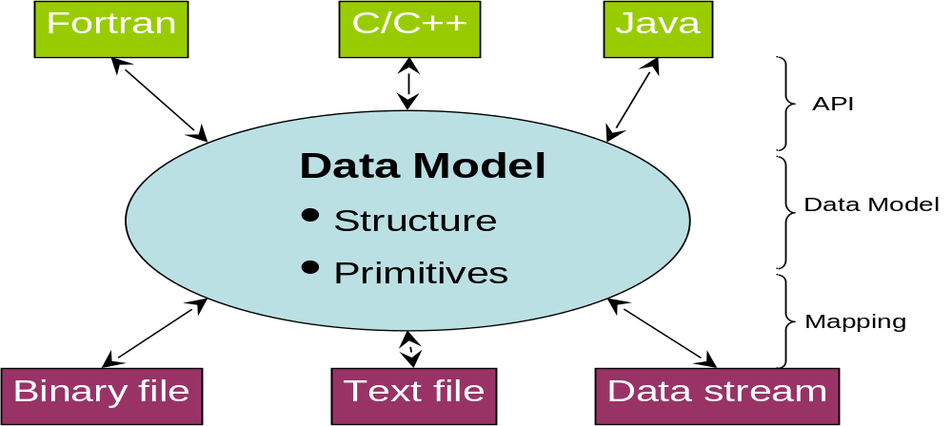

DFDL Language Requirements
To support the functionality described above, DFDL must be capable of describing several things. Many are obvious. First, it must be able to describe the conceptual structure of the data as a sequence of primitive and composite types. It must also support the semantic labeling of the data. This is primarily to support eventual interpretation of the data by data consumers. DFDL does not attempt to describe or make use of the semantics of the labels, but will use the labels themselves. For example, a data description may define an integer labeled “imagewidth”, which is then referred to later in the same description to specify the length of a vector of floats. Similarly, DFDL must support logical and numerical comparison of data to support format variations, e.g. if “flag” equals 1, the file contains a header structure followed by data, otherwise, the file contains only the data.
Implicit in the design of DFDL as a description language versus a programming language is a requirement that DFDL must be able to describe multiple layers of conceptual data structures. Nominally, this is required even for very basic examples such as those above. For example, a vector whose length is determined by an integer value in the file in some sense implies an intermediate structural view of the file as containing an integer followed by a potentially infinite number of floats, which can then be reinterpreted as a single fixed length vector of floats. More complex examples involve relatively common practices such as compression (zip, run-length encoding) and delimited tables (common separated values). While it is tempting to keep these intermediate representations implicit, discussion to date have concluded that, to make DFDL sufficiently powerful to handle the wide range of formats in use today, it must allow them to be explicitly described. This is still an active topic within the DFDL group, as it is one of the more complex features.

DFDL Syntax
The remainder of this document assumes a particular syntax for the DFDL language based on XML Schemas (XSD). While this syntax does not yet address all of the issues above and should not be considered final, it does provide a concrete framework for discussion and it is clear that many elements of this syntax will have to be present in any final specification.
XSD is normally used to describe the structure of XML documents. In the proposed syntax the DFDL user describes the abstract data model using an XSD. The current DFDL syntax requires only a subset of the available XSD capabilities. While there are benefits in terms of being able to use XSD-based tools to validate DFDL descriptions, it is not currently considered desirable or in-scope to assure that every XSD can be mapped to a DFDL description.
This XSD-based model is then supplemented by information specifying how the data model is represented in an underlying text or binary form (the mapping layer). Hence, data that is described by DFDL can be thought of as if it were XML data even though the representation is a much smaller and more efficient one. This concept is generally called "tagless XML". It is anticipated an XSD approach will make it possible to construct DFDL APIs similar to DOM and SAX and to simplify export of DFDL described data to XML documents.
The XSD standard describes a mechanism for extending XSD with additional appinfo annotations. The term "appinfo" means application information. As shown in the examples below, the proposed DFDL syntax uses these appinfo annotations to embed the mapping layer information in the XSD itself.

DFDL Information Model
The following diagram is a UML class diagram showing the basic or primitive types of XML. This picture is derived from the book "Definitive XML Schema" (ISBN 0-13-065567-8 page 222).
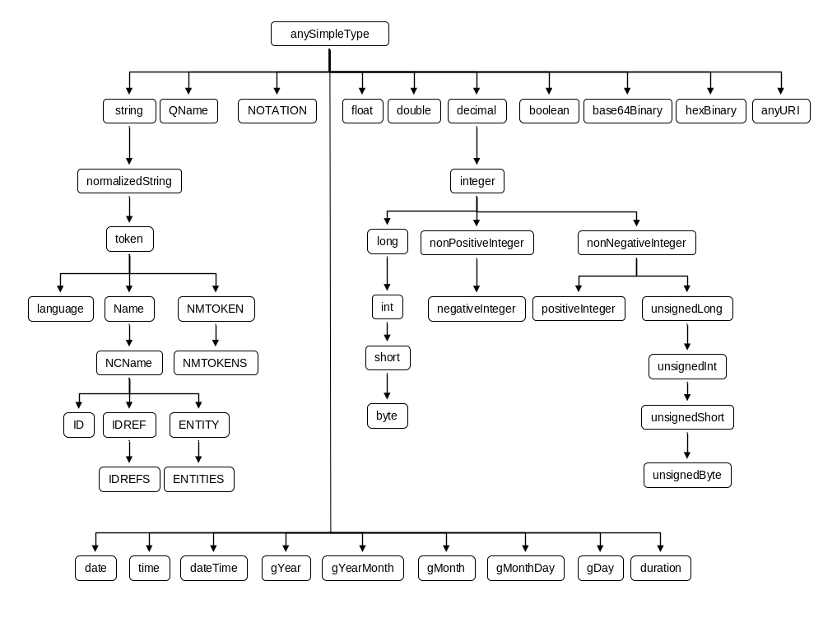
As will be shown below, these types are used in conjunction with the element definition and type definition capabilities of XSD to describe abstract data. Annotations are then used to describe non-XML representation characteristics for this same data. In effect you get both an XML Schema definition and a DFDL definition simultaneously.

Definition Libraries
The DFDL standard will provide a number of predefined types and mappings that can be used in describing a text or binary file using DFDL. In the proposed syntax, mappings are invoked by specifying a specific mapped subtype of the general types listed above.
- A mapped type is an XSD type that has been given a special restriction which defines the mappings that are to be applied to the raw data in order to access it.
- A mapping is a declaration of the signature of a function which translates from one mapped type to another. This can be unidirectional or bidirectional. Generally these mappings should be information-preserving, i.e., lossless. The name of the function does not need to be specified as the mapping is identified by the mapped types.
Libraries of these definitions can be created, and a standard set is assumed to be part of any DFDL implementation. New DFDL definitions can be added to describe new types and new mappings, which might be specific to a particular domain or file format.

DFDL Examples
Several examples will be given below to illustrate how DFDL works. We start by presenting an example definition and then use it to describe a simple file. For clarity some of the non critical pieces of XML in this example have been placed in Appendix A. these examples do not show all of the features expected in the final DFDL specification. In particular, additional standard data structures such as multi-dimensional arrays, and additional functionality such as non-zero-based indexing of dimensioned types and a mechanism for making intermediate representations explicit, are not addressed.

Example 1: A simple binary file
This simple example is intended to expose the basic mechanisms used by DFDL. It consists of a single file containing 4 consecutive values two integers (4 bytes each), a double (8 bytes) and a float (4 bytes) respectively.
The first part of the example is definitions. These are not really necessary as the definitions here would be part of the standard library. However these are included here to help fill in the picture as to how the definitions are used.

Definitions
Our first definitions consist of mappings and mapped types. For this example we have two mappings:
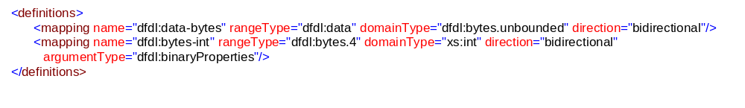Notice that both mappings are bidirectional. The types dfdl:bytes.4 and dfdl:bytes.unbounded are defined in Appendix A. The type dfdl:data is a special type that represents raw (untyped) data. The second mapping has arguments associated with it. The form of these arguments is defined as the type dfdl:binaryProperties this type is shown in Appendix A.
Next we need to define, what we term, mapped types. These are specially restricted types that imply a particular transformation path. In this case we have three similar to this one:

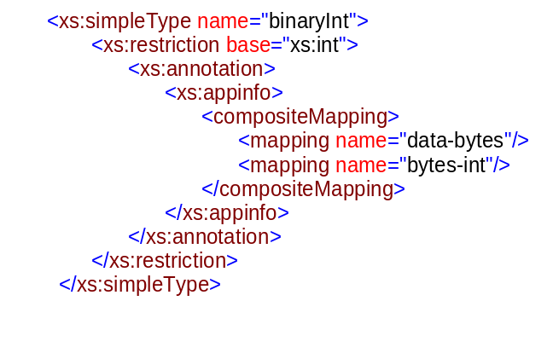
The intended semantics is that this is an xs:int type which is restricted to take its input via a composite mapping. The mapping takes the raw data turns it into bytes, which are then mapped to an xs:int. Examples for xs:double and xs:float are given in Appendix A.

DFDL
We are now ready to write the DFDL for of the example itself, it looks like:
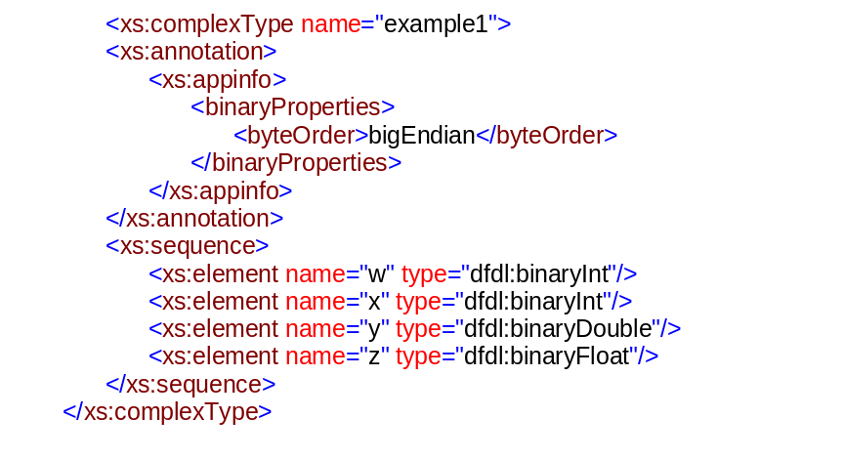
The initial annotation supplies an argument used by all the mappings, then the rest is just a simple sequence which lists the three values, names them and sets their types to our newly defined mapped-types.

Example 2: A simple text file
This example describes a file with the same basic data model, however this time the representation is as a text file.
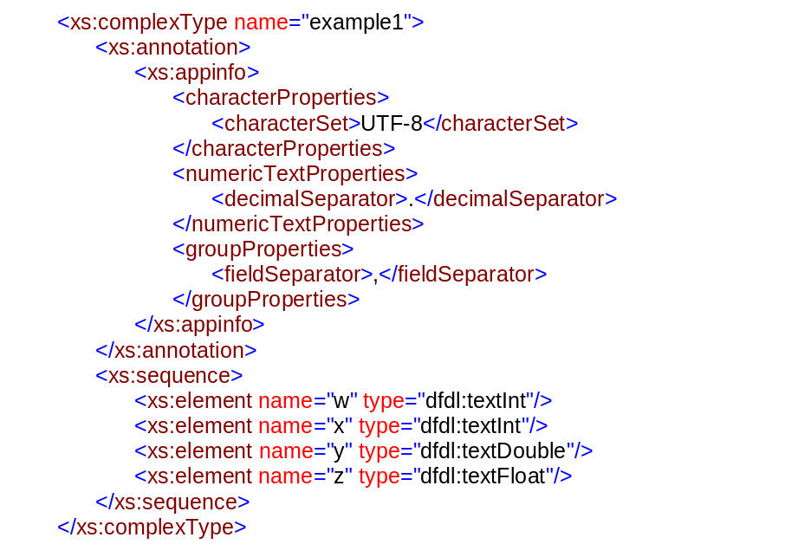
This time the argument set is more complex since more mappings are required. Definitions of the argument types, mappings and mapped types can be found in Appendices A, B and C respectively.
[Note: To show how this can be strongly typed in XML, a definition for an element “appinfo” is added to the end of Appendix A. This definition shows how the property elements can be associated in a substitution group. N.B. This example is illustrative only clearly the appinfo element defined here is in the wrong namespace…but I believe we can define a schema for what a dfdl annotation is allowed to contain base on this approach]

Example 3: Separating Model and Mappings
Examples 1 and 2 are limited because they link the primitive types directly with their mappings. It is desirable to separate the model from the mapping information so that alternative mappings can be applied to the same data model in a way that is completely transparent to the application. In this section we explore how this separation can be achieved.
We will use the term abstract model to refer to the data model without any mapping information and mapped model as the complete set of abstract model and mapping. [Note that if the data is represented in XML the abstract model and the mapped model are the same…or are they? Do we need a way to explicitly state “represented in XML”?]
The abstract model for example 1 is as follows:
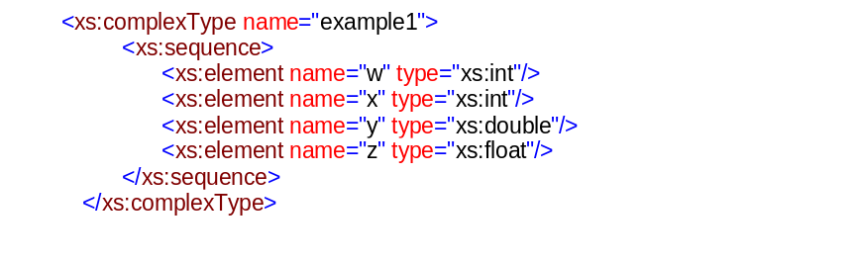
Now we introduce a new tag “use” that allows us to apply our new types in place of the old ones. [MW: I called it use and put it in so many examples that I’m not going to change for this iteration but something more explicit like “applyType” might be more meaningful.
Giving us:
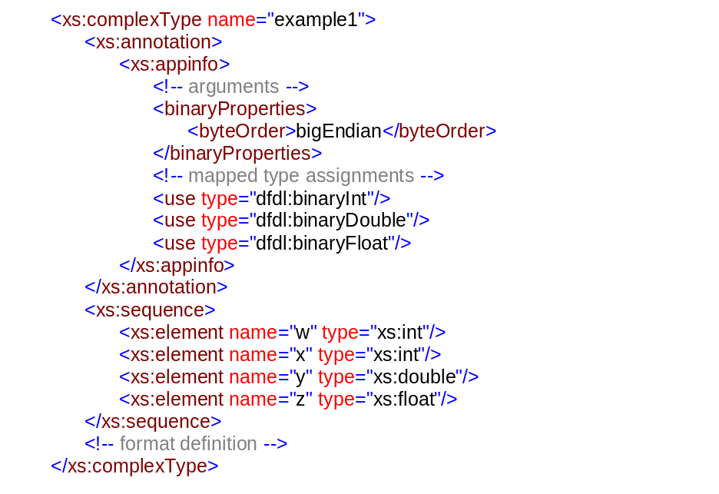

The use tag has the following semantics:
<use type="dfdl:binaryInt"/>
Implies that every occurrence of xs:int (and restrictions of it) should be interpreted as a dfdl:binaryInt. We know that it is xs:int that is to be interpreted (and not another type) because dfdl:binaryInt is a restriction on xs:int.
Since it such mappings are likely to occur in clusters DFDL allows the definition of what is called a mapped type set which groups together transformations that are likely to apply to a whole file. Appendix B contains an example of a definition of a mapped type set. It is applied as follows:
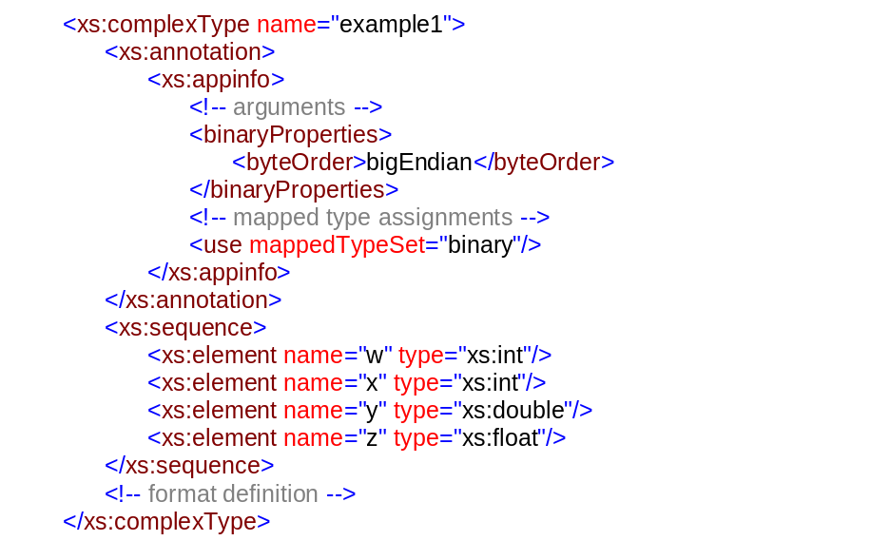
This description is equivalent to the previous one, each of the mappings in the mapped type set is considered to apply.

Example 3: Annotation scope
In the previous example we showed how mapped types can be associated with XSD types on a global basis. But what if my file mixes different representations, binary and text of the same XSD types? For example we might have a file, containing integers in text and binary. Equally, we could imagine a situation in which the mapping arguments were different for different fields of the file.
To handle this we introduce the notion of scoping to the annotations added to the DFDL description. A DFDL annotation is considered to apply to the element which it annotates and that element’s descendants. If an element has more than one ancestor with a DFDL annotation then the closest annotation takes precedence. i.e. ascending the tree parent by parent from the element in question, the first annotation encountered takes precedence.
Returning to our example, suppose, have another file, which is again a representation of the same data model, only this time the first integer is represented in text and the other values are represented in binary. This could be described as follows:

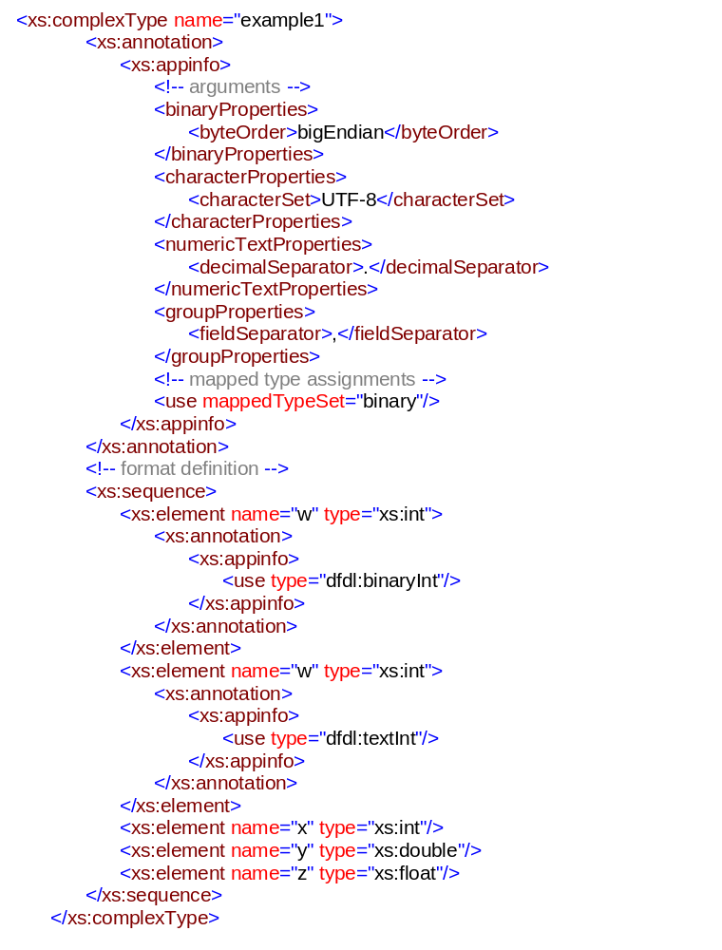

Transitivity of type substitution
Type substitution is intended to apply to all primitive types even those which have been embeded in other type and do not appear directly in the document. For example, if I were to define a new data type, “complex”, as follows:
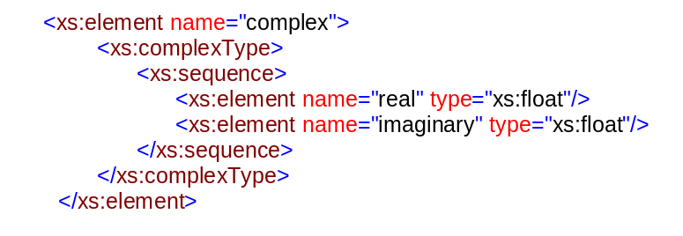
If this new type is used in the DFDL description of a file which contains the top-level annotation:
<use mappedTypeSet="binary"/>
Then the xs:float within the complex will be treated as dfdl:binaryFloat.

Associating DFDL with Data
A DFDL description is a piece of metadata. It can stand alone. E.g., it can be used to create a metadata description of data that doesn't yet exist, or that exists in separate files from the DFDL description.
Our hope is to take DFDL farther than this and to solve the problem of keeping track of the association of metadata with the right set(s) of data. This ability to create self-describing data is one of the key strengths of XML representation that we'd like to obtain for DFDL-described data also, or at least provide a way to achieve it as one of the standard ways to use DFDL. To achieve this DFDL should be able to be tightly tied to the data it describes in several ways.
Associated: DFDL files are associated with data files by an additional association description. Different association mechanisms are possible, for example all files with a particular extension might be associated with a given description, or all files in a particular directory.
Embedded: Data in arbitrary binary format can be encoded (possibly along with optionally being compressed and/or encrypted). The encoding can be a known standard XML encoding such as binHex or base64. The data can then live within the same XML document that contains the DFDL metadata for that data.
The drawback of embedded data in XML is that for very large data the time needed to encode it can be very large and depending on the processing, not worthwhile. This is also not suitable for data streaming in many instances, makes random-access challenging or impossible, etc.
(Note: encoding algorithms should be well known, like base-64, or should be specified by URIs which specify the exact encoding technique used. E.g., gzip version 2.7 with a URL to the source code in ANSI C for a decompressor. This is required for the lifetime of encoded data to span multiple years.)
Linked: An XML file can contain a DFDL descriptor and a list of one or more URLs identifying the data.
These URLs can be absolute or relative.
The drawback of associated data is that while the XML DFDL descriptor can be used to keep everything together, the pieces can be moved around without updating the descriptor, leaving the descriptor broken, so maintaining these descriptors requires tools and discipline.
Attached: Untouched binary data is stored in the same file with a XML DFDL prepended descriptor. The binary data begins immediately after the end of the descriptor. Because DFDL can describe data that is aligned, the actual data may begin some number of bytes after the end of the descriptor.
There are other standards like MIME and DIME for embedding text and binary data together. These standards contain 32-bit data size limits, and so may require extensions to deal with very large data.
Referenced: A DFDL description can be referenced from a descriptor file. This is directly analogous to how an XML file refers to its XML Schema via a URI. The file can reference the DFDL descriptor and the data file(s), or one could share a DFDL data descriptor among files that reference the DFDL descriptor but contain the data directly.
Use of DFDL with these mechanisms gives much of the attractive properties of XML-format data back to binary data, that is, the strong association of metadata to the data, and the self-contained file formats.

Implied XML Schema
A DFDL data description can be automatically turned into an XML Schema that can represent the same data, but in such a way that the information content is not changed. There is a minor exception in that conversion of binary floating point numbers to base-10 text equivalents can cause a minor loss of precision.
Because the DFDL descriptor is built on XSD using the annotations, the erasing of these annotations provides the XSD for the equivalent XML data.
DFDL processors that actually convert binary data to XML and vice versa should be among the first demonstrations of DFDL technology.

The leverage of using XSD
Many issues come up in the creation of large complex XML schemas and these have motivated the introduction of features in XSD to control this complexity. By layering DFDL on XSD we get these capabilities "for free". This is good because we anticipate that DFDL-based data descriptions will be equally complex. Some of these features are listed here only because they identify issues that the DFDL specifications will NOT have to address:
- sharing of a definition over multiple source files
- include
- import
- redefine
- namespaces and qualified names
- derived types
- extension
- restriction
- definitions and uses of reusable groups of elements
- named and anonymous types
- annotations: documentation and appnotes
- rules for equality of type and value

Differences from XSD
[[TBD: How to do multi-dimensional arrays]]
[[TBD: The following aspects of XSD have not been analyzed yet for their implications for DFDL. They might be fine. They might cause trouble.
- final, block, abstract
(TBD: Why? Sure seems like a bad idea in XSD too!)
- identity constraints: both uniqueness and key constraints.
- simple content and mixed content: There's no notion of content in DFDL outside of fields. The DFDL equivalent of empty content is just a record (or subrecord) with no fields.
- substitution groups
- reusable groups where both the group definition and group use specify maxOccurs/minOccurs.
]]

Conclusion
While the handling of general data descriptions is complex, it is possible to create a uniform data format description language which can, once and for all, solve the problem of describing data formats. At the same time these capabilities are not inconsistent with convenient capture and expression of most common data formats.
The ubiquity of grid computing in the future and the emphasis today on high-end large-data applications makes the GGF the ideal forum in which to advance an industry standard associated with data format descriptions.

Security Considerations
All data regions must be properly initialized before writing so as to prevent accidental (or purposeful) transmission of data in the unused parts of data formats.
If regions within a DFDL-described data object are encrypted, then when decrypting them proper means must be used to assure secure passage of passwords to the decrypting software. Such means are beyond the scope of DFDL.

Appendix: About Literal String Values in DFDL
In a DFDL description, it is necessary to express the representation characteristics of binary data. Such data may contain characters in charsets distinct from the one that the DFDL descriptor itself is written in. In addition, we may need to express characters from these charsets which are not allowed in any XML document.
Certain character codes are disallowed in XML, yet we need to specify those character codes in delimiters, patterns, null indicators, and enumerations of allowed values.
An example of this is that the character with codepoint 0 is not valid in any XML document. So, it is not possible in the XML syntax of a DFDL descriptor to write '&#x00;' or '&#0;' or use any other way to actually embed the character code 0 into the DFDL descriptor document. This is unlikely to change as the restriction was put into the XML specifications due to concerns that XML processing code written in C would have trouble with embedded zeros in XML data since the standard string terminator for C is a zero character code at the end of the string.
Nevertheless, there are lots of examples where we need these character codes like zero. We need a way to specify that the character with character code zero is to be used as a delimiter string in a data file created by a C program. Also, in null-valued data the representation of a null string may be a single character with code zero. Finally, many data formats will pad fixed length strings with zero char codes. So it should be clear there are plenty of places where we need to refer to character codes that XML won't let us write directly.
Hence, we require a mechanism for expressing Unicode characters by their numeric character codes, which will pass by the XML processor so that the DFDL processor can interpret them.
To express these disallowed characters we use this escape-sequence notation:
\#D; \#DD; ... \#DDDDDDD;
\#xH; \#xHH; ... \#xHHHHHH;
These sequences are similar to the numeric character entity references of XML in that they use "#" or "#x" to introduce decimal and hex numbers respectively, and that the sequences are terminated by semicolon. However, the sequences are introduced by a "\" backslash character instead of a "&" ampersand character. If the string "\#" needs to be expressed then the backslash is doubled: "\\#".
For XML 1.1 implementations the only characters where this escape sequence is required is "\#0;" character code zero, and for character codepoints in UTF-16 that are in the surrogate pairs space, i.e., #xD800-#xDFFF. While #xD800 isn't a valid Unicode character, it is a valid UTF-16 code point that we might need to refer to from within DFDL with respect to a data string that is represented in UTF-16.
For XML 1.0 implementations there is a slightly larger set of characters that cannot be used directly. To the above we add: #x1 to #x8, #xB, #xC, #xE to #x1F, #xFFFE, and #xFFFF.
In XML 1.1 implementations there is the further restriction that characters #x1 to #x8, #xB, #xC, #xE to #x1F, #x7F to #x84 and #x86 to #x9F must appear textually as numeric character entity references, i.e., in form like "&#x7F;". These specific character codes must not appear as ordinary characters.
Finally, much use of CDATA sections is expected in DFDL descriptors since they will have to mention quoting characters frequently.
Programs that write DFDL descriptors must never write out XML that contains any of the disallowed characters. Expressions involving quote characters must be converted to "&quot;" and similar, or encapsulated with "<[CDATA[" and "]]>". The escape sequences needed for character code zero and other disallowed codes must be inserted automatically, and the new XML1.1 requirement for use of entity references must be respected.

Appendix: About Length of Character Strings
Character sets are divided into two types: fixed-width and variable-width. ISO-8859-1 is a fixed-width, single-byte character set. That is, each character code is represented by a single byte. UTF-16 is a fixed-width, double-byte character set. That is, each character codepoint is represented by a 2 byte integer. UTF-8 is a variable-width character set where a single character code can be encoded by from 1 to 4 bytes. The implications of this are that for variable-width character sets, a text representation can have a fixed number of characters, but the representation of that string can take a variable number of bytes. In this situation the length of the string, or end position of the string can be computed only by parsing the text from start towards the end.

Appendix: Character code vs. UTF-16 codepoints
All character sets except UTF-16 store character codes. UTF-16 stores a 2-byte character codepoint. This is an exception due to rare characters with Unicode character codes above 0xFFFF since these require more than 2 bytes to represent. Because these characters are quite rare, we make this exception for UTF-16 and store these characters as a pair of UTF-16 codepoints called a surrogate pair. This means that in general the number of codepoints in a UTF-16 string is not equal to the number of full Unicode characters.

Intellectual Property Statement
The GGF takes no position regarding the validity or scope of any intellectual property or other rights that might be claimed to pertain to the implementation or use of the technology described in this document or the extent to which any license under such rights might or might not be available; neither does it represent that it has made any effort to identify any such rights. Copies of claims of rights made available for publication and any assurances of licenses to be made available, or the result of an attempt made to obtain a general license or permission for the use of such proprietary rights by implementers or users of this specification can be obtained from the GGF Secretariat.
The GGF invites any interested party to bring to its attention any copyrights, patents or patent applications, or other proprietary rights which may cover technology that may be required to practice this recommendation. Please address the information to the GGF Executive Director.

IPv6 Considerations
None.

Full Copyright Notice
Copyright (C) Global Grid Forum (2004). All Rights Reserved.
This document and translations of it may be copied and furnished to others, and derivative works that comment on or otherwise explain it or assist in its implementation may be prepared, copied, published and distributed, in whole or in part, without restriction of any kind, provided that the above copyright notice and this paragraph are included on all such copies and derivative works. However, this document itself may not be modified in any way, such as by removing the copyright notice or references to the GGF or other organizations, except as needed for the purpose of developing Grid Recommendations in which case the procedures for copyrights defined in the GGF Document process must be followed, or as required to translate it into languages other than English.
The limited permissions granted above are perpetual and will not be revoked by the GGF or its successors or assigns.
This document and the information contained herein is provided on an "AS IS" basis and THE GLOBAL GRID FORUM DISCLAIMS ALL WARRANTIES, EXPRESS OR IMPLIED, INCLUDING BUT NOT LIMITED TO ANY WARRANTY THAT THE USE OF THE INFORMATION HEREIN WILL NOT INFRINGE ANY RIGHTS OR ANY IMPLIED WARRANTIES OF MERCHANTABILITY OR FITNESS FOR A PARTICULAR PURPOSE."

Author Information
Mike Beckerle, mike.beckerle@ascential.com, Ascential Software, Inc., 50 Washington St. Westborough, MA 01581, USA
This document is provided in part by Ascential Software, Inc. (www.ascential.com). Ascential supplies the Enterprise computing market with integration solutions including high-volume data processing systems that span both batch and real-time computing environments. Ascential's software has run on large-scale clusters (100+ computers) since 1995 solving complex data processing problems across industries from airlines to web-target-marketing. Ascential's software emphasizes construction of flow-based software using reusable components, a set of techniques that are very effective but relatively unknown in the Grid and HPC communities today. It provides scalable parallel pathways to and from most Enterprise computing data stores including file systems and relational databases. Pluggable data interfaces are crucial to the success of this style of software application development and this drives Ascential's interest in the DFDL-WG.
Martin Westhead, M.Westhead@epcc.ed.ac.uk.
[TBD: Bio/Credentials thingy]

References and Notes
OMG Common Warehouse Metadata (CWM) (http://www.omg.com/cwm)
Orchestrate Schema Format (http://www.ascential.com/) - Not publicly available.
Mercator Type Trees (http://www.mercator.com/) - Not publicly available.
Binary Format Description (BFD) language: http://collaboratory.emsl.pnl.gov/docs/collab/sam/bfd
BinX: http://www.epcc.ed.ac.uk/~gridserve/WP5/Binx/ or http://www.edikt.org/binx
HDF: http://hdf.ncsa.uiuc.edu/
XML 1.0 http://www.w3.org/TR/REC-xml
XML 1.1 http://www.w3.org/TR/xml11/
Unicode (now at version 4.0) http://www.unicode.org/
IANA character set encoding names: (http://www.iana.org/assignments/character-sets)
XML Schema: http://www.w3.org/XML/Schema
MIME: http://www.faqs.org/rfcs/rfc2045.html
ISO COBOL standard: http://www.cobolstandard.info/wg4/wg4.html
MicroFocus Cobol 1993 Manual (http://www.microfocus.com/)
SAS: http://www.sas.com/
POSIX/Unix Locale http://www.opengroup.org/onlinepubs/007908799/xbd/locale.html
ICU: International Components for Unicode http://oss.software.ibm.com/icu/userguide/index.html
ISO 8601 standard for dates and times: http://www.iso.ch/iso/en/prods%2Dservices/popstds/datesandtime.html
The U.S. Social Security Administration Gives date of conversion of Greece (actually the Orthodox Catholic Church in Greece) to the Gregorian calendar as 1924-03-24. (see http://policy.ssa.gov/poms.nsf/lnx/0200307180). Turkey converted in 1926, but they converted the days in 1917 and converted the year in 1926.
Leap Seconds: see http://tycho.usno.navy.mil/leap.html or search the web!
Java Internationalization (ISBN 0-596-00019-7)
- XSIL homepage http://www.cacr.caltech.edu/SDA/xsil/
- XDR (IETF RFC 1832) http://www.faqs.org/rfcs/rfc1832.html
- ASN.1 http://asn1.elibel.tm.fr/en/standards/index.htm
- DIME http://www.ibm.com/developerworks/webservices/library/ws-dime/
- IBM OS/390 DFSMS: Using Data Sets. IBM publication SC26-7339-01, Second Edition, December 2000. (online at: http://publibz.boulder.ibm.com/cgi-bin/bookmgr_OS390/BOOKS/DGT1D411/CCONTENTS?SHELF=EZ239126&DN=SC26-7339-01&DT=20001014144419)

Appendix A Supporting type definitions
This appendix contains supporting material for the examples from section 8.
<?xml version="1.0" encoding="UTF-8"?>
<xs:schema targetNamespace="http://www.dfdl.org/schema/2004" xmlns:xs="http://www.w3.org/2001/XMLSchema" xmlns:ns1="http://www.dfdl.org/schema/2004" elementFormDefault="qualified" attributeFormDefault="unqualified">
<xs:complexType name="bytes.4">
<xs:sequence>
<xs:element name="anon" type="xs:byte" minOccurs="4" maxOccurs="4"/>
</xs:sequence>
</xs:complexType>
<xs:complexType name="bytes.8">
<xs:sequence>
<xs:element name="anon" type="xs:byte" minOccurs="8" maxOccurs="8"/>
</xs:sequence>
</xs:complexType>
<xs:complexType name="bytes.unbounded">
<xs:sequence>
<xs:element name="anon" type="xs:byte" minOccurs="0" maxOccurs="unbounded"/>
</xs:sequence>
</xs:complexType>
<xs:complexType name="string.unbounded">
<xs:sequence>
<xs:element name="anon" type="xs:string" minOccurs="0" maxOccurs="unbounded"/>
</xs:sequence>
</xs:complexType>
<xs:element name="binaryProperties" substitutionGroup="ns1:properties">
<xs:complexType>
<xs:sequence>
<xs:element name="byteOrder">
<xs:simpleType>
<xs:restriction base="xs:NMTOKEN">
<xs:enumeration value="bigEndian"/>
<xs:enumeration value="littleEndian"/>
</xs:restriction>
</xs:simpleType>
</xs:element>
</xs:sequence>
</xs:complexType>
</xs:element>
<xs:element name="numericTextProperties" substitutionGroup="ns1:properties">
<xs:complexType>
<xs:sequence>
<xs:element name="decimalSeparator">
<xs:simpleType>
<xs:restriction base="xs:string">
<xs:maxLength value="1"/>
<xs:minLength value="1"/>
<xs:pattern value="[.,]"/>
</xs:restriction>
</xs:simpleType>
</xs:element>
</xs:sequence>
</xs:complexType>
</xs:element>
<xs:element name="characterProperties" substitutionGroup="ns1:properties">
<xs:complexType>
<xs:sequence>
<xs:element name="characterSet">
<xs:simpleType>
<xs:restriction base="xs:NMTOKEN">
<xs:enumeration value="UTF-8"/>
<xs:enumeration value="UTF-16"/>
<xs:enumeration value="ASCII"/>
</xs:restriction>
</xs:simpleType>
</xs:element>
</xs:sequence>
</xs:complexType>
</xs:element>
<xs:element name="stringSplitProperties" substitutionGroup="ns1:properties">
<xs:complexType>
<xs:sequence>
<xs:element name="fieldSeparator">
<xs:simpleType>
<xs:restriction base="xs:string">
<xs:maxLength value="1"/>
<xs:minLength value="1"/>
<xs:pattern value=",|\w"/>
</xs:restriction>
</xs:simpleType>
</xs:element>
</xs:sequence>
</xs:complexType>
</xs:element>
<xs:element name="appinfo">
<xs:complexType>
<xs:sequence minOccurs="0" maxOccurs="unbounded">
<xs:choice>
<xs:element ref="ns1:properties"/>
<xs:element name="use">
<xs:complexType>
<xs:attribute name="type" type="xs:string"/>
<xs:attribute name="mappedTypeSet" type="xs:string"/>
</xs:complexType>
</xs:element>
</xs:choice>
</xs:sequence>
</xs:complexType>
</xs:element>
<xs:element name="properties"/>
</xs:schema>

Appendix B Mapping definitions
This appendix contains supporting material for the examples from section 8.
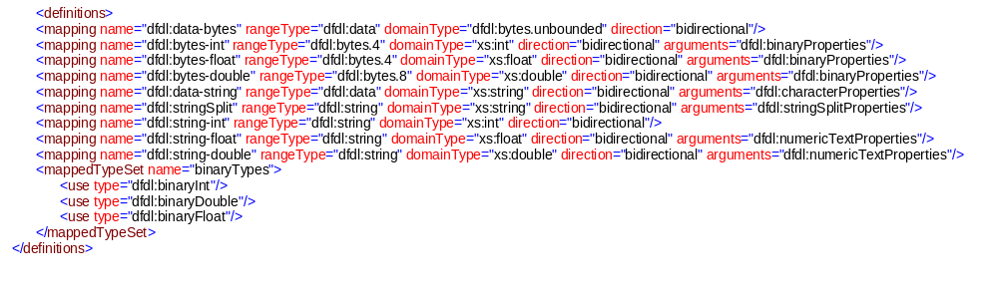

Appendix C Library types
This appendix contains supporting material for the examples from section 8.
