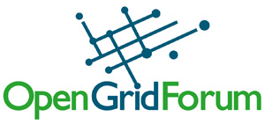

Remote Instrumentation Services In Grid Environment (RISGE-RG)

Collection of use cases
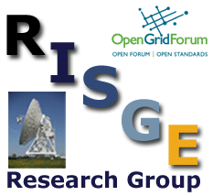

Abstract
This document is an result of the work of OGF RISGE-RG. It presents collection of use cases that represents various existing approaches in defining remote access interfaces to sophisticated laboratory equipment. One of the important aspect covered by this examples is an exploitation of Grid technologies for conducting and monitoring measurement tasks and experiments on complex remote scientific equipment.
Table of Contents

1 Remote Operations of Experimental Facilities 4
1.1 Summary 4
1.2 Customers 4
1.3 Scenarios 4
1.4 Involved resources 5
1.5 Functional requirements 5
1.6 Non-functional requirements 7
1.7 Related work / Experience in the field 7
1.8 Use case situation analysis 7
1.9 References 7
2 On line Processing in Experimental Science 8
2.1 Summary 8
2.2 Customers 8
2.3 Scenarios 8
2.4 Involved resources 9
2.5 Functional requirements 9
2.6 Non-functional requirements 10
2.7 Related work / Experience in the field 10
2.8 Use case situation analysis 10
2.9 References 10
3 AugerAccess Use Case 11
3.1 Summary 11
3.2 Customers 11
3.3 Scenarios 11
3.4 Involved resources 12
3.5 Functional requirements 15
3.6 Non functional requirements 15
3.7 Related work 15
3.8 Use case situation analysis 15
3.9 References 16
4 Device Farm Use Case 17
4.1 Summary 17
4.2 Customers 17
4.3 Scenarios 17
4.4 Involved resources 18
4.5 Functional requirements 19
4.6 Non functional requirements 19
4.6.1 Security considerations 19
4.6.2 Performance considerations (incl. real-time properties) 19
4.7 Related work 19
4.8 References 20
5 Ocean Observatory Initiative: Integrated Observatory 21
5.1 Summary: 21
5.2 Customers 21
5.3 Scenarios 22
5.4 Functional requirements: 23
5.5 Non-functional requirements: 24
5.6 Involved resources: 25
5.7 Related work / Experience in the field: 25
5.8 References: 25
6 Use case of NMR spectrometry in Virtual Laboratory 27
6.1 Summary 27
6.2 Customers 27
6.3 Scenarios 27
6.4 Involved resources 29
6.5 Functional requirements 29
6.6 Non-functional requirements 30
6.6.1 Security considerations 30
6.7 Related work 31
6.8 Use case situation analysis 31
6.9 References 32
7 Use case of ARGUGRID: Earth Observation satellite 33
7.1 Summary: 33
7.2 Customers/Actors 33
7.3 Scenario 33
7.4 Functional requirements 35
7.5 Non-functional requirements 35
7.6 Involved resources 35
7.7 Related work/Experience in the field 36
7.8 References 36

Remote Operations of Experimental Facilities

Contributor: Roberto Pugliese (Sincrotrone Trieste S.C.p.A.)

Summary
Remote operations of experimental facilities like Accelerators, Synchrotrons and Free Electron Lasers, but also experimental stations, involve planning of the operations, maintenance and troubleshooting, repair of delicate equipment, understanding and pushing performance limitations, performing commissioning and set ups and various routine operations. All these activities are based on large amounts of information, normally accessible only at the site where the facility is located.
Operators of the experimental setup and remote experts through a Virtual Control Room can collaboratively operate the experimental setup both in a routine and in a troubleshooting scenario.
All the high level software and workflows is suitable to be implemented using Grid technologies. One example is the implementation of feedback workflows where a high level of integration of instruments and traditional Grid resources is required.
In the feedback parameters of the setup are sent via Grid to a remote computing center where the feedback correction code is executed and the corrections are feed back to the equipment thus improving some working parameters of the controlled equipment.
Remote control of an experimental facility has the potential of revolutionizing the mode of operation and the degree of exploitation of large experimental physics facilities. Grid technologies facilitate the sharing of these resources across a distributed computing environment. In particular, the Grid handles issues of authentication, authorization, resource description and location, data transfer and resource accounting. Moreover Grid technologies can be used to integrate operations with computing farms where complex models of the experimental facility can run.

Customers
The potential customers are operators of the experimental facility and the remote experts, which are scientist (e.g. machine physicists for an accelerator) and experimental scientist working at these research laboratories.

Scenarios
Actors involved in this use case are software developers, scientists (the experts) and operators of the experimental equipment. The developers can perform all the activities of the scientists and also deploy software and define the collective behavior (workflows and scripts). The scientist can perform all the activities of the operators plus control and monitor the equipment. The operators can define the operations parameters, run the workflows involved in the operations and monitor the evolution of the workflows. The can access and visualize historical data for example when they need to do post mortem analysis. In specific situations (for example for troubleshooting) they need to collaborate with experts to understand where the problem is and how to solve it. They can also run simulations and then compare the simulated results with historical data and possibly understand how to improve the performance of the equipment.
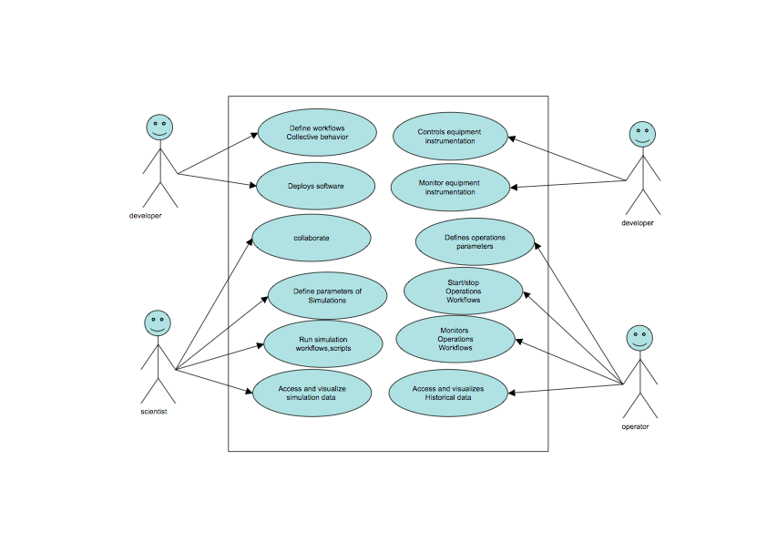

Involved resources
The resources involved in the remote operations are instruments, sensors and detectors interfaced with the equipment. We will refer to them as Instrument Elements (IE) from now on. These IE are generally co-located but sometimes can be distributed geographically (e.g. antennas of a radio telescope).
Data acquired need to be stored in Storage Resources and processed by Computing Resources. We will refer to them respectively as Storage Elements (SE) and Computing Elements (CE).
Brokers of resources both storage and computing and other support systems (information, security, …) are also involved.
User interacts with the involved resources and collaborates with the other users via User Interaction Elements. These components are generally web portals and we will refer to them as Virtual Control Rooms.

Functional requirements
Incl. quality control / validation of data
The following diagram describes how these components interact during operations workflows.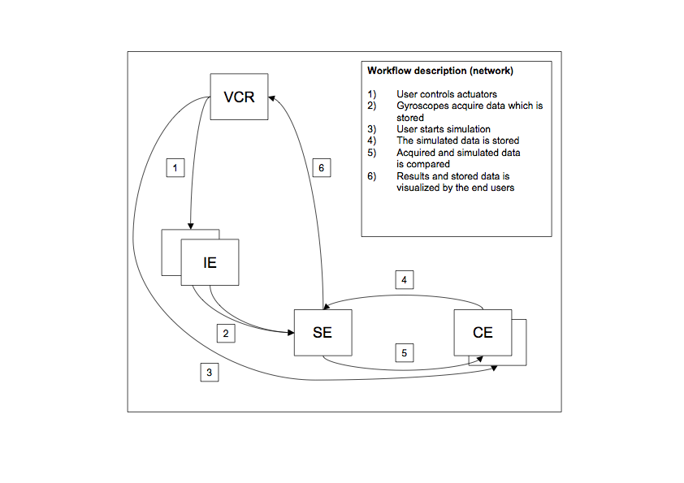
The following diagram is a challenging scenario. It represents an orbit correction workflow (i.e. a feedback via Grid). The orbit correction loop, in order to be effective need to be run at 1 Hz, which has challenging implication in the middleware.
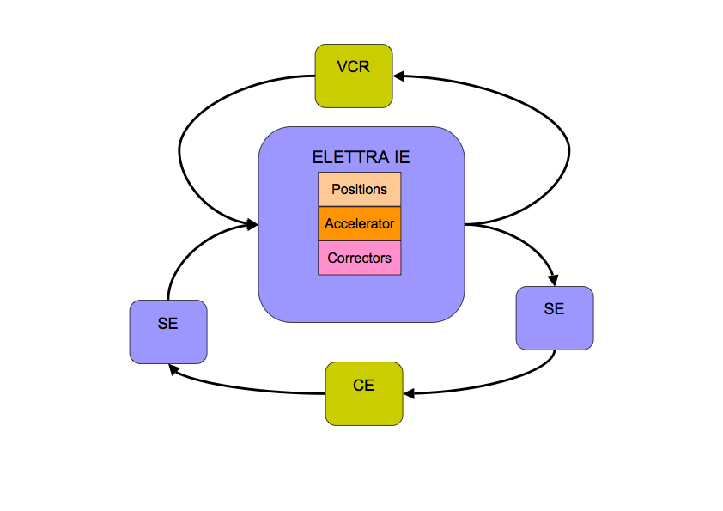
Video and Audio conference support is also requested for collaboration.

Non-functional requirements
An appropriate AAA-mechanism is required. Normal VO management systems can solve the problem.
Remote operations requires adequate quality of service and performance on the whole pipeline from instrument control, to data acquisition, transfer to storage resources, fast computation and data transfer back to storage and instruments. The feedback via Grid to perform orbit correction is a typical example where real time response is needed. This can be achieved by locking all the required resources including bandwidth. Interactivity is also required when interacting with instruments.

Related work / Experience in the field
“Remote operations” was one of the pilot applications of the GRIDCC project. Other experiences have been carried out using CIMA middleware. The same problem was implemented using a different (not Grid) approach by the EUROTeV project and resulted in the implementation of a system called Multipurpose Virtual Laboratory for a Global Accelerator Network.

Use case situation analysis
These use case and the required support was tested at Sincrotrone Trieste S.C.p.A. within the EC funded project GRIDCC (Grid enabled Remote Instrumentation with Distributed Control and Computation).
In the testbed the high level software of a Synchrotron Radiation Facility (ELETTRA) was implemented using the GRIDCC middleware. The most interesting part is a feedback via Grid to implement an orbit correction.

References
www.gridcc.org
www.dorii.eu
www.eurotev.org
www.elettra.trieste.it

On line Processing in Experimental Science
Contributor: Roberto Pugliese (Sincrotrone Trieste S.C.p.A.)

Summary
Experimental stations in facilities like Synchrotrons and Free Electron Lasers produce huge quantities of data. These data need to be analyzed on-line, which requires considerable computing power and often teamwork. The problem is even more difficult considering the increased efficiency of the light sources and detectors. Complex calculations are required to take diffraction images and convert them in a 3D protein structure. Similarly, complex calculations are required to calculate tomography and then perform an analysis of the result.
The results of these analyses often need to be visualized by a distributed team and used to modify interactively the data collection strategy. Data from instruments and sensors are saved in distributed repositories, computational models are executed, and finally an interactive data mining process is used to extract useful knowledge.
This kind of application requires both the support of a standard Grid computing environment, that is a virtual organization, a set of distributed storage and computing resources and some resource brokering mechanism, a workflow definition and execution environment and the capability to integrate instruments (the detectors) and interactively collaborate in the data analysis process. QoS handling mechanism is necessary to use effectively the available network structure.
This application can be considered actually as a group of applications since each beamline and experimental station represents a completely different data collection process, with specific processing, storage, analysis and sharing and visualization requirements.

Customers
The beamline scientist and experimental scientist working at these research laboratories, the users of the laboratory beamlines, remote collaborators.

Scenarios
Actors involved in this use case are software developers, beamline scientists, and users of the experimental stations. The developers can perform all the activities of the scientists and also deploy software and define the collective behavior (workflows and scripts). The beamline scientist can perform all the activities of the users plus control the beamline instrumentation and the detectors. The user can access and visualize data even remotely, collaborate with other users, beamline scientists and developers, define the data collection strategy, start stop data acquisition and monitor the acquisition and online processing process. The user can also run scripts and workflows and monitor their execution and perform offline processing of the available data.
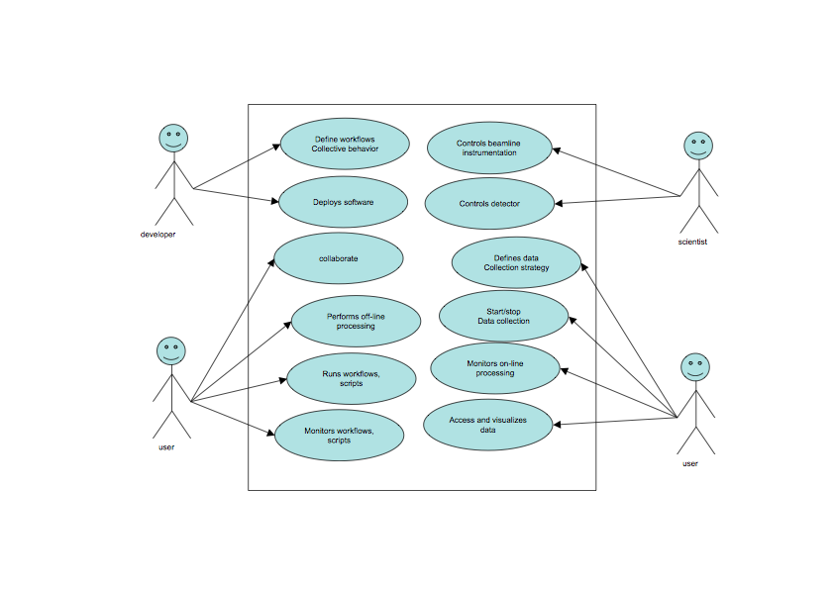

Involved resources
The resources involved in the online processing related to experimental science are instruments, sensors and detectors (for example X-Ray Diffraction detectors, and other Imaging Detectors mounted beamlines and experimental stations). These are the data sources and we will refer to them as Instrument Elements (IE) from now on. These IE are generally co-located but sometimes can be distributed geographically (e.g. antennas of a radio telescope).
Data acquired need to be stored in Storage Resources and processed by Computing Resources. We will refer to them respectively as Storage Elements (SE) and Computing Elements (CE).
Brokers of resources both storage and computing and other support systems (information, security, …) are also involved.
User interacts with the involved resources and collaborates with the other users via User Interaction Elements. These components are generally web portals and we will refer to them as Virtual Control Rooms.

Functional requirements
Incl. quality control / validation of data
The following diagram describes how these components interact during a typical workflow of the online processing in experimental science.
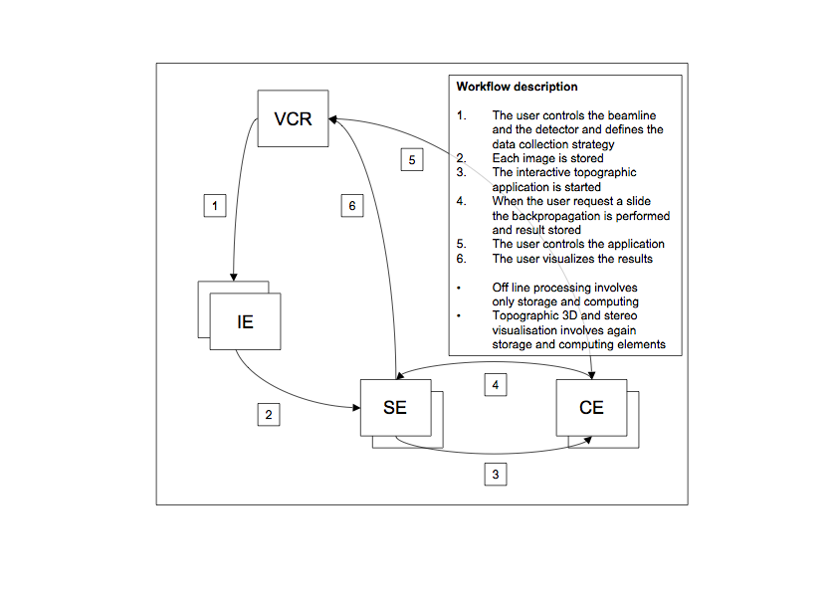

Non-functional requirements
An appropriate AAA-mechanism is required. Normal VO management systems can solve the problem.
The online processing requires adequate quality of service and performance on the whole pipeline from instrument control, to data acquisition, transfer to storage resources, fast computation and data transfer back to storage and visualization to the end user. Interactivity is also required both at when interacting with instruments and during job execution and finally when visualizing the results.

Related work / Experience in the field
Even if some form of remote operations was implemented using different middleware (GRIDCC and CIMA), online processing can be considered quite new. It includes some form of remote operations but is demanding in terms of resource interaction and transparence to the end user.

Use case situation analysis
These use case and the required support is under development at Sincrotrone Trieste S.C.p.A. within the EC funded project DORII (Deployment of Remote Instrumentation Infrastructure).

References
www.gridcc.org
www.dorii.eu
www.lkightsources.org

AugerAccess Use Case
Contributor: Michael Sutter (FZK)

Summary
AugerAccess (http://www.augeraccess.net/menu.htm) is a project dedicated to improve the access capabilities of European research groups to the Pierre Auger Observatory. Located in a field area in the Pampa Amarilla in Argentina the Auger Observatory is designed to measure the flux of ultra-high energy cosmic ray particles with unprecedented accuracy and statistical significance, whereas the measured data of the particles is event based and time controlled.
Realization of reliable and large bandwidth connectivity between the Auger Observatory and the rest of the world will allow the implementation of techniques for remote monitoring of the detectors and the use of remote databases. This in turn will provide fast feedback on the quality of the data being taken at the observatory, giving the possibility of the rapid discovery of malfunctioning detector components with the consequence of early remedial action.
The presented use case describes the requirements for the remote control and remote monitoring of the telescopes (Fluorescence Detectors FD) of the Pierre Auger Observatory.

Customers
To control and monitor the FD of the Auger Observatory remotely, the users must have access to the telescopes from the world wide networks to the private Auger networks. So they must be able to access the six telescopes in every of the four telescope buildings and to start up, calibrate, monitor and shutdown the system as well as manage the data acquisition and Slow control system.
One aim of the remote control is that a developer of the systems can assist a local collaborator at the central campus.
Nevertheless the main aim is that it should be possible to control and monitor the system remotely without having any local collaborator at the central campus.

Scenarios
The aim of the use case is to remotely control and monitor the Data Acquisition (DAQ) and Slow control system of the FD of the Auger Observatory, where the primary scenario is very simple (the different states in the brackets can be seen in the State Machine of the DAQ - figure1):

Init + test:
- Switch on the hardware (kIdle)
  - Create a new log file for the shift
  - Check network connectivity and communication
    - Is it available – if not switch it on
  - Check if all needed services (software) are running on the especial PCs
    - If not restart them
Configure:
- Calibrate the hardware (kCalibration)
  - Set hardware default parameters
  - Set system in calibration mode
  - Provide reference input and check if output is of reference values
  - Record dead pixels of the FDs in the log file
Init data acquisition software:
- Start data acquisition (kDAQ)
  - Set system to data acquisition mode
  - Attach the needed telescopes
  - Start the run
Measurement and monitoring:
- Monitor the run
  - Check the variance of all attached telescopes
  - Check weather conditions (rain, storm, moon light)
  - Check if the components are still available
  - Check trigger rates and incoming data
  - Check the measured events – to much normally belongs to lightning
- Measured data
  - The data is stored in a ROOT tree
  - Automatic storage or replication to Grid infrastructures or storage elements
Shutdown:
- Shutdown the system
  - Stop the run of the DAQ
  - Calibrate the system again (see above)
  - Stop all the services not needed any more
  - Bring the hardware in standby mode (kIdle)

The DAQ of the FD also have a secondary scenario as it is necessary to dynamically add or remove telescopes from one or even more telescope buildings to the DAQ. Therefore another scenario is needed:

Add or remove telescope(s):
- Stop the DAQ in the according building
- Add or remove the telescope(s)
- Newly added telescope sub-systems will be automatically parameterized
- Start the data acquisition with the new configuration
  - System is already in data acquisition mode (kDAQ) – simply start it
- Monitor the run (see above)

Involved resources
The system for data acquisition with the telescopes is very complex and shown in figure 2. For the remote control and monitoring of the system it is important to access it from outside the central campus. The access from outside to the telescope buildings (Los Leones, Los Morados, Loma Amarilla and Coihueco) is only possible via the Ipecdas computer, as the Auger network only consists of components in class A and B private subnets.
Every telescope building consists of a Calibration PC (for calibration of the telescopes located in the building), Slow Control PC (to prevent the system from damage), Eye PC, six Mirror PCs, six Front-End-Crates (custom hardware for measuring data with the telescopes and capable to handle a huge data rate up to several thousand MByte/sec peak rate) and six telescopes each. The Eye PC allows the communication with the Mirror PCs as they are in an own private network. The MirrorPCs are needed to access the Front-End-Crates and the telescopes behind the MirrorPCs, to get the measured data out of telescopes, store it as a ROOT tree and replicate it for the post processing.
For the communication with the software part of the DAQ system (running on the Eye and Mirror PCs) there exists all needed functionality in the so called Pbus protocol, which allows the communication with the Front End Crates from the DAQ system.
The communication link from the central campus of the observatory to Mendoza is provided by the RETINA network. From there the international networks are accessible without bandwidth problems.

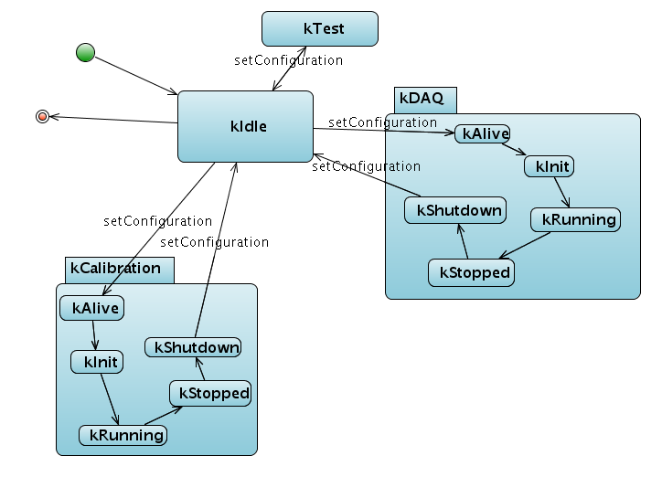

Figure 1. The State Machine of the DAQ system. Visible are the main configuration states (kIdle, KCalibration, kDAQ and kTest) and the sub states in which the system switches during runtime.
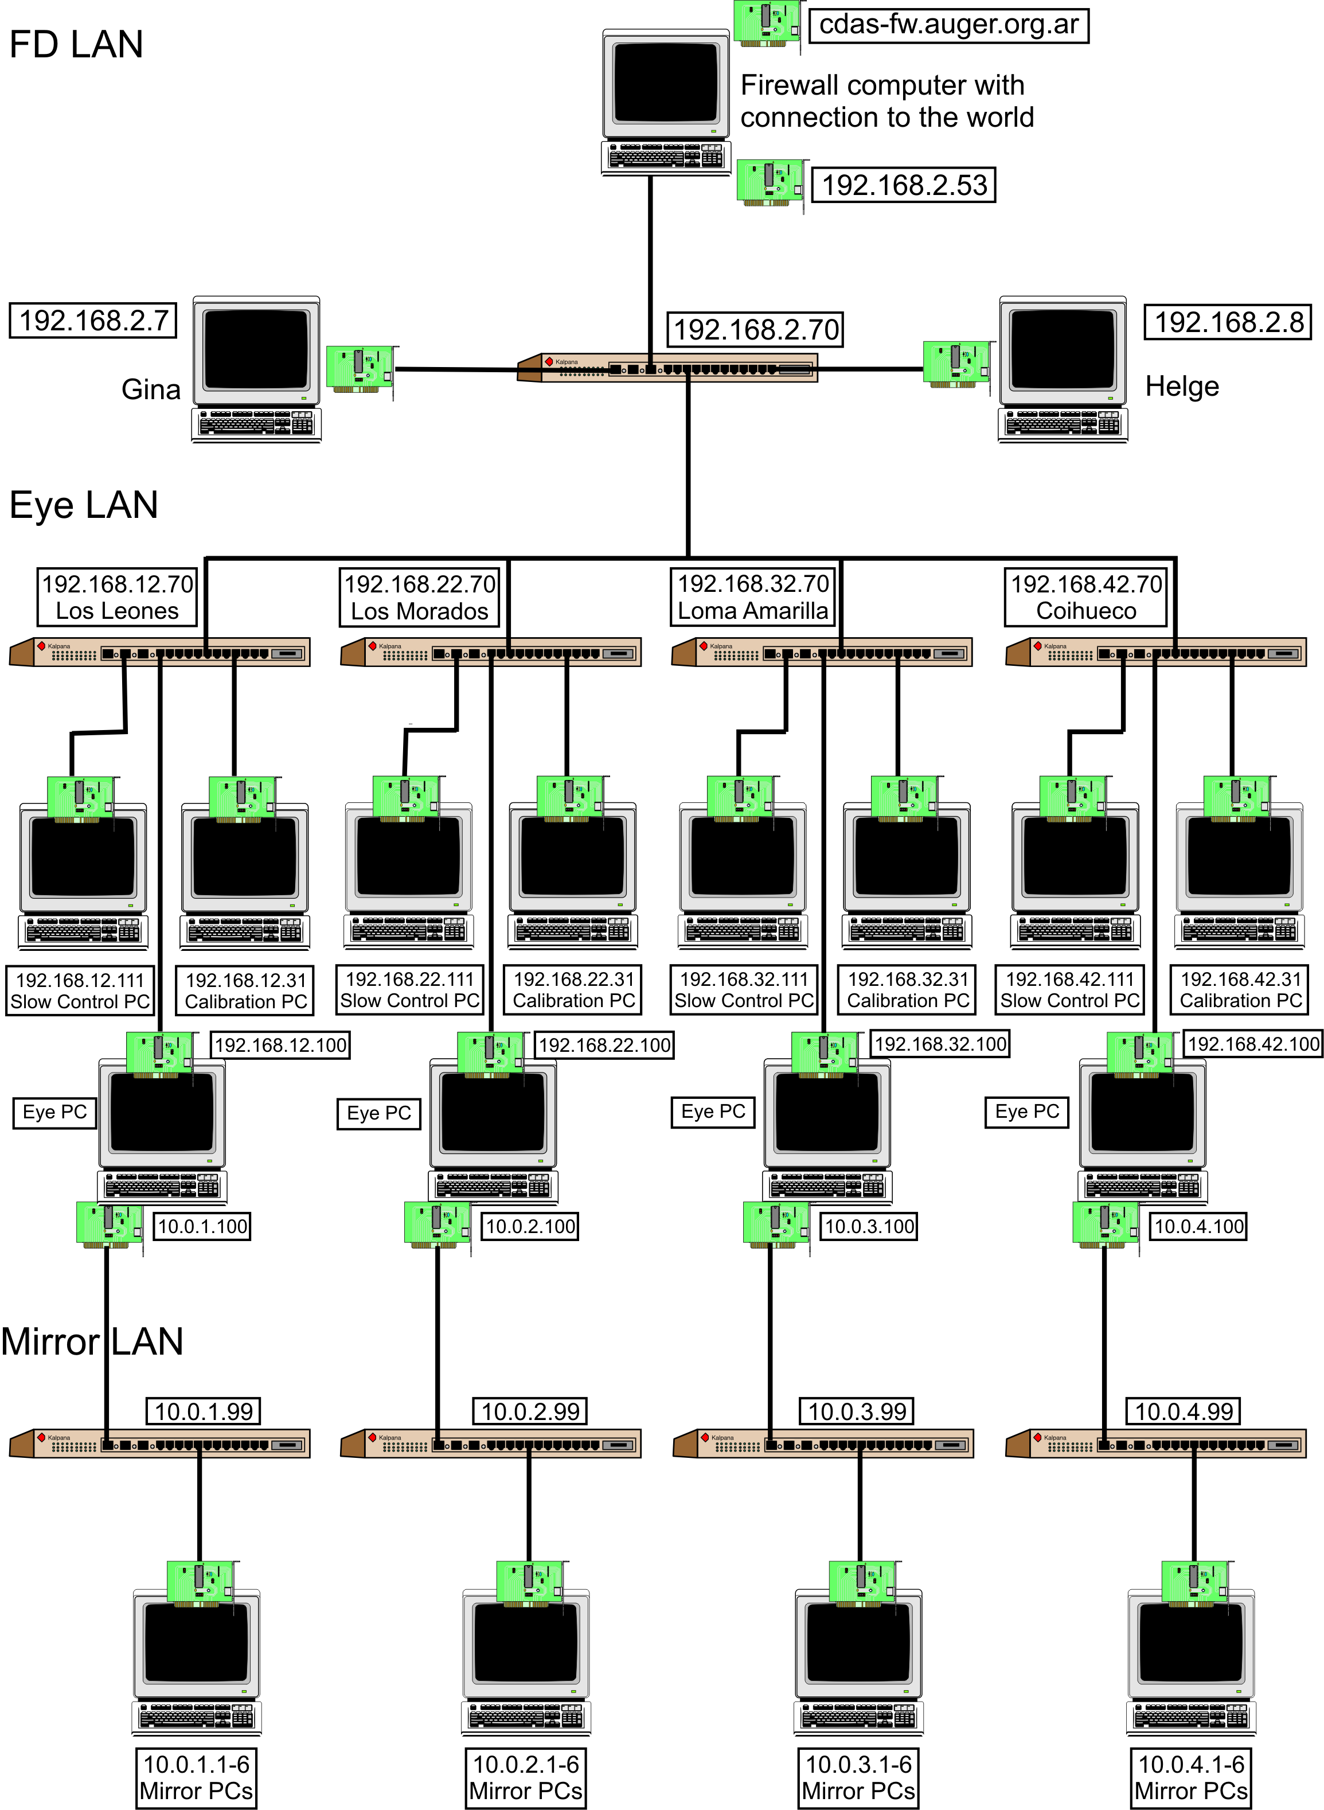

Figure 2. The scheme of the network needed for FD. Every computer and the connection to the network with switches and network cards are visible. Behind the Mirror PCs are the Front-End-Crates and telescopes

Functional requirements
For a successful remote control of the Auger Observatory the availability and accessibility of the system is essential. This means on the one hand the connection inside the central campus to the telescope buildings and on the other hand the connection from world wide networks to the central campus. For the connection from outside the central campus at least a 10 Mbit/s communication link is required.
Also the measured data should be automatically stored and/or replicated to Grid infrastructures or storage elements to provide easy access for the post processing of the measured data. So we don’t only need remote control, but also remote data acquisition probabilities.

Non functional requirements
A strong cryptography for user authentication and communication with the systems from world wide is a strict requirement. Otherwise it is not possible to ensure that the measured data is authentic.
Also it is important to define different security levels for different user groups to allow peoples only the access belonging to the group rights, e.g. if it should be allowed to update the software of the system:
- Software update of the system (highest)
- Control and monitor the system (high)
- Reading measured data (lowest)

A successful measurement with the FD is only at night and when the fraction of the moon illuminated at midnight isn’t too high possible, as the FDs are very light-sensitive. A timetable for the possible measurement dates with the FDs can be obtained from the Astronomical Applications Department. Therefore choose UTC as the time zone and press the “Compute table” button. As approximate value it is possible to measure with the FDs when the fraction is below 0.6. From this table the FDs for measurement are chosen, belonging to the date, location of the FDs and the moon.
The real time properties for measuring data with the telescopes are handled by the Front-End-Crates, as they are especially developed for this purpose.

Related work
All the work is done in the scope of the AugerAccess project (http://www.augeraccess.net/menu.htm).
This includes the setup of a virtual testbed for simulating the whole hardware architecture of the Auger Observatory and the development of software for remote control of the especial systems. This software is based on GT 4 Grid security for authentication and authorization of the users from world wide and Axis 2 services for the communication inside the Auger Observatory.

Use case situation analysis
The presented use case offers necessary requirements for remote instrumentation in Grid environments. These are the authentication and authorization of the users and the secure communication with the systems. Special for the presented use case is the access to private networks for controlling the observatory from world wide, the dynamical adding and removing of telescopes to the running system, the need for different security levels for different user groups and the need for remote data acquisition, not only remote control.
Therefore needed is a fast and reliable communication link to the observatory to make the remote control and monitoring possible and to replicate the measured data to server’s located world wide. The communication link at the moment is provided by the RETINA network, but will be replaced by a faster 10Mbit/s link from the AugerAccess project.
All the hardware and network components inside the central campus of the Auger Observatory are provided from the Auger collaboration.

References
[1] H. Gemmeke, “The Auger Fluorescence Detector electronics”, ICRC 2001 (http://www.auger.org/technical_info/pdfs/icrc2001/papers/ici6189_p.pdf).
[2] H.-J. Mathes, S. Argiro, A. Kopmann and O. Martineau, “The DAQ system for the Fluorescence Detectors of the Pierre Auger Observatory”, Chep 2004 (http://indico.cern.ch/contributionDisplay.py?contribId=119&sessionId=3&confId=0)

Device Farm Use Case
Contributor: Luca Berruti, Franco Davoli (CNIT)

Summary
This is an experiment in the area of Telecommunications Engineering, which aims at evaluating the effects of noise and fading on a video transmission performed over a wireless channel.

Customers
The primary actor would be the Engineer, who has to perform measurements over a wireless channel. The owner of the equipment in this case might be the manufacturer itself. Imagining a scenario where a user should perform measurements by means of devices that are too costly for the user's budget, or too infrequently employed to justify buying even a single piece of equipment, manufacturers might offer a pool of devices for temporary lease, without physically moving them. A matter to be considered on the basis of the specific experiment is whether the Device Under Test (DUT) may still reside at the user's premises or it should be moved and placed at the same location of the measurement instrumentation. In any case, the user would perform the experiment by operating the measurement instrumentation remotely.

Scenarios
The system under inspection is a wireless telecommunication channel that may belong to different types (e.g., IEEE 802.11 WLAN, Bluetooth, GSM, UMTS, WiMax, etc.). In the specific case considered, the system is an IEEE 802.11b channel, and the measurement devices are a channel emulator (used to generate fading and noise) and a spectrum analyzer. A video sequence is transmitted over the WLAN at the remote location, and the effects of adding fading and noise are evaluated both qualitatively (observing the corrupted video sequence) and quantitatively (e.g., packet loss) (see Figure 1).
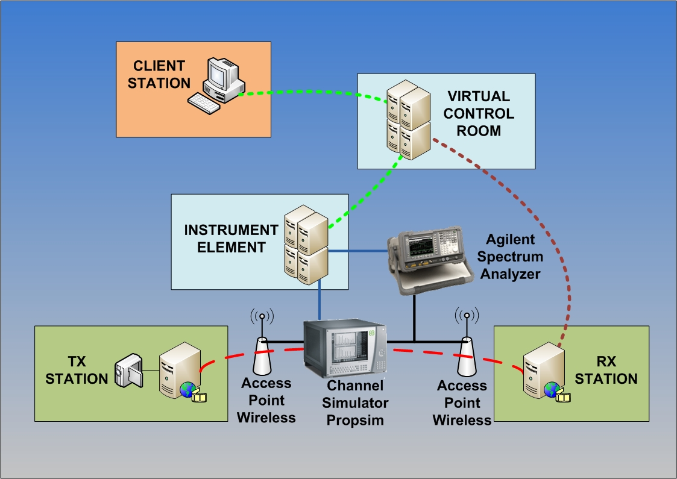Figure 1: Device Farm Experimental Setup
Preconditions:
- Video received on receiver without channel simulator
Minimal guarantee:
- Packet loss and missing video frames when generating fading and additive noise.
Success guarantee:
- Poor video quality observed on receiver in the presence of heavy fading and/or noise levels.

Main success scenario
- Logging in to client that transmits video
- Setup video transmitter
- Logging in to client that receives video
- Setup video receiver
- Connect the wireless Access Point output at the transmitter end to the input of the channel simulator (Elektrobit PropSim C2) [must be performed by remote operator, unless already in place (or connected to a remotely controllable signal switching matrix)]
- Connect the output of the channel simulator to the input of the wireless Access Point at the receiver end [must be performed by remote operator, unless already in place (or connected to a remotely controllable signal switching matrix)]
- By using a directional coupler, connect the output of the channel simulator to the input of the Spectrum Analyzer (Agilent E4404B) [must be performed by remote operator, unless already in place (or connected to a remotely controllable signal switching matrix)]
- Turn on channel simulator, spectrum analyzer and access points
- Start the receiver
- Start video transmission
  - Video not received
    - Ping the receiver from the transmitter
    - Check physical connection [needs remote operator]
    - Restart access point
  - Poor video quality on receiver
    - Change transmitted video (e.g., reduce bit rate)
- Choose a fading profile, switch on and configure the channel simulator
- Set noise level in the channel simulator
- Observe the effects of fading and noise on the decoded video stream [needs VNC or other tool to transfer the decoded video stream to the remote location (without video compression)]
  - Video not received
    - Select another fading profile
- Observe the spectrum
- Measure the packet loss and missing video frames [by means of a software monitoring tool]
- Repeat the measurement after changing noise level and/or fading profile
- Switch-off channel simulator, spectrum analyzer, access points, transmitter and receiver

Involved resources
The testbed consists of:
- a video transmitter station (Video LAN Client running on Windows XP)
- a video receiver station (Video LAN Client running on Windows XP)
- two wireless access points
- a channel simulator (Elektrobit Propsim C2)
- a spectrum analyzer (Agilent E4404B)
- an Instrument Element (running on Windows XP)
- a Virtual Control Room (running on Debian GNU/Linux)
- a Data Collector Broker (running on Scientific Linux)

Instrument Element related software/components
- Instrument Abstraction Layer (IAL)
- NI 488.2 (ENET/GPIB interface device driver)
- AgilentInstumentManager (Agilent E4404B Instrument Manager )
- Data Collector
- E4404B IAL wrapper
  - Agesa E4404B (Agilent E4404B device driver)
- SpectrumAnalyzerInstrumentElement (Elektrobit Propsim C2 Instrument Manager)
  - PropSimC2 IAL wrapper
  - Propsim VISA (PropSimC2 device driver)
Virtual Control Room related components
- mceremotedesktop (used to show video at receiver station)

Functional requirements
User interfaces. It is important in this application to reproduce (totally or partially) the front panel(s) of the instrument(s) with a certain fidelity. A more realistic user interface can be employed both to display measurement outputs (e.g., in the form of graphics) and to input configuration parameters in a fashion as close as possible to that of the real instrument (i.e., pushing buttons, turning knobs, and moving sliders).
Data collection. Measurement data can be acquired from the Instrument Elements controlling the various pieces of equipment in the Device Farm in (at least) two possible modes. One consists in continuously polling the Instrument Element for new data; the other mechanism is based on a publish/subscribe paradigm, to allow asynchronous communication between the Instrument Elements and the user clients (possibly through a Virtual Control Room). The choice between the two operating modes can be based on performance considerations (see below).

Non functional requirements

Security considerations
Each observer must be authenticated to allow video data.
Some authorized users allowed to remotely manage instruments.

Performance considerations (incl. real-time properties)
Polling the IE for instruments' readings (e.g., from the spectrum analyzer) may result in excessive data transfer delays towards the client stations for waveforms' visualization.
In these cases, the adoption of a publish/subscribe mechanism employing, for instance, JMS for event notification and automatic measurement data transfer is recommended.

Related work
The CNIT teams at the Universities of Genoa and Bologna, and at the National Laboratory for Multimedia Communications in Naples, Italy, have over 8 years experience in the field. In particular, they have conducted the LABNET project [1], part of the experimental activity of the VICOM project [2], and they have participated in European projects GRIDCC (http://www.gridcc.org), RINGrid (http://www.ringrid.eu), and DORII (http://www.dorii.eu). Participation in the activity of the NoE SatNEx (http://www.satnex.org) has allowed to establish a liaison between Remote Instrumentation Services and the usage of satellite links for data transfer (an important aspect when accessing harsh or secluded environments).

References
GridCC Device Farm Demo Video:
http://www.gridcc.org/cms/index.php?option=com_content&task=view&id=17&Itemid=9

- F. Davoli, G. Spanò, S. Vignola, S. Zappatore, "LABNET: towards remote laboratories with unified access", IEEE Transactions on Instrumentation and Measurement, vol. 55, no. 5, pp. 1551-1558, Oct. 2006.
- L. Berruti, F. Davoli, G. Massei, A. Scarpiello, S. Zappatore, "Remote laboratory experiments in a Virtual Immersive Learning environment", Advances in Multimedia, vol. 2008 (2008), Article ID 426981, 11 pages, doi:10.1155/2008/426981.
- F. Davoli, S. Palazzo, S. Zappatore, Eds., Distributed Cooperative Laboratories: Networking, Instrumentation, and Measurements, Springer, New York, NY, 2006; ISBN 0-387-29811-8.
- L. Berruti, L. Caviglione, F. Davoli, M. Polizzi, S. Vignola, S. Zappatore, "On the integration of telecommunication measurement devices within the framework of an instrumentation Grid", in F. Davoli, N. Meyer, R. Pugliese, S. Zappatore, Eds., Grid-Enabled Remote Instrumentation, Springer, New York, NY, 2008; ISBN 978-0-387-09662-9.
- L. Berruti, F. Davoli, S. Vignola, S. Zappatore, "Interconnection of laboratory equipment via satellite and space links: investigating the performance of software platforms for the management of measurement instrumentation", in E. Del Re, M. Ruggieri, Eds., Satellite Communications and Navigation Systems, Springer, New York, NY, 2007, pp. 657-666.

Ocean Observatory Initiative: Integrated Observatory
Contributor: Duane Edgington (MBARI)

Summary:
Source of use cases:

OOI CI Requirements and Design Workshops
http://www.oceanobservatories.org/spaces/display/WS/CI+Workshops
http://rucool.marine.rutgers.edu/index.php/COOL-Research/Projects-Ocean-Cyberinfrastructure.html
SENSORS: Ocean observing system instrument network infrastructure Workshop Report
http://www.mbari.org/rd/sensors/2004_workshop_report.htm
http://www.mbari.org/rd/sensors/documents/MBARI%20Sensors%20Workshop%20Report-final.pdf

Customers
Primary Actor:
The scientist performing the remote experiment

Secondary actors:
• Marine observatory equipment operator (on-site at shore station)
• Infrastructure and instrument technicians/maintenance engineers
• Site security manager
• Instrument/infrastructure owner
• Instrument interface engineer
• Instrument representative
• Input provider
• Observer of the observatory data (could be a scientist, a member of the public, or a student from Kindergarten through graduate school)

Scope:
The Remote Instrumentation Infrastructure (RII), also known as the Integrated Observatory (IO) as composed by:
• The instruments
• The network
• The computing and storage resources
• The enabling middleware and the post-processing software

Stakeholders and interests:
• The scientist performing the experiment has an interest in concluding it successfully and retrieve reliable measurements (or other results). This execution of the experiment must be as economic and technically complete as possible. Additionally, the scientist has an interest performing the experiment in a secure environment, which guarantees that access to results (and the input) is restrained to well-specified entities.
• Owner of the equipment and infrastructure. The owner has an interest in ensuring that the equipment is working properly and is not damaged as a consequence of the experiment. If the owner is also the manufacturer (possible in the case that vendors are leasing their equipment or providing it for testing purposes), the owner needs to ensure that the performance of the equipment is appropriate, in order to improve the equipment’s reputation and therefore gain a competitive advantage. The owner has an interest in maximizing use of the equipment through efficient scheduling of the experiments.
• Instrument interface engineer(s). The instrument interface engineer(s) are responsible for providing (and/or verifying) the hardware and software that connects a scientific oceanographic instrument to the observatory
•Instrument Representatives. The instrument representatives monitor instrument data/metadata quality, processing and operation. They work with Instrument Interface Developer to define requirements for the instrument interface. They are responsible for Pre-deployment validation
• Infrastructure and instrument technicians/maintenance engineers. The engineers of the infrastructure and of the instrument equipment have an interest in ensuring the proper operation of both, for reasons of professional reputation.
• Site security manager. The site security manager has an interest in ensuring that any access policy changes on the network and the software infrastructure will not affect negatively the overall site security, and will not increase an intruder’s chances to access the site.
• Input provider (if any). The quality of the input may affect an experiment, when input is relevant. The provider has an interest in improving their reputation through quick delivery of quality input and successful completion of experiments.
• Observer of the observatory data (could be a scientist, a member of the public, or a student from Kindergarten through graduate school). It is the mission of the observatory to have “real-time” data available to the general public, students in schools, and general scientific community. There may be situations in which these actors are permitted to input requests for experiments or particular measurements (to support classroom projects, for example).

Scenarios

Preconditions:
• The RII (as defined in Scope) must be operational.
• The user has appropriate access rights to the infrastructure.
• When exclusive access is required, or there is a restriction in the number of concurrent users, the infrastructure must offer this functionality.
• It must be possible to verify at all times that the RII is functioning properly, either remotely or with the assistance of a local collaborator.
• It must be possible to define access policies that restrict access to some or all of the experimental process and results.
• If remote control of the instrument is not possible, a local collaborator must be on site.

Minimal guarantee:
• The RII must remain operational, without the security measures being affected in any way.

Success guarantee:
• The experiment was conducted in full; partial instrument output has been obtained and post-processed to extract the final output data.

Main success scenario:
1. If needed, schedule the experiment for a specific timeslot, indicating exclusive access or concurrent access limitations.
2. If needed, prepare the input.
3. If needed, switch on instruments, check and prepare processing infrastructure.
4. If needed, define access policies for the access of additional entities to the experiment and the output produced.
5. If needed, provide the input to the instrument(s) (directly or through marine operator).
6. If needed, calibrate the instrument(s), by modifying its settings and parameters.
7. Execute the experiment performing measurements and control of the instrument(s).
8. Evaluate the output of the specific measurement.
9. If additional runs are required, jump to step 4 and repeat onwards.
10. If needed, perform cleanup activities, such as deleting intermediate data and switching off the instrument(s) and other relevant equipment.

Extensions:
1a. The instrument(s) are not available for exclusive access at that time and day, or maximum number of concurrent users has been reached.
1a1. Try another day and/or time.
1b. Operation of one instrument would conflict with concurrent experiment using another instrument.
1b1. Reschedule experiment.
1b2. Negotiate with operator of conflicting instrument to resolve interference between the instruments.
2a. Input is not of acceptable quality or has been destroyed.
2a1. Contact input provider and receive new input.
2a2. Reschedule experiment.
3a. Instrument or other part of the infrastructure is not available for technical reasons.
3a1. Contact corresponding engineers to fix the problem(s).
3a. Instrument or other part of the infrastructure is not available for technical reasons.
3a1. If fixing the problem is a lengthy process, reschedule experiment.
4a. It is not possible for the user to define access policies.
4a1. Contact the site security managers and ask them to append new policies.
4a2. If addition of new policies is a lengthy process, reschedule experiment.
5a. It is not possible to provide the (digital) input to the instrument.
5a1. Contact the site infrastructure engineers.
5a2. If fixing the problem is a lengthy process, reschedule experiment.
5b. It is not possible to collaborate efficiently with the local assistant.
5b1. Contact instrument owner to arrange for another local collaborator.
5b2. Reschedule experiment according to availability of alternative collaborator.
6a. Calibration of the instrument fails.
6a1. Contact the site infrastructure engineers.
6a2. If fixing the problem is a lengthy process, reschedule experiment.
7a. The instrument or other part of the infrastructure is malfunctioning during experimentation.
7a1. Contact the site infrastructure engineers.
7a2. If fixing the problem is a lengthy process, reschedule experiment.
8a. The instrument cannot be switched off, or other technical problem has occurred.
8a1. Contact site infrastructure engineers.

Functional requirements:

• Selection services (scheduling and reservation, also including computational, storage
and networking resources) – Optional;
• Input management (identification, preparation processes) – Optional;
• Instrument virtualization / Service provider (representation as manageable resource) –
Obligatory;
• Policy decision and enforcement – Optional;
• Data management of input – Optional, applies to digital input only;
• Local operator (shore side) – Optional if remote control of instruments is possible. Can be assistive to input management as well;
• Visualization devices – Optional;
• Software for post-processing – Optional; Includes ability to merge data (extracted from local instrument storage unit after recovery from remote site) with incomplete/summary data transmitted in real-time from instrument.
• Workflow management – Optional;
• Accounting and Monitoring – Obligatory;
•Instrument representative – Obligatory. Each instrument has an individual tasked with monitoring the data stream and accessing the quality of that data

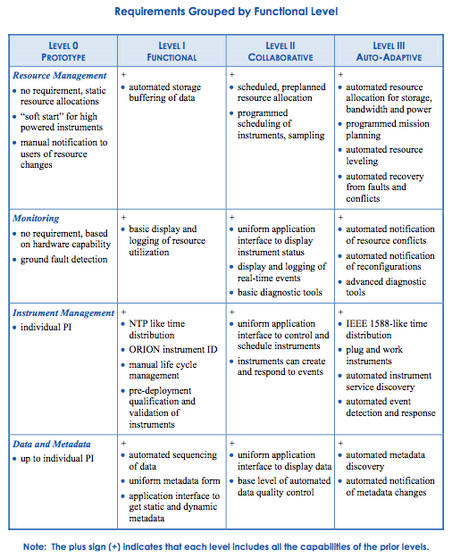

Non-functional requirements:
•Security considerations
•The observatory assets and instruments must be protected against damage that could be caused by unauthorized access
•Each user must be authenticated to allow access to data
•Some authorized users allowed to access restricted data
•Some authorized users allowed to control specific instruments or processes
•Operators must be authenticated to allow additional operations (change parameters, turn instruments on or off, do maintenance, etc.)
•Performance considerations (incl. real-time properties)
•Strict QoS requirements on data flow from instruments to shore station under operator control
•Expectation of near-real-time data delivery from community instruments (expectation varies depending upon the instrument and the platform type [cabled vs coastal moored vs global moored vs underwater autonomous])

Involved resources:
•Incl. available interfaces for the specific instrument(s)
•Individual ocean science instruments (no current standards)
•Instrument interface software (proprietary, SIAM, IEEE1451, JDDAC)
•Instrument controllers / data loggers on individual platforms
•Communication interfaces between controllers and shore station
•Real-time data network (IP)
•Intermittent wireless networks (satellite)
•Command and control network
•Shore side station (operators, local data storage, monitoring, etc)
•“Campus” compute center (compute facilities, data storage, streaming services)
•Virtual laboratory at user site

Related work / Experience in the field:
•Extensive experience from smaller ocean observatories (LEO-15, MVCO, MOOS, H2O, VENUS, MARS etc) and terrestrial observatories (Earthscope, ROADNET, etc).
•Leveraging experience in other scientific fields and environmental monitoring fields

References:
•Ocean Observatories Initiative Cyberinfrastructure:
•http://forge.gridforum.org/sf/docman/do/listDocuments/projects.risge-rg/docman.root.meeting_materials.ingrid08
•http://www.joiscience.org/ocean_observing
•RingGRID Deliverable 6.2 Report on requirements verification
http://www.ringrid.eu/public/deliverables/RINGrid-WP6-D6_2-2008-04-20-1-GRN-Report_on_requirements_verification.pdf
•OOI CI Requirements and Design Workshops
•http://ooici.ucsd.edu/spaces/display/WS/Home
•ROADNet
•http://roadnet.ucsd.edu/
•Earthscope
•http://www.earthscope.org/
•MVCO
•http://www.whoi.edu/mvco/
•MOOS
•http://www.mbari.org/moos/
•MARS Cabled Observatory User Requirements
•http://www.mbari.org/rd/sensors/documents/2300002_User%20Requirements.pdf
•LEO-15
•http://marine.rutgers.edu/mrs/LEO/LEO15.html
•VENUS
•http://www.venus.uvic.ca/
•H₂O
•http://www.soest.hawaii.edu/h2o/
•MARS
•http://www.mbari.org/mars/
•SENSORS: Ocean observing system instrument network infrastructure Workshop Report
•http://www.mbari.org/rd/sensors/2004workshop.htm

Yet to do:
•Open Grid Services Architecture (OGSA) capabilities and services utilization
•To be determined
•Matrix: Use case / functionalities (essential, optional)
•To be done

Use case of NMR spectrometry in Virtual Laboratory
Contributor: Dominik Stokłosa (PSNC)

Summary
This document describes use case scenario in the field of Nuclear magnetic resonance (NMR) spectroscopy. The use case has been implemented in the Virtual Laboratory project. Varian spectrometer has been deployed in the VLab environment as a pilot scientific device. Moreover, thanks to the VLab architecture it is possible to conduct and control NMR experiments remotely, process data and finally visualize them. Nuclear magnetic resonance spectroscopy, most commonly known as NMR spectroscopy, is the name given to a technique which exploits the magnetic properties of certain nuclei. This phenomenon and its origins are detailed in a separate section on nuclear magnetic resonance.
NMR spectroscopy applications area is very wide and contains medicine, chemistry, non-destructive testing, data acquisition in petroleum industry, process controlling, Earth’s field NMR, magnetometers

Customers
Primary Actor:
The scientist interested in examining some kind of material with the use of NMR spectroscopy.

Secondary actors:
NMR Spectrometer operators (sometimes scientist and operator can be the same person).

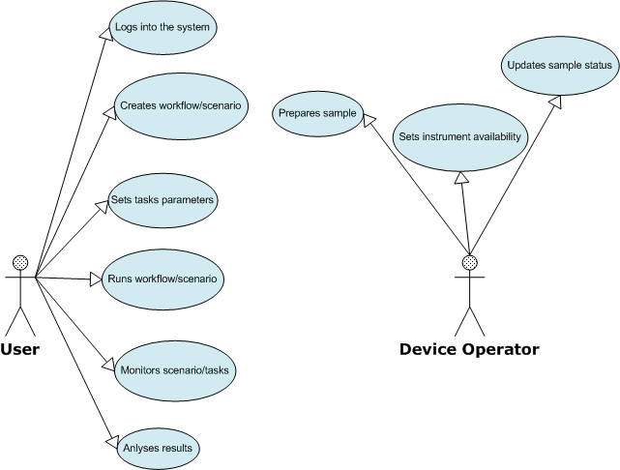
Stakeholders and interests:
The scientist, spectrometer operator(s). If the experiment is conducted with use of third party sample material - the owner of the sample is also in this group. In many cases the scientist and equipment operator is the same person and can use spectrometer for his own scientific purposes. Operator can also play a utility role for an external person who submits the sample material to be examined, used in NMR experiment.

Scenarios
Preconditions:
NMR Spectrometer and its controlling computer must be up and ready. Sample material must be prepared for experiment: mixed with appropriate solvent and inserted into the spectrometer.

Minimal guarantee:
The spectrum of the examined sample must be received as output from the spectrometer.

Success guarantee:
The spectrum of the examined sample is satisfied in the terms of its parameters that allow to answer the questions set by scientist before the experiment.

Main success scenario:
- Log onto the computer controlling the spectrometer.
- Lock on the sample in the spectrometer.
- Make the shimming of the sample (calibration process).
- Acquire spectrum for the sample with the required parameters, store it in the local data sink if needed
- Log off from the spectrometer controlling computer.

Extensions:
Situations that can result in bad (corrupted in some way) spectrum result. The causes of bad result (spectrum not good enough for the user) can be as follow:

2a. Sample degradation - sample can be applicable to perform the experiment only for some limited time. Outdated sample can cause poor spectrum result.
2a1. New experiment material must be delivered

2b. Sample was not prepared properly - NMR sample preparation in short means dissolving it in a proper solvent. Errors made during this process can cause wrong experiment result.
2b1. Sample should be prepared again if there is enough of initial material to do it.
2b2. The new experiment material must be delivered

3a. Spectrometer calibration - the equipment should be properly tuned up just before gathering the results. Errors can cause wrong spectrum as a result. Sometimes it can be noticed during the experiment duration and there is no need for waiting until its end - usually the experiment can be interrupted if partial results are not correct (not fitting user’s expectations)
3a1. Calibration process must be repeated and experiment must be restarted.

4a. Unstable temperature. The room that contains the spectrometer equipment must ensure very stable temperature parameters. If there are temperature fluctuations during the experiment it will cause noise in the experiment result.
4a1. The spectrometer environment must have stabilized temperature. Experiment must be restarted after reaching this condition.

4b. Similar situation like in previous point but relevant to magnetic fields. Major changes in the magnetic field of the close spectrometer environment will cause wrong experiment result.
4b1. The spectrometer environment must have stabilized magnetic field. Experiment must be restarted after reaching this condition.

4c. Spectrometer technical failure can cause total lack of result. There are many areas where such problem may occur. It can be electrical failure in the electronic part of spectrometer controlling devices, software/hardware problem in spectrometer's controlling computer, technical problems with spectrometer pneumatic, air-conditioning and other installations.
4c1. Experiment should be restarted after maintaining the equipment technical failure.

Involved resources
In the Virtual laboratory of NMR spectroscopy there are several types of resources to be distinguished:
- Laboratory Devices – laboratory apparatus and software for experiment execution (in scope of NMR it can be Varian 300MHz, Bruker 600MHz)
- Computational Servers – software for data pre-processing and post-processing. Applications for data processing can be run on grid resources using existing grid middleware such as Globus toolkit (versions 4.0.3 or 4.0.4) and GRMS Gridge Resource Monitoring Service (GRMS) to submit and execute computational tasks on the grid
- Visualization Servers – visualization software used for experiment results presentation (e.g.VMD application).
- Storage element/Science library – stores experiment’s data and allows other users sharing the works results

The resources can be geographically distributed inside the laboratory the user belongs to. There is a multiple user access to the VLab server (with varying levels of access; laboratory administrator, device operator, user).
NMR spectrometer – equipment consists of the following components:
- magnet with additional supporting equipment (like cryogenic installation, air filtering system, samples handling system, etc. – full list of equipment depends on particular implementation);
- steering, computer unit that controls magnet, provides data acquisition from it;
- interface: controlling software that allow to adjusting and monitoring NMR spectrometer parameters during the experiment duration.

Sample: material that will be examined in NMR spectrometer. Usually it has to be properly prepared before the experiment - mixed with appropriate solvent and inserted into the spectrometer (or samples handling system that can automatically manage inserting/extracting process with more than one sample).

Interface – software that allows remote access to the equipment: software system that allows remote users to perform full path of NMR experiment with use of spectrometer. It can contain following modules (on the example of VLAB system developed in PSNC):
- scenario builder - allows to predefine steps of the experiment, parameters, conditions (triggers and filters), main points in its path of execution;
- monitoring module – allows to watch experiments steps, status, progress;
- interactive sessions application – in the case of need allows remote user directly access the spectrometer controlling software or collected data post-processing applications working on remote systems;
- data library – storage system that allows to collect, manage and share results of experiments

Functional requirements
The functional requirements were divided into two groups. First group covers the general requirements for a remote instrumentation system, its basic functionality, and the second group reflects the specific requirements of NMR spectroscopy and remote access to NMR spectrometer. The requirements were collected from scientists working in Laboratory of Structural Chemistry of Nucleic Acids of Institute of Bioorganic Chemistry, Polish Academy of Sciences, Poznan, Poland.

General requirements:
- F1, Logging into the system
- F2, Displaying the usage statistic
- F3, Setting the maximum limits for scientific devices and computational systems
- F4, User rights management
- F5, Monitoring of task queue for a laboratory
- F6, Communication between laboratory members
- F7, Confirmation of device readiness for experiment
- F8, Aborting the experiment
- F9, Access management to the scientific devices and computational systems (incl. software)
- F10, Setting the user availability hours
- F11, Displaying the device User Interface
- F12, Overview of the experiment progress
- F13, Ending the experiment – storing the results
- F14, Submitting the experiments in batch mode
- F15, Browsing the list of performed experiments
- F16, Interactive post processing of acquired data
- F17, Submitting computational jobs
- F18, Monitoring of computational jobs

Specific requirements of NMR spectroscopy
- F19, Monitoring of task queue for NMR spectrometer
- F20, Definition of additional scheduling criteria for scientific device – NMR spectrometer
- F21, Temperature control of the sample used in experiment
- F22, Submitting interactive jobs on NMR spectrometer
- F23, Changing the pulse sequence
- F24, Changing the initial parameters values
- F25, Setting the lock and shim for NMR experiments (acqi window)
- F26, Changing probe temperature
- F27, Starting the NMR experiment

Non-functional requirements

Security considerations
In case of NMR spectroscopy we are dealing with very sophisticated and expensive scientific devices. Therefore, it is very important to ensure that only the authorised people have the possibility to connect and gain the control of the NMR spectrometer. Also, the locally present device operator, must have a possibility to closely monitor experiment progress and all its parameters, as it is possible to damage the spectrometer by giving wrong or inappropriate user input. The device operator must have the rights to abort the experiment at any time, grant and deny an access to a specific users or all users at the same time.
Another important aspect is to provide the high security level of produced experiment output, as in most cases scientists perform very important, often confidential, research. Users have to have a full control on where and how their scientific output is stored, with the possibility of granting/denying the access to other members of their organization or in general, other remote instrumentation system users.

Related work
Various international projects already tried to target at least some of the aspects involved in system-level science and instrumentation grids.
The GRIDCC (IST-511382) (Grid-enabled Remote Instrumentation with Distributed Control and Computation) project extends the Grid to include access to and control of distributed instrumentation. RINGrid (Remote Instrumentation in Next generation Grids) is identifying instruments and user communities, defining requirements and trying to find synergies between remote instrumentation and next-generation high-speed communications networks and grid infrastructures.
But this is of course not a European-only effort. The NEESgrid project links earthquake researchers across the U.S. with leading-edge computing resources and research equipment, allowing collaborative teams (including remote participants) to plan, perform, and publish their experiments. Through NEESgrid software, researchers can: perform tele-observation and tele-operation of experiments, access computational resources and open-source interactive analytical tools.
CIMA, the Common Instrument Middleware Architecture of the Instrument-Middleware Project in the U.S. is following an approach different than the one of GRIDCC to achieve similar goals. CIMA is investing in semantic descriptions of instruments, which can be consumed by interested peers to generate dynamic clients and invoke their functionality according to those descriptions. Although CIMA goes for extensibility and manages well in this regard, it is harder to be abstract enough and apply this methodology in highly complex equipment to describe their very fine-grained functionality.

Use case situation analysis

Experiments executed in the NMR VLab system consist of many stages. Usually it looks as follows: a scientist prepares a sample and/or input data (e.g. parameters) which will be measured/computed. Next she/he uses laboratory devices to achieve data which are the processed by a specialized software. Processing can include the visualization stage if it is needed to assess the results.
In case of undesirable results some measurement stages should be repeated. At each stage the scientist decides which way the research should go next. As we can see, the experiment process execution may consist of very similar stages in many scientific disciplines (laboratories). The given experimental process is often executed recurrently by some parameters modification. Obviously, the presented scenario is typical but we realize that scholars can have more sophisticated needs.
The conception of the dynamic measurement scenarios in VLab system allows defining the process of an experiment in any way, from pre-processing, through executing the experiment, to the post-processing and visualization tasks. Defining the measurement scenario allows to spare a lot of time during computation. The user does not have to wait for the end of a given process stage to submit another one. It is made automatically.
Below we present activity diagram for NMR Virtual Laboratory for 3-stage measurement scenario which consists of the following phases:
- execution of experiment on spectrometer (Varian 300 MHZ),
- performing post-processing with Felix application,
- visualization using VMD application – final stage of scenario.

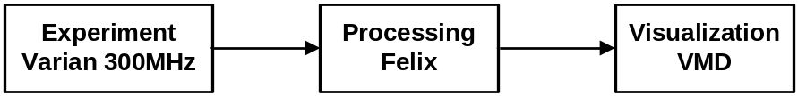

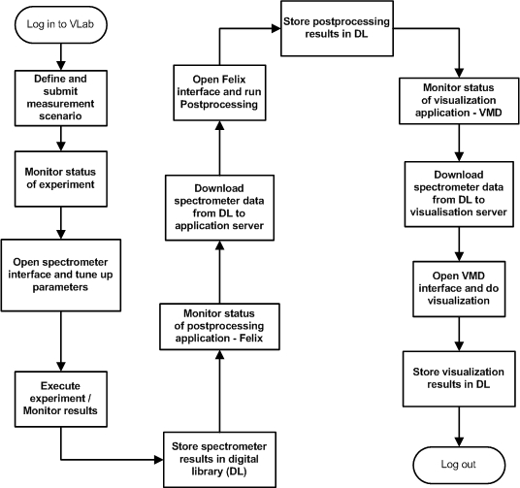
Figure 2.Diagram of activity for 3-element (Varian→Felix→VMD) scenario

A digital library is seen a storage system where all (also intermediate) results/data are stored. Moreover, it allows users to share experiment results and bibliography concerning a given scientific discipline.

References
Lawenda M., Meyer N., Rajtar T., Okon M., Stoklosa D., Kaliszan D., Kupczyk M., Stroinski M, Workflow with Dynamic Measurement Scenarios in the Virtual Laboratory, http://vlab.psnc.pl/pub/Workflow_With_Dynamic_Measurement_Scenarios_In_The_Virtual_Laboratory.pdf
Virtual Laboratory project - http://vlab.psnc.pl/
RINGrid project http://www.ringrid.eu/
GridCC project http://www.gridcc.org/cms/
Institute of Bioorganic Chemistry, Polish Academy of Sciences http://www.ibch.poznan.pl/En/str_glowna.htm
Rek, P., Kopec, M., Gdaniec, Z., Popenda, L., Adamiak, R.W., Wolski, M., Lawenda, M., Meyer, N., Stroinski, M.: Digital Science Library for Nuclear Magnetic Resonance Spectroscopy. The 4th Cracow Grid Workshop, ISBN 83-915141-4-5, pp. 404-411, Cracow, Poland, December 12-15, 2004
RINGRid deliverable: Report requirements verification
http://www.ringrid.eu/public/deliverables/RINGrid-WP6-D6_2-2008-04-20-1-GRN-Report_on_requirements_verification.pdf

Use case of ARGUGRID: Earth Observation satellite
Contributor: Mary Grammatikou

Summary:
Earth observation satellites are specifically designed to observe Earth from orbit, and intended for environmental monitoring, meteorology, and maps making. Each Earth Observation satellite brings on-board a series of instruments, i.e sensors intended to collect, save and transmit data about the Earth. Each instrument carries on different sensors apt to different observations. According to the way they collect data, sensors could be classified in two main groups: Radar sensors and Optical sensors.
Information about Earth Observation services, availability and applications is currently accessible only in a very scattered way through different mission operators, scientific institutes, service companies, data catalogues, etc. and request for EO images cannot be performed automatically since human interaction is often required.
Some providers have created web catalogues to allow users to request for archive images. Users have to log in and manually filling up a form, to request for images or products. Web catalogues usually shows a list of quick looks and information about all available images matching the request. Finally, user can select between the available images and confirm the purchase getting the EO image by e-mail, FTP, or DVD distribution.
Accordingly, only a limited community, knowing what to search for, is in a position to collect and compile the Earth Observation information. Easier and timely access to large quantities of primary data is a condition for delivering effective services. Therefore, the ARGUGRID platform is utilised in this test case in order to provide an easy and effective way for delivering EO images to a variety of users.
With the increasing availability of Earth Observation images, some new providers have appeared in the market, offering new implementations of common and new operations.
Some of this services are already provided by the image providers, but this new specialized services intends to improve the current ones, by using new algorithms, better auxiliary data or just faster processing. Simple examples include, clipping, format conversion, resizing, reprojection etc. services.

Customers/Actors

- Service Provider: Business that provides EO images and Clipping Services to customers over the network as web services
- Agents: Software intelligent agents that represent the service providers and the users for negotiation reasons
- Users: Customers that request EO image and clipping services

Scenario

The use case scenario describes the simple case where a user wants valid earth observation products for studying an oil spill caused by a disaster event. The user knows location and time of this oil spill.
Moreover the user desires to perform clipping operation to the ordered image so as to keep the data within the desired polygon for further calculation and processing.
The large number of satellites as well as clipping services complicates the decision. Moreover, a deep knowledge of the sensors and its characteristics is needed. A system with that knowledge, and able to select the best option, would be very appreciated in crises.
Using the ARGUGRID system, a non-expert user could get useful information in an easy and quick way.

All services (clipping and Earth Observation image acquisition) are offered as GRIA web services within the network and are represented by intelligent agents, capable of internal reasoning and argumentation as well as negotiation with other agents. The following figure represents the execution of the scenario and the following steps explain in detail the whole procedure.
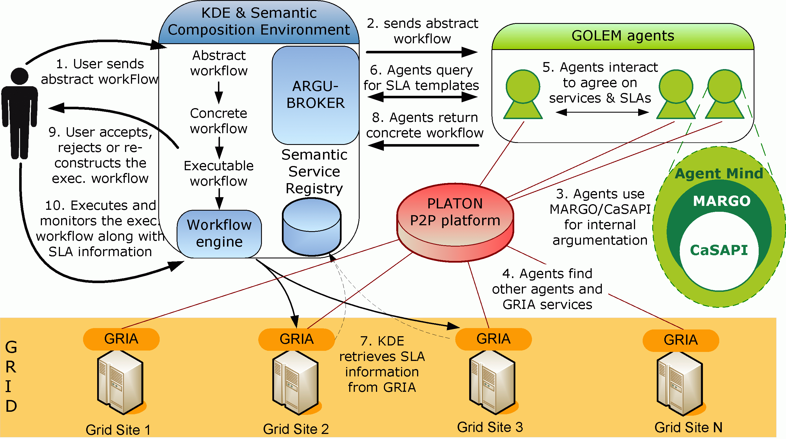

- The user uses the KDE Authoring Tool interface in order to submit an abstract workflow that reflects, at a high-level, the user requirements.
- The KDE ArguBroker delegates the abstract workflow to GOLEM software agents. The GOLEM agent representing the user will start finding which GRIA services should be used in order to derive a concrete workflow, to be executed on the Grid.
- To accomplish this, the GOLEM agent uses the MARGO argumentation engine for decision-making, which in turn uses the CaSAPI general-purpose argumentation engine. These are implemented within the mind of every GOLEM agent and work in a way to reason about services and make decisions, aiding the refinement process of the abstract workflow.
- To find out appropriate GOLEM agents that represent GRIA Grid service, GOLEM agents are given the capability to use the PLATON P2P platform, linking all available GOLEM agents and GRIA services in a virtual registry that can be queried. The GOLEM user agent discovers a set of GOLEM agents that can fulfil its goal requirements.
- Agents interact with each other in other to find appropriate services to use to satisfy their goals.
- Non functional properties, such as resolution of image, delivery time and cost of each service are stored in Service Level Agreements (SLAs) within the GRIA registries, and can be retrieved by the Semantic Registry. Agents after discovering a set of appropriate services, query the Semantic Registry to retrieve the SLA templates of the services.
- The Semantic Registry retrieves the SLA information from the GRIA registry residing in each GRIA node.
- Having carried out its mission, the GOLEM agent representing the user (i.e. the initial agent that received the abstract workflow from the KDE) will return back to the KDE the concrete workflow, constituted by a set of GRIA services (an image acquisition and a clipping service) to be executed in a certain manner/sequence. The agent also returns the negotiated SLAs of the services within the workflow.The KDE uses the capabilities of the ARGUBROKER component in order to produce an executable workflow, based on the concrete workflow received by the GOLEM Agent representing the user.
- At this point, an executable workflow with an associated set of SLAs is presented to the user, giving him the choice of either accepting the concrete workflow or rejecting it or deciding to modify the abstract workflow, in order to get a better solution. In the latter case, the abstract workflow will be given again as input to the KDE, repeating steps until the user either accepts or rejects the ARGUGRID executable workflow solution. In the case of acceptance, the system will follow step 9 below.
- The workflow engine within the KDE will use its workflow execution service to send the execution workflow, along with its related SLA information, for execution on the Grid infrastructure, running the GRIA Grid middleware. Upon successful execution of the final executable workflow, the user is informed and the execution results/data are returned back to the user in an FTP site where he can download the clipped image.

Functional requirements

For the use case scenario to be considered successful, a concrete executable workflow needs to be returned to the user consisting of two services: one that orders an earth observation image from an oil spill territory and another that performs clipping to the first image, resulting to new one.

Preconditions:
- Different GRIA host machines that store the offered services along with their SLAs. Each service has to be wrapped as a GRIA service.
- Different machines containing GOLEM containers. Each GOLEM agent is equipped with the CASAPI argumentation engine and is assumed to have basic knowledge as defined by each use case scenario.
- A peer-to-peer platform, PLATON, runs as underlying middleware with each GOLEM container constituting a PLATON node.
- Set up of distributed Semantic Registries holding semantic information about the services, upon which the GOLEM agents query.
- KDE authoring tool interface, where the users enter to set their goals forming abstract workflows.

Non-functional requirements

Security considerations:

Each user should be authenticated to use the ARGUGRID system. Moreover, the services offered at the GRIA sites need to grant access to the KDE execution engine, in order to call and execute them. This can be simply solved by use of the GRIA VO management system, the PBAC 2 mechanism.

Trust:

Models of trust are envisaged to be used in relation with the agent negotiation. These models may feed into the VO model, and it may be used to evaluate the effectiveness of the VOs and individual agents’ effectiveness in that VO. For example, an agent may ask another agent if it can deliver a service or if it knows of another who can reliably provide the service.

Involved resources

The resources involved compose the whole ARGUGRID platform. Therefore we have:
- A Grid infrastructure consisting of different GRIA nodes.
- A peer-to-peer infrastructure.
- GOLEM containers of agents
- Semantic Registries
- KDE workflow authoring Tool and Semantic Composition Environment

Related work/Experience in the field

Information about Earth Observation services, availability and applications is currently accessible only in a very scattered way through different mission operators, scientific institutes, service companies, data catalogues, etc. In general, to get an image of a specific area, a user should be subscribed to one of the image service providers or he should contact them either via e-mail or by phone call, as in the RadarSat image request and delivery workflow.
Even if what is described above, could help while understanding how image request works, it is necessary to underline that most of the providers, have subscribed to the “Charter On Cooperation To Achieve The Coordinated Use Of Space Facilities In The Event Of Natural Or Technological Disasters” (http://www.disasterscharter.org/charter_e.html).
According to it, the member agencies should provide a unified system of space data acquisition and delivery to those affected by natural or man-made disasters through Authorized Users. Each member agency has committed resources to support the provisions of the Charter and thus is helping to mitigate the effects of disasters on human life and property.

Moreover, as far as EO information providers are concerned, some European initiatives intend to provide European service industry with a more straightforward and cheaper access to basic data and products.
- GMES Services Element focuses upon the delivery of policy-relevant services to end-users, primarily (but not exclusively) from EO sources.
GMES (Global Monitoring for Environment and Security) is a joint initiative of the European Commission and European Space Agency, aimed at achieving an autonomous and operational capability in the exploitation of geo-spatial information services.
- EOMD (Earth Observation Market Development) aims to foster the use of Earth Observation based geo-information services within new market sectors. EOMD supports and funds the EO service industry to grow their business by attracting new clients and encouraging partnership building.
- DUE (Data User Element) mission is to encourage the establishment of a long-term relationship between user communities and Earth Observation. DUE is a programmatic component of the Earth Observation Envelope Programme (EOEP). EOEP is an optional programme of the European Space Agency, currently subscribed by 14 ESA Member States.
Providers can be divided in image providers and operations providers. The first group allow users to access to images and data from the satellites, while the second group process or transform the data provided by the first group.

References

- L. Lymberopoulos, S. Bromuri, K. Stathis, S. Kafetzoglou, M. Grammatikou and S. Papavassiliou, “Towards a P2P Discovery Framework for an Argumentative Agent Technology assisted GRID”, CoreGRID workshop, June 2007, Crete, Greece
- D. Kollia, S. Kafetzoglou, M. Grammatikou and S. Papavassiliou, “Discovery of resources in a distributed Grid environment based on specific Service level Agreements (SLAs)”, INGRID 08 - 3rd International Workshop on Distributed Cooperative Laboratories: Instrumenting the GRID, April 2008, Ischia, Italy
- F. Toni, D. Gaertner, M. Grammatikou, S. Kafetzoglou, L. Lymberopoulos, S. Papavassileiou, M. Morge, S. Bromuri, J. McGinnis, K. Stathis, V. Curcin, M. Ghanem, L. Guo, “The ArguGRID platform: an overview”, GECON08 - 5th International Workshop on Grid Economics and Business Models, August 2008, Las Palmas, Canary Islands, Spain
- V. Curcin, M. Ghanem, Y. Guo, K. Stathis and F. Toni, “Building next generation Service-Oriented Architectures using argumentation agents”, Proceedings of the 3rd International Conference on Grid Services Engineering and Management (GSEM 2006), September 2006, Erfurt, Germany
- http://gs.mdacorporation.com/products/sensor/radarsat/rsiug98_499.pdf

