Appendix to the Base Usecase : Real Example Step by Step

General Notes:
a. distinguish in the usecase vocabularies between Data Vocabularies and Property Vocabularies
b. general recommendation: only put in vocabulary elements that are actually used by infoD instances – otherwise an update of a non-used element causes the registry manager to re-match publishers and subscribers
c. general recommendation: reduce instances of vocabulary by maximizing communality
d. consumers must have a epr, publishers and subscribers may have epr – add to interface doc that the requests have to contain the entity epr (must not be the ws-request epr (on behalf of)) TBD

1. Registration of Data_Vocabulary (red: correct in section 3.6.1 in the Interface doc)
Animation Vocabularies

1.1 Request:

<wsinfod:RegisterDataVocabulary> NOTE: Change to distinguish Property and Data Vocabulary registration
<wsinfod:VocabularyType>INFOD_Data_Vocabulary</wsinfod:VocabularyType>
->TAKE OUT
<wsinfod:VocabularyName>NextGridAnimationVocab</wsinfod:VocabularyName>
<wsinfod:VocabularyDescription>Can tell you whenever the status of a rendering job CHANGES</wsinfod:VocabularyDescription> ADD to INTERFACE DOC – all things that cannot be formulated yet (although this is essentially a capability of the publisher, it would be too confusing for now to allow different change policies for each possible publisher)
<wsinfod:VocabularyVersion>1.0_alpha</wsinfod:VocabularyVersion> ? delete questionmark mark as optional
<wsinfod:VocabularyLanguage>XML Schema (Namespace/URI of DataFormat) </wsinfod:VocabularyLanguage>
<wsinfod:VocabularyBody>
xsd:string
NOTE: this would need to be encoded correctly (escaped etc.)
e.g. “<” => &lt
<?xml version="1.0"?>
<xsd:schema xmlns:xsd="http://www.w3.org/2001/XMLSchema"
xmlns:ident="http://www.w3.org/INFOD/Entity"
targetNamespace="http://www.w3.org/INFOD/Entity">
<xsd:element name = “Designer Name” type = “xs:string”/>
<xsd:element name = “Job Name” type = “xs:string”/>
<xsd:element name = “Start Time” type = “xs:time”/>
<xsd:element name = “Time Limit” type = “xs:time”/>
</wsinfod:VocabularyBody>
</wsinfod:RegisterDataVocabulary>

1.2 The RegisterVocabulary response message is a message of the following form:

Return message: only get back identifier (take out version and time)

Success case:
<wsinfod:RegisterDataVocabularyResponse> NOTE: Change to distinguish Property and Data Vocabulary registration
<wsinfod:INFODVocabularyIdentifier>
<wsa:Address>http://www.nextgrid.org/NGInfoDRegistry/NextGridAnimationVocabEPR</wsa:Address>
</wsinfod:INFODVocabularyIdentifier>
<wsinfod:VocabularlyVersion>1.0_alpha</wsinfod:Version>
</wsinfod:RegisterDataVocabularyResponse>

Failure:

Possible failures
Authorization failure
Vocabulary Language not supported
Vocabulary plugin error
Name & Version exists

Using Base Fault Spec:
http://docs.oasis-open.org/wsrf/wsrf-ws_base_faults-1.2-spec-pr-01.pdf
SOAP v1.1

<s11:Envelope
xmlns="http://schemas.xmlsoap.org/soap/envelope/"
xmlns:s11="http://schemas.xmlsoap.org/soap/envelope/"
xmlns:wsa=" http://www.w3.org/2005/03/addressing"
xmlns:wsrf-bf="http://docs.oasis-open.org/wsrf/bf-1"
xmlns:wsrf-r="http://docs.oasis-open.org/wsrf/r-1">
<s11:Header>
<wsa:Action>
http://docs.oasis-open.org/wsrf/fault
</wsa:Action>
…
<!-- other headers elided for clarity -->
</s11:Header>
<s11:Body>
<s11:Fault>
<faultcode>s11:Client</faultcode>
<faultstring>No such resource exists</faultstring>
<faultactor>http://example.org/someactor</faultactor>
<detail>
<wsrf-r:ResourceUnknownFault>
<wsrf-bf:Timestamp>
2005-05-04T20:18:44.970Z
</wsrf-bf:Timestamp>
<wsrf-bf:Description>
Resource unknown
</wsrf-bf:Description>
</wsrf-r:ResourceUnknwnFault>
</detail>
</s11:Fault>
</s11:Body>
</s11:Envelope>

2. Registration of Property_Vocabulary
Media Organization, Rendering Service, Employee Vocabularies

2.1 Request

<wsinfod:RegisterPropertyVocabulary>
<wsinfod:VocabularyName>NextGridRenderingServiceVocab</wsinfod:VocabularyName>
<wsinfod:VocabularyVersion>1.0_alpha</wsinfod:VocabularyVersion>
<wsinfod:VocabularyBody>
xsd:string – will be xml
NOTE: this would need to be encoded correctly (escaped etc.)
e.g. “<” => &lt
<?xml version="1.0"?>
<xsd:schema xmlns:xsd="http://www.w3.org/2001/XMLSchema"
xmlns:ident="http://www.w3.org/INFOD/Entity"
targetNamespace="http://www.w3.org/INFOD/Entity">
<xsd:element name = “Service Name” type = “xs:string”/>
<xsd:element name = “Service Address” type = “xs:uri”/>
<xsd:element name = “Service Organization” type = “xs:string”/>
<xsd:element name = “Rendering Software” type = “xs:complexType”/>
<xsd:element name = “Pricing Model” type = “xs:string”/>
</wsinfod:VocabularyBody>
</wsinfod:RegisterPropertyVocabulary>

2.2 Response

Similar as 1.2 – different error messages (to be listed later)

3. Create Publisher(s)

3.1. Request

<wsinfod:CreatePublisher>
<wsinfod:PublisherName>NextGridRenderingService</wsinfod:PublisherName> ? delete questionmark

<wsinfod:PublisherDescription Vocabulary=”xsd:anyURI”>
{any} ?
</wsinfod:PublisherDescription> ? this looks confusing – need to clarify -> this is to aid the reader – so it should be a free form string – take out the Vocabulary – CHANGE IN EVERY SECTION

NOTE: Replace text on page 16 - PublisherPolicy; fact that new subscriber have arrived and left is mandatory and doesn’t get mentioned in the policy here

NOTE: add the ‘schedule’ to the interface doc

</wsinfod:CreatePublisher>

3.2. Response

Similar as 2.2

4. Create Subscriber(s)

4.1 Request

<wsinfod:CreateSubscriber>
<wsinfod:SubscriberName>John Boss</wsinfod:SubscriberName> ?
<wsinfod:SubscriberDescription Vocabulary=”xsd:anyURI”>
{any} ?
</wsinfod:SubscriberDescription> ? this looks confusing – need to clarify

NOTE: INTERFACE DOC - Take out SubscriberPolicy (page 20)

NOTE: INTERFACE DOC - add the ‘schedule’ to the interface doc

</wsinfod:CreateSubscriber>

4.2. Response

Similar as 2.2
Note: INTERFACE DOC - the SubscriberName does not have to be unique

5. Create Consumer(s)

5.1 Request

<wsinfod:CreateConsumer>
<wsinfod:ConsumerName>Peter Reviewer</wsinfod:ConsumerName>
</wsinfod:CreateConsumer>

NOTE: INTERFACE DOC - ConsumerPolicy makes sense

NOTE: INTERFACE DOC - add the ‘schedule’ to the interface doc

5.2 Response

Similar as 2.2

NOTE: INTERFACE DOC - If operation is supported, subscriber can be notified by the registry whenever properties of its publishers or one of its consumers has changed

6 Create Subscription

6.1 Request

<wsinfod:CreateSubscription>
<wsinfod:SubscriptionName>Designer Monitoring Jobs Subscription</wsinfod:SubscriptionName>

<wsinfod:SubscriptionDescription>
Designer monitoring animation jobs subscription
</wsinfod:SubscriptionDescription>

<wsinfod:SubscriptionSubscriberIdentifier>
wsa:EPR
JohnBossEPR
</wsinfod:SubscriptionSubscriberIdentifier> NOTE: INTERFACE DOC: add SubscriptionSubscriberIdentifier

<wsinfod:SubscriptionDataConstraints>
AnimationDataVocabEPR.Status = “Completed”
AnimationDataVocabEPR.Project= “Toy Story 3”
</wsinfod:SubscriptionDataConstraints>

<wsinfod:SubscriptionPropertyConstraints>
(EmployeeVocabEPR.Employee_Name=AnimationDataVocabEPR.Designer_Name)
wsinfod:EntityEPR = PeterReviewerEPR
</wsinfod:SubscriptionPropertyConstraints>

</wsinfod:CreateSubscription>

Note: INTERFACE DOC - wsinfod:ConstraintType -> change in interface doc to xsd:string

Note: INTERFACE DOC – need to distinguish between the entities and the EPR

Note: add more understandable description to PropertyConstraints – could be constraints on the properties of publishers, consumers, subscribers and data/messages – implicitly defined through the reference of the vocabulary EPR.

7 Create Associations
Note: INTERFACE DOC – Remove 3.7.1

7.1. Request

Boss creates association

<wsinfod:AssociateVocabulary>

<wsinfod:AssociateVocabularyName>PublisherAndDataVocabAssoc
</wsinfod:AssociateVocabularyName>

<wsinfod:AssociateVocabularyDescription>
optional
</wsinfod:AssociateVocabularyDescription> ?

<wsinfod:AssociateVocabularyEntityIdentifier> Note: formerly: AssociateVocabularyIdentifier
NextGridRenderingServiceEPR
</wsinfod:AssociateVocabularyEntityIdentifier>

<wsinfod:AssociateVocabularyVocabularyIdentifier> Note: formerly: AssociateVocabularyAssociationIdentifiers
NextGridAnimationDataVocab
</wsinfod:AssociateVocabularyVocabularyIdentifier> +

<wsinfod:AssociateVocabularyPropertyConstraints>
wsinfod:ConstraintType
</wsinfod:AssociateVocabularyPropertyConstraints> ?

<wsinfod:AssociateVocabularyPolicy>
wsinfod:PolicyType
</wsinfod:AssociateVocabularyPolicy> ?

<wsinfod:AssociateVocabularyDataSource>
{any} ?
</wsinfod:AssociateVocabularyDataSource>

</wsinfod:AssociateVocabulary>

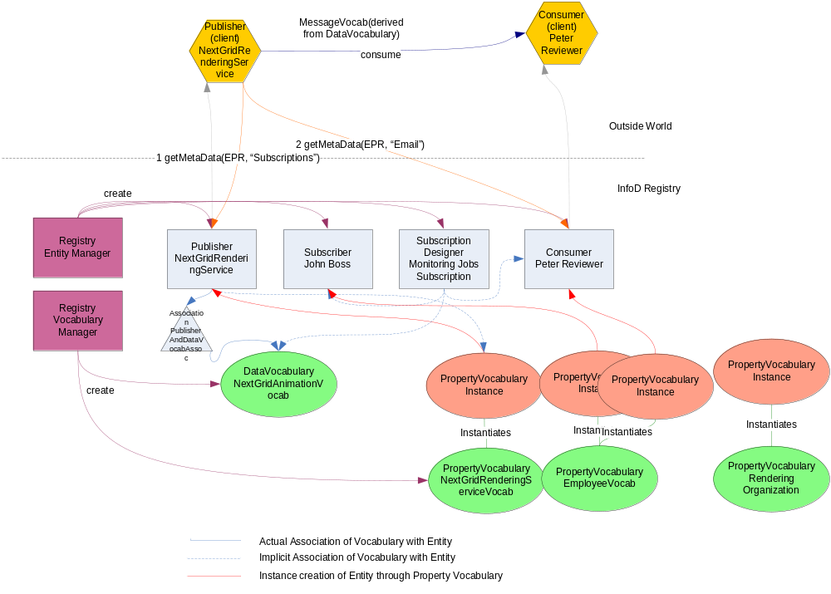

8 Create an Instance using the Property Vocabulary (for the publisher)
Note: INTERFACE DOC: Distinguish between defining/creating a vocabulary and create instances using a vocabulary

<wsinfod:CreatePropertyVocabularyInstance> Note: formerly CreateVocabularyInstance - TBD

<wsinfod:VocabularyInstanceEntityReference>
NextGridRenderingServiceEPR
</wsinfod:VocabularyInstanceEntityReference>

<wsinfod:VocabularyInstanceVocabularyType> Note: INTERFACE DOC: not used anymore
[“INFOD_Property_Vocabulary” | “INFOD_Data_Vocabulary”]
</wsinfod:VocabularyInstanceVocabularyType>

<wsinfod:VocabularyInstanceVocabularyReference>
RenderingServiceVocabEPR
</wsinfod:VocabularyInstanceVocabularyReference>

<wsinfod:VocabularyInstanceVocabularyBody>
<?xml version="1.0"?>
<xsd:schema xmlns:xsd="http://www.w3.org/2001/XMLSchema"
xmlns:ident="http://www.w3.org/INFOD/Entity"
targetNamespace="http://www.w3.org/INFOD/Entity">
<Service_Name>SuperInc Rendering Service</Service_Name>
<Service_Organisation>SuperInc</Service_Organization>
<Service_Address>http://superinc.com</Service_Address>
<Rendering_Software>3D Max</Rendering_Software>
<Pricing_Model>myPricingModel</Pricing_Model>
</wsinfod:VocabularyInstanceVocabularyBody>

</wsinfod:CreateVocabularyInstance>

9-x getMetadata calls

X+1 Consume

Message Body to Consumer
The below defines the XML schema for a message body. The type of the body is infoDMsg:BodyType.

<element name=”Body” type=”infoDMsg:BodyType”/>
<complexType name=”infoDMsg:BodyType”>
<sequence>
<element name=”Type” type=”string”/>
<element name=”Length” type=”integer”/>
<element name=”Data” type=”extensionType”/>
“JobName=AnimationJobID12345
DesignerName=Peter Designer
Status=Completed”
<element name=”Flag” type=”integer”/>
<element name=”Transform” type=”string”/>
</sequence>
</complexType>

