AugerAccess Use Case

Summary
AugerAccess (http://www.augeraccess.net/menu.htm) is a project dedicated to improve the access capabilities of European research groups to the Pierre Auger Observatory. Located in a field area in the Pampa Amarilla in Argentina the Auger Observatory is designed to measure the flux of ultra-high energy cosmic ray particles with unprecedented accuracy and statistical significance, whereas the measured data of the particles is event based and time controlled.
Realization of reliable and large bandwidth connectivity between the Auger Observatory and the rest of the world will allow the implementation of techniques for remote monitoring of the detectors and the use of remote databases. This in turn will provide fast feedback on the quality of the data being taken at the observatory, giving the possibility of the rapid discovery of malfunctioning detector components with the consequence of early remedial action.
The presented use case describes the requirements for the remote control and remote monitoring of the telescopes (Fluorescence Detectors FD) of the Pierre Auger Observatory.

Customers
To control and monitor the FD of the Auger Observatory remotely, the users must have access to the telescopes from the world wide networks to the private Auger networks. So they must be able to access the six telescopes in every of the four telescope buildings and to start up, calibrate, monitor and shutdown the system as well as manage the data acquisition and Slow control system.
One aim of the remote control is that a developer of the systems can assist a local collaborator at the central campus.
Nevertheless the main aim is that it should be possible to control and monitor the system remotely without having any local collaborator at the central campus.

Scenarios
The aim of the use case is to remotely control and monitor the Data Acquisition (DAQ) and Slow control system of the FD of the Auger Observatory, where the primary scenario is very simple (the different states in the brackets can be seen in the State Machine of the DAQ - figure1):

Init + test:
- Switch on the hardware (kIdle)
  - Create a new log file for the shift
  - Check network connectivity and communication
    - Is it available – if not switch it on
  - Check if all needed services (software) are running on the especial PCs
    - If not restart them
Configure:
- Calibrate the hardware (kCalibration)
  - Set hardware default parameters
  - Set system in calibration mode
  - Provide reference input and check if output is of reference values
  - Record dead pixels of the FDs in the log file
Init data acquisition software:
- Start data acquisition (kDAQ)
  - Set system to data acquisition mode
  - Attach the needed telescopes
  - Start the run
Measurement and monitoring:
- Monitor the run
  - Check the variance of all attached telescopes
  - Check weather conditions (rain, storm, moon light)
  - Check if the components are still available
  - Check trigger rates and incoming data
  - Check the measured events – to much normally belongs to lightning
- Measured data
  - The data is stored in a ROOT tree
  - Automatic storage or replication to Grid infrastructures or storage elements
Shutdown:
- Shutdown the system
  - Stop the run of the DAQ
  - Calibrate the system again (see above)
  - Stop all the services not needed any more
  - Bring the hardware in standby mode (kIdle)

The DAQ of the FD also have a secondary scenario as it is necessary to dynamically add or remove telescopes from one or even more telescope buildings to the DAQ. Therefore another scenario is needed:

Add or remove telescope(s):
- Stop the DAQ in the according building
- Add or remove the telescope(s)
- Newly added telescope sub-systems will be automatically parameterized
- Start the data acquisition with the new configuration
  - System is already in data acquisition mode (kDAQ) – simply start it
- Monitor the run (see above)

Involved resources
The system for data acquisition with the telescopes is very complex and shown in figure 2. For the remote control and monitoring of the system it is important to access it from outside the central campus. The access from outside to the telescope buildings (Los Leones, Los Morados, Loma Amarilla and Coihueco) is only possible via the Ipecdas computer, as the Auger network only consists of components in class A and B private subnets.
Every telescope building consists of a Calibration PC (for calibration of the telescopes located in the building), Slow Control PC (to prevent the system from damage), Eye PC, six Mirror PCs, six Front-End-Crates (custom hardware for measuring data with the telescopes and capable to handle a huge data rate up to several thousand MByte/sec peak rate) and six telescopes each. The Eye PC allows the communication with the Mirror PCs as they are in an own private network. The MirrorPCs are needed to access the Front-End-Crates and the telescopes behind the MirrorPCs, to get the measured data out of telescopes, store it as a ROOT tree and replicate it for the post processing.
For the communication with the software part of the DAQ system (running on the Eye and Mirror PCs) there exists all needed functionality in the so called Pbus protocol, which allows the communication with the Front End Crates from the DAQ system.
The communication link from the central campus of the observatory to Mendoza is provided by the RETINA network. From there the international networks are accessible without bandwidth problems.

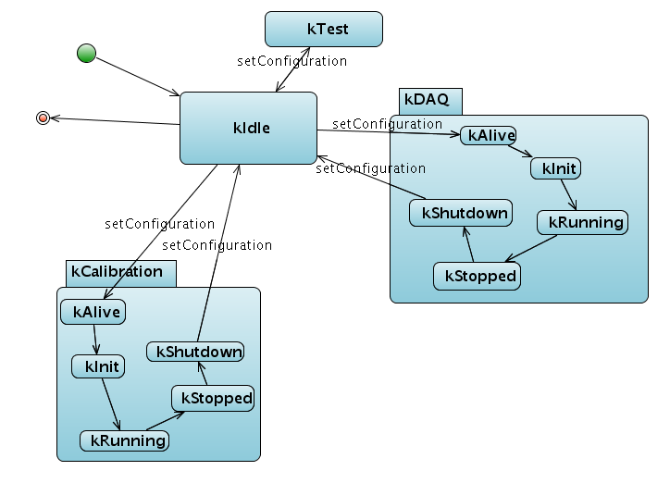

Figure 1. The State Machine of the DAQ system. Visible are the main configuration states (kIdle, KCalibration, kDAQ and kTest) and the sub states in which the system switches during runtime.
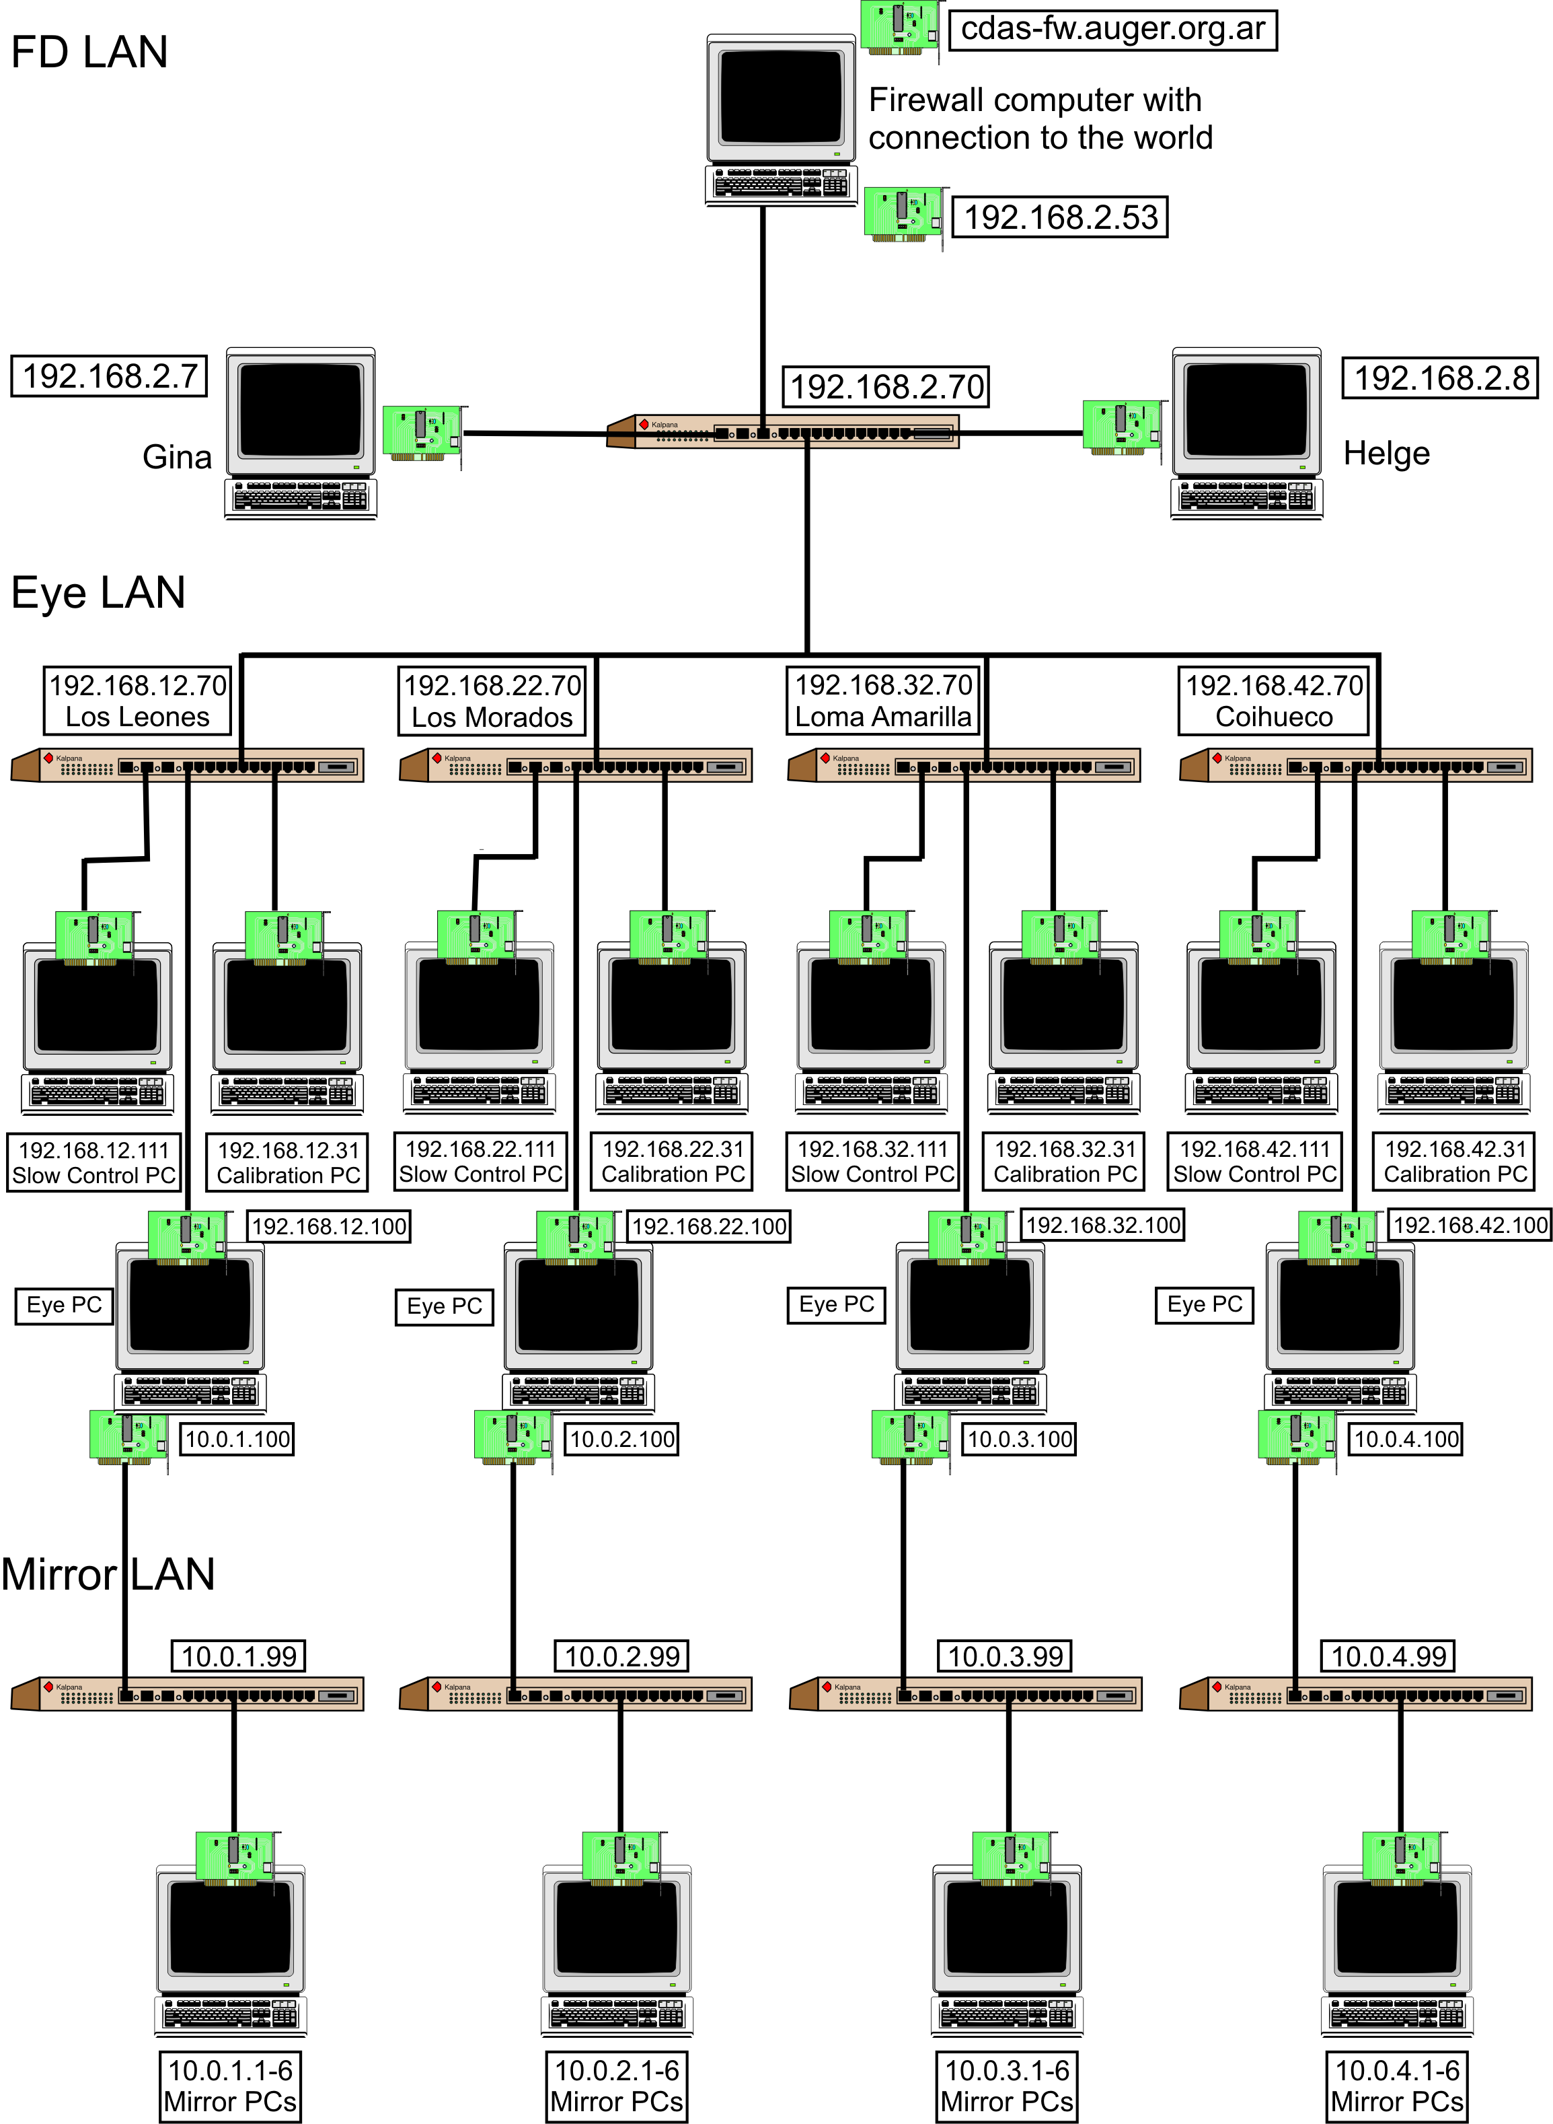

Figure 2. The scheme of the network needed for FD. Every computer and the connection to the network with switches and network cards are visible. Behind the Mirror PCs are the Front-End-Crates and telescopes
Functional requirements
For a successful remote control of the Auger Observatory the availability and accessibility of the system is essential. This means on the one hand the connection inside the central campus to the telescope buildings and on the other hand the connection from world wide networks to the central campus. For the connection from outside the central campus at least a 10 Mbit/s communication link is required.
Also the measured data should be automatically stored and/or replicated to Grid infrastructures or storage elements to provide easy access for the post processing of the measured data. So we don’t only need remote control, but also remote data acquisition probabilities.

Non functional requirements
A strong cryptography for user authentication and communication with the systems from world wide is a strict requirement. Otherwise it is not possible to ensure that the measured data is authentic.
Also it is important to define different security levels for different user groups to allow peoples only the access belonging to the group rights, e.g. if it should be allowed to update the software of the system:
- Software update of the system (highest)
- Control and monitor the system (high)
- Reading measured data (lowest)

A successful measurement with the FD is only at night and when the fraction of the moon illuminated at midnight isn’t too high possible, as the FDs are very light-sensitive. A timetable for the possible measurement dates with the FDs can be obtained from the Astronomical Applications Department. Therefore choose UTC as the time zone and press the “Compute table” button. As approximate value it is possible to measure with the FDs when the fraction is below 0.6. From this table the FDs for measurement are chosen, belonging to the date, location of the FDs and the moon.
The real time properties for measuring data with the telescopes are handled by the Front-End-Crates, as they are especially developed for this purpose.

Related work
All the work is done in the scope of the AugerAccess project (http://www.augeraccess.net/menu.htm).
This includes the setup of a virtual testbed for simulating the whole hardware architecture of the Auger Observatory and the development of software for remote control of the especial systems. This software is based on GT 4 Grid security for authentication and authorization of the users from world wide and Axis 2 services for the communication inside the Auger Observatory.

Use case situation analysis
The presented use case offers necessary requirements for remote instrumentation in Grid environments. These are the authentication and authorization of the users and the secure communication with the systems. Special for the presented use case is the access to private networks for controlling the observatory from world wide, the dynamical adding and removing of telescopes to the running system, the need for different security levels for different user groups and the need for remote data acquisition, not only remote control.
Therefore needed is a fast and reliable communication link to the observatory to make the remote control and monitoring possible and to replicate the measured data to server’s located world wide. The communication link at the moment is provided by the RETINA network, but will be replaced by a faster 10Mbit/s link from the AugerAccess project.
All the hardware and network components inside the central campus of the Auger Observatory are provided from the Auger collaboration.

References
[1] H. Gemmeke, “The Auger Fluorescence Detector electronics”, ICRC 2001 (http://www.auger.org/technical_info/pdfs/icrc2001/papers/ici6189_p.pdf).
[2] H.-J. Mathes, S. Argiro, A. Kopmann and O. Martineau, “The DAQ system for the Fluorescence Detectors of the Pierre Auger Observatory”, Chep 2004 (http://indico.cern.ch/contributionDisplay.py?contribId=119&sessionId=3&confId=0)

