AutoBAHN architecture and requests

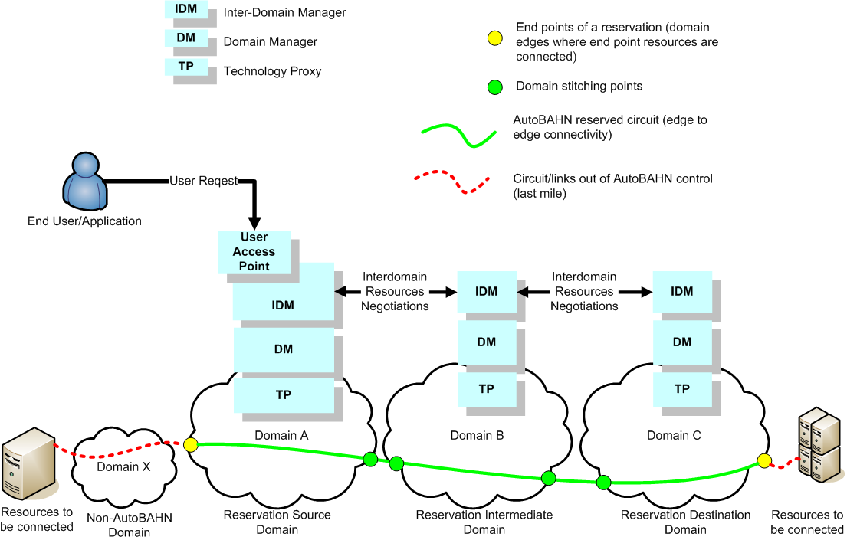

The above AutoBAHN architecture overview depicts the main terminology used in GN2 JRA3 activity. Resources to be connected are in fact the end points of whole circuit, but in fact the circuit is created by AutoBAHN only between edge points (edge to edge reservation). Thus the yellow points are the end points of the circuit/reservation in this context. The green points are ingress and egress points of particular domains where circuit is configured. Domain X, where one of the resources is connected, is out of AutoBAHN management. It is up to this domain administrator to

User request example:

<soap:Envelope xmlns:soap="http://schemas.xmlsoap.org/soap/envelope/">
<soap:Body>
<ns2:submitService xmlns:ns2="http://useraccesspoint.jra3.geant2.net/">
<request>
<userName>user1</userName>
<reservations>
<startPort>10.10.32.5</startPort><endPort>10.11.32.10</endPort>
<startTime>2008-12-11T12:29:36.343+01:00</startTime><endTime>2008-12-11T12:30:36.343+01:00</endTime>
<priority>NORMAL</priority>
<description>res1</description>
<capacity>500000000</capacity>
<maxDelay>0</maxDelay>
<resiliency>NONE</resiliency>
<bidirectional>false</bidirectional>
<processNow>false</processNow>
</reservations>
</request>
</ns2:submitService>
</soap:Body>
</soap:Envelope>

The user needs to specify:
- The request must be sent to proper IDM. In general any IDM is fine, while user home domain is preferred. However current implementation expects that request is sent to reservation source domain (the first one on a path).
- end ports of the reservation
- start and end time of the reservation
- priority (currently ignored)
- description (just informational purposes)
- reserved circuit capacity (bps)
- maximum allowed delay on the circuit (currently ignored, but pathfinding is optimized with delay)
- requested resiliency type (1:1, 1:n, 1+1, currently ignored, work in progress)
- bidirectional – indication whether circuit needs to be uni- or bidirectional (currently only bidirectional circuits are created, attribute is ignored)
- processNow – used to force system to schedule and activate reservation immediately (forces start time attribute to be ignored)

A part of User Access Point WSDL file for service/reservations request
<xs:complexType name="ServiceRequest">
<xs:sequence>
<xs:element minOccurs="0" name="userName" type="xs:string"/>
<xs:element minOccurs="0" name="userHomeDomain" type="xs:string"/>
<xs:element minOccurs="0" name="userEmail" type="xs:string"/>
<xs:element minOccurs="0" name="justification" type="xs:string"/>
<xs:element maxOccurs="unbounded" name="reservations" nillable="true" type="tns:ReservationRequest"/>
</xs:sequence>

<xs:complexType name="ReservationRequest">
<xs:sequence>
<xs:element minOccurs="0" name="startPort" type="xs:string"/>
<xs:element minOccurs="0" name="endPort" type="xs:string"/>
<xs:element minOccurs="0" name="startTime" type="xs:dateTime"/>
<xs:element minOccurs="0" name="endTime" type="xs:dateTime"/>
<xs:element minOccurs="0" name="priority" type="ns1:priority"/>
<xs:element minOccurs="0" name="description" type="xs:string"/>
<xs:element name="capacity" type="xs:long"/>
<xs:element name="maxDelay" type="xs:int"/>
<xs:element minOccurs="0" name="resiliency" type="ns1:resiliency"/>
<xs:element name="bidirectional" type="xs:boolean"/>
<xs:element name="processNow" type="xs:boolean"/>
</xs:sequence>
</xs:complexType>

The request forwarded to neighbor IDM, has the following form (IDM to IDM request example):
<soap:Envelope xmlns:soap="http://schemas.xmlsoap.org/soap/envelope/">
<soap:Body>
<ns1:scheduleReservation xmlns:ns1="http://interdomain.jra3.geant2.net/">
<reservation>
<bodID>localhost:8080@1228996801734_res_1</bodID>
<startPort>
<bodID>10.10.32.5</bodID>
<address>10.10.32.5</address>
<technology>Ethernet</technology>
<bundled>false</bundled>
<node>
<bodID>10.10.0.2</bodID>
<provisioningDomain>
<bodID>http://client-domain.domain1.com</bodID>
<adminDomain>
<bodID>http://client-domain.domain1.com</bodID>
<name>http://client-domain.domain1.com</name>
<clientDomain>true</clientDomain>
</adminDomain>
</provisioningDomain>
</node>
</startPort>
<endPort>
<bodID>10.11.32.10</bodID>
<address>10.11.32.10</address>
<technology>Ethernet</technology>
<bundled>false</bundled>
<node>
<bodID>10.11.0.3</bodID>
<provisioningDomain>
<bodID>http://client-domain.domain2.com</bodID>
<adminDomain>
<bodID>http://client-domain.domain2.com</bodID>
<name>http://client-domain.domain2.com</name>
<clientDomain>true</clientDomain>
</adminDomain>
</provisioningDomain>
</node>
</endPort>
<startTime>2008-12-11T13:03:01.578+01:00</startTime>
<endTime>2008-12-11T13:04:01.578+01:00</endTime>
<priority>0</priority>
<description>res1</description>
<capacity>500000000</capacity>
<maxDelay>0</maxDelay>
<resiliency>NONE</resiliency>
<bidirectional>false</bidirectional>
<globalConstraints>
<domainsIds>http://localhost:8080/autobahn/interdomain</domainsIds>
<domainConstraints>
<pathConstraints>
<rangeNames>VLANS</rangeNames>
<rangeConstraints>
<ranges>
<min>150</min>
<max>200</max>
</ranges>
</rangeConstraints>
</pathConstraints>
</domainConstraints>
</globalConstraints>
<path>
<links>
<bodID>10.10.64.1</bodID>
<kind>3</kind>
<startPort>
<bodID>10.10.32.4</bodID>
<address>10.10.32.4</address>
<technology>Ethernet</technology>
<bundled>false</bundled>
<node>
<bodID>10.10.0.1</bodID>
<provisioningDomain>
<bodID>http://localhost:8080/autobahn/interdomain</bodID>
<adminDomain>
<bodID>http://localhost:8080/autobahn/interdomain</bodID>
<name>http://localhost:8080/autobahn/interdomain</name>
<clientDomain>false</clientDomain>
</adminDomain>
</provisioningDomain>
</node>
</startPort>
<endPort>
<bodID>10.10.32.5</bodID>
<address>10.10.32.5</address>
<technology>Ethernet</technology>
<bundled>false</bundled>
<node>
<bodID>10.10.0.2</bodID>
<provisioningDomain>
<bodID>http://client-domain.domain1.com</bodID>
<adminDomain>
<bodID>http://client-domain.domain1.com</bodID>
<name>http://client-domain.domain1.com</name>
<clientDomain>true</clientDomain>
</adminDomain>
</provisioningDomain>
</node>
</endPort>
<bidirectional>false</bidirectional>
<delay>0</delay>
<manualCost>0.0</manualCost>
<monetaryCost>0.0</monetaryCost>
<granularity>0</granularity>
<minResCapacity>0</minResCapacity>
<maxResCapacity>0</maxResCapacity>
<capacity>1000000000</capacity>
<type>
<type>2</type>
</type>
<operationalState>
<state>1</state>
</operationalState>
<administrativeState>
<state>1</state>
</administrativeState>
</links>
<links>
<bodID>10.10.64.0</bodID>
<kind>1</kind>
<startPort>
<bodID>10.10.32.0</bodID>
<address>10.10.32.0</address>
<technology>Ethernet</technology>
<bundled>false</bundled>
<node>
<bodID>10.10.0.0</bodID>
<provisioningDomain>
<bodID>http://localhost:8080/autobahn/interdomain</bodID>
<adminDomain>
<bodID>http://localhost:8080/autobahn/interdomain</bodID>
<name>http://localhost:8080/autobahn/interdomain</name>
<clientDomain>false</clientDomain>
</adminDomain>
</provisioningDomain>
</node>
</startPort>
<endPort>
<bodID>10.10.32.1</bodID>
<address>10.10.32.1</address>
<technology>Ethernet</technology>
<bundled>false</bundled>
<node>
<bodID>10.10.0.1</bodID>
<provisioningDomain>
<bodID>http://localhost:8080/autobahn/interdomain</bodID>
<adminDomain>
<bodID>http://localhost:8080/autobahn/interdomain</bodID>
<name>http://localhost:8080/autobahn/interdomain</name>
<clientDomain>false</clientDomain>
</adminDomain>
</provisioningDomain>
</node>
</endPort>
<bidirectional>false</bidirectional>
<delay>0</delay>
<manualCost>0.0</manualCost>
<monetaryCost>0.0</monetaryCost>
<granularity>0</granularity>
<minResCapacity>0</minResCapacity>
<maxResCapacity>0</maxResCapacity>
<capacity>10000000000</capacity>
<type>
<type>2</type>
</type>
<operationalState>
<state>1</state>
</operationalState>
<administrativeState>
<state>1</state>
</administrativeState>
</links>
<links>
<bodID>10.12.64.1</bodID>
<kind>3</kind>
<startPort>
<bodID>10.10.32.3</bodID>
<address>10.10.32.3</address>
<technology>Ethernet</technology>
<bundled>false</bundled>
<node>
<bodID>10.10.0.0</bodID>
<provisioningDomain>
<bodID>http://localhost:8080/autobahn/interdomain</bodID>
<adminDomain>
<bodID>http://localhost:8080/autobahn/interdomain</bodID>
<name>http://localhost:8080/autobahn/interdomain</name>
<clientDomain>false</clientDomain>
</adminDomain>
</provisioningDomain>
</node>
</startPort>
<endPort>
<bodID>10.12.32.0</bodID>
<address>10.12.32.0</address>
<technology>Ethernet</technology>
<bundled>false</bundled>
<node>
<bodID>10.12.0.0</bodID>
<provisioningDomain>
<bodID>http://localhost:8082/autobahn/interdomain</bodID>
<adminDomain>
<bodID>http://localhost:8082/autobahn/interdomain</bodID>
<name>http://localhost:8082/autobahn/interdomain</name>
<clientDomain>false</clientDomain>
</adminDomain>
</provisioningDomain>
</node>
</endPort>
<bidirectional>false</bidirectional>
<delay>0</delay>
<manualCost>0.0</manualCost>
<monetaryCost>0.0</monetaryCost>
<granularity>0</granularity>
<minResCapacity>0</minResCapacity>
<maxResCapacity>0</maxResCapacity>
<capacity>1000000000</capacity>
<type>
<type>2</type>
</type>
<operationalState>
<state>1</state>
</operationalState>
<administrativeState>
<state>1</state>
</administrativeState>
</links>
<links>
<bodID>10.12.64.2</bodID>
<kind>3</kind>
<startPort>
<bodID>10.11.32.7</bodID>
<address>10.11.32.7</address>
<technology>Ethernet</technology>
<bundled>false</bundled>
<node>
<bodID>10.11.0.1</bodID>
<provisioningDomain>
<bodID>http://localhost:8081/autobahn/interdomain</bodID>
<adminDomain>
<bodID>http://localhost:8081/autobahn/interdomain</bodID>
<name>http://localhost:8081/autobahn/interdomain</name>
<clientDomain>false</clientDomain>
</adminDomain>
</provisioningDomain>
</node>
</startPort>
<endPort>
<bodID>10.12.32.1</bodID>
<address>10.12.32.1</address>
<technology>Ethernet</technology>
<bundled>false</bundled>
<node>
<bodID>10.12.0.0</bodID>
<provisioningDomain>
<bodID>http://localhost:8082/autobahn/interdomain</bodID>
<adminDomain>
<bodID>http://localhost:8082/autobahn/interdomain</bodID>
<name>http://localhost:8082/autobahn/interdomain</name>
<clientDomain>false</clientDomain>
</adminDomain>
</provisioningDomain>
</node>
</endPort>
<bidirectional>false</bidirectional>
<delay>0</delay>
<manualCost>0.0</manualCost>
<monetaryCost>0.0</monetaryCost>
<granularity>0</granularity>
<minResCapacity>0</minResCapacity>
<maxResCapacity>0</maxResCapacity>
<capacity>1000000000</capacity>
<type>
<type>2</type>
</type>
<operationalState>
<state>1</state>
</operationalState>
<administrativeState>
<state>1</state>
</administrativeState>
</links>
<links>
<bodID>10.11.64.1</bodID>
<kind>1</kind>
<startPort>
<bodID>10.11.32.2</bodID>
<address>10.11.32.2</address>
<technology>Ethernet</technology>
<bundled>false</bundled>
<node>
<bodID>10.11.0.2</bodID>
<provisioningDomain>
<bodID>http://localhost:8081/autobahn/interdomain</bodID>
<adminDomain>
<bodID>http://localhost:8081/autobahn/interdomain</bodID>
<name>http://localhost:8081/autobahn/interdomain</name>
<clientDomain>false</clientDomain>
</adminDomain>
</provisioningDomain>
</node>
</startPort>
<endPort>
<bodID>10.11.32.3</bodID>
<address>10.11.32.3</address>
<technology>Ethernet</technology>
<bundled>false</bundled>
<node>
<bodID>10.11.0.1</bodID>
<provisioningDomain>
<bodID>http://localhost:8081/autobahn/interdomain</bodID>
<adminDomain>
<bodID>http://localhost:8081/autobahn/interdomain</bodID>
<name>http://localhost:8081/autobahn/interdomain</name>
<clientDomain>false</clientDomain>
</adminDomain>
</provisioningDomain>
</node>
</endPort>
<bidirectional>false</bidirectional>
<delay>0</delay>
<manualCost>0.0</manualCost>
<monetaryCost>0.0</monetaryCost>
<granularity>0</granularity>
<minResCapacity>0</minResCapacity>
<maxResCapacity>0</maxResCapacity>
<capacity>1000000000</capacity>
<type>
<type>2</type>
</type>
<operationalState>
<state>1</state>
</operationalState>
<administrativeState>
<state>1</state>
</administrativeState>
</links>
<links>
<bodID>10.11.64.3</bodID>
<kind>3</kind>
<startPort>
<bodID>10.11.32.8</bodID>
<address>10.11.32.8</address>
<technology>Ethernet</technology>
<bundled>false</bundled>
<node>
<bodID>10.11.0.2</bodID>
<provisioningDomain>
<bodID>http://localhost:8081/autobahn/interdomain</bodID>
<adminDomain>
<bodID>http://localhost:8081/autobahn/interdomain</bodID>
<name>http://localhost:8081/autobahn/interdomain</name>
<clientDomain>false</clientDomain>
</adminDomain>
</provisioningDomain>
</node>
</startPort>
<endPort>
<bodID>10.11.32.10</bodID>
<address>10.11.32.10</address>
<technology>Ethernet</technology>
<bundled>false</bundled>
<node>
<bodID>10.11.0.3</bodID>
<provisioningDomain>
<bodID>http://client-domain.domain2.com</bodID>
<adminDomain>
<bodID>http://client-domain.domain2.com</bodID>
<name>http://client-domain.domain2.com</name>
<clientDomain>true</clientDomain>
</adminDomain>
</provisioningDomain>
</node>
</endPort>
<bidirectional>false</bidirectional>
<delay>0</delay>
<manualCost>0.0</manualCost>
<monetaryCost>0.0</monetaryCost>
<granularity>0</granularity>
<minResCapacity>0</minResCapacity>
<maxResCapacity>0</maxResCapacity>
<capacity>1000000000</capacity>
<type>
<type>2</type>
</type>
<operationalState>
<state>1</state>
</operationalState>
<administrativeState>
<state>1</state>
</administrativeState>
</links>
<monetary_cost>0.0</monetary_cost>
<manual_cost>0.0</manual_cost>
<capacity>1000000000</capacity>
</path>
<intState>4</intState>
</reservation>
</ns1:scheduleReservation>
</soap:Body>
</soap:Envelope>

The request between IDMs are far more complex due to addition of extra information. That includes:
- Defined path (abstracted links and nodes at inter-domain level). This information are part of topology information, thus the messaging implies some redundancy according to domain knowledge (e.g. link speed, cost, etc.). This is still field for optimization.
- Constraints that must be respected for global path (e.g. same VLAN identifier for Ethernet technology)

