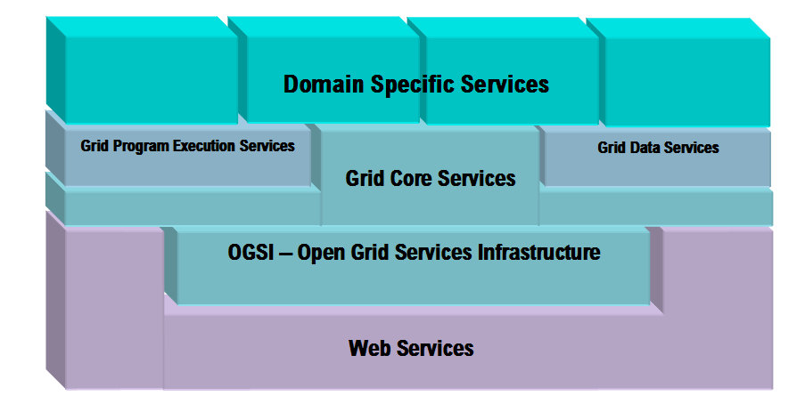
DFS: This diagram is a bit too restrictive. Many domain specific services may expose OGSI functions directly. They may even use Web Services. I would draw it as a stair for the infrastructure layers so that all layers reach to the Domain specific. Then draw multiple domain specific service one behind each other. I might also question the separation between Data and Program execution services, as I believe there to be some commonality quite far up the tree.

Core Services – These are the lowest level architected OGSA services that are the foundation for all other service components. They are expected to be exploited by most other higher level OGSA defined (whether architected or not) services and are probably required in all OGSA implementations. They provide fundamental means for services to be instantiated, interact, communicate, and be managed.

Services Management – These are services primarily intended to help manage the overall distributed services grid. The provide means for services to be registered and locate each other as well a mechanisms for composing multiple lower level services into aggregations. They also include functions for deploying the software images that implement services in hosting environments and collecting data about their operation for management, accounting and billing purposes.

DFS: The work of CMM should fill in the infrastructure to these services.

Service Groups and Discovery Services
Attribute Naming and Registries
Path Naming and Directories
Service Domain
Service Orchestration
Metering & Accounting
Installation & Deployment

Service Communication – The services provide the basic methods for services to communicate. They support several communication models that may be composed to permit effective inter-service communication.

DFS: These issues need to be clearly separated form binding level issues, e.g. reliable messaging.

Messaging and Queuing Services
Event Services
Distributed Secure Logging
DFS; Security may be a management function.

Security - These components provide the means to secure inter-service communication including both message level protection (DFS: Isn't this a binding level issue?) and end-point (user or service) authentication. They provide for multi-domain security contexts to be created and maintain and mitigate between different security mechanisms and credential systems. They also supply a framework for policy-based authorization and access control that service can exploit to control their operation in various security contexts.

Authentication
Authorization & Access Control
Credential Validation & Transformation
Trust Broker

DFS: This Policy stuff is still very vague and abstract. Clearly there need to be languages for policy representation. They could be exchanged via something like OGSI-Agreement. But these services seem undefined to me.

Policy Management – These services create a general framework for creation, administration and management of policies for system operation, security, resource allocation, etc. as well as an infrastructure for “policy aware” services to use the set of defined and managed policies to govern their operation. These services do not actually enforce policies but permit policies to be managed and delivered to resource managers that can interpret and operate on them.

Policy Service Manager
Policy Agent
Policy Transformation Service
Policy Resolution Service
Policy Validation Service
Policy Administration Services

Data Services - These are a group of services that provide fundamental management of and access to data in the distributed OGSA environment. They support various kinds of data formats including files, data bases, XML documents and application generated streams. They provide services for managing data sources in these various formats including catalogs that allow naming, attribute and location information to be used across the distributed grid environment. These service support a variety of data access methods and interfaces that deliver information to distributed grid applications as record sets, binary or character streams, relational tables, XML documents etc. In some instances these services may provide translation of data sources from one format to another to meet applications requirements. They may also supply capabilities to allow federation of data in disparate formats. These services will also provide for management of the quality of service (QoS, performance and quality of data (QoD, consistency, completeness, correctness). To do this they may employ mechanisms such as remote data access, data replication, and distribution caching to keep needed data logically “near” executing distributed applications.

Data Access Services
Data Transformation & Federation Services
Data Replication Service
Data Cacheing Service
MetaData Catalog Services

Program Execution Services – These OGSA services provide a defined set of interfaces and methods for managing program execution in the distributed grid system. On top of the OGSA service oriented architecture they provide a means for creating and orchestrating arbitrary program execution. The “jobs” that these services define and manage may themselves be fundamental or composed “grid services” or they may be “wrapped” executables that run outside the OGSA defined infrastructure and exploit this framework of service to “attach” them to other OGSA components for management, communication and other services. The services include functions for managing collections of “executables” as a single entity and for scheduling and managing the execution of these collections across the distributed resources in the grid.

Job Scheduler & Queuing Services
Resource Reservation Services
Workload Managers and Micro-Scheduling Services

