GLUE Specification v. 2.0 (draft 5)

Status of This Document

This document provides information to the Grid community regarding the specification of the GLUE information model. Distribution is unlimited. This document is a draft.

Copyright Notice

Copyright © Open Grid Forum (2007). All Rights Reserved.

Trademark

Open Grid Services Architecture and OGSA are trademarks of the Open Grid Forum.

Abstract

Contents

Abstract 1
1. Introduction 3
2. Notational Conventions 3
3. Conceptual Model of the Main Entities 4
3.1 Domain 4
3.1.1 AdminDomain 5
3.1.2 UserDomain 5
3.2 Policy 5
3.2.1 ManagementPolicy 5
3.2.2 AccessPolicy 6
3.3 Element 6
3.4 Service 6
3.5 Share 7
3.6 Resource 7
3.7 Activity 7
4. Conceptual Model of the Computing Element 9
4.1 ComputingElement 9
4.2 ComputingResource 10
4.3 ExecutionEnvironment 10
4.4 ApplicationEnvironment 11
4.5 ComputingService 11
4.6 ComputingShare 12
4.7 ComputingSharePolicy 12
4.8 ComputingShareState 12
4.9 Job 13
5. Conceptual Model of the Storage Element 14
6. Relationship to OGF Reference Model 15
7. Collection of Questions and Open Issues 15
8. Template 16
9. Security Considerations 17
10. Contributors 17
11. Glossary 17
12. Intellectual Property Statement 17
13. Disclaimer 17
14. Full Copyright Notice 18
15. References 19

Introduction

In this document, we present a conceptual information model for Grid entities described in natural language enriched with a graphical representation using UML Class Diagrams. As a conceptual model, this is meant to be implementation-independent. Mapping to concrete data models such as XML Schema, LDAP, relational and RDF are provided in the Appendix. From the semantic viewpoint, the concrete data model should represent the same concepts and relationships of the conceptual information model; nevertheless it can contain simplifications specific to the target data model in order to improve query performance or other aspects.
This information model is based on the experience of several modeling approaches being used in current production Grid infrastructures (e.g., GLUE Schema 1.x [glue-1.x], NorduGrid schema [ng-schema], Naregi model [naregi-schema]). The proposed initial collection of entities is motivated also by the use cases document [glue-usecases].

Notational Conventions

Only include this section if applicable.

The key words ‘MUST,” “MUST NOT,” “REQUIRED,” “SHALL,” “SHALL NOT,” “SHOULD,” “SHOULD NOT,” “RECOMMENDED,” “MAY,” and “OPTIONAL” are to be interpreted as described in RFC 2119 [BRADNER1]

Conceptual Model of the Main Entities

The GLUE information model proposes a number of main entities and relationships represented in Figure 1.

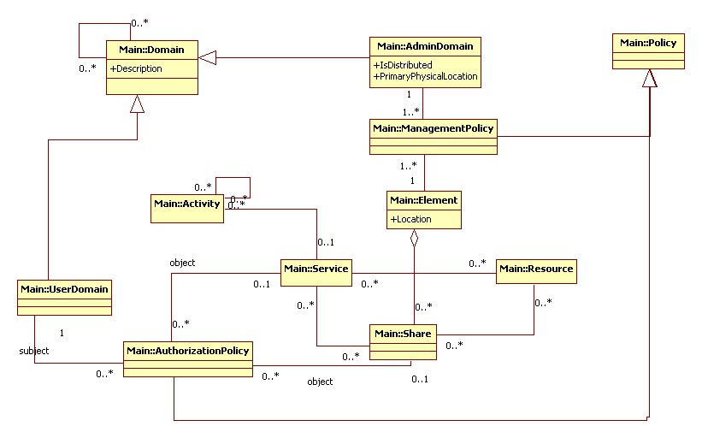
Figure 1 GLUE main entities and their relationships

Domain

Entity | Inherits from |  |  | Description
Domain |  |  |  | Assignment of roles to a collection of actors where their roles and privileges are governed by policies. A domain may have relationships to other domains.
Property | Type | Mult. | Unit | Description

A Virtual Organization (VO) comprises a set of individuals and/or institutions having direct access to computers, software, data, and other resources for collaborative problem-solving or other purposes. Resources utilized by a VO are expected to be provisioned via Service Level Agreement’s (SLA). The VO can exhibit the internal structure in terms of groups of individuals.
In the GLUE Information Model, the Virtual Organization can be realized by using the concept of Domain. If the VO has an internal structure, this can be represented by using different domains related to each other.

AdminDomain

Entity | Inherits from |  |  | Description
AdminDomain | Domain |  |  | Assignment of administrative roles and privileges to a collection of actors via policies. An AdminDomain may be linked to one or more physical locations through the managed entities.
Property | Type | Mult. | Unit | Description
IsDistributed | boolean | 1
PrimaryPhysicalLocation |  | 1

Properties from old schemas: URI (ex-UniqueID), Name, Description, Contact (Email, Web page, ...), Location (Latitude, Longitude, ...?), Sponsor, OtherInfo

UserDomain

Entity | Inherits from |  |  | Description
UserDomain | Domain |  |  | Assignment of user roles and privileges to a collection of actors via policies. Such policies may apply to services or shares
Property | Type | Mult. | Unit | Description

Policy

Entity | Inherits from |  |  | Description
Policy |  |  |  | Statements, rules or assertions that specify the correct or expected behavior of an entity
Property | Type | Mult. | Unit | Description

ManagementPolicy

Entity | Inherits from |  |  | Description
ManagementPolicy | Policy |  |  | Statements, rules or assertions that assign management capabilities to actors as regards a manageable entity
Property | Type | Mult. | Unit | Description

AccessPolicy

Entity | Inherits from |  |  | Description
AccessPolicy | Policy |  |  | Statements, rules or assertions that govern the access by actors to an entity
Property | Type | Mult. | Unit | Description

Element

Entity | Inherits from |  |  | Description
Element |  |  |  | It groups concepts that participate in the creation of an entity useful in a Grid environment. The element is autonomous and denotes a weak aggregation of services, the exposed resources, and the defined shares.  The element enables to identify the whole set of entities providing a functionality with a persistent name.
Property | Type | Mult. | Unit | Description
Location |  | 1 |  | Physical location of the Element, i.e., physical location of the related entities

The simplest Element is composed by one single service (e.g., metadata catalogue service). Other types of Element can include both services and the exposed resources where services apply shares to resource access. In an element, the same resource part of it can be shared across multiple services. For instance, in the area of storage systems, SRMv1 and SRMv2.2 services can expose the same resource via different interface versions; in the area of computing systems, the CREAM and GRAM services can expose the same batch system.

Service

Entity | Inherits from |  |  | Description
Service |  |  |  | An abstracted, logical view of actual software components having a well-defined interface and offering one or more functionalities; it may have network endpoint(s); it abstracts some functionality
Property | Type | Mult. | Unit
Key,Value pairs

For Grid services requiring a richer set of properties, specific models can be defined by specializing from the Service entity and adding new properties or relationships. The current proposal contains the Computing Service specialization (see Section )

properties from old schemas: URI (ex-UniqueID), Name, Type, Version, Endpoint, Status, StatusInfo, WSDL (?), Semantics, StartTime, Owner (?), AccessControlBaseRule (AuthorizationInfo), ServiceData=set of (Key,Value), Authentication (nordugrid-cluster-issuerca-hash, nordugrid-cluster-trustedca nordugrid-cluster-issuerca), SupportedProfile

Share

Entity | Inherits from |  |  | Description
Share |  |  |  | A utilization target for a set of resources defined by policies and characterized by status information
Property | Type | Mult. | Unit | Description

Resource

Entity | Inherits from |  |  | Description
Resource |  |  |  | An entity that is useful in a Grid environment and offered through service(s). A resource usually represents aggregated information
Property | Type | Mult. | Unit | Description

For Grid resources requiring a richer set of properties, specific models can be defined by specializing from the Resource entity and adding new properties or relationships. The current proposal contains the Computing Resource specialization (see Section ).

Activity

Entity | Inherits from |  |  | Description
Activity |  |  |  | An activity is a unit of work managed by a service; an activity can have relationships to other activities being managed by different services, therefore it shares a common context.
Property | Type | Mult. | Unit | Description

Grid jobs are example of activities for a Computing Service. An interesting type of relationship for jobs derives from its propagation through several services. For instance, a broker service submits a Grid job to a selected execution service, upon completion the execution service submits a logging record to an accounting service. Each of these services will have associated an instance of a Grid job related to the lifecycle of the job within the service. All instances refer to the same conceptual job submitted by the user.

Conceptual Model of the Computing Element

The conceptual model of the Computing Element is based upon the main entities and uses specializations of Element, Resource, Share, Service and Activity entities. Further computing related concepts such as Execution Environment and Application Environment are introduced.

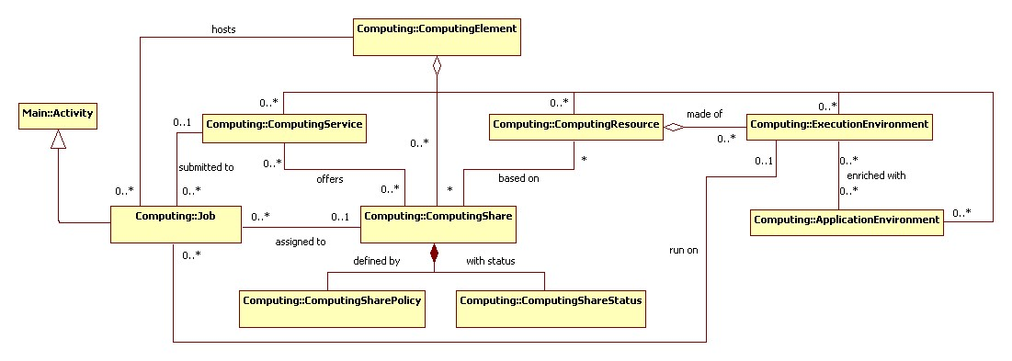
Figure 2 Entities and relationships for the Computing Element conceptual model

ComputingElement

Entity | Inherits from |  |  | Description
ComputingElement | Element |  |  | It groups concepts that participate in the creation of a entity providing computational capacity in a Grid environment. The element is autonomous and denotes a weak aggregation of computing services, the exposed computing resources, and the defined computing shares.  The element enables to identify the whole set of entities providing the computing functionality with a persistent name.
Property | Type | Mult. | Unit | Description

The simplest computing element is formed by a computing service exposing a computing resource via a single share. In case of a single computing resource exposed by multiple computing services, then such computing services are part of the computing element. In case of a computing service exposes many computing resources, then these computing resources are part of the computing element.

The computing element always aggregate computing services and resources forming a connected set. In other words, service A exposing resource A and service B exposing Resource B form two different computing elements. On the other side, Service A exposing Resource A and Service B exposing Resource A and B form a computing element.

Properties from previous schemas: URI, Name, LRMS(Type, Version, Note) (if the hypothesis that a CE maps to a set of resources managed by the same LRMS), nordugrid-cluster-support?, nordugrid-cluster-localse (similar to Glue.CESEBind.SEUniqueID), TotalJobs, RungningJobs, WaitingJobs, nordugrid-cluster-prelrmsqueued, nordugrid-cluster-owner, OtherInfo (e.g., to adversite a URL of a web page giving info about this element)

ComputingResource

Entity | Inherits from |  |  | Description
ComputingResource | Resource |  |  | Grouping concept for a set of different types of execution environments offered through computing service(s). The computing resource usually represents aggregated information. The aggregation is defined by the common local management scope.
Property | Type | Mult. | Unit | Description

A local resource management system like a batch system is an example of aggregation scope. The Operating System can be the simplest case of LRMS.
Properties fromold schemas: URI/LocalID (?), Total, Used, Physical/LogicalCPUs, Shared directories (e.g., TmpDir, ScratchDir, DataDir), Homogeneity, NetworkInfo (type of internal network available among the execution environments), Aggregated/Global Benchmark Info (?), CPUDistribution (number of boxes:number of CPUs, it can be repeated, e.g.: 1:16 3:2), nordugrid-cluster-sessiondir-free, nordugrid-cluster-sessiondir-total, nordugrid-cluster-cache-free, nordugrid-cluster-cache-total

ExecutionEnvironment

Entity | Inherits from |  |  | Description
ExecutionEnvironment |  |  |  | A description of hardware and software characteristics that defines the environments available to and requestable by a Grid job when submitted to a Computing Service; the description also includes information about the total/available/used instances of the execution environment
Property | Type | Mult. | Unit | Description

An execution environment can be realized in several ways. Examples are a computing node or a virtual machine image that can be requested by a job (different virtual machine images can coexist on the same node). The description about individual software packages is considered by the ApplicationEnvironment class.

Properties: URI/LocalID (?), Type (e.g., virtualnode, realnode, smp, thread, multicore), LogicalUnitNumber (?), Total, Used, Unavailable, Physical/LogicalCPUs, CPU (Vendor, Model, Version, ClockSpeed, InstructionSet, OtherDescription), Memory (RAMSize, VirtualSize), OS (Name, Release, Version), Node benchmark (e.g., SPECInt2000, SPECfp2000), NetworkConnectivity (Inbound, Outbound), PlatformType (e.g., IA64),

ApplicationEnvironment

Entity | Inherits from |  |  | Description
ApplicationEnvironment |  |  |  | Description of the application software environment available within one or more execution environments
Property | Type | Mult. | Unit | Description

The Application Environment is suggested to be used also for describing application software in terms of a simple tag.

properties from old schemas: ID (URI, local, global, relative?), Catalogue/NameServer, Name, Version, Status (e.g.: tested, dynamic, installable), Lifetime, Bootstrapping (InstalledRoot, EnvironmentSetup, ModuleName), SoftwareData: (key,value)

ComputingService

Entity | Inherits from |  |  | Description
ComputingService | Service |  |  | Service for creating, monitoring, and controlling computational activities called jobs
Property | Type | Mult. | Unit | Description

properties: staging capabilities attributes, suspend capabilities

ComputingShare

Entity | Inherits from |  |  | Description
ComputingShare |  |  |  | A utilization target for a set of computing resources defined by policies and characterized by status information
Property | Type | Mult. | Unit | Description

In a computing resource describing a batch system, a typical implementation of a computing share is via a batch queue with the associated policies and status information. The same computing share can be implemented using different batch system configuration strategies. In complex batch systems, it is possible to define different set of policies for the same batch queue, this will imply a share for each set of policies. A computing share can be implemented by virtual machine management systems. The model supports heterogeneity by being able to represent different execution environments associated to the same computing share.

properties: LocalID, Name, Max(WallTime, CPUTime, TotalJobs?, RunningJobs, WaitingJobs, nordugrid-cluster-prelrmsqueued, Memory, DiskSpace, SlotsPerJob, StageInStreams, StageOutStreams), Min (CPUTime, WallTime), Default (WallTime, CPUTime), preemption, priority?, authorization?, state (runningJobs, waitingJobs, totalJobs?, estimatedResponseTime, WorstResponseTime, freeJobSlots, Status?), meta-information (e.g., human-readable description, scheduling policy, comment), directory? (Data?, Application?), DefaultSE?, nordugrid-cluster-sessiondir-lifetime

ComputingSharePolicy

Entity | Inherits from |  |  | Description
ComputingSharePolicy |  |  |  | Set of policies that defines a computing share
Property | Type | Mult. | Unit | Description

ComputingShareState

Entity | Inherits from |  |  | Description
ComputingShareState |  |  |  | Set of attributes describing the dynamic state of a computing share
Property | Type | Mult. | Unit | Description

Job

Entity | Inherits from |  |  | Description
Job | Activity |  |  | An activity managed by an OGSA execution capability service
Property | Type | Mult. | Unit | Description
State

A Job is typically described by an XML document compliant to the JSDL specification. In this specification, the Job is related to a single processor job. Other job types such “collection of jobs” and workflows will be considered in a future revision.

properties: ID (globalID, localID, globalOwner, localOwner, nordugrid-job-jobname), Requests/Environment (nordugrid-job-reqwalltime, nordugrid-job-reqwalltime nordugrid-job-reqcputime, nordugrid-job-runtimeenvironment, nordugrid-job-cpucount, nordugrid-job-stdout nordugrid-job-stderr nordugrid-job-stdin), Status (nordugrid-job-comment, nordugrid-job-status, nordugrid-job-queuerank, nordugrid-job-rerunable, nordugrid-job-exitcode, nordugrid-job-errors, nordugrid-job-executionnodes, nordugrid-job-execcluster, nordugrid-job-execqueue, nordugrid-job-usedwalltime nordugrid-job-usedmem nordugrid-job-usedcputime, nordugrid-job-completiontime, nordugrid-job-submissionui, nordugrid-job-submissiontime, nordugrid-job-clientsoftware, nordugrid-job-gmlog, nordugrid-job-sessiondirerasetime, nordugrid-job-proxyexpirationtime), it would be useful to have a multi-value (tag, timestamp) to capture state changes

Conceptual Model of the Storage Element

A preliminary UML figure is included below.
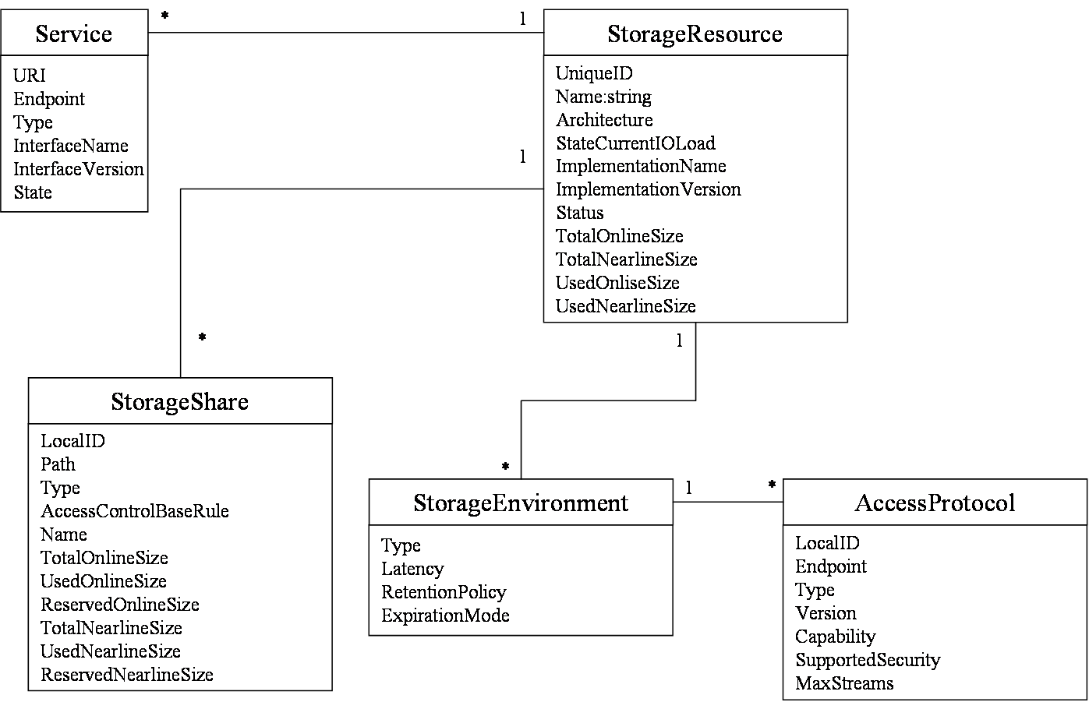
Figure 3 Entities and relationships for the Storage Element model. Very first sketch!

Relationship to OGF Reference Model

In this section, we describe the integration of the GLUE information model with the OGF Reference Model.
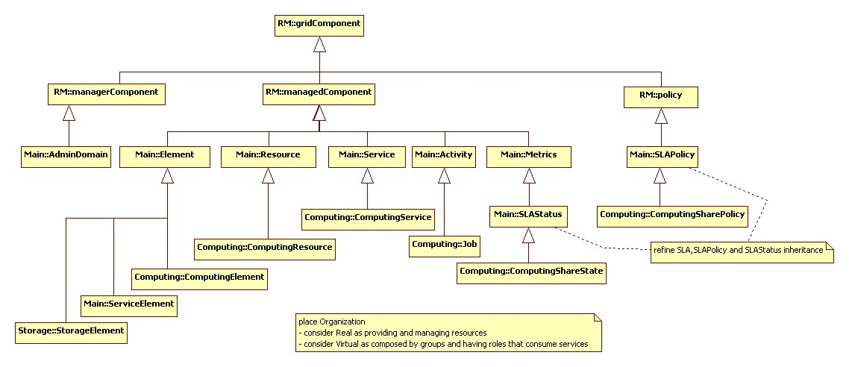
Figure 4 GLUE and Reference Model integration (draft)

Template

Entity | Inherits from |  |  | Description
Property | Type | Mult. | Unit | Description

Security Considerations

Please refer to RFC 3552 [RESCORLA] for guidance on writing a security considerations section. This section is required in all documents, and should not just say “there are no security considerations.” Quoting from the RFC:

“Most people speak of security as if it were a single monolithic property of a protocol or system, however, upon reflection, one realizes that it is clearly not true. Rather, security is a series of related but somewhat independent properties. Not all of these properties are required for every application.

We can loosely divide security goals into those related to protecting communications (COMMUNICATION SECURITY, also known as COMSEC) and those relating to protecting systems (ADMINISTRATIVE SECURITY or SYSTEM SECURITY). Since communications are carried out by systems and access to systems is through communications channels, these goals obviously interlock, but they can also be independently provided.”

Contributors

Contact information for authors. You can also use this section to recognize contributions by people who are not listed on the title page, but made a useful contribution (it’s OK to mention the nature of the contribution).

The actual Authors (or Editors) listed on the title page are those committed to taking permanent stewardship for this document – receiving communication in the future and otherwise being responsive to its content. The GFSG recommends at most three Author/Editors be listed on the title page, unless there are compelling reasons to list more.

Glossary

Recommended but not required.

Intellectual Property Statement

The OGF takes no position regarding the validity or scope of any intellectual property or other rights that might be claimed to pertain to the implementation or use of the technology described in this document or the extent to which any license under such rights might or might not be available; neither does it represent that it has made any effort to identify any such rights. Copies of claims of rights made available for publication and any assurances of licenses to be made available, or the result of an attempt made to obtain a general license or permission for the use of such proprietary rights by implementers or users of this specification can be obtained from the OGF Secretariat.

The OGF invites any interested party to bring to its attention any copyrights, patents or patent applications, or other proprietary rights which may cover technology that may be required to practice this recommendation. Please address the information to the OGF Executive Director.

Disclaimer
This document and the information contained herein is provided on an “As Is” basis and the OGF disclaims all warranties, express or implied, including but not limited to any warranty that the use of the information herein will not infringe any rights or any implied warranties of merchantability or fitness for a particular purpose.

Full Copyright Notice

Copyright (C) Open Grid Forum (applicable years). All Rights Reserved.

This document and translations of it may be copied and furnished to others, and derivative works that comment on or otherwise explain it or assist in its implementation may be prepared, copied, published and distributed, in whole or in part, without restriction of any kind, provided that the above copyright notice and this paragraph are included on all such copies and derivative works. However, this document itself may not be modified in any way, such as by removing the copyright notice or references to the OGF or other organizations, except as needed for the purpose of developing Grid Recommendations in which case the procedures for copyrights defined in the OGF Document process must be followed, or as required to translate it into languages other than English.

The limited permissions granted above are perpetual and will not be revoked by the OGF or its successors or assignees.

References
Note that only permanent documents should be cited as references. Other items, such as Web pages or working groups, should be cited inline (i.e., see the Open Grid Forum, http://www.ogf.org). References should conform to a standard such as used by IEEE/ACM, MLA, Chicago or similar. Include an author, year, title, publisher, place of publication. For online materials, also add a URL. It is acceptable to separate out “normative references,” as IETF documents typically do. Some sample citations:

[glue-wg] The Glue Working Group of OGF, https://forge.gridforum.org/sf/projects/glue-wg
[glue-usecases] Glue 2.0 Use Cases (early draft), https://forge.gridforum.org/sf/go/doc14621
[glue-1.x] The Glue Schema 1.3, https://forge.gridforum.org/sf/go/doc14185
[ng-schema] The NorduGrid/ARC Information System, NORDUGRID-TECH 4,https://forge.gridforum.org/sf/go/doc14273
[naregi-schema] NAREGI information and data model, https://forge.gridforum.org/sf/go/doc14300

