GLUE Specification v. 2.0 (draft 11)

Status of This Document

This document provides information to the Grid community regarding the specification of the GLUE information model. Distribution is unlimited. This document is a draft.

Copyright Notice

Copyright © Open Grid Forum (2007). All Rights Reserved.

Trademark

Open Grid Services Architecture and OGSA are trademarks of the Open Grid Forum.

Abstract

Contents

Abstract 1
1. Introduction 4
2. Notational Conventions 4
3. Conceptual Model of the Main Entities 5
3.1 Location 5
3.2 Contact 6
3.3 Domain 6
3.3.1 AdminDomain 7
3.3.2 UserDomain 7
3.4 Policy 7
3.4.1 ManagementPolicy 8
3.4.2 AccessPolicy 8
3.4.3 MappingPolicy 8
3.5 Service 8
3.6 Endpoint 9
3.7 Share 11
3.8 ShareState 11
3.9 SharePolicy 11
3.10 Resource 11
3.11 Activity 11
4. Auxiliar Entities 12
4.1 Extension 12
4.2 Metadata 12
5. Conceptual Model of the Computing Service 14
5.1 ComputingService 14
5.2 ComputingResource 15
5.3 ExecutionEnvironment 16
5.4 ApplicationEnvironment 17
5.5 ComputingEndpoint 17
5.6 ComputingShare 17
5.7 ComputingSharePolicy 18
5.8 ComputingShareState 18
5.9 Job 19
6. Conceptual Model of the Storage Service 20
6.1 StorageService 20
6.2 StorageResource 21
6.3 StorageShare 21
6.4 StorageComponent 22
6.5 StorageShareEnvironment 22
6.6 StorageSharePolicy 22
6.7 StorageShareState 23
6.8 StorageEndpoint 23
7. Relationship to OGF Reference Model 24
8. Template 24
9. Security Considerations 24
10. Author Information 25
11. Contributors & Acknowledgements 25
12. Glossary 25
13. Intellectual Property Statement 25
14. Disclaimer 25
15. Full Copyright Notice 26
16. References 27
17. Appendix A: Data Types 27
17.1 ContactType_t 27
17.2 PolicyScheme_t 27
17.3 ServiceCategory_t 27
17.4 ServiceType_t 27
17.5 QualityLevel_t 27
17.6 EndpointCategory_t 27
17.7 EndpointState_t 27
17.8 DN_t 27

Introduction

In this document, we present a conceptual information model for Grid entities described in natural language enriched with a graphical representation using UML Class Diagrams. As a conceptual model, this is meant to be implementation-independent. Mapping to concrete data models such as XML Schema, LDAP, relational and RDF are provided in the Appendix. From the semantic viewpoint, the concrete data model should represent the same concepts and relationships of the conceptual information model; nevertheless it can contain simplifications specific to the target data model in order to improve query performance or other aspects.
This information model is based on the experience of several modeling approaches being used in current production Grid infrastructures (e.g., GLUE Schema 1.x [glue-1.x], NorduGrid schema [ng-schema], Naregi model [naregi-schema]). The proposed initial collection of entities is motivated also by the use cases document [glue-usecases].

Notational Conventions

Only include this section if applicable.

The key words ‘MUST,” “MUST NOT,” “REQUIRED,” “SHALL,” “SHALL NOT,” “SHOULD,” “SHOULD NOT,” “RECOMMENDED,” “MAY,” and “OPTIONAL” are to be interpreted as described in RFC 2119 [BRADNER1]

Conceptual Model of the Main Entities
The GLUE information model proposes a number of main entities and relationships represented in Figure 1.

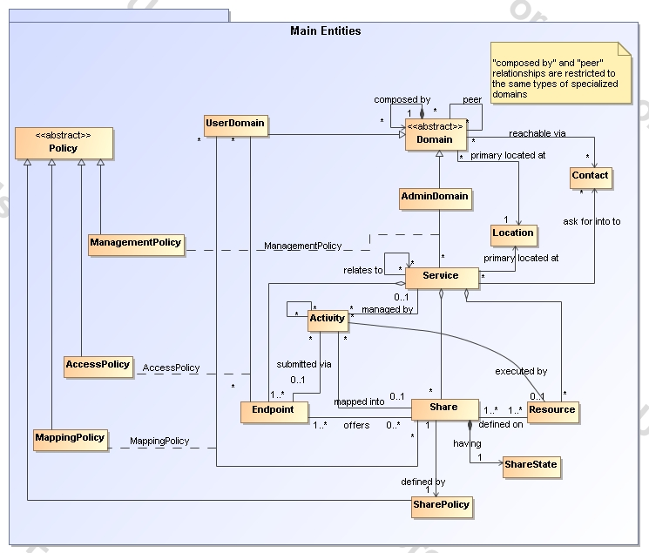
Figure 1 GLUE main entities and their relationships

Location
Entity | Inherits from |  |  | Description
Location |  |  |  | A geographical position
Property | Type | Mult. | Unit | Description
LocalID | String | 1 |  | A local identifier
Name | String | 1 |  | A human-readable name
Address | String | 0..1 |  | Street address
Place | String | 0..1 |  | Name of town/city
Country | String | 0..1 |  | Country name
PostCode | String | 0..1 |  | Postal code
Latitude | Real32 | 0..1 | Degree | The position of a place north or south of the equator measured from -90° to +90° with positive values going north and negative values going south
Longitude | Real32 | 0..1 | Degree | The position of a place east or west of Greenwich, England measured from -180° to +180° with positive values going east and negative values going west

The location entity is meant to be used for describing reference geographical positions of domains and services. They aim is to provide a simple way to express geographical information and is not intended to be used in complex geographical information systems. The accuracy of latitude and longitude should be defined in an interoperability profile.

Contact

Entity | Inherits from |  |  | Description
Contact |  |  |  | Information enabling to establish a communication with a person or group of persons part of a domain
Property | Type | Mult. | Unit | Description
LocalID | String | 1 |  | A local identifier
URL | URL | 1 |  | URL embedding the contact information. The syntax of URI depends on the communication channel
Type | ContactType_t | 1 |  | Type of contact
OtherInfo | String | * |  | Placeholder to publish info that does not fit in any other attribute. Free-form string, comma-separated tags, (name, value ) pair are example of syntax

This entity can be used to represent contact information for user support, security, sysadmin. The various types of contact are identified by the Type attribute. In case of time-depend contact information, the instances of this entity should represent only the active contact information.

For telephone and fax: http://www.ietf.org/rfc/rfc2806.txt
For email: http://www.ietf.org/rfc/rfc2368.txt
For irc: http://www.w3.org/Addressing/draft-mirashi-url-irc-01.txt

http://www.ietf.org/rfc/rfc2806.txt

Domain

Entity | Inherits from |  |  | Description
Domain |  |  |  | A collection of actors that can be assigned with roles and privileges to entities via policies. A domain may have relationships to other domains.
Property | Type | Mult. | Unit | Description
ID [key] | URI | 1 |  | A global unique ID
Name | String | 0..1 |  | Human-readable name
Description | String | 0..1 |  | A description of the domain
WWW | URL | * |  | The URL identifying a web page with more information about the domain
OtherInfo | String | * |  | Placeholder to publish info that does not fit in any other attribute. Free-form string, comma-separated tags, (name, value ) pair are example of syntax

This is an abstract entity not meant to be instantiated.

AdminDomain

Entity | Inherits from |  |  | Description
AdminDomain | Domain |  |  | A collection of actors that can be assigned with administrative roles and privileges to services via policies.  An AdminDomain manages services that can be geographically distributed, nevertheless a primary location should be identified.
Property | Type | Mult. | Unit | Description
Distributed | Boolean | 0..1 |  | True if the services managed by the admindomain are considered geographically distributed by the administrators themselves
Owner | String | * |  | Owner of the managed resources

UserDomain

Entity | Inherits from |  |  | Description
UserDomain | Domain |  |  | A collection of actors that can be assigned with user roles and privileges to services or shares via policies
Property | Type | Mult. | Unit | Description
Level | Int32 | 1 |  | The number of hops to reach the root for hierarchically organized domains described by the “composed by” association (0 is for the root)
ManagerService | URI | * |  | The Service ID managing the users part of the domain and the related attributes such as groups or roles

In the GLUE Information Model, the Virtual Organization can be realized by using the concept of UserDomain. If the VO has an internal structure, this can be represented by using different domains related to each other. A Virtual Organization (VO) comprises a set of individuals and/or institutions having direct access to computers, software, data, and other resources for collaborative problem-solving or other purposes. Resources utilized by a VO are expected to be accessible via network endpoints and constrained by defining utilization targets called shares. The VO can exhibit the internal structure in terms of groups of individuals, each of them being a UserDomain. UserDomains can be hierarchically structured. This structure can be represented via the “composed by” association. A userDomain can be also related to other other userDomains via a “peer” relationship.

As regards the ManagerService, a commonly used implementation is the VOMS.

Policy

Entity | Inherits from |  |  | Description
Policy |  |  |  | Statements, rules or assertions that specify the correct or expected behavior of an entity
Property | Type | Mult. | Unit | Description

This is an abstract entity not meant to be instantiated.

ManagementPolicy

Entity | Inherits from |  |  | Description
ManagementPolicy | Policy |  |  | Statements, rules or assertions that assign management capabilities to actors as regards a manageable entity
Property | Type | Mult. | Unit | Description

The existence of relationship among an AdminDomain and a Service implies that an AdminDomain can manage a Service. Currently, there is no use cases for having attributes in this entity.

AccessPolicy

Entity | Inherits from |  |  | Description
AccessPolicy | Policy |  |  | Statements, rules or assertions that govern the access by actors to an entity
Property | Type | Mult. | Unit | Description
Scheme | PolicyScheme_t | 1 |  | Scheme adopted to define the policy rules
Rule | String | * |  | A policy rule

This entity can be used to express which UserDomains can access a certain service endpoint. The granularity of these policies should be coarse-grained and suitable for pre-selection of services. The actual decision on the service side is performed by an authorization component that can contain a finer-grained set of policy rules that in some case can contradict the published coarse-grained policy rules. Examples of actors involved in this entity are userDomains representing VOs or groups.

MappingPolicy

Entity | Inherits from |  |  | Description
MappingPolicy | Policy |  |  | Statements, rules or assertions that govern the mapping of actors to shares
Property | Type | Mult. | Unit | Description
Scheme | PolicyScheme_t | 1 |  | Scheme adopted to define the policy rules
Rule | String | * |  | A policy rule

This entity can be used to express which UserDomains can consume a certain share of resources.

Service

Entity | Inherits from |  |  | Description
Service |  |  |  | An abstracted, logical view of actual software components that participate in the creation of an entity providing one or more functionalities useful in a Grid environment. A service exposes one or more endpoints having well-defined interfaces, zero or more shares and zero or more resources. The service is autonomous and denotes a weak aggregation among endpoints, the exposed resources, and the defined shares. The service enables to identify the whole set of entities providing the functionality with a persistent name.
Property | Type | Mult. | Unit | Description
ID [key] | URI | 1 |  | A global unique ID
Name | String | 0..1 |  | Human-readable name
Capability | ServiceCapability_t | * |  | The capability provided by this service according to the OGSA architecture
Type | ServiceType_t | 1 |  | The type of service according to a middleware classification
QualityLevel | QualityLevel_t | 1 |  | Maturity of the service in terms of quality of the software components
StatusPage | URL | * |  | Web page providing additional information like monitoring aspects
Complexity | String | 0..1 |  | Human-readable summary description of the complexity in terms of the number of endpoint types, shares and resources. The syntax should be: endpointType=X, share=Y, resource=Z.
OtherInfo | String | * |  | Placeholder to publish info that does not fit in any other attribute. Free-form string, comma-separated tags, (name, value ) pair are example of syntax
The simplest Service is composed by one endpoint, no share and no resource (e.g. a metadata catalog service). In the context of a Service, the same resource part of it can be exposed via multiple endpoints based on defined shares. For instance, in the area of storage systems, SRMv1 and SRMv2.2 interfaces can expose the same resource via different endpoints offering different interface version; in the area of computing systems, the CREAM and GRAM endpoints can expose the same batch system. Endpoints, shares and resources can belong to only one service.

Endpoint

Entity | Inherits from |  |  | Description
Endpoint |  |  |  | A network location having a well-defined interface and exposing the service functionalities
Property | Type | Mult. | Unit
ID [key] | URI | 1 |  | A global unique ID
Name | String | 0..1 |  | Human-readable name
URL | URL | 1 |  | Network location of the endpoint to contact the related service
Capability | EndpointCapability_t | * |  | The capability exposed by this interface
Type | EndpointType_t | 1 |  | The type of endpoint according to a middleware classification
QualityLevel | QualityLevel_t | 1 |  | Maturity of the service in terms of quality of the software components
SpecificationName | String | 0..1 |  | Name of the interface specification
SpecificationVersion | String | 0..1 |  | Version of the interface
Implementor | String | 0..1 |  | Main organization implementing this software component
ImplementationName | String | 0..1 |  | Name of the implementation
ImplementationVersion | String | 0..1 |  | Version of the implementation (e.g., major version.minor version.pathcversion)
State | EndpointState_t | 1 |  | The operational state of the endpoint
StateInfo | String | 0..1 |  | Textual explanation of the state endpoint
ServingState | ServingState_t | 1 |  | The serving state (production, draining, queueing, closed)
WSDL | URL | * |  | URL of the WSDL document describing the offered interface (applies to Web Services endpoint)
SupportedProfile | URI | * |  | URI identifying a supported profile
Semantics | URL | * |  | URL of a document providing a human-readable description of the semantics of the endpoint functionalities
StartTime | POSIXTime | 0..1 |  | The POSIX timestamp for the start time of the endpoint
DowntimeAnnounce | POSIXTime | 0..1 |  | The POSIX timestamp for the announcement of the next scheduled downtime
DowntimeStart | POSIXTime | 0..1 |  | The starting POSIX timestamp of the next scheduled downtime
DowntimeEnd | POSIXTime | 0..1 |  | The ending POSIX timestamp of the next scheduled downtime
DowntimeInfo | String | 0..1 |  | Description of the next scheduled downtime
IssuerCA | DN_t | 0..1 |  | Distinguished name of Certification Authority issuing the certificate for the endpoint
TrustedCA | DN_t | * |  | Distinguished name of the trusted Certification Authority
Association End |  | Mult. | Description
Association to UserDomain via Access Policy

For Grid services requiring a richer set of properties for the endpoint, specific models can be derived by specializing from the Endpoint entity and adding new properties or relationships. The current proposal contains the ComputingEndpoint specialization (see Section )

Share

Entity | Inherits from |  |  | Description
Share |  |  |  | A utilization target for a set of resources offered via related endpoints defined by policies and characterized by status information
Property | Type | Mult. | Unit | Description
LocalID [key] | URI | 1 |  | A local ID unique within a service instance
Name | String | 1 |  | Human-readable name

ShareState

Entity | Inherits from |  |  | Description
ShareState |  |  |  | State information for a share
Property | Type | Mult. | Unit | Description

Currently, there is no use cases for having attributes in this entity.

SharePolicy

Entity | Inherits from |  |  | Description
SharePolicy |  |  |  | Statements, rules or assertions that specify the correct or expected behavior of a share
Property | Type | Mult. | Unit | Description

Currently, there is no use cases for having attributes in this entity.

Resource

Entity | Inherits from |  |  | Description
Resource |  |  |  | An entity useful in a Grid environment part of a logical service, reachable via one or more endpoints and having one or more shares defined on it. A resource usually represents aggregated information
Property | Type | Mult. | Unit | Description
ID [key] | URI | 1 |  | A global unique ID
Name | String | 1 |  | Human-readable name

For Grid resources requiring a richer set of properties, specific models can be defined by specializing from the Resource entity and adding new properties or relationships. The current proposal contains the Computing Resource specialization (see Section ).

Activity

Entity | Inherits from |  |  | Description
Activity |  |  |  | An activity is a unit of work managed by a service and submitted via an endpoint; an activity can have relationships to other activities being managed by different services, therefore it shares a common context.
Property | Type | Mult. | Unit | Description
ID [key] | URI | 1 |  | A global unique ID

Grid jobs are example of activities for a Computing Service. An interesting type of relationship for jobs derives from its propagation through several services. For instance, a broker service submits a Grid job to a selected execution service, upon completion the execution service submits a logging record to an accounting service. Each of these services will have associated an instance of a Grid job related to the lifecycle of the job within the service. All instances refer to the same conceptual job submitted by the user.

Auxiliar Entities

The auxiliary entities currently provides extensibility mechanisms and metadata applicable to all GLUE entities. Widely used extensions will be considered for addition in future GLUE information model revision as primary properties.

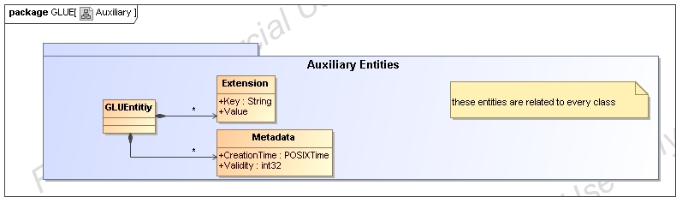

Extension

Entity | Inherits from |  |  | Description
Extension |  |  |  | A key,value pair providing extra information not captured in the current model
Property | Type | Mult. | Unit | Description
Key | String | 1 |  | A local ID, typically an attribute name that could be added in future info model revisions
Value | String | * |  | A value for the attribute

Metadata

Entity | Inherits from |  |  | Description
Metadata
Property | Type | Mult. | Unit | Description
CreationTime | POSIXTime | 1 |  | POSIX timestamp when the entity instance was generated
Validity | Int32 | 1 | s | The time period for how long the generated information is considered to be relevant by the information provider

Conceptual Model of the Computing Service

The conceptual model of the Computing Service is based upon the main entities and uses specializations of Service, Resource, Share, Endpoint and Activity entities. Further computing related concepts such as Execution Environment and Application Environment are introduced.
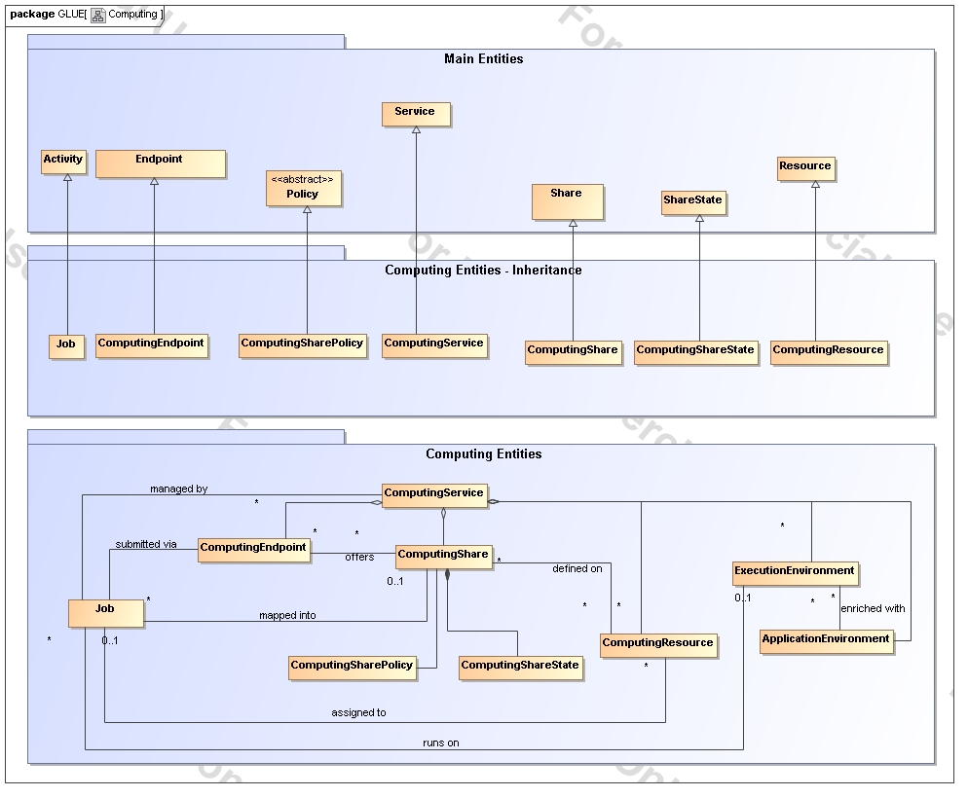
Figure 2 Entities and relationships for the Computing Service conceptual model

ComputingService

Entity | Inherits from |  |  | Description
ComputingService | Service |  |  | An abstracted, logical view of actual software components that participate in the creation of a computational capacity in a Grid environment. A computing service exposes one or more endpoints having well-defined interfaces, one or more computing shares and one or more computing resource.  The service is autonomous and denotes a weak aggregation among endpoints, the exposed computing resources, and the defined computing shares.  The service enables to identify the whole set of entities providing the computing functionality with a persistent name.
Property | Type | Mult. | Unit | Description
TotalJobs | int32 | 1 | job | Number of total jobs
RunningJobs | int32 | 1 | job | Number of running jobs
WaitingJobs | int32 | 1 | job | Number of jobs waiting in the LRMS
StagingJobs | int32 | 1
PreLRMSWaitingJobs | int32 | 1

The simplest computing service is formed by a computing endpoint exposing an interface for job submission and control, a computing share and a computing resource. In case of a single computing resource exposed by multiple computing endpoints, such computing endpoints have to be considered part of the computing service. In case of a computing endpoint exposing many computing resources, then these computing resources are part of the computing service.

The computing service always aggregate computing endpoints, shares and resources forming a connected set. In other words, Endpoint A exposing resource A via share A and Endpoint B exposing Resource B via share B form two different computing services. On the other side, Endpoint A exposing Resource A via a share and Endpoint B exposing Resource A and B via another share form a computing service.

Properties from previous schemas: nordugrid-cluster-localse (similar to Glue.CESEBind.SEUniqueID)

ComputingResource

Entity | Inherits from |  |  | Description
ComputingResource | Resource |  |  | Grouping concept for a set of different types of execution environments offered through computing endpoint(s). The computing resource usually represents aggregated information. The aggregation is defined by the common local management scope.
Property | Type | Mult. | Unit | Description
LRMSType | LRMSType_t | 1 |  | Type of the underlying local resource management system
LRMSVersion | String | 1 |  | Version of the underlying local resource management system
LRMSInfo
Total | int32 | 1 |  | Number of execution environments
Used | int32 | 1 |  | Number of used execution environments
PhysicalCPUs | int32 | 1 |  | Number of managed physical CPUs accessible via any of the available endpoints
LogicalCPUs | int32 | 1 |  | Number of managed logical CPUs accessible via any of the available endpoints
TmpDir | string | 1
ScratchDir | string | 1
DataDir | string | 1
Homogeneity | boolean | 1
NetworkInfo | net_t | 1 |  | Type of internal network available among the execution environments
CPUDistribution
SessionDirTotal
SessionDirFree
SessionDirLifeTime
CacheTotal
CacheFree
Benchmark

A local resource management system like a batch system is an example of aggregation scope. The Operating System can be the simplest case of LRMS.

ExecutionEnvironment

Entity | Inherits from |  |  | Description
ExecutionEnvironment |  |  |  | A description of hardware and software characteristics that defines the environments available to and requestable by a Grid job when submitted to a Computing Service; the description also includes information about the total/available/used instances of the execution environment
Property | Type | Mult. | Unit | Description
ID [key] | URI | 1 |  | A global unique ID
Type | execEnv_t | 1 |  | Type of execution environment Type (e.g., virtualnode, realnode, smp, thread, multicore)
Total | int32 | 1 |  | Number of execution environment instances
Used | int32 | 1 |  | Number of used execution environment instances
Unavailable | int32 | 1 |  | Number of unavailable execution environment instances (e.g. for maintenance or failure)
PhysicalCPUs | int32 | 1 |  | Number of physical CPUs in each execution environment
LogicalCPUs | int32 | 1 |  | Number of logical CPUs in each execution environment as showed by the OS
CPUVendor | int32 | 1
CPUModel | String | 1
CPUVersion | String | 1
CPUClockSpeed | Int32 | 1 | MHz
MainMemorySize | Int64 | 1
VirtualMemorySize | Int64 | 1
OSName | OSName_t | 1
OSRelease | String | 1
OSVersion | String | 1
Benchmark set of (name,value)
SPECInt2000 | int32 | 1
SPECfp2000 | int32 | 1
ConnectivityIn | boolean | 1
ConnectivityOut | boolean | 1
PlatformType | platform_t | 1
NetworkInfo

An execution environment can be realized in several ways. Examples are a computing node or a virtual machine image that can be requested by a job (different virtual machine images can coexist on the same node). The description about individual software packages is considered by the ApplicationEnvironment class.

ApplicationEnvironment

Entity | Inherits from |  |  | Description
ApplicationEnvironment |  |  |  | Description of the application software environment available within one or more execution environments
Property | Type | Mult. | Unit | Description
ID [key] | URI | 1 |  | A global unique ID
Name | string | 1 |  | Name
Version | string | 1 |  | Version
State | appEnvState_t | 1
LifeTime |  | 1
InstalledRoot | string | 1 |  | The directory where the software is installed on the file system
EnvironmentSetup | string | 1 |  | Fully qualified script for the setting of the application environment
ModuleName | string | 1 |  | The name of the module that gets loaded (to set the environment) before the job runs
Description | URI
(key,value) pairs

The Application Environment is suggested to be used also for describing application software in terms of a simple tag.

ComputingEndpoint

Entity | Inherits from |  |  | Description
ComputingEndpoint | Endpoint |  |  | Endpoint for creating, monitoring, and controlling computational activities called jobs
Property | Type | Mult. | Unit | Description
StagingCapabilities
SuspendCapabilities

ComputingShare

Entity | Inherits from |  |  | Description
ComputingShare |  |  |  | A utilization target for a set of computing resources defined by policies and characterized by status information
Property | Type | Mult. | Unit | Description

In a computing resource describing a batch system, a typical implementation of a computing share is via a batch queue with the associated policies and status information. The same computing share can be implemented using different batch system configuration strategies. In complex batch systems, it is possible to define different set of policies for the same batch queue, this will imply a share for each set of policies. A computing share can be implemented by virtual machine management systems. The model supports heterogeneity by being able to represent different execution environments associated to the same computing share.

ComputingSharePolicy

Entity | Inherits from |  |  | Description
ComputingSharePolicy |  |  |  | Set of policies that defines a computing share
Property | Type | Mult. | Unit | Description
MaxWallTime | Int64 | 1 | s
MaxCPUTime | Int64 | 1 | s
MaxTotalJobs | Int64 | 1 | s
MaxRunningJobs | Int64 | 1 | s
MaxWaitingJobs | Int64 | 1 | s
MaxPreLRMSWaitingJobs
MaxUserRunningJobs | Int64
MaxSlotsPerJob | Int64 | 1 | s
MaxStateInStreams | Int64 | 1 | s
MaxStageOutStreams | Int64 | 1 | s
MinCPUTime | Int64 | 1 | s
MinWallTime | Int64 | 1 | s
DefaultWallTime | Int64 | 1 | s
DefaultCPUTime | Int64 | 1 | s
SchedulingPolicy
MaxMemory
MaxDiskSpace
Priority
OtherInfo
DefaultSE
ApplicationDir
DataDir
Preemption | boolean
AssociationEnd |  | Mult. | Description
Association to UserDomain via Mapping Policy

ComputingShareState

Entity | Inherits from |  |  | Description
ComputingShareState |  |  |  | Set of attributes describing the dynamic state of a computing share
Property | Type | Mult. | Unit | Description
TotalJobs | Int64 | 1
RunningJobs | Int64 | 1
LocalRunningJobs
WaitingJobs | Int64 | 1
LocalWaitingJobs
StagingJobs
PreLRMSWaitingJobs
EstimatedResponseTime | Int64 | 1 | S
WorstResponseTime | Int64 | 1 | S
FreeJobSlots | Int64 | 1
State | ShareState_t | 1

Job

Entity | Inherits from |  |  | Description
Job | Activity |  |  | An activity managed by an OGSA execution capability service
Property | Type | Mult. | Unit | Description
ID [key] | URI | 1 |  | A global unique ID
LocalID | string | 1
Name | string | 1
State |  | 1
ReRunable
ExitCode
LRMSExitCode
Errors
WaitingPosition
Owner | string | 1
LocalOwner | string
RequestedWallTime
RequestedCPUTime
RequestedApplicationEnvirnment
RequestedCPUs
StdOut
StdErr
StdIn
LogDir
Comment
LRMSComment
ExecutionNodes
ExecutionCluster
ExecutionQueue
UsedWallTime
UsedMemory
UsedCPUTime
NodeCount
CompletionTime
SessionDirEraseTime
ProxyExpirationTime
SubmissionTime
SubmissionClient
SubmissionClientSoftware

A Job is typically described by an XML document compliant to the JSDL specification. In this specification, the Job is related to a single processor job. Other job types such “collection of jobs” and workflows will be considered in a future revision.

Conceptual Model of the Storage Service

Like the Computing Service, the conceptual model of the Storage Service is based upon the main entities and uses specializations for those entities. Further on, storage related concepts such as StorageShareState, StorageSharePolicy, StorageComponent and StorageShareEnvironment are introduced.
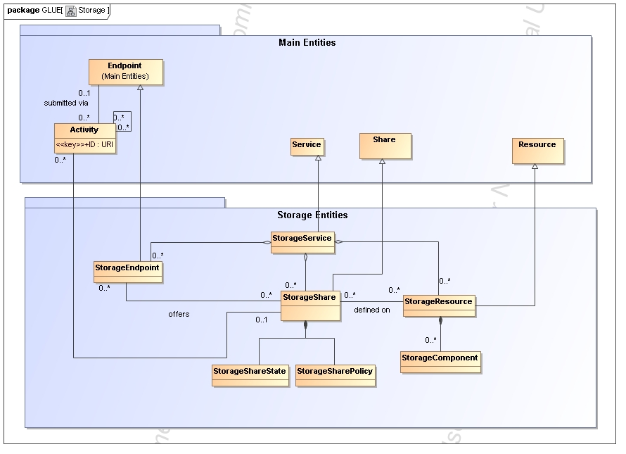

Figure 3 Entities and relationships for the Storage Element model

StorageService

Entity | Inherits from |  |  | Description
StorageService | Service |  |  | An abstracted, logical view of actual software components that participate in the creation of a storage capacity in a Grid environment. A storage service exposes one or more endpoints having well-defined interfaces, one or more storage shares and zero or more storage resource.
Property | Type | Mult. | Unit | Description

StorageResource

Entity | Inherits from |  |  | Description
StorageResource | Resource |  |  | A StorageResource represents a local resource management system and manages StorageShares representing logical storage space.
Property | Type | Mult. | Unit | Description
ID |  |  |  | A unique identifier for this resource
Name
Implementation Name |  |  |  | The name of the running software
Implementation Version |  |  |  | The version of the running software
Information Service URL |  |  |  | A resource location where to retrieve local information
Architecture |  |  |  | The Architecture this storage management software is running on.
TotalOnlineSize
TotalNearlineSize
UsedOnlineSize
UsedNearlineSize

A StorageResource could be for example a NAS (Network Attached Storage) system. It offers the capability to access or store information via an exposed service and it manages StorageShares which represent the available file systems on the NAS.
A StorageResource could also be a Mass Storage System [MSS] offering ways to store data onto (several) media. This media (StorageComponents) offer logical storage spaces (StorageShares).

StorageShare

Entity | Inherits from |  |  | Description
StorageShare | Share |  |  | A StorageShare represents logical storage space within a resource.  A StorageResource can hold many Shares.  The Access to this Share is managed through the AccessPolicy and Service.
Property | Type | Mult. | Unit | Description
ID |  |  |  | A unique identifier for this share
Path |  |  |  | The namespace of this share (not unique)
Type |  |  |  | The type of the share
Name |  |  |  | A descriptive Name for this share (not unique)

The StorageShare is a logical space made available by a StorageResource. A VO can access this if it is listed in the AccessPolicy for the Service this share offers.

StorageComponent

Entity | Inherits from |  |  | Description
StorageComponent |  |  |  | Aggregation of Policy and Environment. Represents the 'physical' characteristics of the Share.
Property | Type | Mult. | Unit | Description

StorageShareEnvironment

Entity | Inherits from |  |  | Description
StorageShareEnvironment |  |  |  | The Environment describes storage characteristics of the component.
Property | Type | Mult. | Unit | Description
Type |  |  |  | The Type of the storage environment
Latency |  |  |  | Online, Nearline, Offline
Retention Policy |  |  |  | Custodial, Output, Replica
Expiration Mode |  |  |  | Never, Warn, Release

StorageSharePolicy

Entity | Inherits from |  |  | Description
StorageSharePolicy |  |  |  | Describes a way to access the data in the StorageShare from the transport level point of view.
Property | Type | Mult. | Unit | Description
Transport Protocol
Transport Protocol Version
Capabilities |  |  |  | Further description like maximum streams etc.
The StorageSharePolicy contains information like the transport protocol a StorageComponent offers. As an example this could be GridFTP and a Capability could be the maximum number of concurrent streams the StorageComponent can process.

StorageShareState

Entity | Inherits from |  |  | Description
StorageShareState
Property | Type | Mult. | Unit | Description
Total free space |  |  | GByte
Total used space |  |  | GByte
Reserved space |  |  | GByte
Total space |  |  | GByte
Status |  |  |  | Up / Down / Maintenance

StorageEndpoint

Entity | Inherits from |  |  | Description
StorageEndpoint | Endpoint |  |  | The StorageEndpoint describes a service oriented way to access a StorageShare. As such, it should offer well-defined interfaces and may offer an Endpoint to contact the storage service.
Property | Type | Mult. | Unit | Description
UniqueID
Endpoint
Type
Interface Version
Interface Name
A StorageService is authorized by a AccessPolicy. Each Service a Share offers, an AccessPolicy is necessary. This enables a Share to offer the same Service with another AccessPolicy (e.g. per VO).
The StorageService attributes:
URI, Endpoint, Type, InterfaceName, InterfaceVersion

Relationship to OGF Reference Model

In this section, we describe the integration of the GLUE information model with the OGF Reference Model.
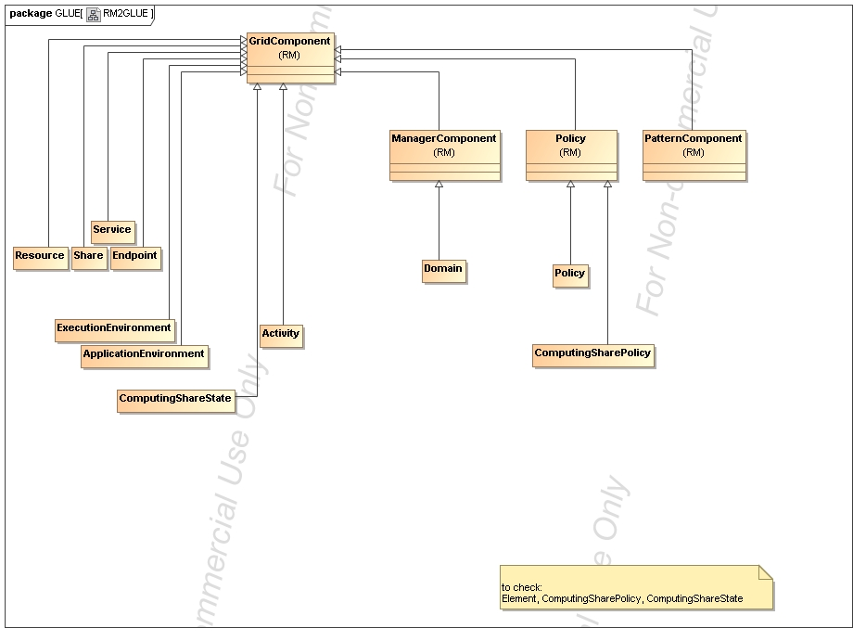
Figure 4 GLUE and Reference Model integration (draft)

Template

Entity | Inherits from |  |  | Description
Property | Type | Mult. | Unit | Description

Security Considerations

Please refer to RFC 3552 [RESCORLA] for guidance on writing a security considerations section. This section is required in all documents, and should not just say “there are no security considerations.” Quoting from the RFC:

“Most people speak of security as if it were a single monolithic property of a protocol or system, however, upon reflection, one realizes that it is clearly not true. Rather, security is a series of related but somewhat independent properties. Not all of these properties are required for every application.

We can loosely divide security goals into those related to protecting communications (COMMUNICATION SECURITY, also known as COMSEC) and those relating to protecting systems (ADMINISTRATIVE SECURITY or SYSTEM SECURITY). Since communications are carried out by systems and access to systems is through communications channels, these goals obviously interlock, but they can also be independently provided.”

Author Information
Contact information for authors.

The actual Authors (or Editors) listed on the title page are those committed to taking permanent stewardship for this document – receiving communication in the future and otherwise being responsive to its content. The GFSG recommends at most three Author/Editors be listed on the title page, unless there are compelling reasons to list more.

Contributors & Acknowledgements
We gratefully acknowledge the contributions made to this document (in no particular order) by

Glossary

Recommended but not required.

Intellectual Property Statement

The OGF takes no position regarding the validity or scope of any intellectual property or other rights that might be claimed to pertain to the implementation or use of the technology described in this document or the extent to which any license under such rights might or might not be available; neither does it represent that it has made any effort to identify any such rights. Copies of claims of rights made available for publication and any assurances of licenses to be made available, or the result of an attempt made to obtain a general license or permission for the use of such proprietary rights by implementers or users of this specification can be obtained from the OGF Secretariat.

The OGF invites any interested party to bring to its attention any copyrights, patents or patent applications, or other proprietary rights which may cover technology that may be required to practice this recommendation. Please address the information to the OGF Executive Director.

Disclaimer
This document and the information contained herein is provided on an “As Is” basis and the OGF disclaims all warranties, express or implied, including but not limited to any warranty that the use of the information herein will not infringe any rights or any implied warranties of merchantability or fitness for a particular purpose.

Full Copyright Notice

Copyright (C) Open Grid Forum (applicable years). All Rights Reserved.

This document and translations of it may be copied and furnished to others, and derivative works that comment on or otherwise explain it or assist in its implementation may be prepared, copied, published and distributed, in whole or in part, without restriction of any kind, provided that the above copyright notice and this paragraph are included on all such copies and derivative works. However, this document itself may not be modified in any way, such as by removing the copyright notice or references to the OGF or other organizations, except as needed for the purpose of developing Grid Recommendations in which case the procedures for copyrights defined in the OGF Document process must be followed, or as required to translate it into languages other than English.

The limited permissions granted above are perpetual and will not be revoked by the OGF or its successors or assignees.

References
Note that only permanent documents should be cited as references. Other items, such as Web pages or working groups, should be cited inline (i.e., see the Open Grid Forum, http://www.ogf.org). References should conform to a standard such as used by IEEE/ACM, MLA, Chicago or similar. Include an author, year, title, publisher, place of publication. For online materials, also add a URL. It is acceptable to separate out “normative references,” as IETF documents typically do. Some sample citations:

[glue-wg] The Glue Working Group of OGF, https://forge.gridforum.org/sf/projects/glue-wg
[glue-usecases] Glue 2.0 Use Cases (early draft), https://forge.gridforum.org/sf/go/doc14621
[glue-1.x] The Glue Schema 1.3, https://forge.gridforum.org/sf/go/doc14185
[ng-schema] The NorduGrid/ARC Information System, NORDUGRID-TECH 4,https://forge.gridforum.org/sf/go/doc14273
[naregi-schema] NAREGI information and data model, https://forge.gridforum.org/sf/go/doc14300

Appendix A: Data Types

ContactType_t

Open enumeration: security, sysadmin, usersupport, general

PolicyScheme_t

ServiceCategory_t

To check OGSA Capabilities

Open enumeration:

ServiceType_t

Every item should start with org.MIDDLEWARENAME.

Open enumeration: org.glite.wms, org.glite.lb

QualityLevel_t

Closed enumeration: production, pre-production, testing, development

EndpointCategory_t

EndpointState_t

Closed enumeration: OK, Warning, Critical, Unknown, Other

DN_t

