GLUE Specification v. 2.0 (draft 24)

Status of This Document

This document provides information to the Grid community regarding the specification of the GLUE information model. Distribution is unlimited. This document is a draft.

Copyright Notice

Copyright © Open Grid Forum (2008). All Rights Reserved.

Trademark

Open Grid Services Architecture and OGSA are trademarks of the Open Grid Forum.

Abstract
The GLUE specification is an information model for Grid entities described in natural language enriched with a graphical representation using UML Class Diagrams. As a conceptual model, this is meant to be implementation-independent. Rendering to concrete data models such as XML Schema, LDAP and relational are provided.

Editorial To Do:

Check:
- In each table, verify that “Inherited Properties” are consistent with original
- All attributes having type, mult and description
- All data type being defined in appendix
- Consistency between main entities and derived models
- All comments answered and removed
- Check authors/contributors list and verify addresses
- Rules for properties
  - Properties name all with first letter of each component word capitol
  - Added data types with suffix _t, capitol as properties
  - Decide if to use multiple in unit of measure
    - http://en.wikipedia.org/wiki/International_System_of_Units
    - http://en.wikipedia.org/wiki/SI_prefix
  - Enumeration values all small letters

Contents

1. Introduction 4
2. Notational Conventions 4
3. General 4
4. Conceptual Model of the Main Entities 5
4.1 Location 6
4.2 Contact 6
4.3 Domain 7
4.3.1 AdminDomain 7
4.3.2 UserDomain 7
4.4 Policy 8
4.4.1 ManagementPolicy 8
4.4.2 AccessPolicy 8
4.4.3 MappingPolicy 9
4.5 Service 9
4.6 Endpoint 10
4.7 Downtime 10
4.8 Share 11
4.8.1 ShareState 11
4.8.2 SharePolicy 11
4.9 Resource 11
4.10 Activity 11
5. Auxiliar Entities 13
5.1 Extension 13
5.2 Metadata 13
6. Conceptual Model of the Computing Service 14
6.1 ComputingService 15
6.2 ComputingEndpoint 16
6.3 ComputingShare 16
6.3.1 ComputingSharePolicy 17
6.3.2 ComputingShareState 18
6.4 ComputingResource 18
6.5 Benchmark 19
6.6 ExecutionEnvironment 20
6.7 ApplicationEnvironment 21
6.8 ComputingActivity 22
7. Conceptual Model of the Storage Service 24
7.1 StorageService 25
7.2 StorageEndpoint 26
7.3 StorageShare 27
7.3.1 StorageShareState 27
7.4 StorageAccessProtocol 27
7.5 StorageEnvironment 27
7.6 StorageSpaceState 27
7.7 StorageMappingPolicy 28
8. Relationship to OGF Reference Model 29
9. Template 29
10. Security Considerations 30
11. Author Information 30
12. Contributors & Acknowledgements 30
13. Glossary 30
14. Intellectual Property Statement 31
15. Disclaimer 31
16. Full Copyright Notice 31
17. References 32
18. Appendix A: Place-holder values for unknown data 33
18.1 Use cases 33
18.2 Place-holder values 33
18.2.1 Fully qualified domain names 34
18.2.2 IPv4 address 34
18.2.3 IPv6 addr 34
18.2.4 Integers 35
18.2.5 File path 35
18.2.6 Email addresses 35
18.2.7 Uniform Resource Identifier (URI) 36
18.2.8 X509 Distinguished Names 36
18.2.9 Fully Qualified Attribute Name (FQAN) 37
18.2.10 Geographic locations 37
19. Appendix B: Data Types 38
19.1 ContactType_t 38
19.2 PolicyScheme_t 38
19.3 DN_t 38
19.4 ServiceCapability_t 38
19.5 ServiceType_t 39
19.6 QualityLevel_t 39
19.7 EndpointCapability_t 39
19.8 EndpointType_t 39
19.9 EndpointHealthState_t 39
19.10 ServingState_t 40
19.11 ActivityType_t 40
19.12 DateTime_t 40
19.13 Staging_t 40
19.14 SchedulingPolicy_t 40
19.15 LRMSType_t 40
19.16 NetworkInfo_t 41
19.17 Benchmark_t 41
19.18 platform_t 41
19.19 CPUMultiplicity_t 41
19.20 OSFamily_t 41
19.21 OSName_t 42
19.22 AppEnvState_t 42
19.23 License_t 42
19.24 SetupMethod_t 42
19.25 ComputingActivityState_t 42
19.26 ExpirationMode_t 42
19.27 StorageShareState_t 43
19.28 StorageAccessProtocol_t 43
19.29 StorageEnvironmentType_t 43
19.30 AccessLatency_t 43
19.31 RetentionPolicy_t 43
20. Appendix C: XML Schema Rendering 45
21. Appendix D: LDAP Rendering 45
22. Appendix E: Relational Rendering 45

Introduction

In this document, we present a conceptual information model for Grid entities described in natural language enriched with a graphical representation using UML Class Diagrams. As a conceptual model, this is meant to be implementation-independent. Mapping to concrete data models such as XML Schema, LDAP, relational and RDF are provided in the Appendix. From the semantic viewpoint, the concrete data model should represent the same concepts and relationships of the conceptual information model; nevertheless it can contain simplifications specific to the target data model in order to improve query performance or other aspects.
This information model is based on the experience of several modeling approaches being used in current production Grid infrastructures (e.g., GLUE Schema 1.x [glue-1.x], NorduGrid schema [ng-schema], Naregi model [naregi-schema]). The proposed initial collection of entities is motivated also by the use cases document [glue-usecases].

Notational Conventions

Only include this section if applicable.

The key words ‘MUST,” “MUST NOT,” “REQUIRED,” “SHALL,” “SHALL NOT,” “SHOULD,” “SHOULD NOT,” “RECOMMENDED,” “MAY,” and “OPTIONAL” are to be interpreted as described in RFC 2119 [BRADNER1]

General

The Information Model and its renderings have to be consider case-sensitive.

Conceptual Model of the Main Entities

This section introduces the main entities of the GLUE information model. They captures the core concepts that relevant in a Grid environment. The main entities SHOULD be used to derive specialized information models. In Figure 1, the classes and the related relationships are presented.

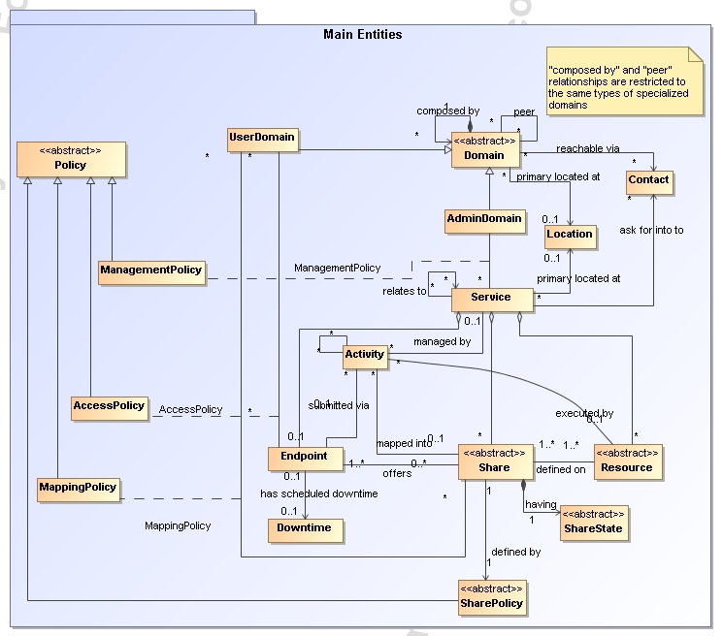
Figure 1 GLUE main entities and their relationships

Location

Entity | Inherits from |  |  | Description
Location |  |  |  | A geographical position
Property | Type | Mult. | Unit | Description
LocalID | String | 1 |  | An opaque local identifier
Name | String | 1 |  | A human-readable name
Address | String | 0..1 |  | Street address
Place | String | 0..1 |  | Name of town/city
Country | String | 0..1 |  | Country name
PostCode | String | 0..1 |  | Postal code
Latitude | Real32 | 0..1 | degree | The position of a place north or south of the equator measured from -90° to +90° with positive values going north and negative values going south
Longitude | Real32 | 0..1 | degree | The position of a place east or west of Greenwich, England measured from -180° to +180° with positive values going east and negative values going west

The location entity is meant to be used for describing reference geographical positions of domains and services. They aim is to provide a simple way to express geographical information and is not intended to be used in complex geographical information systems. The accuracy of latitude and longitude should be defined in an interoperability profile.

Contact

Entity | Inherits from |  |  | Description
Contact |  |  |  | Information enabling to establish a communication with a person or group of persons part of a domain
Property | Type | Mult. | Unit | Description
LocalID | String | 1 |  | An opaque local identifier
URL | URI | 1 |  | URL embedding the contact information. The syntax of URI depends on the communication channel
Type | ContactType_t | 1 |  | Type of contact
OtherInfo | String | * |  | Placeholder to publish info that does not fit in any other attribute. Free-form string, comma-separated tags, (name, value ) pair are example of syntax

This entity can be used to represent contact information for user support, security, sysadmin. The various types of contact are identified by the Type attribute. In case of time-depend contact information, the instances of this entity should represent only the active contact information.

For telephone and fax: http://www.ietf.org/rfc/rfc2806.txt
For email: http://www.ietf.org/rfc/rfc2368.txt
For irc: http://www.w3.org/Addressing/draft-mirashi-url-irc-01.txt

http://www.ietf.org/rfc/rfc2806.txt

Domain

Entity | Inherits from |  |  | Description
Domain |  |  |  | A collection of actors that can be assigned with roles and privileges to entities via policies. A domain may have relationships to other domains.
Property | Type | Mult. | Unit | Description
ID [key] | URI | 1 |  | A global unique ID
Name | String | 0..1 |  | Human-readable name
Description | String | 0..1 |  | A description of the domain
WWW | URI | * |  | The URL identifying a web page with more information about the domain
OtherInfo | String | * |  | Placeholder to publish info that does not fit in any other attribute. Free-form string, comma-separated tags, (name, value ) pair are example of syntax

This is an abstract entity not meant to be instantiated. It SHOULD be used in order to derive specialized entities.

AdminDomain

Entity | Inherits from |  |  | Description
AdminDomain | Domain |  |  | A collection of actors that can be assigned with administrative roles and privileges to services via policies.  An AdminDomain manages services that can be geographically distributed, nevertheless a primary location should be identified.
Inherited Property | Type | Mult. | Unit | Description
ID [key] | URI | 1 |  | A global unique ID
Name | String | 0..1 |  | Human-readable name
Description | String | 0..1 |  | A description of the domain
WWW | URI | * |  | The URL identifying a web page with more information about the domain
OtherInfo | String | * |  | Placeholder to publish info that does not fit in any other attribute. Free-form string, comma-separated tags, (name, value ) pair are example of syntax
Property | Type | Mult. | Unit | Description
Distributed | Boolean | 0..1 |  | True if the services managed by the admindomain are considered geographically distributed by the administrators themselves
Owner | String | * |  | Owner of the managed resources

UserDomain

Entity | Inherits from |  |  | Description
UserDomain | Domain |  |  | A collection of actors that can be assigned with user roles and privileges to services or shares via policies
Inherited Property | Type | Mult. | Unit | Description
ID [key] | URI | 1 |  | A global unique ID
Name | String | 0..1 |  | Human-readable name
Description | String | 0..1 |  | A description of the domain
WWW | URI | * |  | The URL identifying a web page with more information about the domain
OtherInfo | String | * |  | Placeholder to publish info that does not fit in any other attribute. Free-form string, comma-separated tags, (name, value ) pair are example of syntax
Property | Type | Mult. | Unit | Description
Level | Int32 | 0..1 |  | The number of hops to reach the root for hierarchically organized domains described by the “composed by” association (0 is for the root)
ManagerEndpoint | URI | * |  | The Endpoint ID managing the users part of the domain and the related attributes such as groups or roles
In the GLUE Information Model, the Virtual Organization can be realized by using the concept of UserDomain. If the VO has an internal structure, this can be represented by using different domains related to each other. A Virtual Organization (VO) comprises a set of individuals and/or institutions having direct access to computers, software, data, and other resources for collaborative problem-solving or other purposes. Resources utilized by a VO are expected to be accessible via network endpoints and constrained by defining utilization targets called shares. The VO can exhibit the internal structure in terms of groups of individuals, each of them being a UserDomain. UserDomains can be hierarchically structured. This structure can be represented via the “composed by” association. A userDomain can be also related to other other userDomains via a “peer” relationship.

As regards the ManagerEndpoint, a commonly used implementation is the VOMS.

Policy

Entity | Inherits from |  |  | Description
Policy |  |  |  | Statements, rules or assertions that specify the correct or expected behavior of an entity
Property | Type | Mult. | Unit | Description

This is an abstract entity not meant to be instantiated.

ManagementPolicy

Entity | Inherits from |  |  | Description
ManagementPolicy | Policy |  |  | Statements, rules or assertions that assign management capabilities to actors as regards a manageable entity
Property | Type | Mult. | Unit | Description

The existence of relationship among an AdminDomain and a Service implies that an AdminDomain can manage a Service. Currently, there is no use cases for having attributes in this entity.

AccessPolicy

Entity | Inherits from |  |  | Description
AccessPolicy | Policy |  |  | Statements, rules or assertions that provide coarse-granularity information about the access by actors to an endpoint
Property | Type | Mult. | Unit | Description
Scheme | PolicyScheme_t | 1 |  | Scheme adopted to define the policy rules
Rule | String | * |  | A policy rule
TrustedCA | DN_t | * |  | Distinguished name of the trusted Certification Authority

This entity can be used to express which UserDomains can access a certain service endpoint. The granularity of these policies should be coarse-grained and suitable for pre-selection of services. The actual decision on the service side is performed by an authorization component that can contain a finer-grained set of policy rules that in some case can contradict the published coarse-grained policy rules. Examples of actors involved in this entity are userDomains representing VOs or groups.

MappingPolicy

Entity | Inherits from |  |  | Description
MappingPolicy | Policy |  |  | Statements, rules or assertions that provide coarse-granularity information about the mapping of activities to a share
Property | Type | Mult. | Unit | Description
Scheme | PolicyScheme_t | 1 |  | Scheme adopted to define the policy rules
Rule | String | * |  | A policy rule
Default | Boolean | 0..1 |  | Default share to which the activity will be mapped if no preference are expressed by the user

This entity can be used to express which UserDomains can consume a certain share of resources.

Service

Entity | Inherits from |  |  | Description
Service |  |  |  | An abstracted, logical view of actual software components that participate in the creation of an entity providing one or more functionalities useful in a Grid environment. A service exposes zero or more endpoints having well-defined interfaces, zero or more shares and zero or more resources. The service is autonomous and denotes a weak aggregation among endpoints, the exposed resources, and the defined shares. The service enables to identify the whole set of entities providing the functionality with a persistent name.
Property | Type | Mult. | Unit | Description
ID [key] | URI | 1 |  | A global unique ID
Name | String | 0..1 |  | Human-readable name
Capability | ServiceCapability_t | * |  | The capability provided by this service according to the OGSA architecture
Type | ServiceType_t | 1 |  | The type of service according to a middleware classification
QualityLevel | QualityLevel_t | 1 |  | Maturity of the service in terms of quality of the software components
StatusPage | URI | * |  | Web page providing additional information like monitoring aspects
Complexity | String | 0..1 |  | Human-readable summary description of the complexity in terms of the number of endpoint types, shares and resources. The syntax should be: endpointType=X, share=Y, resource=Z.
OtherInfo | String | * |  | Placeholder to publish info that does not fit in any other attribute. Free-form string, comma-separated tags, (name, value ) pair are example of syntax
The simplest Service is composed by one endpoint, no share and no resource (e.g. a metadata catalog service). In the context of a Service, the same resource part of it can be exposed via multiple endpoints based on defined shares. For instance, in the area of storage systems, SRMv1 and SRMv2.2 interfaces can expose the same resource via different endpoints offering different interface version; in the area of computing systems, the CREAM and GRAM endpoints can expose the same batch system. Endpoints, shares and resources can belong to only one service.

Endpoint

Entity | Inherits from |  |  | Description
Endpoint |  |  |  | A network location having a well-defined interface and exposing the service functionalities
Property | Type | Mult. | Unit
ID [key] | URI | 1 |  | A global unique ID
Name | String | 0..1 |  | Human-readable name
URL | URI | 1 |  | Network location of the endpoint to contact the related service
Capability | EndpointCapability_t | * |  | The capability exposed by this interface
Type | EndpointType_t | 1 |  | The type of endpoint according to a middleware classification
QualityLevel | QualityLevel_t | 1 |  | Maturity of the service in terms of quality of the software components
SpecificationName | String | 0..1 |  | Name of the interface specification
SpecificationVersion | String | 0..1 |  | Version of the interface
Implementor | String | 0..1 |  | Main organization implementing this software component
ImplementationName | String | 0..1 |  | Name of the implementation
ImplementationVersion | String | 0..1 |  | Version of the implementation (e.g., major version.minor version.pathcversion)
HealthState | EndpointHealthState_t | 1 |  | A state representing the health of the endpoint
HealthStateInfo | String | 0..1 |  | Textual explanation of the state endpoint
ServingState | ServingState_t | 1 |  | The serving state (production, draining, queueing, closed)
WSDL | URI | * |  | URL of the WSDL document describing the offered interface (applies to Web Services endpoint)
SupportedProfile | URI | * |  | URI identifying a supported profile
Semantics | URI | * |  | URL of a document providing a human-readable description of the semantics of the endpoint functionalities
StartTime | DateTime_t | 0..1 |  | The timestamp for the start time of the endpoint
IssuerCA | DN_t | 0..1 |  | Distinguished name of Certification Authority issuing the certificate for the endpoint
Association End |  | Mult. | Description
Association to UserDomain via Access Policy

For Grid services requiring a richer set of properties for the endpoint, specific models can be derived by specializing from the Endpoint entity and adding new properties or relationships. The current proposal contains the ComputingEndpoint specialization (see Section )

Downtime

Entity | Inherits from |  |  | Description
Downtime |  |  |  | A description of a scheduled downtime event
Property | Type | Mult. | Unit
DowntimeAnnounce | DateTime_t | 0..1 |  | The timestamp for the announcement of the next scheduled downtime
DowntimeStart | DateTime_t | 1 |  | The starting timestamp of the next scheduled downtime
DowntimeEnd | DateTime_t | 0..1 |  | The ending timestamp of the next scheduled downtime
DowntimeInfo | String | 0..1 |  | Description of the next scheduled downtime

Share

Entity | Inherits from |  |  | Description
Share |  |  |  | A utilization target for a set of resources offered via related endpoints defined by policies and characterized by status information
Property | Type | Mult. | Unit | Description
LocalID [key] | String | 1 |  | An opaque local identifier
Name | String | 0..1 |  | Human-readable name
Description | String | 0..1 |  | Description of this share

This is an abstract entity not meant to be instantiated. It SHOULD be used in order to derive specialized entities.

ShareState

Entity | Inherits from |  |  | Description
ShareState |  |  |  | State information for a share
Property | Type | Mult. | Unit | Description

This is an abstract entity not meant to be instantiated.

SharePolicy

Entity | Inherits from |  |  | Description
SharePolicy |  |  |  | Statements, rules or assertions that specify the correct or expected behavior of a share
Property | Type | Mult. | Unit | Description

This is an abstract entity not meant to be instantiated. It SHOULD be used in order to derive specialized entities.

Resource

Entity | Inherits from |  |  | Description
Resource |  |  |  | An entity useful in a Grid environment part of a logical service, reachable via one or more endpoints and having one or more shares defined on it. A resource usually represents aggregated information
Property | Type | Mult. | Unit | Description
ID [key] | URI | 1 |  | A global unique ID
Name | String | 0..1 |  | Human-readable name

This is an abstract entity not meant to be instantiated. For Grid resources requiring a richer set of properties, specific models can be defined by specializing from the Resource entity and adding new properties or relationships. The current proposal contains the Computing Resource specialization (see Section ).

Activity

Entity | Inherits from |  |  | Description
Activity |  |  |  | An activity is a unit of work managed by a service and submitted via an endpoint; an activity can have relationships to other activities being managed by different services, therefore it shares a common context.
Property | Type | Mult. | Unit | Description
ID [key] | URI | 1 |  | A global unique ID
Type | ActivityType_t | 1 |  | The type of this activity

Grid jobs (named Computing Activities in GLUE) are example of activities for a Computing Service. An interesting type of relationship for jobs derives from its propagation through several services. For instance, a broker service submits a Grid job to a selected execution service, upon completion the execution service submits a logging record to an accounting service. Each of these services will have associated an instance of a Grid job related to the lifecycle of the job within the service. All instances refer to the same conceptual job submitted by the user.

Auxiliar Entities

The auxiliary entities currently provides extensibility mechanisms and metadata applicable to all GLUE entities. Widely used extensions will be considered for addition in future GLUE information model revision as primary properties.

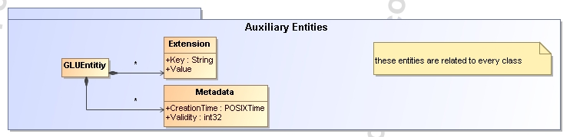

Extension

Entity | Inherits from |  |  | Description
Extension |  |  |  | A key,value pair providing extra information not captured in the current model
Property | Type | Mult. | Unit | Description
Key | String | 1 |  | A local ID, typically an attribute name that could be added in future info model revisions
Value | String | * |  | A value for the attribute

Metadata

Entity | Inherits from |  |  | Description
Metadata
Property | Type | Mult. | Unit | Description
CreationTime | DateTime_t | 1 |  | Timestamp when the entity instance was generated
Validity | Int32 | 1 | s | The time period for how long the generated information is considered to be relevant by the information provider

Conceptual Model of the Computing Service

The conceptual model of the Computing Service is based upon the main entities and uses specializations of Service, Resource, Share, Endpoint and Activity entities. Further computing related concepts such as Execution Environment and Application Environment are introduced.
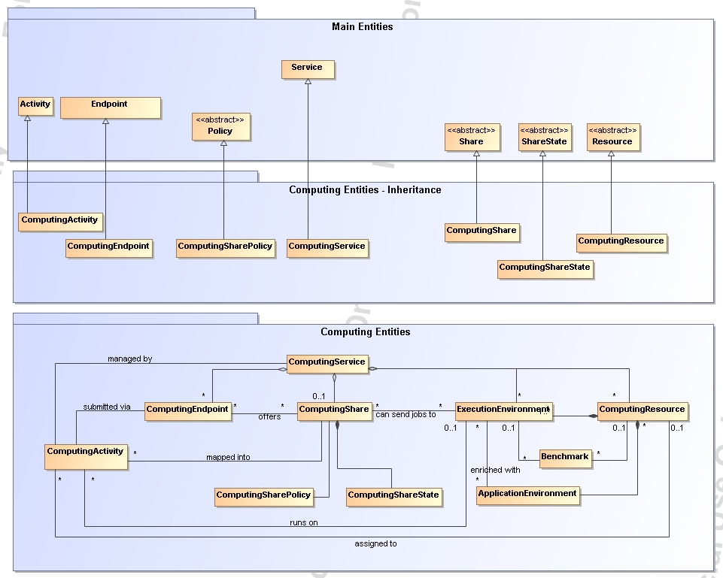
Figure 2 Entities and relationships for the Computing Service conceptual model

ComputingService

Entity | Inherits from |  |  | Description
ComputingService | Service |  |  | An abstracted, logical view of actual software components that participate in the creation of a computational capacity in a Grid environment. A computing service exposes one or more endpoints having well-defined interfaces, one or more computing shares and one or more computing resource.  The service is autonomous and denotes a weak aggregation among endpoints, the exposed computing resources, and the defined computing shares.  The service enables to identify the whole set of entities providing the computing functionality with a persistent name.
Inherited Property | Type | Mult | Unit | Description
ID [key] | URI | 1 |  | A global unique ID
Name | String | 0..1 |  | Human-readable name
Capability | ServiceCapability_t | * |  | The capability provided by this service according to the OGSA architecture
Type | ServiceType_t | 1 |  | The type of service according to a middleware classification
QualityLevel | QualityLevel_t | 1 |  | Maturity of the service in terms of quality of the software components
StatusPage | URI | * |  | Web page providing additional information like monitoring aspects
Complexity | String | 0..1 |  | Human-readable summary description of the complexity in terms of the number of endpoint types, shares and resources. The syntax should be: endpointType=X, share=Y, resource=Z.
OtherInfo | String | * |  | Placeholder to publish info that does not fit in any other attribute. Free-form string, comma-separated tags, (name, value ) pair are example of syntax
Property | Type | Mult | Unit | Description
TotalJobs | int32 | 0..1 | job | Number of total jobs
RunningJobs | int32 | 0..1 | job | Number of running jobs
WaitingJobs | int32 | 0..1 | job | Number of jobs waiting in the underlying LRMS’s
StagingJobs | int32 | 0..1 | job | Number of jobs that are staging files in/out
SuspendedJobs | Int32 | 0..1 | job | Number of jobs which started their execution, but are suspended (e.g., for preemption)
PreLRMSWaitingJobs | int32 | 0..1 | job | Number of jobs that are in the Grid layer waiting to be passed to the underlying LRMS

The simplest computing service is formed by a computing endpoint exposing an interface for job submission and control, a computing share and a computing resource. In case of a single computing resource exposed by multiple computing endpoints, such computing endpoints have to be considered part of the computing service. In case of a computing endpoint exposing many computing resources, then these computing resources are part of the computing service.

The computing service always aggregate computing endpoints, shares and resources forming a connected set. In other words, Endpoint A exposing resource A via share A and Endpoint B exposing Resource B via share B form two different computing services. On the other side, Endpoint A exposing Resource A via a share and Endpoint B exposing Resource A and B via another share form a computing service.

Properties from previous schemas: nordugrid-cluster-localse (similar to Glue.CESEBind.SEUniqueID)

ComputingEndpoint

Entity | Inherits from |  |  | Description
ComputingEndpoint | Endpoint |  |  | Endpoint for creating, monitoring, and controlling computational activities called jobs
Inherited Property | Type | Mult | Unit | Description
ID [key] | URI | 1 |  | A global unique ID
Name | String | 0..1 |  | Human-readable name
URL | URI | 1 |  | Network location of the endpoint to contact the related service
Capability | EndpointCapability_t | * |  | The capability exposed by this interface
Type | EndpointType_t | 1 |  | The type of endpoint according to a middleware classification
QualityLevel | QualityLevel_t | 1 |  | Maturity of the service in terms of quality of the software components
SpecificationName | String | 0..1 |  | Name of the interface specification
SpecificationVersion | String | 0..1 |  | Version of the interface
Implementor | String | 0..1 |  | Main organization implementing this software component
ImplementationName | String | 0..1 |  | Name of the implementation
ImplementationVersion | String | 0..1 |  | Version of the implementation (e.g., major version.minor version.pathcversion)
HealthState | EndpointHealthState_t | 1 |  | A state representing the health of the endpoint
HealthStateInfo | String | 0..1 |  | Textual explanation of the state endpoint
ServingState | ServingState_t | 1 |  | The serving state
WSDL | URI | * |  | URL of the WSDL document describing the offered interface (applies to Web Services endpoint)
SupportedProfile | URI | * |  | URI identifying a supported profile
Semantics | URI | * |  | URL of a document providing a human-readable description of the semantics of the endpoint functionalities
StartTime | DateTime_t | 0..1 |  | The timestamp for the start time of the endpoint
IssuerCA | DN_t | 0..1 |  | Distinguished name of Certification Authority issuing the certificate for the endpoint
Property | Type | Mult. | Unit | Description
Staging | Staging_t | 0..1 |  | Supported staging functionalities

ComputingShare

Entity | Inherits from |  |  | Description
ComputingShare |  |  |  | A utilization target for a set of computing resources defined by policies and characterized by status information
Inherited Property | Type | Mult | Unit | Description
LocalID [key] | String | 1 |  | An opaque local identifier
Name | String | 0..1 |  | Human-readable name
Description | String | 0..1 |  | Description of this share
Property | Type | Mult. | Unit | Description

In a computing resource describing a batch system, a typical implementation of a computing share is via a batch queue with the associated policies and status information. The same computing share can be implemented using different batch system configuration strategies. In complex batch systems, it is possible to define different set of policies for the same batch queue, this will imply a share for each set of policies. A computing share can be implemented by virtual machine management systems. The model supports heterogeneity by being able to represent different execution environments associated to the same computing share.

ComputingSharePolicy

Entity | Inherits from |  |  | Description
ComputingSharePolicy | SharePolicy |  |  | Statements, rules or assertions that specify the correct or expected behavior of a computing share
Inherited Property | Type | Mult | Unit | Description
Property | Type | Mult. | Unit | Description
MappingQueue | string | 0..1 |  | Name of a queue available in the underlying LRMS where jobs of this share are submitted (different shares can be mapped to the same queue; it is not foreseen that a single share can be mapped to many queues)
MaxWallTime | Int64 | 0..1 | s | The maximum obtainable wall clock time that can be granted to the job upon user request
MinWallTime | Int64 | 0..1 |  | The minimum Wall clock time for a job
DefaultWallTime | Int64 | 0..1 | s | The default wall clock time allowed to each job by the LRMS if no limit is requested in the job submission description. Once this time has expired the job will most likely be killed or removed from the queue
MaxCPUTime | Int64 | 0..1 | s | The maximum obtainable CPU time that can be granted to the job upon user request
MinCPUTime | Int64 | 0..1 |  | The minimum CPU time for a job
DefaultCPUTime | Int64 | 0..1 | s | The default CPU time allowed to each job by the LRMS if no limit is requested in the job submission description
MaxTotalJobs | Int64 | 0..1 |  | The maximum allowed number of jobs in this share
MaxRunningJobs | Int64 | 0..1 |  | The maximum allowed number of jobs in running state in this share
MaxWaitingJobs | Int64 | 0..1 |  | The maximum allowed number of jobs in waiting state in this share
MaxPreLRMSWaitingJobs |  | 0..1 |  | The maximum allowed number of jobs that are in the Grid layer waiting to be passed to the underlying LRMS for this share
MaxUserRunningJobs | Int64 | 0..1 |  | The maximum allowed number of jobs in running state per Grid user in this share
MaxSlotsPerJob | Int64 | 0..1 |  | The maximum number of slots which could be allocated to a single job (defined to be 1 for a computing service accepting only standard jobs)
MaxStageInStreams | Int64 | 0..1 |  | The maximum number of streams to stage in files
MaxStageOutStreams | Int64 | 0..1 |  | The maximum number of streams to stage out files
SchedulingPolicy | SchedulingPolicy_t | 0..1 |  | Implied scheduling policy of the share
MaxMemory | Int64 | 0..1 | Byte | The maximum RAM that a job can use
MaxDiskSpace | Int64 | 0..1 | Byte | The maximum disk space that a job can use excluding shared area such as cache
DefaultStorageService | URI | 0..1 |  | ID of the default Storage Service to be used to store files from jobs in case where no destination Storage Service is explicitly stated
Preemption | Boolean | 0..1 |  | If true, the computing resource enables preemption of jobs; a preempted job is supposed to be automatically resumed
AssociationEnd |  | Mult. | Description
Association to UserDomain via Mapping Policy

ComputingShareState

Entity | Inherits from |  |  | Description
ComputingShareState | ShareState |  |  | Set of attributes describing the dynamic state of a computing share
Inherited Property | Type | Mult | Unit | Description
Property | Type | Mult. | Unit | Description
ServingState | ServingState_t | 1 |  | The share state (production, draining, queueing, closed)
TotalJobs | Int32 | 0..1 | job | Number of total jobs
RunningJobs | Int32 | 0..1 | job | Number of running jobs submitted via any type of interface (local and Grid)
LocalRunningJobs | Int32 | 0..1 | job | Number of running jobs submitted via a local interface
WaitingJobs | Int32 | 0..1 | job | Number of jobs waiting in the underlying LRMS’s submitted via any type of interface (local and Grid)
LocalWaitingJobs | Int32 | 0..1 | job | Number of jobs waiting in the underlying LRMS’s submitted via a local interface
StagingJobs | Int32 | 0..1 | job | Number of jobs that are staging files in/out
SuspendedJobs | Int32 | 0..1 | job | Number of jobs which started their execution, but are suspended (e.g., for preemption)
PreLRMSWaitingJobs | Int32 | 0..1 | job | Number of jobs that are in the Grid layer waiting to be passed to the underlying LRMS
EstimatedAverageWaitingTime | Int64 | 0..1 | S | Estimated time to last for a new job from the acceptance to the start of its execution
EstimatedWorstWaitingTime | Int64 | 0..1 | S | The estimated worst waiting time assuming that all jobs run for the maximum wall time
FreeJobSlots | Int64 | 0..1 |  | Number of single-processor jobs which could be started if no other jobs are submitted and no jobs finish in the interim

ComputingResource

Entity | Inherits from |  |  | Description
ComputingResource | Resource |  |  | Grouping concept for a set of different types of execution environments offered through computing endpoint(s). The computing resource usually represents aggregated information. The aggregation is defined by the common local management scope.
Inherited Property | Type | Mult | Unit | Description
ID [key] | URI | 1 |  | A global unique ID
Name | string | 0..1 |  | Human-readable name
Property | Type | Mult. | Unit | Description
LRMSType | LRMSType_t | 1 |  | Type of the underlying local resource management system
LRMSVersion | String | 0..1 |  | Version of the underlying local resource management system
LRMSOtherInfo | String | 0..1 |  | Additional information about the LRMS
TotalJobSlots | Int32 | 0..1 |  | Number of managed job slots
SlotsUsedByLocalJobs | Int32 | 0..1 |  | Number of slots used by jobs submitted via local interface
SlotsUsedByGridJobs | Int32 | 0..1 |  | Number of slots used by jobs submitted via a Grid interface
TotalPhysicalCPUs | Int32 | 0..1 |  | Number of managed physical CPUs accessible via any of the available endpoints (there is one physical CPU per socket)
TotalLogicalCPUs | Int32 | 0..1 |  | Number of managed logical CPUs accessible via any of the available endpoints (a logical CPU corresponds to a CPU visible to the operating system)
TmpDir | String | 0..1
ScratchDir | String | 0..1
DataDir | String | 0..1
Homogeneity | Boolean | 0..1 |  | True if the computing resource manages only one type of execution environment
NetworkInfo | NetworkInfo_t | 0..1 |  | Type of internal network available among the execution environments
LogicalCPUDistribution | String | 0..1 |  | Syntax: X1:Y1, …, Xn:Yn where Xi is the number of logical CPUs and Yi is the number of boxes for the execution environment i
GridAreaTotal | Int32 | 0..1 | GB | Total shared disk space allocated in the computing resource available to Grid jobs
GridAreaFree | Int32 | 0..1 | GB | Free shared disk space allocated in the computing resource available to Grid jobs
GridAreaLifeTime | Int32 | 0..1 | min | Lifetime of the Grid job directory after the end of the jobs
CacheTotal | Int32 | 0..1 | GB | Total disk space allocated for caching files of Grid jobs
CacheFree | Int32 | 0..1 | GB | Free disk space allocated for caching files of Grid jobs

A local resource management system like a batch system is an example of aggregation scope. The Operating System can be the simplest case of LRMS.

Benchmark

Entity | Inherits from |  |  | Description
Benchmark |  |  |  | Benchmark information about a computing entity
Property | Type | Mult. | Unit | Description
Type | Benchmark_t | 1 |  | Type of benchmark
Value | Int32 | 1 |  | Value

ExecutionEnvironment

Entity | Inherits from |  |  | Description
ExecutionEnvironment |  |  |  | A description of hardware and software characteristics that defines the environment available to and requestable by a Grid job when submitted to a Computing Service via a Computing Endpoint; the description also includes information about the total/available/used instances of the execution environment
Property | Type | Mult. | Unit | Description
ID [key] | URI | 1 |  | A global unique ID
PlatformType | Platform_t | 1 |  | The type of platform running the execution environment instance
VirtualMachine | Boolean | 0..1 |  | True if the execution environment is based on a virtual machine (in this case, the values of the other attributes are related to the virtualized environment and not to the hosting environment)
TotalInstances | Int32 | 0..1 |  | Number of execution environment instances
UsedInstances | Int32 | 0..1 |  | Number of used execution environment instances (an instance is used when, according to the policies of the LRMS, it cannot accept new jobs because it already runs the maximum number of jobs)
UnavailableInstances | Int32 | 0..1 |  | Number of unavailable execution environment instances because of failures or maintenance
PhysicalCPUs | Int32 | 0..1 |  | Number of physical CPUs in an execution environment instance (counted by socket)
LogicalCPUs | Int32 | 0..1 |  | Number of logical CPUs in an execution environment instance as showed by the operating system
CPUMultiplicity | CPUMultiplicity_t | 0..1 |  | Multiplicity of the CPU
CPUVendor | String | 0..1 |  | Name of the CPU vendor
CPUModel | String | 0..1 |  | CPU model as defined by the vendor
CPUVersion | String | 0..1 |  | CPU version as defined by the vendor
CPUClockSpeed | Int32 | 0..1 | MHz | CPU nominal clock speed
MainMemorySize | Int64 | 1 | byte | Amount of RAM (if many jobs run in the same execution environment, they compete for the total RAM)
VirtualMemorySize | Int64 | 0..1 | byte | The amount of Virtual Memory (RAM+Swap)
OSFamily | OSFamily_t | 1 |  | Family of the operating system
OSName | OSName_t | 0..1 |  | Name of the operating system
OSVersion | String | 0..1 |  | Version of the operating system
ConnectivityIn | Boolean | 1 |  | Permission for direct inbound connectivity, even if limited
ConnectivityOut | Boolean | 1 |  | Permission for direct outbound connectivity, even if limited
NetworkInfo | NetworkInfo_t | 0..1 |  | Type of internal network available among the execution environments

An execution environment can be realized in several ways. Examples are a computing node or a virtual machine image that can be requested by a job (different virtual machine images can coexist on the same node). The description about individual software packages is considered by the ApplicationEnvironment class.

ApplicationEnvironment

Entity | Inherits from |  |  | Description
ApplicationEnvironment |  |  |  | Description of the application software environment available within one or more execution environments
Property | Type | Mult. | Unit | Description
ID [key] | URI | 1 |  | A global unique ID
Name | String | 1 |  | Name
Version | String | 0..1 |  | Version
State | AppEnvState_t | 0..1 |  | State about the installation
LifeTime | Int32 | 0..1 | s | Time left before removal
License | License_t | 0..1 |  | The type of license
InstalledRoot | String | 0..1 |  | The directory where the software is installed on the file system
SetupMethod | SetupMethod_t | 0..1 |  | Method for setting the environment
SetupKey | String | 0..1 |  | Fully qualified script for the setting of the application environment
Description | String | 0..1 |  | The description of this application environment
MaxCPUs | Int32 | 0..1 |  | Maximum number of CPUs that can run the application environment at the same time
MaxJobSeats | Int32 | 0..1 |  | Maximum number of jobs that can use the application environment at the same time
MaxUserSeats | Int32 | 0..1 |  | Maximum number of users that can use the application environment at the same time
FreeCPUs | Int32 | 0..1 |  | Available number of CPUs that can run the application environment at the same time
FreeJobSeats | Int32 | 0..1 |  | Available number of jobs that can use the application environment at the same time
FreeUserSeats | Int32 | 0..1 |  | Available number of users that can use the application environment at the same time

The Application Environment is suggested to be used also for describing application software in terms of a simple tag. In this case, the Name property should be used.

ComputingActivity

Entity | Inherits from |  |  | Description
ComputingActivity | Activity |  |  | An activity managed by an OGSA execution capability service (the computing activity is traditionally called job)
Inherited Property | Type | Mult | Unit | Description
ID [key] | URI | 1 |  | A global unique ID
Type | ActivityType_t | 1 |  | The type of this activity
Property | Type | Mult. | Unit | Description
LocalID | String | 0..1 |  | The job ID as assigned by the LRMS
Name | String | 0..1 |  | The job name as specified by the userin the jobdescription document
State | ComputingActivityState_t | 1 |  | The status of the Grid job
ReRunable | ComputingActivityState_t | 0..1 |  | The name of the Grid job state from which a failed grid job can be rerun following a client request.
ExitCode | Int32 | 0..1 |  | The exit code of the executable of Grid job
LRMSExitCode | Int32 | 0..1 |  | The exit code provided by the batch system
Errors | String | 0..1 |  | Textual explanation of the job’s failure, the error message provided by the Grid layer running on  the resource
WaitingPosition | Int32 | 0..1 |  | The queue/LRMS position of a waiting Grid job
Owner | String | 1 |  | The Grid identity of the job’s owner
LocalOwner | String | 0..1 |  | The maped local userID of the job’s owner
RequestedWallTime | Int32 | 0..1 | min | The wallclock time request of the job
RequestedCPUTime | Int32 | 0..1 | min | The CPU time request of the job
RequestedApplicationEnvirnment | String | * |  | The name of the requested ApplicationEnvironment
RequestedCPUs | Int32 | 0..1 |  | The number of requested cpus
StdOut | String | 0..1 |  | The name of the file which contains the standard output of the job
StdErr | String | 0..1 |  | The name of the file which contains the standard error of the job
StdIn | String | 0..1 |  | The name of the file which is used as the standard input of the job
LogDir | String | 0..1 |  | The name of the directory which contains the Grid session related logs within the session directory of the job
Otherinfo | String | * |  | The multivalued attribute contains the optional job comments provided by either the Grid Layer or the Local Resource Management System
ExecutionNodes | String | * |  | The multivalued attribute presents the local node names of the cluster nodes which are occupied by the running Grid job
ExecutionQueue | String | 0..1 |  | The name of the LRMS queue executing the grid job
ExecutionComputingService | String | 0..1 |  | The name of the ComputingService executing the Grid job
UsedWallTime | Int32 | 0..1 | min | The consumed wall clock time of the job
UsedCPUTime | Int32 | 0..1 | min | The consumed cpu time of the job
UsedMemory | Int32 | 0..1 |  | The memory usage of the job
CompletionTime | DateTime_t | 0..1 |  | The completion time of the Grid job. The time stamp when the job entered its final state
SessionDirEraseTime | DateTime_t | 0..1 |  | The time when the dedicated Grid job area will be removed from the Computingservice
ProxyExpirationTime | DateTime_t | 0..1 |  | The expiration time of the proxy assigned to the job
SubmissionTime | DateTime_t | 0..1 |  | The time stamp of the submission of the job to the ComputingService
SubmissionClient | String | 0..1 |  | The attribute specifies client machine from where the job was submitted in a fixed format string. The string contains the submission host’s IP, the port and the host name
SubmissionClientSoftware | String | 0..1 |  | The name of the client software which was used to submit the job

A Job is typically described by an XML document compliant to the JSDL specification. In this specification, the Job is related to a single processor job. Other job types such “collection of jobs” and workflows will be considered in a future revision.

Conceptual Model of the Storage Service

Like the Computing Service, the conceptual model of the Storage Service is based upon the main entities and uses specializations for those entities. Further on, storage related concepts such as StorageShareState, StorageSpaceState, StorageMappingPolicy, StorageEnvironment and StorageAccessProtocol are introduced.
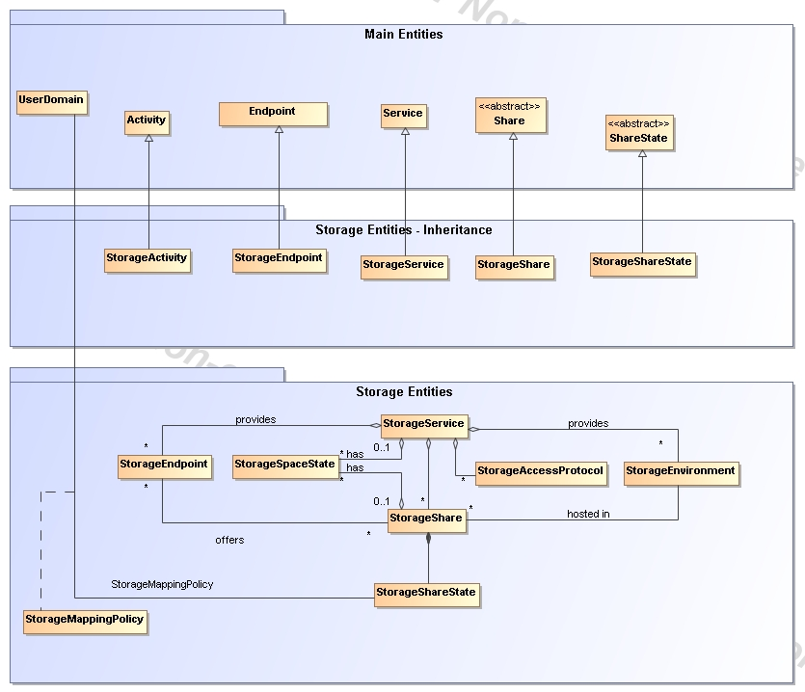
Figure 3 Entities and relationships for the Storage Element model

StorageService

Entity | Inherits from |  |  | Description
StorageService | Service |  |  | An abstracted, logical view of actual software components that participate in the creation of a storage capacity in a Grid environment. A storage service exposes one or more endpoints having well-defined interfaces and one or more storage shares.  The service is autonomous and denotes a weak aggregation among endpoints and the defined storage shares.  The service enables to identify the whole set of entities providing the storage functionality with a persistent name.
Inherited Property | Type | Mult | Unit | Description
ID [key] | URI | 1 |  | A global unique ID
Name | String | 0..1 |  | Human-readable name
Capability | ServiceCapability_t | * |  | The capability provided by this service according to the OGSA architecture
Type | ServiceType_t | 1 |  | The type of service according to a middleware classification
QualityLevel | QualityLevel_t | 1 |  | Maturity of the service in terms of quality of the software components
StatusPage | URI | * |  | Web page providing additional information like monitoring aspects
Complexity | String | 0..1 |  | Human-readable summary description of the complexity in terms of the number of endpoint types, shares and resources. The syntax should be: endpointType=X, share=Y, resource=Z.
OtherInfo | String | * |  | Placeholder to publish info that does not fit in any other attribute. Free-form string, comma-separated tags, (name, value ) pair are example of syntax
Property | Type | Mult. | Unit | Description
Implementation Name | String | 1 |  | The name of the running software
Implementation Version | String | 1 |  | The version of the running software
Architecture | String | 1 |  | The Architecture this storage management software is running on.

The storage service is formed by storage endpoints offering interfaces to the service and storage shares which represent allocated storage capacity on the service which can be utilized for storage activities. The access to the endpoint and shares is controlled by a mapping policy instance.
A storage service is instantiated when it offers at least one endpoint. It may have zero or more shares. A storage service without a storage share does not offer any storage capabilities.

StorageEndpoint

Entity | Inherits from |  |  | Description
StorageEndpoint | Endpoint, Downtime |  |  | Endpoint for accessing and controlling storage activities.
Inherited Property | Type | Mult | Unit | Description
ID [key] | URI | 1 |  | A global unique ID
Name | String | 0..1 |  | Human-readable name
URL | URI | 1 |  | Network location of the endpoint to contact the related service
Capability | EndpointCapability_t | * |  | The capability exposed by this interface
Type | EndpointType_t | 1 |  | The type of endpoint according to a middleware classification
QualityLevel | QualityLevel_t | 1 |  | Maturity of the service in terms of quality of the software components
SpecificationName | String | 0..1 |  | Name of the interface specification
SpecificationVersion | String | 0..1 |  | Version of the interface
Implementor | String | 0..1 |  | Main organization implementing this software component
ImplementationName | String | 0..1 |  | Name of the implementation
ImplementationVersion | String | 0..1 |  | Version of the implementation (e.g., major version.minor version.pathcversion)
HealthState | EndpointHealthState_t | 1 |  | A state representing the health of the endpoint
HealthStateInfo | String | 0..1 |  | Textual explanation of the state endpoint
ServingState | ServingState_t | 1 |  | The serving state (production, draining, queueing, closed)
WSDL | URI | * |  | URL of the WSDL document describing the offered interface (applies to Web Services endpoint)
SupportedProfile | URI | * |  | URI identifying a supported profile
Semantics | URI | * |  | URL of a document providing a human-readable description of the semantics of the endpoint functionalities
StartTime | DateTime_t | 0..1 |  | The timestamp for the start time of the endpoint
IssuerCA | DN_t | 0..1 |  | Distinguished name of Certification Authority issuing the certificate for the endpoint
DowntimeAnnounce | DateTime_t | 0..1 |  | The timestamp for the announcement of the next scheduled downtime
DowntimeStart | DateTime_t | 1 |  | The starting timestamp of the next scheduled downtime
DowntimeEnd | DateTime_t | 0..1 |  | The ending timestamp of the next scheduled downtime
DowntimeInfo | String | 0..1 |  | Description of the next scheduled downtime
Property | Type | Mult. | Unit | Description
Capability | String | * |  | Other information regarding this Endpoint

A StorageEndpoint exposes one interface of how a storage service can be contacted. It gives information about the control protocol and its status as well as possible downtimes.
A storage endpoint is linked to storage shares and thereby knows which shares it gives access to. The Capability field can be used to specify other restrictions such as WAN read-only/LAN read-write.

StorageShare

Entity | Inherits from |  |  | Description
StorageShare | Share |  |  | A utilization target for a set of storage resources defined by policies and characterized by status information
Inherited Property | Type | Mult | Unit | Description
LocalID [key] | String | 1 |  | An opaque local identifier
Name | String | 0..1 |  | Human-readable name
Property | Type | Mult. | Unit | Description
Path | String | 0..1
ExpirationMode | ExpirationMode_t | 0..1 |  | The expiration mode for files contained in the share
Tag | String | * |  | A user defined tag for additional information

A storage share represents allocated, (to a user domain) dedicated logical storage space within a storage service and can be accessed through the service’s endpoint(s).
The access of UserDomains to StorageShares is described by the StorageMappingPolicy.

StorageShareState

Entity | Inherits from |  |  | Description
StorageShareState |  |  |  | Describes the State of a StorageShare.
Property | Type | Mult. | Unit | Description
Status | StorageShareState_T | 1 |  | Up / Down / Maintenance

StorageAccessProtocol

Entity | Inherits from |  |  | Description
StorageAccessProtocol |  |  |  | Describes the access protocols of a Service.
Property | Type | Mult. | Unit | Description
LocalID | String | 1 |  | An opaque local identifier
Type | StorageAccessProtocol_T | 1 |  | The name of the protocol
Version | String | 1 |  | The version of the protocol
MaxStreams | Int64 | 1 |  | The number of parallel streams this protocol supports

StorageEnvironment

Entity | Inherits from |  |  | Description
StorageEnvironment |  |  |  | Description of the storage environment of the StorageShare.
Property | Type | Mult. | Unit | Description
ID [key] | String | 1 |  | A global unique ID
Type | StorageEnvironmentType_t | 0..1 |  | Volatile, Durable, Permanent
AccessLatency | AccessLatency_t | 0..1 |  | Online, Nearline, Offline
RetentionPolicy | RetentionPolicy_t | 0..1 |  | Custodial, Output, Replica

StorageSpaceState

Entity | Inherits from |  |  | Description
StorageShareState |  |  |  | Describes
Property | Type | Mult. | Unit | Description
FreeSize | Int32 | 1 | GByte | The free space left
UsedSize | Int32 | 1 | GByte | The used space
TotalSize | Int32 | 0..1 | GByte | The total size
ReservedSize | Int32 | 0..1 | GByte | The reserved

StorageMappingPolicy

Entity | Inherits from |  |  | Description
StorageMappingPolicy | MappingPolicy |  |  | Statements, rules or assertions that specify which instantiation of a Domain may use the associated StorageShare..
Inherited Property |  |  |  | Description
Scheme | PolicyScheme_t |  |  | 1
Rule | String |  |  | *
Property | Type | Mult. | Unit | Description
LocalID | URI | 1 |  | A local identifier for this Policy
Name | String | 1 |  | An descriptive name for this Policy
Path | String | 1 |  | Path used by VO for writing in an associated Share
Tag | String | 1 |  | A user defined tag for this policy

The StorageMappingPolicy describes the relationship of a Userdomain and StorageShare it may access. It keeps further information of how the Userdomain may utilize the StorageShare.

Relationship to OGF Reference Model

In this section, we describe the integration of the GLUE information model with the OGF Reference Model.
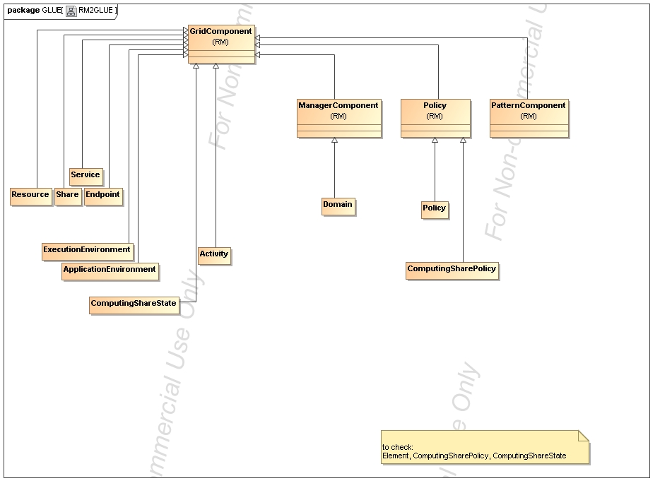
Figure 4 GLUE and Reference Model integration (draft)

Template

Entity | Inherits from |  |  | Description
Property | Type | Mult. | Unit | Description

Security Considerations

Please refer to RFC 3552 [RESCORLA] for guidance on writing a security considerations section. This section is required in all documents, and should not just say “there are no security considerations.” Quoting from the RFC:

“Most people speak of security as if it were a single monolithic property of a protocol or system, however, upon reflection, one realizes that it is clearly not true. Rather, security is a series of related but somewhat independent properties. Not all of these properties are required for every application.

We can loosely divide security goals into those related to protecting communications (COMMUNICATION SECURITY, also known as COMSEC) and those relating to protecting systems (ADMINISTRATIVE SECURITY or SYSTEM SECURITY). Since communications are carried out by systems and access to systems is through communications channels, these goals obviously interlock, but they can also be independently provided.”

Author Information
Sergio Andreozzi, INFN
Stephen Burke, RAL
Felix Ehm, CERN
Laurence Field, CERN
Gerson Galang,
Balazs Konya, Lund University,
Maarten Litmaath, CERN
Paul Millar, Desy
JP Navarro

Contributors & Acknowledgements
We gratefully acknowledge the contributions made to this document (in no particular order) by Shiraz Memon and Matt Vilionen

Glossary
Recommended but not required.

Intellectual Property Statement

The OGF takes no position regarding the validity or scope of any intellectual property or other rights that might be claimed to pertain to the implementation or use of the technology described in this document or the extent to which any license under such rights might or might not be available; neither does it represent that it has made any effort to identify any such rights. Copies of claims of rights made available for publication and any assurances of licenses to be made available, or the result of an attempt made to obtain a general license or permission for the use of such proprietary rights by implementers or users of this specification can be obtained from the OGF Secretariat.

The OGF invites any interested party to bring to its attention any copyrights, patents or patent applications, or other proprietary rights which may cover technology that may be required to practice this recommendation. Please address the information to the OGF Executive Director.

Disclaimer
This document and the information contained herein is provided on an “As Is” basis and the OGF disclaims all warranties, express or implied, including but not limited to any warranty that the use of the information herein will not infringe any rights or any implied warranties of merchantability or fitness for a particular purpose.

Full Copyright Notice

Copyright (C) Open Grid Forum (applicable years). All Rights Reserved.

This document and translations of it may be copied and furnished to others, and derivative works that comment on or otherwise explain it or assist in its implementation may be prepared, copied, published and distributed, in whole or in part, without restriction of any kind, provided that the above copyright notice and this paragraph are included on all such copies and derivative works. However, this document itself may not be modified in any way, such as by removing the copyright notice or references to the OGF or other organizations, except as needed for the purpose of developing Grid Recommendations in which case the procedures for copyrights defined in the OGF Document process must be followed, or as required to translate it into languages other than English.

The limited permissions granted above are perpetual and will not be revoked by the OGF or its successors or assignees.

References
Note that only permanent documents should be cited as references. Other items, such as Web pages or working groups, should be cited inline (i.e., see the Open Grid Forum, http://www.ogf.org). References should conform to a standard such as used by IEEE/ACM, MLA, Chicago or similar. Include an author, year, title, publisher, place of publication. For online materials, also add a URL. It is acceptable to separate out “normative references,” as IETF documents typically do. Some sample citations:

[glue-wg] The Glue Working Group of OGF, https://forge.gridforum.org/sf/projects/glue-wg
[glue-usecases] Glue 2.0 Use Cases (early draft), https://forge.gridforum.org/sf/go/doc14621
[glue-1.x] The Glue Schema 1.3, https://forge.gridforum.org/sf/go/doc14185
[ng-schema] The NorduGrid/ARC Information System, NORDUGRID-TECH 4,https://forge.gridforum.org/sf/go/doc14273
[naregi-schema] NAREGI information and data model, https://forge.gridforum.org/sf/go/doc14300
[ogf-ts] Technical Strategy for the Open Grid Forum 2007-2010. GFD-I.113. http://www.ogf.org/documents/GFD.113.pdf
[omii-jra2-djra2.1] Sergio Andreozzi, Antonia Ghiselli, Chunming Hu, Jinlei Jiang, Balazs Konya, Morris Riedel, Davy Virdee, Li Zha. D:JRA2.0 Report on Grid Activities relevant to the identification of new services http://omii-europe.org/OMII-Europe/News/DJRA20.pdf

Appendix A: Place-holder values for unknown data

Whilst people endeavour to provide accurate information, there may be situations where specific GLUE attributes may be assigned place-holder (or dummy) values. These place-holder values carry some additional semantic meaning; specifically, that the correct value is currently unknown and the presented value should be ignored. This appendix describes a set of such place-holder values.

Some attributes within the GLUE schema are required whilst others are optional. If the attribute is optional and the corresponding information is unavailable, the information provider must either
publish a place-holder or not to publish the attribute. If the attribute is required, then the information must either publish a place-holder value or refrain from publishing the GLUE object.

If a place-holder value is published, it must conform to the scheme described in this appendix. This is to increase the likelihood that software will understand the nature of the information it receives.

This appendix describes place-holder values that have be chosen so they are obvious "wrong" to humans, unlikely to occur under normal operation and valid within the attribute type. This also allows for detection of failing information provider components.

Use cases

There are two principle use-cases for place-holder values, although others may exist.

Scenario 1. a static value has no good default value and has not been configured for a particular site.

Some provisions for GLUE Schema provide templates. These templates may contain attributes that have no good default value; for example, supplying the correct value may require site-specific knowledge. Whilst it is expected that these attributes be configured, it is possible that this does not happen, so exposing the attributes' default values.

Scenario 2. information provider is unable to obtain a dynamic value.

A dynamic value is provided by an information provider by querying the underlying grid resources. This query will use a number of ancillary resources (e.g., DNS, network hardware) that might fail; the grid services might also fail. If an attribute is required and the current value is unobtainable, a place-holder value must be used.

Place-holder values

This section describes a number of values that can be represented within a given address space (e.g., Strings/UTF-8, Integers, FQDNs, IPv4 address space). Each of the different types are introduced along with the place-holder value and a brief discussion on usage, rational
and any other considerations.

Simple strings (ASCII/UTF-8) should use "UNDEFINEDVALUE" or should start "UNDEFINEDVALUE:"

Upper-case letters make it easier to spot and a single word avoids any white-space issues.
A short error message can be incorporated into the message by appending the message after the colon.

Examples:
UNDEFINEDVALUE
UNDEFINEDVALUE: unable to contact torque daemon.

Using UNDEFINEDVALUE is a default option for strings that have no widely-known structure. If a value is of a more restrictive sub-type (e.g., FQDNs, FQANs, URIs) described below, then the rules for more restrictive form must be used.

Fully qualified domain names

They must use a hostname ending either "example.org" for scenario 1, or "invalid" for scenario 2.

RFC 2606 defines two second-level domains: "example.org" and "example.com". These domains have the advantage of ending with a recognisable TLD, so are recognisable as a DNS name. Default configuration (scenario 1, above) must use DNS names that end "example.org"

RFC 2606 also reserves the "invalid" Top-Level-Domain (TLD) as always invalid and clearly so. For dynamic information gathering, a value ending "invalid" must be used.

In both cases, additional information may be included by specifying a prefix to "example.org" or "invalid". This may be used to specify the class of machine that should be present. For dynamic
infomation, if the class of machine is not published then the FQDN "unknown.invalid" must be used.

Examples:
www.example.org
your-CE.example.org
unknown.invalid
site-local-BDII.invalid

IPv4 address

It must use 192.0.2.250

There are several portions of IPv4 addresses that should not appear on a network, but none that are reserved for documentation or to specify a non-existent address. Using any address leads to the risk of side-effects, should this value be used.

The best option is an IP address from the 192.0.2.0/24 subnet. This subnet is defined in RFC 3330 as "TEST-NET" for use in documentation and example code. For consistency, the value 192.0.2.250 must be used.

IPv6 addr

It must use 2001:DB8::FFFF

There is no documented undefined IPv6 address. RFC 3849 reserves the address prefix 2001:DB8::/32 for documentation. For consistency, the address 2001:DB8::FFFF must be used.

Integers

It must use "all nines"
For uint32/int32 this is 999,999,999
For uint64/int64 this is 999,999,999,999,999,999

For integers, all numbers expressible within the encoding (int32/uint32/etc.) are valid so there is no safe choice.

If an unsigned integer is encoded as a signed integer, it is possible to use negative numbers safely. However, these numbers will be unrepresentable if the number is stored as an unsigned
integer. For this reason a negative number place-holder must not be used.

The number was chosen for three reasons. First, attribute scales are often chosen to reduce the likelihood of overflow: numbers towards MAXINT (the large number representable in an integer domain) are less likely to appear. Second, repeated numbers stand out more clearly to humans. Finally, the statistical frequency of measured values often follows Benford's law, which indicates that numbers starting with "1" occur far more frequently than those starting with "9" (about six times more likely). For these reasons, information providers must use all-nines to indicate an unknown value.

File path

It must start either "/UNDEFINEDPATH" or "\UNDEFINEDPATH".

As with the simple string, a single upper-case word is recommended. The initial slash indicates that the value is a path. Implementations must use whichever slash is most appropriate for the underlying system (Unix-like systems use a forward-slash). Software should accept either value as an unknown-value place-holder.

Additional information can be encoded as data beyond the initial UNDEFINEDPATH, separated by the same slash as started the value. Additional comments should not use any of the following characters: \ [ ] ; = " : | , * .

Examples:
/UNDEFINEDPATH
\UNDEFINEDPATH
/UNDEFINEDPATH/Path to storage area
/UNDEFINEDPATH/Broker unavailable

Email addresses

It must use an undefined FQDN for the domain.

RFC 2822 defines emails addresses to have the form: <local-part> '@' <domain>

The <domain> must be an undefined FQDN; see above for a complete description. For email addresses, information providers should use "example.org" for scenario 1. and "unknown.invalid" for scenario 2.

The <local-part> may be used to encode a small amount of additional information; for example, it may indicate the class of user to whom the email address should be delivered. If no such information is to be encoded the value "user" must be used.

Examples:
user@example.org
user@unknown.invalid
site-local-contact@example.org
local-admin@example.org

Uniform Resource Identifier (URI)

It is schema-specific

RFC 3986 defines URIs as a "federated and extensible naming system." All URIs start with a schema-name part (e.g., "http") and no schema-name has been reserved for undefined or documenting example values.

For any given URI schema ("http", for example), it may be possible to define an unknown value within that name-space. If a GLUE value has only one valid schema, the undefined value must be taken from that schema. If several schemata are possible, one must be chosen from the available options. This should be the most commonly used.

Take care with the URI encoding. All unknown URI values must be valid URIs. If additional information is included, it must be encoded so the resulting URI is valid.

For schemata that may include a FQDN (e.g., a reference to an Internet host), an undefined URI must use an undefined FQDN; see above for details on undefined FQDNs.

URI schemata that reference a remote file (e.g., "http", "ftp", "https"), additional information may be included as the path. The FQDN indicates that the value is a place-holder, indicating an unknown value, so information providers should not specify "UNDEFINEDPATH".

For "file" URIs, the path part must identify the value as unknown and must use the forward-slash variant; see above for details on undefined paths.

For "mailto" URIs [RFC 2368] encapsulates valid email addresses with additional information (such as email headers and message body). Unknown mailto URIs must use an unknown email address (see above). Any additional information must be included in the email body.

There may be other schemata in use that are not explicitly covered in this section. A place-holder value should be agreed upon within whichever domain such schemata are used. This place-holder value should be in the spirit of the place-holder values described so far.

Examples:
http://www.example.org/
httpg://your-CE.example.org/path/to/end-point
httpg://unknown.invalid/User%20certificate%20has%20expired
mailto:site-admin@example.org
mailto:user@maildomain.invalid?body=Problem%20connecting%20to%20WLMS
file:///UNDEFINEDPATH
file:///UNDEFINEDPATH/path%20to%20some%20directory

X509 Distinguished Names

It must start /O=Grid/CN=UNDEFINEDUSER

X509 uses a X500 namespace, represented as several Relative Domain-Names (RDNs) concatenated by forward-slashes. The final RDN is usually a single common name (CN), although multiple CNs are allowed.

Unknown DN values must have at least two entries: an initial O=Grid followed immediately by CN=UNDEFINEDUSER.

Additional information can be encoded using extra CN entries. These must come after CN=UNDEFINEDUSER.

Examples:
/O=Grid/CN=UNDEFINEDUSER
/O=Grid/CN=UNDEFINEDUSER/CN=Your Grid certificate DN here
/O=Grid/CN=UNDEFINEDUSER/CN=Cannot access SE

Fully Qualified Attribute Name (FQAN)

It must use a VO of "vo.example.org" (for scenario 1.) or "unknown.invalid" (for scenario 2).

The "VOMS Credential Format" document,

http://edg-wp2.web.cern.ch/edg-wp2/security/voms/edg-voms-credential.pdf

states that FQANs must have the form:

/VO[/group[/subgroup(s)]][/Role=role][/Capability=cap]

Where VO is a well-formed DNS name. Unlike DNS names, VO names must be lower-case. The unknown place-holder value for FQAN is derived from the unknown DNS name (see above). It must have no subgroup(s) or Capability specified.

Any additional information must be encoded within a single Role name. Care should be taken that only valid characters (A-Z, a-z, 0-9 and dash) are included.

Examples:
/vo.example.org
/vo.example.org/Role=Replace-this-example-with-your-FQAN
/unknown.invalid
/unknown.invalid/Role=Unable-to-contact-CE-Error-42

Geographic locations

It must use longitude 0 degrees, latitude 0 degrees.

Meridians of longitude are taken from (-180,180] degrees, whilst parallels of latitude are taken from [-90,90] degrees. For a place-holder value to be a valid location, it must also be taken
from these ranges.

By a happy coincidence, the (0,0) location is within the Atlantic Ocean, some 380 miles (611 kilometers) south of the nearest country (Ghana). Since this location is unlikely to be used and repeated numbers are easier for humans to spot, (0,0) must be used to specify an unknown location.

Appendix B: Data Types

ContactType_t

Open enumeration

Value | Description
security
sysadmin
usersupport
general

PolicyScheme_t

Value | Description

DN_t

ServiceCapability_t

List of values initially drafted from [omii-jra2-djra2.1]. To be refined by examples. Open enumeration.

Value | Description
security.authentication | Capacity of providing authentication mechanisms for Grid users machine and services
security.credentialStorage | Capacity of providing an online credential repository that allows users to securely obtain credentials when and where needed
security.delegation | capacity for a user to give a service the authority to undertake specific activities or decisions on its behalf
security.authorization | capacity of handling authorization aspects, making authorization decisions about the subject and the requested mode of access based upon combining information from a number of distinct sources
security.identymapping | capacity of mapping Grid-level credentials to local level credentials (e.g., mapping a user X.509 certificate into a UNIX account).
security.attributeauthority | capacity of associating a user with a set of attributes in a trusted manner to a relying party, by way of digitally signed assertions
security.accounting | capacity of systematically recording, reporting, and analyzing the usage of resources
data.transfer | capacity of moving a file from one network location to another. It refers to the actual transfer (e.g., as performed by protocols like FTP, GridFTP, or HTTP)
data.management.transfer | capacity of managing a transfer of files from the start to the completion
data.management.replica | capacity of managing the creation of file replicas upon request
data.management.storage | capacity of managing a storage resource, from simple systems like disk-servers to complex hierarchical systems
data.naming.resolver | capacity of resolving one name to another (for example, search the associated abstract name to a certain human-oriented name)
data.naming.scheme | capacity of attaching names to data resources. (To evaluate if it should moved to the main category infrastructure instead of data). In OGSA, a three-level naming scheme is defined: (1) human-oriented name, (2) abstract name and (3) address
data.access.relational | capacity of providing access to a relational data source
data.access.xml | capacity of providing access to an XML data source
data.access.flatfiles | capacity of providing access to a flat file
information.model | capacity of modelling resources based on a community accepted definition
information.discovery | capacity of locating unknown resources or services, possibly satisfying a set of requirements
information.logging | capacity of recording data, often chronologically
information.monitoring | capacity of periodically observing measurements, transform them and make available to users or other applications
information.provenance | capacity of providing long-term storage of information related to Grid activity and to let this information be accessed by users or other applications.
execman.bes | capacity of executing a job or set of jobs.
execman.jobdescription | capacity of letting users be able to describe a job submission request based on a machine-processable language
execman.jobmanager | capacity of managing the execution of a job or set of jobs from start to finish
execman.executionandplanning | capacity of building schedules for jobs, that is, the capability of defining mappings between services and resources, possibly with time constraints
execman.candidatesetgenerator | capacity of determining the set of resources on which a nit of workcan execute
execman.reservation | capacity of managing reservation of resources for future usage

ServiceType_t

Every item should start with org.MIDDLEWARENAME. Open enumeration.

Value | Description
org.glite.wms
org.glite.lb
…

QualityLevel_t

Closed enumeration

Value | Description
development
testing
pre-production
production

EndpointCapability_t

The initial set of values is drafted from [omii-jra2-djra2.1]. At the moment, we use the same of ServiceCapability_t. Open enumeration

EndpointType_t

Every item should start with org.MIDDLEWARENAME. Open enumeration.

Value | Description
org.glite.wmproxy
…

EndpointHealthState_t

Closed enumeration

Value | Description
ok
warning
critical
unknown
other

ServingState_t

Closed enumeration

Value | Description
production
draining
queueing
closed

ActivityType_t

Open enumeration
Value | Description
computing

DateTime_t

Extended ISO 8061 format: [-]CCYY-MM-DDThh:mm:ss[Z|(+|-)hh:mm]
This data type maps the XSD dateTime simple type.
We restrict this syntax to GMT timezone: yyyy '-' mm '-' dd 'T' hh ':' mm ':' ss Z

Staging_t

Open enumeration:

Value | Description
none | No staging of files supported
stagingin | Automatic staging in of files supported
stagingout | Automatic staging out of files supported
staginginout | Automatic staging in and out of files supported

SchedulingPolicy_t

Open enumeration:

Value | Description
fairshare | Statistically guarantees the allocated share
fifo | First-In First-Out
random | Random choice

LRMSType_t

Open enumeration:

Value | Description
openpbs
lsf

NetworkInfo_t

Closed enumeration

Value | Description
gigabitethernet
myrinet
infiniband

Benchmark_t

Open enumeration

Value | Description
specint2000
specfp2000
bogomips

platform_t

Open enumeration:

Value | Description
ia32
ia64

CPUMultiplicity_t

Open enumeration:

Value | Description
singlecpu-singlecore | The execution environment is run by a single CPU with a single core
singlecpu-multicore | The execution environment is run by a single CPU with multiple cores
multicpu-singlecore | The execution environment is run by multiple CPUs with a single core each
multicpu-multicore | The execution environment is run by multiple CPUs with a multiple cores each

OSFamily_t

Open enumeration:

Value | Description
linux
macos
windows
solaris

OSName_t

Open enumeration:

Value | Description
scientificlinuxcern
scientificlinux
windowsxp
windowsvista
Ubuntu
debian
centos
leopard

AppEnvState_t

Open enumeration:

Value | Description
tested
installed
dynamic
toberemoved

License_t

Closed enumeration
Value | Description
opensource
commercial
unknown

SetupMethod_t

Closed enumeration
Value | Description
default
setenv
…

ComputingActivityState_t

Open enumeration:

Value | Description

ExpirationMode_t

Closed enumeration:

Value | Description
Nnever
warn
release

StorageShareState_t

Closed enumeration:

Value | Description
ok
down
maintenance

StorageAccessProtocol_t

Open enumeration:

Value | Description
gsiftp
Nfs
afs
rfio
gsirfio
dcap
gsidcap
root
https

StorageEnvironmentType_t

Closed enumeration:

Value | Description
volatile
durable
permanent

AccessLatency_t

Closed enumeration:

Value | Description
online
nearline
offline

RetentionPolicy_t

Closed enumeration:

Value | Description
custodial
output
replica

In the final section, this page will contain the XML Schema rendering of GLUE 2.0. Meanwhile, the draft schema can be located at the following page:

http://forge.ogf.org/sf/wiki/do/viewPage/projects.glue-wg/wiki/GLUE2XMLSchema

Appendix C: XML Schema Rendering

Appendix D: LDAP Rendering

In the final section, this page will contain the LDAP rendering of GLUE 2.0 (both schema and Directory Information Tree description). Meanwhile, the draft schema can be located at the following page:

http://forge.ogf.org/sf/wiki/do/viewPage/projects.glue-wg/wiki/GLUE2LDAP

Appendix E: Relational Rendering

In the final section, this page will contain the Relational Schema rendering of GLUE 2.0. Meanwhile, the draft schema can be located at the following page:

http://forge.ogf.org/sf/wiki/do/viewPage/projects.glue-wg/wiki/GLUE2Relational

