Execution Management Services (Re-factoring) – OGSA (Rev 0)
Proposal: Ravi Subramaniam (Intel)

Goals:
Define all aspects of architecture to
- Provision, manage and co-ordinate the lifecycle of any resource on the Grid
- Define and meet SLAs and optimize Qualities of Service of resources with respect to the work to be done against them.

Focus:
Define
- Capabilities
- Services
  - Semantics
  - Roles
  - Behavior
  - Responsibility
  - Attributes
  - Composition paradigm
- Service Interoperability
  - Interactions
  - Collaborations
  - Interoperability profiles
  - Communication – including message formats
- Ontology
  - Terms
  - Relationships

Specific formats, protocols, interface definitions where compatible will be adopted from current standards or standards in progress. We will not be limited by these standards.

Guiding Principles
- Focus on defining a highly factored architecture. As a early step, try to factor the services around those functions that we have seen again and again in different grid implementations – in other words the common functions that not only does one normally need to use – but also that are plug points where one or more different implementations may be desirable
- Promote compositional models to drive aggregation of the services and capabilities
- Focus on identifying and defining the services and high level interactions. All definitions and services must promote interoperability.
- All services defined need not and probably will not be used for every use case i.e. all of the time. Some grid implementations will not need some of the services – or may bury some of the services within other services and not make them explicitly available
- Ensure that definitions and services will be applicable to general grid/web service execution – not just the execution of legacy “jobs”
- Adopt/adapt/extend other standards work where applicable
- Use a subset of Unified Modeling Language (UML) to express the architecture
- Adhere to the general OGSA design principles.

Conceptual Framework and Pattern

Workload and resources
Resources are used in its most general sense and can include virtualized physical resources like CPU, storage, memory and/or virtual resources like software licenses or data. Workload is the work entity that the system is attempting to realize at a given instance. Workloads may refer to single or composite entities and can have multiple levels of “specification”, “management” and/or “execution entities”. Workloads may be generated from domain (e.g. business) processes or can represent any level of specification or execution hierarchy. The hierarchy of specification and/or execution is as shown in Error: Reference source not found where processes (business, management etc) are made up of workflows which include jobs that include tasks which in turn are made of tasklets. Each of these composite entities may have a manager.
Processes
Workflow/Flow
Job
Task
Tasklet
Figure 1: Workloads and hierarchy

EMS Framework/Pattern
The overall conceptual architecture can be visualized as shown in Figure 1. Execution management can be visualized as a mapping between “demand” in the form of workloads and “supply” in the form of the available Grid resources to execute/support/realize the workloads. The interactions between the “Demand” and the “Supply” can be visualized as i) Primary and ii) Meta.
In the primary interaction scenario (or execution plane), the system brings into play the minimum set of services that provide the mechanisms to realize these workloads on the resources. In this scenario a direct and implicit mapping between workload and resources is assumed. These services are core and must be available for “execution” capabilities. An example of such an interaction would be like that provided by the ‘rsh’ command (in UNIX) for the case where the workload and the resources are not on the same host. In this case, the user provides the implicit mapping knowing the application to be run and the machine/hosts to be run on and the ‘rsh’ provides the minimum capability to transport the request, set up the appropriate context (security, execution), execute it and return the results.
This primary mode can be augmented with other services, mechanism and capabilities that modulate the primary interaction to provide alternate modes of interaction including optimization of the mapping and scheduling a temporal and topological execution profile (Optimization Framework). In addition, other services manage and enforce of the service level agreements with the user (Workload Optimization Framework) and still other services tweak the resources and manage the available capacity to ensure a desired quality of service is delivered (Resource Optimization Framework). The set of services that modulate the primary interaction provide the meta-interaction (or control plane) for the system. The alternate modes are not core to the execution framework but can be added to augment the efficacy and efficiency of the overall system.
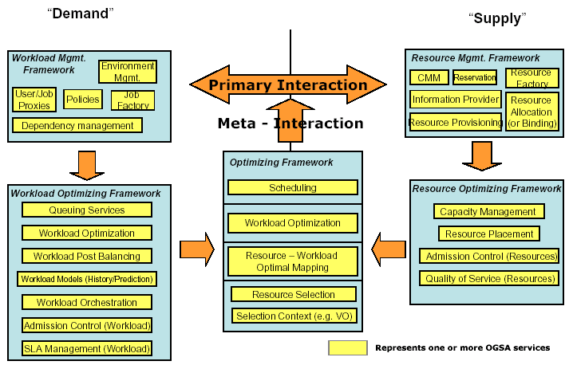
Control
Plane
Execution
Plane
Figure 2 Grid Frameworks - Execution
Services that belong to the Resource Optimization Framework are focused on the optimization of the supply side of the mapping. This can be done by admission control, resource utilization monitoring and metering, capacity projections, resource provisioning and load balancing across equivalent resources, negotiation with workload optimization and/or management services to migrate workloads onto other resources so as to maximize resource utilization.
Services that belong to the Workload Optimization Framework are focused on the demand side of the mapping. These services may queue requests to prevent request saturation and manage relative priorities in requests, perform post-balancing by migration workloads to appropriate resources depending on the potential to violate or be rewarded for missing or exceeding SLAs respectively.
Services in the Optimizing Framework are focused on resolving any contentions that the myopic views of the respective resource or workload optimization frameworks may create. These services arbitrate and modulate the primary interactions either in an ‘in-band’ or ‘out-of-band’ manner.

Execution Management Services
Execution Management Services (OGSA-EMS) are concerned with the problems of balancing the requirements of work to be done on the Grid with the constraints of the resource required to complete the work. Work may be at specified at any of the levels of granularity described in Figure 1. Within OGSA-EMS the atomic unit of work is the task and can in its simplest cases refer to, for example, a legacy batch job, a database server, a servlet running in a Java application server container, etc. Further levels of granularity are implementation dependent.

Execution Management and Provisioning
The execution management services in the “execution” portion of the framework (in Figure 2) are very closely related with provisioning. If the job is modeled as a resource then making the job available is a provisioning operation. The aspects of the environment that is required by the job are the dependencies that the provisioning of the ‘job resource’ has on the other resources that need to be provisioned before. The ‘control’ framework determines when that provisioning process is to be triggered and the granularity of control over this process.

Current diagram focuses on the creation of jobs
Provisioning
Deployment
Configuration
Information Services
Service
Container
Data
Container
Accounting Services
Execution Planning Services
Candidate Set Generator (Work -Resource mapping)
Job Manager
Reservation
Figure 3: Interactions of EMS services to execute a legacy job

Question to be resolved
- How do jobs and job documents lifetime correlate with the lifetime of long running services? What are the issues in keeping distributed information on the ‘job’
- Do we need to introduce the notion of a job manager as a first class service rather than providing it as a capability to be implemented by some other service. Or some other service becomes a job manager by virtue of exhibiting such behavior?
- Are there different behaviors in instantiating a) a single legacy job, b) an interacting set of legacy jobs (including management groups, communication groups etc), c) grid services (infrastructure services and user services)?
- We need mechanisms (services?) that manage the post instantiation of a service (including rebinding of jobs to resources). Most of the models currently looked at are for first instantiation.
- How do we handle fault tolerance? Do we need to identify the fault modes? How does the system behave under these mode?
- How do we manage admission control? How much of policy is within the service as opposed external to the service?
- What are the relevant standards that currently apply?
- What are the composition paradigms? What are the composition plug points (if any)? Is composition purely message oriented? What are the requirements on implementation composition?
- What is the granularity of resources?
- What do we mean by a resource? How do we represent and access resources?
- How do we build the services for the “supply” and “demand” sides of the environment?
- What is the control scheme used to manage the interaction of the services? Eliminate race conditions etc?
- What are the requirements to be made of other OGSA services? i.e. what “knobs and whistles” should they provide and what capabilities should then manifest?
- Need to understand delegation models required? What can a service delegate? How do policies tie into the delegation? This ties into the proxy models applicable (e.g. traversing a firewall). What makes sense to delegate?
- What have we forgotten about? What do we need to drive? Especially around the provisioning. How do we get a handle to it?
- Need to revisit job and resource.
- What types of meta-data are required for these services?
- Manageability (interaction with DMTF). And how do we relate to DMTF profiles? (Read the DMTF documentation)

Process:

- Look at the input into the V1 OGSA documents. (GSA sent detailed information).
- Look at questions to be resolved. Can we do the following? If we can test the question against the architecture then see where the gaps? Each one provides their views.

