Notes:
This submission contains proposed replacement wording for §6.13 in draft-ggf-ogsa-ogsa-013a.doc which can be found at:
https://forge.gridforum.org/docman2/ViewCategory.php?group_id=42&category_id=469
It is composed of content adapted from the draft-ggf-ogsa-logservice-10.doc document which can be found at:
https://forge.gridforum.org/docman2/ViewProperties.php?group_id=42&category_id=469&document_content_id=1538
and represents the output of the Logging System Focus Area of the OGSA-WG.
The submission outline and guidance for content were obtained from service_description_template_v31.doc which can be found at:
https://forge.gridforum.org/docman2/ViewProperties.php?group_id=42&category_id=357&document_content_id=1586
... BH
Bill Horn (hornwp@us.ibm.com)

OGSA Services

Logger System
The OGSA Logger System serves as an intermediary between log artifact suppliers and log artifact consumers. Suppliers write log artifacts that may or may not be read at a later time by consumers. As documented in [ref:draft-ggf-ogsa-usecase-2], several Grid usage scenarios require logging services. These scenarios include those based on problem determination, metering resource consumption, failure recovery, transaction processing, and security. The logging system requirements generated by these usage scenarios are summarized in the following section.

Requirements
Added “Requirements” subsection (not in description template) … BH
Services that consume log artifacts place a number of requirements on the OGSA Logger System. These requirements are described in the following subsections.

Legacy Logger Systems
To ensure the general acceptance of the basic log semantics and to enable the exploitation of existing implementations, the OGSA Logger System should support key features found in existing logging implementations (e.g., zOS System Logger, Windows event logging, and UNIX syslog facility).

Persistency
One of the basic goals of any logging system is to provide a mechanism to persist log records. The retention period for a log record should be determined by consumer requirements. For example, in a real-time monitoring application, data may become irrelevant in a very short amount of time. Data for an auditing program may be needed months or even years after it was generated. Some applications are best served by circular logs. Other applications depend on persistent log records to recover their state in case of failure. As discussed in §6.17.1.14, the OGSA Logger System should support a variety of persistency QoSs (e.g., circular logs, logs with policy-specified record retention periods).

Support for Sequential Writes
The OGSA Logger System should support sequential writes at the granularity of an individual record, with each record representing one log artifact. Writes always append a record to the end of a log stream. Byte-level access is not required.

Stateful Read Cursor
The OGSA Logger System should permit consumers to sequentially access the records in a log stream using a stateful cursor that is not invalidated by supplier writes or reads from other consumers. The System should provide an efficient mechanism to position the cursor using the record timestamp or the record GUID.

Ordering of Log Records
Logs are frequently used to record a time-ordered sequence of events. At a minimum, the OGSA Logger System should, for a given write connection, permit consumers to efficiently read (time-stamped) records in the same order that they were originally written. The timestamps used for ordering should be established by the Logger subsystem and not the application. This timestamp should include be expressed in GMT and include the offset between GMT and Local time. As discussed in §6.17.1.14.1, other implementations may choose to provide stricter ordering requirements.

Standard Schema for Log Records
A standard, structured log artifact schema facilitates the effective intercommunication amongst disparate applications. In some cases, such as when performance is paramount and interoperability is not a concern, less structured artifacts are more appropriate. The OGSA Event (§ogsadraft10-6.15) is designed to accommodate varying degrees of structure and should be used as the basis for the structured log artifact.

Decoupling of Suppliers from Consumers
The ultimate usage of a log artifact (e.g., audit, system management, problem determination) should be determined, potentially at runtime, by the log artifact consumer not the log artifact supplier. The OGSA Logger System should enable the decoupling of the log artifact supplier from the log artifact consumer. This requirement is closely related to the requirement expressed in §6.17.1.7.

Broker
The OGSA Logger System should support mechanisms that permit: (1) multiple suppliers to write records into log stream and (2) multiple consumers to read records from a log stream. Furthermore, the system should be able to coordinate concurrent reads and writes. This is a fundamental behavior supported by all production OS logger systems. This requirement is closely related to the requirement expressed in 6.17.1.6.

Filtering
Frequently the quantity of logging data generated is much greater then the quantity of data actually consumed. To reduce resource consumption, the OGSA Logger System should provide filter mechanisms for both read and write operations. A filter on the write operation avoids the cost of storing the record.

Merged Log
Some use cases (e.g., a single log for a clustered system) require that the logger system exploit underlying merge mechanisms. The OGSA Logger System should expose the capabilities of these merge mechanisms.

Synchronous and Asynchronous Write Semantics
Some applications require an acknowledgement for every write. Other, typically time-sensitive applications, obtain acknowledgements using a callback mechanism. Still other applications do not require any acknowledgement. The OGSA Logger System should support all three patterns.

Duplication of Log Streams
To facilitate the manipulation and maintenance of logs, the OGSA Logger System should provide the capability to create a new log stream by copying records from an existing log stream.

Deletion of Log Records
Log maintenance (e.g., cleanup) requires a mechanism for performing time stamp-based deletes on existing log records in a log stream.

Coexistence with OGSA Messaging
Patterns for the consumption of events vary according to the needs of the consuming applications. In a distributed environment, RPC-based reads on a log stream may not be the best mechanism for consuming applications to access events. For example, a real time monitoring application may need to be asynchronously notified whenever a high-severity artifact is logged (push mode). Another example would be a consumer that polls for metering data every 24 hours (pull mode). These scenarios are better served by using OGSA Messaging System brokers than by using an OGSA Logger System. However, both of the above examples might require that a log be kept of all events that flow through a messaging broker. The OGSA Logger System should be designed such that an OGSA Messaging System broker (§ogsadraft10-6.14) can act as logging broker by implementing the Logger interfaces.

Standard Set of Specialized Logstreams
Different applications have different requirements on the features and qualities of service associated with a logstream. To accommodate these demands the OGSA Logger System should support a finite set of specialized logstreams that somehow span the space of required features and QoSs. Specializations should include the following types.
        - Secure Logs
Some applications (e.g., metering, AAA) require that logs be secure (e.g., encrypted). OGSA Security mechanisms are covered in § ogsadraft10-4.1.4.
        - Globally-ordered logs
Some parallel, transaction-oriented applications require merged logs that maintain a global order based on a common clock.
        - Circular logs
For some applications it is preferable to specify retention using a space constraint instead of a time constraint.
        - Duplexed logs
A Log may offer a high reliability QoS by duplexing all writes.
        - Compressed logs
Compressed logs trade performance for space.

Detailed List of Services
The OGSA Logger System is composed of five services. They are:

- LogManager service
- Log service
- LogStream service
- LogStreamConnection service
- LogBrowseSession service

The portTypes supporting these services and their relationships are shown using UML Figure 1 and are described in the following subsections.
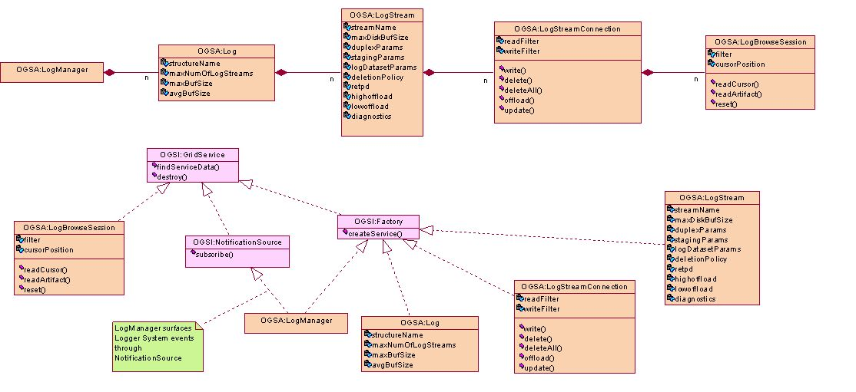
Figure 1: OGSA Logger System Overview

LogManager service
The LogManager service is responsible for managing an instance of the OGSA Logger System. The LogManager service implements the OGSA LogManager portType. The OGSA LogManager portType inherits from the OGSI NotificationSource and OGSI Factory portTypes. The LogManager service acts as a factory for Log service instances. As a NotificationSource, it is responsible for surfacing all OGSA Logger System state changes, providing a single point of contact for obtaining all management-related events.

Log service
The Log service implements the OGSA Log portType. The OGSA Log portType inherits from the OGSI Factory portType. The number of LogStream instances that can be created is specified when a Log service is instantiated (using the factory operations in LogManager portType). If the underlying system supports a hardware-assisted merge facility then the details of the connection to the enabling hardware (e.g., zSeries Coupling Facility) are specified when the Log service is instantiated. The Log service acts as a factory for LogStream service instances.

LogStream service
The LogStream service implements the OGSA LogStream portType. The OGSA LogStream portType inherits from the OGSI Factory portType. A relatively long list of parameters is available to configure a particular LogStream service instance. LogStream policies for retention, offload, persistence, availability, and staging are defined by these parameters. The LogStream service acts as a factory for LogStreamConnection service instances.

LogStreamConnection service
All access (read or write) to the records in a LogStream are made through the LogStreamConnection service. The LogStreamConnection service implements the OGSA LogStreamConnection portType. The OGSA LogStreamConnection portType inherits from the OGSI Factory portType. The LogStreamConnection portType has operations which permit the writing and importing of log records. Additionally, the LogStreamConnection service acts as a factory for LogBrowseSession service instances.

LogBrowseSession service
An instance of the LogBrowseSession service is used to read log records from a LogStream. The LogBrowseSession service implements the OGSA LogBrowseSession portType. The OGSA LogBrowseSession portType inherits from the OGSI GridService portType. Each LogBrowseSession maintains a cursor for navigating its corresponding LogStream. The LogBrowseSession portType has operations to access records by id or by timestamp, position its cursor, or to use its cursor to read a sequence of records.

Standard schema/document
I’m not sure I understand what goes here … BH

Underlying services
The OGSA Logger System has dependencies on underlying services. These are described in the following subsections.

OGSA Event
As described in §6.17.1.5, the Logger System will represent log artifacts using the schemas defined by the OGSA Event (§ogsadraft10-6.15).

OGSA Policy and Agreements
Much of the state contained the LogManager, Log, and LogStream services is specified using policy. The Logger System will use the OGSA Policy mechanisms described §ogsadraft10-6.16 to handle policy.

OGSA Security Services
As described in §6.17.1.14.0, the Logger System is required to support secure logging. OGSA security mechanisms are described in §ogsadraft10-4.1.4.

Related services
As described in §6.17.1.13, the Logger System is required to coexist with the OGSA messaging infrastructure (§ogsadraft10-6.14).

Related standard
TBD
Should we only include “standards”-based specifications or should other reference specification be also included? … BH

References for POSIX Logging, LINUX Logging, NT Events, zOS Logger System.

Owner WG(s)
TBD

